

UNDP Project Document

UNDP-GEF Medium-Size Project (MSP)

Government of Burkina Faso

United Nations Development Programme

PIMS No. 3968

National Subprogram for Coordination and Institutional Development
on Sustainable Land Management

− Abbreviated: the National Coordination subprogram −

Brief description

Burkina Faso's Country Partnership Programme for Sustainable Land Management (CPP/SLM) is a 3-phase program. The first phase consists of 5 subprograms, as follows: a national coordination subprogram (i.e. this project) 4 regional SLM subprograms (to be implemented by IFAD, UNDP and WB. The present subprogram is meant to provide overall CPP coordination and to strengthen national policy/institutional capacities around SLM. Its objective is to enhance programme-wide effectiveness and efficiency of SLM initiatives in Burkina Faso. It consists of 4 components: Coordination platform; Institutional and policy reforms; Promotion of best practices; and Subprogram and CPP management. It has a budget of US$ 1 million and a co-financing of US$ 8.7 million (co-financing includes Government and a number of multilateral projects). It will be implemented by a project management unit within the Ministry for the Environment. This project will play a coordinating role for the entire CPP portfolio, while creating the institutional capacities for a Government-led programmatic approach to SLM (planning, investment and monitoring). It will also stimulate multi-stakeholder dialogue and cooperation on SLM. It will finally play advisory and M&E support roles for the other 4 regional subprograms, as well as leading a substantial knowledge uptake on SLM, country-wide.

Table of Contents

Acronyms 3
I. Narrative 4
PART I: SITUATION ANALYSIS 4
Environmental context 4
Socio-economic context 6
Institutional context of the land and environment management in Burkina Faso 8
Policy context of the land and environment management in Burkina Faso 8
Land degradation in Burkina Faso 10
Barriers to Sustainable Land Management to be addressed through the project 11
Local and global implications of land degradation 13
PART II: THE STRATEGY 14
Programme framework (CPP) 14
Project rationale and objective 15
Expected project outcomes and outputs 15
PART III: MANAGEMENT ARRANGEMENTS 19
Implementation arrangements 19
Cooperation and co-financing partners 20
Organisational diagram 21
PART IV: MONITORING AND EVALUATION PLAN AND BUDGET 23
M&E arrangements 23
M&E Work Plan and Budget 27
PART V: LEGAL CONTEXT 29
II. PROJECT RESULTS FRAMEWORK AND GEF INCREMENT 30
III. TOTAL BUDGET AND WORK PLAN 33
IV. ADDITIONAL INFORMATION 36
Endorsement letter by Government 37
English translation of the Endorsement letter by Government 38
Support letters from co-financing partners 39
Terms of Reference of the subprogram's Coordinator (outline) 46
Terms of Reference of the subprogram's M&E expert (outline) 47
Terms of Reference of the subprogram's Administrative & Financial Officer (outline) 48

Acronyms

ADEPAC Project to support Decentralisation and Citizen's Participation
ANGDT National Authority for Sustainable Land Management
APR Annual Project Report
AWP Annual Work Plan
CFA African Financial Community
CO Country Office
CONEDD National Council for the Environment and Sustainable Development
CPP Country Partnership Program
CSIF Country Strategic Investment Framework
CVGT Village Committee for Territorial Management
DMP Desert margin Program
FAO U.N. Food and Agriculture Organisation
FCFA Franc of the CFA
GDP Gross Domestic Product
GEF Global Environment Facility
GEF-3 3rd replenishment of the GEF's Trust Fund
GEF-4 4th replenishment of the GEF's Trust Fund
ha hectare
IFAD International Fund for Agricultural Development
IW Inception Workshop
INERA National Institute for the Environment and Agricultural Research
km kilometre
LPDRD Policy Letter in Decentralised Rural Development
MAHRH Ministry for Agriculture, Water Resources and Fisheries
MATD Ministry for Territorial Administration and Decentralisation
MECV Ministry for the Environment
mm millimetres
M&E Monitoring and Evaluation
MRA Ministry for Animal Resources
MTR Mid-Term Review
NAP/CCD National Action Program / Convention to Combat Desertification
NGO Non-Governmental Organisation
NRM Natural Resources Management
ONEDD National Observatory for the Environment and Sustainable Development
PASE Project to support Access to Energy Services
PFIE Programme for Environmental Information and Training
PIR Project Implementation Report
PMU Project Management Unit
PNGIM National Programme for Information Management
PNGT-2 National Programme for Territorial Management (phase 2)
PN-PTF-LCP National Programme for multifunctional platforms to combat poverty
PROGEREF Project for Sustainable Forest Resources Management
PRSP Poverty Reduction Strategy Program
RAF Agrarian and Tenure Reorganisation
RCU Regional Coordinating Unit
SDR Rural Development Strategy
SLM Sustainable Land Management
SOFITEX Fibres and Textiles Company
SOSUCO Sugar Company of the Comoé
TPR Tripartite Project Review
UNCCD United Nations Conference to Combat Desertification
UNDP United Nations Development Programme
US$ United States' Dollar
WB The World Bank

I. Narrative

PART I: SITUATION ANALYSIS

Environmental context

Burkina Faso can be divided into two large agro-ecological zones: the Sahelian and Sudanian zones. They can be also subdivided into 4 sub-zones: the Sahelian, Sub-sahelian, North Sudanian and South Sudanian zones (see map 1 below as well as Table 1 further down for a climatic summary).

Map 1: Agro-ecological Zones of Burkina Faso

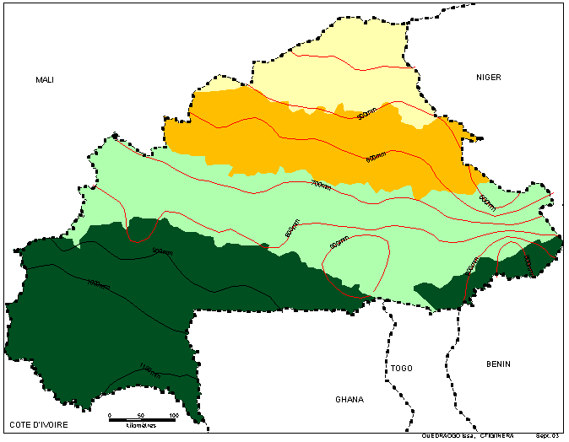
Key
National Boundaries
Strict Sahelian Zone North Sudanian Zone
Sub-Sahelian Zone Sub-Sudanian Zone
Isohyets Isohyets

The strict Sahelian zone is the extreme northern part of the country where rainfall is between 200 and 500 mm/year. It makes up 11 percent of the country. The population density is around 5 inhabitants per km². It is primarily a region of livestock herding. The system of production has evolved towards agro-pastoralism with a tendency towards sedentary activity even if pastoral transhumance is still practiced. This zone is characterized by a significant important loss of woody and herbaceous plants. Precipitation has seen a major drop and ponds dry up very quickly. It is estimated that there is a biomass deficit of 1.2 million tons, equivalent to annual forage resources for 175,000 head of cattle. The early drying up of ponds, which limits livestock watering, brings about non-utilization of some grazing areas and overuse of others. The reduction in productivity has led to cultivation of the inland valleys, which further limits access of animals to food supplies. In addition, erosion has increased following the disappearance of the woody resources.

The Sub-Sahelian zone is located between the north Sudanian zone and the strict Sahelian zone. It has an annual rainfall of 600 to 750 mm. This zone is home to 19 percent of the population with a density varying from 36 to 50 inhabitants per km^{2.} The pedo-climatic conditions that prevail (insufficient or irregular rains, plus low soil fertility) constitute a serious constraint to the development of agriculture. This means the problem of food security is acute. Given the limited abilities of most of the producers to invest in inputs, leaving land fallow has been the existing practice used to maintain soil fertility and to reclaim the soils. This practice also ensures sustainability of the production systems. A good fallow lands approach presumes that there is enough available land for it. Such an area is almost non-existent today with the strong demographic pressures which have led to abandoning fallow practices and also led to the shrinking of pasturelands creating conflicts between farmers and herders. Also production of monoculture cereal grains without the support of fertilizer has reduced soil fertility.

The north Sudanian zone covers the middle part of the country with a rainfall of 600 to 900 mm. This area makes up 34 percent of the country and has 50% of the population. This is where the highest population density in the country is found. The pressure on land is very strong because of the demographic pressures in this part of the country. The amount of agricultural land per inhabitant is low, varying between 0.7 to 1 hectares. The soils and agro-climatic conditions are less favourable to agriculture than in zone mentioned above. The systems of production remain traditional and are essentially oriented towards food crops, dominated by sorghum and millet and using very little fertilizer. The secondary crops which are marketed commercially include cotton, cowpeas (niebe) peanuts, and corn. The market gardens play an increasingly important role in agricultural production especially in the peri-urban areas. Nomadic pastoralism coexists with agro-pastoral production.

The south Sudanian zone has rainfalls of over 900 mm. It is the area which receives the most rainfall. It occupies 36% of the territory with an average population density of 20 inhabitants per km². It is also a destination zone for migrants, essentially Mossi and Peul people coming from other regions of the country. The environment is undergoing change due to the effect of migratory pressures and extensive production systems. Representing less than 30% of the population in 1985, the West has 35% of the country’s arable land. The population densities are relatively low, as is the coefficient of farming intensity.⁽⁾ The agricultural land per inhabitant varies from 1.5 to 4 hectares. The abundance of land is one of the factors that has attracted migrants from the Central Plateau. As a result there has been an increase in the area of cultivated land, a reduction in the length of time that land lies fallow, a degradation of soils, a change in the behaviour of local residents regarding the exploitation of their land assets, and a race to the land provoked by the migrants. In certain villages, the critical agro-demographic threshold has already been reached.

Table 1: Characteristics of climate per agro-ecological zone

 | South Sudanian | North Sudanian | Sahelian
Annual Rainfall | > 1000 mm | 1000 - 600 mm | < 600 mm
Length of rainy season | 180-200 days | 150 days | 110 days
Number of days of rain | 85-100 days | 50-70 days | <45 days
Annual mean temperature | 27 °C | 28 °C | 29 °C
Seasonal temperature range | 5 °C | 8 °C | 11 °C
Atmospheric Humidity  Dry season  Wet season | 25 %  85 % | 23 %  75 % | 20 %  70 %
Annual Evaporation | 1500-1700 mm | 1900-2100 mm | 2200-2500 mm
Annual Evaporation (Class A container) | 1800-2000 mm | 2600-2900 mm | 3200-3500 mm

Regarding climate, rainfalls are subject to high irregularity from year to year. Since the beginning of the 1970s, Burkina Faso has experienced chronic drought, including the most serious periods in the years 1972-74 and 1983-84.

The natural forests covered 16,620,000 hectares, of which 880,000 hectares were classified forests, according to the results of the National Forest Inventory of 1980 (Parkan, 1986). They are essentially composed of shrub and tree savannah, characteristic of the Sudanian and Sahelian regions with poor pedological and precipitation conditions. Relatively rich growth is found in regions where population is dense, which is half the country (Southwest and East). The human-derived vegetation cover includes fallow areas and fields. The system of exploitation traditionally saves sought after woody vegetation. It is this group of plant formations which constitute the basis of forestry production. Table 2 shows the evolution of forest cover between 1978 and 1987.

Table 2: Evolution of forest cover in Burkina Faso

Plant Types | Area in 1978  (x 1,000 ha) | Area in 1987  (x 1,000 ha)
Tree savannah  Shrub Savannah  Steppes  Thickets | 4,848  10,185  1,200  3,870 | 4,684  2,828.6  4,762.5  621.9
Total | 16,620 | 12,897
Cultivated and fallow areas | 8,770 | 14,523

Socio-economic context

Burkina Faso is an agricultural country and the evolution of its GDP depends essentially on agricultural production, which is largely dependent on climatic conditions because of the modes and technologies of production used (low mechanization and little fertilizer use). Agriculture makes up the primary source of employment and income for nearly 85 percent of the population. Agriculture contributes more than 30% of the GDP as compared to livestock, which is 16% of GDP. In the Western region, cash crops contribute 36 % of income, followed by food crops which are 29%. Livestock production makes a particularly important contribution in the Northern and Centre-North regions, or 39 % and 27 %, respectively.

Not counting some products such as game, fishing, honey and several others, the forestry sector contributes 15.6% of GDP. According to FAO, in 1987 wood made up 9 % of GDP, woody forage almost 3 %, shea nuts (karité) 1 %, and traditional herbal medicines about 1 %. This corresponds to 66 billion CFA francs (CNRST, 1995).

The economic activities of Burkina Faso are concentrated in agriculture, livestock production, fishing, and forest products (carried out by 87% of men and 90% of women). The distribution of these activities shows a great predominance for agriculture, livestock, fishing and hunting in the rural areas (95% of all activities), compared to 4.2% of activities occurring in urban areas. The population can be divided into major groups which include: salaried workers, small traders and artisans, farmers, herders, inactive people and those who work for others. It can be seen from this table that 78% of the Burkinabe population practices food and cash crop agriculture.

Table 3: Division of socio-economic activities by gender (nation-wide).

Socio-economic group | Male | Female | Combined Totals
Socio-economic group | Male | Female | Total | Percentage (%)
Public sector salaried workers | 201,265 | 202,457 | 403,722 | 4.3
Private sector salaried workers | 128,478 | 121,801 | 250,279 | 2.7
Artisans | 293,973 | 293,866 | 587,839 | 6.3
Other activities | 30,837 | 31,567 | 62,404 | 0.6
Food Crops | 3,159,056 | 3,234,954 | 6,394,010 | 68.1
Cash crops | 496,884 | 482,868 | 979,752 | 10.4
Total | 4,656,747 | 4,735,820 | 9,392,567 | 100
Source: INSD: Priority Survey of Household Living Conditions 1996

The secondary sector is not well-developed: it contributes an average 17 % to GDP. In the mining sector, exploration activities have indicated the presence of gold, phosphates, zinc, silver, lead, nickel, calcareous bauxite, manganese, diamonds, oil shale, magnetite and vanadium. Currently, gold is mined industrially, semi-industrially and by artisanal gold-panning. The tertiary sector (marketed and non-marketed services) is well-developed (with the exception of the west) and contributes to an average 37 % of real GDP. Remittances of funds from emigrant Burkinabe workers are very important and in the 1990s ranged around 45 billion CFA francs annually.

Overall, household revenues are weak and variable, particularly in rural areas. The weak per capita income and indicators of “sustainable human development” place Burkina Faso among the poorest countries in the world. According to the National Statistics and Demography Institute (INSD 1994), 44.5% of the population lives below the national poverty line, which is 41,099 FCFA per year. This threshold is calculated based on the food and non-food household expenses and on the daily adult food calorie needs. Among the poor, agricultural income is the most important at 55% (20% are cash crops, 17% are food crops, and 18% are livestock herding). Poverty incidence is summarised in the map below.

Map 2: Incidence of poverty distribution by Administrative Region from 1998 to 2003
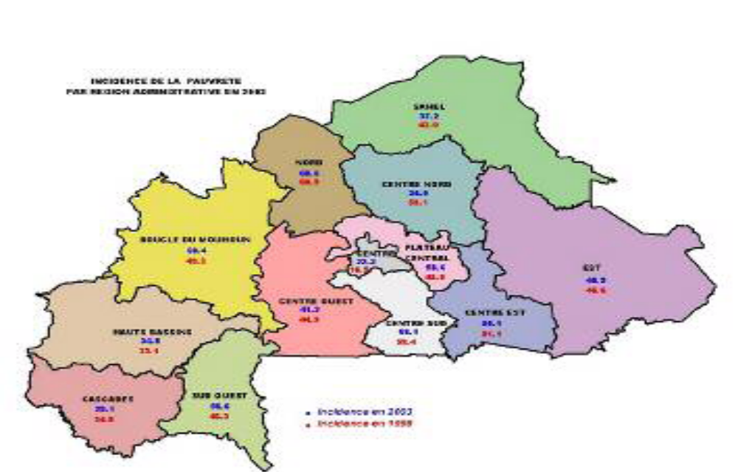

Institutional context of the land and environment management in Burkina Faso

Land resources fall within the domain of various governmental agencies. Above all, the Ministry of the Environment (MECV) is responsible for the management natural resources, including land (its conservation and sustainable use) and the overall environment. The Ministry of Agriculture, Water Resources and Fisheries (MAHRH) is responsible for the production and productivity dimensions of land and its related resources. Because of the role it plays in the areas of agricultural and fish production, this ministry is very interested in and concerned with ensuring high productivity of resources from non-irrigated and irrigated agricultural land, inland valleys and hydro-agricultural development, as well as with productivity of fishery resources, primarily fish, in water bodies. The Ministry of Animal Resources (MRA) is responsible for aspects of productivity of grazing lands and pastures, ensuring access to water holes to herders and to forage reserves for cattle, and for capacity building of producers. Other relevant ministries for sustainable land management include the Ministry of Territorial Administration and Decentralization (MATD), the Ministry of Economy and Development (MEDEV), the Ministry of Finance and Budget and the Ministry for Secondary Education and Scientific Research (MESSRS).

Other relevant parties interested in SLM: the Chambers of Agriculture, umbrella farmer organizations, commercial enterprises operating in the rural economy sector (such as SOFITEX and SOSUCO), many NGOs, some consulting firms, and local finance entities (such as credit unions and rural banks). At the local level, and taking into account the operational implementation strategy of NAP/CCD, the directives of the SDR and the general code for territorial collectivités, one notes three groups of strategic local players for sustainable land management: the Territorial Collectivités (Regional Council and Communal Council), traditional institutions, and grassroots community organizations. These three groups represent three forms of legitimacy and power which have considerable influence over local decision-making and popular participation at the local level.

Policy context of the land and environment management in Burkina Faso

The relevant legal framework for rural development and for SLM in Burkina Faso is broad. There are many strategies and action plans that have influence on the SLM domain. The most important ones for the CPP are summarised next:

  - The Strategic Framework to Combat Poverty (PRSP) aims to reconcile the necessities of structural reform and economic recovery with objective of increasing the incomes of the poor and income transfers to the poorest of the poor. The PRSP will establish the reference framework from now on for all development plans and programs for Burkina Faso.
  - The National Action Program to Combat Desertification (NAP/CCD) aims to contribute to the establishment of sustainable development in the country through capacity-building for local authorities and ensuring active participation by districst and local groups in the actions to combat desertification and to mitigate the effects of drought. The participatory process of developing the NAP/CCD has contributed to a better organization of the actors and to a raise their awareness to the necessity of coordinating their actions for a more effective fight.
  - The Policy Letter on Decentralized Rural Development (LPDRD), adopted in 2002, centres its actions on the environment in the “promotion of sustainable and decentralized management of natural, animal, and fishery resources by co-management and concession mechanisms, through the creation of development and participatory management plans for forests, water bodies and wildlife protection areas, as well as training, organization and empowerment of local communities, monitoring of the evolution of forest, wildlife, and fishery resources, the fight against bush fires as well as an array of measures which aim to preserve natural resources.”
  - The Regulations for the Land Tenure Reform Act (RAF), developed in 1984 and reviewed several times to become the Land Tenure Reform Act, defines the National Public Lands (Domaine Foncier National - DFN) and organizes the authorities responsible for its management. The RAF seeks the empowerment of village communities to manage natural resources and rural lands, and to implement development programs. The RAF has, in particular, set up Village Land Management Commissions (CVGTs), the desired expansion of which across the entire country has faced several constraints.
  - The Rural Development Strategy (SDR) was developed at the end of 2003. Its overall objective is to ensure continued growth of the rural sector in order to contribute to the fight against poverty, to the strengthening of food security and to the promotion of sustainable development. The SDR is meant to: (i) increasing agricultural, livestock, forest products, game, and fishery production through improved productivity; (ii) increasing revenues from diversification of economic activities in rural areas; (iii) strengthening the links between producers and markets; (iv) ensuring sustainable management of natural resources; (v) improving the economic conditions and the social status of women and the youth in rural areas; and (vi) empowering rural populations to become development actors.
  - The National Land Management Program (PNGT), established in 1992, is a national program endowed with capacity for organizing land use. A reorganization of land-use on the basis of constraints, potentials and roles was created through more than one hundred land management plans. This was a response to the need to instil an awareness of the land’s limitations among the population in order to direct them towards an intensification of agro-pastoral production, in particular the monitoring and organization of migration. The second phase of the program (PNGT 2) has been operational since 2001 and covers the entire country.

Confronted also with the desertification front, the Government of Burkina Faso has made early efforts in an ambitious program to combat desertification, aiming primarily at curbing and reversing trends in the degradation of the natural resources base through rehabilitation of soil productive capacity. The program has been in place for several decades; its goals and expectations have sometimes been met, but often failed to be achieved. For example, Burkina Faso has arguably one of the most successful dryland forest management programs in all of Africa and is a leader in savanna fire management. Furthermore, Burkina Faso has some success stories in the development and adoption of farm-level soil and water conservation technologies: for instance, anti-erosive barriers, assisted natural regeneration, farm fences, early fires, fire-protective measures, organic fertilization (manure), community forest conservation, and a traditional technique, named zaï, that involves the creation of pits during the dry season that collects sediments and runoff water during the rainy season. However, the application of these technologies remains isolated success stories that have not been adequately scaled up at national level. With regard to rangeland management, Burkina has made even more limited progress, especially on the development of integrated forest/range/wildlife management systems. Even more challenging is the long-term maintenance of agricultural soil productivity, which remains a huge, chronic problem..

The CPP has been finalised and will be implemented under the TerrAfrica framework. TerrAfrica is a partnership between Sub-Saharan African countries, development donors, civil society and the research community with the collective goal of coordinating, institutionalising and scaling-up SLM efforts. The CPP will work under the principles of TerrAfrica and thereby represent the core policy, institutional and investment umbrella for SLM in Burkina Faso. Both TerrAfrica (as the regional African platform for SLM) and the CPP (as Burkina Faso's policy and programmatic platform for SLM) will go hand in hand. In fact, it is not by chance that UNDP is the lead agency for TerrAfrica in Burkina Faso and will be the implementing agency for the CPP's National Coordination subprogram, in order to ensure coordination at international level. At national level, coordination is simpler given the primary role of the CONEDD as well as the leading role that the CPP will play, including the institutional strengthening for SLM.

The CPP is thus conceived as the country- and field-level implementation mechanism for SLM, under the regional TerrAfrica framework. The CPP will follow TerrAfrica's principles and guidelines and, for instance, will work on strategic investment planning and on financing mechanisms for SLM, as TerrAfrica advocates for. The different policy, financing and operational tools for SLM that TerrAfrica has been developing, or is developing, will be adopted by the CPP and each of its subprograms. In particular, TerrAfrica tools on monitoring around SLM, on investment planning (the so-called CSIF) and on knowledge management will be adopted by the CPP for its work.

Land degradation in Burkina Faso

In Burkina Faso, the economy is dominated by agriculture and animal production, which together provide employment to more than 85% of the population and account for approximately 70% of export earnings. Some 30% percent of the country’s arable land (81,808 km²) suffers from severe degradation, while another 4% (10,537 km²) is severely degraded. The trend is increasing and accelerating.
In general, environmental degradation has accelerated and affects all of the country’s regions. Population growth, unsustainable farming practices and ongoing desertification have intensified pressures on the natural resource base. Poor soils in the northern and central regions, where population concentrates, together with several drought crises in the last decades have caused population displacements to the southern and eastern regions and to urban centres. As a consequence, pressures on the environment have augmented and lands are overexploited. The natural resource degradation, exacerbated by recurrent droughts, has resulted in the loss of numerous services provided by ecosystems, notably food production, soil conservation and water retention, posing major constraints to the livelihoods and the well-being of both rural and urban populations.
The principal processes which cause land degradation in Burkina Faso are as follows:
- Land tenure insecurity may be an obstacle to the adoption of some SLM technologies and leads to increased clearing/exploitation of marginal lands that are susceptible to erosion and on which soil fertility maintenance is even more difficult and results in poor range management.
- Unsustainable agricultural practices, including poor soil and vegetation management practices in shifting agriculture expose the soil to rainfall impact, degradation of surface layers, reduced infiltration, increased runoff and loss of rooting matter in the soil, leading to sheet, rill and gully erosion, reduced aquifer recharge and limited soil moisture levels. Increases in the intensity of production (cotton), in the absence of appropriate nutrient management, lead to losses of soil fertility and organic matter content.
- The use of fire, for land clearance and the rejuvenation of pasture grasses, degrades vegetation and leads to soil surface crusting, reduced infiltration and increased erosive cross-surface flow, and also affect soil nutrient status by leading to the loss of soil carbon and nitrogen.
- Unsustainable range management, overgrazing and overstocking lead to degradation of vegetation resources through grazing and browsing, and the compaction of soils through trampling.
- Unsustainable forest and woodland management (including deforestation for timber and fuel wood, bush fires, and hunting and gathering needs) leads to the loss and degradation of forests and major economic losses.

Barriers to Sustainable Land Management to be addressed through the project

Analyses carried out during the CPP preparation identified a number of barriers, which are to be addressed through the 5 projects which constitute the CPP. These "barriers", which limit the possibilities of achieving widespread application of SLM throughout Burkina Faso, are as follows (they are described subsequently, including their relevance to this sub-program's outcomes):
- Insufficient human resource and institutional capacities
- Overlapping and inconsistent policies fail to serve as efficient mechanisms and do not adequately incorporate SLM considerations
- Large number of institutions active in rural development issues and limited inter-sector integration makes coordination of activities difficult, increases transaction costs and creates conflicts of interest. (Limited inter-institutional coordination)
- Lack of widespread knowledge of land degradation, SLM and best practices
- Inadequacy of systems for monitoring land degradation, and the management of related information
- Limited development of financing and incentive mechanisms for SLM

SLM barrier 1: Insufficient human resource and institutional capacities. Currently regulations governing NRM in Burkina Faso are not fully enforced. Scaling up, replication and adaptation of successful SLM models, such as community-based forest management, is blocked because of the lack of capacity from the national to the local levels. Rural land users lack sufficient capacities to practice sustainable land use practices. Moreover, insufficient capacities hinder conceptualizing the relationship between the environment and other development sectors and linking its effects to economic development (growth and generating prosperity) and poverty reduction through practical means. Under the second outcome of the CPP National Sub-Program, activities will contribute to capacity-building of different Governmental agencies and civil society parties, in order to empower them in combating desertification at central and decentralized levels. Activities will build both human and institutional capacities of Burkina Faso in order to have the necessary skills to face sustainable land management responsibilities and challenges.
SLM barrier 2: Fragmented and inconsistent policies fail to serve as efficient mechanisms and do not adequately incorporate SLM considerations (lack of an integrated vision). Design and identification of natural resources management by the administration and its subdivisions have been fragmentary and ad hoc, thus creating an institutional/political context that is increasingly complex and more complicated to manage over time. This established fact is demonstrated by the existence of a high number of public actors, from "strategic frameworks" and "policies" to "programs and action plans", resulting from a narrow viewpoint and sector-based rationales. This plethora of frameworks and plans translates into compartmentalization and institutional logics used until now. The current land reform, which was designed under a top-down approach and failed to consider the full breadth of land use and land access issues, has yet to be applied “to the ground.” The CPP National Sub-Program will address this barrier through the establishment of an inter-sector and cross-stakeholder cooperation framework. In particular, under its first outcome/component, the National Sub-Program will be to develop and set up a platform for partnerships to enable better coordination and an integrated approach to sustainable and equitable land management. The platform will be a consultative process and will ensure a national programmatic approach, providing coherence among the various land management activities in Burkina Faso and based on the respective comparative advantages of the partners seeking synergy. In addition, this project's outcome 2 will contribute to the creation of a conducive legal, regulatory and policy environment to sustainable land management along two strategic thrusts: (i) mainstreaming SLM into sector planning; and (ii) strengthening the coherence and articulation of the decentralization process, incorporating NRM and SLM perspectives.

SLM barrier 3: Large number of institutions active in rural development and limited inter-sector integration makes coordination of activities difficult, increases transaction costs and creates conflicts of interest (limited inter-institutional coordination). Currently, limited coordination between the multiple institutions related to natural resources in Burkina Faso is a key problem, affecting all of the other CPP barriers cited above. Each institution, seeking survival and legitimacy by developing its own programs, legislation and policies, fails to seek complementarities with others and to build their respective capacities of coordination and support for national development. The CPP aims to address this barrier in part by systematically reviewing the successes and failures on community organization and horizontal and vertical coordination. Under outcome 1, this National Coordination sub-program will focus on establishing, in a progressive fashion, a mechanism for coordinating SLM policies, programs and activities between partners, government sectors and stakeholders at the national level to achieve greater synergies and cost effectiveness. During phase 1 of the CPP, this responsibility will be assumed by CONEED, but will be progressively shifted to a permanent and independently budgeted institution, the National Sustainable Land Management Agency (ANGDT), with sustainable land management issues as its core mandate.

SLM barrier 4: Lack of widespread knowledge of land degradation, SLM and best practices. The problems of SLM in Burkina Faso are less the resolved technical and technological problems than they are the absence of an “eco-citizen” conscience. Although the knowledge level has increased strongly over the past several decades, there is very little knowledge on the integrated management of ecosystems at the landscape level. Professionals tend to be specialist in one particular field and have not learned to think transversally, to think in terms of trade-offs between market and non-market ecosystem services, to think in think in terms of different stakeholders and interests, and in terms of different spatial and temporal scales. Nevertheless, a significant part of this heritage of knowledge and experience is in danger of being lost due to the lack of appropriate policies and mechanisms for capitalization and validation. Activities under outcome 3 of this National Coordination sub-program will support the development of a system promoting farmer/herder innovations as well as promoting knowledge and best-practice exchanges. Environmental awareness and education will be a significant part of this outcome, with the aim of engendering a culture of conservation in both public and private life.

SLM barrier 5: Inadequacy of systems for monitoring land degradation and for SLM information management. There is no systematic attention at the institutional level to the global environmental benefits that accrue from sustainable land management. They tend to be by-products and are not monitored. Within a private-public partnership, an Observatory will be established with its main purpose being to develop and implement a monitoring and evaluation system using GIS-based tools and common indicators elaborated on the basis of agreed objectives and building on information exchange and lessons learned. Furthermore, outcome 1 includes necessary activities for the strategic guidance and monitoring of the overall CPP and will rely on the strong field presence of the sub-programs. Thus, the National Coordination Sub-Program will strengthen capacities for gathering and managing information on conditions of degradation and the impacts of SLM, in order to ensure that the information is up-to-date, correct, usable and accessible by decision makers.

SLM barrier 6: Limited development of financing and incentive mechanisms for SLM. Under outcome 1, the CPP National Coordination sub-program will take charge of investigating one or more mechanisms for the financial sustainability of Sustainable Land Management in Burkina Faso. The selected financial mechanisms will be established for subsequent phases of the CPP.

Local and global implications of land degradation

At local and national levels, land degradation is affecting the livelihoods and the quality of life of a large number of Burkinabe people, since it reduces agriculture and livestock productivity, disrupts hydrological flows with loss of surface and subsurface water availability, quality and reliability, reduces vegetation and above-ground biodiversity (reducing soil nutrients, organic carbon and below-ground biodiversity) and increasing the vulnerability to the effects of climatic variability.
The severity of the land degradation processes, described more fully in the CPP Project Document (paragraphs 62–73), is leading to a general decline of both local and global ecosystem services. The major threats that have global costs are related to deteriorating ecosystem components and loss of functions. Provisioning ecosystem services are used at the expense of those services that provide global benefits, and/or have no market price, such as regulating services. Given the scale of the area and the wide range of ecosystems affected by these processes, land degradation is not longer an isolated phenomenon but rather affects the landscape as a whole across large expanses of the country. On top of this, land degradation is triggering many positive feedback mechanisms that badly affect ecosystem integrity.
All these processes contribute not only to land degradation but also affect other GEF focal areas, i.e.: loss of biodiversity, loss of carbon sequestration potential and increases in carbon emissions to the atmosphere, contributing to climate change.

PART II: THE STRATEGY

Programme framework (CPP)

In order to solidly tackle the environmental challenges, and particularly SLM, the government has worked on a Country Partnership Program for Sustainable Land Management (CPP/SLM). The CPP/SLM is born from the fact that the several projects and programs aimed at improving land management are often poorly connected and therefore contribute little to policy changes. Its primary objective is thus not only to promote actions on the ground, but to remove the main constraints and barriers that limit the performance and impacts of sustainable land management projects and programs nationwide. Specifically, these constraints and barriers include: (i) weak coordination between interventions; (ii) inadequate enforcement of laws that govern natural resources management; (iii) weak intervention capacities among actors; and (iv) land-tenure insecurity.

The CPP aims at removing the above-mentioned barriers and constraints to SLM by:

- supporting the establishment of an interactive and effective partnership between all actors to provide a foundation for common action to combat land degradation;
- improving the quality, coherence, and efficacy of government policies, strategies and programs;
- introducing fiscal and legislative incentive mechanisms intended to improve land resources;
- building capacity for institutions and actors around SLM;
- promoting environmental citizenship; and
- supporting “knowledge and know-how” in the area of SLM, particularly by integrating biophysical, socio-economic, and legal dimensions.

The CPP is conceived as a 3-phase program that will cover a 15-year period. Phase-1 (5 years) is characterized by building national capacities, testing and piloting innovations in four selected regions, and launching a programmatic approach that links policies, institutions and practices. CPP's Phase 1 has an overall GEF budget of US$ 10 million (accompanied by some US$ 60 million in co-financing). It consists of 5 subprograms: a national coordination subprogram and four regional interventions. These subprograms and their respective implementing agencies (IAs) are as follows:
- National SLM Coordination and Institutional Development Subprogram (UNDP) – i.e. this project
- Boucle de Mouhoun SLM Subprogram (UNDP)
- Centre-West Region's SLM Subprogram (UNDP)
- East Region's SLM Subprogram (WB)
- North Region's Subprogram (IFAD)

Adopted by the GEF Council in August 2006, still under the GEF-3 financing framework, the technical design started in October 2006, with the support of the respective IAs and the strong engagement and interest of the Government of Burkina Faso, through its National Council for the Environment and Sustainable Development (CONEDD). In accordance with the selected implementation modalities, each of the involved GEF executing agencies is responsible for formulating and implementing its component, namely: the East Region by the World Bank, the North Region by the International Fund for Agricultural Development (IFAD), and the Boucle du Mouhoun, Central West regions and the National Coordination by the United Nations Development Programme (UNDP). This project document concerns the subprogram for CPP National Coordination.

The entire CPP will enable the Government to achieve the following GEF-3 Specific Objectives:
#1: To develop and implement a sustainable inter-sector partnership platform for improved coordination and an integrated approach to sustainable and equitable land management.
#2: To promote a policy and institutional environment that is favourable to sustainable and equitable land management.
#3: To foster an integrated approach to sustainable and equitable land management practices including innovative and/or local-knowledge based practices.
The CPP and this National Coordination subprogram are equally aligned with GEF-4 Strategic Objectives, notably:
#1: To develop an enabling environment that will place sustainable land management in the mainstream of development policy and practices at regional national and local levels.
#2: To upscale sustainable land management investments that generates mutual benefits for the global environment and local livelihoods.

Project rationale and objective

The objective of the National Coordination subprogram is to enhance programme-wide effectiveness and efficiency of SLM initiatives in Burkina Faso. It will play two key roles: (i) coordinating the implementation of the entire CPP portfolio; and (ii) strengthening national policy and institutional capacities around SLM. In relation to the first role, the National Coordination subprogram will, among others, help harmonizing implementation among all the CPP subprograms, provide guidance on monitoring and evaluation, and disseminate lessons learnt. Regarding the second role, the subprogram will address a number of regulatory and institutional issues that are critical for a national commitment to foster SLM and to establish a due policy/institutional framework to respond to the United Nations Convention to Combat Desertification (UNCCD). The subprogram will thus enable the entire CPP to become a genuine national program to combat land degradation and desertification. Furthermore, it is meant to foster cooperation, exchanges and synergies among all the regional CPP subprograms and the various SLM stakeholders across the country.
The project will also contribute directly to the achievement of all the global CPP outcomes. This will occur in a general way through ensuring the effective and efficient implementation of the different CPP projects through which these outcomes will be achieved on a regional and local level. In addition, the National Sub-Program will specifically contribute to the achievement of the following Outcomes of the CPP:

Expected project outcomes and outputs

The project has 4 outcomes, which are aligned to the outcomes for the global CPP. The description of the subprogram's outcomes, as well as their specific contributions to the global CPP are presented next.

Outcome 1. Coordination mechanism for partnerships to enable an integrated approach to sustainable and equitable land management is in place. GEF: US$ 315,000; Co-financing: US$ 2,224,000. This component of the subprogram will aim at a number of coordination mechanisms around SLM, from dialogue and knowledge sharing spaces to the institutionalisation of SLM planning and monitoring. The major activities and expected outputs are as follows:

  - Creation and functioning of a national observatory that monitors SLM indicators.
  - Establishment of a participatory, national M&E system for SLM (this will include tools to monitor land degradation, to measure impacts of initiatives, and to provide information for improving SLM effectiveness).
  - Establishment of a forum of stakeholders (including all CPP partners) in order to build consensus on key SLM issues – SLM national platform.
  - Identification and development of sustainable financing mechanisms for SLM (a toolkit for developing a Country Strategic Framework for Investment (CSIF) on SLM is available from TerrAfrica to assist in this activity).

The SLM National Platform is envisioned as a cross-sectoral and multi-stakeholder coordination mechanism. It will rally government, civil society, private sector and development partners around a common vision and program, building upon existing successful SLM approaches and experiences. The objective of this platform is to align development support for SLM with country priorities and to harmonize approaches and implementation modalities to reduce transaction costs, increase the focus and consistency of interventions and thereby maximize impacts. The platform will work to build a national programmatic approach to SLM, providing coherence in programming, funding, design and implementation of sustainable land management activities in Burkina Faso. The Platform will take a lead in inventorying and consolidating SLM strategies and efforts, promoting dialogue among stakeholders, and identifying opportunities for scaling-up SLM. The national platform will rely on and reinforce the strong field presence of the CPP regional sub-programs for collecting and sharing best practices and lessons learned from SLM activities implemented by platform partners.
The platform will function using a consultative process with the objective of consolidating and harmonizing SLM activities across sectors and at different scales. Financial and technical partners will collaborate based on their respective comparative advantages and in compliance with the SLM framework developed by the Government. A code of conduct will be developed and validated by all platform partners to create a transparent and objective national SLM platform. One important role of the National Platform will be to develop and implement an operational road map for making SLM approaches and interventions consistent. This will include the selection and prioritization of investments for existing and additional funding. The prioritization process will build upon existing plans and strategies, including the PRSP, SDR, NAP, NAPA and other related SLM development programs. It will use the "Country Strategic Investment Framework" (CSIF) tool that has been developed under the TerrAfrica Initiative, in order to improve financial efficiency in sustainable land management by avoiding duplication, harmonizing approaches, ensuring synergy between sectoral actions and developing new SLM financial mechanisms. The platform will oversee the design and implementation of a full CSIF in Burkina Faso (this activity will be supported by the TerrAfrica Initiative). The CSIF is a guiding tool for a gap analysis for investments in SLM, and will help to ensure institutional, financial and activity coordination. Country investments and public expenditure frameworks will be reviewed to identify constraints and entry points for SLM and to increase predictability of financial flows to SLM. A preliminary CSIF will guide activities under Phase 1 whereas a full CSIF will be prepared under Phase 1 to lay the framework for Phases 2 and 3 of the CPP.
Under the National SLM Platform, a National SLM Observatory will be established with the objective of developing and implementing a monitoring and evaluation system, using a common set of indicators elaborated on the basis of SLM-relevant indicators, including those developed under the SDR, PRSP and other national policy instruments. The national SLM M&E system will focus on measuring qualitative and quantitative results of mainstreaming SLM, institutional and human capacity building in SLM and SLM investment planning. SLM impact measurement tools will also be developed. Key indicators for the national SLM M&E system will be developed early during Phase 1. Experiences from the PNGIM, DSE, INERA/DMP, and PNGT2 should specifically inform the development of tools and procedures for information collection and processing.
The subprogram will design and implement rapid, cost-effective and reliable methods of land degradation assessment and monitoring, aiming at land use planning and management exercises. The SLM monitoring system will integrate climate risk analysis into SLM planning. A GIS-supported database will be developed. To further support SLM knowledge management and sharing, a SLM Scientific Committee will be formed to regularly review SLM technologies, and to identify innovations, best practices and lessons learned. The Committee will keep abreast of relevant climate change literature recommend appropriate revisions of national SLM strategies and activities to better enable Burkina Faso to adapt to climate-induced changes.
The National Coordination subprogram will also take charge of identifying one or more mechanisms for financial sustainability of SLM under Outcome 1. Preliminary investigations under the preparatory phase of the CPP identified several promising mechanisms including: (i) establishment of a National Fund for Desertification Control which could rely on debt relief program and other sources of funding; (ii) payment for environmental services; and (iii) carbon finance and biofuels, both of which involve integration of the private sector. The objective is to provide incentives for SLM adoption. In addition, a toolkit for developing a Country Strategic Investment Framework (CSIF) on SLM has been developed by the TerrAfrica platform and will be used by the CPP.
Outcome 2. Promoting an enabling institutional and policy environment and enhancing awareness of the importance of sustainable and equitable land management for national development. GEF: US$ 218,000; Co-financing: US$ 2,632,000. This component will look at the institutional and policy dimensions of SLM and propose/catalyse reforms to enable a programmatic SLM approach. The main actions and expected outputs are as follows:

- Design a National Authority for SLM (ANGDT) that shall be ready for functioning at the start of CPP's phase 2.
- Establish a participatory process for legislative and regulatory reform
- Strengthen capacities at national and regional levels for supporting a participatory, decentralized SLM approach
- Development of a toolbox for an effective transfer of natural resource management to local authorities (e.g. guidelines, advice brochures), including roles and responsibilities of local authorities, a code of conduct for land users regarding endangered natural resources, and guidance on conflict resolution.

This outcome will contribute to capacity-building of government agencies and relevant civil society actors in combating desertification at both central and decentralized levels. The objective is to build both human and institutional capacities of Burkina Faso by equipping actors with the skills necessary to meet the SLM challenges the country is facing. The National Coordination subprogram will place a particular emphasis on contributing to the creation of a conducive legal, regulatory and policy environment for sustainable land management. A full review of Burkina Faso’s SDR, PRSP, and other national instruments for implementing rural development policies will be conducted. The institutional and legal frameworks will be assessed in their ability to improve governance and promote up-scaling of SLM. Key laws and regulations will be harmonized and revised to integrate SLM objectives and requirements. The subprogram will also evaluate the adequacy of the legal and regulatory framework for decentralization as well as the capacity and needs of decentralized institutions to carry out the SLM mandate. Furthermore, a Code of Conduct for land users for the use of endangered natural resources will be elaborated. In addition, guidance, tools and training on conflict resolution practices for land issues will be conducted.
The subprogram will elaborate a detailed roadmap to create a National Agency for Sustainable Land Management (ANGDT) by Year 3. This is an institutional design exercise, based on abundant multi-stakeholder dialogue. A prototype of the ANGDT could be tested during the remaining period in the first phase of the CPP. All work should be launched and coordinated by the CPP Steering Committee under the aegis of the MECV. The ANGDT should fully coordinate the CPP from the start of phase 2. Until the ANGDT is formally in place, a CPP Coordination Unit, under the direction of CONEDD, will ensure management and implementation of the National Coordination subprogram as well as the overall CPP portfolio.
Outcome 3. Promote best practices for integrated, sustainable and equitable management of land, including innovative practices and indigenous knowledge GEF: US$ 304,000; Co-financing: US$ 1,920,000. This component consists basically in the identification, dissemination and promotion of best practices around SLM. The main activities will comprise as follows:
• Assessment of information needs for SLM through a participatory process.
• Review, compilation and dissemination of SLM best practices and lessons learned.
• Establishment of a system for regular exchange of best practices on SLM, such as may be a national forum on farmer and herder innovations, a regular bulletin on best SLM practices and a website.
• Organisation of knowledge and technology transfer between Burkina's CPP actors and other partners in the sub-region, ready for uptake by TerrAfrica.
• Establishment of a "Best Practices" Award to recognize local SLM innovations on an annual basis
• Integration of SLM into the curricula of key education and training centres.
• In-depth analysis of the impact of climate change on land degradation and land use, as well as possible responses and adaptation measures identified
Activities under this component will thus serve to promote the adoption of sustainable land management, soil conservation and restoration practices, including efficient water use measures. Adaptation and scaling-up of indigenous and innovative practices will be emphasized. A national competition for “Excellence in SLM Innovation” may be established under which annual prizes will be awarded. With the aim of strengthening stakeholders capacity for innovation, a national-level “SLM Innovations Fund” may be also piloted during Phase 1, awarding small grants to research and grassroots organisations for developing, refining/adapting or scaling up innovative SLM technologies and techniques.
In collaboration with the four regional CPP projects, the National Coordination subprogram will facilitate and contribute to the elaboration of an integrated SLM Communication, Information and Education strategy. The objective of the strategy would be to capitalize on the experiences, best practices and lessons learned by land users throughout the country but collecting, categorizing and disseminating this information. A user-friendly SLM technologies and techniques database and website will be developed at the national level and made accessible in the four pilot regions during Phase 1. Furthermore, the National Coordination subprogram will coordinate, under the lead of the Ministry of Education, a revision and adaptation of the primary school curricula, integrating NRM and with a special focus on SLM and climate change issues. The national coordination unit will facilitate and coordinate the full integration of SLM issues into the PFIE Kit and KIT Naturama.
A modest exchange visit program may be organized and funded under the subprogram. During Phase 1 exchanges between regions will be organized in an effort to encourage the replication and scaling up of best practices found in specific localities. In addition, a National Forum will be organized at the end of Year 4 of Phase 1 during which SLM innovations, best practices, and lessons learned will be widely shared and systematised. The Forum will provide an important opportunity to reinforce and build collaboration between researchers, extension agents and local resource users for the development, adoption and improvement of SLM technologies and practices. In addition, the Forum will provide an opportunity to take stock of the progress made to date under the CPP and identify the Outputs for Phase 2 of the CPP.

Outcome 4. Effective and adaptive management of the CPP. GEF: US $163,000; Co-financing: US$ 1,839,000. This component will serve for the management of the subprogram itself (with its institutional and policy roles) and the oversight of the entire CPP portfolio. The Monitoring and Evaluation (M&E) needs of both this subprogram and the entire CPP subprograms will be supervised from this component. The goal is to ensure a harmonic implementation of all CPP subprograms and foster synergies among them. The National Coordination subprogram will provide crucial M&E advisory support to the CPP's regional subprograms. Key activities and expected outputs under this component are as follows:

• Operationalisation of internal project management structures and systems for the CPP.
• Development and implementation of an internal project monitoring and evaluation strategy as well as a financing plan for SLM.
• Developed of adaptive management principles to be adopted by the entire CPP.

Results from the subprogram and the CPP as a whole will be disseminated within and beyond the subprogram's intervention domain through existing information sharing means, networks and forums, as well as new ones to be established by the subprogram. In addition, the project will participate, as relevant and appropriate, in UNDP- and GEF-sponsored networks that are organized for professionals that work on similar projects. The subprogram will identify and participate, as relevant and appropriate, in scientific, policy-based and/or any other networks, which may be of benefit to project implementation through lessons learned. This will be particularly the case with TerrAfrica, which is a platform intended for advancing the SLM agenda across Sub-Saharan Africa.

The subprogram will extract, analyze and disseminate lessons learned that might be beneficial in the design and implementation of similar, future projects. In particular, it will provide ample grounds for an intense presence of the TerrAfrica initiative. The identification and analysis of practical knowledge and lessons learned is a continued process, and the need to communicate such knowledge and learning is one of the subprogram’s central contributions, and shall therefore happen at least once annually in a substantial manner. The UNDP/GEF team shall assist the CPP team in documenting and reporting on knowledge and lessons uptake. To this end, a proportion of CPP resources will be allocated to document and disseminate knowledge and learning around SLM (see budget for details).

PART III: MANAGEMENT ARRANGEMENTS

Implementation arrangements

The CPP is envisioned as a 3-phase program that will last some 15 years. Phase 1, which comprises four regional subprograms and a National Coordination subprogram, is envisioned to establish a programmatic approach to SLM, including mechanisms for continued policy dialogue, M&E, and testing and dissemination of best practices. The National Coordination subprogram will lead the building of this programmatic approach to SLM. This will thus include coordination among CPP subprograms, support for the policy and institutional processes nationwide, guidance for a common M&E and, towards the final stages, preparation for CPP's Phase 2.
The project execution will follow a national execution modality. At the national level, the overall supervisory responsibility for the CPP has been entrusted to the Ministry for the Environment, abbreviated MECV (Ministère de l’Environnement et du Cadre de Vie). This conforms with the oversight role this ministry already plays in the NAP/CCD process, which represents the basis for the CPP and for the TerrAfrica platform. Accordingly, the MECV will be in charge of SLM policy management as well as overall CPP oversight, including relations with GEF and UNDP. Given the inter-sectorial nature of SLM, the MECV will foster dialogue with other relevant ministries and national agencies, including the ministry for agriculture (MAHRH), the ministry for animal resources (MRA) and the ministry for territorial administration and decentralization (MATD).
The National Steering Committee for the NAP/CCD will constitute the formal steering committee of the CPP and for each of its sub- subprograms. This will ensure synergy and coherence with the NAP/CCD.
The CONEDD, which is the National Council for the Environment and Sustainable Development, will oversee this subprogram and, therefore, the entire CPP process. This will ensure that CPP subprograms converge towards the goal of establishing a programmatic approach around SLM. The National Coordination subprogram will actually lead this process. In particular, it will put in place an intermediate structure to provide oversight for the global CPP, as well as to supervise the consensus-building process for developing the National SLM Platform and establishing a national authority for sustainable land management (abbreviated ANGDT, in French language).
A Project Management Unit (PMU) will be established to implement the National Coordination subprogram and to oversee the rest of the CPP projects as well as the CPP process as such. The PMU will be hosted by the CONEDD and composed of a coordinator, an M&E specialist, 2 SLM experts and an administrative-financial assistant. GEF and UNDP will finance together (50% each agency) the subprogram's Coordinator, M&E specialist and Administrative-Financial assistant (their respective terms of reference are synthesized in Annex C). The Government will provide 2 SLM experts (who will be in charge of technical dossiers) and a secretary. The PMU will recruit a number of experts (consultants), both national and a few international, to carry out a number of specialized tasks regarding policy development, institutional analysis, knowledge management and M&E, among others. In addition, 6 experts will be selected and supported on a part-time basis to establish and run ad interim the national observatory for environment and sustainable development.
The National Steering Committee for NAP/CCD will designate a National Scientific and Technical Committee for SLM to advise the PMU as well as the CPP and its subprograms. The main role of this committee will be to provide advice and quality-control in the overall program execution. In particular, this committee will review and approve core reports and documents generated by the CPP and provide advice on their scientific merit and content. Its composition will include the main stakeholders in SLM and natural resource management (such as may be the CONEDD, the CPSA, the CNCPDR, the CNSFMR, the PRSP, the CONAD, the PGNT2, the MATD, the DG-COOP, the CNRST/INERA, the CCPFT-E, the FENOP, the CA, and representatives of customary leadership, among others). The committee will meet three times per year and, if needed, more frequently.
The National Coordination subprogram, through its PMU and the CONEDD, will be in charge of the adaptive management for SLM, which will concert all CPP subprograms and the main SLM stakeholders across the country.
GEF recognition. In order to accord proper acknowledgement to GEF for providing funding, a GEF logo should appear on all relevant GEF project publications, including among others, project hardware and vehicles purchased with GEF funds. Any citation on publications regarding projects funded by GEF should also accord proper acknowledgment to GEF. The UNDP logo should be more prominent -- and separated from the GEF logo if possible, as UN visibility is important for security purposes.

Cooperation and co-financing partners
During formulation, the National Coordination subprogram established a number of co-financing arrangements and partnerships, including Government, 5 different projects and UNDP's co-financing. In total, about US$ 8.7 million of co-financing have been mobilised to support or create synergy with the GEF financing of US$ 1 million. The respective contributions of the co-financing institutions are presented in the table below. The official co-financing letters are attached in Section IV of this document.

Table 4. Co-financing sources for the National Coordination subprogram
Name of co-financing source | Classification | Type | Amount ($) | %
Government of Burkina Faso | Government | in-kind (74%); cash (26%) | 1,353,750 | 16
ADEPAC | Multilateral | in-kind | 100,000 | 1
PN-PTF-LCP | Multilateral | in-kind | 2,000,000 | 23
PROGEREF | Multilateral | in-kind | 620,380 | 7
PNGT2 | Multilateral | in-kind | 714,286 | 8
PASE | Multilateral | in-kind | 927,672 | 11
UNDP | Multilateral | in-kind (70%); cash (30%) | 2,977,419 | 34
Total Co-financing |  |  | 8,693,507 | 100

Organisational diagram

An organizational diagram of the National Project in relation to the CPP as a whole is presented below. This will function until the ANDGT is established, by Phase 2, and assumes CPP/SLM management roles.
Figure 6. Organizational diagram of the National Project in relation to the CPP as a whole (until ANDGT is established, by Phase 2)
CPP Executive Group
Technical Advisory Committee
FSP Technical Staff
FSP Coordinators
Intervention Area Coordination Teams
Demonstration Site Work Teams
National Steering Committee (CPP subprograms)
FSP (4 Regional Projects) Steering Committees
CPP Director
FSP Implementation Units
CPP and National Coordination subprogram Implementation Unit
CPP Director
National Program Coordinator
Technical staff

PART IV: MONITORING AND EVALUATION PLAN AND BUDGET

M&E arrangements

Monitoring and evaluation (M&E) of the subprogram will be adapted from procedures established by GEF and UNDP for Medium-Sized Projects and will be employed by the CPP team and UNDP's Country Office (UNDP-CO) with support from the UNDP-GEF team. The Logical Framework Matrix provides performance and impact indicators for project implementation along with their corresponding means of verification. These will form the basis on which the project’s M&E system will be built. The M&E Plan for the subprogram and for the entire CPP will be finalized and presented in the CPP Inception Report, following a collective fine-tuning of indicators, means of verification, and a full definition of CPP staff's M&E responsibilities.

Given that the CPP's National Coordination subprogram is a central component of the entire CPP, and that its start up will mark the operational commencement of all CPP projects, there will be close integration between the Monitoring, Evaluation and Reporting procedures of this subprogram and those of the CPP as a whole.

The project will create a National Observatory for Environment and Sustainable Development (ONEDD) (see output 1.2). In the long term, ONEDD will assume the M&E functions for the CPP and for SLM activities at the national level. In other words, the National Coordination subprogram of the CPP will carry out such functions ad interim, yet ONEDD will to perform such roles during CPP's phases 2 and 3.

Monitoring and reporting of performance and project implementation will include an inception workshop, quarterly reports, annual project implementation reports (PIRs) and a number of project board meetings. The purpose of monitoring and reporting will focus on: (i) tracking project performance vis a vis its planned outcomes and indicators, adjusting, if needed, the project strategy in the spirit of adaptive management; and (ii) tracking project expenditures and financial status to ensure sound financial management. In addition, this subprogram will provide advice to the various CPP subprograms on M&E matters and ensure harmonization on M&E around SLM.

A joint Inception Workshop (IW) will be carried out for the CPP and its 5 subprograms, if possible 5. This will involve the full CPP team, relevant government counterparts, co-financing partners, the UNDP-CO and representation from the UNDP-GEF Regional Coordinating Unit. A fundamental objective of the Inception Workshop will be to assist the coordination team to understand and take ownership of the goals and objectives of the CPP, as well as finalize preparation of the respective first Annual Work Plans (AWP) on the basis of their respective log frame matrices. This will include reviewing the log frames (indicators, means of verification, assumptions), imparting additional detail as needed, and on the basis of this exercise finalize the Annual Work Plans with precise and measurable performance indicators, in a manner fully consistent with expected program and project outcomes and established intermediate and final indicator targets, as depicted in the log frames. Additionally, the purpose and objective of the Inception Workshop will be to: (i) introduce project staff with the UNDP-GEF expanded team which will support the project during its implementation, namely the CO and responsible Regional Coordinating Unit (RCU) staff; (ii) detail the roles, support services and complementary responsibilities of UNDP-CO and RCU staff vis à vis the CPP team; (iii) provide a detailed overview of UNDP-GEF reporting and monitoring and evaluation (M&E) requirements, with particular emphasis on the Annual Program and Project Implementation Reviews (PIRs) /Annual Program Report (APR), Tripartite Review Meetings, as well as intermediate and final evaluations. Equally, the IW will provide an opportunity to inform the team on UNDP budgetary planning, budget reviews, and mandatory budget re-phasings. The IW will also provide an opportunity for all parties to understand their roles, functions, and responsibilities within the project’s decision-making structures, including reporting and communication lines, and program- and project- based conflict resolution mechanisms. The Terms of Reference for project staff and decision-making structures will be discussed again, as needed in order to clarify for all, each party’s responsibilities and expected deliverables during the CPP and project's implementation phase.

An Inception Report for the project will be prepared immediately by the Project team following the Inception Workshop. This will include a detailed First Year/Annual Work Plan divided in quarterly time-frames detailing the activities and progress indicators that will guide implementation during the first year of the project. This Annual Work Plan would include the dates of support missions from the UNDP-CO or the Regional Coordinating Unit (RCU) or consultants, as well as time-frames for meetings of the decision making structures of the project. The Report will also include the detailed budget of the project, for the first full year of implementation, prepared on the basis of the Annual Work Plan, and including any monitoring and evaluation requirements to effectively measure project performance during the targeted 12 months time-frame. The Inception Report will include a more detailed narrative on the institutional roles, responsibilities, coordinating actions and feedback mechanisms of project related partners, in complement to those stated in the Project Document, as needed. In addition, a section will be included on progress to date on project establishment and start-up activities and an update of any changed external conditions that may affect project implementation. When finalized, the Inception Report will be circulated to program partners who will be given a period of one calendar month in which to respond with comments or queries. Prior to this circulation of the Inception Report, the UNDP Country Office and UNDP-GEF’s Regional Coordinating Unit will review the document.

Day to day monitoring of implementation progress will be the responsibility of the Project Coordinator, based on the project’s Annual Work Plan and its indicators. The CPP Team will inform the UNDP-CO of any delays or difficulties faced during implementation so that the appropriate support or corrective measures can be adopted in a timely and remedial fashion.

The Project Coordinator will fine-tune the progress and performance/impact indicators of the project in consultation with the full project team at the Inception Workshop with support from UNDP-CO and assisted by the UNDP-GEF Regional Coordinating Unit. Specific targets for implementation progress indicators in Year One, together with their means of verification, will be developed at this Workshop. These will be used to assess whether implementation is proceeding at the intended pace and in the right direction and will form part of the Annual Work Plan. The local implementing agencies will also take part in the Inception Workshop in which a common vision of overall project goals will be established. Targets and indicators for subsequent years are to be defined annually as part of the internal evaluation and planning processes undertaken by the CPP team.

Periodic monitoring of implementation progress will be undertaken by the UNDP-CO through quarterly meetings with the program proponent, or more frequently as deemed necessary. This will allow parties to take stock and to troubleshoot any problems pertaining to the project in a timely fashion to ensure smooth implementation of project activities.

Annual Monitoring will occur through joint CPP/National Sub-Program Tripartite Program/Project Review (TPR) meetings, which will occur at least once every year. The first such meeting will be held within the first twelve months of the start of full implementation. The program proponent will prepare an Annual Project Report (APR) and submit it to UNDP-CO and the UNDP-GEF regional office at least two weeks prior to the TPR for review and comments. The program and project level APRs will be used as the basic documents for discussions in the TPR meeting. The program proponents will present the APRs to the TPR, highlighting policy issues and recommendations for the decision of the TPR participants. The proponent will also inform the participants of any agreement reached by stakeholders during the APR preparation on how to resolve operational issues. Separate reviews of each component of the project may also be conducted if necessary. The TPR has the authority to suspend disbursement of the project if performance benchmarks are not met.

Annual Project Reports (APRs) is a UNDP requirement and part of UNDP’s Country Office central oversight, monitoring and project management. It is a self-assessment report by program/project management to the CO and provides input to the country office reporting process and the ROAR, as well as forming a key input to the Tripartite Program/Project Review. An APR will be prepared on an annual basis by the project team prior to the TPR, to reflect progress achieved in meeting the Annual Work Plans and assess performance of the project in contributing to the intended outcomes through outputs and partnership work. The format of the APR is flexible but should include the following:

- An analysis of performance over the reporting period, including outputs produced and, where possible, information on the status of the outcome
- The constraints experienced in the progress towards results and the reasons for these
- The three (at most) major constraints to achievement of results
- AWP, CAE and other expenditure reports (ERP generated)
- Lessons learned
- Clear recommendations for future orientation in addressing key problems in lack of progress

The Project Implementation Review (PIR) is an annual monitoring process mandated by the GEF. It has become an essential management and monitoring tool for project managers and offers the main vehicle for extracting lessons from ongoing projects. Once the project has been under implementation for a minimum of one year, a PIR will be completed for the National Sub-Program by the program team. The PIR is prepared and submitted annually around July, ideally prior to the TPR. The PIR will then be discussed in the TPR so that the result would be a PIR that has been agreed upon by the project, the executing agency, UNDP CO and the concerned RCU staff member. The PIR will be collected, reviewed and analyzed by the RCU prior to sending it to the focal area cluster leader at UNDP/GEF headquarters. The Land Degradation focal area cluster leader, supported by the UNDP/GEF M&E Unit, will analyze the PIR by focal area, theme and region for common issues/results and lessons. All Regional Technical Advisors and Principal Technical Advisors will play a key role in this consolidating analysis. The focal area PIRs will then be discussed in the GEF Interagency Focal Area Task Forces in or around November each year and consolidated reports by focal area are collated by the GEF Independent M&E Unit based on the Task Force findings. The GEF M&E Unit provides the scope and content of the PIR. In light of the similarities of both APR and PIR, UNDP/GEF has prepared a harmonized format for reference, to avoid duplication of efforts.

Short quarterly progress reports (100 words) outlining main updates in project progress will be provided quarterly to the local UNDP Country Office and the UNDP-GEF regional office by the project team.

As and when called for by the Implementing Partner, UNDP or UNDP-GEF, the project team will prepare Specific Thematic Reports, focusing on specific issues or areas of activity. The request for a Thematic Report will be provided to the project team in written form by UNDP and will clearly state the issue or activities that need to be reported on. These reports can be used as a form of lessons learned exercise, specific oversight in key areas, or as troubleshooting exercises to evaluate and overcome obstacles and difficulties encountered.

Technical Reports are detailed documents covering specific areas of analysis or scientific specializations within the overall project. As part of the Inception Report, the project team will prepare a draft Reports List, detailing the technical reports that are expected to be prepared on key areas of activity during the course of the project, and tentative due dates. Where necessary this Reports List will be revised and updated, and included in subsequent APRs. Technical Reports may also be prepared by external consultants and should be comprehensive, specialized analyses of clearly defined areas of research within the framework of the project. These technical reports will represent, as appropriate, the project's substantive contribution to specific areas, and will be used in efforts to disseminate relevant information and best practices at local, national and international levels.

Project publications will form a key method of crystallizing and disseminating the results and achievements of the project. These publications may be scientific or informational texts on the activities and achievements of the project, in the form of journal articles, multimedia publications, etc. These publications can be based on Technical Reports, depending upon the relevance, scientific worth, etc. of these Reports, or may be summaries or compilations of a series of Technical Reports and other research. The project team will determine if any of the Technical Reports merit formal publication, and will also (in consultation with UNDP, the government and other relevant stakeholder groups) plan and produce these publications in a consistent and recognizable format. Project resources will need to be defined and allocated for these activities as appropriate and in a manner commensurate with the project's budget.

The subprogram, together with the CPP subprograms as a whole, will be subject to two independent external evaluations: a Mid-Term Review (MTR) after 2 ½ years and a Final Evaluation, which will be part of the overall evaluation of CPP's Phase 1. The MTR will be combined, where possible, with the mid-term or final evaluations of other subprograms within the CPP, thereby resulting in substantial cost savings and optimization of synergies. If possible, the evaluations will also be coordinated with those of the cooperating investment projects. The success of the CPP, and therefore of the National Coordination subprogram, will be measured partly by the sustainability of the impacts of its constituent subprograms.

The Mid-Term Review (MTR) will determine progress being made towards the achievement of outcomes and will identify course of corrections, if needed. The MTR will assess as follows: (i) effectiveness, efficiency and timeliness of project implementation; (ii) issues requiring decisions and actions; and (iii) initial lessons learned about the CPP's design, implementation and management. It will provide recommendations for enhanced implementation during the remainder of the subprogram term. The organization, terms of reference and timing of the MTR will be decided after consultation between the parties to the CPP.

The Final Evaluation will take place three months prior to the terminal tripartite review meeting. It will focus on the same matters as the MTR and, furthermore, it will look at impact and sustainability of results, including the contribution to capacity development and the achievement of global environmental benefits. The Final Evaluation will also document the extent to which the co-financing has materialized and has been implemented fully in synergy and support of the GEF funding. This evaluation will be carried out jointly with the Final Evaluation of the overall CPP and the final evaluations of the 2 regional subprograms for which UNDP is the Implementing Agency (i.e. the Boucle de Mouhoun and Centre-Ouest subprograms). The Final Evaluation will also provide recommendations for follow-up and related activities, as well as for CPP's Phase 2.

During the last three months of the project, the project team will prepare a Terminal Report. This comprehensive report will summarize all activities, achievements and outputs of the project, lessons learned, objectives met or not achieved structures and systems implemented, etc. and will be the definitive statement of the project’s activities during its lifetime. It will also lay out recommendations for any further steps that may need to be taken to ensure sustainability of the project’s activities and to replicate them.

A joint Terminal Tripartite Review (TTR) for the CPP and National Sub-Program will be held in the last month of the CPP Phase 1. The project proponent will prepare a Terminal Report for the project (separate from that of the CPP as a whole) and submitting it to UNDP-CO and West and Central Africa’s Regional Coordinating Unit (RCU) in Dakar. It shall be prepared in draft at least two months in advance of the TTR in order to allow review, and will serve as the basis for discussions in the Terminal Tripartite Review. The terminal tripartite review considers the implementation of the project as a whole, paying particular attention to whether it has achieved its stated objectives and contributed to the broader environmental objective. It decides whether any actions are still necessary, particularly in relation to sustainability of project results, and acts as a vehicle through which lessons learned can be captured to feed into other projects under implementation or formulation.

In terms of impact measurement, this national coordination subprogram, which is intended as a coordination and policy/institutional project, will not deliver impacts on the ground per se. However, it will set up an impact monitoring and evaluation system for the country. Thanks to its coordination role, the subprogram will ensure that best practices generated from the 4 regional subprograms and from other SLM interventions and actors are well documented, analyzed, disseminated and replicated throughout the country. Therefore the subprogram will indirectly generate impacts in terms of global environmental benefits, partly within the lifetime of CPP's Phase 1, but more so after the other projects start delivering impacts and best practices. This statement is contingent on the availability of resources and the possibility for the government to promote these practices through internal funding and additional donor support.

M&E Work Plan and Budget
An indicative M&E Work Plan and Budget, which integrates the M&E elements presented above, is compiled in the table below. It will be fine tuned during the Inception Workshop.

Indicative Monitoring and Evaluation Work Plan and Corresponding Budget

Type of M&E activity | Responsible Parties | Budget () | Time frame
Inception Workshop for National Coordination subprogram | - CPP Coordination Unit  - UNDP-CO  - UNDP-GEF | US$ 16,000 | Within months 1-2 of start. If possible, connected to inception workshop of other subprograms
Inception Report | - CPP Coordination Unit  - UNDP-CO | − | Immediately following Inception Workshop
Measurement of Means of Verification for Project Progress and Performance (measured on an annual basis) | - Measurements by project team staff (or, when so warranted, by specialized expertise/institutions)  - Oversight by Project Coordinator, UNDP-CO and UNDP-GEF (RCU) | This is part of the M&E system and the establishment of the Observatory  (indicative:  US$ 5,000) | Annually prior to APR/PIR and to the definition of the forthcoming annual work plan
APR and PIR | - CPP Coordination Unit  - UNDP-CO  - UNDP-GEF (RCU/HQ) | − | Annually
TPR and TPR report | - Government Counterparts  - UNDP CO  - CPP Coordination Unit  - UNDP-GEF (RCU) | − | Every year, upon receipt of APR
Periodic status reports | - CPP Coordination Unit | US$ 2,000 | To be determined by CPP team, UNDP-CO
Technical reports | - CPP Coordination Unit  - Hired consultants as needed | US$ 2,000 | To be determined by CPP team, UNDP-CO
Beneficiaries' surveys (2) | - CPP Coordination Unit | US$ 5,000 | Just before both MTR and Final Evaluation
Mid-Term Review (independent) | - CPP Coordination Unit  - UNDP- CO and UNDP-GEF  - External consultants (MTR team) | US$ 23,000 | at mid-point of project (circa 2 ½ years after onset)
Final Evaluation () | - CPP Coordination Unit  - UNDP-CO  - UNDP-GEF RCU  - External Consultants (i.e. evaluation team) | US$ 32,000 () | At the end of project implementation; external evaluation
CPP's Phase 1  Terminal Report | - CPP Coordination Unit  - UNDP-CO | − | At least 1 month before end of project
Audit | - MECV  - CPP Coordination Unit  - UNDP-CO | −
Total estimated budget (M&E and supporting actions) |  | US$ 85,000

PART V: LEGAL CONTEXT

This Project Document shall be the instrument referred to as such in Article I of the Standard Basic Assistance Agreement between the Government of Burkina Faso and the United Nations Development Programme, signed by the parties on [date]. The host country implementing agency shall, for the purpose of the Standard Basic Assistance Agreement, refer to the government co-operating agency described in that Agreement.

The UNDP Resident Representative in Ouagadougou, Burkina Faso, is authorized to effect in writing the following types of revision to this Project Document, provided that he/she has verified the agreement thereto by the UNDP-GEF Unit and is assured that the other signatories to the Project Document have no objection to the proposed changes:

- Revision of, or addition to, any of the annexes to the Project Document;

- Revisions which do not involve significant changes in the immediate objectives, outputs or activities of the project, but are caused by the rearrangement of the inputs already agreed to or by cost increases due to inflation;

- Mandatory annual revisions which re-phase the delivery of agreed project inputs or increased expert or other costs due to inflation or take into account agency expenditure flexibility; and

- Inclusion of additional annexes and attachments only as set out here in this Project Document

II. PROJECT RESULTS FRAMEWORK AND GEF INCREMENT
Strategy | Objectively Verifiable Indicators | Baseline  (Project Start) | Target Values | Sources of Verification | Assumptions
GOAL (CPP): To combat land degradation and contribute to poverty reduction through sustainable and equitable land management while preserving ecosystem functions.
OBJECTIVE  Enhanced programme-wide effectiveness and efficiency of SLM initiatives in Burkina Faso | Participatory adaptive management events are held for policy dialogue, consensus building and knowledge exchange around SLM every year. | No annual adaptive management events are currently held; SLM stakeholders rarely meet together | All CPP subprograms and partners hold annual adaptive management meetings (coordinated by this subprogram) to exchange experiences and reach consensus on policy and project responses | - Project reports | Continuation of a high level policy commitment and leadership accorded to SLM in Burkina Faso  Climatic changes will not be so severe as to prohibit SLM
 | Innovations and lessons from each CPP subprogram are replicated by other projects | Exchange of SLM principles and practices is not conducted on a regular basis (i.e. no knowledge exchange mechanism in place) | Every year, at least 4 SLM principles or practices from different subprograms are replicated in another project (total = 20) | - Project reports  - Field visits  - Stakeholders' surveys
Outcome 1  Coordination mechanism for partnerships to enable an integrated approach to sustainable and equitable land management in place | Creation of a national observatory on environment and sustainable development that will monitor SLM issues | No such type of observatory in place in the country | National observatory is functional and monitors a set of SLM indicators that are widely endorsed by stakeholders | - Project reports  - Official documents  - Stakeholders' surveys | All of the strategic partners show a high level of commitment to, and ownership of a coordinated approach to SLM in Burkina Faso
 | A battery of practical SLM indicators is elaborated and used by CPP subprograms and beyond | No SLM indicators developed and agreed upon nationwide | At least 10 organizations and projects (both CPP and elsewhere) use the CPP-developed SLM indicators as part of their M&E system | - Project reports  - Institutional reports  - Official documentation

Strategy | Objectively Verifiable Indicators | Baseline  (Project Start) | Target Values | Sources of Verification | Assumptions
Outcome 2  An enabling institutional and policy environment and enhanced awareness of the importance of sustainable and equitable land management for national development | National Authority for SLM (ANGDT) is a legal entity with its own government budget | National Authority does not exist | National Authority has legal status and Government has some budget allocated | - Legal document creating the NA  - National budget for 2013 | Stakeholders, especially managers in ministries and NGOs, agree to change the “way of doing business” and to learn new techniques  A consultative and consensual approach is adhered to by all key players and guides the CPP
 | Proportion of legal and regulatory constraints that are identified in adaptive management events in years 1 to 3 that are solved through due legal and regulatory reform | No mechanism to identify constraints and address them in place | at least 50% of identified constraints are solved through legal and regulatory reform | - Project reports  - Final evaluation
Outcome 3  Best practices for integrated, sustainable and equitable management of land, including innovative practices and indigenous knowledge | Number of sound local innovations for SLM recognized by a grant award | 0 | 40 | - Project reports  - Final Evaluation | The Government shows a high degree of and timely commitment to the transfer of resources and competencies to decentralized agencies
 | Number of SLM experts in the regional administration | Few, if any (to be determined at project start) | Each region has at least one competent SLM practitioner who regularly provides support/advice to communes | - Project reports  - Stakeholders' surveys  - Final Evaluation
Outcome 4  Effective and adaptive CPP management | Numbers of annual work plans and budgets (AWPB) and project implementation reviews (PIRs) which adequately take into account the results of M&E | 0 | 4 AWPBs and  4 PIRs | - Review of AWPBs and PIRs | −
Outcome 4  Effective and adaptive CPP management | Number of practical SLM documents produced and widely disseminated by CPP  (e.g. best practices, field guides, local innovations, lessons learned, leaflets, radio series) | few and poorly disseminated | At the end of the subprogram, at least 8 good-quality documents and 12 IEC products are elaborated by various organizations jointly | - Project documentation | −

GEF incremental reasoning and cost-effectiveness
Since the principal role of this subprogram will be to support the implementation of the CPP as a whole, it has the same incremental justification as the CPP, as set out in the overall CPP document (see its Annex A: Incremental Cost Matrix). In particular, the incremental benefits of the CPP, to which this project will thereby contribute, will be: (i) improved coordination between sectors and effective implementation of land management plans and activities in support of local benefits of SLM, and (ii) effective replication nationwide of SLM practices which contribute to farmers’ livelihood security. The subprogram will ensure that different stakeholders at national, regional and local levels have institutional structures in place, supported by enabling and effective land use policies.
The subprogram will particularly contribute to the harmonization of policy documents regarding SLM, including an effective discussion and decision-making platform at the national level that allow incentives, shared responsibilities and empowerment. In addition the project will lead the development of a toolbox for land use planning and management. The subprogram will also contribute to a strong increase of human capital at all levels, covering SLM and land use planning in an integrated way.
Finally, the subprogram will have a major and pioneering role in developing an M&E system for SLM, including the establishment of a national Observatory for environment and sustainable development, which will pay major attention to SLM (issues and indicators). Section G above provides further details on the M&E dimensions of this subprogram, which will have an impact beyond the subprogram and will become a reference for the other CPP subprograms and, in the long term, for SLM-related institutions and stakeholders alike.
With a total GEF budget of US$ 1 million, this medium-sized project will ensure the effective coordination and the program-level monitoring and evaluation of the entire US$ 10 million CPP. In addition, it will build a policy and institutional framework for SLM nationwide for long-term coordination of SLM in Burkina Faso beyond the duration of GEF funding. This represents good value for money in itself and will also help to maximize the cost-efficiency of the other CPP subprograms, as the National Coordination subprogram will provide M&E guidance and oversight, will foster knowledge exchange and will minimize the risk of duplication of efforts.
In addition, a number of measures have been taken in order to minimize costs in relation to the effectiveness of this subprogram. They include the following ones: (i) M&E costs will be minimized by combining the external evaluations of this subprogram with those of the CPP as a whole, and when possible with those of the other CPP subprograms; and (ii) the programmatic approach to be established under the National Coordination subprogram will optimize synergies between SLM interventions and stakeholders at national level.
The global benefits of the National Coordination subprogram are the same as those of the overall CPP, as approved in 2006; namely: conservation and restoration of ecosystem function; conservation of biodiversity; sequestration of carbon; and the protection of productive potential, at small, medium and large (landscape) levels. The National Coordination subprogram will focus on the national policy and institutional capacities to deliver those global benefits that will ensure sustained provision of ecosystem services important to human well-being, such as food, water, medicines and fibres.

III. TOTAL BUDGET AND WORK PLAN

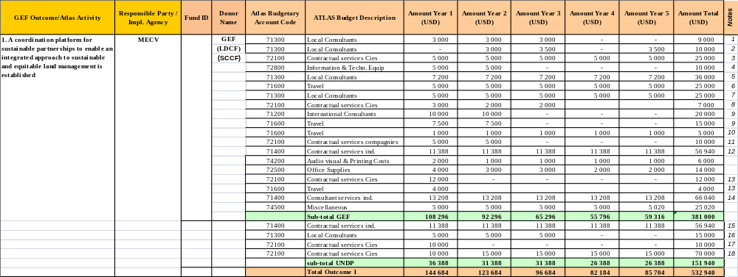

Notes:

1. SLM concertation mechanisms
2. SLM financing mechanisms (2 months)
3. SLM coordination & policy dialogue (events, tasks)
4. Observatoire equipment
5. Observatoire: 6 resource persons (part-time)
6. Observatoire members - field travel
7. Observatoire: research and analysis
8. Observatoire: miscellaneous support
9. M&E system development: international support

10. M&E system development (internal fieldwork)
11. M&E system: workshops and training
12. Project's M&E expert (50% @ US$ 22,800 / year)
13. Inception workshop
14. Project Coordinator - institut. coord. (50% @ US$ 26,400 / year)
15. Project's M&E expert (50% @ US$ 22,800 / year)
16. M&E system development: local support
17. Contribution to project's launching
18. Stakeholders forum: meetings, events et al.

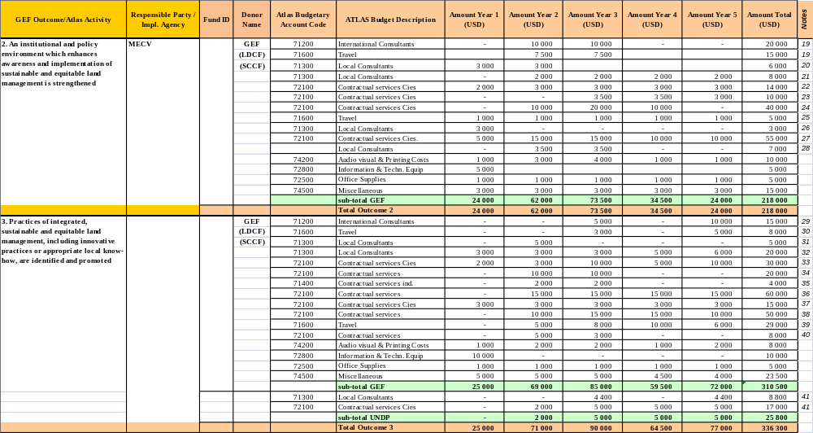

Notes:

19 Policy and institutional advise (int'l):
20 Institutional reform
21 Regulatory reform
22 Meetings & events to create the ANGDT
23 Support / cooperation with land tenure services
24 Training workshops and events
25 Institutional and/or policy consultations at field level
26 Elaboration training materials and training plan
27 SLM Training for regional authorities and rural communes
28 Elaboration of tools for transferring NRM roles to local authorities
29 Systematisation/Analysis of best practices on SLM
30 Int. Consultant: Travel + DSA
31 Elaboration strategy for environmental education
32 Compile lessons learnt and best practices on SLM
33 Production / dissemination of SLM best practices materials
34 Formation de formateurs et education environnementale
35 Integration of SLM in environmental education and related activities
36 Grant-prize for community SLM innovations
37 IEC + radio: preparation of SLM materials and difussion
38 Knowledge-sharing workshops and events
39 Visites d'exchanges pour les partenaires locaux
40 Studies on climate change and land degradation linkages
41 Miscellaneous support for knowledge management and dissemination

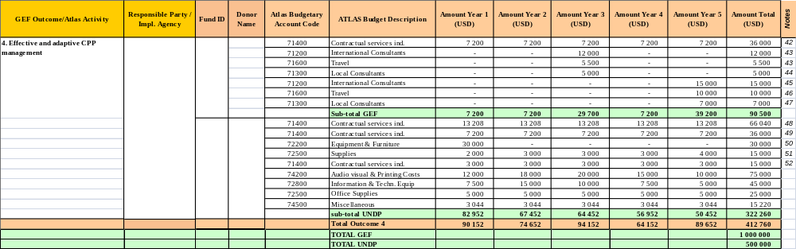

Notes:

42. Project's Administrative & Financial officer (50% salary @ US$ 14,400/year)
43. Mid-Term review (20 days, int'l travel, DSA 15 days)
44. Mid-Term Review (local support, including Beneficiaries' Survey)
45. Final Evaluation (30 days)
46. Final Evaluation (international travel + DSA 20 days)
47. Final Evaluation (local support, including beneficiaries' Survey)
48. Project Coordinator - project management (50% @ US$ 26,400 / year)
49. Project's Administrative & Financial officer (50% salary @ US$ 14,400 / year)
50. Vehicle
51. Vehicle maintenance
52. Project's driver
53. This comprises in kind and cash contributions, 2 senior officers, project assistencial staff, contribution to project building.

IV. ADDITIONAL INFORMATION

This section contains the following information:

- Endorsement letter by Government
- English Translation of the Endorsement letter by Government
- Support letters from co-financing partners
- Terms of Reference of the subprogram's Coordinator (outline)
- Terms of Reference of the subprogram's M&E expert (outline)
- Terms of Reference of the subprogram's Administrative & Financial Officer (outline)

Please note this proposal is not drawn from a PIF since it derives from the GEF-3 financial cycle. No PIF can therefore be attached (as customary in UNDP's Project Documents submitted to GEF). Instead, a PDF-B for the entire CPP (which comprises 5 subprograms, including this one) was developed in 2005-2006, leading to a CPP program document that was approved by the GEF Council in August 2006. The second phase of the PDF-B (i.e. its effective execution) started in January 2007 with the official political inception of the program. This was followed by the preparation and development of the 5 subprograms by the 3 implementing agencies: UNDP, World Bank and IFAD. Each agency bore the financial and technical responsibility for the preparation of its subprogram/s and for co-financing them.

Endorsement letter by Government

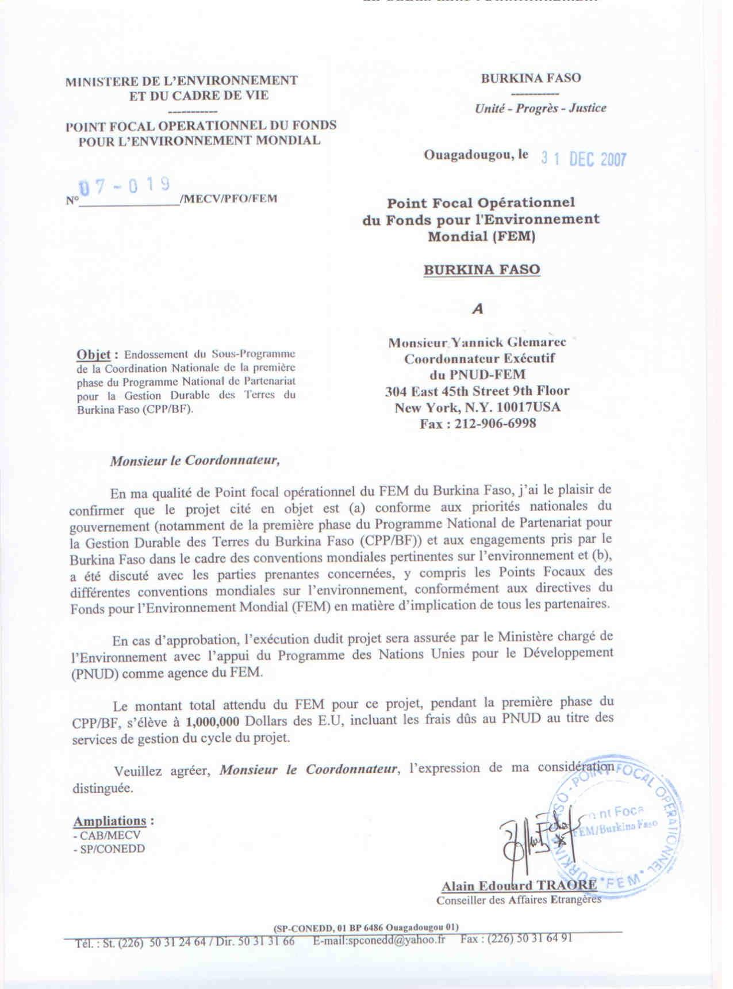

English translation of the Endorsement letter by Government

MINISTRY FOR THE ENVIRONMENT
OPERATIONAL FOCAL POINT FOR THE GEF
BURKINA FASO

Ouagadougou, 31st December 2007

No. 07-019/MECV/PFO/FEM

To : Mr Yannick Glemarec
UNDP GEF Coordinator
304 East 45th Street 9th Floor
New York, N.Y. 10071 USA
212-906-6998

Subject: Endorsement for the project: Burkina Faso CPP subproject - National Sustainable Land Managment Country Programme

In my capacity as GEF Operational Focal Point for Burkina Faso, I confirm that the above project proposal (a) is in accordance with the government’s national priorities (in particular the phase 1 of the Country Partnership Programme on Sustainable Land Management in Burkina Faso (CPP/BF)) and the commitments made by Burkina Faso under the relevant global environmental conventions and (b) has been discussed with relevant stakeholder, including the global environmental conventions focal points, in accordance with GEF’s policy on public involvement.

If approved, the project will be implemented by Ministry in charge of Environment with the support of the United Nations Development Program (UNDP) as GEF implementing agency.

I understand that the total GEF financing being requested for this project, under the phase 1 of the CPP/BF is $1,000,000 inclusive of UNDP fees for project cycle management services associated with this project.

Sincerely,

CC: - CAB/MECV
- SP/CONEDD

(signed)

Alain Edouard TRAORE
Councilor of the Foreign Affairs

Support letters from co-financing partners

- PROGERT: Projet de Gestion Durable des Ressources Forestiers
- ADEPAC: Projet d'Appui à la Décentralisation et à la Participation Citoyenne
- PASE: Projet d'Accès aux Services Energétiques
- PN-PTF/LCP: Programme National Plate-Formes Multifonctionnelles pour la lutte contre la Pauvreté
- PNGT2: Programme National de Gestion des Terroirs – phase 2
- UNDP: United Nations Development Programme
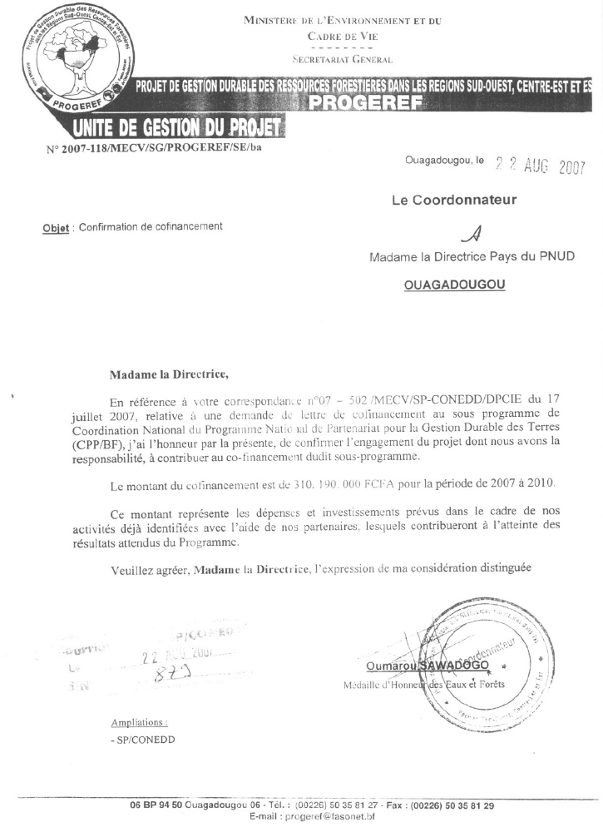
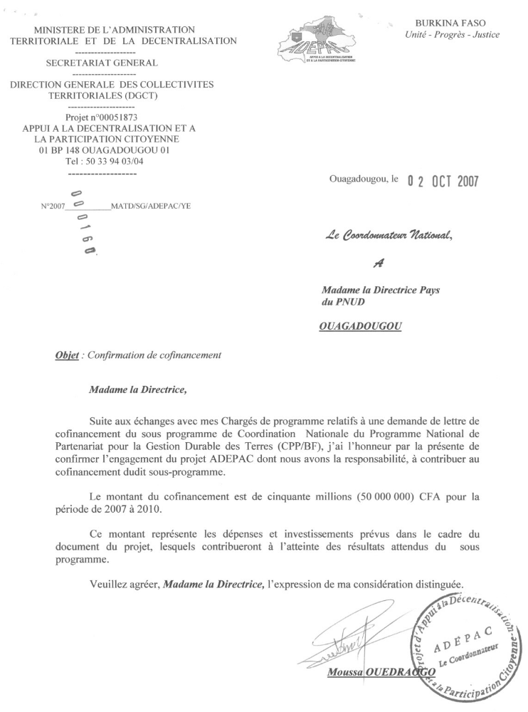
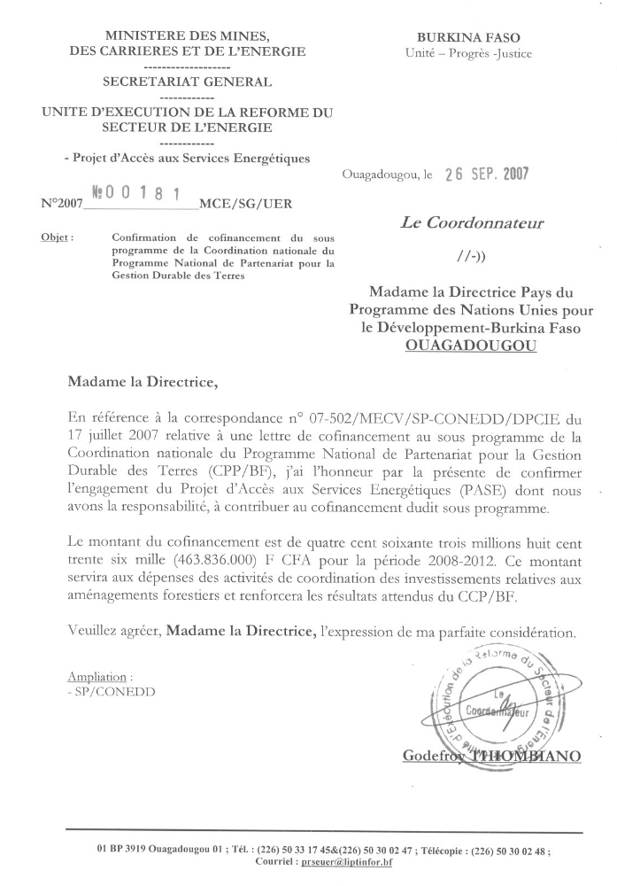
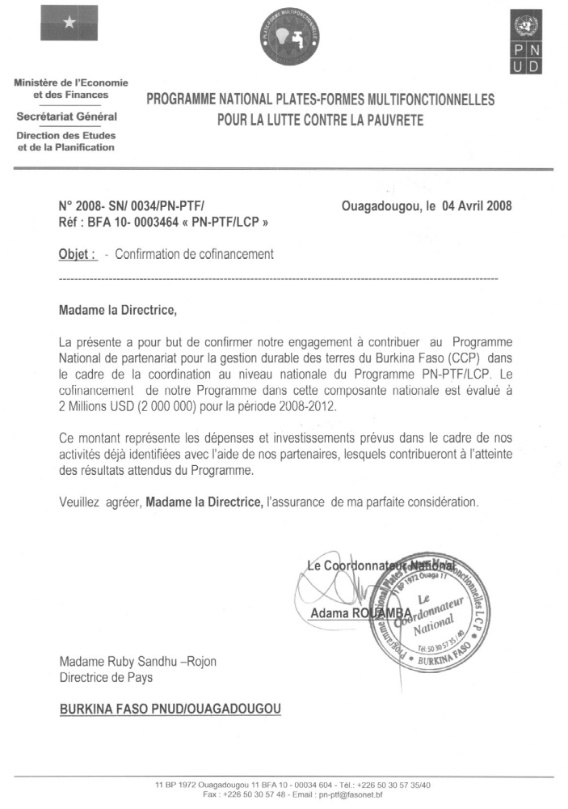
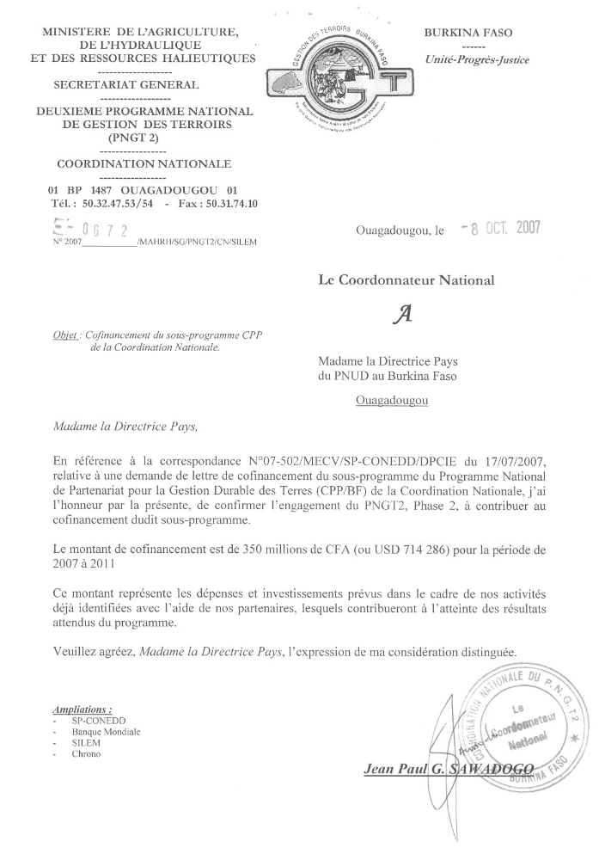
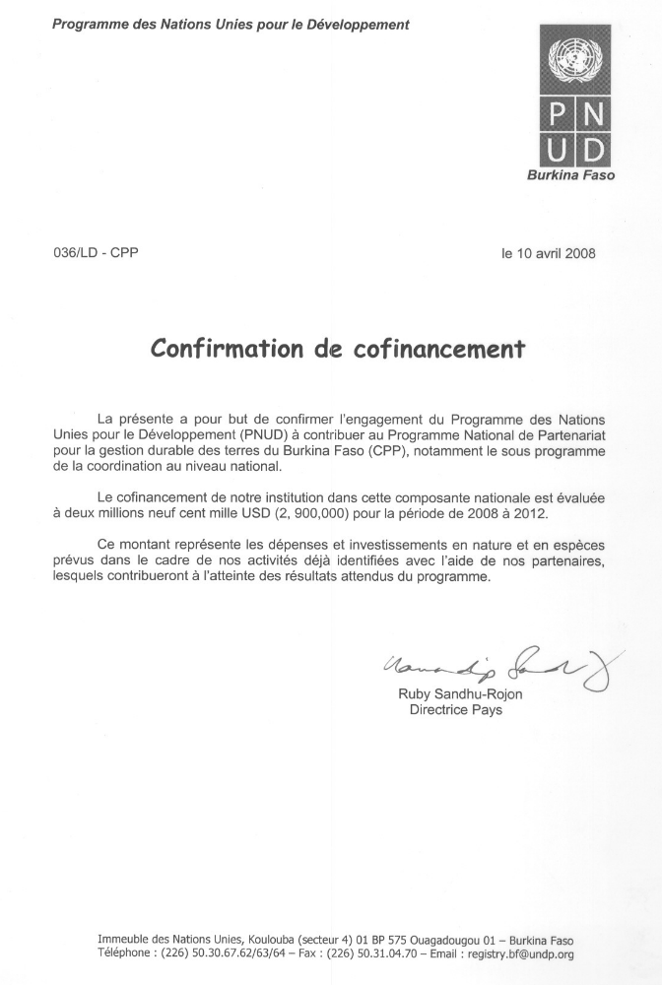

Terms of Reference of the subprogram's Coordinator (outline)

• Manage the National Coordination subprogram.
• Support communication, cooperation and harmonic implementation of all CPP projects, leading a joint adaptive management and M&E process.
• Foster synergies, exchanges and cooperation among CPP projects and stakeholders.
• Planning of project activities, including the preparation of the AWPBs.
• Recruitment of consultants and support organizations for project implementation.
• Liaison with Government (CONEDD, MECV) and donors (GEF, UNDP) regarding the subprogram and the entire CPP process.
• Ensure transparent and sound use of the project's financial and material resources.
• Ensure the administrative and financial procedures are duly applied.
• Raise awareness on SLM issues, policies and practices.
• Launch, negotiate and develop cooperative partnerships around SLM.
• Foster the systematization and dissemination of best practices and lessons learnt on SLM from CPP projects.
• Guide the establishment of the ANGDT.
• Ensure implementation of recommendations from audits and the Mid-Term Review.

Terms of Reference of the subprogram's M&E expert (outline)

• Guide the design and lead the implementation of the CPP's M&E system.
• Advise and oversee the M&E activities and functions of the national SLM Observatoire.
• Monitor the activities planned for the subprogram.
• Coordinate and harmonize the M&E systems of the different CPP subprograms; provide M&E advice and capacities to the 4 regional CPP subprograms.
• Participate in the different evaluations, reviews and audits of the subprogram and ensure the implementation of the recommendations.
• Contribute to the drafting of the main reports on the subprogram's execution and progress.
• Revise and advise on the main execution reports of the other CPP subprograms.
• Prepare technical profiles on the monitoring of subprogram's activities.
• Contribute to the creation and maintenance of CPP's website.

Terms of Reference of the subprogram's Administrative & Financial Officer (outline)

• Supervise the financial and fiduciary aspects of the subprogram's execution
• Support the Coordinator on the application of administrative and financial management procedures
• Implement due accounting and financial management in accordance with agreed accounting principles and instruments, and taking into consideration UNDP's financial rules.
• Participation in the preparation of the annual budget.
• Ensure the practical organisation of the project, supporting the coordinator and the M&E expert;.
• Produce financial and budget reports, and provide the financial reports required by UNDP timely.
• Administrative management of the personnel recruited and the contracts of the subprogram.
• Conduct administrative tasks related to the implementation or assigned by the Coordinator.

SIGNATURE PAGE

Country: ___________________

UNDAF Outcome(s)/Indicator(s): _____________________________________
(Link to UNDAF outcome., If no UNDAF, leave blank)

Expected Outcome(s)/Indicator (s): _____________________________________
(CP outcomes linked t the SRF/MYFF goal and service line) _____________________________________

Expected Output(s)/Indicator(s): _____________________________________
(CP outcomes linked t the SRF/MYFF goal and service line) _____________________________________

Implementing partner: _________________________
(designated institution/Executing agency)

Other Partners: _________________________

_________________________

Total budget: ____________
Allocated resources: ____________
- Government ____________
- Regular ____________
- Other:
  - Donor _________
  - Donor _________
  - Donor _________
- In kind contributions _________

Programme Period:_____________
Programme Component:_________
Project Title:__________________
Project ID: _________________
Project Duration: ______________
Management Arrangement: ______

Agreed by (Government): _______________________________________________________
Agreed by (Implementing partner/Executing agency):________________________________
Agreed by (UNDP):_____________________________________________________________
Notes:

UNDAF Outcome and Indicator(s)
The signature page details the UNDAF outcome(s) as well as the Outcome(s) and Output(s) related to the project. If the UNDAF lists outcomes, they should be included in the signature page. When UNDAF outcomes are not clearly articulated, country teams may decide to either revisit the UNDAF to clarify the outcomes or leave the field blank.

UNDAF Outcome indicators should be listed here.

Expected Outcome(s) and Indicator(s)
Expected Outcomes are Country Programme (CP) outcomes. They should reflect MYFF/SRF outcomes and ACC sector, which will be in the ERP).

Outcome indicator(s) should be listed here.

Expected Output(s) and Indicator(s)
Expected Outputs are Country Programme outputs. They should reflect MYFF/SRF outputs.

Output indicator(s) should be listed here.

Implementing partner:
Same as designated institution in the simplified project document – name of institution responsible for managing the programme or project (formerly referred to as executing agency). Implementing partners include Government, UN agencies, UNDP (see restrictions in Programming Manual Chapter 6) or NGOs.

Other partners:
Formerly referred to as implementing agencies in the simplified project document—partners that have agreed to carry out activities within a nationally executed project. This would include UNDP when it provides Country Office Support to national execution. Private sector companies and NGOs hired as contractors would generally not be included. The agency (i.e. Government, UN agency) that contracts with the private sector company and/or NGO is the responsible party. ‘Other partners’ can also apply to other execution modalities.

When an NGO contributes to an output, it can be noted along with the responsible party with which it contracts (e.g., UNDP/NGO, Govt/NGO). Consistent with current practice the rationale for selecting an NGO as a contractor, must be documented.

Programme period: Refers to the Country Programme period

Programme component: MYFF Goal

Project title, project code, project duration (self explanatory)

Management arrangement: Indicate NEX, AGEX, NGO Execution, DEX

Budget: Total budget minus the General Management Services Fees

General Management Services Fees: This was formerly COA (Country Office Administrative fee) for cost sharing and UNDP Administstative Fee for Trust Funds.

Total budget: Includes the budget and General Management Services Fees. In-kind contributions can be listed under ‘other’ resources. Unfunded amounts cannot be committed until funds are available.

Signatures:
The Implementing partner is the institution responsible for managing the programme or project. (The institution now commonly referred to as the “executing agency” but will now be referred to as the “implementing partner”)

UNDP is the UNDP Resident Representative.

The Government counterpart is the government coordinating authority.

This is the relationship between the cultivated and cultivatable land.
Excluding project team's staff time and UNDP's staff and travel expenses.
Final Evaluation to be combined with evaluation of the CPP as a whole and of the 2 regional projects for which UNDP is the Implementing Agency, if possible.
This budget will be completed with lessons learnt work (US$ 58,000) and contributions from regional sub-programs.

