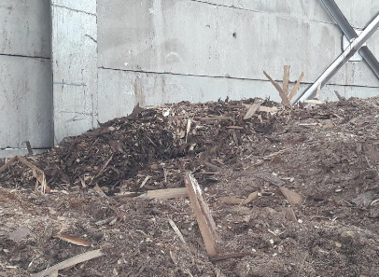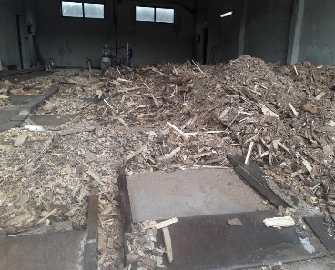

***OF BOSNIA AND HERZEGOVINA***

***REPORT ON ACTIVITIES OF AKTIVNOSTIMA***

***BIOMASS ASSOCIATION BIOMASA***

**April**

**2019**

# 1. Report on activities of the Biomass Association of BiH since its establishment

The Association was established under the UNDP GEF project “Biomass Energy for Employment and Energy Security in Bosnia and Herzegovina” in 2012. Within the project, several workshops were held throughout BiH with key stakeholders in order to identify the needs in the bioenergy sector in BiH.

Having in mind the current situation in the BiH wood biomass sector, the market conditions of the concerned sector and the need to raise awareness on the benefits of using biomass as a national, environmentally-friendly and price-competitive energy source, a clear need was identified for an increase and creation of self-sustainability of the biomass market.

Over the past seven years of its existence, the Association has become recognizable both in BiH and internationally as one of the major advocates of sustainable use of bioenergy in accordance with the principles of cascading use of wood, market principles and support mechanisms to the projects in this area that are tailored to the needs of BiH, however based on the experience of EU countries.

Since 2016, the Association is a member of Bioenergy Europe (ex AEBIOM), having its member in the Board of Directors. In addition, Agreements on cooperation with associations in Germany and Croatia were signed.

## 1.1. Objectives and activities of the Association

The main objectives and activities of the Biomass Association of BiH include:

* support and assistance in promotion of technology for use of biomass and the potentials for electricity generation from biomass;
* support and assistance in promotion of standards for biomass;
* support and assistance in employment promotion through the use of biomass;
* exchange of experiences and information with the same or similar associations in the country and abroad;
* cooperation with the relevant institutions and other bodies and organizations in Bosnia and Herzegovina aimed at achieving the objectives of the Association;
* advocating for socially and environmentally acceptable efficient use of energy and resources with an emphasis on wood biomass;
* encouraging actions to protect the environment, forests and biodiversity conservation in Bosnia and Herzegovina;
* encouraging introduction and improvement of legislation in Bosnia and Herzegovina in the field of biomass;
* coordinating harmonization of national standards and regulations with the standards and regulations of the European Union in the field of biomass;
* monitoring supply and demand on the national and international wood biomass market and the equipment for processing and use of wood biomass;
* issuing books, brochures and other publications aimed at achieving the objectives of the Association, in accordance with the Law;
* assistance and support in the design and implementation of projects and programs in accordance with the objectives of the Association;
* organizing congresses, consultations, seminars and other forms of scientific and professional training;
* encouraging training and information activities of citizens and raising awareness on the importance of biomass and its use in Bosnia and Herzegovina.

**1.2. Activities of the Biomass Association of BiH in the period 2012-2019**

Over the past period, the focus of the activities of the Association was on training aimed at promoting bioenergy as environmentally-friendly and price-competitive energy source. The training courses were mainly delivered at the local level, such as municipalities (e.g. municipality Centar, Prijedor) and the local community (e.g. Nemila). In addition, representatives of the Association participated in training courses for young experts in BiH and from the region (summer schools and similar). Municipality Centar financially supported implementation of the education project under which the supporting materials were produced.

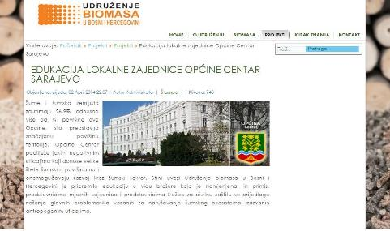

Considering that the energy and boiler/furnace market is key to the success of biomass in BiH, a quality analysis of pellets and boilers used for pellet burning was carried out. Encouraged by rather poor results of this research, an initiative was raised to establish a biomass and boiler quality testing centre. During 2018, UNDP “Biomass Energy for Employment and Energy Security” Project, funded by Czech Republic, provided funding for establishment of a Biomass Innovation Centre, established at the Faculty of Mechanical Engineering in Sarajevo. For the needs of the operations of the Centre, basic equipment (biomass boiler, precision scale and calorimeter) was purchased from these funds. The Faculty of Mechanical Engineering has devices for determining fuel calorific value and the composition of the flue gases. In this way, the Centre is able to examine the power of biomass boilers, efficiency rate, air emissions, and the calorific value of wood biomass.

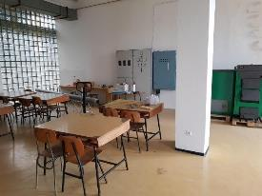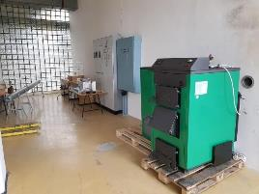

Biomass Innovation Centre at the Faculty of Mechanical Engineering in Sarajevo (established by funding of the UNDP “Biomass Energy for Employment and Energy Security” Project, funded by Czech Republic,)

In general, the activities of the Association in the past period included:

* Over the last 7 years, the Association has been systematically working on stakeholders’ training, creating better market conditions and raising awareness of both members of the Association and all citizens of BiH.
* Seminars, conferences and workshops were held throughout BiH with all key stakeholders (decision-makers, non-governmental sector, academia, companies, etc.)
* Promotion of the potentials of the BiH market at international level through the activities in Bioenergy Europe (ex AEBIOM)
* The Association was represented at sectoral conferences both in BiH and abroad
* The Association promotes biomass standards

Cooperation between sectoral associations from BiH and Croatia was formalized by signing a letter of intent between the Biomass Association of BiH and the Croatian Association of Biomass CROBIOM aimed at achieving long-term cooperation and encouraging increased use of biomass in the region. Memorandum of Cooperation was signed at the conference "Major Sectoral Conferences: Future of Forestry and Wood Industry in BiH. European topics on Kupres” in April 2018. The conference was facilitated in cooperation between the Croatian Wood Cluster, Hercegbosna Forestry Company, FBiH Chamber of Commerce, Biomass Association of BiH and the Wood Cluster Herzegovina, and it was aimed at tackling sectoral problems, as well as offering examples of good practice and possible solutions.

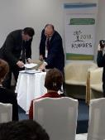

Signing of Agreement on cooperation between Biomass Association of BiH and Croatian Association of Biomass CROBIOM

(Kupres, April 2018)

A similar agreement was signed with the German association. Representatives of the Biomass Association of BiH participated in a two-day Biomass Energy Conference organized by the German Biomass Association Bundesverband Bioenergie e.V. The aim of the conference was to provide support for wood biomass and to ensure this renewable energy source a place in future energy and climate strategies. During the two-day conference, several workshops, forums and panel discussions were held on various topics such as: the future of wood biomass, wood biomass in the electricity and heat market, wood biomass gasification, potential and ecological boundaries of wood biomass, etc.

The President of the Assembly of the Biomass Association of BiH, prof. Azrudin Husika presented the state of biomass use in BiH, market development and biomass usage trends in BiH. Member of the Management Board of the Association, Vanja Ćurin participated in a panel that was dedicated to experience exchange in the field of biomass usage in different countries.

During the conference, the Agreement on cooperation between the two associations on the promotion of biomass usage was signed. Under the Agreement a need was emphasized for cooperation in the development of biomass supply logistics, model of long-term arrangement for biomass supply, promotion of efficient cogeneration and the incentive schemes for biomass usage.

Participation at the conference was funded by GIZ Renewable Energy Project. In addition to the representatives of the Association, BiH delegation was also consisted of representatives of public institutions who deal with the challenges of biomass usage in BiH.

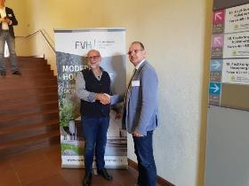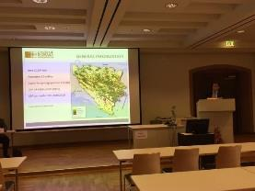

Signing of the Agreement on cooperation between the Biomass Association of BiH and the German Biomass Association Bundesverband Bioenergie e.V. (Wurzburg, Germany, September 2019)

In addition to the cooperation with associations from Croatia and Germany, representatives of the Association also visited the Biomass Association in the Czech Republic, under the activity of Establishment of the Biomass Innovation Centre in Bosnia and Herzegovina. In addition to getting acquainted with the experiences in the Czech Republic on the promotion of biomass, a visit was paid to the district heating with biogas cogeneration in Trebic (a town 50 kilometres away from Brno).

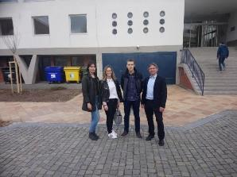

Visit to the Biomass Association in Czech Republic and Bioenergy Fair in Brno (Brno, Czech Republic, April 2018)

Under the activity of Establishment of the Wood Biomass Innovation Centre in Bosnia and Herzegovina, during 2018, the Association organized four round tables and four seminars. The roof topic of all these events was the sustainable use of wood biomass in BiH, both in individual household heating systems and in district heating. Participants of these events were:

1. Manufacturers of biomass production equipment,
2. Manufacturers of equipment for the use of biomass,
3. Consulting companies,
4. Biomass-fired district heating,

5. Non-governmental organizations and

6. Universities

The events were held in Kupres, Fojnica and Sarajevo. In Sarajevo, the round table was held within the RENEXPO Energy Fair. The average number of participants at all meetings was around 20.

At the Faculty of Mechanical Engineering in Sarajevo, in November 2018, a Biomass Conference “Energy from Wood Biomass in BiH” was held.

Conclusions from the conference and all other events represent the basis for further work of the Association. The main conclusions are that it is necessary to establish long-term contracting of biomass procurement, to oblige everyone to use standards for wood biomass, to improve the quality of biomass and boilers, to reduce the black market, to pay special attention to biomass in incentive mechanisms for renewable energy sources.

In addition, it was emphasized that it is necessary to intensify professional activities in view of the key decision-makers, that there is a need for the establishment of an accredited biomass boiler testing laboratory and that biomass-based energies should be treated equally to other energy sources (commodity reserves, energy quality control, etc.).

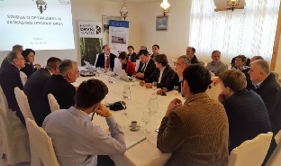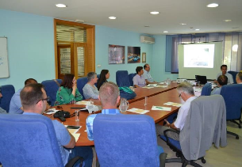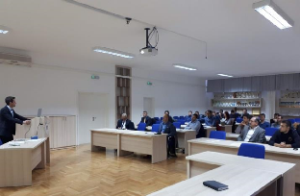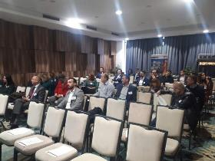

Roundtables, workshops and conferences organized by the Association during 2018.

## 1.3. Members of the Association

Members of the Association may include:

* Manufacturers of biomass-fired equipment
* Producers of energy-generating products (woodchips, briquettes, pellets ...)
* Manufacturers of electric and thermal energy from biomass/district heating companies
* Sawmills and wood processing companies
* Consulting companies (project developers, energy contractors ...)
* Forestry enterprises/Public and Utility Companies
* Higher Education Institutions/Scientific and research staff
* Non-governmental organizations
* International, regional and local development agencies
* Physical persons

Current members (2019) of the Association are:

Legal entities:

* REIC NVO –Regional education and information centre for sustainable development
* Planinarsko Društvo/Mountaineering Society “Busija“
* BIOENERGI d.o.o. Vitez
* Dvokut-pro d.o.o Sarajevo
* U.G. Centar za okolišno održivi razvoj COOR/Association of citizens – Centre for environmentally sustainable development COOR
* EMPES d.o.o. Banja Luka
* VG-MONTING d.o.o. Vitez
* CETEOR d.o.o. Sarajevo
* ENOVA d.o.o. Sarajevo
* “Esco eco energija” d.o.o. Livno
* UNIOR savjetovanje I trgovina BH d.o.o. /advisory and trade company
* “Duzel group-J” d.o.o Žepče
* “Peštalić” d.o.o. Gradačac

In addition to legal entities, 10 physical persons are members of the Association.

Registration of membership of the Austrian company Polytehnika is underway.

The Association is constantly working to attract new members through the web site [www.biomasa.ba](http://www.biomasa.ba), as well as by means of direct contacts. On its website, the Association publishes news on bioenergy in BiH, in the region and the world.

# 2. Activity Plan of the Biomass Association of BiH for 2019

In 2019, the Association is working on strengthening the Biomass Innovation Centre in cooperation with the Faculty of Mechanical Engineering. Due to the integration of the University of Sarajevo, procurement procedure slowed down, which is why the contract for the service of connecting equipment with the metering/regulating set is not yet completed. The Faculty has secured funds for these purposes. Under the agreement between the Association and the Faculty, the Association has an uninterrupted access to the Innovation Centre.

In addition, the Association is working on advocating for the development of biomass market and the appropriate incentives through the activities of Bioenergy Europe and participation in meetings where future incentive mechanisms are presented.

In general, the focus of activities in 2019 is on:

* Raising competences and competitiveness of Small and Medium entrepreneurs in the wood biomass industry sector – of the existing and new members of the Biomass Association of BiH, as main stakeholders, as well as the general public
* Extension of the membership list of the Association through inclusion of new members, companies dealing with wood biomass segment in BiH, as well as chambers of commerce in BiH
* Provision of support to entrepreneurs (its beneficiaries) through offering all the necessary elements for successful professional development through a range of services, but also to the education sector, environmental protection institutions, the media and similar.
* Raising awareness of the professional and general public on the advantages of use of wood biomass as a national, environmentally-friendly and price-competitive energy source;
* Contribution to the creation of a competitive and sustainable wood biomass market in BiH.
* Capacity building of young experts in the areas pertaining to different aspects of wood biomass (forestry, mechanical engineering, etc.)

For the autumn of 2019, the Association is planning to organize one-day conference, the central topic of which would be the development of the biomass market through training of all key stakeholders. The plan is to invite representatives of Bioenergy Europe, biomass associations from Croatia, Germany and the Czech Republic to the conference, so as to present their experience in the ways of promoting biomass use. The aim is to create recommendations for decision makers on biomass treatment in the biomass legislative framework (energy efficiency, incentives for renewable energy sources, forestry, agriculture, heating, etc.).

The Association is planning to publish a brochure on efficient use of biomass in both small and large boilers with the aim of energy efficiency, reduction of costs and emissions in the environment. The brochure will, *inter alia*, contain advices for proper selection of furnaces/boilers. Particular emphasis will be placed on the documentation that buyers need to check during the purchase, such as certificates on testing efficiency, power, emissions, etc. On the energy-generating products side, instruction will be given on how to identify good quality pellets, how to define quality of woodchips, and how to store pellet, firewood, woodchips, straw, etc. The brochure is intended for end users of biomass (citizens, district heating systems, industrial consumers), therefore it will be written in a simple language. The brochure will be published through the Association's web site and in printed form it will be publicized at all appropriate meetings on which the representatives of the Association will participate. The brochure will be promoted at the planned conference. Currently, we are in search for sponsor of this activity.

Issuing of a policy paper on bioenergy in BiH is planned, which will serve for advocating the bioenergy position in strategic documents at various levels in relevant sectors, as well as in incentive systems for renewable energy sources.