United Nations Development Programme
Region: Asia and the Pacific
Project Document
Asia Regional Governance Programme; Phase II

Expected RP Outcome(s): Improved inclusive participatory processes in policy making and implementation for more equitable development
International norms and standards on anti-corruption and human rights implemented through public policies
Expected Output(s): 1. Parliaments and representative bodies are better able to engage in development policy planning and oversight and be more effective representatives of all groups in society;
2. State and non-state actors are capacitated to harness communication mechanisms (access to information policies, e-governance, and media) for enhanced government transparency and effectiveness;
3. Policy-makers in key ministries and non-state parties are better able to develop effective governance arrangements for MDG-focused service delivery;
4. State and non-state actors are capacitated to support implementation of international instruments, norms and standards to increase integrity in governance;
5. Capacities of justice sector-related institutions and stakeholders are strengthened to deliver and enhance access to justice and promote human rights;
6. National governments are able to better align aid flows, develop management action plans to implement Paris Declaration regulatory framework and contribute to achieving the MDGs.
Implementing Partner/Executing Entity: UNDP/RCB
Responsible Parties/Implementing Agencies: UNDP/RCB

Narrative
Democratic governance is seen as the critical ingredient for ensuring more equitable growth to fully achieving the MDGs and to addressing a rising inequality gap. More effective systems and avenues for inclusive representation and participation are required, as is a greater emphasis on facilitating more expeditious justice and protecting and promoting human rights. Corruption remains a grave concern and is seen as a growing threat to continued growth and prosperity. The delivery of services requires significant strengthening. Countries also need to more effectively manage and align their aid towards poverty reduction. The Asia Regional Governance Programme, Phase II, will assist countries strengthen their capacities for more responsive and accountable government through the a) promotion of regional public goods, b) facilitating knowledge sharing and learning, c) engaging in cutting-edge research and trend analysis and d) pilot-testing new and innovative methodologies. South-South cooperation for exchange of good practice and building of national and regional capacity will be underpinning operating principles of programming.

Programme Period: 2008-2011
Project Title: Asia Regional Governance Programme; Phase II
Atlas Award ID: 00048517
Start date: April 1, 2008
End Date December 31, 2011

LPAC Meeting Date October 23, 2007
BPAC Meeting Date November 28, 2007
Total resources required 8,954,760.00
Total allocated resources: 5,322,647.32
- Regular 5,174,760.00
(Regional Activities, line 1.2)
- Other:
  - Donor (DFID) 147,887.32
  - Donor _________
  - Donor _________
  - Government _________
Unfunded budget: 3,632,112.68
In-kind Contributions _________

Agreed by (Government)___________________________________________________________________
Agreed by (Implementing Partner/Executing Entity):____________________________________________
Agreed by (UNDP):______________________________________________________________________________________
Government Endorsements

Endorsed by the Government of Signature & Title Date

____________________________ _____________________________ __________

List of Acronyms
ADB | Asia Development Bank
AFPPD | Asia Forum of Parliamentarians on Population & Development
AIPO | ASEAN Inter-Parliamentary Organization
APBU | Asia-Pacific Broadcasting Union
ASEAN | Association of South East Asian Nations
AWP | Annual Work Plan
BDP | Bureau for Development Policy
CEDAW | Convention on Eliminating Discrimination Against Women
CPA | Commonwealth Parliamentary Association
CoP | Community of Practice
CPAP | Country Programme Action Plan
CSO | Civil Society Organization
DAC | Development Assistance Community
DFID | Department for International Development, U.K.
ICT | Information & Communication Technology
IFAD | International Fund for Agriculture & Development
ILO | International Labour Organization
MDGi | Millennium Development Goals Initiative
MDGs | Millennium Development Goals
MRC | Mekong River Commission
NDS | National Development Strategy
NGO | Non-Governmental Organization
ODA | Overseas Development Assistance
OECD | Organization of Economic Cooperation & Development
NHRI | National Human Rights Institution
OGC | Oslo Governance Centre
OHCHR | Office of the High Commissioner for Human Rights
PC | UNDP Pacific Centre
PPP | Public-Private Partnership
RBAP | Regional Bureau for Asia and the Pacific
RCB | Regional Centre in Bangkok
RCC | Regional Centre in Colombo
RM | Resource Mobilization
RRF | Results and Resources Framework
SAARC | South Asian Association for Regional Cooperation
SAPAC | South Asia Parliamentarians Against Corruption
SAFMA | South Asia Free Media Association
SEAPAC | Southeast Asia Parliamentarians Against Corruption
SSC | South-South Cooperation
UNCT | United Nations Country Team
UNDAF | United Nations Development Assistance Framework
UNDP | United Nations Development Programme
UNEP | United Nations Environmental Programme
UNICEF | United Nations Children’s Fund
UNMC | United Nations Millennium Campaign
UNCTAD | United Nations Conference on Trade and Development
UNCDF | United Nations Capital Development Fund
UNODC | United Nations Office for Drug Control
UNIFEM | United Nations Fund for Women
UNCAC | United Nations Convention Against Corruption
UNESCAP | United Nations Economic and Social Commission for Asia and the Pacific

Situation Analysis
Between 1996 and 2005, countries in South and Southeast Asia sustained robust average economic growth rates of 7.4 percent and 5.9 percent respectively, as the Asia-Pacific Regional Programme Document (RPD) 2008-2011 notes. However, while globalization has benefited many and this pattern of growth has contributed to expanding affluence, the region also has witnessed exploding inequalities both within and between countries and sub-regions. Poverty remains a stark problem, with South Asia still accounting for a staggering 43 percent of the world’s poor and East Asia and the Pacific for an additional 21 percent.

If current trends persist, several Millennium Development Goals (MDGs) will not be met unless countries adopt targeted, inclusive strategies to ensure that benefits of growth are shared equitably. This alarming scenario has been confirmed by the 2007 MDG progress report for the region, produced by UNDP, ESCAP and ADB. Clearly, therefore, growth alone is insufficient to achieve the broad-based development gains envisioned in the Millennium Declaration.

The failure of economic growth to reach women as well as poor and disadvantaged people, including ethnic minorities, is linked to underlying structures of inequality that remain deeply embedded and result in exclusion for many. In this regard, democratic governance that is both inclusive and responsive is seen as essential to secure equitable, pro-poor sustainable growth.

The majority of Asia-Pacific countries, recognizing the integral role of good governance in furthering national development strategies, have committed to enhancing their systems of governance since the Asian economic crisis of the late 1990s. This vision for deepening democracy has resulted in increased roles for parliaments and local representative institutions, even as CSOs and media have come to play a more active role in ensuring greater accountability and transparency in public policy making and implementation. In addition, integrity institutions such as anti-corruption agencies and human rights and ombudsman bodies were infused with greater independence and empowered to serve as guarantors of rights. Despite these positive trends, however, the practice and quality of democratic governance in the region has stagnated and, in some cases, been reversed in recent years. Now, a growing perception exists that much more can – and should – be done to address the governance deficits at the origin of expanding income and social gaps.

These governance deficits remain rooted in insufficient application of the rule of law and inadequate access to justice and information. Social service provision and capacities of authorities to deliver services remain variable in quality and efficiency. Access to and efficient delivery of services such as education, water and health are integral to achieving the MDGs. In this context, effective and inclusive representation, along with participation of the broader citizenry in democratic processes and public policy debates, and in ensuring accountability, is still wanting. As such, the role and capacity of representative bodies at national and sub-national levels must be strengthened to allow these bodies to discharge their constitutional obligations, particularly for the benefit of women, youth, indigenous peoples and other disadvantaged groups. A new commitment to deepening democracy is needed, given that claims rooted in lack of participation can potentially trigger conflict that may spill over national boundaries, threatening regional peace and security.

In many Asia-Pacific countries, the absence of an independent judiciary and a culture of impunity represent a major governance deficit contributing to an environment in which poor and disadvantaged people cannot obtain legal advice or equal access to the legal system. Challenges also remain in promoting and protecting human rights. A competent legal profession, an independent and accountable judiciary, and respect for the rule of law are necessary to ensure access to justice for all.

Corruption likewise remains a serious impediment to securing broad-based, inclusive growth and development. Indeed, high levels of corruption and bureaucratic cultures that obstruct open, transparent governance have diluted the region’s remarkable development gains. Persistent gaps in accountability and transparency endanger the legitimacy and stability of institutions -- but perhaps more critically, they also discriminate in the delivery of services and put women and disadvantaged groups at particular risk.

Growing evidence indicates that the most disadvantaged communities remain excluded from governance processes, often due to limited access to information and communications facilities. Many communities in the region, particularly in remote rural areas, lack essential information on basic rights and entitlements, public services, social and economic opportunities, agricultural prices and other market information that would empower them to take more control of their lives. New ICTs are reframing relationships between media, citizens and the state and offer possibilities for better governance. Similarly, a vibrant media can significantly improve the quality of governance and progress in achieving the MDGs, yet surveys show that more than one-third of countries in the Asia-Pacific region still do not have an independent media.

The high incidence of poverty, the large number of Least Developed Countries, and the high number of conflict or post-disaster contexts explain the relatively high inflows of development assistance to the Asia-Pacific region. In 2006 Asia received 23 percent of net ODA (OECD/DAC, 2006). While this represents a slight decrease from 1994-1995 (29 percent), it still totals US$17.5 billion excluding debt relief; moreover, these figures exclude flows to the Pacific. At the same time, the remaining substantial challenges for South, North and Southeast Asia to achieve the MDGs underline the continuing critical importance of aid effectiveness in deepening democracy. In this regard, 25 countries in the region have signed the Paris Declaration on Aid Effectiveness and are seeking to apply these principles at country level. Most members of the international community also are signatories but have not yet managed to design and deliver aid in line with the overarching principles of country leadership and alignment with national development plans/priorities. Governments of Asia and the Pacific, and their development partners, will need to work across borders to bring about needed change through South-South cross-country learning and peer support.

Strategy
The Asia-Pacific RPD 2008-11 was designed to respond to national priorities, emerging challenges, the United Nations reform and harmonization agenda, and UNDP corporate priorities, as reflected in the UNDP Strategic Plan 2008-11 endorsed by the Executive Board in October 2007. Regional cooperation is a mechanism to promote and achieve national development objectives and regionally agreed plans of action and commitment to greater integration. Based on the RPD, strategic programmatic interventions aim to: (i) promote regional public goods and encourage and support greater regional integration; (ii) undertake regional trend analysis and facilitate regional comparison, learning and knowledge sharing; (iii) engage in awareness raising and promote regional networking; and (iv) promote regional dialogues on emerging development issues. To this end, regional programming will aim to promote policies and programmes that maximize opportunities to build greater national and regional capacities for enhanced regional development cooperation and integration.

The ARGP focus areas are consistent with those outlined in the UNDP Strategic Plan for 2008-2011. Regional interventions outlined through the outputs and activities in the Results and Resources Framework (RRF) are aligned with Key Result 1, Key Result 2 and Key Result 3 of the Strategic Plan’s Democratic Governance focus area, namely, on a) Fostering Inclusive Participation b) Strengthening Responsive Governance Institutions and c) Grounding democratic governance in international principles. This regional programme document is also fully aligned with the operational principles outlined in the new strategic plan, with respect to emphasizing the importance of capacity development, south-south cooperation, aid management and gender equality.

In the context of furthering democratic governance processes, systems and structures in the region, the Asia Regional Governance Programme (ARGP) Phase II will build on results achieved under Phase I during 2004-07. The strategy is a composite of mutually reinforcing components to promote democratic governance in line with the UNDP Strategic Plan 2008-2011 and the RPD

The link between democratic governance and poverty reduction/achievement of the MDGs underpins the programme and is reflected in the six proposed outputs. Priority will be placed on enhancing national capacities to more effectively and productively engage in regional cooperation and coordination, thus better managing externalities and benefiting from increasing cross-border flows of information, goods, ideas, knowledge, resources and capital. All interventions will rely upon capacity development, gender equality, South-South cooperation, cross-Practice synergies, knowledge sharing and management, a human rights-based approach (HRBA) to development programming, and civic engagement.

Project outputs will focus on six areas with a view to achieving the outcomes envisioned:

Output 1: Parliaments and representative bodies are better able to engage in development policy planning and oversight and be more effective representatives of all groups in society

Interventions in this area will target representative bodies at national as well as sub-national levels so that they are better able to mediate and articulate public opinion and choices. Emphasis will be placed on enabling regulatory frameworks for bringing women into positions in decision-making bodies as both members and leaders. Through cross-national comparative learning efforts, budgetary and legislative tools and methodologies will be developed to enhance capacities of legislatures to be more engaged and informed on MDG-based national development strategies. Research will be undertaken to provide best-practice knowledge on improving representation arrangements with respect to the interests of women, indigenous and disadvantaged groups. Capacity development courses will be undertaken at sub-regional level with an emphasis on strengthening women’s decision-making roles in representative bodies and supporting women’s wings/caucuses. In this regard, media and communication strategies for legislatures and individual members will be pursued through developing partnerships with national and regional media groups. An internally driven institutional capacity and needs assessments framework for legislatures will be developed and adapted for national contexts in close partnership with the UNDP Capacity Development Group. Networking of individuals and institutions will be facilitated and encouraged for peer exchange, learning and to benefit from South-South experiences. Existing networks (ASEAN Inter-Parliamentary Organization, Asia Forum on Parliamentarians on Population and Development and others) will be formally engaged and serve as a mechanism for the delivery and dissemination of applied research and policy analysis knowledge products.

Output 2: State and non-state actors are able to harness communications mechanisms (access to information policies, e-governance, and media) for enhanced government transparency and effectiveness.

Activities in this area will address both the supply and demand side of access to relevant information (A2I) and will enable people to participate in decision-making processes and influence decisions that affect their lives. Research and analysis, along with regional exchange and dialogues, will be carried out to catalyze debate and distil lessons on right to information legislation and public service broadcasting policies. In partnership with national institutions, the ARGP will help develop policy guidelines and comparative frameworks and support where requested, adaptation and pilot testing in countries to further dialogue and national implementation strategies on A2I formulation and adoption.

Interventions will also stress the role of e-governance as an important mechanism for improving A2I and governance accountability. Models of good practice will be captured and shared at regional, sub-regional and national forums, following which, through the development of assessment tools and the delivery of sub-regional training, the capacity of national and local institutions will be improved to better design and implement sustainable e-governance initiatives. Subsequent pilot initiatives will be undertaken to replicate good e-government and e-governance at national and sub-national levels. In this regard, ARGP II will actively seek and broker private sector partnerships. To enhance the enabling conditions for public debate and civic engagement in public affairs, ARGP II will strengthen capacities of media organizations and formally network with regional media organizations such as the South Asia Free Media Association. Dialogue on development issues including the MDGs will be undertaken with media groups and the programme will support the optimization of professional standards in media and independent and balanced journalism.

Output 3: Policy-makers in key ministries and non-state parties are better able to develop effective governance arrangements for MDG-focused service delivery

An important element of ARGP II will be to address issues related to governance arrangements for effective delivery of basic services within the framework of the MDG-I. The recently initiated United Nations Inter-Agency initiative for support to national policies and MDG strategies will be up-scaled, moving beyond the initial five priority countries. Drawing on regional analysis and development of methodologies, and delivered within a joint United Nations framework, support will be provided to senior officials in key ministries and research institutions to examine the divisions of sectoral responsibilities, roles and functions between national and sub-national levels of government, as well as financing arrangements in the delivery of health, education, water services and local services supporting income generation. Both direct/public and regulated/private and CSO contexts will be researched and examined. The aim is to contribute to broad-based national dialogues on design and development of sectoral policies, administrative and financial arrangements and regulatory functions, including those concerning relevant private sector activities. As part of this output, support will be provided for the development of policies on CSO engagement in public policy processes. This output will be implemented in partnership with UNICEF, UNCDF and other UN partners and will create strong synergies between RCB and RCC.

Output 4: State and non-state actors are capacitated to support implementation of international instruments, norms and standards to increase integrity in governance;

UNDP’s regional Community of Practice (COP) “Integrity in Action” (INTACT) will be the primary means for capacity development efforts under this output, mainly focused on the legislative guide for implementation of the United Nations Convention on Anti-Corruption (UNCAC). The knowledge generated will be used to support the policy debate in the region on how to maximize the efficiency of UNCAC anti-corruption measures. The project will work collaboratively not only with INTACT but also with the ADB-OECD Anti-Corruption Initiative, and will exploit opportunities of global gatherings such as the United Nations Office for Drug Control (UNODC) UNCAC-related conferences. Media outlets will be used extensively for advocacy and awareness raising campaigns to reach the broadest possible audience of stakeholders.

Both the demand and supply side of the integrity equation will be focused on developing capacity of both state and non-state actors (CSOs, the media, and people’s representatives at national and local levels). Collaboration with UNODC will be pursued, as well South-South cooperation to promote mutual learning and best-practice exchanges. Anti-corruption links with local governance and decentralization policies will be stressed, as will efforts to develop model anti-corruption indicators in partnership with the UNDP Oslo Governance Centre. ARGP II likewise will work on tools and policy guidelines for gender-sensitive implementation of UNCAC related to public service reforms as a preventive measure for combating corruption. It will conduct research and develop partnerships with other United Nations Agencies and partners to promote and implement a new Education for Integrity and Ethics (EDUFINE) initiative, which is intended to instill in young people a better sense of the links between ethics, integrity, human rights and development. ARGP II will work jointly with the Regional Indigenous Peoples Project in addressing the links between the UNCAC and the Declaration of the Rights of Indigenous Peoples including compiling best practices on corporate social responsibility in natural resource extractive industries.

Output 5: Capacities of justice sector-related institutions and stakeholders are strengthened to deliver and enhance access to justice and promote human rights.

ARGP II will work with ministries of justice and civil society groups with respect to enhancing capacities for the implementation of specific conventions (e.g. Convention on the Elimination of All Forms of Discrimination against Women [CEDAW] and the International Covenant on Economic Social and Cultural Rights (ESCR)). Best practices will be documented on alignment of national with international legal frameworks and methodologies for use and adaptation on such legislative compliance will be developed. UNIFEM will be a key partner in these efforts. The programme will engage with national human rights institutions to help build their capacities to discharge duties with respect to the promotion and protection of human rights. The ARGP will work closely with sub-regional human rights bodies (such as in ASEAN) by distilling and disseminating lessons from other regions on good practices and required policy, institutional and regulatory changes. In this regard, regional debates and dialogues for learning and exchange will be facilitated and south-south cooperation and networking will be promoted. Platforms for mutual learning and sharing among all justice sector actors in the region, particularly with regard to legal empowerment issues will be established and the programme will work across the justice sector in this area, including working with national bar associations and public defender groups.

Output 6: National governments are able to better align aid flows develop management action plans to implement Paris Declaration regulatory framework and contribute to achieving the MDGs

Governments and partners face capacity constraints in responding to increased pressure for aid efficiency and effectiveness, linked to budget support imperatives. Increases in international accountability for aid practice (for example, through OECD/DAC surveys in 2008 and 2010) also will necessitate that development partners work closely with governments to demonstrate evidence of increased effectiveness and comparative advantages on aid management.

Energies will be focused on documenting and disseminating best practices on common approaches to the provision of international aid in the region. National capacities of related ministries and budget offices will be supported in developing good policy, practice and infrastructure, including information and management systems. Aid effectiveness training courses will be developed, institutionalized and delivered to national stakeholders and a web-based resource centre and help desk will be established to foster South-South cooperation and country-country networking. The World Bank, ADB, Government of Japan, UK/Department for International Development (DFID), and the European Commission all significantly shape the aid environment in which UNDP works. ARGP II will work and partner with these and other agencies to ensure that international partners in the region work as far as possible toward the same objectives through strengthening aid practices in-country. It also will serve as a connector between country-based work and global policy making on aid effectiveness.

Partnerships and Resource Mobilization Strategy
The partnership and resource mobilization strategy for the ARGP, Phase II, is based on the overall partnership plan of the Regional Center in Bangkok, outlined in its October 2007 document ‘Strategy for Resource Mobilization and Partnership (2008-2011)’. In this regard, ARGP II will engage in a partnership and resource mobilization strategy with the following in mind: a) strengthening partnerships with United Nations Agencies and bilateral and multilateral donors in the context of United Nations reform and the evolving aid environment; b) linking better with Asia-Pacific’s growing intellectual capital through South-South partnerships, with a view to providing programme countries with a wider pool of high-quality regional expertise; c) deepening advocacy and communications in order to influence public interest and policy; d) and more strategically engaging with the private sector and traditional and new donors.

South-South cooperation will be an integrative aspect of implementation of the regional programme. Capacity development strategies outlined, will be pursued among other avenues, through strategic engagement, exchange and development of cross-national learning platforms and networks for enabling more intensive and result-oriented South-South partnership for reform and for providing regional public goods.

As such, the success and effectiveness of ARGP II will in large part depend upon the quality and reach of partnerships. In this regard, ARGP II will engage with key regional inter-governmental organizations such as SAARC and ASEAN; United Nations Agencies, including UNESCAP, UNICEF, ILO, UNIFEM UNCDF, OHCHR, UNODC, among others; it will engage with regional and national centers of excellence , and regional bodies and networks such as APDCM, Action Aid and Forum Asia. In this regard, given the focus on promoting the role of civil society, the programme will strive to engage in strategic partnerships with regionally based civil society organizations in the relevant programming focus areas. To ensure coherence and maximize benefits, strategies for collaboration with key Practice Areas will be emphasized, including the Practice Areas of poverty reduction (incorporating gender equality), energy and environment, and conflict prevention and recovery.

UNDP core resources through ARGP II will be used to leverage sustainable partnerships, to seed innovative initiatives, and to mobilize additional resources and capacity to ensure long-term impact of interventions. Building on the current productive relationships with a number of donors such as DFID, SIDA, CIDA, and ADB, ARGP II will proactively explore opportunities to further engage these and other bilateral donors. Donors that share UNDP’s goals and mandate to help country partners strengthen democratic governance include, Irish Aid, US AID, AusAID, NZAID, EC, and others, and the programme will seek partnerships in areas of common interests. In addition to the ADB, engagement with the World Bank on mutual areas of governance interest will be actively pursued. Traditional donors committed to deepening democratic governance for achievement of the MDGs will continue to be engaged in delivering and implementing ARGP II, but efforts likewise will be made to establish mutually beneficial partnerships with emerging and interested donors such as India, Republic of Korea, Thailand and Malaysia.

Joint strategies will be developed with United Nations Agencies on common focus areas such as corruption, human rights and gender equality. United Nations trust fund mechanisms also will be sought as a vehicle for mobilizing resources based on past successes, including the United Nations Democracy Fund and the e-Asia Fund and Knowledge Partnership. The governance priorities of international foundations and philanthropic institutions such as Ford, Rockefeller and Soros, and those in the region such as Tata, will be researched and efforts made to engage in dialogue.

Finally, the regional programme will seek synergies and partnerhsips with ongoing Global Programmes of UNDP in the area of governance such as the Global Parliamentary Strengthening Programme, the Global Human Rights Strengthening Programme (HURIST) and the Global Programme against Corruption.

Results and Resources Framework
Intended Outcome 2 as stated in the Regional Programme Results and Resource Framework:
Improved inclusive participatory processes in policy making and implementation for more equitable development
Outcome indicators as stated in the Regional Programme Results and Resources Framework, including baseline and targets:
1. Representatives from Parliaments, Assemblies and Other Representative Institutions at national and sub-national levels more regularly debate and discuss national development strategies and action plans and international commitments such as MDGs and better represent women and disadvantaged groups
2. Civil Society groups more regularly engage with national counterparts, particularly local authorities on public policy decision making and implementation oversight frameworks including localization of the MDGs through more effective approaches to assessing delivery of services
3. Media capacities to report on pressing development issues enhanced in at least ten countries and the viability and institutionalization of better freedom of information and access to information laws, regulation and mechanisms are debated and discussed in at least 7 countries in Asia
4. E-Governance policies and frameworks for more pro-poor development debated and discussed at national levels.
Partnership Strategy: The Regional Centre will establish or draw upon existing partnerships with: Regional and global bodies and networks working on parliaments such as Asia Parliaments for Population and Development; Asian Association of Secretariats-General of Parliaments; SEAPAC and SOPAC, ASEAN Inter-Parliamentary Organization; Commonwealth Parliamentary Association; UN Millennium Campaign; UNDP Oslo Governance Centre; national and regional policy and academic institutions, CSOs and media institutions such as SAFMA and APBU. The project will engage with intergovernmental institutions such as SAARC, ASEAN, Mekong River Commission; and UN agencies ESCAP, UNIFEM, UNODC, OHCHR and others; key development, research agencies at national levels in the region, and with CSO groups
Project title and ID (ATLAS Award ID): Asia Regional Governance Programme, Phase II (Award ID 00048517)
INTENDED OUTPUTS | OUTPUT TARGETS FOR (YEARS) | INDICATIVE ACTIVITIES | RESPONSIBLE PARTIES | INPUTS
Output 1: Parliaments and representative bodies are better able to engage in development policy planning and oversight and be more effective representatives of all groups in society  Baseline:  1. On average very low levels of women running for office or in decision-making levels in representative institutions and lack of effective policy/legal frameworks to address needs & concerns of women and disadvantaged groups  2. Low levels of parliamentary engagement in formulation and oversight of national development plans and budgets and inadequate representation of interests of women and disadvantaged groups  3. Media coverage of parliamentary dialogues and debate inconsistent across countries and public outreach strategies not institutionalized  Indicators:  1. Increase in national dialogue on formulation of policy/legal reform initiatives intended to increase representation of women and disadvantaged groups in parliaments and sub-national assemblies  2. Increase in MPs at national and sub-national levels debating issues on the MDGs in the Chamber and/or committees.  3. Increase in coverage and dissemination of parliamentary positions on issues such as MDGs and other development concerns in a # of countries. | 2008  -Comparative research and cross-national studies on representative institutions’ engagement and oversight responsibilities with MDGs, gender equality and other development policy issues completed  -Sub-regional policy dialogues held involving legislative representatives, with an emphasis on the MDGs  2009  -Capacity needs assessments for representative institutions completed  2010  -2 Capacity development / networking training events completed for representative institutions, particularly focusing on women representatives and youth at regional, national and sub-national levels  2011  -Public advocacy and media strategies for Members of Parliaments completed and disseminated, with emphasis on women’s issues and disadvantaged groups | 1.1 Conducting research and implementing strategies to mainstream development policy concerns (MDGs, PRSs, climate change, gender, trade, aid coordination, debt relief etc) into parliamentary activities, actions and debates  1.2 Analyzing and monitoring trends on good practices of parliamentary oversight on alignment of MDGs and PRSs with national development plans and policies and budget processes  1.3 Engaging in research and awareness-raising at national and sub-national levels on more effective representation strategies for women and disadvantaged groups  1.4 Strengthening and where needed facilitating and building linkages and capacity of regional inter-governmental parliamentary groupings such as the AFPPD, ASEAN Inter-Parliamentary Organization; Asia-Pacific Parliamentary Forum and Women in Development Forums  1.5 Researching and developing frameworks and methodologies for Capacity assessments for representative institutions and administrative strengthening  1.6 Developing and disseminating media and public advocacy strategies for legislative capacity building and conducting training courses on sub-regional levels  1.7 Assessing trends and good practices in strengthening and making more effective representative-constituency relationships  1.8 Facilitating engagement and networks of youth parliamentary bodies in Asia | UNDP/ RCB | Staff costs: $740,000  Capacity Development / Training Workshops: $30,000  Consultancies: $35,000  Contractual services- companies $15,000  Subtotal for output 1:  $820,000  Resources to be Mobilized: $630,000
Output 2: State and non-state actors are capacitated to harness communication mechanisms (access to information policies, e-governance, and media) for enhanced government transparency and effectiveness  Baseline:  1. Large investments made for national e-government initiatives not benefiting poor and vulnerable communities  2. Situation varies from country to country but the region is falling behind the rest of world with regard to A2I policies and only X number of countries has RTI Acts.  3. More than 1/3 of the Asia Pacific countries do not have free media.  Indicators:  1. At least 5 national e-governance and ICT master plans and initiatives support pro-poor public service delivery for the achievement of the MDG targets.  2. 5 countries plan A2I policy formulation.  3. At least 10 media groups capacitated to develop accurate, ethical and unbiased reporting and programming. | 2008  -Typology of pro-poor e-governance applications and e-primer on e-Gov interoperability framework completed.  2009  -Survey and study on A2I policies completed.  -Workshop on sharing e-governance lessons organized.  2010  -Training tools and events completed for strengthening capacity of media groups  -Compendium of E-Governance tools produced.  2011  -Lessons from pro-poor e-governance pilots shared.  -Piloting the use of RTI toolkits completed. | 2.1 Assessing and analyzing e-governance trends and national demands and developing responsive tools and knowledge products  2.2 Designing and implementing pro-poor e-governance pilots aimed particularly at disadvantaged groups, and hold workshop(s) to exchange lessons, raise awareness, and develop capacities on e-governance policies, trends and applications.  2.3 Surveying and studying the effectiveness of access to information laws and policies in Asia and the Pacific, especially with a gendered perspective.  2.4 Assessing, adapting and piloting RTI toolkits  2.5 Facilitating knowledge sharing and learning on the development of pro-poor and gender sensitive RTI Acts and Public Service Broadcasting policies.  2.6 Undertaking media trends analysis and holding of event(s) to capacitate independent media groups, community media and new media to improve their ability to function as a mechanism for policy debate and public expression | UNDP/ RCB | Staff costs: $620,000  Research, Surveys and Trends Analysis: $40,000  Capacity Development Workshops: $40,000  Subtotal for output 2:  $700,000  Resources to be Mobilized: $630,000
Output 3: Policy-makers in key ministries and non-state parties are better able to develop effective governance arrangements for MDG-focused service delivery  Baseline:  1.Insufficient civil society engagement on national development plans and MDG implementation strategies in the region  2. Intergovernmental arrangements for institutional functions, financing and other governance systems for delivery of basic services are not sufficiently analysed and clarified as part of the development of MDG-based national development strategies  Indicators:  1. # of civil society-government dialogues on MDG-based national development plans  2. # of national assessments of governance arrangements for service delivery (and # of sectors covered) and quality/inclusiveness of national dialogue | 2008  -Assessment report on regional practices for civil society engagement in public policy with focus on MDG strategies  -Governments in 5 priority countries supported to undertake assessments of governance arrangements for service delivery in 1-2 priority sectors with joint UN agency support and regional technical consultation conducted  2009  -Regional conference on civil society engagement organised;  -Regional synthesis report on governance arrangements for service delivery developed to assist policy-makers in Asia  2010  -Support for assessments of governance arrangements for service delivery in 3 countries (beyond 5 initial) and 1-2 additional sectors  2011  -Pilot activities for service delivery and civil society engagement in MDG service delivery completed in 2-3 additional sectors | 3.1 Assessing of regional trends and best practices on civil society engagement in public policy-making with regard to accelerating MDG progress  3.2 Engaging with CSOs and NGOs on assessing legal aid and empowerment policies and practices for poverty reduction  3.3 Analyzing varying governance frameworks and arrangements for service delivery in key sectors as part of national MDG based strategies  3.4 Facilitating national and regional policy consultations on governance arrangements for service delivery  3.5 Researching and awareness raising on the role of private sector and community groups in improving service delivery | UNDP/ RCB | Staffing: $227,750  Consultancies: $50,000  Capacity Development Workshops: $30,000  Subtotal for output 3:  $307,750  Resources to be Mobilized: $630,000

Intended Outcome 3 as stated in the Regional Programme Results and Resource Framework:
International norms and standards on anti-corruption and human rights implemented through public policies
Outcome indicators as stated in the Country/ Regional/ Global Programme Results and Resources Framework, including baseline and targets
1. Governments reporting progress on implementation of Convention against Corruption, Bill of Rights, Convention on the Elimination of All Forms of Discrimination against Women, and other human rights treaties relating to Discrimination, Children, Migrant Workers, to United Nations treaty and other monitoring bodies (ECOSOC, PFII, Human Rights Council).
2. Increase public awareness and advocacy on regional and international standard setting;
3. Capacity to use new regional tools for implementation
Partnership Strategy: The Regional Centre will establish or draw upon established partnerships with: Regional and global bodies addressing human rights and anti-corruption issues, including ASEAN, SAARC, UN specialised agencies active in the protection of Human Rights and access to justice and the fight against corruption and ESCAP; NHRIs, CSOs and regional networks (including of judges and lawyers), working on justice and human rights, key development agencies in the region including WB, ADB, IFAD
Project title and ID (ATLAS Award ID): Asia Regional Governance Programme, phase II (Award ID 00048517)
INTENDED OUTPUTS | OUTPUT TARGETS FOR (YEARS) | INDICATIVE ACTIVITIES | RESPONSIBLE PARTIES | INPUTS
Output 1: State and non-state actors are capacitated to support implementation of international instruments, norms and standards to increase integrity in governance  Baseline:  1. Average score of 26 developing countries on the TI Perception Index 2007 is 2.9 and 15 countries score below 3.  2. 2 programme countries in the region have conducted UNCAC legal gap analysis  3. No training has been conducted on UNCAC implementation in the region  4. Several countries in the region are going through democratic developments for which their public service is ill-prepared in terms of values and professional standards.  5. Current analysis of corruption in local governance is mixed and requires further research.  6. Initiatives to build up the integrity of the young generations in the region are insufficient and scattered.  Indicators:  1. # of countries ratifying UNCAC  2. # stakeholders trained on UNCAC implementation & # of UNCAC legal gap analysis undertaken in the region  3. Model anti-corruption indicators available on-line  4. # of programme countries that adopt measures for enhancing integrity in local governance  5. # of requests for UNCAC assistance submitted to the regional help desk  6. # of countries that adapt the EDUFINE model training and awareness raising package for youth. | 2008  -Advocacy campaign on corruption and human development  -Series of capacity development events for state and non-state actors and elected officials on UNCAC implementation  2009  -A set of model anti-corruption indicators developed and made available on-line  -Tools and policy guidelines for a gender-sensitive implementation of article 7 of the UNCAC convention on public service reforms  2010  -Guidelines for UNCAC implementation in local governance  -Launch the Education for Integrity and Ethics initiative for Asia (EDUFINE)  2011  -Research and analysis of links between UNCAC and the Declaration on the Rights of Indigenous Peoples (DRIP) completed | 1.1 Preparing and implementing national and regional anti-corruption communication strategies (using the RHDR and other UNDP publications) through regional conferences, regional networks, Public Service Announcements and other outreach means  1.2 Preparing training package for capacity development workshops on UNCAC implementation (legislative guide, legislative gap analysis) and delivery of workshops in sub-regions  1.3. Compiling a set of anti-corruption UNCAC indicators  1.4. Organizing a validation workshop to discuss model indicators through peer reviews with AC bodies, civil society and academics  1.5. Making model indicators available on-line at RCB portal – assessing and refining on a regular basis through peer feedback  1.6. Documenting and analysing trends in public service values and professional standards in new or restored democracies  1.7. Undertaking advocacy for gender responsive PAR in the Asian region through sharing of lessons and experiences and availability of tools  1.8. Organizing a CoP meeting to discuss RHDR findings and defining regional needs and plan of action 2008-2011  1.9. Documenting, researching and analysing trends related to corruption in local governance (including land and natural resource management)  1.10. Drafting guidelines for UNCAC implementation at local levels  1.11 Conducting research, preparing concept notes and developing partnerships to launch this new initiative  1.12. Creating a network of interested ministries of education, NGOs and teachers’ associations  1.13. Developing model curriculum and training packages for various levels of education for use around the region  1.14. Organising regional EDUFINE events (e.g. writing contests, art competitions and cultural events)  1.15. Undertaking a rights-based oriented comparative study on legislation related to natural resource management and its impact on the rights of indigenous peoples  1.16. Compiling best practices on corporate social responsibility related to extractive industries and local communities  1.17. Developing practical tools for UNCAC implementation in line with DRIP principles | UNDP/ RCB | Staff costs: $1,290,710  Community of Practice/ Networking: $35,000  Consultancies: $50,000  Subtotal for output 1:  $1,375,710  Resources to be Mobilized: $630,000
Output 2: Capacities of justice sector-related institutions and stakeholders are strengthened to deliver and enhance access to justice and promote human rights.  Baseline:  1. Most countries in Asia-Pacific have ratified CEDAW, but a regional comparative review of legislative compliance has not been carried out (aside from the Pacific);  2. Courts in Asia-Pacific have come together as a Forum to develop shared vision and solutions for judicial reforms in the region;  3. NHRIs in Asia-Pacific have insufficient training on women’s ESCR;  4. There are no regional networks of Bar Associations that can facilitate South-South cooperation in the sharing of relevant knowledge and expertise, and foster a culture of pro bono legal services in public interest causes.  Indicators:  1. # of NGOs/bar associations participating in knowledge exchange platform (Al-AID Asian Legal Aid Resource Centre)  2. # of NHRIs and policymakers trained on implementation of HR standards and HRBA to development  3. Documentation of laws implementing CEDAW published and disseminated;  4. # of justice reform actors participating in conferences on judicial reforms in accordance with international standards | 2008  -Tools for capacity assessments of NHRIs developed  -Asia Pacific Judicial Reform Handbook launched  2009  -Regional Asian Legal Aid Resource Centre (Al-AID) established in partnership with a regional institution  -Indicators for national legislative compliance with CEDAW developed in partnership with state and civil society  -Legislation implementing CEDAW mapped in South-Asia and indicators of compliance developed  -Comparative study of key features of regional and sub-regional human rights bodies, focusing on their influence over national human rights institutions  2010  -Tools for integration of ESCR in NDS developed.  -Legislation implementing CEDAW mapped in South-East Asia  -3 sub-regional meetings on judicial reform promoting international standards held  2011  -Dissemination of comparative assessment of regional and sub-regional human rights bodies and analysis of options to enhance the effectiveness of the ASEAN human rights institution in the sub-region. | 2.1. Adaptation and developing of methodology to undertake capacity assessments of NHRIs including self-assessment of performance by NHRIs;  2.2. Holding of regional consultation of NHRIs to validate and apply tools;  2.3. Mapping and developing in partnership with state and non-state actors, indicators for national legislative compliance and enforcement of CEDAW  2.4 Delivering regional training for justice sector personnel and government ministries on CEDAW norms.  2.5 Developing and adapting tools for integration of ESCR in national development plans  2.6 Undertaking regional workshops of policy makers and NHRIs on tools and methodologies for integrating human rights in NDSs  2.7 Establishing an Asian Legal Aid Resource Center (Al-AID) to facilitate mutual learning and exchange of good practices  2.8. Holding of sub regional workshops on access to justice for vulnerable and marginalised groups  2.9 Commissioning comparative assessment of key features of regional and sub-regional human rights bodies;  2.10 Organizing regional workshops to identify issues and options pertinent to enhancing the effectiveness of regional bodies  2.11 Facilitating task forces comprising civil society organizations to identify strategic options for enhancing capacities of regional human rights bodies  2.12 Developing in partnership with regional judicial reform networks and forums a handbook on judicial reforms for Asia-Pacific  2.13 Holding of sub-regional awareness meetings on issues of judicial reforms relevant to the sub-region | UNDP/ RCB | Staff costs: $510,000  Capacity Development Workshops: $35,000  Consultancies: $45,000  Subtotal for output 2:  $590,000  Resources to be Mobilized: $630,000
Output 3: National governments are able to better align aid flows, develop management action plans to implement Paris Declaration regulatory framework and contribute to achieving the MDGs:  Baseline:  1. No rigorous analysis of lessons learned in introducing aid information management systems exists  2. seven countries in region have robust systems to track off-budget ODA flows  3. Three countries have operational aid effectiveness action plan.  Indicator:  1. Assessment of aid management systems completed;  2. # of countries with aid management systems to track off-budget ODA flows; aid effectiveness training course developed;  3. # countries completed OECD DAC Paris Declaration survey & implementing aid effectiveness plans | 2008  -Regional lessons in introducing aid management systems assessed,  documented and disseminated;  -6 countries implementing Survey (from 4 in 2006; to 6 in 2008)  2009  -Aid Effectiveness training course developed and pilot delivered;  -Training institutionalised within Asian facility, and delivered biannually  2010  -8 countries implementing Survey (from 4 in 2006; to 6 in 2008 to 8 in 2010)  2011  -8 countries implementing aid effectiveness action plans (from 5 in 2008 to 10 in 2011);  - 12 countries using aid management systems to track aid flows | 3.1 Undertaking assessment of aid management systems used in Asia and Pacific, covering capacity development and policy requisites, and technological robustness/fitness for purpose.  3.2. Developing course curriculum and delivering aid effectiveness modular training course, with objective of enhancing analytical skills and ability of senior officials to manage and lead aid relationships.  3.3 Developing gender sensitive needs assessment tools which take account of the institutional, organisational and individual capacity requirements needed for aid management systems to function effectively.  3.4 Providing a regional help desk service to facilitate south-south cross-border cooperation and country twinning arrangements for the implementation of the OECD DAC Survey on Monitoring the Paris Declaration (2008 & 2010) and the High Level Forums (2008 & 2011).  3.5 Establishing a regional advisory group comprising key regional donors and partner country representatives, including gender experts, to guide sub-regional consultations for the OECD DAC High Level Forums and enhance the Asia-Pacific perspective within these and other international aid forums.  3.6 Developing and maintaining a regional web-portal and resource centre documenting and disseminating evidence on implementation of the Paris Declaration in Asia-Pacific. | UNDP/ RCB | Staffing: $1,301,300  Consultancies $50,000  Capacity Development Workshops: $30,000  Subtotal for output 3:  $1,381,300  Resources to be Mobilized: $630,000
Total Funding under RPD (2008-2011): $5,174,760
To be mobilized $3,780,000

Annual Work Plan from Atlas
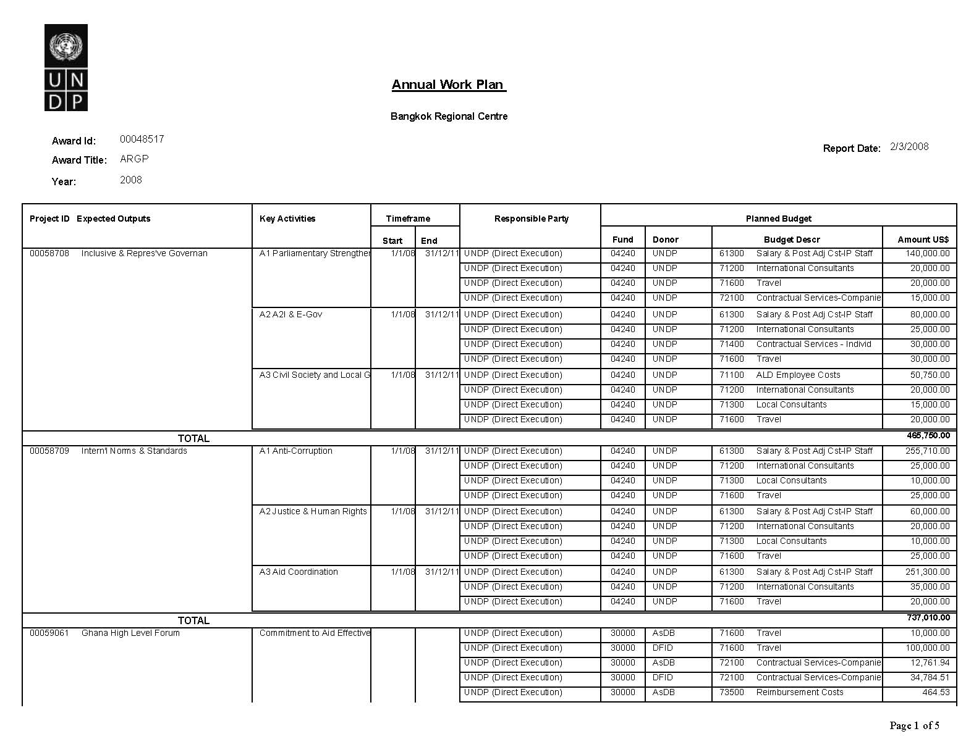
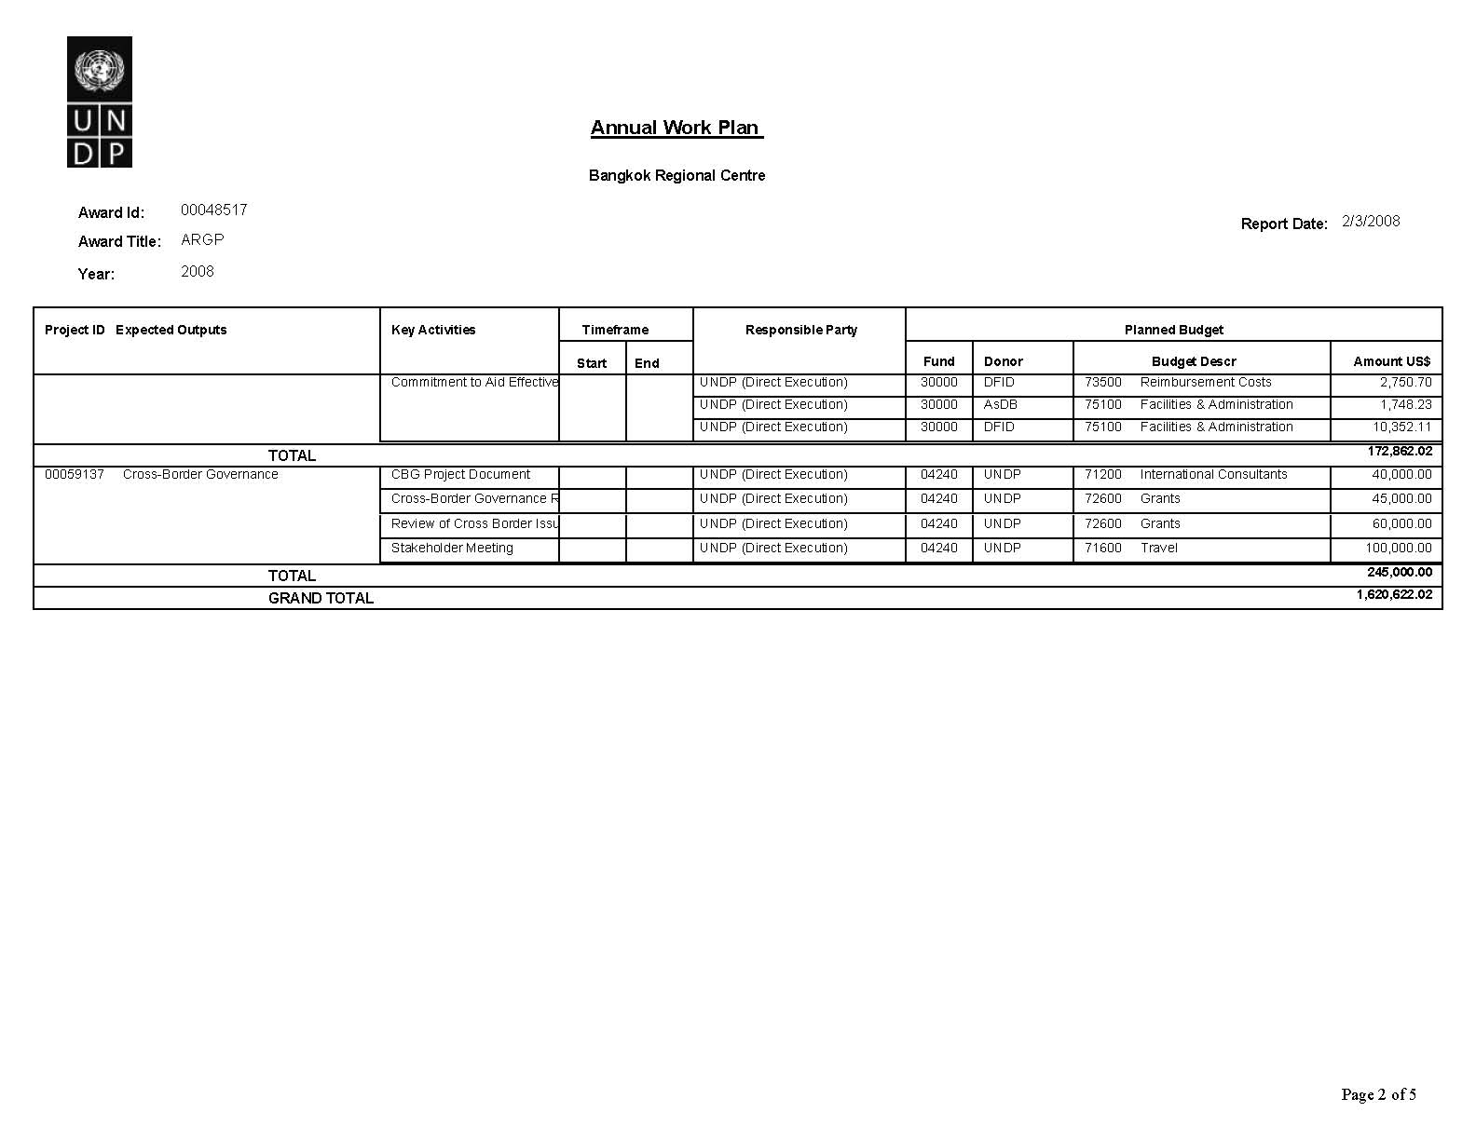
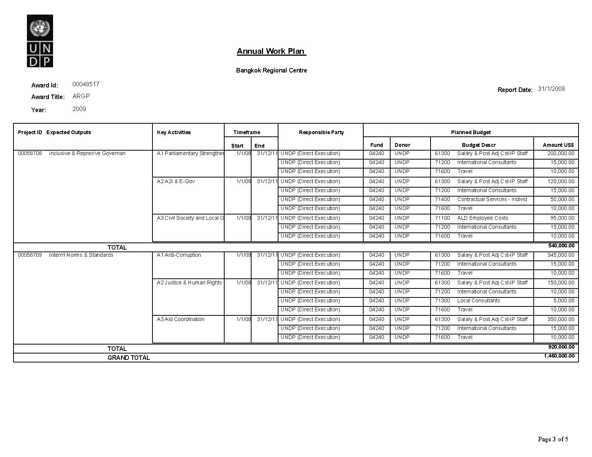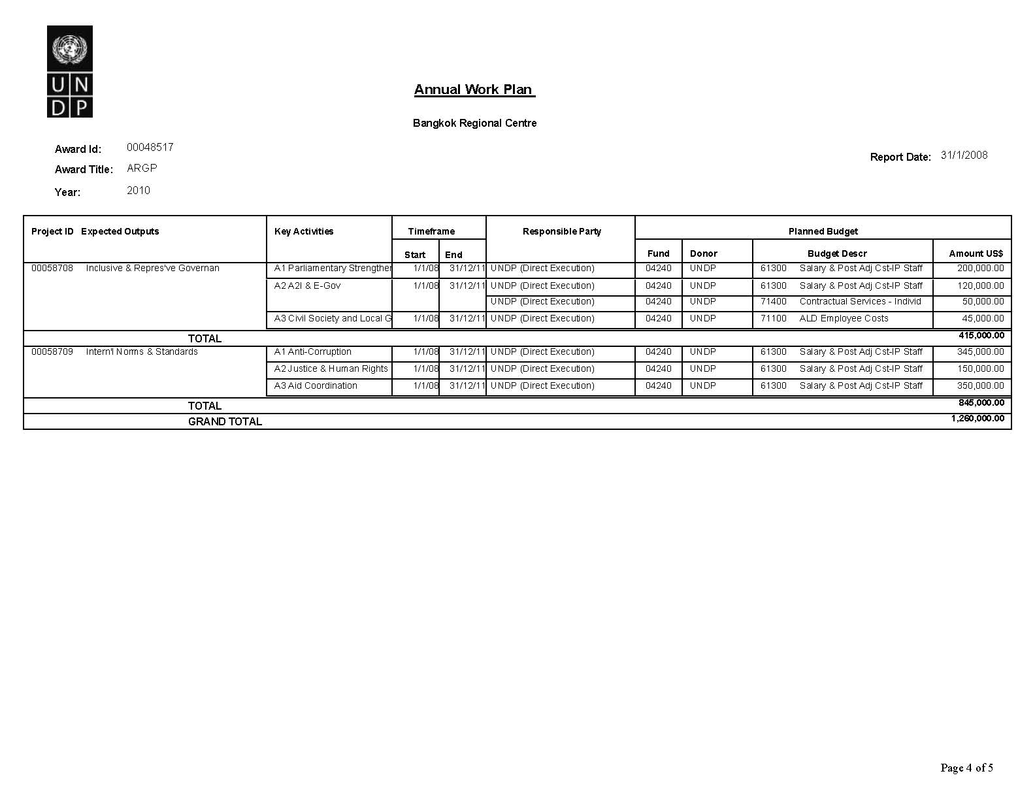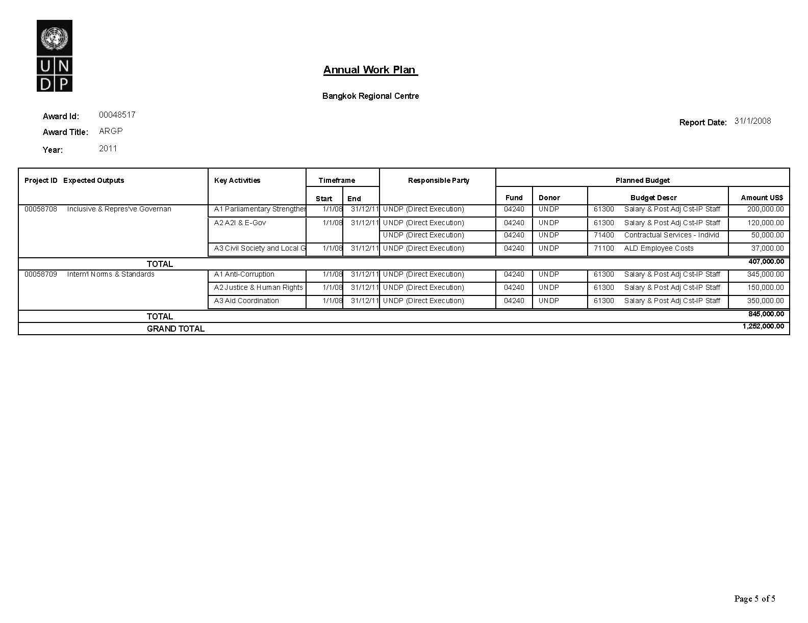

VI. Management Arrangements

DEX

The project will be implemented over a period of 45 months, commencing in January 2008 and ending in December 2011. The project will be directly executed by the UNDP Regional Centre in Bangkok (RCB). This is line with The Regional Programme document for 2008-2011, approved by the Executive Board at its September 2007 session, which states that "under the guidance of the Regional Bureau for Asia and the Pacific and the Bureau for Development Policy, the two Regional Centres in Bangkok and Colombo and the Pacific Centre in Suva will manage all regional/ subregional projects".

The Regional Centre in Bangkok (RCB) was established in 2004 with the purpose of managing regional projects and programmes. During these three years of experience, the RCB has proven its capacity to provide all necessary project management and implementation support to regional projects, including Tsunami recovery projects and all RCF II projects in the area of democratic governance, environment and sustainable development, and crisis prevention and recovery.

The RCB will be responsible for the technical and financial management of the project, and for all fiduciary arrangements. The RCB will partner with implementing agencies to achieve the results defined in the project’s Results and Resources Framework (RRF).

The RCB will establish a Project Steering Committee, chaired by the RBAP Deputy Regional Bureau Director. Chief of RBAP Regional Support Unit or his/her nominee will participate in PSC meetings. The RCB Head of Policy and Programmes will be the alternate of Chair of the PSC. The project’s day-to-day operations will be managed/coordinated by the Project Coordinator. The Project Coordinator will be supported by Project Support Assistant(s), who will be recruited to assist in coordinating the routine activities of the project and will report on a regular basis to the Project Coordinator.

Project Steering Committee
A Project Steering Committee (PSC) will be established (see diagram below) to provide guidance to the project and the Project Coordinator. Periodic project reviews by the PSC will be done in accordance with key reporting requirements of UNDP, i.e., annual reviews, a mid-term evaluation and a final evaluation.

The annual review reports will include detailed information on the status of project implementation and the achievement of project outputs and outcomes as outlined in the project’s RRF. The detailed expenditure report will indicate expenses by category as outlined in the project budget (original or latest approved revision).

The Steering Committee will be consulted if and when the Project Coordinator’s tolerances (in terms of time and budget) have been exceeded. These tolerances will be monitored by the Project Assurance Officer. Quarterly Progress Reports (QPRs), prepared by the Project Coordinator, will be reviewed by the Project Assurance Officer and consolidated for submission to Project Steering Committee meetings.

The Project Assurance Officer will have overall responsibility for project monitoring, risk management, quality assurance and for timely submission of reports to the PSC. This function will be performed by the Regional Monitoring and Evaluation Specialist, to be recruited by RBAP and located at the RCB. This Specialist will support all Asia Pacific regional centres.

Project Advisory Panel
An Advisory Panel of experts serving in their personal capacity shall advise on project implementation and ways to strengthen linkages with partners and donors. Meetings may be held virtually or in person.

Project Management Structure
The project management structure described above can be illustrated as follows:
Project Steering Committee
Senior Supplier
RCB Chief of Operations

Executive
RBAP Deputy Regional Bureau Director

Senior Beneficiary
1-2 Government representatives
Project Coordinator
(TBR)

(ADPC - Loy Rego)
Project
Support
Assistant
Project Assurance
Monitoring and Evaluation Specialist
(TBR)
Output Team 1
Representative Institutions
Output Team 2
Access to Information, E-Governance & Media

Output Team 3
Civil Society & Local Governance

Output Team 4
Access to Justice & Human Rights

Output Team 5
Anti-Corruption
Output Team 6
Aid Coordination

Monitoring Framework And Evaluation
The project will be monitored through the following:

Within the annual cycle
On a quarterly basis, a quality assessment shall record progress towards the completion of key deliverables, based on quality criteria and methods captured below:
- An Issue Log shall be activated in Atlas and updated by the Project Coordinator to facilitate tracking and resolution of potential problems or requests for change.
- Based on the initial risk analysis submitted, a Risk Log shall be activated in Atlas and regularly updated based on the external environment that may affect project implementation.
- Based on the above information recorded in Atlas, Quarterly Progress Reports (QPR) shall be submitted by the Project Coordinator to the Project Steering Committee through the Project Assurance Officer, using the standard report format available in the Executive Snapshot.
- Lessons-learned Log shall be activated and regularly updated to ensure on-going learning and adaptation within the organization, and to facilitate the preparation of the Lessons-learned Report at the end of the project.
- A Monitoring Schedule Plan shall be activated in Atlas and updated to track key management actions/events.

Annually
- Annual Review Report. An Annual Review Report shall be prepared by the Project Coordinator and submitted to the PSC in advance of PSC meetings. As minimum requirement, the Annual Review Report shall consist of the Atlas standard format for the QPR covering the whole year with updated information for each of the above elements of the QPR as well as a summary of results achieved against pre-defined annual targets at the output level.
- Annual Project Review. Based on the above report, an annual project review shall be conducted during the fourth quarter of the year or soon after, to assess the performance of the project and appraise the Annual Work Plan (AWP) for the following year. In the last year, this review will be a final assessment. This review is driven by the PSC and may involve other stakeholders as required. It shall focus on the extent to which progress is being made towards output attainment, and whether these remain aligned to appropriate outcomes.
- A Project Completion Report will be prepared in a draft form two months prior to the completion of the project.

Monitoring and communication plan

Monitoring Actions | Report Recipient | Due by | Completed on | Status
Planning workshop | Project Coordinator | Q1 | Q 2
Annual review Report | Project Steering Committee | Q4 | Q4
Annual Work Plan | PSC | Q4 | Q4
Periodic progress reports | PSC | Quarterly | Q1-4

Project Evaluations
In consultation with the PSC, an independent evaluation will be undertaken towards the end of the project cycle, and preferably no later than the third quarter of 2011.
The evaluation will cover (but will not be limited to) the following:
- Assessment of the achievement of all Outputs and Activities against the expected results and indicators set out in the Project Document and the RRF
- Interview with partner agencies and target beneficiaries on the impact of project activities in selected participating countries
- Overall adequacy, effectiveness, efficiency and impact of the project in high-risk countries.

Regional Programme Document (RPD) Outcome Evaluation
An outcome evaluation will be commissioned by RBAP in mid-2010 as per the Outcome Evaluation Plan annexed to the RPD. This evaluation will review reports prepared by the project since its inception: quarterly progress reports, monitoring review reports, and project completion report; end of project impact evaluation reports, minutes of Project Steering Committee meetings. In addition, there will be a Regional Programme Evaluation commissioned by the Evaluation Office in 2011 covering the entire Regional Programme Document.

Quality Management for Project Activity Results
Output 1: Parliaments and representative bodies are better able to engage in development policy planning and oversight and be more effective representatives of all groups in society
Activity Result 1  (Atlas Activity ID) |  | Analyzing and monitoring trends on parliamentary budget oversight on MDGs and PRSs |  |  |  | Start Date:01 Jan 08  End Date:31 Dec 11
Purpose |  | Parliamentarians are better engaged with and capacitated with tools and skills on MDGizing national budgets and development plans
Description |  | Reviewing existing tools and best practices of MDG based budgeting and parliamentary involvement
Quality Criteria  how/with what indicators the quality of the activity result will be measured? |  |  |  |  | Quality Method  Means of verification. what method will be used to determine if quality criteria has been met? | Date of Assessment  When will the assessment of quality be performed?
Relevance and appropriateness of tools and methods |  |  |  |  | Demand for tools from parliaments in target countries | At the end of workshops and training events
Plans and documents include disaggregated data and analysis |  |  |  |  | National and regional Plans and strategies | 2010
Output 2: State and non-state actors are capacitated to harness communication mechanisms (access to information policies, e-governance, and media) for enhanced government transparency and effectiveness
Activity Result 1  (Atlas Activity ID) |  | Designing and implementing pro-poor e-governance pilots |  |  |  | Start Date: 01 Jan 08  End Date: 31 Dec 11
Purpose |  | To help national and local governments better harness communication and e-governance strategies for poverty reduction
Description |  | A review of good practices in application of e-governance policies and strategies and applications at regional, national and sub-national levels and pilot testing of methods in select countries
Quality Criteria  how/with what indicators the quality of the activity result will be measured? |  |  |  |  | Quality Method  Means of verification. what method will be used to determine if quality criteria has been met? | Date of Assessment  When will the assessment of quality be performed?
Number of state, national and local government entities integrating pro-poor e-governance policies and strategies |  |  |  |  | National and Local Govt feedback and follow up | Following each training activity
Relevance and appropriateness of tools |  |  |  |  | Demand for tools, methods and demand for additional assistance | 2009
Quality of National/local Plans and e-governance pilots |  |  |  |  | Monitoring and evaluation of pilot initiatives | 2011
Output 3: Policy-makers in key ministries and non-state parties are better able to develop effective governance arrangements for MDG-focused service delivery
Activity Result 1  (Atlas Activity ID) |  | Governance arrangements to improve service delivery for the MDGs |  |  |  |  | Start Date:01 Jan 08  End Date:31 Dec 11:
Purpose |  | Support governments and non-state parties to analyze varying governance frameworks and arrangements for service delivery in key sectors as part of national MDG based strategies
Description |  | Drawing on regional analysis and development of methodologies, and delivered within a joint UN framework, support will be provided to senior officials in key ministries and research institutions to examine the divisions of sectoral responsibilities, roles and functions between central and sub-national levels of government, and financing arrangements in the delivery of health, education and water related services. Support will also be provided for a regional and national dialogue involving non-state parties
Quality Criteria  how/with what indicators the quality of the activity result will be measured? |  |  | Quality Method  Means of verification. what method will be used to determine if quality criteria has been met? |  |  |  | Date of Assessment  When will the assessment of quality be performed?
1. Relevance of analytical framework developed through regional intervention |  |  | Application of tools in target countries |  |  |  | Q4 2009
2. Quality of regional analytical frameworks and technical support provided |  |  | Assessment of quality of sectoral analysis/ if relevant survey to assess satisfaction of key government counterparts |  |  |  | Q4 2009
Output 4: State and non-state actors are capacitated to support implementation of international instruments, norms and standards to increase integrity in governance
Activity Result 1  (Atlas Activity ID) |  |  |  | Advocacy campaign on corruption and human development |  |  | Start Date: 01 Jan 08  End Date: 31 Dec 11
Purpose
Description
Ensure wide distribution and debate of UNDP’s work on corruption and human development to guide further research and programming on corruption in the region and future activities of the Community of Practice.
A communication strategy that will include media outlets, public service announcements, participation in regional and global forums and participatory workplanning within the Community of Practice
Quality Criteria  how/with what indicators the quality of the activity result will be measured? |  |  | Quality Method  Means of verification. what method will be used to determine if quality criteria has been met? |  |  |  | Date of Assessment  When will the assessment of quality be performed?
Number of communication outlets produced |  |  | Websites, use in media, speeches and papers submitted to conferences and workshops, two Integrity briefs available on the web per year |  |  |  | 2009
Output 5: Capacities of justice sector-related institutions and stakeholders are strengthened to deliver and enhance access to justice and promote human rights
Activity Result 1  (Atlas Activity ID) | Develop and launch an Asia Pacific Judicial Reform Handbook |  |  |  |  |  | Start Date: 01 Jan 08  End Date:31 Dec 11
Purpose | Create a practical tool for exchanging learning and use by each other an empower and enable reform actors throughout the justice system
Description | Develop judicial reform tools relevant for Asia Pacific based on regional experiences of judicial reform through a collaborative engagement of supreme courts in the region
Quality Criteria  how/with what indicators the quality of the activity result will be measured? |  |  | Quality Method  Means of verification. what method will be used to determine if quality criteria has been met? |  |  |  | Date of Assessment  When will the assessment of quality be performed?
Supreme courts in the region participate in the forum and discussions leading to the compilation of the document |  |  | Monitoring of web-forum exchanges |  |  |  | 2008
Handbook reflects regional experiences |  |  | Project evaluation by independent regional institution |  |  |  | 2009
Output 6: National governments are able to better align aid flows, develop management action plans to implement Paris Declaration regulatory framework and contribute to achieving the MDGs
Activity Result 1  (Atlas Activity ID) |  | Develop aid effectiveness course curriculum and institutionalize its delivery by a partnership of Asian service providers |  |  |  |  | Start Date: 2008  End Date: 2011
Purpose |  | Address country-level aid effectiveness capacity constraints and promote cross- and intra-regional peer learning
Description |  | Deliver high quality capacity development and training support on a multi-country basis, including through regional help desk and dissemination of aid effectiveness knowledge products.
Quality Criteria  how/with what indicators the quality of the activity result will be measured? |  |  |  | Quality Method  Means of verification. what method will be used to determine if quality criteria has been met? |  |  | Date of Assessment  When will the assessment of quality be performed?
Aid Effectiveness Capacity development training course will be evaluated by government participants |  |  |  | Evaluations forms |  |  | During pilot courses in 2008 and annually from 2009-2011
OECD DAC agrees to partner with UNDP in introducing a regional help desk in Asia to support the Paris Declaration Survey and both preparations for and follow up to High Level Forums in 2008-2011 |  |  |  | Co-Sponsorship of regional help desk implemented and joint support to practitioner network |  |  | Mid 2008; and subsequently annually
Partner governments and country offices incorporate findings from regional public goods created under this output |  |  |  | Findings on Aid Mgt Information Systems are drawn upon in the development of new AIMS in Asia and the Pacific |  |  | 2009-2011

Legal Context

This regional project is directly executed by the UNDP Regional Centre in Bangkok and located in Bangkok, Thailand. As Thailand, as host country, has not signed the SBAA, the following text applies:

The project document shall be the instrument envisaged in the Supplemental Provisions to the Project Document, attached hereto.
Consistent with the above Supplemental Provisions, the responsibility for the safety and security of the executing agency and its personnel and property, and of UNDP’s property in the executing agency’s custody, rests with the executing agency.
The executing agency shall:
- put in place an appropriate security plan and maintain the security plan, taking into account the security situation in the country where the project is being carried;
- assume all risks and liabilities related to the executing agency’s security, and the full implementation of the security plan.
UNDP reserves the right to verify whether such a plan is in place, and to suggest modifications to the plan when necessary. Failure to maintain and implement an appropriate security plan as required hereunder shall be deemed a breach of this agreement.
The executing agency agrees to undertake all reasonable efforts to ensure that none of the UNDP funds received pursuant to the Project Document are used to provide support to individuals or entities associated with terrorism and that the recipients of any amounts provided by UNDP hereunder do not appear on the list maintained by the Security Council Committee established pursuant to resolution 1267 (1999). The list can be accessed via http://www.un.org/Docs/sc/committees/1267/1267ListEng.htm. This provision must be included in all sub-contracts or sub-agreements entered into under this Project Document.

Project activities will be undertaken in those countries which have endorsed the project. For those countries which have signed the Standard Basic Assistance Agreement (SBAA), the following text applies:

This project document shall be the instrument referred to as such in Article 1 of the SBAA between the Government of (country) and UNDP, signed on (date).
Consistent with the Article III of the Standard Basic Assistance Agreement, the responsibility for the safety and security of the executing agency and its personnel and property, and of UNDP’s property in the executing agency’s custody, rests with the implementing partner.
The executing agency shall:
- put in place an appropriate security plan and maintain the security plan, taking into account the security situation in the country where the project is being carried;
- assume all risks and liabilities related to the executing agency’s security, and the full implementation of the security plan.

UNDP reserves the right to verify whether such a plan is in place, and to suggest modifications to the plan when necessary. Failure to maintain and implement an appropriate security plan as required hereunder shall be deemed a breach of this agreement.
The executing agency agrees to undertake all reasonable efforts to ensure that none of the UNDP funds received pursuant to the Project Document are used to provide support to individuals or entities associated with terrorism and that the recipients of any amounts provided by UNDP hereunder do not appear on the list maintained by the Security Council Committee established pursuant to resolution 1267 (1999). The list can be accessed via http://www.un.org/Docs/sc/committees/1267/1267ListEng.htm. This provision must be included in all sub-contracts or sub-agreements entered into under this Project Document.

For those countries which have not signed the SBAA, the same text applicable to this Thailand-based regional project (and quoted above) applies.

X. Annexes
Annex 1: Initial Risk Log

# | Description | Category | Impact &  Probability | Countermeasures / Mgt response | Owner | Author | Date Identified | Last Update | Status
1 | Several areas of the governance work are getting overcrowded with multilateral and bilateral donor support. This is particularly the case in the area of corruption and aid effectiveness. | Strategic | With limited core funds and a dire need to mobilise resources, the risk is that UNDP becomes marginalised in the governance sector at regional level, also because of lack of core program funds.  P = 2; I = 4 | Partnership can help to overcome this risk. UNDP has the geographic coverage in the region which is attractive for both UN agencies and bilateral donors that are not present throughout the region. | Project Team | Project Team | November 1, 2007
2 | Core funding and resource mobilization not sufficient for proposed activities | Organisational | Impact on expected results will be significant  P= 2; I=4 | Prevention: A concerted resource mobilization strategy will be required and UNDP core resources to ensure staff capacity committed | Project Team | Project Team | November 1, 2007
3 | Regional Activities not sufficiently anchored to country level priorities | Organisational | Impact on results will be affected  P = 2 I = 2 | Prevention: Chose national implementing partners and dissemination and implementation strategies in careful consultation with UNDP COs. | Project Team | Project Team | 1 November 2007
4 | Programming activities cannot take be effective due to political and security reasons in participating countries | Political/Security | Impact: the scope of activities and countries covered through regional efforts will be minimized P = 2, I = 2 | Prevention: Revamp strategies to engage with different actors and countries | Project Team | Project Team | 1 November 2007
5 | Research and Knowledge Products do not have effective buy in or dissemination strategy | Strategic | The project’s contribution to the outcomes and the RPD would diminish  P = 2; I = 2 | Prevention; Means test first by assessing through COs the interest for a particular research and development activity and product | Project Team | Project Team | 1 November

Annex 2. Terms of Reference for Project Steering Committee

The Project Steering Committee (PSC) provides overall technical advisory and management guidance, project assurance and oversight for the implementation of the project. Day-to-day management/coordination of the project will rest in the Project Coordinator

The PSC will comprise:

- Executive: UNDP RBAP Deputy Bureau Director (Chair). The RCB Head of Policy and Programme will act as Secretariat.
- Senior Supplier: Chief of Operations (alternate, Deputy Chief of Operations)
- Senior Beneficiary: 1-2 Government representative(s) from the region

The Project Steering Committee will meet annually to review progress of the project. Given the regional scope of the project, meetings of the PSC may take place mid-year through video/phone conference facilities and where possible, face to face.
The Project Steering Committee will be responsible for the following:
- Provide overall guidance and direction to the project.
- Agree on Project Coordinator’s tolerances (time and resources) in the achievement of Outputs and Activities; and provide direction and advice for exceptional situations when the Project Coordinator’s tolerances have been exceeded.
- Provide guidance and agree on possible management actions to address specific risks.
- Appraise the Project Annual Review Report and make recommendations for inclusion in the next Annual Work Plan.
- Assess and decide on project changes through project revisions.
- Assess whether planned outputs have been satisfactorily attained; and provide guidance, as appropriate.

For the process of closing a project:
- Assure that all planned deliverables are delivered satisfactorily.
- Review independent project evaluation and approve the end project report.
- Make recommendations for follow-on actions and post project review plan.

Annex 3: Terms of Reference for Project Coordinator (L6)

The Project Coordinator will be primarily responsible for the overall management, coordination and reporting of project activities. S/he has the authority to run the project on behalf of the Project Steering Committee within the constraints laid down by the PSC. The Project Coordinator is responsible for day-to-day management and decision-making for the project. The PC’s prime responsibility is to ensure that the project produces the results specified in the AWP, to the required standard of quality and within the specified constraints of time and cost. The PC will oversee the delivery of reporting requirements to the PSC in a timely manner in accordance with the Activities described in the Project Document. The Project Coordinator will report to the RCB Head of Policy and Programmes, keeping the respective Practice Team Leader (PTL) fully informed, and consulting with the PTL, as appropriate.

Specific responsibilities:

Overall project management:
- Prepare the Annual Work Plan and manage the production of the planned deliverables
- Draft TORs and work specifications for consultancies/subcontracts
- Direct and motivate the project team
- Liaise with the PSC to ensure the overall direction and integrity of the project
- Agree on a technical and quality strategy with appropriate members of the PSC
- Identify and obtain any support and advice required for the management, planning and control of the project
- Be responsible for overall project administration
- Be responsible for change control and any required configuration management

Project monitoring:

- Plan and monitor activities as determined in the Project Monitoring Schedule Plan; and update the plan, as required
- Manage the risks as determined in the Project Risks Log, including the development of contingency plans as necessary,
- Take responsibility for overall progress and use of resources and initiate corrective actions where necessary
Project reporting:

- Prepare and report to the PSC through annual project reports and end project report
- Prepare the Lessons-learned Reports
- Prepare any follow-on action recommendations reports, required

Qualifications:

The Project Coordinator will be of such caliber as to be able to work with high-level government officials and intergovernmental bodies, and be able to represent UNDP in regional and subregional forums with ability for strategic thinking in policy and programming. Qualifications required are:

- Masters degree in political science, international development, or democratic governance-related field
- Five to ten years of professional experience in development work, with experience in the Asia and the Pacific region
- Proven programme planning and management experience, with excellent interpersonal skills
- Considerable experience and understanding of gender equality and women’s empowerment issues
- Experience with UNDP and the UN System; good understanding of UNDP programme, finance and operational procedures will be an asset
- Proven track record as partnership builder and resource mobilizer.
- Deep knowledge of the Asia-Pacific region.
- Languages: Full English fluency is a requirement. Knowledge of other UN or Asian languages would be an asset.

Technical:
- Provide technical guidance, inputs and advice to the work of the output teams
- Provide substantive oversight and support to the project and play a central initiating role on substantive issues including performing a lead role in identifying consultants, providing technical inputs, facilitating reviews of draft reports and overseeing the finalization and publication of reports, policy papers and briefs
- Provide technical advisory services to support member countries in the formulation of their respective democratic governance related policies and strategies, including building capacities in the formulation and implementation of policies, and prepare related documents and materials
- Work with various other projects, services and units of the regional centres and bureaus to deliver on regional programme objectives

Annex 4: Terms of Reference for Project Assistant

Duties and Responsibilities:
The Project Assistant will provide day-to-day support to the Project Coordinator (PC) in a range of areas including: day-to-day administrative support; financial record tracking; document/report management. Under the supervision of the PC, the Project Assistant will provide the following services to the project team members:

Administrative:
- Maintain and update inventory of all project equipment and coordinate with vendors for maintenance and renewal of suppliers.
- Maintain and update a shared database of project contacts/networks.
- Liaise with the Operations Support Team (OST) and UNDP’s travel agent and others as necessary on administrative, procurement and financial matters as appropriate.
- Contact other UN agencies, government and other external partners to set up meetings and other activities as per project requirements.
- Prepare and process requisitions requests in accordance with the project work/procurement plan.
- Provide necessary administrative support to project consultants.
- Maintain a calendar of events (international, regional and national) relevant to the project’s work plan.
- Archive all project reports (Quarterly, annual, BTORs, workshops events, etc.) and publications, including those produced by participating countries with project funding.
- Distribute project reports and publications to participating countries and partners, as appropriate.
- Contact and follow-up with identified focal points in the UNDP COs of the project countries on matters relevant to the implementation of the project.
- Other duties as directed

Travel and logistical arrangements:
- Prepare in advance travel arrangements for the project team’s official missions, including visa requests, travel requests/authorizations, security clearances, hotel reservations and transportation, documentation for the mission.
- Maintain all supporting documents related to official missions needed to settle travel claims and for audit purposes according to UNDP Regulations and Rules (i.e. ticket stubs; receipts related to hotel bills, visas, DSA, security clearance requirements, etc.)

Qualifications:
- Secondary Education. University Degree in Business or Public Administration would be desirable.
- Prior experience of at least 3 years in administrative and secretarial work. Familiarity with UNDP administrative/financial systems would be an asset.
- Experience of using Atlas tool would be an asset.
- Computer Skills: MS Office, Email communication
- Languages: Strong written and oral communication skills in English and Thai
Annex 5: Terms of Reference for Project Assurance Officer
The Project Assurance Officer (PAO) will have overall responsibility for project monitoring, risk management, quality assurance and for timely submission of reports to the Project Steering Committee. Specifically, the PAO will perform the following tasks:
- Ensure that funds are made available to the project on a timely basis.
- Ensure that risks and issues logs are prepared and properly managed, and that the logs in Atlas are regularly updated.
- Ensure that critical project information is monitored and updated in Atlas, using the Activity Quality Assessment page in particular.
- Ensure that Project Quarterly Progress Reports, Annual Reports, Evaluation Report, End of Project Report are prepared and submitted on time, and according to standards in terms of format and content quality.
- Ensure that financial reports are submitted to UNDP on time, and that CDRs are prepared and submitted to the Project Steering Committee.
- Perform oversight activities, such as periodic monitoring visits and “spot checks”.
- Ensure that the Project Data Quality Dashboard remains “green”.
Annex 6: Terms of Reference for Programme Staff

Position: Policy Advisor – Parliamentary Strengthening

Duty Station: Bangkok, Thailand
Level: L5
Duration: 1 year (renewable)

Role of the Policy Advisor:

Under the supervision of the Project Coordinator the adviser will contribute to the parliamentary strengthening and development components of the project and is responsible for the management, coordination and reporting of project output activities in this specified area. The policy adviser’s prime responsibility is to ensure that the project produces the results specified in the AWP, to the required standard of quality and within the specified constraints of time and cost.

Specific responsibilities:

- Have specific responsibilities for provision of policy and technical advisory services to UNDP country offices and partner governments in the area of parliamentary development and strengthening.
- In close collaboration with the Regional Governance Practice Team Leader and Project Coordinator mobilize resources for additional programming for the Governance Programme.
- Share knowledge and facilitate sharing of knowledge by practitioners in the region, including south-south learning, by supporting the development of corporate parliamentary strengthening guidelines and tools.
- Be responsible for delivery and implementation of regional project outputs and activities in the area of parliamentary strengthening and development per the Results and Resource Framework and Annual Workplans.
- In collaboration with other members of the Governance Practice Team and other practice and cross practice teams in the Regional Centre(s), initiate capacity development tools, draft policy documents, develop new and innovative methodologies in the focus area, including providing training at regional and national and global levels, helping identify specialized expertise and developing roster of expertise, developing databases and/or other tools for use by UNDP country offices and development partners;
- Monitor, review and evaluate progress of parliamentary component of ARGP
- Undertake other related tasks as requested by the Project Coordinator

Qualifications

- A Master’s Degree (PhD is an asset) in the relevant field
- Minimum of 10 years of work experience in the development field
- Familiarity with UNDP and UN system policies is a distinct advantage.
- Working knowledge/experience in inter-country and regional programming a distinct advantage
- Strong conceptual understanding and demonstrated experience working on regional, national and global issues / policies and capacity development initiatives with regard to governance issues.
- Knowledge of the broader field of governance is essential
- Knowledge of the Asian region is a strong asset
- Ability to work as part of a team.
- Understanding of and ability to work within a knowledge management culture will be considered as a plus.
- Capable of working under deadline pressure and of taking on responsibility for range of tasks.
- Strong analytical, communications, reporting and advocacy skills and ability to work in an environment requiring liaison and collaboration with multiple actors including government representatives, donors and other stakeholders.
- Proficiency in English is required and ability to work in Asian languages would be an asset.
- Excellent computer skills, including full working knowledge of standard word processing, spreadsheet and presentation software packages, as well as user ERP management knowledge
Position: Aid Effectiveness Adviser

Duty Station: Bangkok, Thailand
Level L5
Duration: 1 year (renewable)

Role of the Adviser:
Under the supervision of the Project Coordinator the adviser will contribute to the aid coordination, aid management and aid effectiveness components of the project and is responsible for the management, coordination and reporting of project output activities in this specified area. The programme adviser’s prime responsibility is to ensure that the project produces the results specified in the AWP, to the required standard of quality and within the specified constraints of time and cost.

Specific responsibilities:
- Provide training, identify specialised expertise, and support the development of aid information management systems for use by development partners or UNDP Country Offices.
- Facilitate inter-regional, cross-regional and cross-thematic learning by promoting networks, drawing and making available best practices and by consulting with other regional advisors and staff on an ongoing basis, and participate in regional and national conferences as required.
- Contribute to the development of the Governance Practice Team’s annual work plans focusing on key results, both at the regional level and the country level.
- Contribute to strengthening UNDP’s relationships with other stakeholders on aid coordination and management, including UN agencies, the Economic and Social Commission for Asia and the Pacific, NGOs and donors working within the thematic area.
- In close collaboration with the Project Coordinator, mobilise resources for additional programming in the focus area and lead the management of mobilised support with donor agencies.
- Advise Governments and UNDP Country Offices at the most senior levels on the potential implications of the Paris Declaration on Aid Effectiveness at country level.
- Support in-country action and learning by providing authoritative information on alignment, donor harmonisation and managing for results drawing on knowledge of country experiences in and beyond the region.
- Provide the authoritative policy and technical analysis and substantive inputs required for country aid information management systems to be established successfully. Promote linkages between systems to track aid resources and results with both public financial management systems and aid coordination dialogue mechanisms.
- Produce technical papers, policy briefs and papers, lessons learned, evaluations to guide policy advocacy and technical programme development efforts in the region.
- Manage and provide support to other colleagues working on the aid effectiveness components of the Annual Work Plan.
- At the request of UNDP Country Offices, lead missions to backstop aid effectiveness projects, and support the skills development and training of responsible government officials in aid management and aid tracking and analysis.
- Work to expand the knowledge and understanding of UNDP staff and government officials on the Paris Declaration, programme based approaches, alignment and harmonization, evaluation and results based management, and other aspects of aid effectiveness.
- Advise on the development of in-depth analyses regarding donor performance vis-à-vis country needs and against Paris Declaration indicators.
- Provide practical recommendations for action concerning aid predictability and increasing the alignment of international financial and technical assistance with country priorities in tsunami-affected countries and other countries in the Asia and Pacific region.
- Promote and conduct Government-donor/UN dialogue at all levels to achieve mutual understanding on aid coordination issues.
- Support maintenance and further development of the national and regional Development Assistance Databases and other aid information management systems.
- Share knowledge and facilitate sharing of knowledge by practitioners in the region, including south-south learning, by supporting the development of corporate aid management tools and the regional www.AidEffectiveness.org wiki.
- Perform other analytical and administrative tasks or any other duties reflecting the overall purpose of supporting Country Offices and governments in aid tracking and coordination.

Qualifications
The candidate shall have an advanced degree in economics, public administration, development studies or political science and:
- At least ten years experience in field of aid coordination, development cooperation, finance or public administration at national or international level.
- Strong experience with UNDP/UN agencies or other international organization, and relevant work experience in developing countries, preferably in the region, will be an asset.
- Expertise in public financial management, aid tracking, results-based management, and programme-based approaches is an advantage.
- A self-starter, able to work with minimum supervision, with sound judgment
- Excellent English language drafting and oral communication skills.

Position: Aid Effectiveness Specialist

Duty Station: Bangkok, Thailand
Level L4
Duration: 1 year (renewable)

Role of the Programme Specialist:
Under the overall supervision of the Project Coordinator and the technical guidance of the Regional Adviser for Aid Effectiveness, the programme specialist will contribute to the aid coordination, aid management and aid effectiveness components of the project. The programme specialist will contribute to ensuring that the project produces the results specified in the AWP, to the required standard of quality and within the specified constraints of time and cost.

Specific responsibilities:
- Advise Governments and UNDP Country Offices on the potential implications of the Paris Declaration on Aid Effectiveness at country level.
- Support in-country action and learning by providing information on alignment, donor harmonisation and managing for results drawing on knowledge of country experiences in and beyond the region.
- Provide authoritative policy and technical analysis and substantive inputs required for country aid information management systems to be established successfully. Promote linkages between systems to track aid resources and results with both public financial management systems and aid coordination dialogue mechanisms.
- At the request of UNDP Country Offices, lead missions to backstop aid effectiveness projects, and support the skills development and training of responsible government officials in aid management and aid tracking and analysis.
- Work to expand the knowledge and understanding of UNDP staff and government officials on the Paris Declaration, programme based approaches, alignment and harmonization, evaluation and results based management, and other aspects of aid effectiveness.
- Advise on the development of in-depth analyses regarding donor performance vis-à-vis country needs and against Paris Declaration indicators.
- Provide practical recommendations for action concerning aid predictability and increasing the alignment of international financial and technical assistance with country priorities in tsunami-affected countries and other countries in the Asia and Pacific region.
- Promote and conduct Government-donor/UN dialogue at all levels to achieve mutual understanding on aid coordination issues.
- Support maintenance and further development of the national and regional Development Assistance Databases and other aid information management systems.
- Share knowledge and facilitate sharing of knowledge by practitioners in the region, including south-south learning, by supporting the development of corporate aid management tools and the regional www.AidEffectiveness.org wiki.
- Perform other analytical and administrative tasks or any other duties reflecting the overall purpose of supporting Country Offices and governments in aid tracking and coordination.

Qualifications

The candidate shall have an advanced degree in economics, public administration, development studies or political science and:
- At least seven years experience in field of aid coordination, development cooperation, finance or public administration at national or international level.
- Prior experience with UNDP/UN agencies or other international organization, and relevant work experience in developing countries, preferably in the region, will be an asset.
- Expertise in public financial management, aid tracking, results-based management, and programme-based approaches is an advantage.
- A self-starter, able to work with minimum supervision, with sound judgment
- Excellent English language drafting and oral communication skills.

Position: Programme Specialist – Access to Information, e-Governance and Independent Media Development

Duty Station: Bangkok, Thailand
Level L3
Duration: 1 year (renewable)

Role of the Programme Specialist:

Under the supervision of the Project Coordinator, the programme specialist will contribute to delivering the outputs within the Access to Information, e-governance and media components of the project. The prime responsibility is to ensure that the project produces the results specified in the AWP, to the required standard of quality and within the specified constraints of time and cost.

Specific responsibilities:

Policy advice and technical backstopping
- Provide substantive and relevant policy and technical advisory services to UNDP country offices and their national counterparts, and to regional initiatives
- Advise on and support the formulation and drafting of programme/project documents, and evaluation of UNDP’s governance activities in the region, ensuring that national, regional and corporate e-governance, access to information and independent media development issues are adequately addressed
- Undertake regional research initiatives of e-governance, access to information and independent media development programmes, produce analysis of good practices and lessons learned, highlighting emerging trends and developments in the region
- Identify needs for additional technical support and expertise to assist in the development of programmes at national and regional levels.
- Contribute with concepts and activities to enhance UNDP’s support to the MDGs and, in this regard, engage particularly with the Regional Team in Colombo that supports the implementation of the MDG initiative in selected countries in the region.

Knowledge management and practice development
- Coordinate the production of key knowledge products and ensure appropriate linkages to other governance sub-areas, other practices and cross-practices
- Organize and participate in relevant regional and international events, networks and processes
- Facilitate cross-regional and cross-thematic learning by promoting networks across regions and consulting with other regional advisors on an ongoing basis
- Represent RCB in key forums in the region on e-governance, access to information and independent media development to advocate, and engage and develop partnerships with leading thinkers, academic institutions, high level government officials and civil society organizations on UNDP’s activities in the region

Management and resource mobilisation
- Prepare annual work plans for the output to support implementation of regional initiatives
- Monitor and report on programme results on the output on an annual basis
- Actively participate in the preparation and implementation of resource mobilisation strategies and the development of new partnerships and initiatives to ensure adequate resource mobilisation for programming in e-governance, access to information and independent media development
- Contribute to the strengthening of the RCB’s relationships and collaboration with other key stakeholders in the region and beyond, including UN and non-UN agencies/organizations.

Qualifications
  - The candidate shall have a Masters in international development, communications, social science, journalism, or a related discipline and:
  - A minimum of 5 years professional experience; at least 3 years of experience in an international developmental context, having worked in the fields of communications and ICT for development, e-governance, access to information and media development
  - Strong technical knowledge in the field of communication for development with emphasis on e-governance, ICT for development, access to information, and media development preferably with in-depth knowledge of the MDGs and the role of information, communication, ICT and media for democratic governance.
  - Practical experience in designing, implementing, and monitoring, e-governance, access to information and independent media development programmes in developing countries, preferably with UNDP programmes in Asia and the Pacific.
  - Ability to forge knowledge networks and products on access to information, e-governance and independent media development to support democratic governance policy-making.
  - Fluent and proficient in English, with knowledge of at least one other UN language an advantage.

Position: Programme Specialist - Decentralization and Local Governance

Duty Station: Bangkok, Thailand
Level A3
Duration: 1 year (renewable)

Role of the Programme Specialist:

Under the overall supervision of the Project Coordinator and the technical guidance of the Regional Adviser on Decentralization, the programme specialist will contribute to delivery of outputs of the ARGP, Phase II. By assisting the Project Coordinator, the programme specialist’s prime responsibility is to ensure that the project produces the results specified in the AWP, to the required standard of quality and within the specified constraints of time and cost.

Specific responsibilities:

- Implement and monitor delivery of regional programme activities and outputs in the related area
- Undertake analytical work as required: preparation of briefing notes/papers;
- Support the preparation of documents, reports and other knowledge product;
- Maintain regular contact with internal and external partners;
- Provision of policy advice and technical expertise to RBAP UNDP Country Offices in the context of Regional Center’s DLG support services;
- Provide technical backstopping through research and other substantive input to the UNDP country offices;
- Take active part in the relevant UNDP, international events and processes;
- Liaise with different UN agencies on behalf of UNDP in promoting strategies for collaborative programming
- Maintain the information content of the Service line RCB homepage and ensure that information on the activities and knowledge products is regularly updated and communicated also to external stakeholders.

Regional Project Management:

Coordinate and backstop regional initiatives through the following activities:

- Liaise and maintain close working relationship with key stakeholders in the implementation of the project activities to ensure maximum results and impact;
- Coordinate and monitor the various project outputs;
- Facilitate regional network discussions, and implement networking activities including liaising and managing the network and mailing list; prepare summaries of e-discussions; carry out substantive research for consolidated replies to the network;
- Plan and organize regional meetings and events;
- Take active part in meetings and other relevant forums related to the project;
- Monitor and ensure that projects/programmes under her/his responsibility are progressing according to the work plan;
- Provide both internal and external clients with timely and adequate support/information on project’s activities;
- Contribute to the development and implementation of other regional outputs in the area of local governance and decentralization;
- Work closely in liaison with all members of the Governance Practice Team and other colleagues, in particular to promote gender mainstreaming.
- Assist Project Coordinator with resource mobilization activities as required;

Global/Regional Policy Development:

- Contribute to the development of UNDP’s global and regional policy through inputs to strategy papers, analysis of lessons learned etc.
- Actively participate in the development of relevant knowledge products;

Knowledge management

- Respond to queries on the regional and global networks, related to DLG issues.
- Liaison with partners and local counterparts think-tanks, and civil society organizations working in the focus areas
- Support the editing/publication of knowledge products

Others
- Carry out other duties as and when requested

Qualifications
- Advanced university degree in a development related field; e.g., Development, Studies, Political Science, Public Administration
- A minimum of five years work experience with a documented record in supporting policy change and implementation of development programmes in the field of local governance and decentralization;
- Proven analytical/research skills;
- Programme/project design and management skills;
- Proficiency in corporate software and IT skills
- Demonstrated ability to work in an independent manner; ability to organize work efficiently and deal with a heavy workload;
- Demonstrated ability to work in harmony with staff members of different national backgrounds in a mutually supportive team approach;
- Prior experience and familiarity with governance issues in the RBAP region and knowledge of UNDP corporate mandate is an asset;
- Excellent communication skills;
- Proficiency in English

Position: Programme Specialist – Access to Information, e-Governance and Media Development

Duty Station: Bangkok, Thailand
Level NOA/B
Duration: 1 year (renewable)

Role of the Programme Specialist:

Under the supervision of the Project Coordinator, and technical guidance of the regional advisor on access to information, the programme specialist will contribute and assist in the implementation of project output activities of access to information, e-governance and media development under the Asia Regional Governance Programme II.

Specific responsibilities:
- Assist project coordinator on implementing regional programming in areas of access to information, e-governance and media development
- Provide technical backstopping through research and other substantive input to the UNDP country offices in the areas of access to information, e-governance and media development
- Undertake analytical work as required: preparation of briefing notes/papers and support the preparation of documents, reports and other knowledge products;
- Maintain regular contact with internal and external partners;
- Take active part in the relevant UNDP, international events and processes;
- Liaise with different UN agencies on behalf of UNDP in promoting strategies for collaborative programming
- Maintain the information content of the Service line RCB homepage and ensure that information on the activities and knowledge products is regularly updated and communicated also to external stakeholders.
- Build and manage communities of practices in the related areas, both online and offline, including the management of a web portal, and facilitation of cross-regional and cross-thematic learning.
- Work with practice team leader in developing and implementing a communications strategy to promote the outputs and activities.
- Respond to queries and requests from clients on access to information, e-governance and media development.
- Contribute to the strengthening of the RCB’s relationships and collaboration with key stakeholders in the region and beyond, including UN and non-UN agencies/organizations.
- Undertake other relevant tasks as requested by the Project Coordinator

Qualifications:

The candidate shall have a Masters Degree or equivalent in development, social sciences or ICT for development and:

- A minimum of five years experience in ICT and development-related work.
- A minimum of five years experience in web development, knowledge and information management, and facilitation of communities of practice networks.
- Experience with programme/project management.
- Possess working knowledge of basic composition, page layout, art and office/web software packages.
- Strong organizational, problem-solving and advocacy skills.
- Good command of written and spoken English and ability to communicate effectively.
- A team player and self-starter, able to work with minimum supervision, with sound judgment.
- Good communication and interpersonal skills and experience in working effectively in a multicultural environment.
- Previous experience with UNDP and/or the UN system and/or bilateral donor(s) in Asia is an advantage.
Position: Policy Analyst - Anti-Corruption

Duty Station: UNDP Regional Centre in Bangkok
Level L3
Duration: 1 year (renewable)

Role of the Policy Analyst:

Under the overall supervision of the Project Coordinator and under the technical guidance of the regional advisor on PAR and anti-corruption, the policy analyst will focus on (1) on supporting the outputs in the Asia Regional Governance project (2nd phase) related to integrity and accountability in governance and related cross-practice initiatives and 2) providing research support to the thematic area of PAR and anti-corruption. By assisting the Project Coordinator, the policy analyst’s prime responsibility is to ensure that the project produces the results specified in the AWP, to the required standard of quality and within the specified constraints of time and cost.

Specific Responsibilities:

- Policy Research/analysis
- Assist the PAR and AC advisor in the Democratic Governance (DG) practice team in conducting comparative research and related policy analysis and the development of policy tools and products in particular in the area of Public Administration Reform and Anti-corruption (policy guidance notes, primers, policy briefs, etc)
- Research and analysis will be conducted in response to and in support of: (a) regional programme and Country Offices requests; (b) Network queries and (c) Requests from other UNDP regional and global entities and other UN agencies as deemed appropriate.
- Collaborate with other practice teams and the KST to promote and conduct cross-practice research and related policy analysis (e.g. corruption in local governance, corruption and natural resource management, corporate social responsibility etc.)
- Programme Development & Technical backstopping
- Assist the practice team in providing support to the design of UNDP country and regional programmes/projects in Asia-Pacific
- Provide technical backstopping to the advisor(s) of the DG practice team in support of missions related to country office advisory services and regional programme activities
- Capacity Development and Training
- Assist the practice team with the organization/facilitation of dedicated training events for UNDP DG practitioners, government staff and civil society counterparts, either virtually or in situ – assist in the preparation of related training materials and presentations in particular those related to efforts to improve integrity and accountability in governance.
- Support contributions to regional networks which support Public Administration Reform and Anti-corruption and related governance initiatives
- Provide, as appropriate, internal (HQ, RCB, and COs) clients with timely/adequate support/information on relevant capacity development activities and initiatives in Public Administration Reform and Anti-corruption

- Knowledge management support
- Contribute to UNDP’s Global expert roster through the compilation and reference checking of DG Practice and/or sub-Practice specific CVs, as well as process practice related referrals on demand; contribute to the regular updating of the experts roster, in collaboration with the Knowledge Service Team and other resource persons in the democratic governance practice team
- Contribute to the preparation of the DG practice team (and/or sub-Practices)’s information brochures and Newsletters, in particular concerning information related to PAR and anti-corruption;
- Assist in review, editing and finalizing of reports and papers prepared by the DG practice team members in particular those related to Public Administration Reform and Anti-corruption

Qualifications:

- Masters Degree or equivalent in Business Administration, Public Administration, Economics, Law, Political Sciences, Social Sciences or related field
- Additional or special training in one or several of the DG sub-Practice is an advantage
- 3 to 5 years of experience in the field of Public Administration Reform and Anti-corruption
- Sustained experience with action-oriented research and related policy analysis in the various domains of Democratic Governance, preferably in Asia
- Experience with the project/programme management is an advantage
- Previous experience with UNDP and/or the UN system and/or bilateral donor(s) in Asia is an advantage
- Excellent writing and editing skills in English is essential
- Knowledge of a language of East Asia, South East Asia, and the Pacific region is an asset

Position: Programme Specialist –Access to Justice and Human Rights

Duty Station: Bangkok, Thailand
Level L3
Duration: 1 year (renewable)

Role of the Programme Specialist:

Under the overall supervision of the Project Coordinator and under the technical guidance of the regional advisor on Rule of Law and Access to Justice, the programme specialist will contribute to implementation of Access to Justice / Human Rights Outputs of the ARGP, Phase II. By assisting the Project Coordinator, the programme specialist’s prime responsibility is to ensure that the project produces the results specified in the AWP, to the required standard of quality and within the specified constraints of time and cost.

Specific responsibilities:

- Programme design, implementation and monitoring in the areas of justice and human rights in Asia Pacific
- Identify strategic and innovative programme areas of cross-country cooperation in the areas of justice and human rights and design appropriate sequencing in the regional Governance Programme wok-plan;
- Monitor and report on the implementation of justice-human rights outputs that have been outsourced in partnership with institutions.
- Provide technical and substantive support to programmes/projects in the areas of justice and human rights to ensure quality, synergy and results and accountability for delivery;
- In collaboration with other members of the Governance Practice Team and other practice and cross practice teams in the Regional Centre(s), identify areas for mainstreaming of Human Rights Based Approaches to development and develop Human Rights Based pilot programmes;
- Support Project Coordinator in resource mobilization
- Direct technical backstopping and policy advisory support to UNDP Country Offices and partners in the Asia Pacific Region
- Prepare, in collaboration with the Justice and Law Reform Regional Advisor, technical papers, policy briefs, papers based on analyses of good practices, lessons learned to guide policy advocacy and programme development efforts in the region in the area of justice reform, access to justice and human rights based approaches;
- On a demand-driven basis, provide authoritative advice to UNDP Country Offices and partners in the Asia Pacific Region on access to justice, human rights based approaches to development and justice reform;
- Support UNDP Country Offices, Governments and development partners in identifying specialized expertise in the areas of justice and human rights.
- Establish and maintain strategic partnerships with relevant UN Agencies, Governments, NGOs and civil society organizations, professional associations, academia and research institutes.
- Help creation and coordinate partnerships with development partners, government institutions, regional professional organizations and networks;
- Analysis of information on partner agencies, preparation of substantive briefs on possible areas of cooperation, identification of opportunities and costs;
- Determination of programmatic areas of cooperation with partners, based on strategic goals of UNDP and regional needs and priorities;
- Promote strategic partnerships between UNDP Country Offices and regional and country-level organizations active in the fields of justice and human rights and promote cross-country learning by fostering the promotion and creation of networks within and across regions.
- Enhance capacity of UNDP Country Offices and partners in Asia Pacific in the areas of justice reform, access to justice and human rights
- In collaboration with other members of the Governance Practice Team and other practice and cross practice teams in the Regional Centre(s), initiate, design, produce and/or supervise the production process of capacity development tools on human rights based approaches to development, inclusive governance, access to justice, and justice reform;
- Assist in design and delivery of training in regional and national capacity development workshops on access to justice, justice reform and human rights based approaches, identify resource persons/institutions, monitor learning, ensure follow up;
- Help provide training and capacity development support to UNDP Country Offices, Governments, NGOs and development partners in the application of a human rights based approach to development and in promoting justice reform and access to justice programmes;
- Act as resource person in regional and global conferences and meeting.

Qualifications
- Masters/Advanced University Degree in law, political science or other relevant field.
- At least 5-7 years experience in planning and management of development projects in the areas justice and human rights, possibly in the region.
- Prior experience with UNDP/UN agencies or other international organization, at country and regional level and relevant work experience in developing countries, preferably in the region.
- Strong conceptual understanding and demonstrated experience working on regional, national and global issues/policies and capacity development initiatives with regard to justice and human rights.
- Strong problem-solving and analytic abilities and advocacy skills
- Experience in website management, coordinating communities of practice, publications, project management will be an asset
- A self-starter, able to work with minimum supervision, with sound judgment
- Knowledge of the broader field of governance.
- Good communication and interpersonal skills and experience in working effectively in teams and in a multicultural environment
- Excellent verbal and written English language skills. Knowledge of additional languages spoken in the region, an asset.

