Progress Brief on LED Project (#00082517) Implementation in 1st Quarter (Jan-Mar) 2013

UNDAF Outcome #2 (Atlas Outcome #36): By 2015, private sector-led Ethiopian manufacturing and service industries, especially small and medium enterprises, sustainably improved their competitiveness and employment creation potential

Overall Project Objective: To promote inclusive growth and create productive employment opportunities for women and youth through creating enabling environment, developing capacities of the relevant public, private sectors and civil societies and targeted intervention.
# | Planned Activity Results/Action Points  (as per the AWP) | Allocated amount ($) |  | Spent/Advanced ($) | Major Achievements
UNDAF/Programme Output 1: Government's policy review and regulatory capacity in selected sectors strengthened for increased private investment in micro, small and medium enterprises (MSMEs)
Targets: a) Endorsed Inclusive Micro-finance Strategies for 20 new cities; b) Endorsed capacity needs and assets strategies of MSE, Revenues, Investment Offices, TVETs and Chambers in selected localities in place for implementation; and c) Set up/strengthened and institutionalized the multi-stakeholder LED management structures and LED Units in 27 LED cities and 5 regions
1 | Development of inclusive Micro-finance Strategies and institutional capacity needs and assets strategies for creating enabling environment for private sector development, revenue generation, investment promotion and entrepreneurship skills development  Action: Develop institutional capacity needs strategies  Action: Undertake workshops to review and endorse the institutional capacity needs strategies |  | 0  (Previous Plan: 80,000) | 0 | - There is no activity in 2013.  - 80,000 to develop an institutional capacity need strategy has been transferred to 2014.
2 | Institutionalizing/strengthening multi-stakeholder framework and LED management/coordination capacities of CAs, BoFED, FeMSEDA/MoFED to lead the economic development initiatives effectively  Action: Provide technical and management support to the key institutions  Action: Procure minimum office assets  Action: Recruit 2 Monitoring Specialists to be fielded in FeMSEDA  Action: Undertake quarterly reviews  Action: Undertake monitoring of the activities at all levels  Action: Administrative and operations expenses |  | 593,702  (Previous Plan: 563,000) | 250,273  (Advance: $56,000 +  Expenditure: $214,627) | - 2 Project Monitoring Specialists started working in FeMSEDA and have been visiting the cities.  - Supply of 20 motorbikes for the new cities is still going on, but the process has been accelerated in the 3rd quarter and will finish by the end of August.  - 38 Recruited professionals continue to provide technical support in each level (28 LED Expert + 4 Regional Coordinator + 1 National Program Coordinator <under recruitment> + 1 Program Assistant + 1 Driver + 1 Cluster Specialist + 2 M&E Expert)  - Steering Committees in regions and cities are supposed to be held quarterly.
 | Sub-Total: |  | $ 593,702 | $ 282,233
UNDAF/Programme Output 2: Private sector support-giving institutions and MSMEs have improved skills, knowledge, technological capacity and linkages with TVETs and research institutions Targets: a) 8 functional BDRCs in 8 new localities; and b) At least 100 people (50% women)/BDRC/annum benefitted by using the products and services of BDRCs in business development, jobs counseling, placement and ICT
3 | Setting up and strengthening of BDRC for promotion of ICT, business and jobs placement services  Action: Provide one-time start-up funds/grants to 8 new BDRC for day-to-day running of the centres ($12,500/BDRC)  Action: Procure minimum assets to equip the BDRC  Action: Conduct planning/orientation workshops regularly to develop action plans for BDRC and orient the professionals accordingly. | 260,000 |  | 260,000  (Start-up funds/grant: 100,000 + procurement: $160,000) | - BDRC in Arbaminch has been inaugurated.  - Out of 8 cities that are supposed to have BDRCs in the LED 2nd Generation, 4 cities have started it so far.
 | Sub-Total: | $260,000 |  | $260,000
UNDAF/Programme Output 3: Value chain and Cluster for MSMEs developed and implemented in selected economic sectors
Targets: a) Endorsed Cluster Development Framework/ guideline and Strategy/ Action Plan; and b) At least 1 priority sector selected for cluster development in 4 localities in 4 regions; and c) One multi-stakeholder coordination mechanism set up in each selected cluster locality; and consensus built on cluster development
10 | Cluster Development intervention with FeMSEDA (Development of Cluster Framework/Guidelines, Strategy and capacity development initiatives)  Action: Develop a Framework and a Strategy, through consultative process  Action: Build consensus, develop skills amongst the key stakeholders for the use of cluster framework and implementation of strategy | 97,000 |  | 0 | - International Consultant for Cluster Development Guideline started working on 19 August 2013 and will work until 18 September.  - ToR for Cluster Development Strategy is completed and is advertised for in the UNDP website until early September.
 | Sub-Total: | $97,000 |  | $0.00
UNDAF/Programme Output 4: MSMEs have improved access to financial services
Target: a) Pro-poor LED Fund and collateral guarantee mechanism set up and functional for SME development in each new locality; b) At least 75 needy people (50% women) benefitted from LED Fund/micro-finance and collateral guarantee mechanism in each new locality; and c) At least 2o MSEs strengthened or/and created in each new locality
11 | Setting up/ strengthening pro-poor and competitive LED Funds and their management mechanism and Collateral Guarantee mechanism (non-financial) in place in the new LED localities, in line with the developed inclusive micro-finance strategies  - Action: Implement the strategies; provide micro-finance capital grants to the needy people, through collateral guarantee mechanism | 1,000,000 |  | 1,000,000  (Advance) | - Implementation of the endorsed Inclusive Micro-finance Strategies rolled out in 20 new LED cities;  - The business potentials of the 20 new LED cities assessed as well as the business proposals developed and selected, through the consultative processes, led by City Administrations and BoFED  - MoUs between City Administrations and MFIs signed (Tigray: Youth Association)  - LED Funds & Non-financial Collateral Guarantee mechanism agreed and set up  - Training is being provided on the setting up/expansion of enterprises & funds
 | Sub-Total: | $1,000,000 |  | $1,000,000
 | TOTAL: | $2,000,000 |  | $1,542,233

Total Project Budget: $2,000,000
Expenditure: $1,542,233 (As at 5 May 2013)
Delivery: 78%

Advance disbursed: ETB 20,936,040.00 (1st quarter)
Advance liquidated: ETB 20,771,592.51 (till 27 April)
Advance to be liquidated: ETB 164,447.49

Total Local Contribution (In-kind & cash): ETB 24,474,472.00 (Equivalent to US $1,325,093)

The largest Challenge: Low Repayment Rate of LED Fund

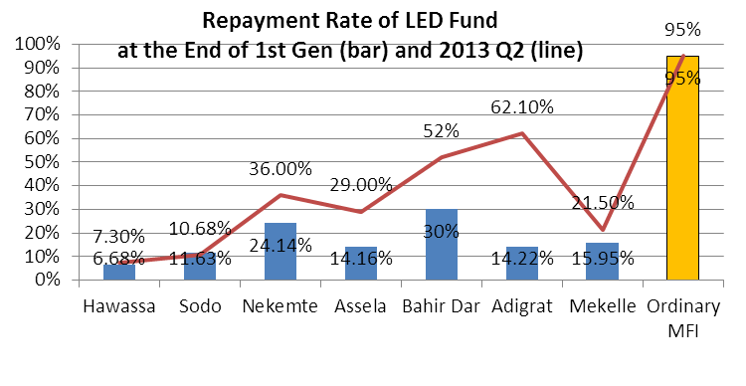
- Low repayment rate: The repayment rate is much lower than the ordinary microfinance loan in all cities.
- Bad Effects of the low rate: The ordinary MSEs other than LED Fund beneficiaries feel unfair, and LED Fund is no longer revolving but vanishing.
- The major reason: The selection of competitive MSEs and follow-up by City Administration are weak, because they are not in a market competition. The MFIs do not follow either, because in no city they take default risk. Since the interest rate is 10% which is lower than general rate of around 16% in many cities, the MFIs rejected to take the risk and just transfer the money from City Admin to the beneficiaries.
- Possible solution: In all cities, the MoUs between the City Administrations and the MFIs should be revised so that the MFIs take a part of the default risk, hopefully 50% minimum 25%. The interest rate can be flexibly negotiated about and agreed in between 10% and the general interest rate adopted by the MFIs. This revision of MoU should be set as a pre-condition to transfer the budget for LED Fund in Q3 of EFY2006.

Other Challenges:

- BDRC in Mekele is temporarily closed: It is to be open before or in September.
- BDRC in Adama, Bishoftu, Alamata, and Axum are not open yet, although the fund for the set-up was advanced in Q1 of 2013. Follow-up of the activities need to be continued.
- Delay in recruitment of LED Expert in Ambo and Bishoftu: As a result, the implementation slowed down in Ambo and in Bishoftu. Close follow up is ongoing with Ambo and Bishofto CA in Oromia

Major Initiatives to be undertaken in the 3rd quarter, 2013:

- Completion of the Cluster Development Guideline
- Recruitment of consultants for development of Cluster Development Strategy to be implemented in Q4 2013
- To review the monitoring result of the M&E experts based on field visits
- To make the 5 BDRCs functioning in Mekele, Alamata, Axum, Bishoftu and Adama
- To implement measures to improve the repayment rate of the LED Fund (to be continued to Q4 2013)

