Assessment – Impact of TC Winston and floods (04 and 06 of April) on Solid Waste Management Facilities
Ba, Lautoka
Date: 18-19/04/2016
- Ba City
- Significant increase in the quantity of waste and debris to be dealt with since TC Winston and floods of 04-06 of April;
- Even if the quantities have been reducing, debris is still being brought from clean up in the city and other locations in the district (villages in peri-urban areas, Tavua town, drains along the road, etc.);
- 3 disposal sites have been used for the (temporary) storage of debris :
  - Site 1: Disposal of construction material (roofing, timber, etc.). Most of the material has been picked up for re-use by the population;
  - Site 2: Disposal of heavy green waste (trunks, etc.), with estimated volume of approx. 4.500 m³;
  - Site 3: Disposal of light green waste (branches, etc.), with estimated volume of approx. 2.000 m³.
- The basic processing of the green waste in Sites 1 & 2 (chainsaw cutting, chipping) will allow second-use of the material by the population / City Council (firewood, mulching), and a quick rehabilitation of the temporary disposal sites;
- The floods did not resulted in big quantities of silt to be removed (as in 2012 floods) since the water flushed quickly, in consequence of the frequent dredging of the mouth of the Ba river by Ministry of Agriculture;
- The dumpsite was not accessible during a few days after TC Winston and floods (access road blocked / flooded), and mixed urban waste was temporarily had to this waste (Site 3). This waste is being progressively removed and disposed to the dumpsite;
- Thanks to the use of the alternative disposal sites and segregation of debris, the dumpsite is still in good conditions to be operated (no saturation of space with debris);
- Projects of Ba City Council (mid-term) for improvement of Solid Waste Management:
  - Composting for market waste, in stand-by (composting shade already in place at Site 1);
  - Recyclable sorting center (to be installed in Site 1);
  - Rehabilitation of the dumpsite (current stage: TORs for design of project to improve the dumpsite and reduce impact, including drainage, landscaping, etc.).

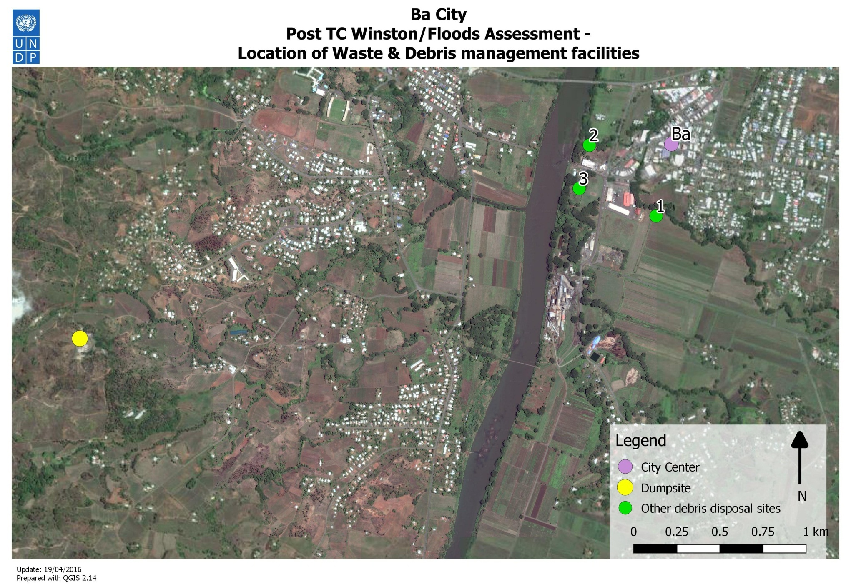
Figure 1 – Location of waste and debris management facilities / Ba
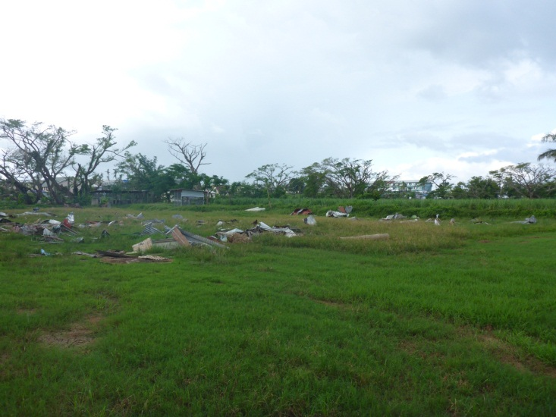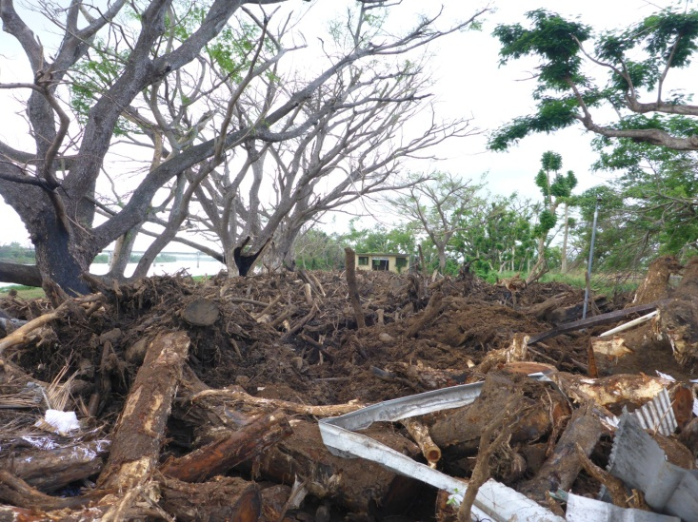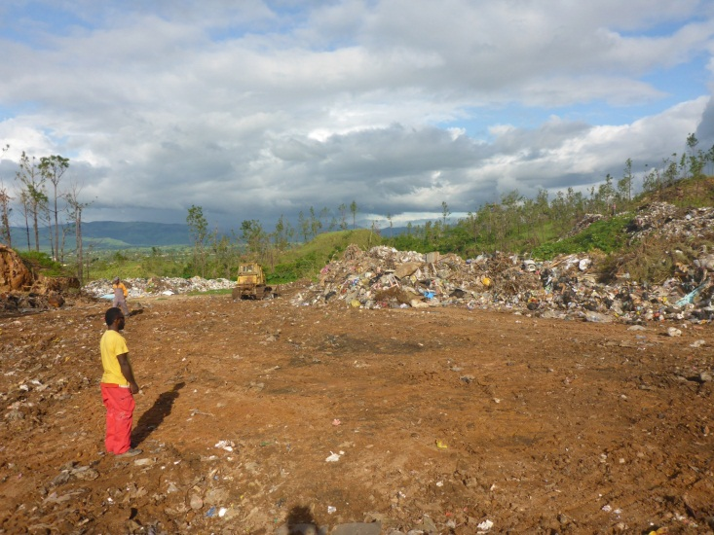
Figure 2 – Disposal sites for construction debris (Site 1), heavy green waste (Site 2) and Ba Municipal Dumpsite

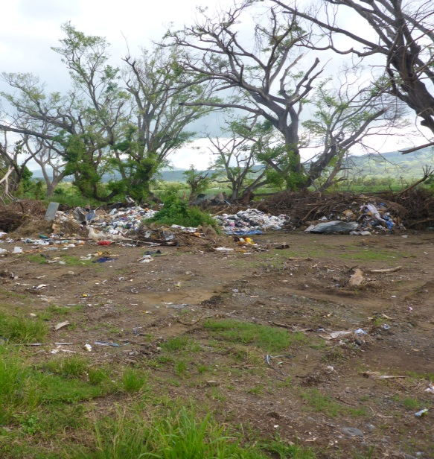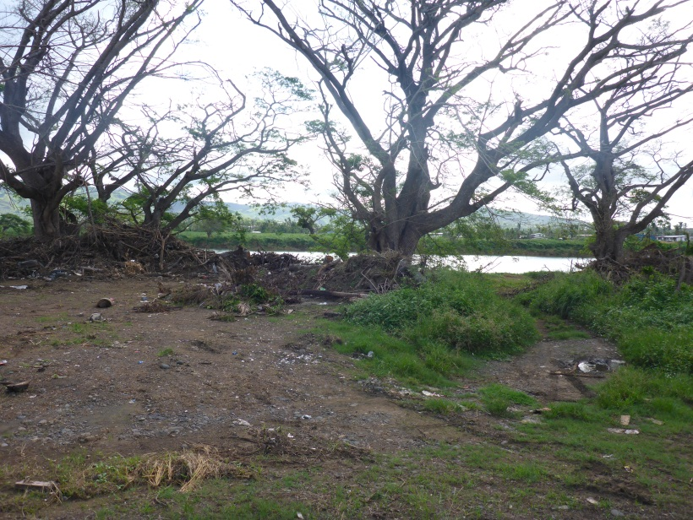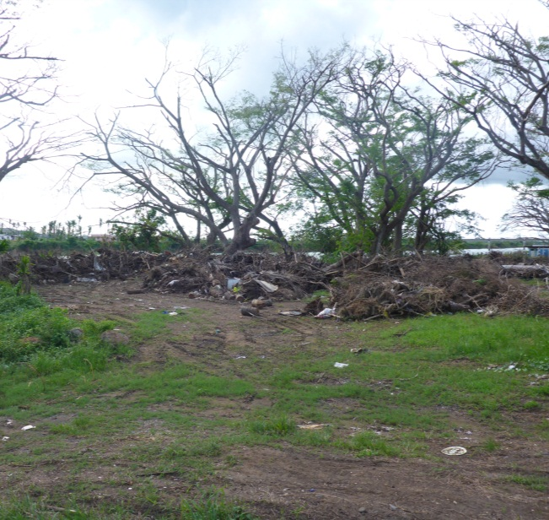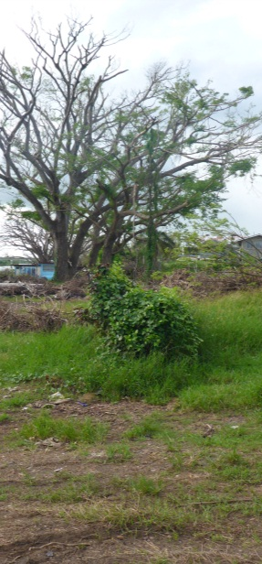
Figure 3 – Location of waste and debris management facilities / Ba
2. Lautoka
- Significant increase in the quantity of waste and debris to be dealt with since TC Winston and floods of 04-06 of April (Lautoka not affected by the floods, but receiving debris / waste from Nadi);
- Even if the quantities have been reducing, debris is still being disposed from clean up in the city and in the district (villages in peri-urban areas, Nadi town, Denarau, hotels, drains along the road, etc.);
- Most of the debris were disposed at the engineered disposal site of Vunato, in different locations inside the disposal facility:
  - Section allocated for disaster waste (mainly green waste) – approx. 6.000 m³ disposed temporarily (need to be processed);
  - Mixed debris disposed in sections 1, 4, and 5 (disaster waste section saturated). Total quantity of bulky green waste to be removed estimated to approx. 2.500 m³;
  - Processed green debris (chipped waste) stored in composting section for further use.
- The sections 1, 4, and 5 will need rehabilitation work, in particular the removal of bulky green waste to allow the reestablishment of normal operations procedures (regular spreading in layers by bulldozer, pushing of waste across the cells, etc.), as well as rehabilitation of secondary accesses and water drainage canals;
- The heavy green debris can be cut in smaller logs and distributed to the surrounding neighborhoods as firewood;
- As the current disaster waste disposal area was saturated by the quantity of debris, an additional area can be prepared to cope with debris in future disasters (around 12.000 m² available);
- Controlled waste pickers / scavengers are collecting recyclable material in the dumpsite (about 25 persons), and most of the reusable material is taken off the debris stream (metal roofing, etc.). They can be involved in disaster waste management activities (as in previous disasters);
- Other ongoing projects (based on previous support of J-Prism project):
  - Composting plant for market waste;
  - Household composting (350 household covered);
  - Green waste chipping equipment already operational.

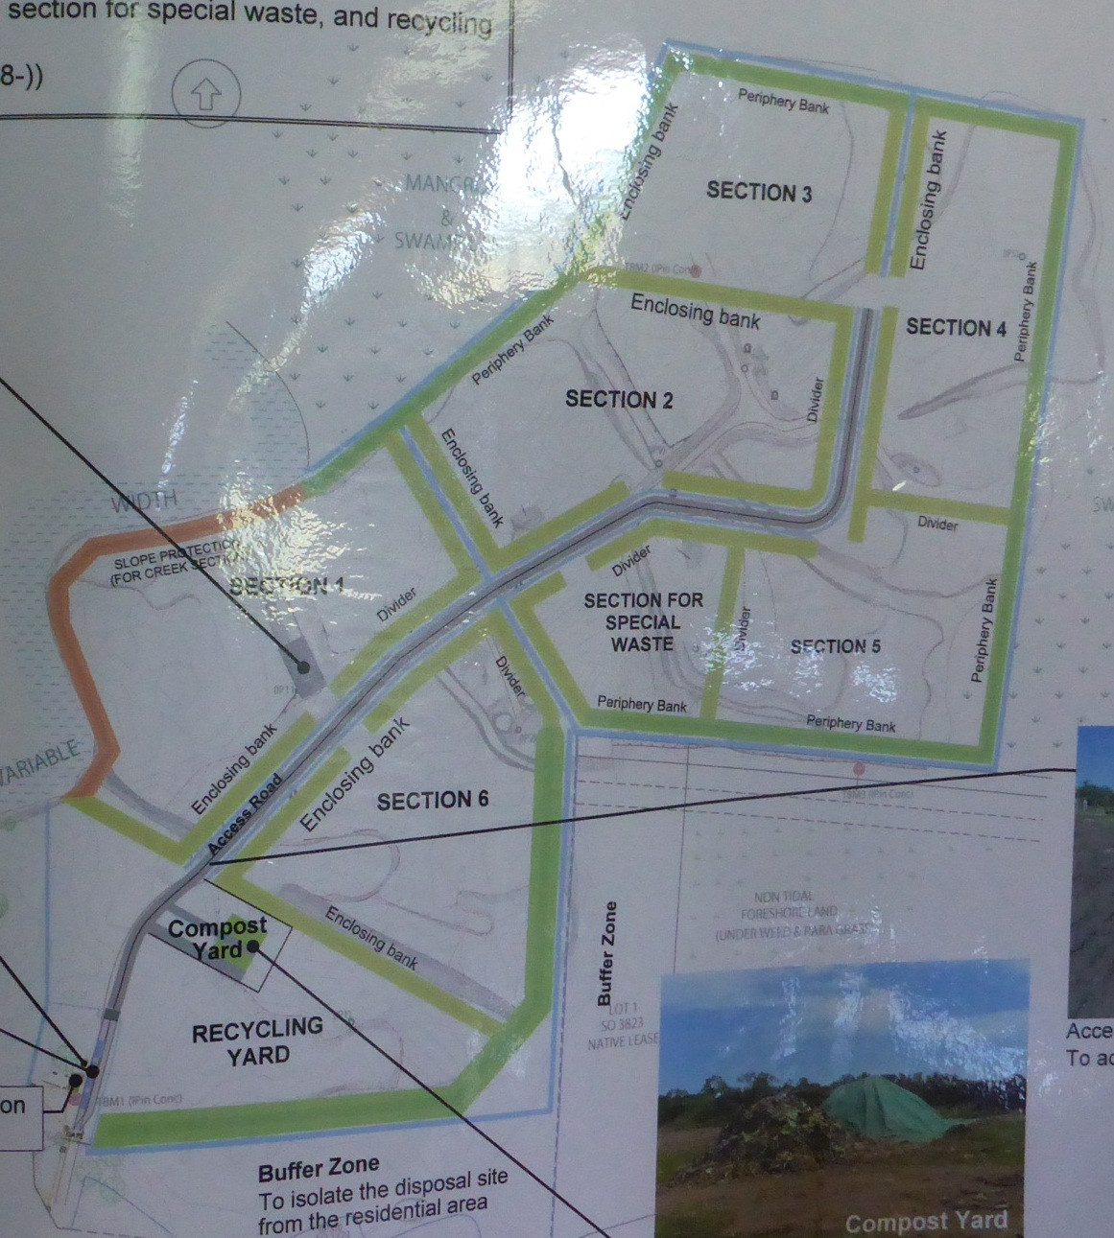
Section 1 & 4: Mixed debris disposed (including bulky green waste) - needs to be removed
Compost yard: Processing (chipping) of green waste (branches)
Disaster waste Section: disposal of disaster waste (in particular bulky green waste)
Figure 4 – Overall scheme of Vunato disposal site
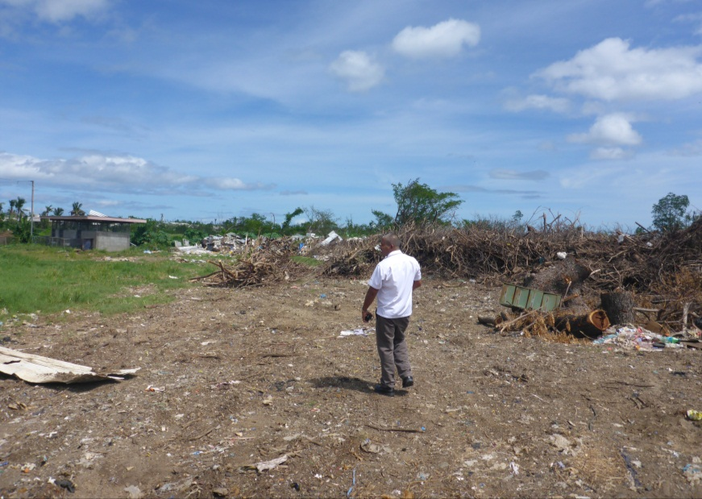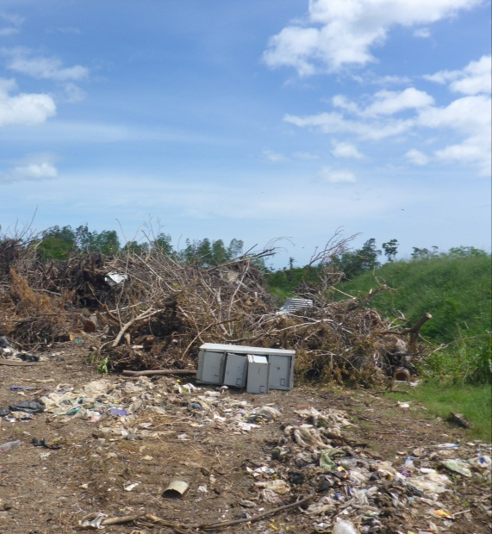
Figure 5 – Vunato disposal site - Disaster waste management section

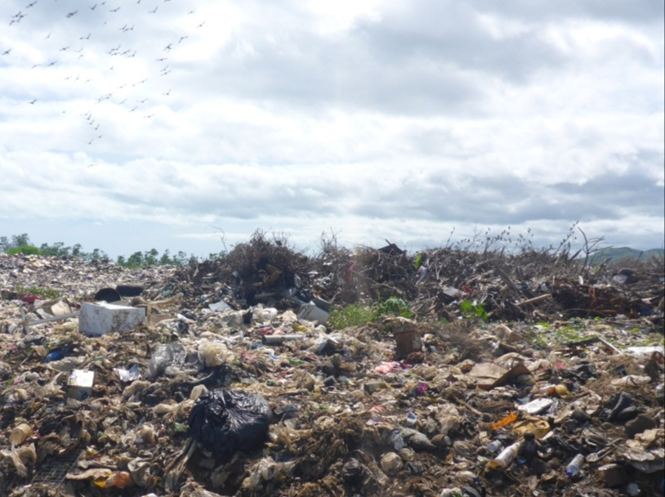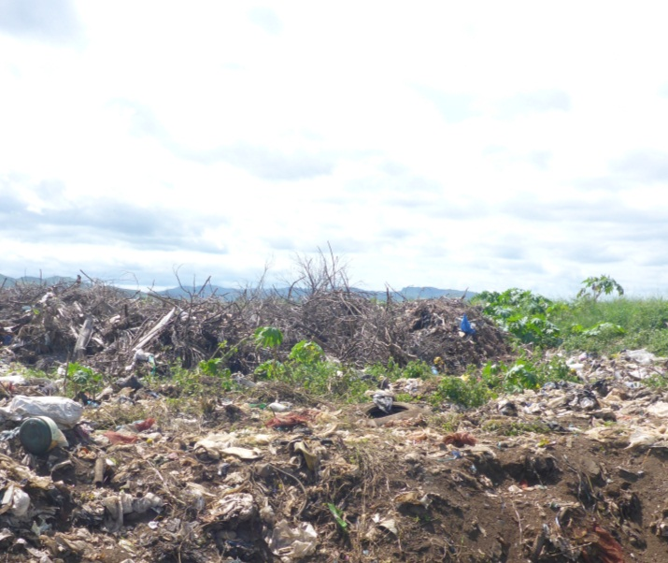
Figure 6 – Vunato disposal site – Green debris disposed at section 1

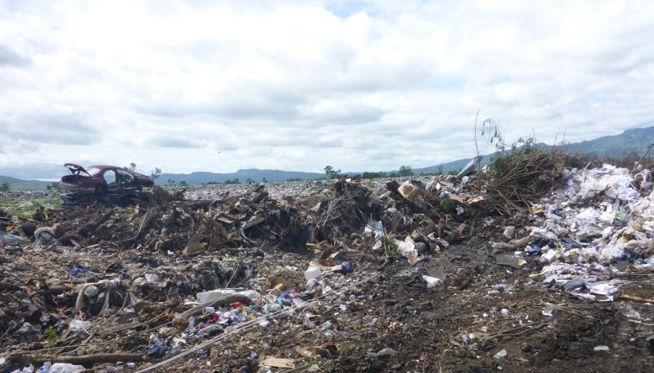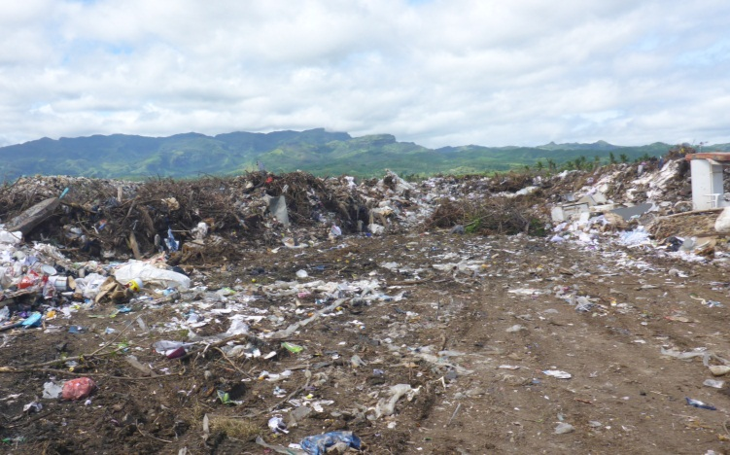
Figure 7 – Vunato disposal site – Green debris disposed at section 4
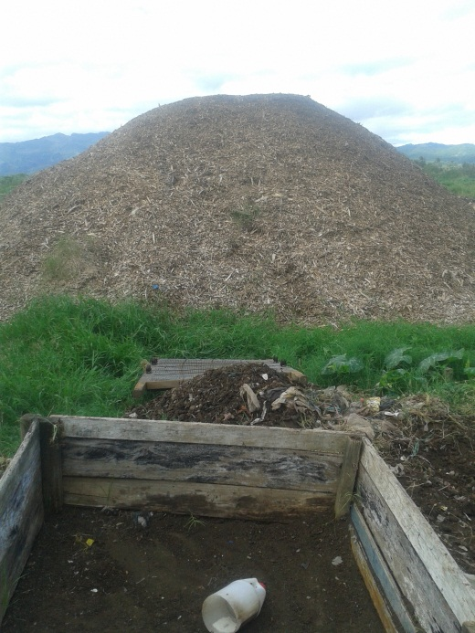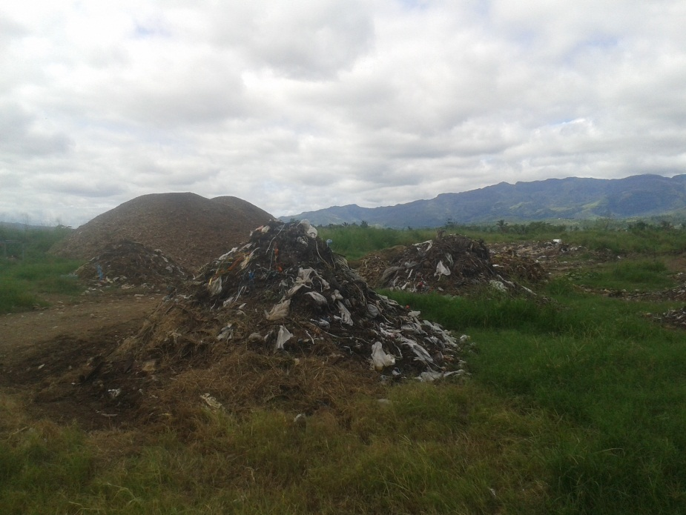
Figure 8 – Processing of light green waste (chipping) in composting section

Assessment based on meeting and field visit with Ba City Council Officers: Mr. Dip Narayan and Mrs. Ronika
See location map and pictures (figures 1 - 3)
Meeting and field visit with Mr. Shalend Prem Singh and Mr. Gyneshar Rao
Previous experience of TC Ethan (2012), 700 tons of green waste had been chipped and used for mulching (in parks) and additional material for composting (mixed together with market waste)

