United Nations Development Programme

Atlas External Access 2.0 (2014)
  - Project Initiation Document

Draft v1.1
September 30, 2014
Contents

1. Background 4
1.1. Business Context 5
1.2. Problems to be addressed, gaps and issues 6
2. Project Definition 8
2.1. Project Objectives 8
2.2. Defined Method of Approach 9
2.2.1. Technical approach 9
2.3. Project Scope and Exclusions 12
2.4. Project Deliverables and/or Desired Outcomes 12
2.5. Project Schedule and Funding Requirement 13
2.5.1. Proposed work plan 13
2.5.2. Proposed Project Budget 13
2.6. Interfaces 13
3. Project Organization Structure 14
3.1. Project Management Team Structure 14
4. Annexes 15
4.1. Annex 1: 2013 and 2014 External Access Users 15
4.2. Annex 2: List of proposed functions 16

Document Properties
Title | External Access to Atlas 2.0
Document Language | English
Responsible Unit | BOM/MCT
Creator (individual) | Carlos Arboleda, MCT
Contributor | Jorge Oliveira (Brazil CO), Lisa Lange (MCT), Naoto Yamamoto (OIST)
Subject (Taxonomy)
Date approved
Audience
Applicability | This document has been produced to capture and record the basic information needed to correctly direct and manage the project
Replaces
Conforms to | UNDP ICT Strategy
Related documents
Document Type | Project Documentation

Revision History
Ver. | Date | Author | Summary of Changes
1.0 | June 20 2014 | Carlos Arboleda | Original version with inputs from projects stakeholders
1.1 | September 30 2014 | Carlos Arboleda | Revised work plan and approach with OIST

Background
Collaborative partnerships with government counterparts, civil society and UN Agencies are a foundational element of UNDP’s contribution to programme countries. Simplifying the way we work and increasing the transparency of our operations is at the core of the UNDP 2014-2017 Strategic Plan, as highlighted within the principles of engagement of UNDP:
“13. All [development] outcomes will be pursued using engagement principles that reflect our approach to development and for which we will be accountable. This means:
…
- Advancing South-South and triangular cooperation, in line with their own principles, utilizing our institutional capacities and resources;
…
- Adhering to universality, offering all programme countries access to the services of UNDP and, through the effective exercise of UNDP’s coordination function, to those of the UN Development System.”

These particular principles speak to UNDP’s commitment to supporting national ownership of development agendas by lending our technical knowhow, institutional assets, and normative position to strengthen each countries development efforts as well as the coordinated assistance of the international development community. External Access to Atlas is one of UNDP’s key institutional resources, in this regard, and as such, maximizing the value of External Access is a key institutional priority within the current Strategic Plan.
Additionally, UNDP is poised to accelerate its long-standing investment in External Access to Atlas in light of the approval of the corporate ICT Investment Plan, which will introduce significant Atlas functionality upgrades that can be extended to external users. In tandem, the past 6+ years of investment in External Access has yielded extensive organizational learning, and UNDP recognizes that a dedicated effort is needed to address user issues and ensure the External Access platform is sufficiently robust to support an expanded external user base and fulfill user requirements. The following timeline illustrates the evolution of technical enhancements introduced from 2003 to our current effort of 2014 to fully rollout the e-Recruitment module of Atlas.
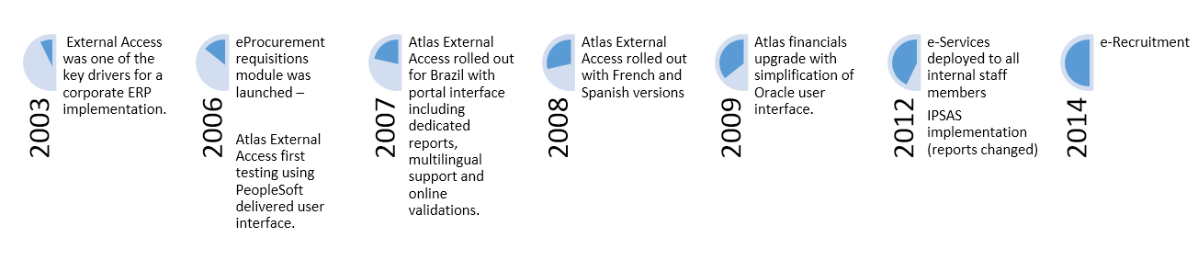
As such, this Project Initiation Document (PID) outlines the envisioned improvements and adjustments to the current External Access platform and required resources to realize greatly enhanced access to UNDP systems and solutions for all users, which will be organized through the External Access 2.0 initiative.

Business Context
The strategic business context for External Access 2.0 includes the varied benefits, all which support national ownership of development agendas, transparency, and a continuous push towards more efficient business partnering arrangements. Specifically:
- Transparency over resources and operations and capacity development as a driver of UNDP ERP – Historically, UNDP has invested in Atlas to ensure that those on the frontline of development project implementation are equipped with evolving tools and resources to plan, execute, monitor, and report on development projects. These enhancements in Atlas functionality and interfacing capacity with complementary systems are instrumental in better leveraging the capacity at the local implementation level. In tandem, greater opportunities have been created for project and programme managers to develop increasingly innovative practices and richer monitoring and reporting capability, which greatly improves planning and real-time resource management. Going forward with External Access 2.0, emphasis is placed on:
  - Increased capacity development support for development planning and project management for UNDP’s national counterparts and implementing partners, thereby facilitating increased levels of national implementation and support for the International agenda for aid effectiveness.
  - Adhering to the QCPR recommendation for increased utilization of common and joint services arrangements to better leverage comparative advantages and technical capacities across UN Partner Agencies with greater cost effectiveness.
  - Ensuring that project personnel with External Access assume responsibility and accountability for implementation activities and associated results. This assumption of responsibility requires a “compact” between the project and UNDP, in which UNDP commits to providing maximum support for the end user’s requirements and constraints. Much of the External Access 2.0 project initiative will direct resources to improving functionality, accessibility and ease of use, and reporting capabilities to better fulfill our end of this compact, and thereby elicit greater levels of responsibility and accountability at the project implementation level.
- Increasing the use of External Access – Expanding the user base of External Atlas for a greater number of national counterparts, implementing partners, and partner UN Agencies results in a greater volume of transactions executed in Atlas and visible for the purposes of quality assurance and oversight. In light of UNDP’s 2014 commitment to co-hosting the IATI Secretariat, and adhering to IATI standards, External Access 2.0 provides increased operational leverage to create greater visibility of how development resources are being utilized and results are being achieved.
- On-time reports and monitoring of activities (interaction with UNDP) – External Access has always allowed joint visibility of all transactions executed in Atlas, and the further enhancements in Atlas reporting capability which are driven by the External Access 2.0 project will improve the coordination and development planning dialogue between UNDP and its national counterparts and implementing partners.
- Cost and process efficiency by eliminating duplications – UNDP, along with its UN and national development partners, will further streamline business processes supported by External Access, and thereby better utilize scarce resources, achieving more results with the same or less resources. The External Access 2.0 project aims to alleviate the use of secondary systems, greatly reduce time delays in reporting, improve data integrity and quality, and ensure improved data security through process efficiency gains that can be realized through direct, External Access to Atlas.

Problems to be addressed, gaps and issues
Overall, External Access to Atlas is a mature solution for a variety of users (see Annex 1), and provides a solid foundation from which necessary improvements can be developed and additional users can participate. The External Access 2.0 project is directly guided by end user requirements, and as such, partner outreach and analysis of end user experiences, problems encountered, desired functionalities, etc. has been completed as part of this project initiation phase. The following problems have been reported through a client survey conducted with the partner country offices in Brazil, Democratic Republic of the Congo, Bangladesh, Panama and Paraguay (28 issues were logged– see pie chart below), and represent key technical issues, which inform the defined method of approach for the External Access 2.0 project:

- User Interface. The current interface was created 7 years ago over a legacy platform (ColdFusion) that is not retained by UNDP as the corporate application and reporting repository. As a result, the interface has had little maintenance and some technical problems remain unsolved (login problems, browser cache management, multilingual function glitches, not properly rendering on mobile browsers, etc.)
- Double user interface. While the national governments and NGO users are given access to the ColdFusion portal (https://external.partneragencies.org), the UN Agency users are given access to the PeopleSoft native interface, without multilingual support or customized reports. This decision was made because of the lack of reliability of the ColdFusion platform.
- System is slow or not responsive. Partially because of the outdated platform and the lack of maintenance, the system is often unavailable or delayed to respond.
- Reports not working properly. The reports included are the ones designed originally 7 years ago, before the changes associated with the implementation of IPSAS in UNDP. The concepts of utilization of resources, pre-commitment, commitment, etc. are not properly reflected in the current reports. As a result, the reports in the External Access are not consistent with Atlas official reports.
- Inaccuracy of the budget and financial availability of resources. This is due mainly to the valuation of expenses and commitments in local currency. This problem is not uniquely related to the External Access, but to Atlas in General. Since the IPSAS implementation, the process called “encumbrance accounting” was discontinued and as a result, the value of unpaid commitments in US dollars is not being updated with the monthly exchange rates update.
- Lack of complete reporting. Some reports are missing from the current platform, for instance:
  - The Combined Delivery Report (CDR);
  - The detail of the CDR (detail of transactions included in the CDR);
  - List of current valid Requisitions and their status;
  - List for Purchase Orders and their status (revalued in local currency); and
  - For UN Agency Users, the Service Clearing Account report.
- Poor user support management. In the early days of the implementation there was an attempt to use the PeopleSoft Customer Relationship Management (CRM) platform to log and follow up user support for the system, but it proved to be cumbersome and difficult to maintain because it was based on emails sent by the users and then manually logged into the platform with no access to the final users on the status of the request.
- Not able to upload documents. Country offices have implemented parallel complementary procedures or systems to capture the supporting documentation for the proposed transactions coming from the implementing partners. In the case of UN Agencies, this still operates with email attachments.
- Duplication of work in different systems. Some country offices keep using legacy systems to support their business processes that create duplication with the External Access transactions, this happens mainly in the areas of Procurement (support to the sourcing and contracting processes), contract management (for individuals and companies), and human resources (Service Contracts Administration).
- User Provisioning needs adjustments. There are several problems in the workflow of the user provisioning system, including the lack of alternate profiles to create and approve new users, the retention of the identity in the browsers’ cache, etc. The structure of the groups, and associated permissions,, should be revised to permit a user to be part of more than one group, or eventually discontinue the use of the groups.

As illustrated below, the majority of issues relate to user provision and user interface, which indicate great potential to improve the user experience through system infrastructure and design investments. Additional improvements related to enhanced functionality and end user support represent a smaller portion of the articulated issues, but will feature in the External Access 2.0 solutions as these functionalities are high-value and will help to better institutionalize the use of Atlas. The Complete list of issues can be found in the project SharePoint Site under the project issues library (https://intranet.undp.org/unit/bom/mct/engagements/External_Access_2.0).
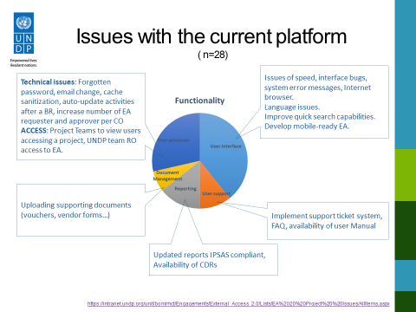
The scale and nature of these issues can jeopardize UNDP’s support for national implementation of development projects, and as such the External Access 2.0 project definition and approach below outlines three key objectives, one of which is the identification and prioritization of solutions needed to end user challenges.

Project Definition

Project Objectives
The External Access 2.0 project has three core objectives:
- Expand the target user groups: To date, the External Access has been successfully utilized by NIM projects as well as DIM projects. Further, External Access is being piloted for UN agency services, with UNOCHA as a current pilot Agency. The EA 2.0 project aims to grow the user base both for NIM and DIM project managers, across newly participating countries, as well as for UN Agencies. As UNDP provides UN Agency services as part of our mandate, UNDP aims to expand access to all UN Agencies to which we render services to advance UN System harmonization.
- Expand the service offer in the External Access: Over the past years, UNDP has developed a series of enhancements to Atlas, and other ICT platforms, that could be encompassed in the External Access platform in order to widen the service offer and increase the usability of the platform. These enhancements would augment the current functionalities, illustrated below:
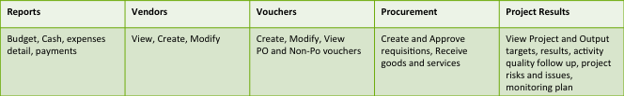
In particular, some key enhancements related to reporting and overall resource management will now allow project financial reports to be IPSAS compliant. Additionally, project results reporting will be integrated into UNDP’s new Results Based Management Platform, which showcases many new analytics capabilities and public information accessibility.
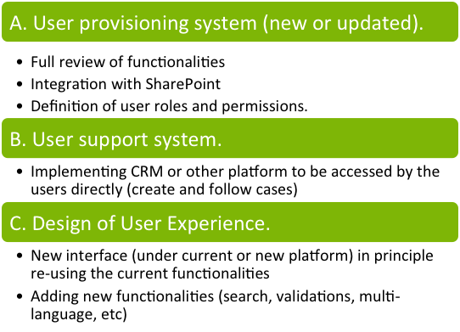
- Improve overall system performance and the user experience with External Access: Introduce solutions to current system problems identified by end users and a comprehensive functionality review planned for the EA2.0 project. These will include key fixes for the user provisioning system, the user support system, and a redesign of the interface functionalities to improve the end user experience, as illustrated in the planned work packages to the right.

Defined Method of Approach
Since the current platform is up and running, the project approach will be to build upon the successful elements of the current External Access, keeping the current functionalities, adding new key functionalities and reports and correcting the issues already identified.
Service interruption has to be minimized and availability of the system cannot be compromised because development partners depend on the current system for project implementation. For the above reason, and given the scarcity of resources to build a fully functional parallel platform, the project will have a staged approach.
Stage 1: Solve selected current issues. Improve reporting and general user Interface. The selection of issues to be solved will be done based on the technical feasibility and immediate availability of a solution. In some cases, the solutions applied will be provisional and could be subject to further improvements in subsequent stages. The main objective in this stage is to fix the most pressing problems and offer a revamped user experience.
Stage 2: User provision redesign and add new customizable functionalities. The objective of this stage is to finalize the enhancement of the external platform by integrating all the proposed modules and developing some generic applications for the management of operations by project and UN agencies personnel.

Technical approach
In line with the current technical approach, the idea is to retain a user portal as the main entry point for the External Access users. The portal will include database applications to generate customized reports and will provide basic data validations for some of the transactions. In terms of applications the main ones today relate to the validation of data entries, report building and the multilingual support, but going forward, there is a great deal of potential applications to be developed at the level business units (support to contract management, training, procurement support, results based management, etc.) or other that could be utilized at a the project level (e.g. detailed work plans and calendars, document management, etc.)
After a first round of discussion with the partner country offices and a review of the current offer in terms of available technology with OIST, some technical solutions have emerged as the ones that could fulfill the requirements for the first stage of the project:

- Use SharePoint platform and the new executive snapshot for reports. Since the ColdFusion environment is not going to be updated, the corporate SharePoint becomes the logic platform to use to host the external access because it currently hosts the new reports for the Atlas Snapshot and there is a plan to add transaction details in that platform.
- Build an external directory over the corporate Active Directory. After discussing with the technical team in OIST, 3 scenarios were proposed to include the external access users into the SharePoint environment:
  - Use the Federated Authentication Directory. Since some of the users from UN Agencies could be already included in the federated authentication project, there could be an advantage in adding the external users (NIM, DIM, and NGO) into the federation. However, this scenario is complicated because not all the UN Agencies are “federation ready,” and in any case, this would need the setup of a new external directory to be federated. In any case, there is no easy way to give access to the Atlas environment from this directory.
  - Use the UNDP Directory (Active Directory). This will allow external users to access the current SharePoint Environment and has already been tested for both UN Agency and external users. As in scenario A, there is no easy way to connect to Atlas environment from this platform.
  - Use the current (Customized-ARGUS based) authentication for the external access. Since this environment has no access to the corporate SharePoint, it would be possible to generate an external directory within the UNDP Active Directory in order to allow access to the domain and corresponding new pages.
After reviewing the pros and cons of the 3 technical options, it is recommended to keep the current user provisioning system (based on ARGUS) for the operation of the external access and create a new external directory within the corporate UNDP Active Directory. By doing this, the access to Atlas environment is granted (with potential changes in the profiles and configuration) and the external list on the ID will permit the access to the SharePoint Resources. Since the integration might depend on synchronization from ARGUS to SharePoint, it is possible that the Country Office users would have to check and even administer some permissions directly into the SharePoint project site.
- Redefine the user experience and redesign the user interface including all reports. The current user interface could serve as a basis for a redesigned interface because the current users are already used to have all the latest transactions in the opening page and a list of available customized reports. Nevertheless, the SharePoint platform will provide additional opportunities for the representation of the information on graphics and charts, as well as navigation features. Ideally, the work done so far for the new Atlas Snapshot and the new Annual Business Plan overview will serve as a guide for the graphic interface to be used.
- Add some modules functionality. There are some modules that could be added/activated in this stage 1 of the project without entering into complicated customizations. The most immediate changes that could be implemented are:
  - Activate the Project Management Module for the external access users to be able to create and edit records. Currently it is read-only. However, the project managers should be able to create or modify Issues, Risks, Monitoring actions and to complete the results for the project outputs and activities.
  - eServices for Service Contract holders. Since the module is ready to operate, it could be good to have it integrated to promote the integration of services for both projects and project personnel. This might need a review in the functionalities of the eServices, because the main role that be used from External Access should be the absence processor role, whereas individuals should have their access through the traditional platform to request and monitor their leave plans.
- Prototype and test, launching the second phase of changes after first prototype is accepted. As previously presented, the overall project approach will be one of prototyping an operational version in a first stage and then collecting user feedback from for the preparation of a second stage. The second stage will also incorporate other modules and functionalities as they are available on the Atlas platform and UNDP cloud applications.

Project Scope and Exclusions

Excluded: Big changes to UNDP user provisioning and directory architecture

Project Deliverables and/or Desired Outcomes

- User provisioning system (updated ARGUS and use of Federated Identity Management for overall user authentication). Full review of functionalities, integration with SharePoint. Definition of user roles and permissions.
- Reports. Design, test and implement full set of reports.
  - Project (award) budget and cash availability
  - Output (project id) budget and cash availability
  - List of pre-commitments with status (requisitions list) by project
  - List of commitments with status (purchase orders) by project
  - Status report for all groups of transactions per project (AP, Vendor, Req, PO, Receipts, Project Management)
- Activating functionalities from Atlas
  - Project Management module
  - E-Services for Service Contracts (Leave Monitor)
- User support system. Implementing CRM or other platform to be accessed by the users directly (create and follow cases)
- Design of User Experience. New interface (under current or new platform) in principle re-using the current functionalities and increasing others (search, validations, multi-language, etc)

Project Schedule and Funding Requirement

Proposed work plan

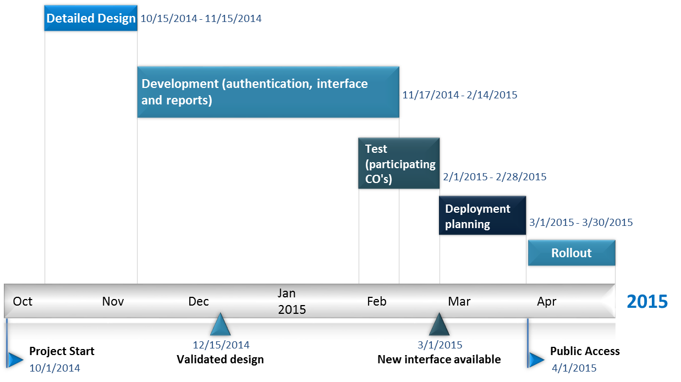

Proposed Project Budget

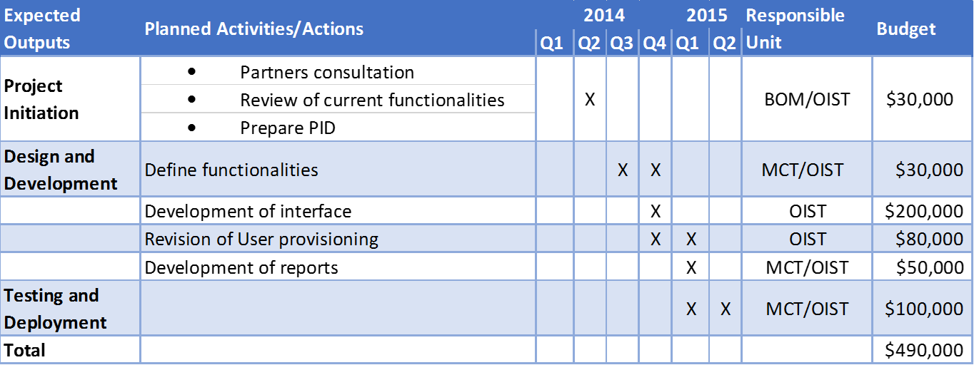

Interfaces
- E-Recruit
- E-Registry
- Clustering and Shared Centers

Project Organization Structure

Project Management Team Structure
Project steering will be accomplished via project board consisting of BOM Directorate and OIST. BOM will appoint senior user and project director. OIST will appoint senior supplier. Pilot Country Offices will also participate as senior users to the board.

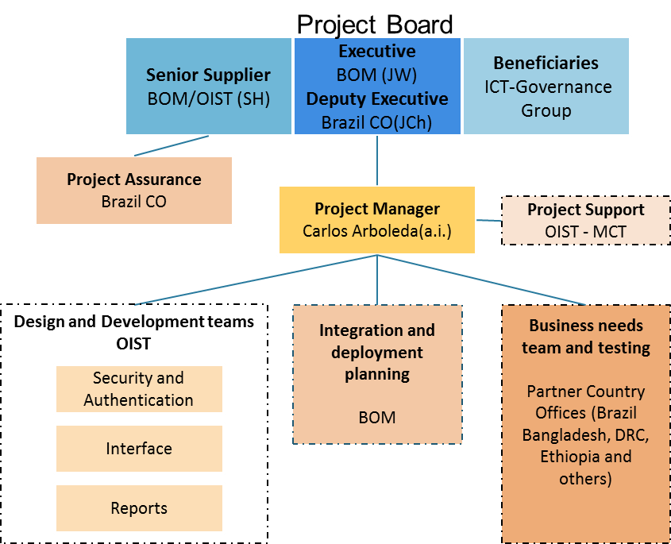
Annexes

Annex 1: 2013 and 2014 External Access Users

December 2013 voucher transactions |  |  | Jan 2014 Users
Unit | Amount | Vouchers | Users | Implem Partner
Bangladesh | 984,803 | 164 | 71 | DEX
Bolivia | 748,394 | 542 | 6 | BOL
Brazil | 5,854,760 | 1,473 | 247 | BRA
Chile | 50,736 | 44 | 9 | UN, DEX
China | 18,119 | 6 | NA
Congo Dem | 36,252 | 19 | 16 | OCHA, UN
Colombia | 4,474 | 9 | 9 | OCHA, DEX
Honduras | 1,373,722 | 118 | 8 | DEX
Jamaica | 35,587 | 3 | 6 | JAM
Kyrgyztan | 45,233 | 63 | 3 | OCHA
Mexico | 188,858 | 135 | 32 | MEX, OCHA
Mongolia | - | 8 | 25 | MNG
Panama | 68,265 | 65 | 78 | PAN, OCHA
Peru | 2,970,750 | 377 | 21 | PER
Paraguay | 74,741 | 119 | 6 | DEX
El Salvador | 1,093,089 | 119 | 11 | DEX
Venezuela | 12,572 | 1 | 3 | VEN and DEX
South Africa | 10,222 | 2 | NA
Grand Total | 13,570,577 | 3,267 | 551

Annex 2: List of proposed functions

- Vendors- Atlas Finance Main Menu>Vendors>Vendor Setup/Maintenance
    - Vendors information- Creation
    - Vendors information- View
    - Vendor Search (name, Id, country, etc.)
- Vouchers- Atlas Finance Main menu> Accounts Payables link
    - Accounts Payable > Vouchers: Create, maintain and review vouchers
      - Entry: (Regular Entry, Quick invoice entry, Complete Register Voucher);
      - Review and Correction: ( batch voucher error detail, review preEdit errors, selective line update, doc tolerance exceptions);
      - Maintenance: (Voucher close, voucher Unpost, voucher Delete )
    - Accounts Payable > Review :Review accounts payable Data
      - Voucher;
      - payment
      - Vendor
    - Accounts Payable > Reports :Review accounts payable Data
      - Vouchers;
      - Voucher Reconciliation
      - Payments
      - Vendor.
- Purchasing- Atlas Finance Main Menu>Purchasing (E-procurement) link.
    - Requisitions
      - Maintain Requisitions
      - Reconcile Requisitions: Reconciliation Workbench
      - Entry Event Request
      - Review requisition information
        - Requisitions
        - Accounting Entries
        - Workbench
        - Document Status
        - Change History
      - Reports
        - Print Requisition
        - PO/Requisition Xref
        - Requisition Template
    - Receipts
      - Maintain Receipts
      - Inspect shipments
      - Receipt Delivery
      - Receipt Activity and comments
      - Review Shipment information
        - Receipts
        - Receipts by location
        - Document Status
      - Reports
        - Receipts Delivery
        - Receipt Summary

- Grant- Atlas Finance main menu>Grant>Project Management: view/update based on Project role: risks log, issues log, monitoring plan, budget revisions, baseline information such as indicators, targets and results (output page).
      - Award Summary :(View only)
      - Revise Project Budget
      - Outcome Monitoring
      - Issues
      - Risks
      - Monitoring Plan

- Project Management Reports- Atlas Finance Main Menu> UN Reports>project management reports
    - Financial Management Reports
      - Expenditure Management Reports
        - Budget Transaction Detail
        - Aging report for NEX
        - AP Voucher Details
        - Project Transaction details (IPSAS version)
        - Cash Balance.
      - Analytical Reports>Executive Snapshot> financial Details
(By Account, practice Area, Donor, Project, Pipeline Projects, and Override Status by Project)- The User should enter the reference of the Account, practice area, donor or project to be able to access to the information. Only the desired and specific information should be displayed. The Quick Project Search form can be used to search a project by name or number.
    - Project Management Reports
      - Portfolio analysis>CDR by Project
      - Portfolio analysis> Quarterly Progress Report
      - Proj/Budget Approval Documents>Annual Work Plan;
      - Proj/Budget Approval Documents >Project Budget Cover Page;
      - Commitment Control Budget Inquiry

- Reports for UN Agencies. In addition to the functionalities described, the UN Agencies will have to have specific reports for the status and details of the SCA transactions they have requested and the status of those transactions.

External Access’ user Groups:
- Project Managers (NEX, AGEX, NGOX)
- Project Managers will have access to UNDP projects executed by them. The project Manager should be able to update all project planning aspects including the approval of requisitions. They should have access to all transactions concerning the project, independently of who generated them.
- Project Users. Should have access to all reports and to create vendors, vouchers, receipts and requisitions.

- UN Agencies non Atlas- partners
- UN Agencies will have access to the requisition life cycle in eProcurement to know the status and drill down to different events for the services rendered by UNDP on their behalf. They will enter directly their authorizations/requisitions sent to UNDP for payments or purchasing on their behalf and an email notification will be automatically send to the CO for information.

Key references are the Nairobi Declaration on South-South Cooperation (General Assembly resolution 64/222 of 2009) and the Buenos Aires Plan of Action for Promoting and Implementing Technical Cooperation among Developing Countries (1978).
UNDP in consortium with UNOPS, Sweden, Ghana, and the UK NGO Development Initiatives

