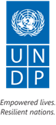
With the financial support of the Russian Federation

Trust Fund of the Russian Federation

YEAR-END PROGRESS REPORT
“Integrated Area-Based Development of Osh Province in Kyrgyzstan” Programme
2018

Presented by the United Nations Development Programme in the Kyrgyz Republic

Osh 2019
TABLE OF CONTENTS
LIST OF ABBREVIATIONS | 2
1. PROJECT INFORMATION | 4
2. MAJOR ACHIEVEMENTS | 4
2.1 IMPLEMENTATION STATUS: Component 1. Sustainable agriculture, tourism, trade and promotion of ‘green technologies’ | 5
2.2 IMPLEMENTATION STATUS: Component 2. Access to sustainable water supply for rural communities | 12
2.3 IMPLEMENTATION STATUS: Component 3. Improvement in welfare of rural communities through a rehabilitation of social and economic infrastructure | 15
2.4 IMPLEMENTATION STATUS: Component 4. Improved employment opportunities via strengthened system of vocational and technical education and training | 18
2.5 IMPLEMENTATION STATUS: Component 5. Improving the local communities’ resilience to natural disasters. | 20
3. PROJECT RISKS | 22
4. LESSONS LEARNED | 23
5. PLANS FOR THE FUTURE | 24
6. PARTNERSHIPS | 26
7. PARTNERSHIP WITH THE RUSSIAN FEDERATION | 27
8. PR, COMMUNICATIONS AND VISIBILITY | 29
9. FINANCIAL MANAGEMENT | 30
10. ANNEXES AND ATTACHMENTS | 31

LIST OF ABBREVIATIONS

AWU | Association of Water Users
AA | Ayil aimak (administrative-territorial unit of a KR province)
АК | Ayil Kenesh (representative local self-government body elected by the citizens of the Kyrgyz Republic for a period of 5 years)
АО | Ayil Okmotu (executive body of a local self-government)
OPRG KR | Office of the Plenipotentiary Representative of the Government of the Kyrgyz Republic
ATVET | Agency for Vocational and Technical Education and Training
RES | Renewable energy sources
DDP&SSES MH KR | Department of Disease Prevention and State Sanitary and Epidemiological Surveillance of the Ministry of Health of the Kyrgyz Republic
GIZ | “Assistance to Sustainable Economic Development” Programme of the German Society for International Cooperation
LHC | Large Horned Cattle
SHC | Small horned cattle
MES KR | Ministry of Emergency Situations of the Kyrgyz Republic
EMERCOM RF | Ministry of Emergency Situations of the Russian Federation
MH KR | Ministry of Health of the Kyrgyz Republic
LDC | Local Development Committee
MH RF | Ministry of Health of the Russian Federation
NGO/NCO | Non-governmental/ non-commercial organization
OSCE | Organization for Security and Cooperation in Europe
NGO | Ministry of Economy of the Kyrgyz Republic
LSG | Local Self-Government
VS | Vocational school
UNDP | United Nations Development Program
VTET | Vocational and Technical Education and Training
DED | Design and estimate documentation
RHC | Rural Health Committee
MM | Mass media
RPADWU | Rural Public Association of Drinking-Water Users
MOS | Medical and obstetric station
SDG | Sustainable Development Goals

- 1. PROJECT INFORMATION

Project title: | Integrated Area-Based Development of Osh Province
Identification number: | 00089664
Implementing partner: | Ministry of Economy of the Kyrgyz Republic
Budget: | Total: USD 4 058 750  Trust Fund: USD 3 500 000  UNDP: USD 58 750;  Government: up to USD 500 000
Implementation period: | July 2016 – December 2019
Time-period covered by report: | January - December 2018
Contributing to implementation of the following Sustainable Development Goals in the Kyrgyz Republic: | №1 No poverty;  №5 Gender Equality;  №6 Clean Water and Sanitation;  №8 Decent Work and Economic Growth;  №13 Climate Change Action;  №16 Peace, justice and strong institutions;  №17 Partnership for the Sustainable Development Goals

The goal of the Integrated Area-Based Development of Osh Province in Kyrgyzstan Project
The “Integrated Area-Based Development of Osh Province in Kyrgyzstan” Project (hereafter referred to as the “Project”) is aimed to provide assistance to the Government of the Kyrgyz Republic in creating conditions for the prevention of violent conflicts and ensuring sustainable human development in Osh province. The Programme helps to create various opportunities for target population groups in order to decrease vulnerability in the short-term and long-term perspectives through various economic activities, improved access to water, environmental security, creation of new jobs and rehabilitation of social and economic infrastructure.
Project components
The Project consists of five interrelated integrated components focusing on development in 17 municipalities of the Kara-Kulzha, Nookat, and Uzgen districts in Osh province:

Component 1. Sustainable agriculture, tourism, trade and promotion of ‘green technologies’;

Component 2. Access to sustainable water supply for rural communities;

Component 3. Improvement in welfare of rural communities through a rehabilitation of social and economic infrastructure;

Component 4. Improved employment opportunities via strengthened system of vocational and technical education and training;

Component 5. Improving the local communities’ resilience to natural disasters.

2. MAJOR ACHIEVEMENTS

- The Programme has supported 102 projects with the total value of USD 1,676,374 designed to improve access to economic opportunities and public services for local communities. The Government of the KR has demonstrated its high commitment to the projects implementation by contributing from 16% to 41% of the overall projects’ value (depending on complexity of initiatives).
- 193,295 rural citizens have benefited from improved quality of drinking water and irrigation water supply, secondary and pre-school education, medical services. This has been achieved through the grant Programme used to finance the rehabilitation of 15 water supply pipelines, 4 headworks, 5 intra-farm channels, 8 secondary schools, 7 kindergartens, 3 sports playgrounds/stadiums, 1 local convention center, street lights in 12 communities, and equipment for 5 health providers.
- 44,149 beneficiaries (25,434 men and 18,715 women) benefited from the Programme’s activities focusing on improved opportunities for employment, access to financial, natural and productive resources, and well as markets at the local, national, regional and international levels.
- Long-term and temporary employment has been provided to 1,638 persons (1,197 men and 447 women), including permanent jobs for 157 persons (93 men and 64 women). Access to short-term employment has been facilitated by organization of civil works for 1,464 persons (1,091 men and 373 women). The civil works organized jointly with the UN World Food Programme at 15 objects of social infrastructure have enabled the local communities earn over 50 tons of flour and over 5 tons of oil.
- Demonstration of the model of Service delivery centers tested in pilot municipalities of Osh province operating as “single-window «centers at the regional level has induced a lot of interest of the State Agency for local self-government and ethnic relations towards replication of these successful practices in other municipalities across the southern regions of Kyrgyzstan.
- 261 persons (204 men and 57 women) apply the available evidence of successful application of the new technologies in agriculture and health care provided by the experts of the Federal center of agricultural consultation and training and the Russian society of cardio-vascular surgeons. 4 companies have been able to grow their exports via agreements with various agricultural scientific research institutes and leading Russian companies that agreed to share commercial information.
- Focusing on increasing economic activities among rural women, the Programme has created an environment to facilitate economic empowerment of 47 women who left informal employment (in shadow economy) and entered the formal labor market. This has resulted from joint efforts involving business communities supporting 27 business projects aimed at development of the market for agricultural produce, rural youth employment and rehabilitation of 75 objects of the social economic infrastructure.
- Improved quality of medical services with the implication of new technologies in diagnostics of cardiovascular diseases has allowed to provide proper medical examination for 2,310 persons (including 878 women) from remote areas by installing the medical equipment procured through the Programme, namely Electrocardiography (ECG) devices with a function of automatic deciphering and automatic external defibrillators (AED) linked to the common server at the Osh regional hospital. Since the installation of the new cardio-equipment, 10 cases have been identified as critical.
- Mobilization of additional resources from the Kyrgyz diaspora in Russia shows evidence of the highly promising source of additional funding for implementation of the local development plans: over 800 labor migrants from Russia have donated USD 20,223 (18% of the total cost of the projects implemented jointly with the migrant community) to rehabilitate 4 objects of the social economic infrastructure in the Osh province.
2.1. Component 1 “Sustainable agriculture, tourism, trade and promotion of ‘green technologies’: implementation status

Creation of the enabling environment for business development and the dialogue with local authorities
15,685 representatives of businesses, farmers and youth, including 8,039 women (51%) benefited from better access to financial resources, market information, and local and international markets. Training courses organized and conducted within the framework of the project included an exchange of knowledge and skills in areas of effective organization of interaction between businesses and local authorities, distribution of regulatory and informational materials on how to do business in accordance with the local legislation and regulations of the Eurasian Economic Commission. A lot of training has been co-funded by the GIZ Osh region economic development Programme and UNDP trade facilitation program, etc.

A delegation from the Osh province consisting of entrepreneurs and local officials have taken an active part in the International Day of the Field in the Republic of Uzbekistan (Andizhon), in the cultural and business mission dedicated to the “Trade and economic cooperation between Saint-Petersburg and Osh” in the city of Osh, an International Investment forum and fair “Greenhouse farming” in Moscow, Agricultural fair “Golden Autumn” in Moscow, as well as numerous meetings with the leading agricultural research institutes from Russia.
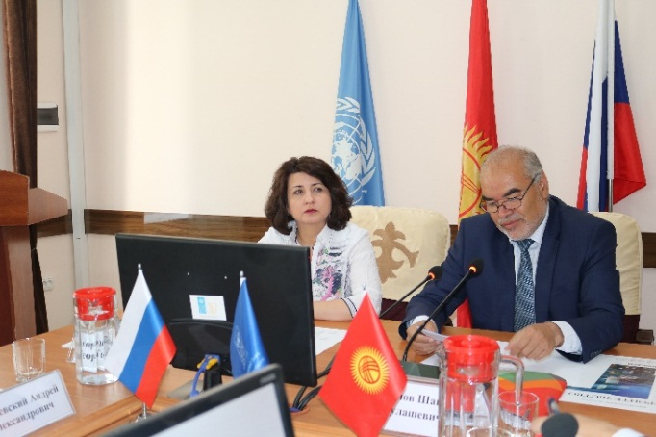 | 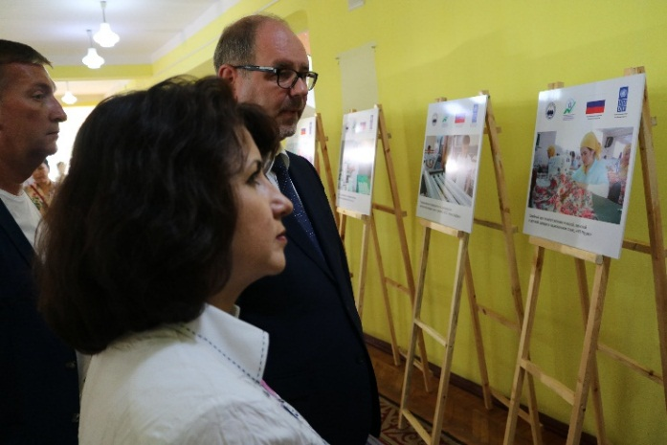
Pic. 1. Round table discussion of the business cooperation possibilities with the city of Saint-Petersburg.
Mr. Raimberdy MONOKBAEV
Head of department of regional development, Office of the Plenipotentiary Representative of the Government of the Kyrgyz Republic in the Osh province
«We’ll make all our efforts possible to assure the best practical use of the new knowledge. In particular, in areas of crops and fruits protection. We have learned about the use of biological plant protection instead of chemicals that would open up new exports opportunities for domestic producers. We have also attended demonstrations of various state-of-the-art agricultural machines that we have not used or seen before. We are greatly impressed and wish we can afford it in the near future”.
The Programme has facilitated a constructive dialogue between businesses and local authorities from the Osh province with various agricultural research institutes and leading companies from the Russian Federation. Over 60 farmers and entrepreneurs have had a chance to explore the best practices from Russia in areas like horticulture, oilseeds and vegetables, as well as dairy sector leading to making the following agreements and contracts:
- An agreement with the Russian Institute of oilseeds regarding direct supply of seeds to the Osh province and technical experts’ support of the crop cultivation process;
- An agreement with the Northern-Caucasian federal scientific center of horticulture, viniculture and wine-making industry regarding supply of high-quality seedlings of fruits and berries as well as on commercial orchard development under experts’ technical support;
- An agreement with the “Yuzhnaya” agribusiness company regarding supply of grape seedlings and the state-of-the-art viniculture technologies;
- Two companies that provide seed testing services in the Osh province have been provided with 125 kilos of seeds of the new highly productive winter crops (wheat, burley, triticale) by the Federal research center of grain named after Lukianenko (Krasnodar) and the Russian national research institute of grain named after Kalinenko (Rostov-on-Don);
- Federal research center of vegetable cultivation (Moscow) and “Gavrish” selection company that produces seeds of greenhouse vegetables supplied seeds of 20 hybrids (cucumbers and tomatoes) for 4 greenhouse farms covering 2.6 hectares of land;
- Pedigree sheep breeding plant from the Osh province is negotiating supply of fine wool rams for reproduction of the fine wool sheep population from 3 branches of the Russian national sheep breeding research institute. Support of the fine wool sheep breeding is prioritized by the Rssian-Kyrgyz Development Fund.

https://m.facebook.com/story.php?story_fbid=1742607529168482&id=116487388447179;
https://m.facebook.com/story.php?story_fbid=1739815202781048&id=116487388447179;
https://m.facebook.com/story.php?story_fbid=1742731755822726&id=116487388447179;
http://www.kg.undp.org/content/kyrgyzstan/ru/home/presscenter/pressreleases/2018/07/field-day---2018--new-horizons-for-agro-development.html
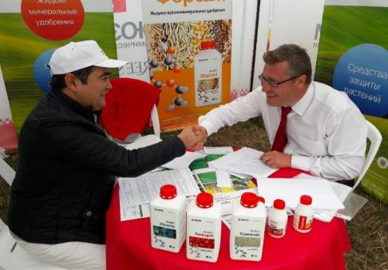 | 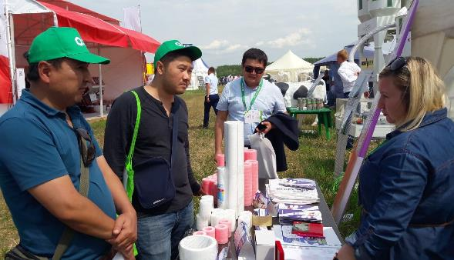
Pic. 2: the All-Russia Day of the Field in the city of Lipetsk and working meetings between entrepreneurs from the two countries.
Russian experts from the “Federal center for agricultural consultations and training/retraining personnel for agriculture and agribusiness” have conducted a series of field trainings for apiculturists and cattle farmers from across the Osh province. In the course of two weeks (November 8-15, 2018), some 201 beekeepers and cattle farmers, including 47 women (23%) have been provided with an opportunity to learn about increasing productivity of apiculture and milk oriented cattle breeding.

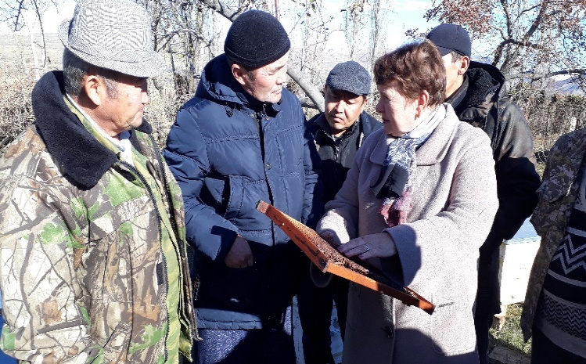 | 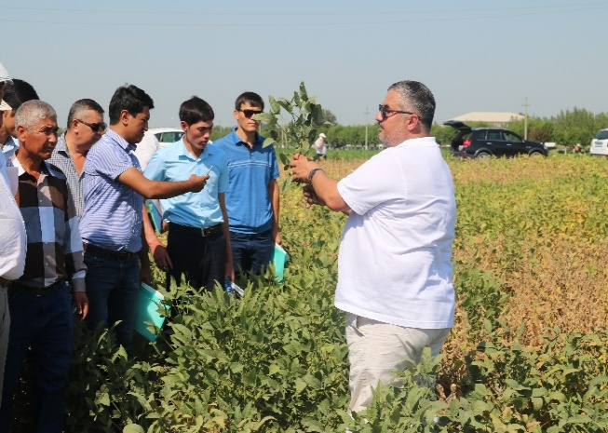
Pic. 3: Consultations and training for farmers in the Osh province by Russian experts

One of the particular issues faced by communities in rural areas and standing in the way of effective partnerships between rural farmers and urban entrepreneurs is the access to internet and use of e-platforms. This was one of the conclusions made by consultants of the Center for Entrepreneurship Support in the city of Osh as a result of 47 training workshops in support of 467 active entrepreneurs and citizens with entrepreneurial initiatives (269 men and 198 women). The Center has entered an agreement with one of the most advanced farms in the region, called “Ziyadin-Ata” to use its fields and greenhouses as a training site and also engages in active interaction with the Regional council of entrepreneurs towards the use of IT technologies (including mobile applications).
https://www.rsp.kg/forum

Demonstration of the business processes at the Service Delivery Center for the population in the Karool village of the Uzgen district operating as a one stop shop (“single window”) has induced a lot of interest among participants of the demonstration, including municipalities from across the south of Kyrgyzstan, representatives of the Kyrgyz government, National parliament (Jogorku-Kenesh), business community and the civil society. As a result of the demonstration the State Agency for local self-government and inter-ethnic relations (GAMSUMO) has requested UNDP to provide operational guidance for delivery of municipal services and take additional steps towards full scale replication of this pilot across the country.

The Project has currently support Service delivery centers in 4 municipalities that offer legal services and negotiate an arrangement for delivery of financial literacy services jointly with the National Bank of the KR. As a result of optimization of the process of municipal services provision in one spot starting from application and ending with delivery of a sought service officials of the local self-government spend less time and therefore can offer additional services leading to decreasing people’s frustration about the quality of public services.
https://www.facebook.com/undpkg/videos/1662908117138424/

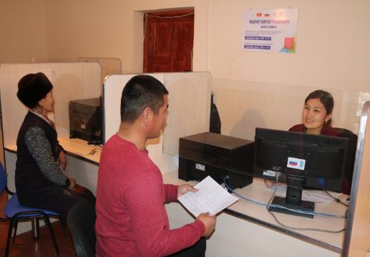 | 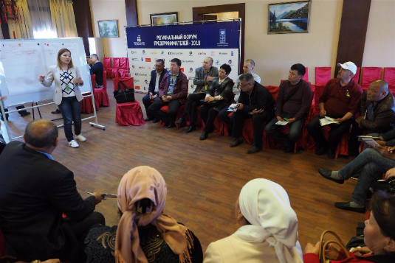
Pic. 4: Examples of service delivery process at one of the Centers and training workshops for entrepreneurs

On the occasion of the International Day of women’s entrepreneurship the Programme has run a range of events designed to build channels of communication between women-entrepreneurs and banks, credit institutions and public bodies in charge of entrepreneurship support and employment. That includes a Forum of women-entrepreneurs held in Osh on November 18-19, 2018 that has brought together 130 entrepreneurs focusing on empowerment of women in making management decisions, support of women leaders in businesses and mentorship for beginner women-entrepreneurs.

https://twitter.com/undpkg/status/1064103618872258561;
https://twitter.com/undpkg/status/1064097016643502080;
https://m.facebook.com/story.php?story_fbid=1932184103544156&id=116487388447179;
https://m.facebook.com/story.php?story_fbid=1930838557012044&id=116487388447179;
https://m.facebook.com/story.php?story_fbid=1930837470345486&id=116487388447179;
https://www.instagram.com/p/BqWRmnfnUJR/;
https://www.instagram.com/p/BqWxE_hHXsL/

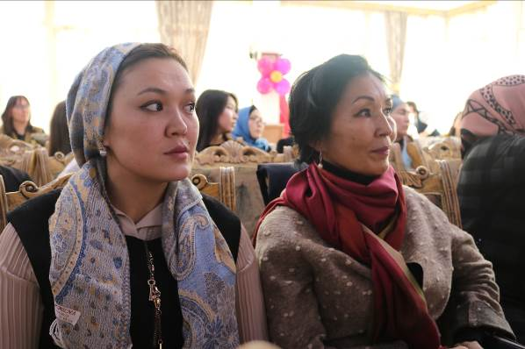 | 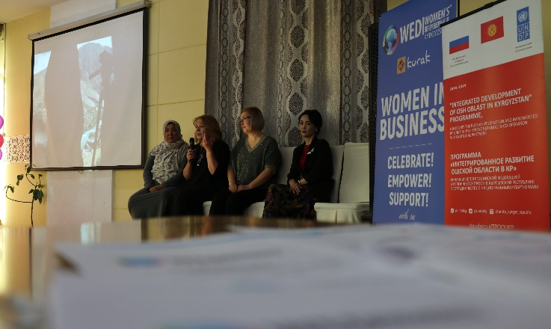
Pic. 5. Forum of women entrepreneurs in Osh

8,039 women have been provided with opportunities for growing their skills in agricultural technologies, marketing, business development and financial literacy. Labor conditions sensitive to the needs of population have been created in order to accommodate business and family responsibilities. These include access to higher quality drinking water and irrigation water supply, better secondary education and pre-school care, health care services which have provided 373 women (25%) with temporary employment in the course of implementation.

Set up and strengthen cold storage facilities for agricultural produce; greenhouse development; facilitate the development of export-oriented and import substituting industries, strengthening agricultural infrastructure.
Five projects for the total of USD 119,058 have been supported as a result of an open contest organized with the aim to select promising business initiatives with a potential to significantly promote the development of the market for agricultural products designed to create at least 25 new jobs (men – 13 and women – 12). Selected project proposals meet the following criteria: relevance and innovation; social responsibility of businesses; focus upon supporting farmers in increasing sales of their produce; promotion of high degree of processing; creation of new employment opportunities.
Over 27,000 farmers including 10,303 women, benefited from the opportunities for stable sales and increased income generation. They can use services of cold storage facility, trade logistical center, and dried fruits workshop, as follows:
- Over 200 farmers in the Nookat district have an opportunity to increase their income due to reduction of waste and sales at higher price by getting an access to services offered by the cold storage facility in Zulpuev ayil aimak. 3 new jobs created, including 1 for a woman.
- Over 24,000 people in the city of Osh and Kyzyl-Kia have year-round access to fruits and vegetables after modernization of 2 greenhouses with innovative technologies. 3 new jobs created, including 1 for a woman.
- Over 3,262 farmers from areas surrounding Osh have access to comprehensive services including collection, sorting and storing agricultural produce at the 1st trade logistical center, which has created 10 new jobs, including for 4 women.
- Over 112 farmers in the Uzhen district can benefit from sales of their products to the fruit processing company “Advantex” Ltd, using the “Oymo Foods” brand. The Project has provided the company with better access to electricity, water supply and sewerage services. The company has offered 6 new jobs, including 2 for women.
- The Project has facilitated acquisition of seeds of 5 oil species and 302,000 grape seedlings by “ElDan Atalyk” Ltd. Company from the Uzgen district, dealing with processing oilseeds and grape cultivation. This cooperation has come true as a result of a constructive dialogue with the Northern-Caucasian federal scientific center of horticulture, viniculture and wine-making industry and the Federal agricultural research center (Rostov-on-Don).
https://www.facebook.com/undpkg/videos/1696727543756481/

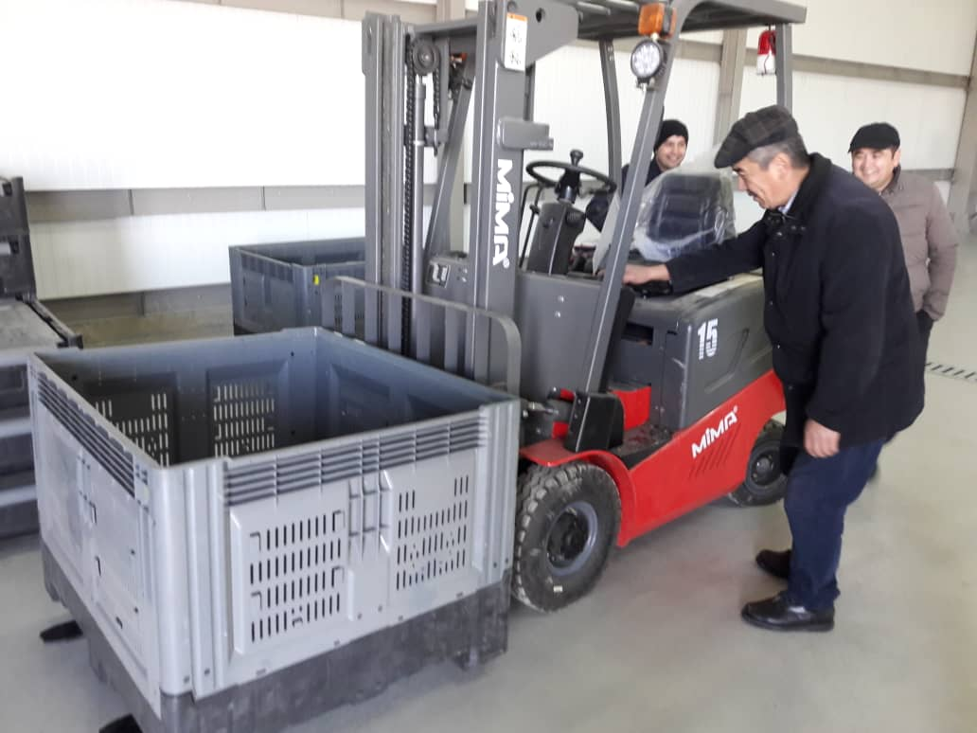 | 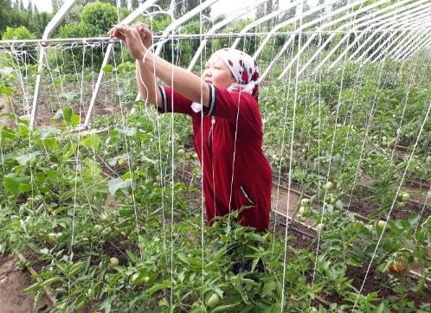
Pic. 6. Business initiatives that impact the agricultural market development

It needs to be emphasized that fruits and vegetables processing companies experience difficulties expanding their businesses due to predominantly small quantities and lack of homogeneity of fruits supplied by local farmers as numerous petty entrepreneurs operating small plots of land are not capable of effectively joining their efforts and supplying sufficient volume of products to the markets.

There is an obvious need to strengthen the management and organizational capacities of trade consolidating companies and cold storage facilities that have to yet grow into fully-fledged centers capable of offering the whole range of collection, consolidation, storage, transportation and distribution services for farmers at the local or regional levels.

Scaling up the outcomes of the “green” technology promotion and positioning the Osh province at the tourism market via competitive touristic products.

Practical demonstration of effective and efficient use of renewable energy sources (biogas, sundried fruits, water heaters, food cooking, greenhouses, LED street lights) and building capacity of the local authorities have significantly contributed to making decisions on integration of RES into the local sustainable development plans and to popularization of renewable sources of energy among the rural population.
Broad scale information and communication campaign in mass media launched by the Project to cover the successful implementation the RES installations have promoted the massive introduction of the LED-based street lighting in villages of the province. High demand for the renewable sources of energy among farmers has prompted the local authorities to set up demonstrational training sites on the basis of the Service delivery centers that would have all necessary information about the most demanded RES and contacts of their suppliers.

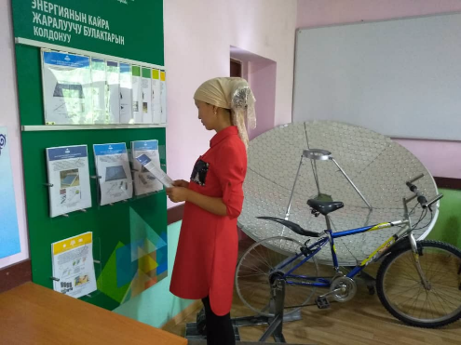 | 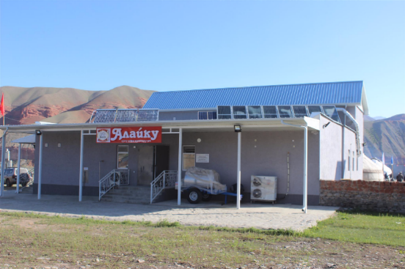
Pic. 7: Practical demonstration of benefits of RES

Another practical outcome of this information and communication campaign is the growing popular use of sun collectors for water heating, dried fruits and even “kurut” (traditional dried fermented milk product) whereas growing understanding of the advantages and benefits of using humus (biomass) as organic fertilizer provides grounds for expecting even more farmers using biogas plants and thus reducing pressure upon the environment.

http://www.kg.undp.org/content/kyrgyzstan/ru/home/presscenter/articles/2018/04/06/green-technologies-embracing-our-villages.html;
https://m.facebook.com/story.php?story_fbid=1696727543756481&id=116487388447179;
https://www.youtube.com/watch?v=6w0wYS2UxLM&feature=youtu.be (news report on national Prime TV channel, starting at 9:56);
http://www.kg.undp.org/content/kyrgyzstan/ru/home/presscenter/articles/2018/06/technologies-that-change-life.html;
https://www.facebook.com/undpkg/videos/1567577023352957/?hc_ref=ARSBpbl9jZftxqHAmuGhVb-VpD-cSlSf3kRUltNgoWVj3wIMM1uAEzpar6XGvckVNBM

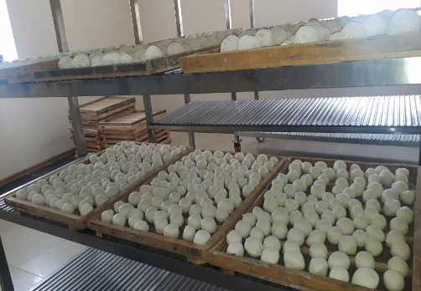 | 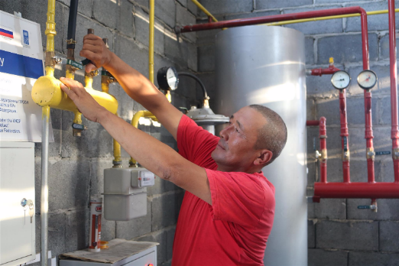
Pic. 8 Production of “kurut” in the Kuyo-Tash village by using sun thermal collectors/Biogas plant in the village of Shoro-Bashat

The Programme has delivered organizational and technical support to the Association of tourism operators “Kyrgyz ecotourism” that joined efforts with the Regional council of entrepreneurs and the local authorities in order to organize the large-scale Tourism festivals in the Alaikuu valley of the Kara-Kulja district, in the Jany-Nookat village of the Nookat district and in the city of Uzgen for better and unique positioning of the region at the market of tourism services. The Festival has brought together a record-breaking number of visitors: over 20 leading tourism companies of Kyrgyzstan, 56 foreign tourists and over 3000 local citizens. All the festivals have been broadly covered by media.

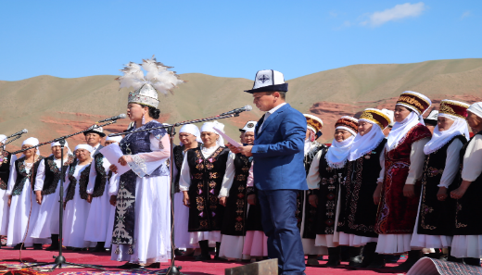 | 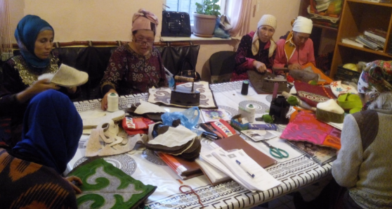
Pic. 9. Tourism festival in the Alaikuu valley of the Kara-Kulja district/Master-class for handcrafted ethnic felt goods

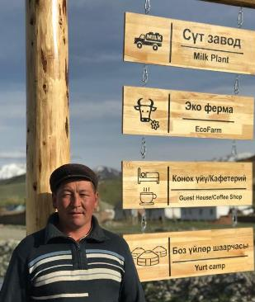
Guests of the Tourism festival in the Alaikuu valley were offered a tour that would include a chance to get to know the living and creative practices of nomadic Kyrgyz people, visit an eco-farm with colorful “yurtas” (traditional Kyrgyz houses), a guesthouse, a coffee-shop and a “kurut” making workshop. Other activities for the festival guests included master-classes dedicated to ethnic cuisine, handcrafted felt goods and traditional sports games.
13 small business projects supported via the Programme in 2017 have not only focused upon creation of new touristic routes and various tourism products but also on addressing infrastructure gaps in areas like power and water supply, absence of toilets and overall low sanitation and hygiene standards at public gathering places, lack of hotels/hostels and overall poor state of the known touristic attractions.
.

http://kabar.kg/news/turoperatory-kr-khotiat-postroit-ekoturizm-v-doline-alaikuu/;
http://kabar.kg/news/v-oshskoi-oblasti-proshel-festival-turizma/;
http://kabar.kg/news/turoperatory-kr-khotiat-postroit-ekoturizm-v-doline-alaikuu/;
https://www.facebook.com/pg/undpkg/photos/?tab=album&album_id=1615624358533467;
http://kabar.kg/news/v-oshskoi-oblasti-proshel-festival-turizma/;
https://www.youtube.com/watch?v=zoNLWdlhadw (starting at 12:22) News report on Yntymak TV in Kyrgyz;
http://kg.one.un.org/content/unct/kyrgyzstan/ru/home/news/kg-news/2018/prospects-of-the-rural-tourism-development-in-osh-oblast.html

Stronger interaction with relevant financial institutions and public bodies towards implementation of a system of building financial literacy of the population
In accordance with the National financial literacy Programme for 2016-2020 approved by decree of the Government of the KR on June 15, 2016 (#319), the Programme is joining efforts with the National Bank of the KR and GIZ towards building broader financial literacy of the population in the Osh province.
An 8-day long training for trainers was conducted in Osh in December 3-10, 2018 based on the training modules developed by NBKR and GIZ and on the Financial literacy building guide for adults with contributions from specially invited certified trainers from the International Labor Organization (ILO). The ToT led to build a pool of trainers consisting of 20 persons who represent the bodies of local self-government and universities.
The training Programme for this audience included a specialized module on adults learning: methodology and skills for teaching adults, methodology of presenting information for adults. The resulting group of trainers serves as an important element in the process of implementation of the National financial literacy Programme as it has already delivered an initial series of training in all pilot municipalities covered by the Project. Training was attended by 425 villagers (287 men and 138 women) who have acquired relevant financial planning and smart spending skills, etc.

Ms. Nurauiym ZHOLCHUBAI KYZY,
Specialist for social affairs in the Tort-Kol AO in Uzgen district:
Very often we would be approached by villagers raising various financial literacy issues that we were not able to address or refer to an expert capable of delivering high quality consultations. The problem has been resolved now. I have learned a lot of information about financial literacy. It was quite a novelty for me with due to no background in this area. I’m glad I have taken this training and learned how to explain things to other people.
Training activities have been well organized through the joint efforts of the Office of the Resident Plenipotentiary of the Kyrgyz Government in the Osh province, the National Bank of the KR, district level state administrations, and bodies of the local self-government.

https://twitter.com/undpkg/status/1073540205427245057
https://m.facebook.com/story.php?story_fbid=1967402716688961&id=116487388447179

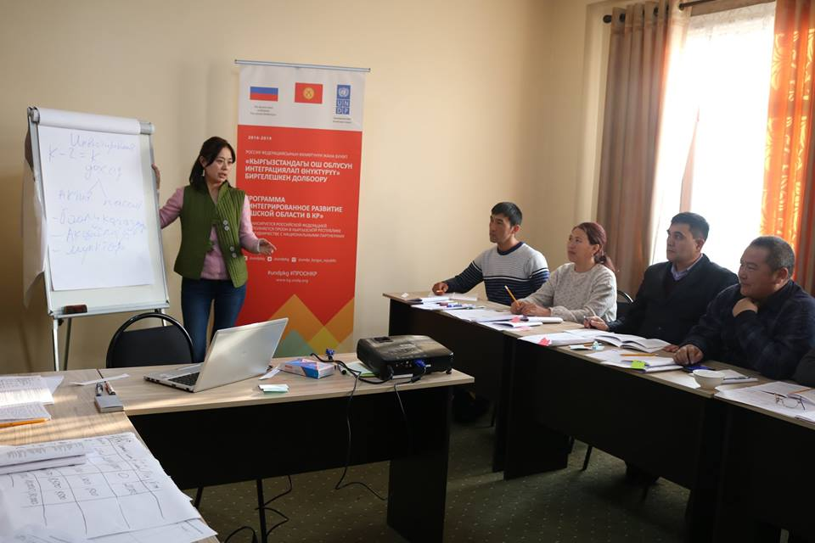 | 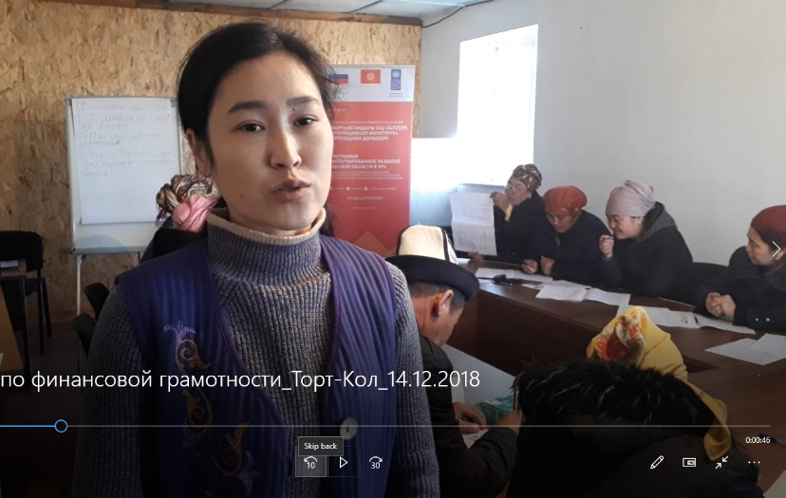
Pic. 10. Financial literacy training for local population

2.2. Status of implementation: Component 2. Access to sustainable water supply for rural communities

Implementation of a grant-based Programme for rehabilitation of the irrigation and drinking water supply systems.

The Programme has supported 29 projects for the total amount of USD 448,790 resulting in over 79,026 villagers (including 38607 men and 40419 women) benefiting from access to higher quality drinking and irrigation water supply. All of these projects are integrated into the local sustainable development plans of the pilot municipalities. UNDP has contributed USD 231,713 (or 52% of the total), along with the Kyrgyz Government - USD 155,143 (35%), whereas contribution from migrants and local water service providers reached USD 61,335 (14%).
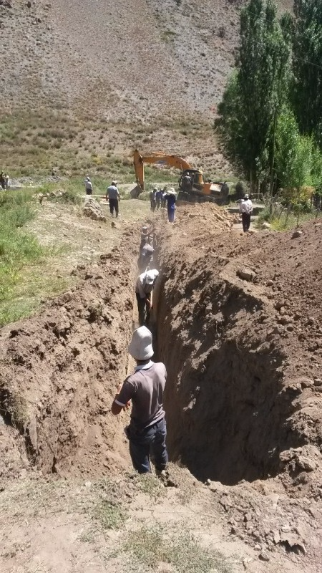 | 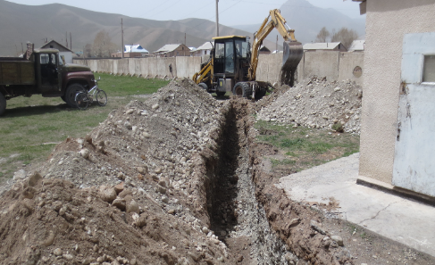
Pic. 11. Water supply system rehabilitation and construction works

15 water pipelines, 4 headworks and 5 intra-village channels have been rehabilitated in 26 villages, in addition to 3 schools and 2 kindergartens provided with access to safe drinking water.
https://twitter.com/undpkg/status/1065492157392404480
https://m.facebook.com/story.php?story_fbid=1819858731443361&id=116487388447179

Ms. Maral ZHANBAEVA,
Manager of Akinay-Gulu pre-school children care center in Isanov village of the Nookat district
Rehabilitation of drinking water supply system and rest rooms in our kindergarten has been our major accomplishment this year. Children now can use indoors toilets and washtubs instead of leaving the building whereas caregivers do not need to spend their time delivering drinking water.
Implementation of the projects provided temporary employment to 701 persons, including 181 women (26%). Persons in charge of implementation, including 140 officers (102 men and 38 women) of municipalities and Drinking Water Associations have acquired new skills related to development of the conflict- and gender-sensitive project proposals and received additional information concerning effective and efficient water resource management. Two communities have run a demonstration of two models of sustainable technology utilization for diversification of the process of drinking and irrigation water supply. These include a hydraulic ram used to secure drinking water supply at a secondary school and MOS in Jatan village of the Nookat district. In these two cases, in additional to installation of hydraulic rams the water supply system is complemented with filters that transform technical water into drinking water. Another model for demonstration is a project for water waste reduction in the irrigation system of Iyri-Suu village through concrete facing that prevents filtration of water from the irrigation channel and protects channel banks from erosion.
One needs to stress that water supply systems and irrigation channels in all pilot villages in general are in very poor technical conditions while in some villages the water supply infrastructure is completely out of order. Very often local people are forced to use the water from unsafe open sources, such as rivers, street canals or creeks that may be dangerous for their health. Obviously, rehabilitation of infrastructure may require a lot more significant investments then the Project has made available for local communities.
Under the existing legislative system, it is very difficult for the Project to systematize the interactions between the pilot Drinking water associations and the local authorities in order to secure sustainability of rehabilitated objects. The Project will take necessary steps towards informing relevant public authorities and sharing recommendations received in the course of implementation of water supply improvement projects.
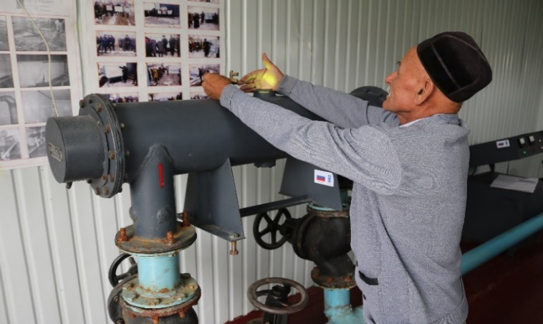 | 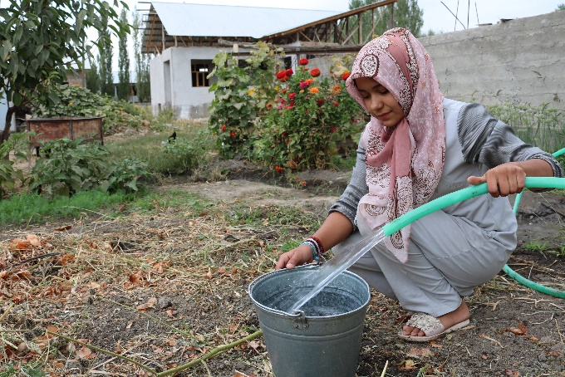
Pic. 12. Access to safe drinking water via rehabilitation of the headworks
Farmers remain skeptical about innovations in irrigation pointing to costly irrigation equipment, potential inflation of the production costs due to fuel expenses, lack of qualified specialists and small sizes of land plots (around 200 households may share one field of just 100 hectares) which limit the Project’s capacity to introduce modern irrigation systems. The Project will raise farmers’ awareness of water waste reduction technologies (effective and efficient models of dispersed and drip irrigation) and shall demonstrate their benefits through practical implementation.

Capacity building and technical support for the district level sanitary-epidemiological stations towards higher quality water testing

One of the extremely important priorities is building a system for interaction between the pilot RPADWUs and the local authorities with the district centers of epidemiological surveillance in order to assure regular drinking water quality and safety control. With this high priority in mind, 9 employees of the pilot sanitary epidemiological surveillance centers including 8 women have been trained at the laboratories of the of Department of Disease Prevention and State Sanitary and Epidemiological Surveillance of the Ministry of Health of the Kyrgyz Republic in the capital city of Bishkek and taught how to use the modern methods of drinking water quality assurance in accordance with international standards.
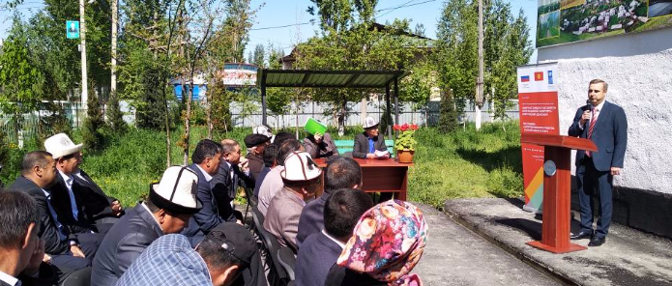 | 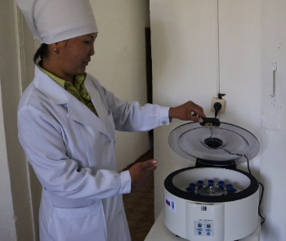
Pic. 13. Demonstration of the process of interaction between the pilot RPADWUs and the local authorities with the district centers of epidemiological surveillance

Demonstration of the process of interaction between the pilot RPADWUs and the local authorities with the district centers of epidemiological surveillance assuring regular drinking water quality and safety control held in the city of Uzgen and the village of Kara-Kulja on the 26th of April, 2018 in presence of the Russian embassy representatives, local authorities, department of the sanitary epidemiological surveillance and local communities.

http://kabar.kg/news/pit-evaia-voda-v-kara-kul-zhinskom-i-uzgenskom-raionakh-stanet-bezopasnei/;
http://www.kg.undp.org/content/kyrgyzstan/ru/home/presscenter/pressreleases/2018/04/26/potable-water-of-kara-kulja-and-uzgen-shall-become-more-safe-3/;
http://yntymak.kg/ru/pitevaya-voda-v-kara-kulzhinskom-i-uzgenskom-rajonah-stanet-bezopasnej/;
https://www.youtube.com/watch?v=b2guLlacw3Y&t=799s (Osh TV news report, starting at 8:44)

2.3. Implementation status: Component 3. Improvement in welfare of rural communities through a rehabilitation of social and economic infrastructure

Institutionalization of the grant funds through the stronger interaction with the local authorities and civil society for the sake of transparent allocation of grants
In the process of implementation of the grant Programme the Project has regularly provided technical and methodological support to the pilot municipalities. The community has proposed for implementation some 61 financially sound and technically substantiated project applications including 29 applications focusing on rehabilitation of the drinking and irrigation water supply and 32 projects of rehabilitation of the social economic infrastructure. According to the regular monitoring all grant funds have been used as designated.
Overall the Programme has supported 32 projects for the total of USD 411,441, where 193,295 rural citizens (including 182,916 men and 10,379 women) benefited from access to higher quality secondary and pre-school education, electrification and health care services. Projects focused on improving conditions at 5 schools and 5 kindergartens, rehabilitation of 3 sports playgrounds/stadiums, 1 community convention center, provision of street lights to 12 communities and procurement of equipment for 5 health providers, rehabilitation of one bridge.
- 458 persons provided with temporary employment during implementation of these projects (343 men and 115 women). The civil works organized jointly with the World Food Programme at 15 objects of social infrastructure have enabled the local communities earn over 50 tons of flour and over 5 tons of oil. The contribution of the UNDP – 205,917 USD (50% of the total), Kyrgyz Government - 168703 USD (41%), migrants and communities – 36,821 USD (9%).
https://twitter.com/undpkg/status/1049992905836900352
https://www.instagram.com/p/BowJsSaHPII/?taken-by=undpkg
https://m.facebook.com/story.php?story_fbid=923504207839465&id=116487388447179
https://m.facebook.com/story.php?story_fbid=1974385175990715&id=116487388447179

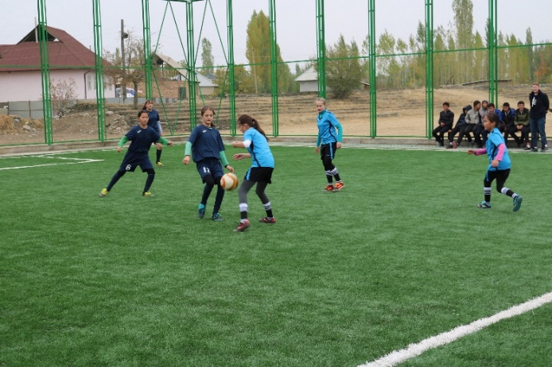 | 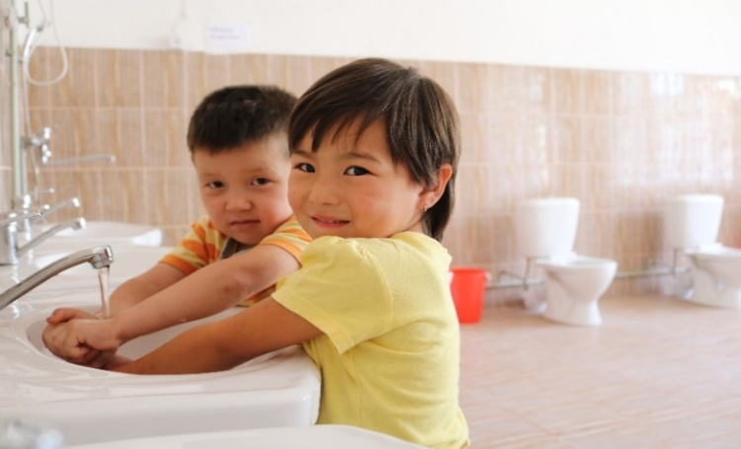
Pic. 14. Improved accommodations at secondary schools and kindergartens

Mobilization of additional resources from the Kyrgyz ethnic diaspora in the Russian Federation shows evidence of the great potential possessed by the migrants’ community that can be used for the regional development by the local self-government bodies. The Kyrgyz diaspora in the Russian Federation represented by the All-Russia association “Kyrgyz Congress” which has regional branches in 56 provinces of Russia has been playing a special role in the rehabilitation of the social economic infrastructure in the pilot villages. Over 800 labor migrants who work in the RF have contributed the total of USD 20,223 (or 18% of the overall value of jointly funded projects) for rehabilitation of 4 pieces of the social and economic infrastructure in the Osh region.
This has largely resulted from a broad scale communication campaign reaching out to both migrants in Russia as well as the pilot municipalities. It included inter alia filming videos about the “Let’s help our village together” initiative in the two languages disseminated through online platforms. The running of the campaign has followed the Memorandum of understanding between the UNDP-Kyrgyzstan and “Kyrgyz Congress” All-Russian association.
https://www.facebook.com/undpkg/videos/1653539494741953/
https://yadi.sk/i/2Kh8FEi-3T2p3u

Representatives of the local governments have attended the Forum of the Kyrgyz diaspora and the “Tabarman” entrepreneurship forum in Moscow on May 22-23, 2018. They have reached an agreement concerning broad dissemination of the information about the “Let’s help our villages together” initiative among the Kyrgyz diaspora in Russia whereas the pilot municipalities have agreed to improve the quality of preparation of project documentation and relevant permissions.
http://members.vb.kg/2018/02/20/podrob/2.html
http://old.kabar.kg/rus/society/full/45838
https://kyrgyzy.com/news/events/18-01-23-id226.html
https://kyrgyzy.com/program/soczialnaya-sfera/223-pomozhem-rodnomu-selu.html
https://kyrgyzy.com/news/events/18-02-14-id271.html
https://www.facebook.com/kyrgyzycom/posts/1535828333182597
https://www.facebook.com/kyrgyzycom/posts/1529173260514771
https://www.facebook.com/100000371751112/videos/1752461224776252/
https://www.facebook.com/undpkg/videos/1710696082359627/

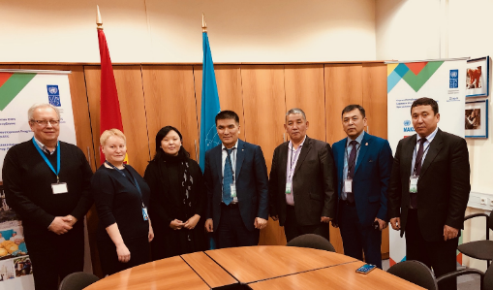 | 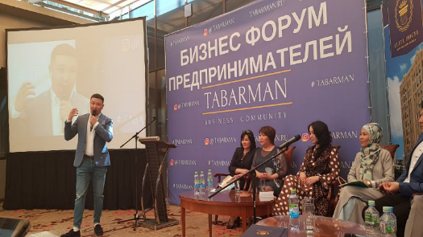
Pic. 15. Partnership with the “Kyrgyz Congress” Association (RF)

Currently, three more project proposals are being finalized whereupon the Programme is planning to organize a regional activity designed to inform the communities about successfully tested mechanisms of open and transparent utilization of funds mobilized by migrants and strengthening partnerships between local authorities and association of Kyrgyz migrants in Russia.

Organization of the process for procurement of equipment and technologies in accordance with UNDP procedures

Russian cardiac surgeons Mr. Alexey Koroteev has been invited to deliver training to 60 cardiologists including 10 women on how to use the state-of-the-art medical equipment for diagnostics of cardiovascular diseases. This training was divided into 4 phases. 2,310 persons (including 878 women) from remote areas have been examined by doctors remotely using medical equipment namely Electrocardiography (ECG) devices with a function of automatic deciphering and automatic external defibrillators (AED) installed in 10 distant village health care units and linked to the common server at the Osh regional hospital. Critical conditions have been identified in 11 cases.

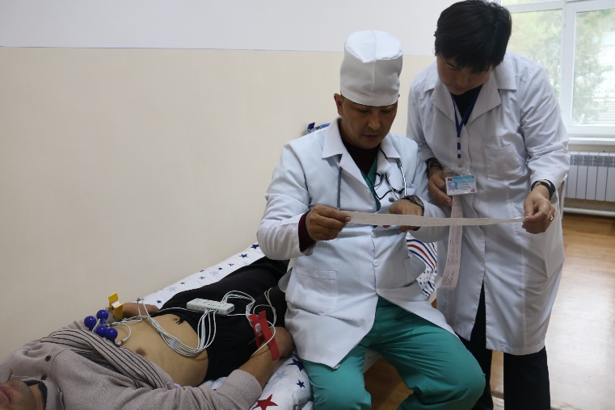 | 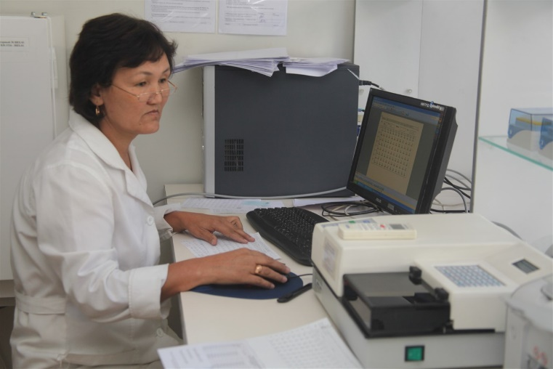
Pic. 16. Use of equipment for distant diagnostics of cardiovascular diseases linked to the server at the Osh regional clinic.

Demonstration of the practical use of newly delivered compact medical equipment for diagnostics of cardiovascular diseases on the April 3, 2018 attended by representatives of the Ministry of health of KR, consulate of the RF in Osh, local authorities, cardiology clinics has been widely covered in media.
https://bit.ly/2uBA4Rv
http://www.kg.undp.org/content/kyrgyzstan/ru/home/presscenter/articles/2018/04/13/taza-koom-starts-from-taza-jurok.html;
https://www.facebook.com/undpkg/posts/1642879779141258;
http://kabar.kg/news/v-oshe-10-organizatciiam-zdravookhraneniia-vruchat-medoborudovanie-rossiiskogo-proizvodstva/;
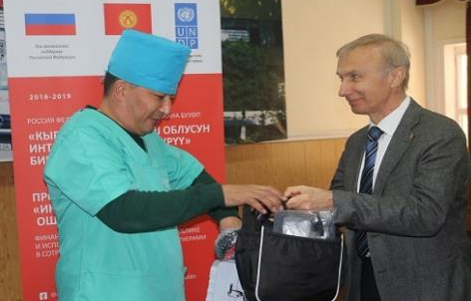 | 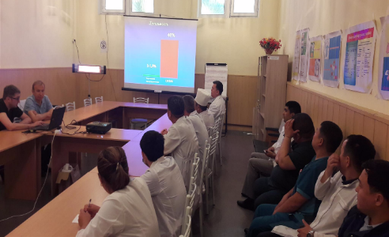
Pic. 17. ECG and AES equipment sets are handed by professor A. Koroteev to the health providers in Osh.

Regular participatory monitoring of the project implementation process involving donors, national partners and civil society
Staff of the Project maintain an ongoing process of monitoring the Project’s progress against its plan. The Monitoring plan includes a system of indicators that fully reflect the operational processes and outcomes of the Projects.
This ongoing monitoring process has let the Project identify the common directions, development options and present to the Project’s Board the information it needs for decision making. During meeting of the Project’s Board on the 14th of May, 2018 its members have agreed on all project activities by the end of 2018 and presented recommendations for long-term sustainability of development outcomes. In order to reach and maintain consensus with all stakeholders regarding sustainability of the Projects development outcomes the Board has included 15 members who represent stakeholders of the Projects (12 men and 3 women), including the donor represented by Consulate of the RF in Osh; implementation partners – Ministry of economy, office of Prime-Minister of the KR, office of the representative plenipotentiary of the Kyrgyz government in the Osh province, other relevant ministries and agencies, and representatives of the target beneficiaries.
The Board’s meeting was attended by over 40 observers who represented media, beneficiaries, state bodies, local self-government, international organizations and NGOs invited to demonstrate the effective and efficient use of funds, equitability, transparency and to maintain the necessary feedback. In addition, a specially organized photo exhibition dedicated to the progress of the “Osh area-based integrated development Program” has presented over 30 images that reflect the background and the progress made by the Project.
http://www.kg.undp.org/content/kyrgyzstan/ru/home/presscenter/pressreleases/2018/05/15/coordination-with-the-national-partners-.html;
http://www.kg.undp.org/content/kyrgyzstan/en/home/presscenter/pressreleases/2018/05/15/coordination-with-the-national-partners-.html;
https://www.youtube.com/watch?v=VP00_ld95mg Osh TV (14:35 – 20:40);
https://www.youtube.com/watch?v=w2i9-foK8DY Osh TV 11:28);
http://kabar.kg/news/glava-oshskoi-oblasti-prinial-novogo-postoiannogo-koordinatora-sistemy-oon-v-kr/
video presentation of the project’s interim progress;
https://drive.google.com/file/d/1fJq0qrGPEAaKhRTOf7e7JDqDlzThz8c0/view in Russian;
https://www.youtube.com/watch?v=l1uKppl1L9U&t=19s in English.

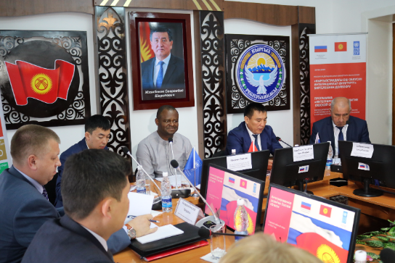 | 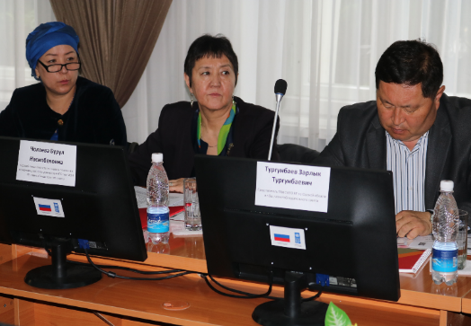
Pic. 18. Meeting of the Project’s Board
An interim project evaluation performed in order to identify and comprehend the outcomes of the Project’s activities and analyze their value has given the Project staff, beneficiaries, partners and other stakeholders an opportunity to learn lessons from its experience and take necessary measures towards improving the Project’s performance during subsequent phases. The evaluation has been performed by an independent national expert Zaure Sydykova.

2.4.Implementation status: Component 4. Increase in the employment rate of the population through a strengthened system of vocational and technical education and training

Market-demand driven creation of new specialties and vocational training curriculum as well as quality assurance system
In order to maintain the long-term training programs funded from the state budget in vocational schools oriented at labor migration into Russia, development of small entrepreneurship and self-employment, and at existing employers in the Osh province the Project has made an attempt to secure financial sustainability of the pilot vocational schools (lyceums).
It has supported an initiative for development of a model of training that incorporates practical component wherein pilot lyceums involve their students into delivery of services/goods for the real-life customers (retail and corporate) on a commercial basis. As an example, one of the lyceums that implement a Programme of training car mechanics is now offering vehicle repairs and maintenance services to the local community. This model helps to address two problems at the same time: to provide at least a part of students with hand-on practical experience and to generate additional income that can be used for development, improvement of quality of training, raising salaries to teachers and instructors.
Two pilot lyceums offer training under three new specialties: carpenter, miller and car mechanic, highly demanded at the domestic as well as external labor market. In order to support training for these new specialties the Project has procured relevant training equipment for the total of USD 272,712 whereas the Government of the KR has contributed in-kind, by providing renovated classes and workrooms (USD 28,194 or 16%). Workrooms equipped with all relevant equipment, qualified instructors, sufficient hand-on practical experience and working supplies enable lyceums to offer commercial services to outside customers in addition to training per se. 6 new jobs are created. Temporary employment has been provided to 39 people, including 8 women.

Improving the quality of teaching and methodology at professional lyceums in line with the new curriculum and today’s labor market needs.
The Programme has agreed on the list of relevant training textbooks and methodological support for the three new specialties jointly with the Republican scientific methodological center under the Agency of vocational training at the Ministry of education and science of the KR and procured specialized textbooks for the total of USD 1,963.
In cooperation with the Project each pilot lyceum has set up an e-library for 849 students and teachers, including 128 girls and women (15%). E-libraries are properly equipped. The Project has plans to deliver consultations in order to systematize e-libraries, develop a catalogue of texts available, and purchase new e-books.
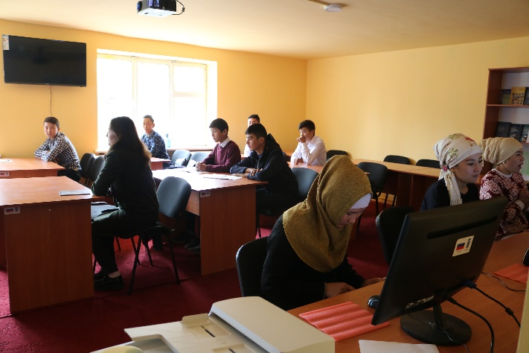 | 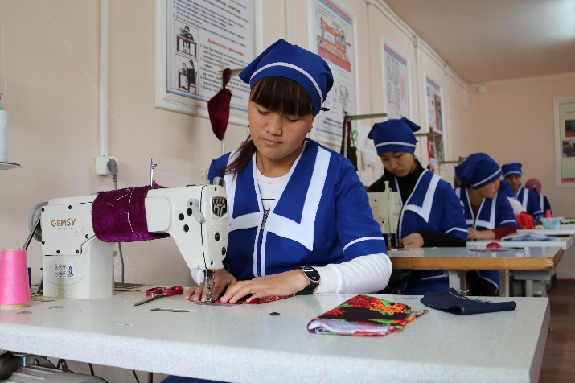
Pic. 19. E-library in a lyceum and sewer courses
For the sake of regular peach-building activities and improved health of students the Project has supported the initiative for building a playfield at the lyceum#58 in Nookat district, where the Kyrgyz Government contributed USD 21,169 (82% of the project cost) and UNDP – USD 5,665 (18% of the total). The Project intends to carry out cultural and other mass events among the youth towards building peace, tolerance, respect to diversity and peaceful coexistence, strengthened moral and ethical values through cultural development and sports.

Closing the gap between educational/training institutions within the system of vocational training and potential employers aiming to broaden employment opportunities including via system of small grants

In a situation where up to 80% of the economically active population choose labor migration in Russia and other countries the Project has made an assessment of the most demanded professions at the labor market in order to actively promote educational opportunities offered by lyceums. As a result of the assessment it has not only organized vocational training programs but also training courses on business planning, gender equality and conflict resolution involving young entrepreneurs. Selection of the participants has strictly followed the principle of gender and ethnic parity. Overall, 254 young people, including 114 women (45%) have taken the short-term professional training courses to become a pastry-cook, farmer, welder, mason, or a sewer.
https://www.facebook.com/undpkg/posts/1691411640954738
http://www.kesip.kg/ru/3/335

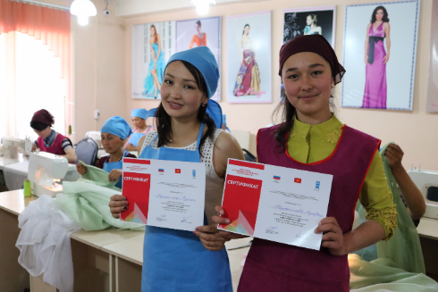 | 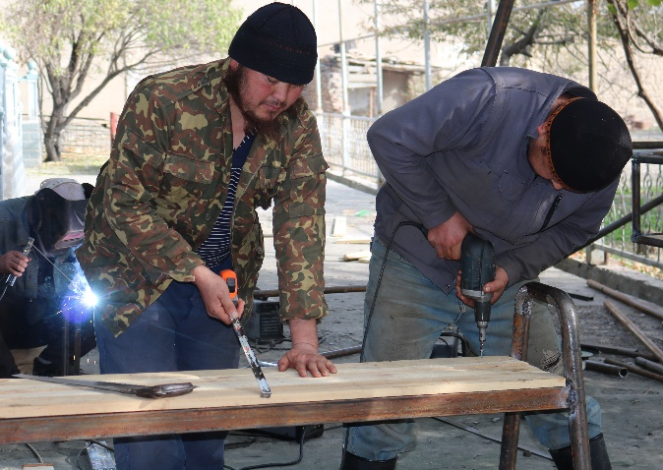
Pic. 20. Professional training courses
Mobilizing additional resources is not easy in absence of active interaction with the relevant environs including potential employers, non-commercial organizations, various bodies of the state (from local authorities to employment administration, etc.), universities, schools, etc..
In just one example of possible partnership between lyceums, businesses and local authorities, the students trained to become welders have during their practical classes produced 2 sets of outdoors equipment for children playgrounds ordered by kindergartens “Aigerzhan” in a village of Kyzyl Beyit in the Nookat district and “Myrza Aryk” of the Myrza Aryk village in the Uzgen district resulting in strongly upgraded conditions for pre-school care for over 208 children, including 105 girls (50%).

Another element of the vocational education/training system development in the Osh province has to deal with activities focusing upon supporting self-employment among young people. One may point to the use of the Project funds by lyceums in order to organize open contests to support entrepreneurship projects among their graduates.
As a result of an open contest of business initiatives among the rural youth some 22 projects have been selected for support for the total of USD 243,338 where businesses contributed USD 106,890 (44%) and UNDP – USD 136,448 (56%). All the business initiatives selected met the criteria of relevance, social partnership and focus upon creation of new employment opportunities.
Local communities have access to services of garment making workshops (4), car service stations (8), bakeries (4), welding workshops (2), furniture, plastic works, turning shop and barber shop. 126 graduates (including 74 young men and 52 girls) have got employed. Access to temporary employment provided to 97 people (including 71 men and 17 girls).

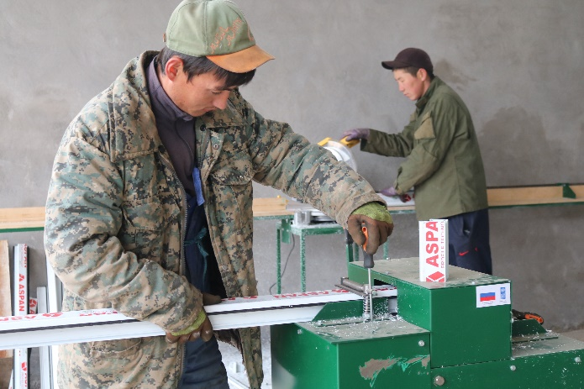 | 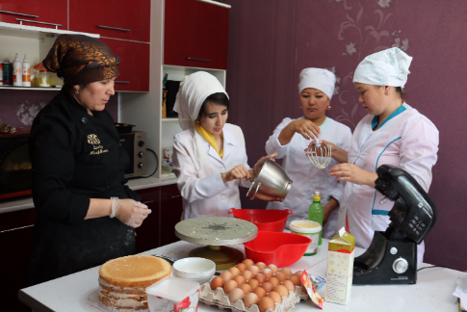
Pic. 21. Youth business initiatives

All the business initiatives selected met the criteria of relevance, social partnership and focus upon creation of new employment opportunities.

2.5. Implementation status: Component 4 “Strengthened resilience of local communities to natural disasters”

Facilitate reduction of risks related to water resources of the region in order to reduce vulnerability of farms/communities/infrastructure through compilation of the relevant catalogues of disasters, risk/hazard profiles and water resources related risks

Finalized disaster risk assessments across 30 pilot villages including specific indicators for identification of natural and man-made hazards, disaster risks based on distant probing using drones, and mapping of hazardous processes foot-prints and potentially affected areas. Each municipality has been provided with risk profiles for the 30 pilot villages along with a photo and video data base including 164 recommended mitigation activities

Comprehensive set of engineering and technical interventions designed to reduce the communities’ and infrastructure’s vulnerability to natural disaster risks

The Programme has delivered technical and methodological assistance to municipalities in preparation of 5 mitigation project proposals. In order to support the preparation of technically relevant and financially sound mitigation project proposals the Programme has provided consultations and technical expertise and conducted training on development of conflict-sensitive project proposals for 19 participants, including 6 women

Based on the findings of the disaster risk assessment the Programme has obtained a list of projects aiming to mitigate natural disaster risks, including in the sector of water resources management and biological safety. Upon agreement with the Ministry of emergency situation of the KR these projects have been integrated into the emergency response plans of the regional branches of the Ministry of emergences in the Nookat, Uzgen and Kara-Kulja districts of the Osh province.
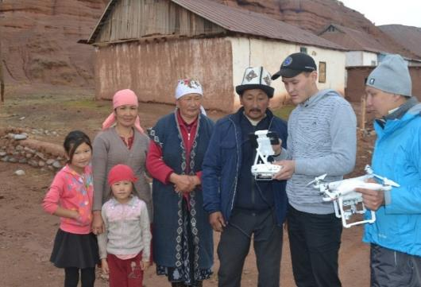 | 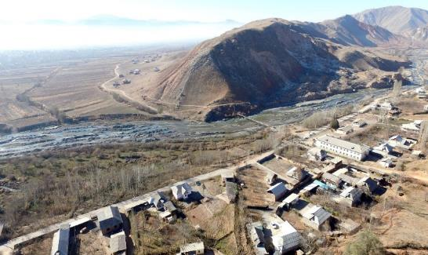
Pic. 22. Identification of natural and man-made hazards and disaster risks using drones

The Programme has agreed the list of all mitigation projects for implementation in 5 villages with the Ministry of emergencies of the KR. All the projects selected are designed to provide protection to the populations and social infrastructures from seasonal mudflows, and to mitigate effects of earthquakes for the communities. The proposed projects cover communities that occupy 264 hectares of irrigated land, 13 hectares of gardens, 6 social objects and 15 km of roads.
Fruit trees planted in some villages within the Kok-Bel Ail-Okmot in the Nookat district of the Osh province mostly vulnerable to ecological risks in order to reduce the risk of natural disasters. This project proposal has been agreed upon with the WFP. Some 9,000 trees have been planted in a territory allocated by the Aiyl-Okmot covering 21 hectares in villages of Jalgaz Tal, Kyzyl Tash and Shoro Zhar of the Nookat district with fencing provided.
The WFP has conducted a training on forestry and forest restoration. Participants of the project are eligible to receive fortified wheat flour and vegetable oil as an incentive for participation in training, trees planting and other forest restoration activities.
Mr. Erkinbek JOROEV,
An informal leader of the Kok Bel village in Nookat district:
This initiative was started by volunteers concerned with the growing situation. Over 50 villagers had done a massive job within just one month. They cleared up the territory from rocks, built 1,200-meter-long fence, planted 720 pistachio, walnut and apricot trees hoping their roots can stop erosion at landslide prone slopes.

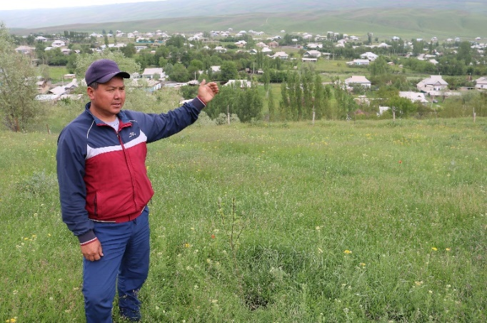 | 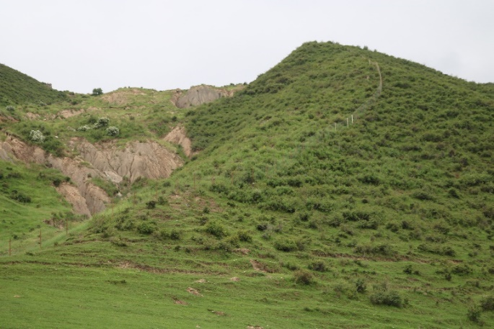
Pic. 23. Planting trees at landslide prone areas.
https://bit.ly/2NkSKQQ
In view of growth of various infections affecting animals and absence of capacities for safe utilization of dead animals the Project has supported a proposal from the veterinary services and the Ministry of emergencies to install a crematorium in the Jalpak Tash village of the Uzgen district for thermal utilization and decontamination of all kinds of biological waste.
The Programme has agreed the list of necessary equipment, tools and other supplies for a mobile health unit with the Ministry of emergencies and the Ministry of health of the Kyrgyz Republic. The process of procurement and delivery of the required equipment and inventory for the mobile health unit in order to strengthen the disaster medicine is going to be finalized in March 2019.

3. PROJECT RISKS

# | Description of risks identified in project documentation | Nature of risk | Impact upon project implementation in 2018 | Response measures in 2017 | Expected risks in 2019
1 | Large scale natural disaster capable of impacting the target groups and Government’s focus and priorities | Environmental | No | No natural disasters capable of affecting the target groups registered. | Implementation of mitigation projects is in progress based on available evidence and data on risks in the risk prone areas in the pilot communities
2 | Lack of political stability and frequent changes in the structure of Government may lead to low commitment to Project results among national partners | Organizational | No | A number of changes in the structure of Government represented at a local level occurred in 2018. Additional working meetings were scheduled for information purposes. Composition of the key departments in charge of agreeing project activities remain unchanged. | Efforts to ensure capacity building of the local authorities and local institutes involved into Project implementation will be continued
3 | Lack of capacities of national partners may result in delays in project implementation and reduce the project’ effectiveness | Organizational | No | Steps taken to ensure approval of the schedule of submission of required project documents by pilot municipalities and maintenance of ongoing monitoring by the head of the OPRG KR | The project has taken measures to ensure joint monitoring of project goals with partners
4 | Project implementation requires specific technical skills. Lack of these skills may hinder quality assurance and project monitoring | Organizational | No | In each specific area that requires technical skills relevant experts hired. E.g., experts for development of technical specifications for procured technologies/equipment/services | Highly qualified experts are going to be sought both in KR and in RF. All Project ToRs are drafted from the quality point of view and compatibility with project goals including coordination with national partners
5 | Complex procurement procedures and absence of relevant expertise may lead to delayed implementation | Organizational | No | In each specific area that requires technical skills relevant experts hired | Procurement plan is in place and monitored by the country office. All procurement risks identified just as mitigation measures.

4. LESSONS LEARNED

- There is an obvious gender disproportion in creation of new employment. Men are more active at the labor market and participation of entrepreneurs in the open contest of business initiatives designed to develop the market of agricultural products and broaden employment opportunities for the rural youth shows it clearly. 60% of entrepreneurs and employers that establish a legal entity are men. 59% of employees hired by entrepreneurs ate also men. Out of 157 villagers who secured a long-term employment there are only 64 women (41%). The project is going to take necessary steps towards raising awareness of the local authorities, business associations, civil society about the problem of gender inequality, low level of women’s leadership development, low level of skills and knowledge in the field of women’s entrepreneurship across the Osh province.

- Fruits and vegetables processing companies supported by the Project experience difficulties expanding their businesses due to predominantly small quantities and lack of homogeneity of fruits supplied by local farmers as numerous petty entrepreneurs operating small plots of land are not capable of effectively joining their efforts and supplying sufficient number of products to the markets. Lack of management and organizational capacities of trade consolidating companies and cold storage facilities does not allow them grow into fully-fledged centers capable of offering the whole range of collection, consolidation, storage, transportation and distribution services for farmers at the local or regional levels. The Project is going to continue building capacities of the trade logistical center and cold storage facilities through regular coaching, raising farmers’ awareness of possible cooperation, and continuing field demonstrations based on the best practices.

- Farmers remain skeptical about innovations in irrigation pointing to costly irrigation equipment, potential inflation of the production costs due to fuel expenses, lack of qualified specialists and small sizes of land plots (around 200 households may share one field of just 100 hectares) which limit the Project’s capacity to introduce modern irrigation systems. The Project will raise farmers’ awareness of water waste reduction technologies (effective and efficient models of dispersed and drip irrigation) and shall demonstrate their benefits through practical implementation.

- Highly deteriorated system of drinking water supply and limited access to water resources do not lead to improved wellbeing of beneficiaries. Under the existing legislative system it is very difficult for the Project to systematize the interactions between the pilot Drinking water associations and the local authorities in order to secure sustainability of rehabilitated objects. The Project will take necessary steps towards informing relevant public authorities and sharing recommendations received in the course of implementation of water supply improvement projects.

- Implementation of drinking and irrigation water system rehabilitation projects could be adversely affected by the high risk of delays in the Project funds disbursement due to complexities of the process of preparing permits and other documentation in relation to construction/renovation of objects and passing the state expertise. Good progress in coordination of efforts with local authorities has been made as a result of approval of the Joint action plan of the UNDP, district state administrations and pilot municipalities upon by the Representative plenipotentiary of the Kyrgyz Government in Osh province.

- Lack of coordination between the Ministry of health and the Ministry of emergencies in areas of emergency health care and use of the mobile health care unit induces difficulties for the project sustainability. The Project shall take necessary measures towards informing relevant state bodies and share recommendations gained in the course of project implementation.

5. PLANS FOR THE FUTURE

The following project outcomes will be delivered in terms of each of the Program’s components in 2019:
Component 1. Sustainable agriculture, tourism, trade and promotion of “green technologies”

- The project will support development of new Service Delivery Centers for the population at the level of local self-government, Center for tax-payer services at the State Tax Inspection in Uzgen, regional Center of financial literacy at one of the regional universities (Osh technological university) in order to ensure improved effectiveness and efficiency of the local bodies of power and improved interaction with the private sector and population. All newly created centers are going to incorporate consultations in area of financial literacy in cooperation with the National Bank of the KR. Success stories will be shared through organization of regional study tour and wide coverage in media.
- Practical demonstration of widely used new technologies from the Russian Federation in the area of irrigation (dispersed and drip irrigation) will be run in the pilot municipalities of the Osh province. New models, multi-dispersed system of water supply in open fields and drip irrigation for nurseries used to increase productivity of vegetables, are going to be adapted to the landscapes and hydrology profile of each respective field and organizational form of farming. Success stories are going to be publicized in media.
- At least 1 cold storage facility provided with necessary equipment in order to reduce waste of agricultural produce and secure better sales prices. As expected the cold storage facility is going to offer and conclude contracts for supply of agricultural produce with over 60 farmers from the pilot villages.
- The Project shall facilitate the development of the Tourism council and organization of a series of tourism festivals in Kara-Kulja and Uzgen in order to continue improving the attractiveness of the Osh province as a touristic destination and continue cooperation with all relevant partners in tourism.
- Building capacities of farmers and entrepreneurs in areas related to use of RES and other advanced technologies in greenhouse farming, rice and vegetable cultivation, horticulture, using experts from Russia and local consulting companies, including the Center of entrepreneurial support in Osh.
- Broad scale financial literacy interventions on the basis of a Memorandum of understanding concluded with the NBKR
- Ensured regular monitoring of the appropriate use of the Project funds while supporting project proposals fro businesses and uninterrupted business consultations for the business community

Component 2. Access to sustainable water supply for rural communities:

- Regular monitoring of the interactions between the SES and Drinking water associations towards assuring safety of drinking water jointly with all relevant partners.
- Actions at the provincial level and in all municipalities designed to disseminate the best practices of the rational use of water resources, building organizational sustainability, proper management in the system of safe drinking and irrigation water supply.
- Ensured regular monitoring of the targeted use of grant funds used in 2017-2018 to improve sanitation standards and rehabilitation of the drinking and irrigation water supply.

Component 3. Improvement in welfare of rural communities through a rehabilitation of social and economic infrastructure:

1. In order to ensure the Project’s sustainability all objects of the grant Programme designed to improve the social and economic infrastructure are going to be covered by regular monitoring jointly with all relevant partners.
2. A turning workshop will be created and equipped in order to improve access of population to turning services and works for mechanisms in business and agriculture;
3. Efforts will be continued in the pilot communities jointly with labor migrants and local self-governments to mobilize additional resources from migrants for rehabilitation of the social and economic infrastructure in villages. At the regional level this model of cooperation with migrants’ communities will be shared through organization of a study tour to visit rehabilitated infrastructure.
4. A video presentation of the Project’s interim results in 2016-2018 will be filmed and shared through social media.
6. A presentation of the Project’s interim results in 2016-2017 using infographics will be produced and shared through social media in English, Russian and Kyrgyz.
5. The final assessment of the Project will be performed using an international evaluation expert.

Component 4. Increase in the employment rate of the population through a strengthened system of vocational and technical education and training

- Regular monitoring of training young people in new specialties will be organized;
- Upgraded class and workrooms of the pilot lyceums will test try a model of development under which such schools maintain their (long-term) training programs funded from the state budget and at the same time enter the market of educational/training services.
- Sharing outcomes of the e-library initiative at vocational schools, upgraded infrastructure and capacities, newly built models of partnership between vocational schools and employers through media and by means of organizing various cultural public events.
- Unemployed youth in pilot villages will be provided with opportunities to take training in various professional areas based on agreements with professional lyceums and employers.

Component 5. Improving the local communities’ resilience to natural disasters:
- All mitigation and forestry development projects supported based on the findings of the risk disaster assessment coordinated and agreed upon with all relevant partners (including in the sector of water resource management and bio social hazards) at the level of pilot communities;
- Pilot veterinary services will be equipped with cremators in order to ensure safe utilization of animals with dangerous infections. All activities are going to be coordinated with the regional department of veterinary services and the office of the Representative Plenipotentiary of the Kyrgyz Government in Osh.
- Capacity of the veterinary services in the Kara-Kulja, Uzgen and Nookat districts strengthened in areas of improved bio social safety and risk reduction potential.
- Creation of the mobile health care unit will be finalized in order to strengthen the disaster medicine. Successful implementation will be publicized through media coverage and organization of a study tour.

Main objectives in the field of monitoring and evaluation for 2019:
1. Another meeting of the Project’s Board scheduled in order to present the outcomes of the Project’s implementation and agree the plans for the future.
2. All recommendations made by national experts in the course of interim evaluation of the project’s activities from 2018 will be incorporated into the year plan and complied with by the end of 2019.
3. International experts’ services will be organized for purposes of the final evaluation of the Project’s progress.

6. PARTNERSHIPS
Table 1
# | Partner | Scope of coordination
1 | Ministry of economy of the KR | Consultations and facilitation in development of a draft Programme of the Kyrgyz Government “Unity. Trust. Creation” (regional policies and industrial development) (Contract № 18-027 от 14 марта 2018 г.)  Consultative support in development of a draft Programme for Uzgen in accordance with the Concept of Regional Policy of the KR
2 | Ministry of health of the KR | Coordination of distribution of 10 sets of Electrocardiography (ECG) devices with a function of automatic deciphering and automatic external defibrillators (AED) linked to the common server at the Osh regional hospital  Coordination of operations of the mobile health care unit designed to improve the disaster medicine jointly with Ministry of emergencies of the KR
3 | Ministry of emergency situations of the KR | Agreeing on the list of mitigation projects and joint implementation;  Coordination of operations of the mobile health care unit designed to improve the disaster medicine
4 | NBKR | Joint well-coordinated broad scale efforts towards financial literacy of population in the Osh province.
5 | GAMSUMO | Joint Action Plans for organization of business processes at the Service delivery centers at the level of local self-government and replication of successful practices through regional seminars and media coverage
6 | Department of drinking water supply under the State agency for architecture and construction of the Government of the KR | Coordination of activities towards rehabilitation of drinking water supply in pilot communities
7 | Department of Disease Prevention and State Sanitary and Epidemiological Surveillance of the Ministry of Health of the Kyrgyz Republic | Training for personnel of the pilot SES in analysis of water quality
8 | State agency for architecture and construction of the Government of the KR | Technical supervision and construction control over projects designed for rehabilitation of the social infrastucture in pilot municipalities
9 | Agency for vocational education/training under the Ministry of education and science of the KR | Agreement on a list of relevant training textbooks and methodological support for the new specialties jointly with the Republican scientific methodological center under the Agency of vocational training at the Ministry of education and science of the KR
10 | Office of the Plenipotentiary Representative of the Kyrgyz Government in the Osh province  Kara-Kulja, Nookat, and Uzgen district state administrations  Pilot municipalities | Coordination and joint activities based on the findings of the regular analysis of the Program’s progress, development of joint action plans, preparation, selection and implementation of projects, accountability, joint monitoring and ensuring sustainability.  Monitoring of the implementation of local strategic development plans for sustainable development of the pilot municipalities based on the Guidelines for strategies and sustainable development plans by the Ministry of economy of the KR (Order № 107 as of July 4, 2014).
11 | Business Associations “Osh-Jia” KURAK | Women’s entrepreneurship forum on the occasion of the International Women’s Entrepreneurship Day
12 | GIZ Economic development program | Access to market information, development of the Center for entrepreneurial support  Coordinated joint broad scale financial literacy activities in Osh province. GIZ supported development of training modules, training programs for financial literacy, Guidelines/Manual on financial literacy
13 | OSCE | Development of the Center for entrepreneurial support in Osh

7.PARTNERSHIPS WITH THE RUSSIAN FEDERATION
Table 2
п/п | Partner | Scope of coordination
- Russian institutions or organizations
1.1 | Embassy of the RF in KR  RF General Consulate in Osh | Briefing based on findings of the regular Project’s progress analysis  Meeting the General Consulate as a part of the Programme evaluation process at the inception stage
1.2 | Federal center for agricultural consultations and training/retraining personnel for agriculture and agribusiness | Using expertise for broadening access of the farmers in Osh province to information on increasing productivity of apiculture and milk oriented cattle breeding
1.3 | “Kyrgyz Congress” Association | Mobilization of human and financial resources from migrants communities for rehabilitation of the social infrastructure in villages
1.4 | “Schvabe-Moscow” Company | Consultations and support for users of procured medical equipment in 10 medical units in the pilot districts including Electrocardiography (ECG) devices with a function of automatic deciphering and automatic external defibrillators (AED) produced in Russia
1.5 | Russian Institute of oilseeds | Technical experts’ support of the crop cultivation process; in addition, celebration of the Day of the Field in the Osh province during 2019
1.6 | Federal research center of grain named after Lukianenko (Krasnodar) and the Russian national research institute of grain named after Kalinenko (Rostov-on-Don) | Arrangements for delivery of 125 kilos of seeds of the new highly productive winter crops (wheat, burley, triticale) to the two companies that provide seed testing services in the Osh
1.7 | “Yuzhnaya” agribusiness company | An agreement with the “Yuzhnaya” agribusiness company regarding supply of grape seedlings and the state of the art viniculture technologies
1.8 | Federal research center of vegetable cultivation (Moscow) and “Gavrish” selection company | Agreement on testing seeds of hybrids (cucumbers and tomatoes) for 4 greenhouse farms
1.9 | Russian Sheep Breeding Research Institute | Negotiating supply of fine wool rams for reproduction of the fine wool sheep population at pedigree sheep breeding plant in Osh province
- Russian experts
1 | Alexey Koroteev,  Cardiac surgeon, MD, professor (Moscow) | Building capacities of health workers in Osh and Bishkek in areas of proper diagnostics, registration and treatment of cardiovascular diseases.
2 | Natalia Popova,  Professor of apiculture, Ryazan state agricultural university | Building capacity of beekeepers in the Osh province and sharing best practices from Russia in apiculture
3 | Tatiana Galkina,  Expert-consultant in milk-oriented cattle-breeding from Yaroslavl research institute of cattle-breeding | Building capacity of cattle farmers in the Osh province and sharing best practices from Russia in cattle farming
4 | Ibragim Khashtyrov,  UNV, Krasnodar | Support to the Project in implementation of the agricultural development projects and closer cooperation

- PUBLIC RELATIONS AND VISIBILITY

The Programme and its interventions have been broadly covered in media in accordance with the communication strategy approved during the 5th meeting of the Steering Committee of the UNDP and RF Trust Fund projects:
- Products and publications for wide coverage are developed in accordance with the Trust Fund communication strategy;
- Programme progress and all activities are regularly publicized at the corporate site of the UNDP in Kyrgyzstan and all Project’s social media accounts. Media coverage has already proven its effectiveness: the Project is recognized at the local level and at the level of UNDP Regional HUB in Istanbul;
- A video presentation of the interim progress of the Project (2017) has been filmed and disseminated;
- An infographics presentation of the interim progress of the Project (2016-17) has been developed and disseminated in English, Russian and Kyrgyz
- 3 photo exhibitions in Osh on various occasions: round table with entrepreneurs from Saint-Petersburg, visit of the UN Special Representative in Central Asia Natalia German, Project’s Board meetings
- 6 field press-tours involving the leading national media to visit the Project implementation sites. A special press-tour organized for the “Strategy 2040” TV Programme by the central state TV channel KTRK resulting in production and airing three evening programs in Russian and Kyrgyz for the nation-wide audience. Another notable initiative of the press-service of the Prime-Minister’s office to cover jointly maintained web-sites resulted in 20 news reports on TV for the nation-wide audiences and 20 articles in printed media.
- A special media report produced by the media partner “Azattyk plus” aired on the national TV channel “ElTR” highlighting the Program’s projects: https://www.azattyk.org/a/kyrgyzstan_azattyk_plus/29313265.html (over 24,256 vies on Youtube alone);
- A list of publications in local media covering the Integrated Development of Osh Oblast Programme is attached (see Attachment 2)

9. FINANCIAL MANAGEMENT

Table 3

Outcome | Budget for the reported period, USD | Utilized in 2016-2017, USD | Budget for (Atlas) | Utilized in 2018 | Utilized since the project’s inception 2016-2018 USD | Preliminary budget for 2019 (Atlas)
Activity 1. Sustainable development | 1 147 600 | 371 208,73 | 472 654 | 344 378,69 | 715 587,42 | 381 218,29
 |  | 32,35% |  | 72,86% | 62,36%
Activity 2. Access to sustainable water supply | 631 900 | 396 924,96 | 279 478 | 234 104,97 | 631029,93 | 48 685,86
 |  | 62,81% |  | 83,77% | 99,86%
Activity 3. Rehabilitation of social-economic infrastructure | 469 700 | 18 279,19 | 345 913 | 300 305,22 | 318584,41 | 124 251,63
 |  | 3,89% |  | 86,82% | 67,83%
Activity 4. Vocational education/training | 327 635 | 28 284,38 | 245 742 | 247 499,76 | 275784,14 | 20 279,05
 |  | 8,63% |  | 100,72% | 84,17%
Activity 5. Natural disaster risk management | 357 623 | 31 140,22 | 269 747 | 97 874,33 | 129014,55 | 172 064,28
 |  | 8,71% |  | 36,28% | 36,08%
Activity 6. Program management GMS 8% | 565 542 | 115 588,45 | 174 888 | 180 662,92 | 296251,37 | 237 673,87
 |  | 20,44% |  | 103,30% | 52,38%
Total: | 3 500 000 | 961 425,93 | 1 788 423 | 1 404 825,89 | 2 366 251,82 | 984 173,00
 |  | 27,47% |  | 78,55% | 67,61%

Realistic expectations of the budget execution in 2019

Budget execution, including all commitment made, is up to 60% as of July 1, 2019. There are currently 9 tenders in the pipeline. Given the planned Programme interventions, payments against closed contracts and new contracts as a result of tendering process the year-end execution of the budget is expected at 96%. (Table 4)

Table 4
Integrated area-based development of the Osh province Programme implementation status by the end of 2019
Результат | Budget execution as of July 1,2019 |  |  |  | Expected rate of budget execution by the end of 2019 (tendering in progress)
 | Current year budget, USD | Disbursements, including commitments, USD | Rate of execution, in % |  | Balance of budget, USD | GMS including commitments, USD | Rate of execution, incl. commitments, %
Activity 1 Sustainable development | 381,218.29 | 190,289.5 | 50% |  | 190,928.79 | 190,928.79 | 100%
Activity 2. Access to sustainable water supply | 48,685.86 | 48,685.86 | 100% |  | 0 | 0 | 0%
Activity 3: | 124,251.63 | 104,251.63 | 84% |  | 20,000.00 | 20,000.00 | 100%
Rehabilitation of social economic infrastructure
Activity 4: Vocational education/training | 20,279.05 | 20,279.05 | 100% |  | 0 | 0 | 0%
Activity 5:  Disaster risk management | 172,064.28 | 85,485.00 | 50% |  | 86,579.28 | 86,579.28 | 100%
Activity 6:  Programme management | 237,673.89 | 118,543.70 | 50% |  | 119,130.19 | 119,130.19 | 100%
Total: | 984,173.00 | 567,534.74 | 58% |  | 416,638.26 | 416,638.26 | 100%

Detailed information of the upcoming activities until the end of 2019 covered in the Table 5:

Table 5
Тable 5: Description of tenders and other activities in progress
Annual Workplan (AWP) | Tender | Estimate in USD | Status
Activities 1.1.4. – 1.1.9 | Procurement of equipment for cold storage | 35,763.00 | Tender finalized.  Contract released on January 29, 2019
 | Provision of IT equipment and furniture to 10 centers (centers providing services to the population in 8 local LSGs, taxpayer service center in the State Tax Inspection of Uzgen city, financial literacy center in Osh Technological University) | 45,000.00 | Tender for office equipment is at the UNDP procurement unit.  Furniture specifications are being developed and agreed with beneficiaries.
 | Provision of the service on development of technical specification of fine sprinkler installation for fields irrigating to increase the yield of vegetables and drip irrigation technology for three nurseries | 10,000.00 | Terms of reference distributed to companies inviting commercial proposals for service provision.
 | Procurement of fine sprinkler installation for fields irrigating to increase the yield of vegetables | 60,000.00 | Tender will be launched after specifications provided by contracted company
 | Materials for installation of drip irrigation for three nurseries | 35,000.00 | Tender will be launched after specifications provided by contracted company
 | Organization of forums for women entrepreneurs and farmers | 9,500.00 | ToR in process of development. Contracting scheduled for February
 | Organization and conducting training for farmers on the basis of the training ground of the Center for the Support of Entrepreneurship on the use of green technology greenhouses | 10,000.00 | Contracting scheduled in May. Procurement under Micro purchase canvass
 | Organization and conducting 20 trainings for 600 farmers (vegetable growing, gardening, rice growing, beef cattling) with the involvement of experts from the Russian Federation | 10,000.00 | Contracting scheduled in May. Procurement under Micro purchase canvass
 | International expert on vegetable growing | 3,750.00 | ToR in process of development. Contracting scheduled for February
 | International expert on gardening | 3,750.00 | ToR in process of development. Contracting scheduled for February
 | International expert on rice growing | 3,750.00 | ToR in process of development. Contracting scheduled for February
 | International expert on beef cattle | 3,750.00 | ToR in process of development. Contracting scheduled for February
 | Organization and conduction of "Field day" in Osh oblast | 10,000.00 | Contracting scheduled in April. Procurement under Micro purchase canvass
 | Organization and conduction of 32 trainings on financial literacy | 10,000.00 | Contracting scheduled for March. Procurement under Micro purchase canvass
Total Outcome 1: |  | 250,263.00
Activity  2.1 – 2.2 | Grant Programme will be implemented in all pilot villages towards rehabilitation of irrigation and drinking water supply based on energy efficient technologies. | 33,212.00
 | Effective management of water resources Activity in all municipalities. | 3,865.00
Total Outcome 2: |  | 37,077.00
Activity 3.1.1.-3.1.3 | Procurement of equipment for the pilot vocational schools in support of new specialties.  Equipment for turnery workshop (retender) | 30,000.00 | Tender submitted to UNDP procurement unit for consideration
 | International expert for the final assessment of the Project | 20,000.00 | Contracting planned in September
 | Grant agreement (LOA) | 60,000.00
 | Organization of the Project’s Board meeting (video filmed, photo exhibition, demonstration of sites, handouts) | 4,494.00
Total Outcome3: |  | 114,494.00
Activity 4.1.1 | Organization and conducting activities for the effective use of the electronic library in the submarine, the training and production base of the submarine, building the relationship of the submarine with employers | 10,000.00
Total Outcome 4: |  | 10,000.00
Activity 5.1.1.  5.1.2  5.1.3.  5.1.4. | Procurement of construction materials for mitigation projects | 19,000.00
 | Expert on development of technical specification for procurement of cremator for incineration for thermal utilization (thermal disinfection) of dead animals and various biological waste | 1,650.00 | Documents for release of a contract submitted to the UNDP procurement unit.  Contract will be released as of February 1, 2019
 | Procurement of cremator for incineration for thermal utilization (thermal disinfection) of dead animals and various biological waste | 51,000.00 | Tender is scheduled for launch in February upon receipt of equipment specifications from the expert
 | Procurement of medical equipment for mobile hospital | 68,000.00 | Tender launched. Scheduled date of closure – February
 | A series of training for veterinaries in pilot municipalities organized and conducted for prophylactics and treatment of animal diseases | 3,700.00
Total Outcome 5: |  | 143,350.00
Total Outcome 6 | Regular project management and administrative costs | 237,673.89

Submitted by: Tuimakan Subankulova, UNDP Osh Office Manager

Date: __ February 6, 2019

10. ANNEXES

10.1 Project Implementation
 | EXPECTED OUTPUTS |  | OUTPUT INDICATORS | BASELINE |  |  |  | Targets of the reporting period |  | Actual for the reporting period |  | Reasons of discrepancies
 |  |  |  | Value |  | Year
 | Output 1 Sustainable agriculture, tourism, trade and promotion of «green" technologies that contribute to job creation, social and economic integration of the poorest groups of the population and improve their living standards. |  | 1.1 # of jobs created, with the special emphasis on women | Low level of agricultural production and processing is not promoting creation of new jobs, especially among women. |  | 2016 |  | 40 new jobs were created in agricultural production and process with the special emphasis on women. |  | 25 |  | Creation of four business entities that expected to provide new jobs rescheduled for 2019 due to delays in renovation of workshops.
 |  |  | 1.2 # of beneficiaries improved their well-being and capacity in conducting income generating activities and increased their profits | Low potential of beneficiaries of the agricultural production and processing is not improving their welfare. |  | 2016 |  | Not less than 75,000 beneficiaries improved their welfare through improving their own capacity in conducing income and profit generating activities. |  | 44,149 |  | Trainings on horticulture, vegetables and rice cultivation and cattle breeding scheduled for 2019
 |  |  | 1.3 # of local development plans in pilot municipalities with the integrated issues of economic growth, citizens' welfare improvement, effective management of land, including agricultural land and pastures; | LSG capacity is not enough to be integrated into local development plans for the issues of economic growth, citizens' welfare improvement, rational land management, including agricultural land and pastures. |  | 2016 |  | At least 4 local development plans in pilot municipalities with economic growth, citizens' welfare improvement, rational land management including agricultural land and pastures. |  | 12 |  | No discrepancy
EXPECTED OUTPUTS |  | OUTPUT INDICATORS |  |  | BASELINE |  |  |  | Targets of the reporting period |  | Actual for the reporting period |  | Reasons of discrepancies
 |  |  |  |  | VALUE |  | YEAR
Output 1 Sustainable agriculture, tourism, trade and promotion of «green" technologies that contribute to job creation, social and economic integration of the poorest groups of the population and improve their living standards. |  | 1.1 # of jobs created, with the special emphasis on women |  |  | Low level of agricultural production and processing is not promoting creation of new jobs, especially among women. |  | 2016 |  | 40 new jobs were created in agricultural production and process with the special emphasis on women. |  | 25 |  | Creation of four business entities that expected to provide new jobs rescheduled for 2019 due to delays in renovation of workshops.
 |  | 1.2 # of beneficiaries improved their well-being and capacity in conducting income generating activities and increased their profits |  |  | Low potential of beneficiaries of the agricultural production and processing is not improving their welfare. |  | 2016 |  | Not less than 75,000 beneficiaries improved their welfare through improving their own capacity in conducing income and profit generating activities. |  | 44,149 |  | Trainings on horticulture, vegetables and rice cultivation and cattle breeding scheduled for 2019
 |  | 1.3 # of local development plans in pilot municipalities with the integrated issues of economic growth, citizens' welfare improvement, effective management of land, including agricultural land and pastures; |  |  | LSG capacity is not enough to be integrated into local development plans for the issues of economic growth, citizens' welfare improvement, rational land management, including agricultural land and pastures. |  | 2016 |  | At least 4 local development plans in pilot municipalities with economic growth, citizens' welfare improvement, rational land management including agricultural land and pastures. |  | 12 |  | No discrepancy
 |  | 1.4 # of beneficiaries who had increased their welfare through effective and rational land management, including agricultural land and pastures |  |  | High level of land degradation, including agricultural land and pasture is not improving welfare of beneficiaries. |  | 2016 |  | At least 45,000 beneficiaries improved their welfare through effective land management, including agricultural land and pastures at the level of pilot municipalities. |  | 20,781 |  | This is the number covered by the pasture management mechanisms at three pilot municipalities.
 |  | 1.5 # of demonstration models designed to facilitate expansion and diversification in producing and processing companies using sustainable technologies  Внедрение |  |  | Lack of proper equipment for agriculture and processing does not allow expansion and diversification of the productive process using sustainable technologies. |  | 2016 |  | At least 2 demonstration models designed to facilitate expansion and diversification in agriculture and agribusiness have been implemented at producing and processing companies using sustainable technologies |  | 2 |  | No discrepancy
 |  | 1.6 # training tools designed to facilitate expansion and diversification in producing and processing companies using sustainable technologies |  |  | Beneficiaries capacities are not sufficient for implementation of the demonstrated models designed to facilitate expansion and diversification of producing and processing companies using sustainable technologies |  | 2016 |  | At least 2 training tools designed to facilitate expansion and diversification in agriculture and agribusiness have been implemented at producing and processing companies using sustainable technologies |  | 3 |  | Activities for practical application of skills during the Day of the Field, Agricultural fairs and exhibitions, Mentorship Forum
 |  | 1.7 # of beneficiaries who have improved their access to energy- saving use of resources. |  |  | Limited access of beneficiaries to energy-saving use of resources |  | 2016 |  | At least 120 beneficiaries have improved their access to energy- saving use of resources. |  | 144 |  | Based on systematic approach in implementation of the Jashyl Aiyl initiative, as a green village prototype
 |  | 1.8 % of target beneficiaries trained that were rated as more effective doing their jobs one year later. |  |  | Low level of practical use of knowledge and skills by beneficiaries in income generating activities. |  | 2016 |  | At least 20% of trained targeted beneficiaries effectively use newly obtained knowledge and skills in income generating activities. |  | 20% |  | All beneficiaries are capable of using newly obtained skills thanks to case-by-case approach to training
Output 2: Water supply rehabilitation (potable water and irrigation) in the pilot districts, also through low cost environmentally safe technologies, will improve access for rural communities to sustainable water supply in target districts. |  | 2.1 # of local development plans integrated with the issues of complex water resources management |  |  | Capacity of LSG and civil society is not efficient for being integrated into local development plans for the complex water resources management; |  | 2016 |  | At least 125% of the pilot municipalities have local development plans, which include issues of integrated water resources management; |  | 25% |  | Comprehensive water resource management integrated in 17 municipalities.
 |  | 2.2 # of implemented demonstration schemes aimed at expanding and diversifying the process of drinking and irrigation water supply with the use of sustainable technologies; |  |  | Capacity of LSG and civil society is insufficient for the expansion and diversification of the potable water supply and process of irrigation water supply with the use of sustainable technologies; |  | 2016 |  | At least 2 demonstration scheme is implemented in pilot municipalities, which is aimed at expanding and diversifying the process of drinking-water and water for irrigation with the use of sustainable technologies; |  | 2 |  | No discrepancy
 |  | 2.3 # of beneficiaries who have improved their well-fare through effective water management at the level of the pilot municipalities; |  |  | The potential of beneficiaries is not sufficient for effective water management at the level of pilot municipalities; |  | 2016 |  | At least 60,000 beneficiaries improved their welfare through the effective water management within pilot municipalities |  | 35,000 |  | Capacity building of Rural Public Associations of Potable Water Users, and Water Users Associations in all pilot communities significantly impacts sharing of information among population
 |  | 2.4 # of beneficiaries who have improved their well-fare due to access to water through energy- saving and environment-friendly supply technologies |  |  | High level of deterioration of water supply and sewerage systems, irrigation system as well as limited access to water do not increase the well-being of the beneficiaries. |  | 2016 |  | Not less than 60, 000 beneficiaries improved their welfare due to the access to water through the energy- saving and environmentally- friendly technologies. |  | 79,026 |  | Taking into account planned targets for 2019
Output 3: Socio-economic infrastructure rehabilitation will facilitate improved rural community welfare in target districts. |  | 3.1 % of pilot municipalities that can provide services for population on a quality level as well as budgeting and self- monitoring; |  |  | Low level of services that are provided in the pilot municipalities |  | 2016 |  | At least 25% of the of the pilot municipalities have implemented mechanisms to improve the quality of functions performed by the provision of public services, budgeting and monitoring of their activities |  | 3% |  | Operations of Service delivery centers for population tested in 4 municipalities with plans to finalize implementation in 2019 in remaining municipalities
 |  | 3.2 # of beneficiaries improved their well-being through improving their potential in critical thinking and conflict reduction potential; |  |  | Beneficiaries are not able to improve their welfare due to absence of local institutions that provide inter-relation of local authorities and civil societies and contribute for critical- thinking development as well as reduction of conflict potential |  | 2016 |  | At least 4000 beneficiaries have improved their well-fare through access to information and knowledge and conflict potential reduction |  | 6,769 |  | Taking into account planned targets for 2019
 |  | 3.3 # of beneficiaries who had improved their well-being due to the expansion of employment opportunities, access to employment services and job market; |  |  | Low level of development, deterioration of social and economic infrastructure does not contribute to the well- fare improvement of beneficiaries; |  | 2016 |  | Not less than 3000 beneficiaries have improved their well-being through access to information and knowledge for expanding employment opportunities, access to employment markets |  | 8,553 |  | Taking into account planned targets for 2019
 |  | 3.4 # of measures taken in the local level and aimed for conflict reduction and people's involvement into the public life |  |  | Pilot municipalities do not have capacity for developing conflict reduction potential action plans and involvement of the population into the public life |  | 2016 |  | At least 25 measures taken at the local level to reduce the potential for conflict and people's participation in public life through rehabilitation of social and economic infrastructure |  | 102 |  | Taking into account planned targets for 2019
 |  | 3.5 # jobs created with the emphases on women. |  |  | High level of unemployment and low economic empowerment among women |  | 2016 |  | At least 25 jobs have been created with special focus on women |  | 458 |  | Only temporary jobs created including 115 for women
 |  | 3.6 % of target beneficiaries trained that were rated as more effective doing their jobs one year later. |  |  | Low level of practical use of knowledge and skills on profit bringing activities by the beneficiaries. |  | 2016 |  | At least 20% of educated beneficiaries effectively using received skills and knowledge in their profit-bringing activities |  | 20% |  | All beneficiaries are capable of using newly obtained skills thanks to case-by-case approach to training
Output 4: Enhanced vocational education will raise employment in target districts in a long term |  | 4.1# of youth who increased their potential in the issues of critical thinking and conflict potential reduction; |  |  | High level of conflict potential among youth |  | 2016 |  | At least 350 youth, who had increased their critical thinking and conflict potential |  | 849 |  | Taking into account planned targets for 2019
 |  | 4.2 # of created jobs with a special emphasis on women; |  |  | High level of unemployment; |  | 2016 |  | At least 100 jobs have been created with special focus on women |  | 126 |  | Taking into account planned targets for 2019
 |  | 4.3 # of youth who had increased their welfare through increasing their professional skills and access to employment services; |  |  | Access of youth to professional skills is limited; |  | 2016 |  | At least 350 youth have improved their well-being through increasing their professional skills and access to employment services; |  | 254 |  | High target
 |  | 4.4 # of training mechanisms aimed at expansion and diversification of the system of vocational education/training |  |  | Poor equipment, poor technical conditions of vocational schools prevent implementation of training mechanisms aimed at expansion and diversification of the system of vocational education/training |  | 2016 |  | Implemented at least 2 training mechanisms aimed at expansion and diversification of the system of vocational education/training |  | 3 |  | New additional specialty supported
 |  | 4.5% of target beneficiaries of youth trained that were rated as more effective doing their jobs one year later. |  |  | Low level of practical use of knowledge and skills on profit bringing activities by the beneficiaries of youth |  | 2016 |  | At least 20% of educated beneficiaries of youth effectively using received skills and knowledge in their profit-bringing activities |  | 20% |  | All beneficiaries are capable of using newly obtained skills thanks to case-by-case approach to training
Output 5: Local community resistance to natural disasters and climate change will be enhanced in target districts |  | 5.1# of integrated “model” profiles of risks met in water management sector on a pilot basis |  |  | Absence of experience of predicting by the LSG of possible harm and damage in water sector |  | 2016 |  | Risks profile integrated into planning for the water resources management sector |  | 30 |  | Risk profiles for all 30 pilot villages integrated into municipality development plans
 |  | 5.2 # of population (all ages) with a reduced vulnerability to climate hazards slope processes and land degradation |  |  | High level of vulnerability of the population and its sources of income to the dangers of hydro meteorological, slope processes and the process of land degradation |  | 2016 |  | # of developed projects designed to mitigate the effects of natural disasters |  | 6 |  | Additional activities planned for 2019
 |  | 5.3 # of tools developed and created net of sanitation infrastructure aimed to increase epizootic situation in the pilot areas; |  |  | Increasing tendency of disease transmitted from animals in the pilot areas; |  | 2016 |  | Number of projects implemented to mitigate the effects of disasters |  | 1 |  | Testing cremators for utilization of dead animals with hazardous infectious diseases
 |  | 5.4 # designed instruments that regulate state-private co-operation to respond on a big-scale disasters and crises including international standards on rehabilitation. |  |  | Absence of /legal/ response mechanisms for possible large-scale emergency and crisis aimed at recovery and sustainable development; |  |  |  | Mechanisms of rehabilitation piloted and tested |  | 0 |  | Rescheduled for 2019

Annex 10.2

MEDIA COVERAGE REPORT WITH LINKS TO MAJOR PUBLICATIONS
№ | Title | Link
General information about the Osh province integrated area-based development Program
1. | 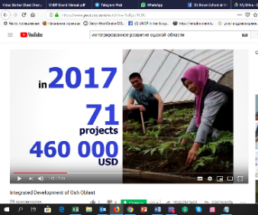  Video presentation of the Programme interim progress | https://www.youtube.com/watch?v=P4AB_NAxa8I Russian
2. |  | https://www.youtube.com/watch?v=l1uKppl1L9U  English
3. | 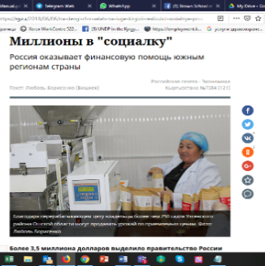  Russia is providing financial support to the southern provinces | https://m.facebook.com/story.php?story_fbid=1738131716282730&id=116487388447179
4. |  | https://rg.ru/2018/06/06/na-dengi-rf-v-selah-na-iuge-kirgizii-realizuiut-socialnye-proekty.html
5. | 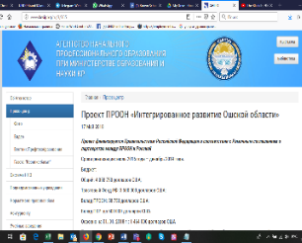  UNDP Integrated area-based development Programme in Osh province | http://www.kesip.kg/ru/3/335
6. | 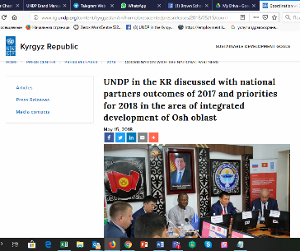  Program’s Board activities | http://www.kg.undp.org/content/kyrgyzstan/en/home/presscenter/pressreleases/2018/05/15/coordination-with-the-national-partners-.html
7. |  | http://www.kg.undp.org/content/kyrgyzstan/ru/home/presscenter/pressreleases/2018/05/15/coordination-with-the-national-partners-.html
8. |  | https://www.youtube.com/watch?v=VP00_ld95mg Osh TV (starting at14:35 – 20:40)
9. |  | https://www.youtube.com/watch?v=w2i9-foK8DY Osh TV (starting at 11:28)
10. | 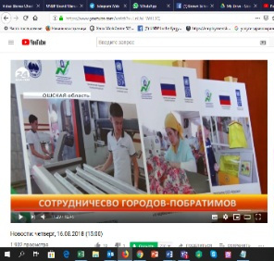  Investment round table attended by representatives of business communities from Saint-Petersburg and Osh | https://www.youtube.com/watch?v=LnUuI_WXL3Q starting at 11:16
11. |  | https://www.facebook.com/undpkg/posts/1807717755990792
12. | 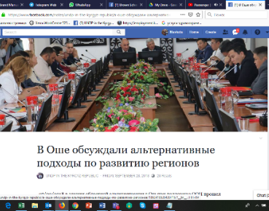  Discussion of alternative approaches to regional development (FAO/UNDP) | Фото: https://flic.kr/s/aHsmsPK7f3  https://bit.ly/2xHXGpa
13. |  | https://bit.ly/2SzeHu0
14. |  | http://kabar.kg/news/sotrudnik-fao-oon-nevozmozhno-razvivat-regiony-podderzhivaia-tol-ko-odnu-ili-neskol-ko-sektorov-ekonomiki/
15. |  | http://www.for.kg/news-515212-ru.html
16. | Public services via “one stop shop “ in village in Uzgen | http://www.kg.undp.org/content/kyrgyzstan/ru/home/presscenter/pressreleases/2018/07/public-services-window-in-uzgen-.html
Component 1. Sustainable agriculture, tourism, trade and promotion of ‘green technologies”
Development of Strategic Sustainable Development Plans in the pilot municipalities
Partnerships with local self-government
17. | 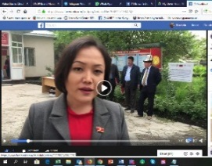  Demonstration of the Service delivery Center operations in the Karool village | https://www.facebook.com/undpkg/videos/1662908117138424/
18. |  | https://www.facebook.com/undpkg/posts/1662571790505390
19 | 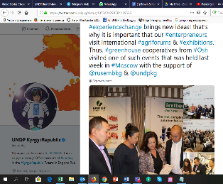  Entrepreneurs from Osh participate in the “Greenhouse farming of Russia - 2018” Forum in Moscow | https://m.facebook.com/story.php?story_fbid=1966904843405415&id=116487388447179
20. |  | https://twitter.com/undpkg/status/1073421293784129536

21. | 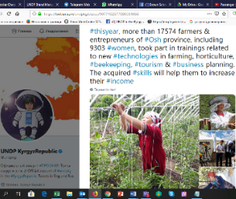  Brief post about the progress in agricultural technologies development | https://m.facebook.com/story.php?story_fbid=1981347995294433&id=116487388447179
22. |  | https://twitter.com/undpkg/status/1077102577593081856
23. | 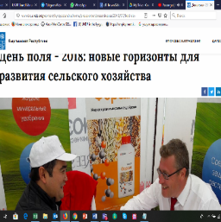  Day of the Field – 2018: new horizons for the agricultural development | http://www.kg.undp.org/content/kyrgyzstan/ru/home/presscenter/pressreleases/2018/07/field-day---2018--new-horizons-for-agro-development.html
24. |  | http://www.kg.undp.org/content/kyrgyzstan/en/home/presscenter/pressreleases/2018/07/field-day---2018--new-horizons-for-agro-development.html
25. | 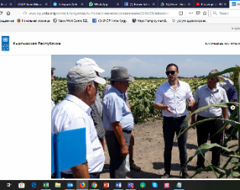  Study tour for farmers from the Osh province | http://www.kg.undp.org/content/kyrgyzstan/ru/home/presscenter/pressreleases/2018/08/educational-tour-for-farmers-.html
26. |  | http://www.kg.undp.org/content/kyrgyzstan/en/home/presscenter/pressreleases/2018/08/educational-tour-for-farmers-.html
27. | 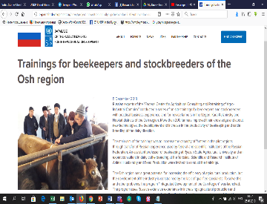  Specially invited experts from Russian research centers deliver trainings for beekepers and cattle breeders in Osh | http://expertsfordevelopment.ru/news/project-news/treningi-dlya-pchelovodov-i-zhivotnovodov-oshskoy-oblasti-.html
28. |  | https://m.facebook.com/story.php?story_fbid=332187370846630&id=116487388447179
29. | 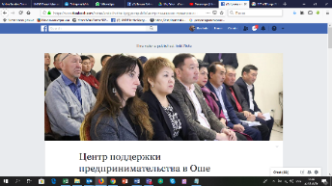  Anniversary of the Center for entrepreneurship support in Osh | https://bit.ly/2QfEg1h
30. |  | https://www.osce.org/programme-office-in-bishkek/405320?fbclid=IwAR1kl2tNlpklfijTDiiQXEF4vp1dvd_5jQlVOkQNNog9zsQCIqIKfPjE7hc
Financial literacy
31. | ToT on financial literacy jointly with the National Bank of the KR | https://m.facebook.com/story.php?story_fbid=1964745386954694&id=116487388447179
32. |  | https://twitter.com/undpkg/status/1072765976775663616
33. |  | https://twitter.com/NuriaChoibaeva/status/1073108931348709376
34. | 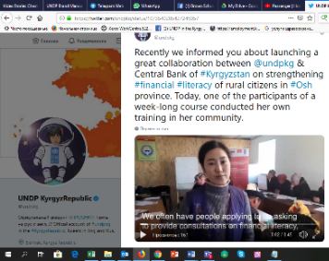  Financial literacy training in Tort-Kol aiylokmotu of the Uzgen district | https://m.facebook.com/story.php?story_fbid=1967402716688961&id=116487388447179
35. |  | https://twitter.com/undpkg/status/1073540205427245057
Sustainable development and pasture management
36. | 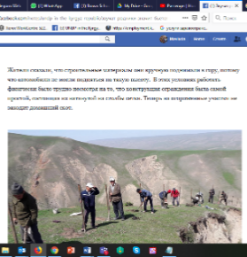  Fortification of 21 hectares of pastures and preservation of a water spring in Kok-Bel village of the Nookat district | https://twitter.com/undpkg/status/1034656724123353089
37. |  | https://bit.ly/2BUahdj
38. | Sheep bathing season launched in Uzgen | http://www.kg.undp.org/content/kyrgyzstan/ru/home/presscenter/pressreleases/2018/07/swimming-season-for-sheep-was-opened-in-uzgen.html
Green technology development
39. | 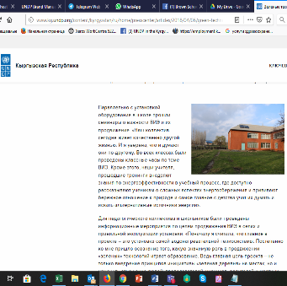 | http://www.kg.undp.org/content/kyrgyzstan/ru/home/presscenter/articles/2018/04/06/green-technologies-embracing-our-villages.html
40. | Green technologies take over our villages | http://www.kg.undp.org/content/kyrgyzstan/en/home/presscenter/articles/2018/04/06/green-technologies-embracing-our-villages.html
41. | We implement projects in remote communities to let people benefit from sustainable income generation based on green technologies. | https://m.facebook.com/story.php?story_fbid=1696727543756481&id=116487388447179
42. | Bio gas installation success story:  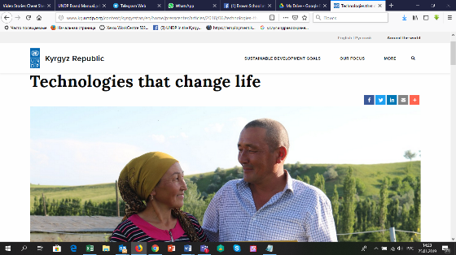  “We’ve got gas, how about you?” | https://m.facebook.com/notes/undp-in-the-kyrgyz-republic/%D0%B0-%D1%83-%D0%BD%D0%B0%D1%81-%D0%BD%D0%B0-%D1%84%D0%B5%D1%80%D0%BC%D0%B5-%D0%B3%D0%B0%D0%B7-%D0%B0-%D1%83-%D0%B2%D0%B0%D1%81/1702837953145440/
43. |  | http://www.kg.undp.org/content/kyrgyzstan/en/home/presscenter/articles/2018/06/technologies-that-change-life.html
44. |  | http://www.kg.undp.org/content/kyrgyzstan/ru/home/presscenter/articles/2018/06/technologies-that-change-life.html
45. | Videoblog on biogas installations produced by UNDP-Kygyzstan in Russian | https://www.facebook.com/undpkg/videos/1702859909809911/
46. | 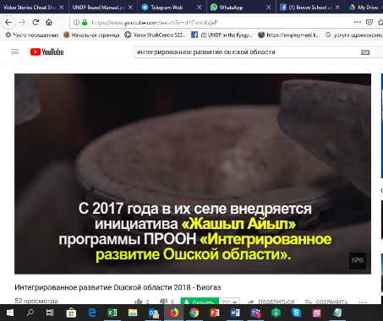  Videoblog on biogas installations produced by UNDP-Kygyzstan in English | https://drive.google.com/file/d/1uu0LWnWN6iSvrG5UmBARNz2sqHRndnQg/view?usp=sharing
47. |  | https://twitter.com/undpkg/status/1006480309418897408
48. |  | https://m.facebook.com/story.php?story_fbid=1703676919728210&id=116487388447179
49. |  | https://www.facebook.com/undpkg/videos/1703676919728210/
50. | Videoblog on biogas installations produced by Azattyk-media 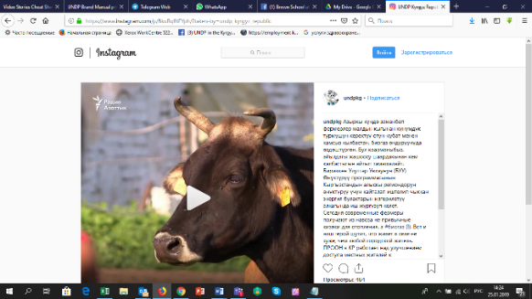 | https://www.facebook.com/undpkg/videos/1567577023352957/?hc_ref=ARSBpbl9jZftxqHAmuGhVb-VpD-cSlSf3kRUltNgoWVj3wIMM1uAEzpar6XGvckVNBM
51. |  | https://www.instagram.com/p/BkuRqlNFYph/?taken-by=undp_kyrgyz_republic
52. | Agribusiness development: Day of the Field in Lipetsk, RF | https://m.facebook.com/story.php?story_fbid=1742607529168482&id=116487388447179
53. |  | https://m.facebook.com/story.php?story_fbid=1739815202781048&id=116487388447179
54. |  | https://m.facebook.com/story.php?story_fbid=1742731755822726&id=116487388447179
55. | 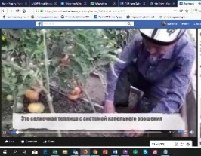  Greenhouse farming in Tort-Kol village | https://www.facebook.com/undpkg/videos/1696727543756481/
Building tourism capacity
56. | 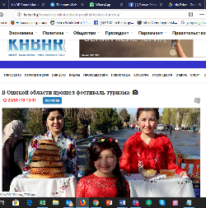  The first Festival of tourism in Osh | http://kabar.kg/news/v-oshskoi-oblasti-proshel-festival-turizma/
57. | Tourism festival in Uzgen (article in Kyrgyz entitled «Өзгөндөгү тарыхый эстеликтерди тааныткан фестиваль уюштурушту»)  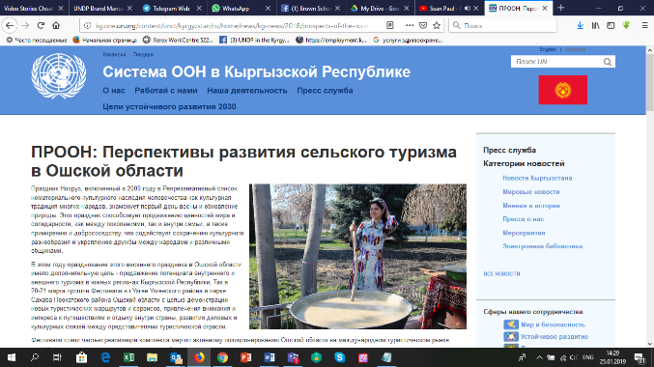 | http://www.turmush.kg/news:342316
58. |  | https://24.kg/obschestvo/79013_glavnyiy_simvol_nooruza_kak_vuzgene_gotovyat_sumolek/
59. |  | https://www.facebook.com/pg/undpkg/photos/?tab=album&album_id=1615624358533467
60 |  | http://kabar.kg/news/v-oshskoi-oblasti-proshel-festival-turizma/
61. |  | https://www.youtube.com/watch?v=zoNLWdlhadw  (starting at12:22) News report on Yntymak TV in Kyrgyz
62. |  | http://kg.one.un.org/content/unct/kyrgyzstan/ru/home/news/kg-news/2018/prospects-of-the-rural-tourism-development-in-osh-oblast.html
63 |  | http://kg.one.un.org/content/unct/kyrgyzstan/en/home/news/kg-news/2018/prospects-of-the-rural-tourism-development-in-osh-oblast/
64. | 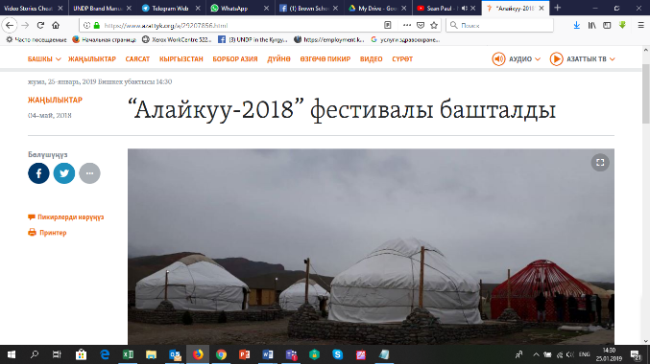  Tourism festival in the Alay-Kuu valley | http://kabar.kg/news/turoperatory-kr-khotiat-postroit-ekoturizm-v-doline-alaikuu/
65. |  | https://www.azattyk.org/a/29209760.html
66. |  | https://www.azattyk.org/a/29207856.html
67. |  | https://24.kg/obschestvo/83657_pervyiy_neposledniy_kak_alayku_provel_festival_iotchego_vvostorge_inostrantsyi/
68. |  | http://for.kg/news-481237-ru.html
69. |  | http://osh.turmush.kg/news:345084/?from=kg_turmush&place=newstoplast  http://osh.turmush.kg/news:345020  http://osh.turmush.kg/news:344996  http://osh.turmush.kg/ru/news:1447047/?from=ru_turmush&place=newstoplast  http://osh.turmush.kg/ru/news:1446878  http://osh.turmush.kg/ru/news:1446676
70. | 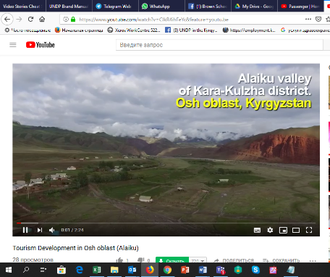  Tourism in Osh province: New tourism infrastructure in the Alay-Kuu village of the Kara-Kulja district in Osh province | https://twitter.com/undpkg/status/1045254417019285504
71. |  | https://twitter.com/UNDPEurasia/status/1045291141770498048
72. |  | https://youtu.be/CIkR4ihFeYc
73. |  | https://m.facebook.com/story.php?story_fbid=209418419777519&id=116487388447179
74. |  | https://www.instagram.com/p/BoMCrYAnbSP/?taken-by=undpkg
75. | 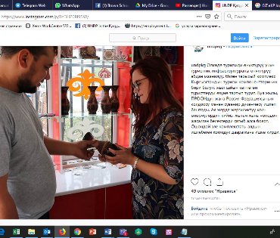  Souvenire shop/renovation of a public toilet at the Uzgen historical monument | https://www.instagram.com/p/Bn3HZ0Rl95W/
Support of women’s entrepenurship
76. | 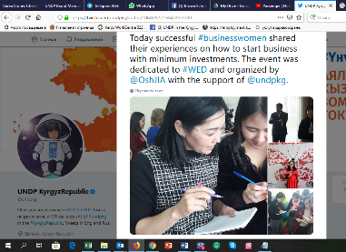  Public activities on the occasion of the International Women’s Entrepreneurship Day attended by women activists from the local communities | https://twitter.com/undpkg/status/1064103618872258561
77. |  | https://twitter.com/undpkg/status/1064097016643502080
78. |  | https://m.facebook.com/story.php?story_fbid=1932184103544156&id=116487388447179
79. |  | https://m.facebook.com/story.php?story_fbid=1930838557012044&id=116487388447179
80. |  | https://m.facebook.com/story.php?story_fbid=1930837470345486&id=116487388447179
81. |  | https://www.instagram.com/p/BqWRmnfnUJR/
82. |  | https://www.instagram.com/p/BqWxE_hHXsL/
Component 2. Access to sustainable water supply
83. | 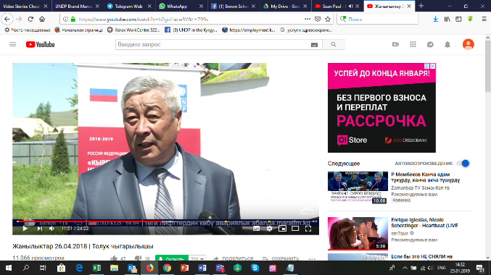  Delivery of equipment for testing the quality of drinking water to the Disease control center and Sanitary Epidemiological Surveillance station  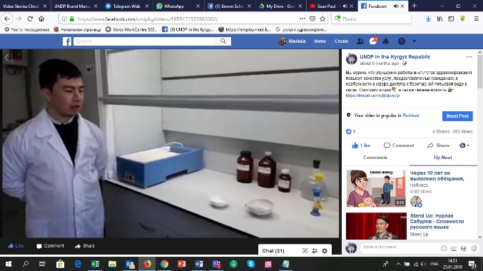 | http://yntymak.kg/ru/pitevaya-voda-v-kara-kulzhinskom-i-uzgenskom-rajonah-stanet-bezopasnej/
84. |  | http://kabar.kg/news/pit-evaia-voda-v-kara-kul-zhinskom-i-uzgenskom-raionakh-stanet-bezopasnei/
85. |  | http://www.turmush.kg/ru/news:1445318/?from=kgnews&place=maincats
86. |  | https://sputnik.kg/economy/20180427/1038887559/rossiya-zhabduu-berdi.html
87. |  | http://www.kg.undp.org/content/kyrgyzstan/ru/home/presscenter/pressreleases/2018/04/26/potable-water-of-kara-kulja-and-uzgen-shall-become-more-safe-3/
88. |  | https://www.facebook.com/undpkg/posts/1655439927885243
89. |  | https://www.facebook.com/undpkg/videos/1655472337882002/
90. |  | https://m.facebook.com/story.php?story_fbid=1655524147876821&id=116487388447179
91. |  | https://www.youtube.com/watch?v=b2guLlacw3Y&t=799s (Osh TV news report, starting at 8:44)
92. | Over 700 local people have access to safe drinking water in new settlements of Tashtak and Kalmak Kiya around the city of Uzgen in the Osh province | https://m.facebook.com/story.php?story_fbid=1937064136389486&id=116487388447179
93. |  | https://twitter.com/undpkg/status/1032816293504839682
94. |  | https://www.instagram.com/p/Bm2NEJNFmmF/?utm_source=ig_share_sheet&igshid=hfly04ckz93m
95. | Drinking water is getting cleaner in Uzgen | http://www.kg.undp.org/content/kyrgyzstan/ru/home/presscenter/pressreleases/2018/07/water-in-uzgen-became-clean.html
Component 3. Improvement in welfare of rural communities through a rehabilitation of social and economic infrastructure.
96. | Information on Delivery of cardiologic equipment to health providers in Osh province posted on the UNDP official website | http://www.kg.undp.org/content/kyrgyzstan/ru/home/presscenter/articles/2018/04/13/taza-koom-starts-from-taza-jurok.html
97. |  | https://www.facebook.com/undpkg/posts/1642879779141258
98. | 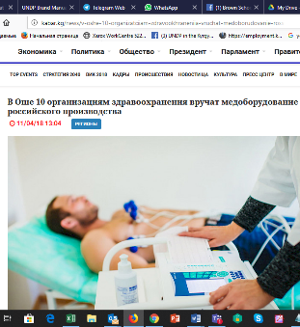  Official ceremony of delivery of cardiologic equipment from Russia to health providers in Osh province | http://kabar.kg/news/v-oshe-10-organizatciiam-zdravookhraneniia-vruchat-medoborudovanie-rossiiskogo-proizvodstva/
99. |  | http://kabar.kg/news/v-oshe-organizatciiam-zdravookhraneniia-vruchili-rossiiskoe-medoborudovanie/
100. | 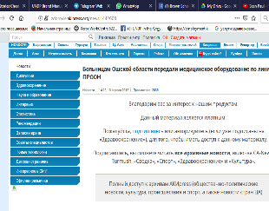  Hospitals in Osh have received medical equipment facilitated by UNDP | http://zdorovie.akipress.org/news:1442608
101. | 10 health providers in Osh to receive medical equipment from Russia | http://www.for.kg/news-477564-ru.html
102. | 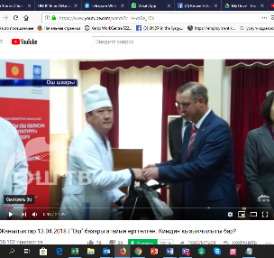  News report on delivery of cardiologic equipment to health providers in Osh province | https://www.youtube.com/watch?v=le-gt9e_1Ek (Osh TV news report in Kyrgyz, starting at 9:34)
103. | 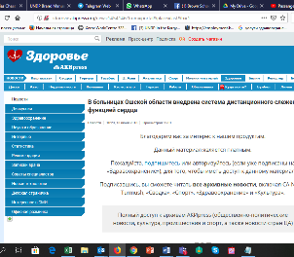  Distant heart monitoring available in Osh clinics | http://zdorovie.akipress.org/news:1454146?from=portal&place=last&b=1
104. | Inauguration of a football field | https://twitter.com/undpkg/status/1049992905836900352
105. |  | https://m.facebook.com/story.php?story_fbid=923504207839465&id=116487388447179
106. |  | https://www.instagram.com/p/BowJsSaHPII/?taken-by=undpkg
107. |  | http://nlkg.kg/ru/society/sport/zhenskij-futbol-v-preddverii-mezhdunarodnogo-dnya-devochek
108. |  | https://osh.turmush.kg/news:353593?from=turmush&place=byregion
109. |  | https://www.youtube.com/watch?v=_O8Sqpo5ZYI (starting at 25:15)
110. |  | https://www.youtube.com/watch?v=0_WWwWEdqVc (starting at 16:45)
111. | Osh health workers have discussed prevention and treatment of heart strokes | http://zdorovie.akipress.org/news:1452140/
112. | Use of medical equipment in health care units in Osh. | https://m.facebook.com/story.php?story_fbid=1974385175990715&id=116487388447179
113. |  | https://twitter.com/undpkg/status/1075530075280424960
114. | 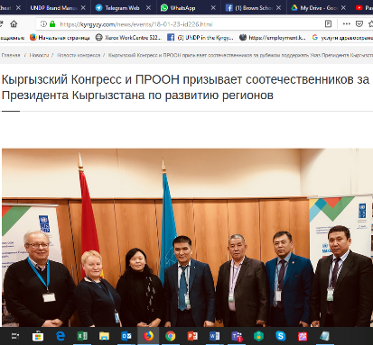  Partnership with labor migrant community in the Russian Federation | https://www.facebook.com/undpkg/videos/1710696082359627/  http://old.kabar.kg/rus/society/full/45838  http://members.vb.kg/2018/02/20/podrob/2.html  https://kyrgyzy.com/news/events/18-01-23-id226.html  https://kyrgyzy.com/program/soczialnaya-sfera/223-pomozhem-rodnomu-selu.html  https://kyrgyzy.com/news/events/18-02-14-id271.html  https://www.facebook.com/kyrgyzycom/posts/1535828333182597  https://www.facebook.com/kyrgyzycom/posts/1529173260514771  https://www.facebook.com/100000371751112/videos/1752461224776252/  http://members.vb.kg/2018/02/20/podrob/2.html  http://soyuznarodov.ru/biznes-forum-tabarman

Component 4. Improved employment opportunities via strengthened system of vocational and technical education and training
115. | Short-term courses for the rural youth to become pastry-cooks and sewers | https://www.facebook.com/undpkg/posts/1691411640954738
116. | Delivery of equipment to support the development of entrepreneurship among rural girls | https://twitter.com/undpkg/status/1057873383763927040
Component 5. Improving the local communities’ resilience to natural disasters.
117. | Protection of landslide prone slopes in Nookat disrtrict | https://24.kg/obschestvo/89154_selo_kok-bel_est_zemlya_net_vodyi_est_mecheti_net_detsada/
Press-tour for the Programme of KTRK «National strategy»:
https://www.youtube.com/watch?time_continue=1131&v=GXaE9VbmURM (на рус. яз.)
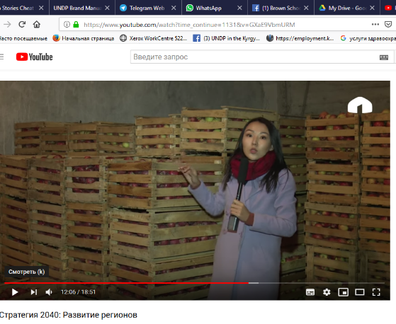
http://www.ktrk.kg/media/video/12770 (на рус. яз.)
https://www.youtube.com/watch?v=iksBbWuUo4Y (на кырг. яз. Часть 1)
https://www.youtube.com/watch?v=LR3texnfMLo (на кырг. яз. Часть 2)
Photos:

Specially invited experts from Russia deliver training for beneficiaries
https://flic.kr/s/aHsmwd3e3i
https://flic.kr/s/aHsmsbADA6

Inauguration of a football field in Karool AO of the Uzgen district in Osh province
https://www.flickr.com/photos/organize/?start_tab=new_set

Green technologies
https://flic.kr/s/aHsmpG4W2E
https://flic.kr/s/aHskGLr71K
https://flic.kr/s/aHskL4vAdd
https://flic.kr/s/aHsmpNt5oj

Pastures/Mitigation:
https://flic.kr/s/aHsmgvSGhQ
https://flic.kr/s/aHsmv82YQT

Use of cardio equipment supplied through the Program
https://flic.kr/s/aHskGLsqxc

Use of equipment provided to the SES
https://flic.kr/s/aHsmqo3hUZ

Guest house/Yurtas village/Ethnic café/Sun-dried fruits
https://drive.google.com/open?id=1QRRbAdqDVllGgMaHs-QoFzMU0IFgBUYl
https://drive.google.com/open?id=1PhBLM7sdo4M5k14W1dKz3ESd3ARhD13E
https://drive.google.com/open?id=1ZshaS_aisBG7qnVKDNZ1nYupCJgfRW9R
https://drive.google.com/open?id=1ZbhIDNHe0_Fuc-sc5wNeHMIW6F4yOUtg

Drip irrigation used in greenhouse:
https://drive.google.com/open?id=1Gee0gxAOim13MMk1cUSWsZl7DmsZyGHH

Biogas installation/’green’ project:
https://drive.google.com/open?id=1g2Pr88h0Lo4UqiaI26PW3EctoRx1C4hb

Based on CDR as of 04.02.2019. Final financial report will follow the 2019 CDR approval in early March 2019.

