Disaster Risk Management Unit

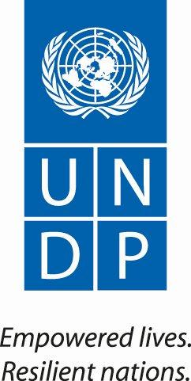





Project: UNDP-Building national disaster reduction systems and management capacities in Lebanon (DRR) – phase 2

Narrative Progress Report

Period covered: June 2013 – March 2014

Table of Contents

1- List of Abbreviations 3
2- Project Background and Objectives 4
2.1 Project Background………………………………………..…………………………….4
2.2 Objectives ………………………………………………………………………………...4
2.3 Update on Outcomes ……………………………………………………………………4
3- Project Performance …………5
3.1. Progress achieved against project outputs…………………………………………...6
3.2. Reason if progress below target………………………………………………………13
3.3. Update on partnership strategies reporting………………………………………….14
3.4. Recommendations and proposed action……………………………………………14
4- Project Performance - Implementation Issues ……………………………………....16
5- Soft Assistance…………………………………………………………………………….16
6- Lessons Learnt……………………………………………………………………………..16
7-Annexes………………………………………………………………………………………17

- List of Abbreviations

DRM Disaster Risk Management
PMO Prime Minister Office
NCC National Coordination Committee
COM Council of Ministers
UNDP United Nations Development Programme
DRR Disaster Risk Reduction
NRP National Response Plan
HFA Hyogo Framework of Action
UNHCR United Nations High Commissioner for Refugees
NOR National Operations Room
MOR Mobile Operation Room
CBRN Chemical – Biological – Radioactive - Nuclear
BRHIA Beirut Rafik Hariri International Airport
UN ISDR United Nations Office for Disaster Reduction
INSARAG International Search and Rescue Advisory Group
CDR Council for Development and Reconstruction
NGO None Governmental Organizations
LAF Lebanese Armed Forces
ISF Internal Security Forces
CDR Council for Development and Reconstruction
CNRS National Council for Scientific Research
LRC Lebanese Red Cross
NCLW National Commission for Lebanese Women
GARD Getting Airport Ready for Disasters
WHO World Health Organization
SOP Standard Operating Procedures
QPR Quarterly Progress Report
APR Annual Progress Report
M&E Monitoring and Evaluation

- Project Background, Objectives and Achievements

2.1 Project Background

Lebanon is subject to a wide range of natural hazards, the biggest threat being of a severe earthquake and/or an associated Tsunami. Smaller-scale disasters which the country also faces include floods, forest fires, land-slides and drought.
Accordingly, in May 2009, UNDP and the Lebanese Government represented by the Prime Minister signed a project document on “Strengthening Disaster Risk Management Capacities in Lebanon”. The project aims to help the Lebanese Government develop its disaster management and corresponding risk reduction strategy.
In order to achieve its outcome “mainstreaming disaste4r preparedness and management in national development framework strategies in Lebanon”, the project needed to evolve through two main phases to provide a stable platform for future developments:

2.2 Objectives

In Phase I (2010-2011-2012), the focus was on initiating a framework at the National level as part of the following outputs:

- Disaster Risk Reduction and Management Unit Established
- National DRR strategy and systems developed and implemented
- Building National capacities at central and regional levels
- Public Awareness on DRR raised
- Gender Equality initiatives integrated into DRR Institutional framework and Regional and Local Plans.

The objectives of Phase II (2013-2014-2015) consist in finalizing the work previously done in addition to targeting sectoral and local levels with a particular concentration on capacity building focusing on highly vulnerable groups as part of the following outputs:

- Institutional mechanisms for DRM established with sufficient capacities to increase national resilience against disaster risks
- DRR considerations integrated into development planning of critical economic and social sectors to reduce vulnerability of development infrastructure and assets
- Local and community capacity for disaster risk reduction enhanced to reduce losses to life and property.

2.3 Update on outcomes

In 2013, the Disaster Risk Management – DRM Unit has made significant progress towards achieving the results of several project objectives, outcomes and activities at the national, sectoral and local levels.

At the national level, steady increase has been achieved in governmental support and a stronger engagement at the institutional level was witnessed, and has been reflected through the establishment of the National Coordination Committee (NCC) by the Prime Minister. The NCC was mandated in February 2013 by decision number 41/2013 under the chairmanship of the Secretary of the Supreme Council for Defense and the membership of major relief commission departments and director generals of concerned relevant ministries including the DRM Unit. The NCC has provided a major boost for Disaster Risk Management at the national level and its work has been very promising making it a reference in building Lebanon’s resilience against natural and as man-made disasters.
In addition, a major breakthrough progress has been accomplished in 2013 at the national level through the finalization of the National Response Plan which became a reference document for all concerned agencies, stakeholders and decision makers.
The first direct impact of the NRP was reflected through the design and implementation of the first-ever table top exercise based on the Prime Minister’s request. The importance of this exercise was later recognized through the improvement of strategic agencies’ coordination in response to the explosions that took place in summer 2013.
The success of the table top exercise also triggered the PM's decision to automatically convene the NCC (which includes the DRM Unit) in the event of any major disaster for the coordination of inter-governmental response and recovery efforts and implementation of the National Response Plan.
In 2014, UNDP through the DRM Unit will support the government among others in equipping the much needed National Operations Room for natural and man-made disasters management so it can be fully functional and operational.
The final flood assessment report has also been finalized and submitted by the CNRS with the support of UNDP. The flood hazard intensity maps and flood hazard maps which were developed mainly provides crucial information to the government’s ability to respond to potential floods.
At the local level and in addition to the finalization of Beirut Response Plan in the previous reporting phase of the project, Jbeil and Tripoli Cazas Response Plans have been completed thus empowering the local and regional authorities’ ability to undertake DRM activities. Continuous support is still being provided to Saida as part of the finalization of the Caza’s Response Plan
The formulation of those local response plans reflect a significant progress towards building the capacities of local authorities, increasing their resilience to both natural and man-made disasters and increasing community awareness on disaster risk reduction.

Local and community awareness on DRR has also been enhanced through the DRM Unit's collaboration with universities, NGO's and others.

UNDP and the DRM Unit are continuously seeking to build new partnerships with counterparts willing to support the Lebanese government in strengthening its DRM capacities and to share their know-how and experience in this field. As such, new partnerships with the Italian Civil Protection and the French Consulate were agreed upon.

3- Project Performance

3.1 Progress achieved against project outputs

3.1. Output 1: Institutional mechanisms for DRM established with sufficient capacities to increase resilience against disaster risks.

3.1.1.1HFA progress report finalized and submitted to UNISDR

In 2014, with the formation of a new government, new liaison officers for the HFA will be appointed from the respective agencies and ministries.
In preparation to the 3rd HFA progress report, letters were addressed to all concerned ministries, agencies and stakeholders to present their remarks, comments including progress and challenges. Separate meetings are also being conducted with these institutions to record their findings prior to holding a general meeting with the HFA new liaison officers to discuss all the findings and submit a consolidated report in April 2014. So far, major accomplishments have been recorded such as the government’s commitment to giving DRM high priority, strengthened cooperation and coordination among different stakeholders, development and implementation of the National Response Plan, an enhanced understanding and work of DRR at the sectoral and local levels especially cities that have high density in population, gender and DRR enhanced.
Main challenges remain such as slow legislation process in Lebanon and the lack of fundingfor DRR at the government, sectoral and local levels.

3.1.1.2 Finalize, approve and implement the National Response Plan (NRP)
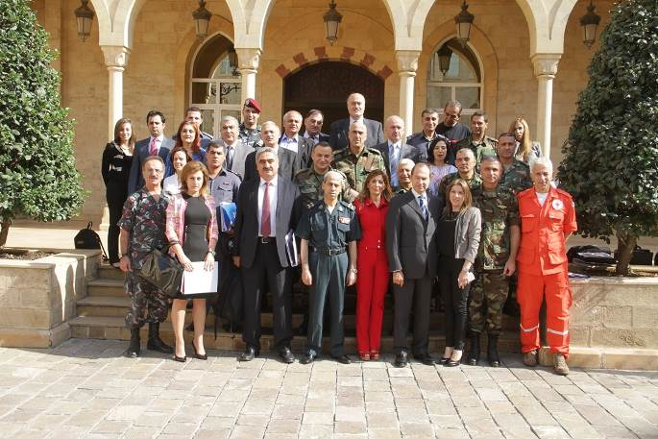
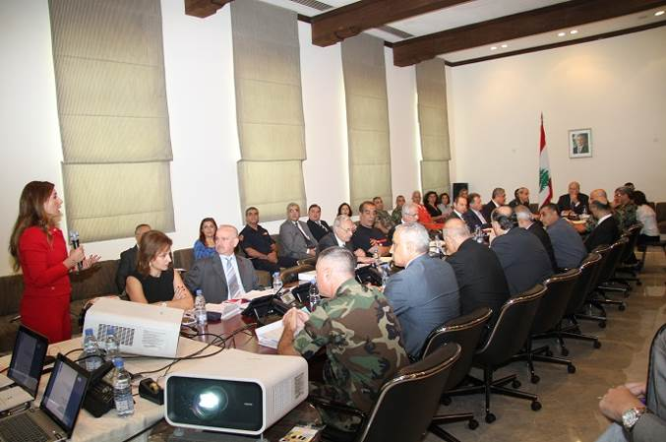
By the end of 2013, the DRM Unit concluded an important task within the project through the accomplishment of the NRP which is now considered as the reference for all agencies in the event of any natural or man-made disaster. This step has paved the way for the proper implementation and endorsement of the NRF at the National level. The NRP is considered the blueprint guideline for the response plans at the sectoral and local levels. This major result that took about three years of work accomplished a significant project achievement at the national level.
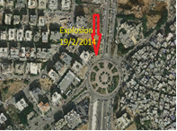
Moreover, as part of the implementation of the national response plan and within the framework of the National Coordination Committee (NCC) formed by the Presidency of the Council of Ministers in February 2013 with the objective to coordinate disaster response and crisis, the NCC held response and coordination meetings following the two explosions that occurred on 21st of January 2014 in Haret Hreik and 19th of February, 2014 in Bir Hassan under the leadership of the general secretary of the high defense council General Kheir and with the presence of director generals from concerned ministries, agencies and the DRM project team. These meetings are increasingly becoming efficient and the project team is further developing and providing updates that are being integrated to the meetings such as site maps, losses and response taken, recommendations and follow up of actions during the disasters, this serves to make up trends in response and follow up progress.

3.1.1.3 Support the establishment and set up of a fully functional and operational central National Operations Room (NOR)

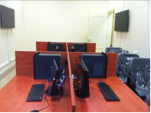
As proposed within the general framework of the national response plan there is a need to establish a National Operations Room (NOR) that will ensure a holistic approach, strategic coordination, implementation of minimum standards in response that caters to the needs, priorities and that maximizes the impact in the management of resources, information and disaster mitigation. This NOR will be at the center of all response and will be mobilized during major operations to protect and safeguard civilians and property. Moreover the NOR will be complemented by a technical operations room run 24 hours a day 7 days a week by the Lebanese army. This room has been allocated within the offices of the General Secretary of Defense at the Presidency of the Council of Ministers. So far the project has supported the establishment of the technical room with offices, desks, laptops, computers, LCD screens, photocopier machines, GIS soft wares and systems, TV's etc the room is currently functional with a team from the LAF.
Currently the project is preparing all the set up for the NOR.

3.1.1.4 Simulation on the NRP (LAF, UNDP, and other stakeholders)

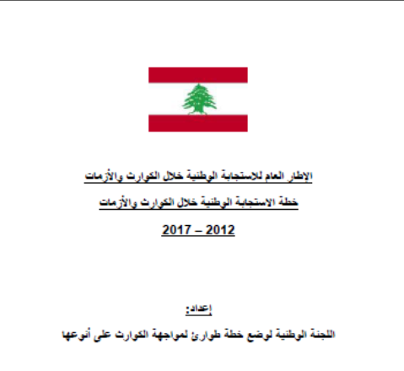
Within the framework of the implementation of the national response plan and the request of the Prime Minister to implement a table top exercise for the coordination among concerned sectors, a table top exercise which is considered the first of its kind in Lebanon was prepared by the NCC's “Technical Coordination Committee” with the objective of testing the NRP in terms in inter-ministerial coordination in the event of a disaster.
The table top exercise was implemented on the 30th of October 2013 at the Grand Serail with the participation of Prime Minister Mikati, President of the NCC and Secretary-General of the Supreme Council for the defense General Kheir, UNDP Country Director Mr. Luca Renda, the director generals of the concerned agencies, members of the technical committee, Army command operations, representatives of the Internal Security Forces, Civil defense, Lebanese Red Cross, Beirut Fire Brigade, and the UNDP DRM Unit.
The importance of this exercise lies in the cooperation and work among all concerned agencies and bodies in one place through a National Operations Room to coordinate response and unify efforts.
The success of the table top exercise also triggered the PM's decision to automatically convene the NCC (which includes the DRM Unit) in the event of any major disaster for the coordination of inter-governmental response and recovery efforts and implementation of the National Response Plan.
Following the successful implementation of the table top exercise in 2013, a real life simulation at the regional level is being prepared. The simulation which is projected to take place on the 8th of May 2014 entails response to an earthquake/Tsunamiin the region of Byblos. This exercise will be the first of its kind at the regional level and will test the capacities of concerned local government institutions in communication and coordination during times of disaster through the activation of crisis management. The simulation will also be a good opportunity to enhance security agencies and regional and local level authorities’ coordination. Weekly meetings among the concerned agencies have been maintained since January 2014, so far the scenario and field simulation exercises have been established, schools trained on drills and evacuation plans, rehearsals are also set up prior to the implementation date.

3.1.1.5 Study tour for Operation Group

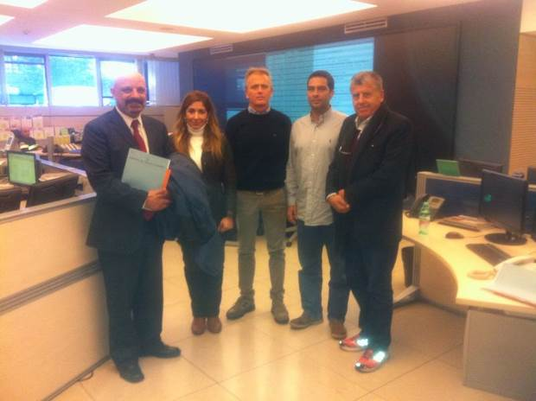
With the objective to enhance the capacities of the Lebanese response agencies and learn from the Italian experience which can be customized to the Lebanese context, the UNDP DRM Unit with the support of TAIEX "Technical Assistance, Information and Exchange" at the EU implemented a study visit to the Italian National Civil Protection Department in November 2013 through a delegation including the project manager of the DRM Unit, a representative of the general defense council, and the director of the Remote Sensing Centre at CNRS.
Technical know-how and expertise of the attendants were enhanced through this study tour which set forth potential cooperation with the Italian National Civil Protection Department who is willing and able to provide support and to start a bilateral cooperation agreement with the UNDP DRM Unit.

3.1.1.6 Organize training sessions for Parliamentarians, Media, Religious Leaders and Government officers
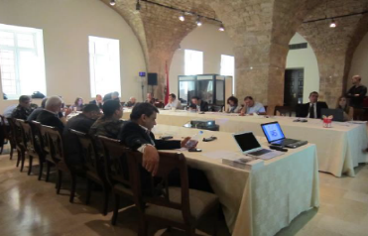
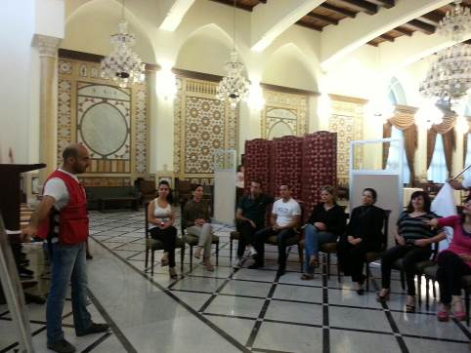
As part of raising awareness and coordinating with different concerned entities including the government public sector the DRM Unit launched a series of trainings for the public sector entities, the first on the 10th and 12th of October and the second on the 24th and 25th of October 2013 for the staff and management team of Grand Serail, targeting more than 80 individuals. Moreover, training for the Internal security forces was launched in December targeting more than 60 members.
These trainings were conducted in cooperation with the Lebanese Army, the Civil Defense and the Red Cross
and proved to be an effective tool to raising awareness among both the public and private sectors.
These trainings add noteworthy value to project objectives as they support saving lives, protecting assets not only in the work place but in households and communities.

3.1.1.7 DRR Day related awareness activities for stakeholders

Since the IDRR includes raising awareness about the importance of DRR and encouraging every citizen and government to take part in building more disaster resilient communities and nations, the UNDP DRM unit prepared several activities which were launched as of October 2013 until the end of December 2013 including:
a) Drills conducted in BAU and LAU Universities which included training their core groups on first aid, search and rescue, as well as securing the perimeter for response agencies to intervene and training on evacuation plans.
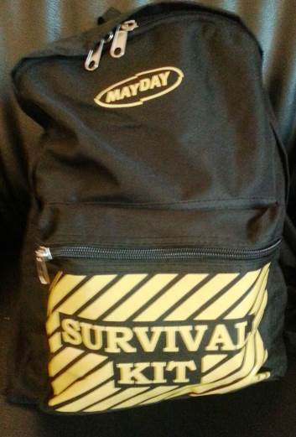
b) Distribution of Emergency kits: Within the context of spreading awareness on disaster risk reduction and safety measures and as part of strengthening the capacities of the personnel and management in private and public institutions to respond efficiently and effectively in the event of an emergency, the UNDP DRM Unit distributed 300 prototype emergency kits to public and private institutions during December 2013 so they can also replicate them within their environment and help spread safety and DRR messages.

3.1.1.9 Early Recovery Workshop with UNISDR

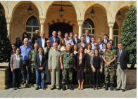
The UNDP DRM Unit in collaboration with the Prime Minister’s Office, UNISDR, IRP, implemented a workshop presented by UNISDR team on disaster recovery planning at the Grand Serail in Beirut, in October 2013. The workshop that was supported through an EC-funded project included around 25 high-level officials from different ministries who explored options of recovery from disasters and conflicts.
Various aspects of recovery planning were discussed in the workshop. In particular, strategies and actions to “build back better” after disaster and conflict were explored using local and global cases as reference. The lessons on recovery, as compiled by IRP from different experiences around the globe provided the participants with additional input to build on the existing government initiatives. The unit will utilize the gained know-how and skills in its work on disaster recovery planning within the context of the project objectives.

3.1.1.10 Gender and DRR: NCLW Grant Agreement to increase DRR awareness in Mount Lebanon and North Lebanon

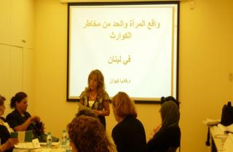
Within the “Gender and DRR component” implemented by the National Commission for Lebanese Women (NCLW) in cooperation with UNDP, the NCLW organized three training workshops in 2013 (one in Baabda, one in Tripoli and one in Zahle). Each workshop included more than 25 participants representing NGO's and women members of municipal councils and aimed at raising awareness and improving the capacities of women in natural disasters situations and preparing them to reduce the risks of natural disasters. The workshops included sessions implemented by the UNDP DRM Unit on DRR and DRM concepts and on the role of women in DRR as well as on the Hyogo Framework for Action HFA, in addition to Briefings on natural disasters in Lebanon The DRM Unit support for those workshops comes from the project objective of empowering women since they have significant contributions in building community resilience to disasters, crisis, prevention and recovery.

3.1.2 Output 2 : DRR Considerations integrated into development planning of critical economic and social sectors to reduce vulnerability of development infrastructure and assets

3.1.2.1 Updating of hazard maps for all important hazards including earthquakes, floods, forest fires, tsunamis and landslides

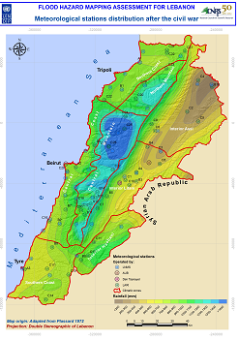
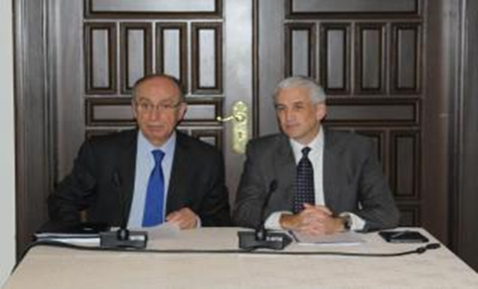
Based on UNDP's project "Flood hazard mapping assessment for Lebanon" which aims to improve the government's capacities in disaster preparedness and to support the National Strategy for disaster risk management, relevant data was gathered and organized to get a hazard picture for different Lebanese regions. A "Flood Hazard Mapping Assessment" report was developed and submitted by CNRS to the UNDP DRM unit. The report sums up all data acquisition, historical and literature review and flood plain delineation to hazard mapping as well as data about the history of floods that had hit the country within the last century for the researchers to use when gauging floodplains and the places that are mostly vulnerable to flooding. It scans through the major physical and hydrological characteristics of the Lebanese watershed. With the completion of the report in 2013 another important project objective has been attained that will serve future actions and plans for disaster risk reduction at the national, sectoral and local levels.
Moreover since incorporating disaster risk reduction (DRR) to natural hazards including floods has been one of the priorities for Lebanon's national agenda and based on the accomplishment of the "Flood hazard assessment report for Lebanon", the DRM unit implemented a workshop in cooperation with the National Council for Scientific Research (NCSR) on the 19th of March, 2014 to disseminate the findings of the Flood Assessment Report for Lebanon.
The workshop was held with the participation of the Secretary General of the National Council for Scientific Research, Dr. Mouin Hamza, and Acting UNDP Country Director, Mr. Shombi Sharp, in the presence of heads of municipalities, stakeholders, decision-makers, academics and specialists in the field.
The importance of disseminating the report findings is that it supports decision-makers, planners and relevant community stakeholders in improving the government's capacities in disaster preparedness. The report will serve as a pillar for the formation of strategies that improve social, physical and institutional resilience to flooding.
With the completion of the report and dissemination of the finding the project objective would have supported future actions and plans for disaster risk reduction at the national, sectoral and local levels to be accomplished.

Moreover, the National Forest Fire Management Strategy that was approved by the council of Ministers in May 2009 under decree 52/2009 still needs to be implemented, the project is working on launching the implementation of the strategy with the support of the Prime Minister's Office.

3.1.2.2 Support and set up coordination with the Ministry of Education MEHE

Within the framework of supporting key ministries in DRM and within the scope of the national response plan and coordination among different agencies, a consultant was hired to support the ministry and draft a plan to integrate the DRR in the Ministry of Education. The objective is to establish a response plan and disaster management cell at the Ministry of Education in line with the National Response Plan. A consultant has been appointed in January 2014 to support he ministry in establishing its response plan. Since early January weekly coordination meetings with MEHE were conducted, ministry technical assistance needs were identified, response plan is in process of development, and liaison with the ministry's regional affiliates in Tripoli and Byblos is maintained.

3.1.2.3 Introduce DRR concepts into the ENA and Military Academy Curriculums

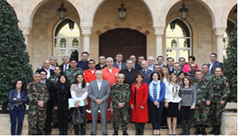
As part of increasing awareness and to help mitigate the repercussions of future potential natural and man-made disasters, the project implemented a 3 day "Training of Trainers on Disaster Risk Management and Emergency Response,” under the patronage of the Secretary General of the High Council of Defense, Major General Mohammad Kheir and UNDP Country Director, Mr. Luca Renda from 19th till the 21st of February 2014 at the Grand Serail.
The main objective of the interactive training that was presented by Mr. Usman Qazi who is a senior recovery advisor at the UN was to enhance the understanding of disaster management and as well as engage the participants in practical techniques for risk reduction in development planning and management.
The three day training included sessions, working groups and case studies on:

• The basic terms in the discipline of disaster management;
• Overview of the various stages in disaster risk management spectrum;
• Identification of the types and sources of risk as well as prioritizing the actions for disaster risk reduction;
• Outline a strategy for risk reduction in development planning and management.
The training was attended by 39 trainees, including senior members representing the Lebanese Army, Internal Security Forces, Red Cross, Civil Defense and civil servants.
The main achievement from this pilot training is the enhanced public and military human resource capacities thanks to the improved competencies on DRM. This will support concerned entities in integrating disaster risk reduction into development projects within their entities.

3.1.2.4 Drills with LAF, LRC, and Civil Defense in 5 different Universities

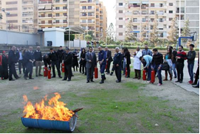
In accordance with project outputs to increase awareness, preparedness and emergency management of public and private institutions, the UNDP DRM Unit implemented two pilot trainings and drills at LAU Jbeil and in BAU Dibiyeh in September 2013 with more than 25 participants in each training. The main participants included security, staff, management, and students.
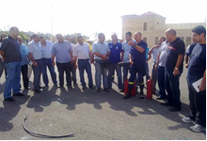
Within the same context, two pilot trainings on DRR were implemented at the campus of the Beirut Arab University in Beirut on the 11th and 12th of February and on the on the 11th and 12th of March 2014. The training’s main objective was to enhance good practices in the field of disaster risk reduction in order to be ready and prepared in the event of any disaster.
The trainings were attended by more than 120 participants representing faculty, management, staff, security and students at the university was implemented within the framework of cooperation with the civil defense, the Lebanese army and the Lebanese Red Cross. The training included sessions on first aid, search and rescue, evacuation, as well as securing the perimeter for response agencies to intervene in the event of a disaster.

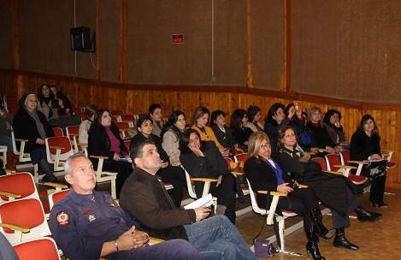
Moreover a training was implemented for the 40 members of management and staff of St Coeur Jbeil on the 15th of February with the support of the civil defense and focused on safety and actions to be taken before during and after a disaster as well as training on the implementation of evacuation plans as part of getting ready and responding efficiently to disasters with the objective of saving lives.

3.1.3 Output 3: Local and community Capacity for DRR enhanced to reduce losses to life and property

3.1.3.1 Byblos Cooperation
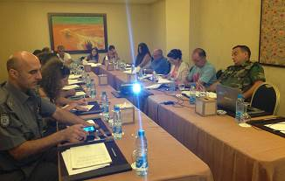
A risk assessment was implemented by the UNDP DRM Unit through a Norwegian consultant. The assessment highlighted the major vulnerabilities in municipal offices as well as services in the municipality and set recommendations.
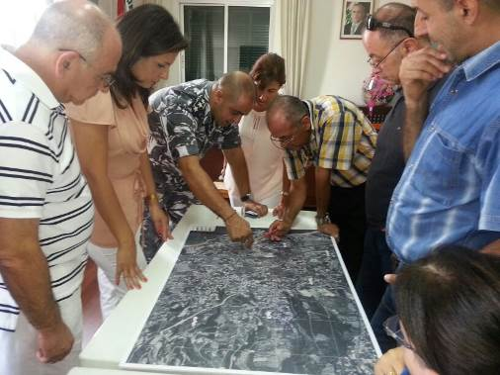
Following the risk assessment, a consultant from the DRM Unit was appointed to support the development of the response plan for the Caza of Byblos. After four months of meetings with concerned agencies the response plan was concluded in November 2013.
The results and report support project objectives at the local level by building the capacity of local stakeholders on emergency preparedness, response and risk reduction for communities and ultimately in mainstreaming disaster risk management into overall development planning in urban areas.
Following the development of the response plan for Byblos in 2014 a simulation and field exercise is projected to be implemented on the 8th of May, 2014 to test the effectiveness and efficiency of the response plan that was developed both regionally and at the national level within the framework of the National Response plan.
Moreover the project team was also present in the launching of the 100 resilient cities campaign as part of the Rockefeller 100 years challenge and gave a session on natural hazards, risk assessment, response and participated in the workshop that was implemented with the participation of Byblos Mayor Mr Ziad Hawat and Mr. Michael Berkowitz the managing director for 100 Resilient Cities at The Rockefeller Foundation.

3.1.3.2. Beirut Municipality Cooperation

The DRM Unit has finalized the Beirut response plan that will be discussed with Beirut governor. Moreover, the DRM Unit started cooperation with the municipality to implement a risk assessment which includes major offices and services as well as prepare for an earthquake master plan for the city of Beirut with the objective of making Beirut more resilient to such risks by providing pilot projects that can be replicated and by increasing awareness. The ultimate objective is making Beirut a role model city to potential natural and man-made disasters. In addition to that a project proposal has been developed and discussed with the municipality as well as concerned stakeholders.

3.1.3.3. Saida Municipality Cooperation
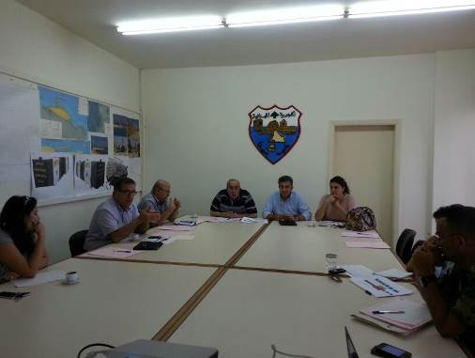
In accordance with supporting major Lebanese cities and based on meetings held with the representatives and mayor of Saida municipality, an agreement was reached for drafting theCaza’s response plan and relevant SOP's. A consultant was assigned and the cooperation with the municipality started in July 2013, however the political situation in the city has halted the meetings nevertheless the municipality is keen to start preparing the response plan as soon as possible.

3.1.3.4 Tripoli Municipality Cooperation

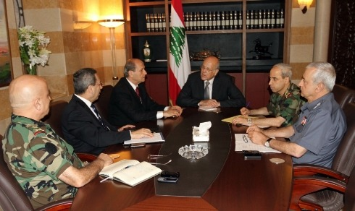
The UNDP DRM Unit has been actively participating in the meetings for Tripoli with the purpose of reactivating the operations room in Tripoli and preparing a response plan for Tripoli. As such the DRM Unit consultant has been appointed for this purpose to help in the development of a response plan for Tripoli, the activation and equipment of the disaster management room and trainings with the objective of enhancing emergency response for all types of disasters that might happen in Tripoli.
The response plan for Tripoli was developed following weekly meetings with the committee that was established by the Governor of North as well as coordination that was established with regional ministry and administrations in the North of Lebanon.
Moreover the technical specification of the Crisis Management Room at the Governorate of Tripoli were also developed and a table-top exercise was designed and planned to be implemented in Tripoli to test the effectiveness and efficiency of the response plan but it was postponed due to the security situation in Tripoli and in order to conduct the simulation under the patronage of Prime Minister’s Office.

3.1.3.5 Medco Presentation

As part of Medco’s Fuel Life seminar for raising awareness about contingency planning in the private sector and alongside the Lebanese Red Cross and Zod security, the DRM Unit project team was invited to speak at MEDCO's Fuel Life seminar that was held in Le Royal Hotel on Wednesday March 19th, 2014 for an elite audience of corporate VIPs. During this seminar, the project provided an overview of natural hazards and disaster that Lebanon is prone to and the disaster risk plans at the national, sectoral and local level including private sector awareness on disaster risk reduction both for companies and personnel.

3.2 Reason if progress below target

Despite the progress and accomplishments achieved, several actions could not be completed during the reporting period. A vital output that could not be accomplished in 2013 was the establishment of the national operations room, the main bottleneck is in the necessary funds required for the completion of the operations room, currently UNDP has allocated a sum of 50,000 USD from its own funds for the operations room, more funds are expected to come to accomplish this objective.
Another challenge the DRM unit faces is in having a full staff working on DRM at the local, sectoral and national level, till January the DRM Unit was functioning with minimal staff due to lack of funds with increasing need to support DRR measures at different levels, in 2014 three new staff were added to the team, a project officer, field officer and admin and finance assistant.
Targets within the projects have been shifted mainly to response to disasters as a result of the political and security situation and Syrian Crisis.

3.3 Update on partnership

For the success of the project, the project has fostered partnerships and built collaboration with the main concerned stakeholders and agencies of DRR which includes: the Prime Minister's Office (PMO), the NCC which constitutes representatives of all ministries and concerned agencies, higher council of defense, relevant ministries, municipalities, Red cross, civil defense, media, private sector, academics (universities) etc.
This collaboration has resulted in higher degree of visibility as well as reinforced partnerships for the DRR at high level decision making in Lebanon as well as local authorities and stakeholders.
Despite the fact that the country was under a care taking government since March 2013 and there has been an increase in man-made disasters through explosions since summer 2013, nevertheless the work of the project has been boosted at the national and agency levels with DRM becoming a necessity uniting efforts for mainstreaming DRM at the national, sectoral and local levels. The government has increased its support by levering the work of the DRM Project and NCC through an official decree. Better coordination among agencies has been ensured mainly through the NCC which enhanced project implementation especially regarding response both to natural and man-made disasters.
Partnerships with governmental, ministry, local level authorities and academic institutions has increased as more requests for supporting them in preparing their contingency plans and increasing awareness is being reported.
The project has played an active role in supporting in day-to-day project management, coordination among donors and agencies, reporting work etc.
The DRM project's partnership with UNISDR is maintained with exchange of information, workshop activities of the project.

3.4 Recommendations and proposed action

According to the project document the executive period of phase II of the project shall be three years. So far UNDP and SDC have financially contributed to the project implementation of the project activities and objectives.
Project activities are shifting more and more to response as a result of the current political instability the country is facing. As such several of the activities mentioned below are within the National Response plan including the National Operations Room, the update of the CBRN plan, response plans for ministries, Mouhafaza and municipalities as well as the Regional Operations Rooms.

The main actions in line with project objectives and desired outcomes as per the annual for plan for 2014 include:
Output 1: Institutional mechanisms for DRM established with sufficient capacities to
Increase resilience against disaster risks

- Supporting the establishment and set up of a fully functional and operational central National Operations Room (NOR).
- Supporting the National Coordination Committee to finalize the CBRN Response Plan and integrate it within the National Response Framework
- Developing the National Strategy for Early Recovery System
- Enhancing awareness of key stakeholders and general public about disaster risks facing Lebanon and strategies to address them

Output 2: DRR Considerations integrated into development planning of critical economic and social sectors to reduce vulnerability of development infrastructure and assets
- Supporting the CNRS monitoring hazards and conducting analysis (early warning systems
- Collaborating and support of concerned Ministries
- Supporting and setting up coordination with the Ministry of Education to develop its response plan and establish its disaster management cell
- Supporting and setting up coordination with the Ministry of Public Health/WHO/ Red Cross
- Supporting and setting up coordination with the Ministry of Social Affairs to develop its response plan and establish its disaster management cell
- Coordinating with BRHIA and military airports for logistics needs
- Introducing DRR concepts into the ENA and Military Academy Curriculums
- Collaborating with the Ministry Of Public works and transportation and the CDR to develop its response plan and establish its disaster management cell
- Supporting Cultural Heritage by implementing workshops on cultural heritage preservation and identifying different cultural sites at risk to be assessed.

Output3: Local and community Capacity for DRR enhanced to reduce losses to life and property
- Supporting Lebanon's 6 Mouhafazat/ Districts and for 10 Municipalities with highest influx of Syrian refugees and vulnerable area to develop their response plans
- Supporting local authorities with high influx of Syrian refugees in critical areas to adopt resilient cities
- Community awareness
- Capacity Building leading to Institutional arrangements within municipalities

4. Project Performance – Implementation Issues

The main bottleneck remains in the necessary funds required for the completion of the set activities.
Moreover, at the national and political level, one of the greatest challenges remains with the political instability, with the security threats of man-made disasters and unrest especially in the North of Lebanon in Tripoli where tensions are escalating and the Bekaa as a result of the Syrian crisis. The country is paralyzed as Lebanon is still in a caretaker government due to political disagreements. In May 2013 the parliament voted to put off elections until November 2014 because of security concerns, no parliamentarian meetings have been held and presidential elections are near with no clear solutions in the horizons all of which add to the very much complicated situation.
Another alarming issue is the increasing number of Syrian refugees with non-adequate infrastructure or services neither for them nor for their host communities Moreover according to UNHCR 20% of Lebanon's population is now composed of Syrian refugees this increasing rate of refugees is alarming. Lebanon currently hosts 36 % of the Syrian refugees present in the area. The situation becomes even more aggravated as most of them suffer from non-adequate infrastructure or services neither for them nor for their host communities posing more threats and tensions into already vulnerable areas and communities.

5. Soft Assistance

The DRM project undertook several activities that were not envisaged in the work plan for 2013. This is mainly reflected in two actions:
- The DRM acted as the consultant for the parliamentary special commission that is discussing the DRR law.
- The DRM Project was appointed as member and technical advisor and support to the national coordination committee for response to disasters.
Main constraints in progress towards outcome that require additional soft assistance:
- The political impasse that cannot support the adoption of the DRR law and its related regulations.
Proposed elements for soft assistance strategy for the next year:
- Support for the DRR law to be approved and adopted.

6. Lessons Learned
- Engagement and involvement of high and low level decision makers in DRM supports in elevating the momentum of work especially in response to man-made and natural disasters.
- International know-how and trainings mainly the training on recovery planning and how to build better, were the case studies and concrete examples that were shared can be used as models for Lebanon.
- Permanent coordination and cooperation among key stakeholders is vital
- Government's commitment, support and interest in accomplishing project priorities. The appointment of a new government project focal point Dr. Souhail Bouji who is General Secretary to the Council of Ministers is a clear message of the Lebanese Government's commitment at the highest levels.
- Training of trainers on DRR and the dissemination of the Lebanon flood Assessment report both of which increase capacities, engagement as well as support the integration of DRR into future development plans.

7 - Annexes
Annex 1: Prime Minister’s Decision 41/2013: Formation of a committee to coordinate national disaster and crisis response

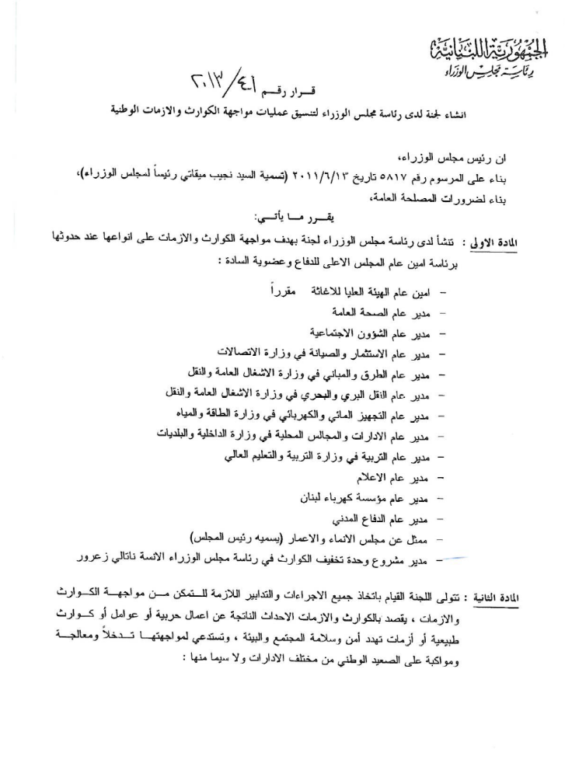

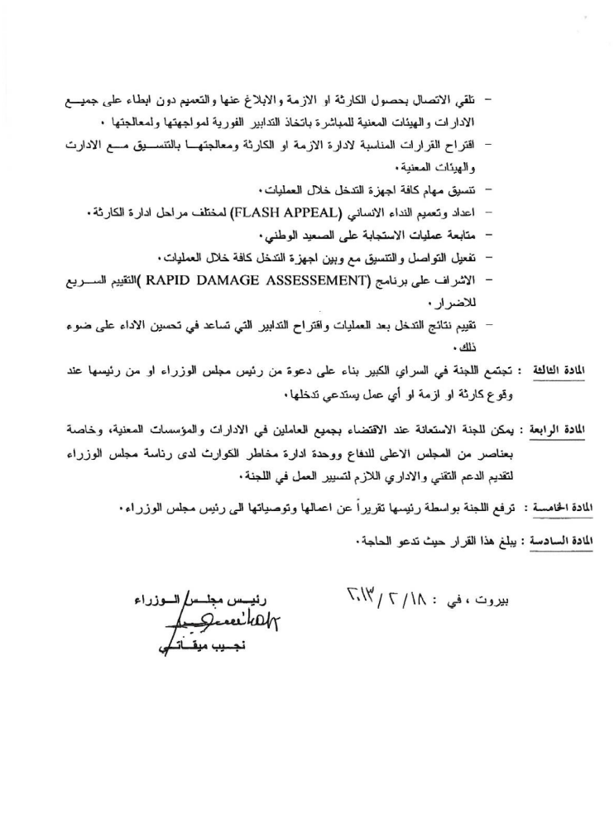

Annex 2: Press Releases of major project activities



ميقاتي افتتح مناورة حول سيناريو وقوع انفجار : لتعميم التنسيق بين مختلف الادارات تحسينا للاداء
الأربعاء 30 تشرين الأول 2013 الساعة 11:25
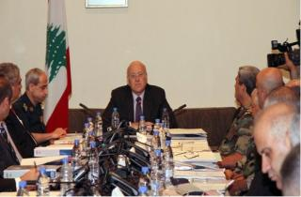
وطنية - أكد الرئيس نجيب ميقاتي أن "التنسيق بين مختلف الادارات اللبنانية هو أمر نحتاج الى تعميمه ليس فقط على مستوى ادارة الكوارث بل ايضا على مستوى الاشغال اليومية توفيرا للمال والوقت"، متمنيا أن "يكون هذا التنسيق نحو الأفضل دائما وفي سبيل تحسين الاداء".
كان الرئيس ميقاتي يتحدث قبل ظهر اليوم في السرايا في بداية "مناورة مكتبية حول سيناريو وقوع إنفجار" أقامتها "اللجنة الوطنية لتنسيق عمليات مواجهة الكوارث والأزمات" التي شكلها رئيس الحكومة في 18 شباط من العام الحالي برئاسة الأمين العام للمجلس الأعلى للدفاع اللواء محمد خير وعضوية المدراء العامين للوزارات المعنية وممثلين عن الادارات والهيئات اللبنانية، وذلك وفق الإطار العام لخطة الاستجابة الوطنية خلال الكوارث والأزمات على أنواعها الذي تم تطويره بالتعاون مع برنامج الأمم المتحدة الإنمائي.
وقد أعطيت هذه اللجنة صلاحية المباشرة بتطبيق الآليات المقترحة لإدارة الكوارث والأزمات، كما تنص الآلية التنظيمية على دور كل وزارة وإدارة ومسؤولياتها وآليات التنسيق والتواصل في ما بين الأجهزة المعنية لمعالجة تداعيات الأزمات والكوارث بالسرعة والفاعلية المطلوبة لإنقاذ الأرواح والمحافظة على الممتلكات.
شارك في المناورة أعضاء اللجنة برئاسة اللواء خير، مدير برنامج الأمم المتحدة الإنمائي لوكا رندا، أعضاء اللجنة التقنية، عمليات قيادة الجيش، عمليات قوى الأمن الداخلي، عمليات الدفاع المدني، عمليات الصليب الأحمر اللبناني، عمليات فوج إطفاء بيروت وفريق عمل وحدة إدارة مخاطر الكوارث لدى رئاسة مجلس الوزراء.
اللواء خير
بداية تحدث اللواء الركن خير فقال:"ان هذا التمرين هو الأول من نوعه في لبنان، بحيث يجتمع وللمرة الأولى ممثلون عن مختلف الوزارات والإدارات الرسمية المعنية بالاستجابة خلال الكوارث لإدارة أزمة وطنية. ويعتبر هذا التمرين فرصة لاختبار قدرة الوزارات والإدارات المعنية كافة على الاتصال والتواصل والتنسيق في ما بينها خلال أوقات الأزمات والكوارث من خلال تفعيل غرفة إدارة الأزمات المقترح أنشاؤها في الإطار العام لخطة الاستجابة الوطنية. يهدف هذا التمرين بشكل خاص الى اختبار تطبيق آلية تفعيل عمل لجنة التنسيق الوطنية لمواجهة الكوارث والأزمات المشكلة من قبل رئيس مجلس الوزراء، وتدريب المسؤولين وأركانهم على العمل المتناسق في ما بينهم، وعلى تقدير الموقف السريع واتخاذ القرار السليم في الوقت المناسب، بالإضافة إلى تدريب القادة الأمنيين على التنسيق في ما بينهم بالدرجة الأولى ومع الأجهزة الأمنية والمدنية".
برنامج الأمم المتحدة الإنمائي
ثم تحدث مدير برنامج الأمم المتحدة الإنمائي لوكا رندا فقال:"ان الحؤول دون المخاطر الطبيعية أو الدراماتيكية كالتي شهدتها الضاحية الجنوبية وطرابلس أخيرا صعب جدا، ان لم يكن مستحيلا، الا أنه يمكن الحد من تبعات هذه الكوارث من خلال الاستعداد لها واستجابة الحكومة على المستويات المحلية والاقليمية والوطنية".
أضاف :"ان مشروعنا يشمل خطة تساهم في تعزيز استجابة الحكومة أمام الكوارث أكانت طبيعية أم من صنع الانسان، الامر الذي يتلاقى مع أولويات "خارطة الطريق لتأمين الاستقرار" التي قدمتها الحكومة اللبنانية أخيرا في واشنطن".
الرئيس ميقاتي
وتحدث الرئيس ميقاتي فقال :"في ظل الظروف الراهنة المحدقة بلبنان والمنطقة، والتطورات التي تحصل، ومن موقعي كرئيس للحكومة مؤتمن على تطبيق الدستور والتنسيق ما بين الوزارات والإدارات، ومن قناعتي بأن الحكم استمرارية وأن حياة المواطنين وممتلكاتهم هي الأولوية، دعوت لجنتكم للاجتماع في آب 2013 إثر إنفجارات الرويس وطرابلس وطالبتكم بالبدء بتطبيق الخطة الوطنية لإدارة الكوارث التي تم إنجازها والتي تعهدت بتعميمها كي تصبح معتمدة إلزاميا من مختلف الوزارات والإدارات. وقد طلبت منكم العمل على إعداد مناورة أشارك فيها شخصيا لاختبار فاعلية الخطة ومكامن ضعفها. وها نحن على موعد اليوم مع مناورة مكتبية على أن تكون في المرة المقبلة مناورة حية ميدانية.
وختم :"إن ما تحقق هو خطوة اساسية على صعيد تفعيل العمل وتنسيقه بين مختلف الادارات اللبنانية وهو أمر نحتاج الى تعميمه، ليس فقط على مستوى ادارة الكوارث، بل ايضا على مستوى الاشغال اليومية توفيرا للمال والوقت. كل ما أتمناه في هذه المناسبة أن يكون التنسيق بين الادارات اللبنانية نحو الأفضل دائما وفي سبيل تحسين الاداء وليس لادارة الكوارث، لان اللبنانيين سئموا المآسي وباتوا يتطلعون الى حياة هادئة تطوى فيها مرحلة الحرب والمآسي والتفجيرات. شعبنا يستحق الحياة ومن حقه ان يعيش بهدوء وسلام".
ثم أعطى الرئيس ميقاتي إشارة الانطلاق لبدء المناورة.
========== ج.س

هيئة شؤون المرأة اطلقت ورشتها الثانية للحد من مخاطر الكوارث
الخميس 29 آب 2013 الساعة 16:22
وطنية - نظمت الهيئة الوطنية لشؤون المرأة اللبنانية بالتعاون مع برنامج الأمم المتحدة الإنمائي، على مدى يومين، ورشة عمل حول "كيفية الحد من مخاطر الكوارث على ضوء اتفاقية هيوغو"، في مركز التدريب التابع للهيئة في بعبدا، في حضور مندوبات عن منظمات غير حكومية تهتم بشؤون المرأة ومندوبات عن بلديات في منطقة جبل لبنان.
وهذه الورشة هي الثانية ضمن سلسلة ورشات العمل حول "الحد من مخاطر الكوارث"، في إطار "دمج النوع الاجتماعي في خطة عمل هيوغو"، هدفها "رفع مستوى الوعي وتحسين الجهوزية لدى المرأة لمواجهة المخاطر الناجمة عن الكوارث والمخاطر الطبيعية".
وأطلقت الورشة، ممثلة الهيئة الدكتورة نجوى نصر، تلتها مديرة "وحدة إدارة الكوارث التابعة لرئاسة مجلس الوزراء اللبناني" ممثلة "برنامج الأمم المتحدة الإنمائي" نتالي زعرور.
ففي المحور الأول، قدمت الدكتورة فاديا كيوان، مفهومي إدارة مخاطر الكوارث "DRM" وتخفيف مخاطر الكوارث "DRR" من منظور النوع الاجتماعي. وتلتها في المحور الثاني سوسن بو فخر الدين التي قدمت إطار عمل اتفاقية هيوغو.
وفي المحور الأول من اليوم الثاني، قدمت المهندسة مارلين براكس، المخاطر الطبيعية التي نواجهها في لبنان، بعدها عرض شربل عيدموني نشاطات الإغاثة التي يقوم بها الصليب الأحمر اللبناني في حالات الطوارىء.
وكانت المشاركات قد توزعن على مجموعات عمل لمناقشة المواضيع المطروحة، وخلصن إلى رفع توصيات تتعلق ب"كيفية تطبيق اتفاقية عمل هيوغو والتدابير التي يجب اتباعها للتخفيف من نتائج المخاطر".
============م.ع.ش.

لجنة إدارة الكوارث: وفد من هيئة الاغاثة سيتوجه غدا إلى حارة حريك للاطلاع على الأضرار
الخميس 02 كانون الثاني 2014 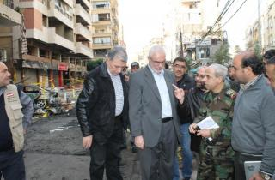
وطنية - صدر عن اللجنة الوطنية لإدارة الكوارث والأزمات في السراي الحكومي البيان الآتي: "بتوجيهات من دولة رئيس مجلس الوزراء الأستاذ نجيب ميقاتي، عقدت اللجنة الوطنية لمواجهة الكوارث والأزمات إجتماعا طارئا في السرايا برئاسة الأمين العام للمجلس الأعلى للدفاع اللواء الركن محمد خير بحضور الأعضاء، وبحثت تداعيات الإنفجار الذي وقع حوالى الساعة الرابعة وعشر دقائق في الشارع العريض في منطقة حارة حريك - الضاحية الجنوبية، والذي أدى إلى استشهاد أربعة مواطنين وإصابة حوالى 74 آخرين، وفق إحصاءات وزارة الصحة العامة والصليب الأحمر اللبناني. كما تضرر عدد من المباني والمؤسسات والمحلات التجارية والسيارات في المكان الناتج عن انفجار سيارة غراند شيروكي سبق لقيادة الجيش أن عممت مواصفاته بتاريخ 20/12/2013. وتقوم الأجهزة الأمنية المختصة بتكليف من القضاء بضرب طوق أمني حول مسرح الجريمة للتحقيق في طبيعة الإنفجار وتطلب من المواطنين الإبتعاد عن المكان، تسهيلا لعمل الأجهزة الأمنية والعسكرية والدفاع المدني والإسعاف. وقد أوعزت وزارة الصحة العامة إلى المستشفيات والمراكز الطبية لاستقبال المصابين والحالات الناتجة من الإنفجار. كما عمدت شركة كهرباء لبنان إلى قطع التيار الكهربائي بسبب تضرر الشبكة على أن تعيد وصلها في الساعات القليلة المقبلة. هذا وتستمر اللجنة الوطنية لإدارة الكوارث والأزمات بإجتماعاتها للتنسيق ومتابعة التداعيات الناتجة من هذا العمل الإرهابي.

وسيتوجه وفد من الهيئة العليا للاغاثة إلى مكان الإنفجار لاطلاع ميدانيا على الأضرار التي سببها الإنفجار وتحديد الإحتياجات لمساعدة المواطنين المتضررين".

خير تفقد مكان الانفجار: معالجات فورية ومسح شامل للاضرار بعد انتهاء عمل الادلة الجنائية
الجمعة 27 كانون الأول 2013 الساعة 14:07
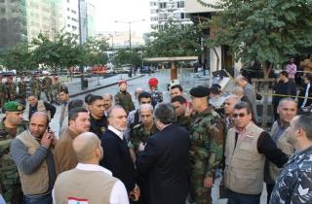
وطنية - جال الامين العام لهيئة ادارة الكوارث الامين العام للهيئة العليا للاغاثة اللواء محمد خير مكان الانفجار في الستاركو متفقدا الاضرار، وقال: "بداية الرحمة للشهداء والشفاء العاجل للجرحى".
اضاف: "بعد عقد الاجتماع الفوري في القصر الحكومي للجنة الوطنية لهيئة ادارة الكوارث، بتوجيه من الرئيس نجيب ميقاتي وفي حضور جميع اعضائها، توجهنا الى مكان الانفجار واتخذنا الاجراءات المناسبة، وتمنينا على الاجهزة كافة اتخاذ الاجراءات والمعالجات الفورية للحؤول دون اعاقة حركة المواطنين. الانفجار كبير وقد أدى الى استشهاد معالي الوزير شطح رحمه الله وخمسة آخرين و70 جريحا توزعوا على المستشفيات، وهناك 7 جرحى في وضع حرج".
وأشار الى ان "الوزارات المعنية بدأت باتخاذ الاجراءات الفورية، ووزارة الصحة اعطت توجيهاتها للمستشفيات والصليب الاحمر والدفاع المدني لان يقوموا بواجبهم".
وقال: "لقد أعطينا توجيهاتنا للهيئة العليا للاغاثة بالمسح الفوري ومساعدة وتقديم ايواء لكل مواطن بحاجة لها، لان معظم المباني سكنية، وكل الاضرار اصبحت واضحة لدينا، وبعد انتهاء الادلة الجنائية سوف نقوم بالمسح الكامل ودفع التعويضات".
واوضح ان "الجيش يمنع حاليا الدخول الى المباني المتضررة، حفاظا على الملكية الخاصة، ونحن ننفذ توجيهات الهيئة العليا للكوارث وكل التعليمات الضرورية للحفاظ على الامن واملاك الناس".
============= ن.م

لبنان يتحضر لمواجهة العاصفة الكسا وارشادات وقائية
الإثنين 09 كانون الأول 2013 الساعة 20:12

وطنية - بدأ لبنان الرسمي والشعبي يتحضر للعاصفة الثلجية "الكسا" التي ستضرب لبنان مساء غد الثلاثاء.
ولهذه الغاية، عقدت اجتماعات في السراي الحكومي والمحافظات والقائمقاميات والبلديات للجنة ادارة الكوارث لمواجهة تداعيات العاصفة والتي من المتوقع ان تستمر حتى يوم الاثنين المقبل وستبلغ ذروتها يوم الاربعاء.
وقد تم وضع خطط تنفيذية لمواجهة العاصفة للحؤول دون تكبد خسائر ووقوع اضرار، وارشاد المواطنين للتقيد بتعليمات القوى الامنية ورجال الدفاع المدني والاطفاء الذين سيتواجدون على الطرق مع بدء العاصفة حفاظا على سلامتهم، وطلب من أهالي طلاب المدارس متابعة وسائل الاعلام لمعرفة ما سيصدر عن وزارة التربية والتعليم العالي.
كما طلب من المواطنين "متابعة الارشادات التي ستصدر عن الاجهزة المعنية حفاظا على سلامتهم.

UNDP, NCSR launch findings of Flood Assessment Report for Lebanon at Grand Serail
Wed 19 Mar 2014 at 19:24
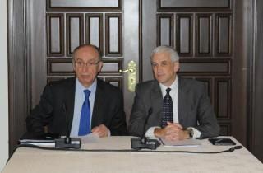
NNA - The United Nations Development Program (UNDP), in cooperation with the National Council for Scientific Research (NCSR), held at the Grand Serail on Wednesday a workshop to unveil the findings of the Flood Assessment Report for Lebanon.
The workshop was inaugurated by the Secretary General of the National Council for Scientific Research, Mouin Hamza, and Acting UNDP Country Director, Shombi Sharp, in the presence municipality heads, stakeholders, decision-makers, academics and specialists.
In his delivered word, Sharp said that economic losses incurred by disasters this century have accounted to a range of $2.5 trillion, adding that among natural disasters, floods affect the largest number of people worldwide and have the greatest potential to cause damage.
"In Lebanon and according to the '2009 Global Assessment Report on Disaster Risk Reduction', economic losses from disasters that have occurred between 1980 and 2010 in Lebanon, amount to USD 5,323,000 per annum. Floods are among the top 10 natural disasters that effect Lebanon be it on the people, their assets and economy," said Sharp.
Incorporating disaster risk reduction (DRR) to natural hazards including floods has been one of the priorities for Lebanon's national agenda.
"Since 2012, and within the framework of the project 'Strengthening Disaster Risk Management Capacities in Lebanon', the UNDP has supported the National Council for Scientific Research (NCSR) to conduct the 'Flood Hazard Mapping Assessment for Lebanon' with the objective of producing flood intensity and hazard maps," Sharp added, explaining further that these maps, and relevant data and recommendations, are of significant importance for the government of Lebanon, concerned agencies, local level authorities, community representatives, academics and concerned stakeholders -- as they are essential for any future action and plan for disaster risk reduction.
"I am honored to be here today to launch the findings of this pioneer report. Moreover, I am very much pleased that the findings of this report will be made available to decision-makers, planners and relevant community stakeholders as they will support improving the government's capacities in disaster preparedness," concluded Sharp, hoping that the recommendations, data and discussions be transformed to strategies that improve social, physical and institutional resilience to flooding.
"We further hope that decision makers integrate the findings of the report to any future planning and development policies and strategies at the local, sectoral and national levels."
In turn, the General Secretary of the National Council for Scientific Research warned that floods were among the most dangerous natural disasters that annually strike different corners of the world, including Lebanon.
"The drought that hit Lebanon this year does not mean that we should give up on studies that aim to protect the country from the negative effects of floods," he said.
Hamza announced that the study had been able to determine many of the weak spots and areas that may be affected by floods, calling on civil and local bodies to adopt appropriate measures and to fortify sensitive areas depending on the research findings.
"Facts have revealed an increase in the frequency of floods in recent decades. The largest flood that had stricken Lebanon in recent history is that of Abu Ali River back in 1955, killing more than 400 people and displacing about 2,000 families and destroying about 800 establishments and residential units. This is not to mention the massive floods of 2003 and those of January 2014," Hamza said, anticipating an increasing number of future floods to be caused by climate change and global warming.
"The most important factor of the study is that it gathers data about the history of floods that had hit the country within the last century for the researchers to use when gauging floodplains and the places that are mostly vulnerable to flooding."
Hamza went on to stress that "the announcement of this study is the first step which we hope would be applied in all fields." He saw that the cycle of heavy rain would return to Lebanon, highlighting the importance of taking the necessary precautions to take advantage of these resources in line with measures to ensure protection from the impact of floods in more than one area in Lebanon.
In conclusion, Hamza thanked UNDP representative Shombi Sharp and the risk management team at the Presidency of the Council of Ministers headed by Nathalie Zaarour, as well as all the workshop participants, for their contribution and efforts towards the completion of this report with a high professional spirit.
=============================R.H.

ورشة عمل عن تقييم مخاطر الفيضانات في لبنان في السراي الحكومي شارب : اطلاق نتائج التقرير يدعم تحسين قدرات الحكومة في التأهب للكوارث
الأربعاء 19 آذار 2014 الساعة 13:04
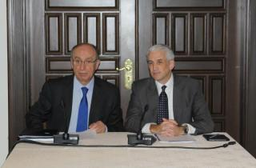
وطنية - نظم برنامج الامم المتحدة الانمائي، بالتعاون مع المجلس الوطني للبحوث العلمية، ورشة عمل عن "تقييم مخاطر الفيضانات في لبنان"، في السراي الحكومي.
افتتح الورشة كل من امين عام المجلس الوطني للبحوث العلمية معين حمزة والقائم باعمال برنامج الامم المتحدة في لبنان شومبي شارب، في حضور رؤساء اتحادات بلديات، اضافة الى عدد من اصحاب القرار واكاديميين واخصائيين.
شارب
واشار شارب الى "أن الخسائر الاقتصادية الناجمة عن الكوارث التي وقعت بين عامي 1980 و2010 في لبنان قد وصلت الى 5,323,000 دولار أميركي سنويا"، وقال: "الفيضانات هي من بين اكبر 10 كوارث طبيعية التي قد تؤثر على لبنان وشعبه واقتصاده"، معتبرا "ان الحد من مخاطر الكوارث الطبيعية، بما فيها الفيضانات، هو احد اولويات جدول اعمال لبنان الوطنية. فمنذ العام 2007 وبهدف دعم الدولة اللبنانية قام برنامج الامم المتحدة الانمائي بأول تقرير "لتقييم المخاطر الوطنية".
اضاف :"منذ العام 2012، وفي اطار مشروع "تعزيز قدرات ادارة مخاطر الكوارث في لبنان" ساعد برنامج الامم المتحدة الانمائي المجلس الوطني للبحوث العلمية لاجراء تقييم ورسم خرائط الفيضانات بهدف انتاج خرائط المخاطر في لبنان. هذه الخرائط والبيانات بالاضافة الى توصيات المجلس الوطني للبحوث هي ذات اهمية كبيرة للحكومة اللبنانية والوكالات المعنية والسلطات على المستوى المحلي، وممثلي المجتمع والاكاديميين اضافة الى اصحاب المصلحة المعنيين، لانها ضرورية لاي عمل في المستقبل ولخطة الحد من مخاطر الكوارث".
وتابع :"يشرفني ان اكون هنا اليوم لاطلاق نتائج هذا التقرير الرائد الذي سوف يدعم تحسين قدرات الحكومة في التأهب للكوارث"، آملا "ان تتحول هذه التوصيات والبيانات الى استراتيجية لتحسين المرونة الاجتماعية والمادية والمؤسسية للفيضانات"، داعيا "صناع القرار الى دمج نتائج التقرير الى سياسات واستراتيجيات التخطيط والتنمية في المستقبل على المستويات المحلية والقطاعية والوطنية".
وشكر شومبي رئاسة مجلس الوزراء على دعمها المستمر، والوكالة السويسرية للتنمية والتعاون الذين عملوا على اعداد التقرير الذي يخدم "جعل لبنان اكثر حصانة ضد الكوارث".
وختم :"نحن سعداء ان نرى ان قدرات الحكومة اللبنانية تتزايد في التأهب للكوارث الطبيعية وتلك التي هي من صنع الانسان"، مجددا "التزام الامم المتحدة نحو بناء قدرة ادارة الكوارث لدعم الحكومة اللبنانية في تنفيذ جدول اعمال الحد من مخاطر الكوارث في جميع مراحله".
حمزة
بدوره، اوضح امين عام المجلس الوطني للبحوث العلمية "ان الفيضانات من الكوارث الطبيعية التي تضرب سنويا اصقاع الارض كافة ومنها لبنان"، مشيرا الى "ان الجفاف الذي يضرب لبنان هذه السنة لا يعفيه من تكثيف الدراسات والبحوث والمبادرات للحماية من آثارها السلبية".
وأعلن حمزة "اننا استطعنا تحديد العديد من نقاط الضعف والمناطق التي قد تتأثر بفعل الفيضانات وتتسبب نتيجة السيول بزحل التربة وانزلاقات الاراضي في ظروف مناخية دقيقة". ودعا الهيئات الاهلية والمحلية الى "اتخاذ الاجراءات المناسبة وتحصين المناطق الحساسة بالاعتماد على البحوث".
وقال :"تشير الادلة المتوفرة في لبنان الى ازدياد وتيرة الفيضانات في العقود الاخيرة، وقد تسببت بخسائر بشرية واقتصادية وتدمير لبعض المنحدرات والسهول الشرقية والغربية"، لافتا الى "ان اضخم فيضان حصل في لبنان في تاريخه المعاصر هو فيضان نهر ابو علي عام 1955 حيث بلغت الاضرار بالارواح ما يزيد عن 400 شخص وتشريد حوالى 2000 عائلة وما يقارب 800 منشاة ووحدة سكنية، هذا بالاضافة الى فيضانات عام 2003 التي غطت العديد من المناطق اللبنانية وصولا الى فيضان كانون الثاني من العام المنصرم. كما ان هذه المخاطر مرشحة للتصاعد في ظل الظاهر التي يشهدها العالم من احتباس حراري وتغييرات مناخية واستهتار بالبيئة والامعان بتخريبها".
اضاف :"ان اهم ما توصلت اليه الدراسة هو جمع المعطيات المتوفرة في القرن المنصرم حول الفيضانات، فقام باحثون بمكننة هذه المعطيات كما تم تحديد السهول الفيضية والاماكن الاكثر عرضة لمخاطر الفيضانات".
وأكد ان "الاعلان عن هذه الدراسة اليوم هو الخطوة الاولى التي نتمنى ان تطبق في كافة مجالاتها. فالسنوات القليلة الامطار لن تدوم طويلا، ودورة الامطار الغزيرة سوف تعود الى ربوعنا، ولا بد من اتخاذ الاحتياطات اللازمة للاستفادة من هذه الموارد واتخاذ الاجراءات الكفيلة بالحماية من اثر السيول الجارفة في اكثر من منطقة لبنانية".
في الختام، شكر حمزة "برنامج الامم المتحدة الانمائي ممثلا بالقائم بالاعمال شومبي شارب ولفريق ادارة المخاطر لدى رئاسة مجلس الوزراء ومنسقته السيدة نتالي زعرور وجميع المشاركين لمساهمتهم وجهودهم بانجاز هذا التقرير باحترافية عالية".
==== ن.م

دراسات عن الزلازل والجفاف.. وقريباً عن الانزلاقات الأرضية

الفيضانات تستنزف لبنان

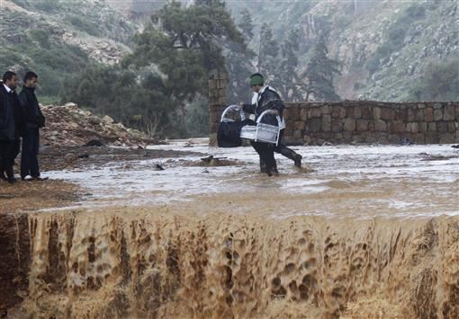
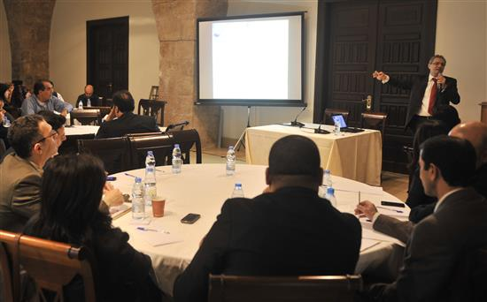
قدم «المجلس الوطني للبحوث العلمية» في السرايا الحكومية أمس دراسة عن المناطق التي تعيش خطر حصول فيضانات عند مجاري الأنهار (الأرشيف
زينب ياغي
تاريخ المقال: 20-03-2014 02:48 AM
بين الجفاف والفيضانات، يعيش لبنان تداخل قوانين الطبيعة مع تعديلات يقوم بها سكانه في أنماط حياتهم، وتساهم في حصول الفيضان، وربما في الجفاف.
ويتفق عدد من الباحثين المتخصصين على أن مخاطر الظواهر الطبيعية في لبنان لا تقل عن مخاطر الحروب، لكنها لا تجد مَن يهتم بها. ولا يزال تشكيل وحدة إدارة الكوارث مستمراً منذ سنوات، فيما قدم «المجلس الوطني للبحوث العلمية» في السرايا الحكومية، أمس، دراسة عن المناطق التي تعيش خطر حصول فيضانات عند مجاري الأنهار، بتمويل من برنامج الأمم المتحدة الانمائي، بعد إجرائه دراسات عن الزلازل، والجفاف، وقريباً دراسة عن الانزلاقات الأرضية.
وأعلن الأمين العام للمجلس معين حمزة، أنه جرى تحديد العديد من نقاط الضعف والمناطق التي قد تتأثر بفعل الفيضانات، وتتسبب نتيجة السيول بزحل التربة وانزلاقات الأراضي. وقال إن الأدلة المتوافرة تشير إلى ازدياد وتيرة الفيضانات في العقود الماضية، وقد تسببت بخسائر بشرية واقتصادية وتدمير بعض المنحدرات والسهول الشرقية والغربية.
من جهته، أوضح القائم بأعمال برنامج الأمم المتحدة الانمائي شومبي شارب أن الخسائر الاقتصادية الناجمة عن الكوارث التي وقعت بين العامين 1980 و2010 في لبنان وصلت إلى 5,323,000 دولار سنوي، مضيفاً أن الفيضانات هي من بين أكبر عشر كوارث طبيعية تؤثر على لبنان وشعبه واقتصاده.
وقد استهل المشرف على الدراسة الدكتور شادي عبد الله من المجلس الوطني عرضه بصور مناطق فيضانات لا تزال في ذاكرة اللبنانيين: نهر الغدير، جدرا عندما جرفت المياه أحد الأطفال، انزلاق سيارة في المنصورية ومقتل سائقها، فيضان نهر بيروت عند الجسر، والنهر الكبير الجنوبي في عكار، وجسري الخردلي والقعقعية في الجنوب، بالاضافة إلى فيضانات في البقاعين الأوسط والغربي.
وأوضح أنه يوجد في لبنان ستة عشر نهراً رئيسياً، ثلاثة منها داخلية هي: العاصي والحاصباني والوزاني، بينما يوجد لدى كل من العاصي والنهر الكبير الجنوبي حدود مشتركة مع سوريا. وتتسم غالبية الأنهار بخصائص مشتركة كونها تسير في الأودية، وتتجه من الشرق إلى الغرب لكي تصب في البحر الأبيض المتوسط.
ويبدو أن عبد الله واجه صعوبات في الحصول على معلومات خاصة بالهاطل المطري وقياس ارتفاع المياه على الأنهر وخرائط التربة. وقد استعان بمحطات الرصد الجوي التابعة لمصلحة الأبحاث الزراعية في البقاع و«الجامعة الأميركية» في بيروت، ومحطات الرصد التابعة لمطار بيروت. ولفت إلى أن المحطات وصلت قبل الحرب الأهلية إلى مئة وأربعين محطة تقريباً، لكنها تعطلت خلال الحرب، ولم يبقَ منها سوى ست محطات، ثم أعيد بناء عدد منها، ووصلت حالياً إلى ست وثلاثين محطة. وقال إن اختيار مكان محطة الرصد الجوي له تأثير كبير في معرفة الأحوال الجوية، وكميات هطول الأمطار.
واستعان بالاقمار الاصطناعية التابعة لـ«وكالة الفضاء الأميركية - النازا»، وداتا معلومات مستخلصة من صور الرادار، ولدى مقارنة معلومات «النازا» بمعطيات الأرصاد الجوية، تبين وجود أخطاء كثيرة في معطيات الأقمار الاصطناعية.
وأكد عبد الله أن لدى المجلس الوطني قاعدة معلومات ضخمة تم بناؤها على مدى عشرين عاماً، من بينها خرائط جيولوجية وخرائط لكل من التربة واستخدامات الأراضي، والأخيرة يعمل المجلس الوطني على تحديثها كل أربع سنوات. بينما استخدم النموذج السويسري لقياس ارتفاع المياه، وهو متران ونصف المتر باعتباره الأقرب إلى خصائص أنهار لبنان.
ومن المشاكل التي واجهته عدم وجود معلومات مستمرة عن كميات الهاطل المطري على مدى مئة عام، وتغير المقاطع النهرية عند محطات القياس مع كل هاطل مطري، وبالتالي عدم معرفة المرحلة الأعلى التي تصل إليها المياه عند الفيضان. وقد استعان عبد الله بالسكان لتسجيل مدى ارتفاع المياه في أماكن عدة مثل نهر القاسمية.
وعرض صوراً مخجلة للتعديات على الأنهار لا يقوم بها الفقراء فحسب، من بينها صورة لفيلا عند نهر ابراهيم تكاد تدخل مياه النهر. ثم اقترح مجموعة من التوصيات، من بينها: ضرورة بناء محطات قياسات للهاطل المطري بشكل أتوماتيكي كل خمس عشرة دقيقة، وإقامة مقاطع عرضية للأنهار بشكل صحيح، وزيادة محطات القياس على الأنهار وعدد العاملين فيها، لأن عددهم حالياً قليل جداً. وأشار إلى أن القياسات لم تؤخذ في عكار والعاصي منذ عامين بسب الوضع الأمني. يضاف إلى ذلك توزيع المحطات بشكل جيد، ومعاينة الناتج يومياً وتحسين نموذج الارتفاع الرقمي للمياه، والبدء بالتفكير باستخدام أجهزة حديثة، والحصول على الصور الرادارية، لتحديد مناطق الفيضانات، وتحديث خرائط استخدامات الأراضي. واقترح استخدام برامج تأمين ضد الكوارث الطبيعية لأن لدى شركات التأمين شروطاً تقضي بتأمين السلامة العامة، ومساعدة المجتمعات الأهلية والبلديات من أجل جمع المعطيات وإعداد خرائط لها علاقة بالكوارث. وأشار إلى أن اتحاد بلديات صور يقوم بإعداد خرائط، وسيشتري محطة رصد بالتعاون مع مصلحة الأرصاد الجوية.
أوضح المشرف على هيئة إدارة الكوارث الدكتور فادي حمدان، خلال المناقشة، أن الكوارث لا تحصل بسبب عوامل طبيعية فقط، وإنما أيضاً بسبب عوامل مؤسساتية واجتماعية، مشيراً إلى تناول الدراسة وتيرة ارتفاع المياه، من دون انعكاساتها على الناس وقابلية التضرر منها. ولفت إلى تأثير الكوارث الممتدة على المناطق الفقيرة حيث تترك البنى وسبل المعيشة هشة، موضحاً أن الجيش يقوم حتى الآن بالمسوحات الخاصة بالأضرار من أجل التعويضات، وليس من أجل المعالجة. وسأل عن الجهة المسؤولة عن مواجهة الأخطار والحوافز التي تقدمها الدولة من الناحية الاقتصادية من أجل الالتزام بتطبيق معايير المواجهة؟ وقال إن تلك الأسئلة تم لحظها في الخطة الاستراتيجة الوطنية لادارة الكوارث التي جرى تقديمها إلى الحكومة السابقة قبل استقالتها مباشرة.
واعتبر الدكتور هادي جعفر من «الجامعة الأميركية» أن الدراسة تضع حجر الأساس لمستوى قياس السيول والفيضانات في لبنان، لكنه سأل: ماذا بعد الخرائط؟ مضيفاً: «نحن نتحدث عن أخطار تطال مباني ومدارس ومؤسسات ومزارع». وسأل عن سبب الحصول على معلومات من «النازا»، في الوقت الذي تملك فيه مؤسسات كثيرة تلك المعلومات؟
ورد عبد الله بأن الحصول على داتا المعلومات مشكلة كبرى، لأن كل مؤسسة تحتفظ بها، مع العلم أنها تصبح غير صالحة بعد مرور خمس أو عشر سنوات، بينما في الولايات المتحدة يقولون للباحث: كل المعلومات أمامك وعليك أن ترينا مهاراتك.
وطرح المشرف على هيئة إدارة الكوارث في اتحاد بلديات صور مرتضى مهنا مسألة ارتباط البحر بالنهر في المنطقة، بينما يقيم أكثر من ثلثي سكان صور عند البحر، وتحصل مشاكل كل عام عند نهر القاسمية. ويفيض البحر ويصل إلى المناطق التجارية في البص، وفي البرج الشمالي يعاني أصحاب المحال من خسائر سنوية. وقد ارسل اتحاد البلديات ثلاثة كتب إلى وزارة الطاقة من أجل تنظيف المجاري، لكنه لم يحصل على جواب.
وانتهت الندوة، بحصة تدريبية للكوادر في هيئة إدارة الكوارث، مع تأكيد عبدالله أن كلاً من تأثير التوسع العمراني على مخاطر السيول وفيضانات البحار ومجاري المياه والصرف الصحي تستدعي دراسات مستقلة.

لجنة ادارة الكوارث بحثت في تداعيات تفجير الهرمل: تدابير لمساعدة المتضررين
الخميس 16 كانون الثاني 2014 الساعة 12:57
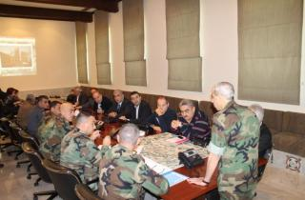
وطنية - صدر عن اللجنة الوطنية لإدارة الكوارث والأزمات البيان الاتي:
"بتوجيهات من رئيس مجلس الوزراء الأستاذ نجيب ميقاتي، عقدت اللجنة التقنية لمواجهة الكوارث والأزمات إجتماعا طارئا برئاسة الأمين العام للمجلس الأعلى للدفاع اللواء الركن محمد خير وبحثت تداعيات الإنفجار الذي وقع قرب السراي الحكومي في الهرمل صباح 16/1/2014 الساعة 8:55 والذى أدى الى إستشهاد ثلاثة مواطنين وإصابة حوالي 30 جريحا بالإضافة الى تضرر عدد من المباني والمؤسسات الرسمية والخاصة والمحال التجارية والعديد من السيارات.
وقد بدأت اللجنة بإتخاذ التدابير المناسبة لتقديم المساعدات للمتضررين وتستمر اللجنة بالعمل لمعالجة تداعيات الإنفجار المذكور".

لجنة الكوارث: سلام كلف الأجهزة المختصة إتخاذ التدابير وتقديم المساعدات للمتضررين والكشف على الأضرار بشكل فوري
الأربعاء 19 شباط 2014 الساعة 11:31
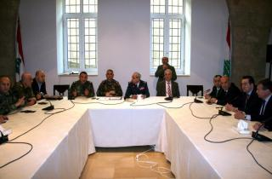
وطنية - صدر عن اللجنة الوطنية لإدارة الكوارث والأزمات من السراي الحكومي البيان الاتي:
"بتوجيهات من دولة رئيس مجلس الوزراء الأستاذ تمام سلام عقدت اللجنة الوطنية لمواجهة الكوارث والأزمات إجتماعاً طارئاً برئاسة أمين عام المجلس الأعلى للدفاع اللواء الركن محمد خير وبحثت تداعيات الإنفجار الذي وقع في بئر حسن قرب مستديرة فؤاد شهاب حوالي الساعة 9:20 من صباح يوم الأربعاء الواقع فيه 19/2/2014 والناتج عن سيارتين مفخختين، والذى أدى الى إستشهاد خمسة أشخاص وإصابة أكثر من 80 آخرين بجروح مختلفة نقلوا على أثرها إلى مستشفيات المنطقة لتلقي العلاج، بالإضافة الى تضرر عدد من المباني والمؤسسات والمحال التجارية والعديد من السيارات.
وقد كلف الرئيس سلام الأجهزة كافة واللجنة الوطنية لإدارة الكوارث بإتخاذ التدابير المناسبة وتقديم المساعدات للمتضررين، كما تم تكليف الهيئة العليا للإغاثة الكشف على الأضرار بشكل فوري. هذا وتستمر اللجنة بالعمل لمعالجة تداعيات الإنفجار المذكور.
وقد طلب وزير الصحة من المستشفيات معالجة المصابين على نفقة الوزارة.

TOR Consultant Table Top Exercise


Terms of Reference (TOR)

Project Name: Support to the Prime Minister Office “Strengthening Disaster Risk Management Capacities”
Reference Number: 00071806
- Subject: Procurement of a National Consultant services to implement a Table-Top Exercise for the National Committee to Coordinate Disasters Management.
- Project Description
Lebanon is subject to a wide range of natural hazards, the biggest threat being of a severe earthquake and/or an associated Tsunami. Smaller-scale disasters which the country also faces include floods, forest fires, land-slides and drought.
Accordingly, In May 2009, UNDP and the Lebanese Government represented by the Prime Minister signed a project document on “Strengthening Disaster Risk Management Capacities in Lebanon”. The project aims to help the Lebanese Government develop its disaster management and corresponding risk reduction strategy. In December 2009, a Project manager and a Project assistant were appointed, leading to the establishment of a Disaster Risk Management Unit located within the Prime Minister’s office for a better coordination with relevant stakeholders. Today, the unit is fully operational with qualified staff and equipped offices.
Recent events, such as the Haiti Earthquake (January, 2010), the Ethiopian Airlines airplane crash (February, 2010) as well as recurring earthquakes in the South of Lebanon have prompted both internal and external focus on disaster risk reduction.
In order to achieve its outcome “mainstreaming disaster preparedness and management in national development framework strategies in Lebanon”, the project needed to evolve through two main phases to provide a stable platform for future developments. In Phase I (2010-2011-2012), the focus was on initiating a framework at the National level as part of the following outputs:
- Disaster Risk Reduction and Management Unit Established
- National DRR strategy and systems developed and implemented
- Building National capacities at central and regional levels
- Public Awareness on DRR raised
- Gender Equality initiatives integrated into DRR Institutional framework and Regional and Local Plans. Phase II (2013-2014-2015), on the other hand, will consist on finalizing the work previously done in addition to targeting sectoral and local levels with a particular concentration on capacity building focusing on highly vulnerable groups as part of the following outputs:
- Institutional mechanisms for DRM established with sufficient capacities to increase national resilience against disaster risks
- DRR considerations integrated into development planning of critical economic and social sectors to reduce vulnerability of development infrastructure and assets
- Local and community capacity for disaster risk reduction enhanced to reduce losses to life and property
In February 2013, the Prime Minister established a National Committee to Coordinate Disasters Management headed by the Secretary General of the Highest Council of Defense and the membership of Directors General of all concerned ministries. The main mandate of this Committee is to undertake all needed actions in order to activate the National Response Framework during disasters. As such, coordination meetings, trainings and simulations were identified.
Under the overall guidance of the National Focal Point and the direct supervision of the Project Manager/Programme Coordinator, the consultant will perform all tasks required for the implementation of the Table-Top exercise.

- Scope of Work
Under the supervision of the Disaster Risk Management Unit Project Manager, the consultant will work on the below:
- Prepare the Table-Top Exercise for the National Committee to Coordinate Disasters Management, through:
- Facilitate the work of the technical committee responsible for developing the scenario and logistics needed for the simulation involving the Army, Internal Security Forces, Civil Defense, Beirut Fire Brigade, the High Council of Defense and the Lebanese Red Cross.
- Conduct regular meetings for all concerned stakeholders to develop the Scenario.
- Draft the Scenario of the table-top exercise including the SOPs and roles for all concerned agencies.
- Coordinate the implementation of the Table-Top Exercise and provide all needed technical assistance.
- Evaluate the Table-Top Exercise and write a full report about it.
- Integrate remarks and possible changes and lessons learned from the Table-Top Exercise in the National Disasters Response Framework.

- Expected Outputs and Deliverables
The following deliverables are expected:
- Table-Top Exercise implemented for the National Committee to Coordinate Disasters Management.
- Final report of the Table-Top exercise.

Deliverables/ Outputs | Estimated Duration to Complete | Target Due Dates | Review and Approvals Required (Indicate designation of person who will review output and confirm acceptance)
Submission of the final report of the Table-Top Exercise | 2 months | End of October | Project manager

- Institutional Arrangement
The contractor will liaise with the Project during the course of performing his work.
The DRM Unit will provide the needed logistic support for the meetings of the Technical Committee.

- Duration of Contract
2 months

- Duty Station
The contractor will be conducting the meetings at the Grand Serail .
The Contractor is not required to report regularly or be present at a certain office during the mission.

- Qualifications and Competencies:
Title: National Consultant services to implement the Table-Top Exercise
The Individual Consultant should possess the following minimum qualifications:
- Academic Qualifications:
- University degree in the area of disaster risk management or relevant field
- Years of Experience:
- 5-7 years of experience in providing similar and/or related consultancy services to UN organizations, national government and other institutions
- Competencies:
- Proven experience in emergency response and preparedness at the national and regional levels;
- Prior knowledge of Lebanese disaster preparedness and risk management context including relevant policy and institutional frameworks;
- Experience working with the Government of Lebanon on disaster preparedness and other related issues is desirable.
- Fluency in oral and written Arabic and English, good command of French is desirable.

- Scope of Price Proposal and Schedule of Payments
The scope of price proposal is a lump sum amount, per deliverables.
- Upon Submission of the final report of the Table-Top Exercise: 4990 USD
J. Approval
This TOR is approved by:
Signature ________________________________
Name and Designation ________________________________
Date of Signing ________________________________

