MEMORANDUM OF UNDERSTANDING

BETWEEN

ELECTORAL COMMISSION

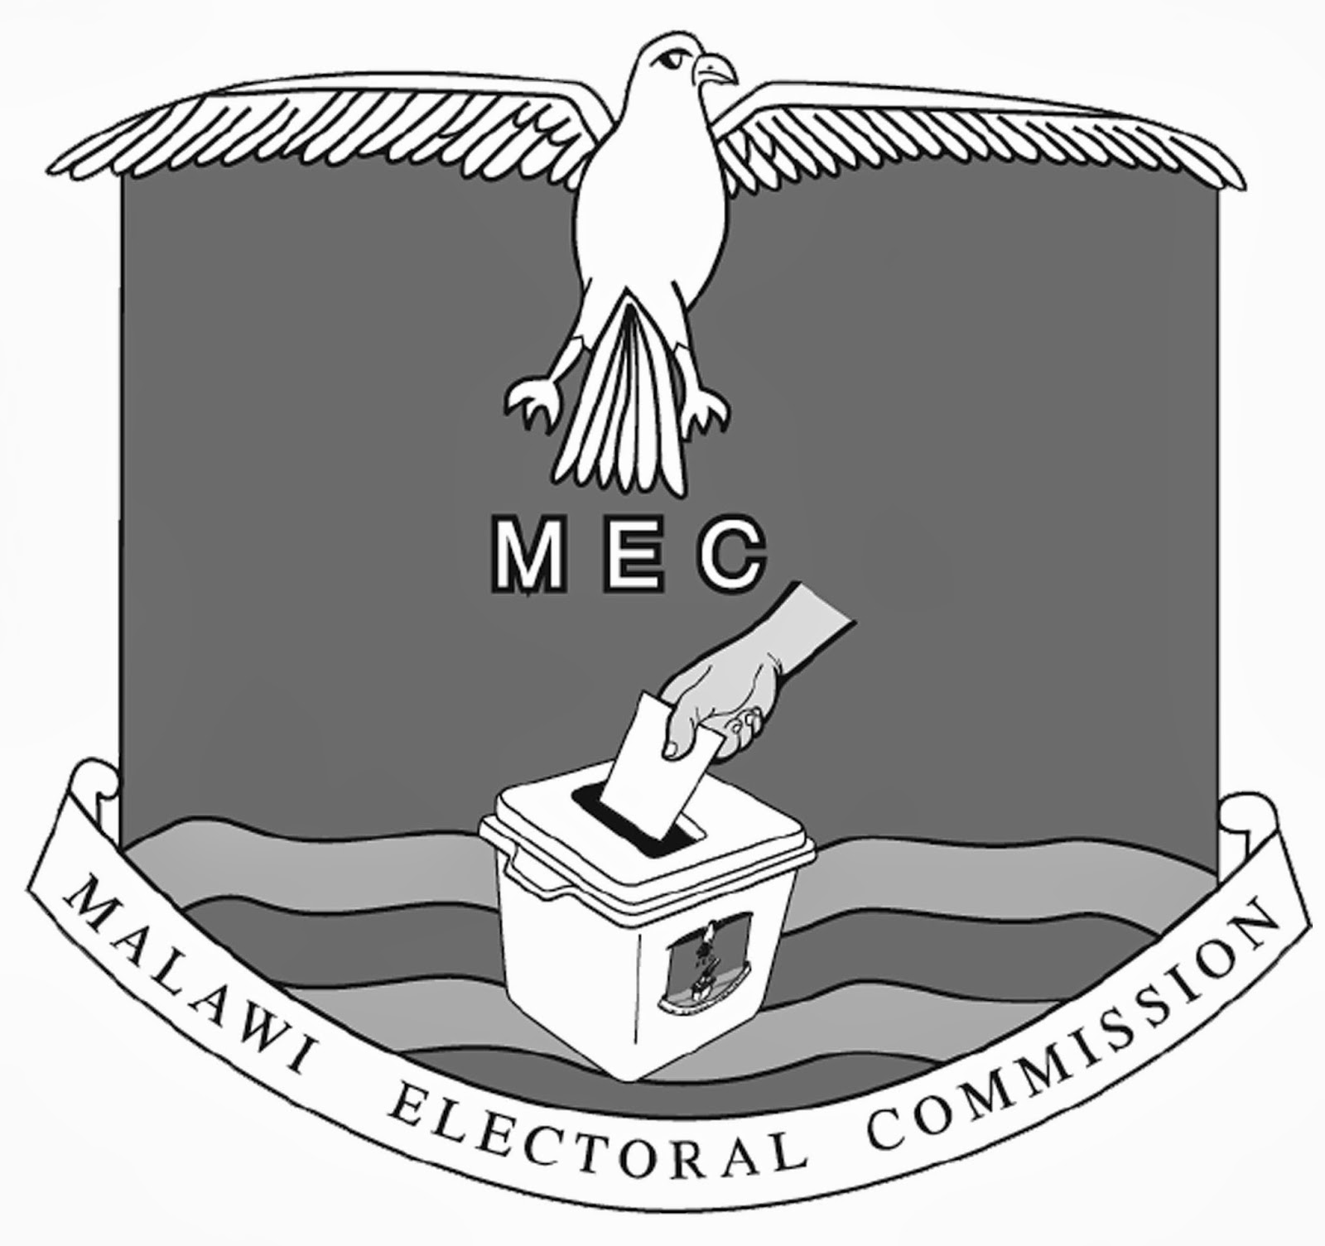

AND

MINISTRY OF HOME AFFAIRS
NATIONAL REGISTRATION BUREAU

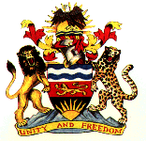

ARTICLE I
PARTIES

  - This Memorandum of Understanding (MoU) is made between the Electoral Commission (hereinafter MEC), Chisankho House, Private Bag 113, Blantyre, Malawi and the National Registration Bureau (hereinafter NRB), Capital Hill, Private Bag B318, Lilongwe 3;

  - General description of MEC’s mandate:

MEC is an independent institution that exercises its functions independent of any direction or interference by other authority or person (Constitution of Malawi, section 76.(4). MEC is the exclusive electoral authority responsible for the preparation and organization of the elections including the registration of voters. MEC’s mandate includes the overall supervision of the electoral process and the adoption of all the necessary measures to ensure that elections are conducted in a free, fair and transparent manner.

  - General description of NRB’s mandate:

NRB is the exclusive authority responsible for the management of the National Register of Malawian citizens. Under the Ministry of Home Affairs and Internal Security, NRB is required to register all Malawians of 16 years of age and older in the national register.
The primary objective of the NRB is to capture, manage and maintain the national population database in a transparent, credible, protected and verifiable manners which meets international standards.

  - General description of the National Register:

1.4.1 The legal framework for the national registration is the National Registration Act of 2010;
1.4.2 The national register will include Malawian citizens’ personal information, facial feature, fingerprints, through direct data entry.
1.4.3 NRB will develop and implement a civic education strategy aimed at ensuring that information disseminated to all Malawians is timely and accurate.

  - Phases of the National Registration:

- Mass registration;
- Continuous registration

ARTICLE II
OBJECTIVE

  - The purpose of this MOU is to ensure that both institutions mutually cooperate in the fulfilment of their respective mandates.

  - This MOU formalizes and records the agreement between MEC and NRB concerning their co-operation in implementing the operational aspects of the voters’ registration and their identification on polling day.

  - The Parties agree to:
a) Co-operate with each other during the term of this MOU through dialogue;
b) Recognize that a biometric national identification system will be administered by the National Registration Bureau:
c) Use the National Identity Card as the basis for voters’ registration and polling.
d) Further develop and agree on the operational aspects related to the voter’s registration.
- Hold consultative stakeholders’ meetings as unique events in which both institutions will engage national stakeholders to explain and update on relevant progress.
- Enable the Government of Malawi to use the available resources prudently without duplication of efforts amongst its agencies resulting in providing timely and accurate data.

ARTICLE III
GOVERNANCE STRUCTURE

  - A joint working mechanism between MEC and NRB will be the basis for common technical discussion on the implementation of the MoU.

  - The governance structure shall be three-level committees for all matters related to the cooperation between the two institutions.

  - The Steering Committee oversees the strategic priorities and progress of the MoU, ensure the coordination between NRB and MEC and provide a forum for high-level decision-making.
  - On a second level, the Technical Committee, co-chaired by a MEC Commissioner and the Chief Director for National Registration Bureau, shall provide on-going quality assurance and technical oversight of the progress, risk identification and monitoring.

  - On a third level, regular MEC/NRB meetings will be the point of principal coordination of efforts and for the MoU’s implementation.

  - Beside the Governance structure, consultative stakeholders meeting will take place as unique events in which both institutions will engage national stakeholders to explain and update on relevant progress.

ARTICLE IV
RESPONSIBILITIES OF MALAWI ELECTORAL COMMISSION

4.1. The Malawi Electoral Commission shall:

    - Recommend to the Ministry of Justice and Local Government and Rural Development to amend Part III of the Presidential and Parliamentary and the Local Government Act to consider the new procedure related to the registration of voters and the terms of this MoU;
    - Construct the voters’ register by using the National IDs to identify registrants;
    - Conduct Voters registration and related field operations;
    - Provide civic education support as stated in the Electoral Commission Act section 8.1 (j);
    - Ensure that during the voters registration the data information will be accurately captured and securely transmitted to MEC Headquarters and safely stored;
    - Upon presentation of a formal request, require NRB to cooperate in the two following cases:
- Confirming, through double checking, the accuracy of the data captured during the voter registration;
- If additional information is required for the construction of voters’ register (i.e pictures).
    - Recognize that the NRB database is one of the main source of information related to Malawian Citizens for extracting voters information, a part from the process of voters registration;
    - Print the voters register for every polling centre.

ARTICLE V
RESPONSIBILITIES OF THE NATIONAL REGISTRATION BUREAU

  - The National Registration Bureau:

    - Fulfil its mandate to register all Malawians of 16 years of age and older
    - Adhere to the deadlines by registering and issuing biometric identity cards to 80% of the projected population number by December 2017.
    - Maintain and protect the national population database.
    - Determine the MoU timeline based on operational needs and the contract arrangements;
    - Ensure the quality of the national population database by deduplication and validation checks resulting in exclusion of multiple registrations, and unqualified foreigners;
    - Print and issue national ID cards with unique identification number for every Malawian citizen on continuous basis;

ARTICLE VI
ENTRY INTO FORCE

  - This MOU will commence on the date of signature of both Parties and, subject to Article 6.3, remain in force for four (4) years (the “Term”).

  - Prior to the expiration of the Term, the Parties agree to carry out in good faith the discussions with a view of renewing this MOU for a further agreed period.

  - Despite article 6.1, either Party may terminate this MOU without liability at any time during the Term upon ninety (90) calendar days’ written notice to the other Party.

ARTICLE VII
AMENDMENTS

7.1. This MoU may be amended or revised by mutual agreement of both parties and in writing.

7.2. Any amendments or revision of this MoU shall come into force only upon signature by both the Parties.

ARTICLE VIII
SETTLEMENT OF DISPUTES

8.1 MEC and NRB shall amicably resolve all the disputes related to the interpretation and the implementation of the MoU through proficient dialogue, consultations and negotiations.

8.2 Where the Parties fail to settle the dispute amicably, either Party may refer the matter for arbitration.

8.3 The arbitration tribunal shall consist of three arbitrators: one to be appointed by MEC, one by the NRB and the third arbitrator shall be chosen by the first two arbitrators. If the tribunal is not constituted within six (6) months from the date of the request made for the submission of the dispute to arbitration, the appointment of the arbitrators not yet designated shall be made in accordance with the provisions of Arbitration Act, Cap. 6:03 of the Laws of Malawi.

8.4 This MoU shall be interpreted in the light of implementing the voter registration.

ARTICLE IX
COST TERMS

9.1 The Parties will agree and specify in writing the expected costs related to the implementation of the MoU and the modality of payment. No expenses will become payable to or by either Party if it was not previously agreed in writing.

ARTICLE X
TERMINATION AND DISPOSITION OF ASSETS

10.1 This MoU may be terminated by mutual agreement of the Parties after a Party gives ninety (90) days written notice to the other.

10.2 Upon such termination, the disposition of all other assets shall be determined by mutual agreement among the parties. In case that no agreement will be reached Article VIII will apply.

ARTICLE XI
GOVERNING LAW

  - This MoU shall be governed by the Laws of Malawi.

ARTICLE XII
PUBLICITY AND CONFIDENTIALITY

  - Any Party to this MOU may take measures to provide public information. The multi-level committees, as described in article III, will ensure that the channel of communication between MEC and NRB will be constantly maintained. And that recognition will always be given to the contribution made by the other Party.

ARTICLE XIII
ADDRESSES

  - All correspondence and notices pursuant to this MoU shall be deemed to have been properly given and delivered in writing to the following addresses:

MALAWI ELECTORAL COMMISSION NATIONAL REGISTRATION BUREAU
Chisankho House, Sports Building
Private Bag, 113 Capital Hill
Blantyre, Malawi Private Bag B318
Lilongwe 3, Malawi

IN WITNESS, WHEREOF the duly authorized representatives of the Parties hereto have signed this MoU in on day of Two thousand and seventeen (2017)

_____________________________________ ______________________________
For: the Malawi Electoral Commission For: National Registration Bureau

