Government of Democratic Republic of Timor-Leste

United Nations Development Programme

Access Improvements to Markets (AIM)
in the Eastern Region

A two year project with an estimated cost of Euro 6.59 million in support of the National Development Plan designed to facilitate the country’s economic and social development through the rehabilitation and reconstruction of the road network in the potentially rich agricultural areas of the eastern region of Timor Leste comprising the districts of Lautem, Viqueque, baucau and southern Manatuto.

The project will target five major bridges including a capacity-building to the Directorate of Roads, Bridges and Flood Control (DoRB&FC) through the strengthening of an existing Project Management Unit (PMU) at the Directorate.

Where appropriate, the project will adopt a labour-based construction method, which will provide short-term employment opportunities to the communities living near the project sites mainly as unskilled labour, semi-skilled workers, equipment operators and supervisors. The project may include qualified national construction companies in the bidding process or as subcontractors for implementing the reconstruction/construction works.

Oecussi Ambeno Community Activation Project

Dili, Timor Leste

Acronyms

DoRB&FC Directorate of Roads, Bridges and Flood Control
EC European Commission
EOI Expression of Interest
GoTL Government of the Democratic Republic of Timor-Leste
JICA Japan International Cooperation Agency
MAFF Ministry of Agriculture, Fisheries and Forestry
MDE Ministry of Development and Environment
MCTPW Ministry of Communications, Transport and Public Works
NDP National Development Plan
PSC Project Steering Committee
PWC Project Working Committee
RFP Request for Proposal
SBAA Standard Basic Assistance Agreement
TOR Terms of Reference
UN United Nations
UNDP United Nations Development Programme
UNOPS United Nations Office for Project Services

Table of Contents

Items Page

Ia Situational Analysis……………………………………………………. 4
Ib Strategy……………………….………………………………………… 5
Project Components………….………………………………………... 7
II Results Framework………….…………………………………………. 9
III Management Arrangements…………………………………………. . 11
IV Legal Context…………………………………………………………. . 11
V Budget ………….…………………………………………………….… 12
VI Indicative Work Plan………………………………………………….. 24

Annexes

1 Logical Framework
2 Map of East Timor Showing Road Network
3 Road Network and Traffic Volume (JICA STUDY)
4 Division of Responsibilities in Procuring Consulting Services
5 Division of Responsibilities in Procuring Works
6. Existing PMU set-up of DORB & FC
7. Emergency Infrastructure Rehabilitation Project Schedule of Performance Indicators
8. Proposed Route Numbering System (ADB STUDY)
9. Proposed Traffic Volumes on main Network (ADB STUDY)
10. Work plane Bar Charts
11. Priority Bridges in Southern Coast Road Network

Part Ia: Situational Analysis

1. The Districts of East Timor are characterised as rural, economically underdeveloped and lacking in basic infrastructure. Access to electricity, safe drinking water and sanitation is limited and mainly confined to the district capitals. Subsistence agricultural crop production is the predominant economic activity. Forestry resources are indiscriminately exploited for cooking and building purposes. Poverty manifests itself in high infant mortality at 20 per 1,000 and low life expectancy at 57 years.

2. Around 85% of the people live in the rural areas where the majority of households are engaged in subsistence agriculture. The main food crops are maize, rice and cassava. Although maize remains the main staple food crop, rice is becoming steadily more important and by 1997, total output was about half of the maize production. Food production in 2001, as reported in the “Suco” Survey is shown in Table VI. The main cash crop is coffee (coffee cherries-26,994 tons and coffee dry beans-14,984 tons) and is grown both on small landholdings and also on small to large estates. The constraints for crop production are known to be the lack of fertiliser and marketing channels. Farmers in productive areas as Viqueque are reluctant to produce surplus crops because there are few buyers. This situation is compounded by the poor state of the road network and the high cost of transporting agricultural inputs and products.

3. The National Development Plan advocates the development of the agriculture sector as a means of alleviating poverty in the districts. The agricultural development potentials are identified as high in the southern coastal areas of East Timor where vast elongated lowland plains are fed by many streams and rivers, which are not heavily silted as the watershed areas in the highlands are still covered by moderate thick forest. Viqueque and Lautem districts are part of this lowland plains, which are suitable for the development of irrigated rice production. The Ira Lalaro Lake in Lautem is also a potential source of irrigation water, which can be pumped to expand rice production on surrounding vast plain areas.

4. The agricultural development of the Viqueque (population of 54,315) and Lautem (population of 49,213) Districts require improved access to markets in Baucau, Manatuto and Dili for the much needed agricultural inputs such as improved seeds, fertiliser, pesticides, hand tools and mechanised farm equipment and also for the distribution of surplus agricultural products. Currently, the only road networks in the eastern region, which are in fair conditions are the national roads on the Manatuto-Baucau, Baucau-Lautem and Baucau-Viqueque. The rest are only passable during the dry season and in great difficulty.

5. In Viqueque District alone, there are 8 major irrigation systems that currently support crop production to about 2,500 hectares and there are plans to rehabilitate them to expand the coverage to their maximum potentials of 3,000 hectares. Statistics before the 1999 violence already confirmed Viqueque as a bread basket in the triangle that supplemented the food requirements of Baucau district but not Lautem district because of poor access from Viqueque to Lospalos. In 1997, only Bobonaro district surpassed Viqueque’s crop production of 18,087 metric tons (maize, milled rice, cassava and sweet potatoes) and 20% of this production went to Baucau even though the general attitude of most East Timorese towards crop production is primarily aimed at subsistence only.

6. While Baucau, Lautem and Viqueque are relatively less poor in terms of live stocks, landholdings, irrigated land and double cropping annually in comparison to other districts who suffered more from the 1999 violence, these three districts have nevertheless limited access to markets. With a combined population of about 230,000 representing 31 % of the country’s total population, the mobility of this large number of people within the country is essential for both economic and social development of the eastern region.

7. One of the priorities in the NDP in reducing poverty is to create sufficient employment opportunities for both current and future generations. Presently, the labour force in the country amounts to 310,000. With the population growing at about 2.5% annually, an additional 20,000 young people adds to the labour force each year. As agriculture is the main source of employment in the country for both consumption and cash income, the development of the road networks is therefore essential for agricultural development. This situation further justifies the need to improve the road networks in the eastern region to support its agricultural development.

8. The development of the road networks in the eastern region would directly benefit the combined 103,528 population of Viqueque and Lautem Districts who are mostly engaged in subsistence farming activities. A small number of this population would also directly benefit from a secondary economic impact on attracting tourists to the region’s spectacular mountains, lakes and hot springs, as well as white and sandy beaches with surf reefs. There are also many interesting colonial buildings, including fortresses and churches. Timor’s relief is broadly characterised by a core of rugged hills and mountains consisting of a confused mass of knife-edged ridges and craggy upland blocks. The land rises to 2,000 meters and above, including Mount Tatamailau at 3,000 meters. As with many small island states, Timor has the right climate and humidity favoured by most tourists.

Part Ib: Strategy

9. The project is directly formulated by the DoRB&FC taking into consideration the NDP and the recognized agricultural development potentials of the eastern region, in particular the districts of Viqueque and Lautem. With a primary focus on improving access to potential growth centers, the project will rehabilitate and reconstruct 5 major bridges.

10. The project will adopt labour-intensive construction methods to respond to the national policy of providing employment opportunities to local communities. The extent of the labour-intensiveness will, however, be thoroughly assessed during the detailed design stage by the selected consulting company. In this regard, construction companies with previous experience in labour-based bridge construction will be invited to participate in the bidding process for implementing the rehabilitation and construction works. If necessary, the DoRB&FC will make available recently acquired fleet of road construction equipment to the Contractors at minimal rental costs.

11. In recognition of local sensitivities, the project will further ensure that qualified Timorese construction companies are included in the bidding process and that local communities (both men and women) are given first priorities in the recruitment of construction workers. The project will also ensure that there is prior consultation with the local communities in terms of access to local construction materials and communal/individual properties that may be affected by project activities.

Coordination and Synergy Creation with Other Development Initiatives

12. The AIM is one of the four programmes proposed for funding by the European Commission. The other three proposals are:

- Oecussi Ambeno Community Activation Programme (OCAP)
- Programme for enhancing rural women’s leadership and participation in nation building in Timor Leste (PERWL)
- Skills Training for Gainful Employment Programme (STAGE)

13. UNDP will forge strong partnerships with ILO, UNIFEM and UNOPS to ensure optimum results. ILO will be instrumental in applying its global experience in employment generation through skill and entrepreneurship development. UNIFEM will impart its expertise to ensure the quality and relevance of women’s empowerment activities with appropriate technical support. UNOPS’ management expertise and its ability to implement development activities will be effectively utilized. The expertise of other UN and international agencies will be brought to bear whenever it is required and whenever an opportunity of partnership and synergy is present.

14. The proposed programmes will reinforce on-going initiatives addressing the priorities of the Government of Timor-Leste, particularly in community development and livelihood opportunities. While the programmes may adopt distinct strategies for their own purposes, they share the ultimate objective of poverty reduction and common entry points of capacity development, participation and the enhancement of food and income security.

OCAP, STAGE, AIM, PERWL

OCAP, FAD

OCAP, STAGE, AIM, PERWL

Capacity Development
Food Security
Participation

Poverty Reduction

Basic Service Delivery
Income Security
Seed Grants

OCAP, AIM

OCAP, STAGE, AIM

OCAP, STAGE

15. UNDP will play a crucial role in coordinating the strategic convergence of the proposed programmes, their interaction with other projects in the same location, and their linkages with similar projects elsewhere for the most effective use of programme resources and maximum impact.

Environmental Aspect

16. Although there is no assessment made, negative environmental impact to lands of the proposed activities is considered to be insignificant as acquisition of new land is not necessary. The habitats of precious plants and wild animals will not be disturbed. However, during construction, detours, temporary yards, and landslides should be properly assessed for their negative environmental impacts.

National, UNDP and EC Priorities

17. The project strongly supports the Timor-Leste government policies, as defined in the NDP Road Map and Stability Program. In particular, the project will:

- Be supportive of labour-intensive construction methods as a means of providing employment opportunities to communities residing near the project sites;
- Be supportive of the participation of qualified national construction companies in the implementation of the rehabilitation and construction works; and

18. One of the two foci of UNDP’s first Country Programme for Timor-Leste (2003-2005) is community development and rehabilitation. Particular emphasis is given to longer-term sustainability of development activities and rehabilitation where infrastructure is currently a major component. As the project supports agricultural development as a means of reducing poverty and creating sustainable livelihoods, it falls within the priorities of UNDP.

19. The UN’s strategy for addressing Timor-Leste’s development needs calls for the rehabilitation of the country’s road network as its poor state is a serious impediment to economic development, particularly to agriculture and rural livelihoods.

20. The project falls firmly within the European Commission’s (EC) strategic focus on rural employment and agriculture where low productivity among the poor is linked, among other factors, to access to markets and other infrastructure.

Assumptions and Assessment of Risks

21. There are a number of assumptions for the successful achievements of the project purpose, results and activities which are beyond the control of the project. These risks, which are mostly related to accompanying actions by relevant Government departments, are as follows:

- Support from MAFF in promoting improved agricultural technologies to increase crop productions including the provision of relevant inputs in market centers. This risk is considered low as MAFF has a strong policy in this area. The project will, however, continuously liaise with MAFF staff on extending its technical outreach to Viquequqe and Lautem Districts.

- Support from the DoRB&FC on social issues emanating from project activities and clearance on specific project implementation. The risk is considered low as the PMU, being part of the government structure, will immediately alert the DoRB&FC when such social issues arise. To prevent delays in project implementation, the PMU will also closely follow-up with the DoRB&FC on agreed formalities for clearing contracts, recruitment of staff, procurement of equipment and training on community-based road maintenance.

Project Components

22. The project is primarily focusing on the reconstruction/construction of 5 major bridges along the Viquequqe-Lospalos Road. This component is specifically targeting long-span river crossings. The type of bridge design (reinforced concrete slab, reinforced concrete T-beam, steel truss, bailey bridge, etc.) will depend on the span length. The Contract for the consulting services will recommend the type of bridge design. The locations of the major bridges are as follows:

- Bebui (90 m span in Viqueque district)
- Wekain (30 m span in Viqueque district)
- Irabere (220 m span in Viqueque/Lautem districts)
- Mauma’a or Rorolai (120 m span in Lautem district)
- Lihulu (45 m span in Lautem district)

23. The project will adopt a two-stage approach in project implementation. The first stage will involve contracting a consulting company to undertake a technical feasibility study of the proposed bridge reconstruction/construction taking into account the topography of the sites, soil conditions, hydrology, availability of local construction materials and other resources, social issues, etc. Based on this feasibility study, appropriate recommendations will be made to the stakeholders before proceeding to the detailed designs, technical specifications, bill of quantities, cost estimates and other documents required for tendering the construction works. It is estimated that the process of undertaking this first stage of project implementation will take about 6 months for the 5 bridge sites. The second stage of project implementation will involve contracting companies to implement the reconstruction/construction works.

24. The contracting of companies for both stages will follow internationally accepted competitive bidding process in terms of shortlisting qualified companies, request for proposals/bids, opening of proposals/bids, evaluation of proposals/bids, recommendations and award of contracts.

Part II: Project Results Framework

Overall Target:

To promote socio-economic development in Viqueque and Lautem Districts as a means of reducing poverty in the two districts.

Intended Outcomes:

Improved access of Viqueque and Lautem districts to market centres in Baucau, Manatuto and Dili for agricultural inputs and products.

Partnership Strategy:

UNDP cooperates with identified key partners and potential partners:

- The GOTL through the DoRB&FC, MAFF and MDE, who will provide the policy guidelines for the plans and activities of the project.
- Local communities participating in the implementation of the project, particularly on the issue of quarrying local construction materials and employment of local labour.
- Support institutions, national and international construction/consulting companies for the implementation of the project.
- UNOPS for management and other support services in the implementation of the project.
- The European Commission for the provision of the financial support.

Project Title:

Access Improvements to Markets (AIM) in the Eastern Region

Intended Outputs | Output Targets | Activities | Inputs
1. Reconstruction/ construction of major bridges. | - Bebui in Viqueque district  - Wekain in Viqueque district  - Irabere in Viqueque/Lautem districts  - Mauma’a or Rorolai in Lautem district  - Lihulu in Lautem district | 1.1. Preparation of a feasibility study, technical designs, construction drawings, specifications and costs. This will involve contracting a consulting and design company based on a competitive bidding process to undertake a topographic survey of the sites, undertake soil investigation and hydrologic analysis, develop field maps, propose appropriate bridge designs, calculate structural designs, prepare construction drawings, define technical specifications, draft bid documents, estimate approximate costs, assist in the bidding process particularly in analysing the bids, and supervise construction works.  1.2. Construction work, which will also require contracting a construction company based on a competitive bidding process to manage the construction activities including establishing a management team, organising field camps, scheduling work programmes, recruitment of labour, procurement of materials and equipment and subcontracting, if necessary. | Consulting services contract; construction contract.

Part III: Management Arrangements

25. The project will utilise an existing Project Management Unit (PMU) at the DoRB&FC to provide operational support to the implementation of the project, with additional resources being provided to the PMU to cope-up with the additional work load. This may take the form of recruiting a national Project Coordinator with 2 national field inspectors, an office secretary, 2 drivers, 2 four-wheel pickups and basic office equipment and supplies.

26. A Project Steering Committee (PSC) in Dili will provide central policy level coordination and over-all guidance to the project. Close involvement of the Ministry of Communications, Transport and Public Works (MCTPW) in this Committee ensures full local ownership of the project. MCTPW will chair the PSC. The Committee will consist of representatives from UNDP, UNOPS and the EC. The PSC will approve project policies, receive and review the project quarterly reports and resolve any policy level issue raised by the Project Working Committee (PWC). The PSC will meet quarterly, with UNDP providing the secretariat services. Special sessions may be called if necessary.

27. A PWC will directly monitor the activities and work plan of the consultants and contractors. It comprises of project officers from UNDP, UNOPS and the DoRB&FC as the chair. The PWC will discuss issues arising from day-to-day operation of the project. The PWC will review periodic progress reports of the consultants and contractors before submitting them to the PSC. The PWC will also submit policy-related proposals and feedback from the PSC. If necessary, PWC may conduct joint inspection of the project.

28. Representatives of the Consultants and Contractors may be requested to attend both PSC and PWC meetings by invitation only when specific clarifications on technical issues are required.

Part IV: Legal Context

29. This document shall be the instrument referred to as such in Article 1 of the Standard Basic Assistance Agreement between the Government of Democratic Republic of East Timor and the United Nations development Programme, signed on 20 May 2002. The host country implementing agency shall, for the purpose of the Standard Basic Assistance Agreement, refer to the government co-operating agency described in the agreement. The following types of revision may be made to this document with the signature of the UNDP Resident Representative only, provide he/she is assured that the other signatories of the document have no objections to the proposed changes:

- Revision in, or addition to, any of the annexes of the document;
- Revisions which do not involve significant changes in the immediate objectives, outputs, or activities of the Programme, but caused by the rearrangement of inputs already agreed to, or by cost increases due to inflation, and
- Mandatory annual revision, which re-phase the delivery of agreed inputs or increased expert or costs due to inflation or take into account agency expenditure flexibility.

Part V: Budget

30. In the absence of detailed site investigations and technical designs on the proposed bridge construction, typical designs and corresponding estimates are derived from JICA’s Study on Urgent Rehabilitation in East Timor, August 2000. The cost estimates includes engineering services for the topographic survey, subsoil investigation, detailed survey and construction supervision as well as the indirect costs related to overheads, profits, insurance, field management expenditures and inland transportation to complete the construction work.

(a) Bridges

Name | Location | Type | Estimated Cost (Euro) | Remarks
1. Bebui (90 m) | Viqueque | 4 span RC T-shaped girder bridge | 806,000 | W=6.0m, L=93.6m
2. Wekain (30 m) | Viqueque | RC T-shaped girder bridge (23.4 m) & RC slan (6.6 m) | 310,000 | W=6.0m, L=23.4 m  W=6.0m, L=6.6 m
3. Irabere (220 m) | Viqueque/Lautem | Standard Steel Truss | 2,520,000 | W=6.0m, L=240.0 m
4. Mauma’a or Rorolai (120 m) | Lautem | Standard Steel Truss | 1,260,000 | W=6.0m, L=120.0m
5. Lihulu (45 m) | Lautem | 2 span RC T-shaped girder bridge | 400,000 | W=6.0m, L=46.8m
 |  | Total Estimated Cost | 5,296,000

(b) River Bank/Bed Protection. The assumptions are: gabions will be used and each bridge site will require bank protection works of about 100 meters on each side of the abutments. The bed protection will stretch the whole span of the bridge with a width of 6 meters.

Name | Bank Protection |  |  | Bed Protection |  |  | Total Cost (Euro)
Name | L(m) | Unit Cost/m | Total Cost (Euro) | Area (sq m) | Unit Cost/sq m | Total Cost (Euro) | Total Cost (Euro)
Bebui | 200 | 590 | 118,000 | 540 | 35 | 18,900 | 136,900
Wekain | 200 | 590 | 118,000 | 180 | 35 | 6,300 | 124,300
Irabere | 200 | 590 | 118,000 | 1,320 | 35 | 46,200 | 164,200
Mauma’a | 200 | 590 | 118,000 | 720 | 35 | 25,200 | 143,200
Lihulu | 200 | 590 | 118,000 | 270 | 35 | 9,450 | 127,450
Total | 1,000 | 590 | 590,000 | 3,030 | 35 | 106,050 | 696,050

(c) Project Management Unit. The purpose of this Unit is to support the DoRB&FC in terms of managing the implementation of the project with appropriate support from the UNOPS.

Description of Inputs | Quantity | Unit Cost (Euro) | Total Cost (Euro)
Project Manager x 1 | 26 man-month | 2,000 | 52,000
Field Inspectors x 2 | 48 man-months | 500 | 24,000
Secretary x 1 | 24 man-months | 300 | 7,200
Drivers x 2 | 48 man-months | 200 | 9,600
Vehicles, 4WD Pick-ups | 2 units | 16,000 | 32,000
Office Equipment | Assorted | 20,000 | 20,000
Office Supplies/ Communications | 24 months | 500 | 12,000
O&M | 24 months | 500 | 12,000
Total |  |  | 168,800

(d) Summary of Budget

Description | Cost (Euro)
1. Bridges | 5,296,000
2. River Protection | 696,050
3. PMU | 168,800
Sub-total | 6,160,850
4. Agency Support Cost (7%) | 431,260
Total Budget | 6,592,110

 | United Nations Development Programme
 | TIM/03/032 - Access Improvement to Markets (AIM)
 | Budget " A"
 | Main Source of Funds: 01 - UNDP-IPF / TRAC - (Trac 1.1.1 & 1
 | Executing Agency: UNOPS - UNOPS
Sbln | Description | Implementing | Funding |  | Total | 2003 | 2004 | 2005 | 2006
010 | PERSONNEL
013 | Administrative Support
013.01 | Secretary | UNOPS |  | Net Amount | 7,200 |  | 3,600 | 3,600
 |  |  |  | W/M | 24 | 0 | 12 | 12 | 0
 |  |  |  | Total | 7,200 |  | 3,600 | 3,600
013.02 | Driver (2) | UNOPS |  | Net Amount | 9,600 |  | 4,800 | 4,800
 |  |  |  | W/M | 24 | 0 | 12 | 12 | 0
 |  |  |  | Total | 9,600 |  | 4,800 | 4,800
013.99 | Line Total | ---------- |  | Net Amount | 16,800 |  | 8,400 | 8,400
 |  |  |  | W/M | 48 | 0 | 24 | 24 | 0
 |  |  |  | Total | 16,800 |  | 8,400 | 8,400
017 | National Consultants
017.01 | Project Manager | UNOPS |  | Net Amount | 52,000 |  | 24,000 | 24,000 | 4,000
 |  |  |  | W/M | 26 | 0 | 12 | 12 | 2
 |  |  |  | Total | 52,000 |  | 24,000 | 24,000 | 4,000
017.02 | Field Inspector (2) | UNOPS |  | Net Amount | 24,000 |  | 12,000 | 12,000
 |  |  |  | W/M | 24 | 0 | 12 | 12 | 0
 |  |  |  | Total | 24,000 |  | 12,000 | 12,000
017.99 | Line Total | ---------- |  | Net Amount | 76,000 |  | 36,000 | 36,000 | 4,000
 |  |  |  | W/M | 50 | 0 | 24 | 24 | 2
 |  |  |  | Total | 76,000 |  | 36,000 | 36,000 | 4,000
019 | PROJECT PERSONNEL TOTAL | ---------- |  | Net Amount | 92,800 |  | 44,400 | 44,400 | 4,000
 |  |  |  | W/M | 98 | 0 | 48 | 48 | 2
 |  |  |  | Total | 92,800 |  | 44,400 | 44,400 | 4,000
020 | CONTRACTS
021 | Contract A
021.01 | Contract A | UNOPS |  | Net Amount | 5,992,050 |  | 2,396,820 | 2,396,820 | 1,198,410
 |  |  |  | Total | 5,992,050 |  | 2,396,820 | 2,396,820 | 1,198,410
021.99 | Line Total | ---------- |  | Net Amount | 5,992,050 |  | 2,396,820 | 2,396,820 | 1,198,410
 |  |  |  | Total | 5,992,050 |  | 2,396,820 | 2,396,820 | 1,198,410
029 | SUBCONTRACTS TOTAL | ---------- |  | Net Amount | 5,992,050 |  | 2,396,820 | 2,396,820 | 1,198,410
 |  |  |  | Total | 5,992,050 |  | 2,396,820 | 2,396,820 | 1,198,410
040 | EQUIPMENT
045 | Equipment
045.01 | Vehicle procurement (2) | UNOPS |  | Net Amount | 32,000 |  | 32,000
 |  |  |  | Total | 32,000 |  | 32,000
045.02 | Office Equipment | UNOPS |  | Net Amount | 20,000 | 15,000 | 5,000
 |  |  |  | Total | 20,000 | 15,000 | 5,000
045.03 | Office supplies / Communications | UNOPS |  | Net Amount | 12,000 |  | 6,000 | 6,000
 |  |  |  | Total | 12,000 |  | 6,000 | 6,000
045.04 | O&M | UNOPS |  | Net Amount | 10,750 |  | 6,000 | 4,750
 |  |  |  | Total | 10,750 |  | 6,000 | 4,750
045.99 | Line Total | ---------- |  | Net Amount | 74,750 | 15,000 | 49,000 | 10,750
 |  |  |  | Total | 74,750 | 15,000 | 49,000 | 10,750
049 | EQUIPMENT TOTAL | ---------- |  | Net Amount | 74,750 | 15,000 | 49,000 | 10,750
 |  |  |  | Total | 74,750 | 15,000 | 49,000 | 10,750
050 | MISCELLANEOUS
052 | Reporting Costs
052.01 | Media and Public Information | UNOPS |  | Net Amount | 1,250 |  | 500 | 500 | 250
 |  |  |  | Total | 1,250 |  | 500 | 500 | 250
052.99 | Line Total | ---------- |  | Net Amount | 1,250 |  | 500 | 500 | 250
 |  |  |  | Total | 1,250 |  | 500 | 500 | 250
059 | MISCELLANEOUS TOTAL | ---------- |  | Net Amount | 1,250 |  | 500 | 500 | 250
 |  |  |  | Total | 1,250 |  | 500 | 500 | 250
099 | BUDGET TOTAL | ---------- |  | Net Amount | 6,160,850 | 15,000 | 2,490,720 | 2,452,470 | 1,202,660
 |  |  |  | W/M | 98 | 0 | 48 | 48 | 2
 |  |  |  | Total | 6,160,850 | 15,000 | 2,490,720 | 2,452,470 | 1,202,660
 | 7% Administrative Costs |  |  | Net Amount | 431,260 | 1,050 | 174,350 | 171,673 | 84,186
 | GRAND TOTAL |  |  | Net Amount | 6,592,110 | 16,050 | 2,665,070 | 2,624,143 | 1,286,846

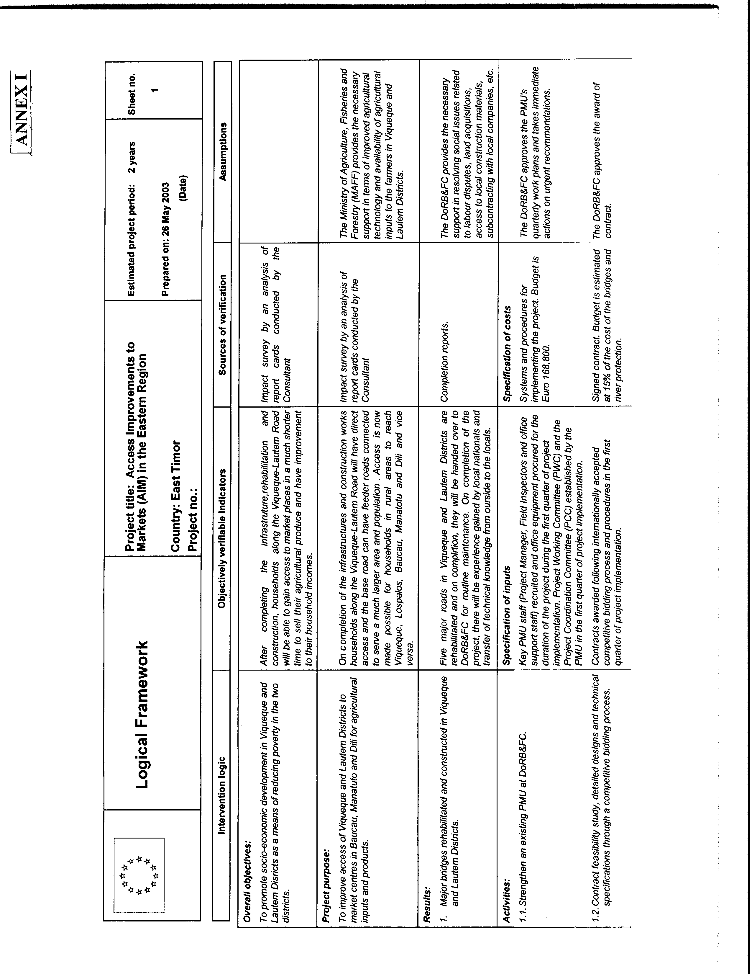

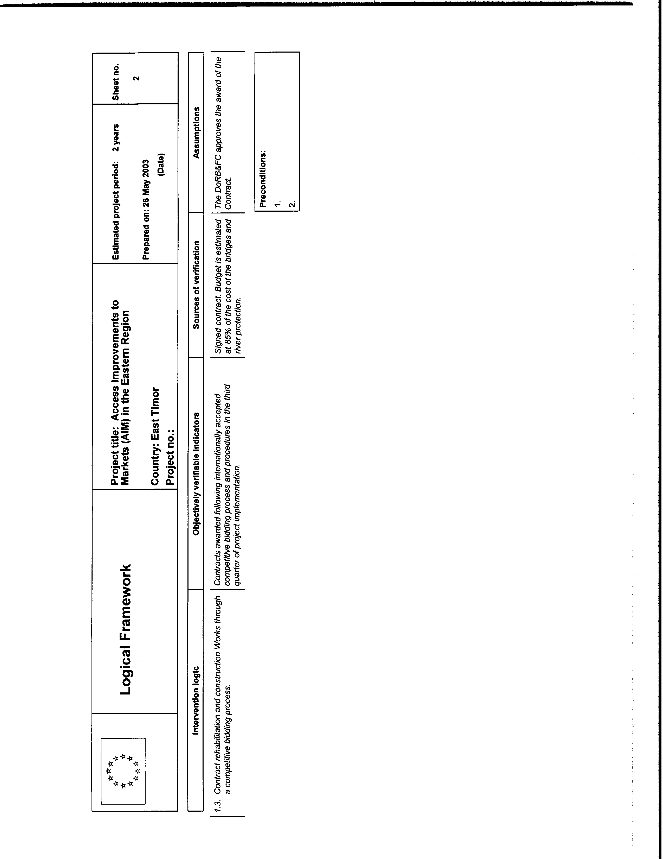

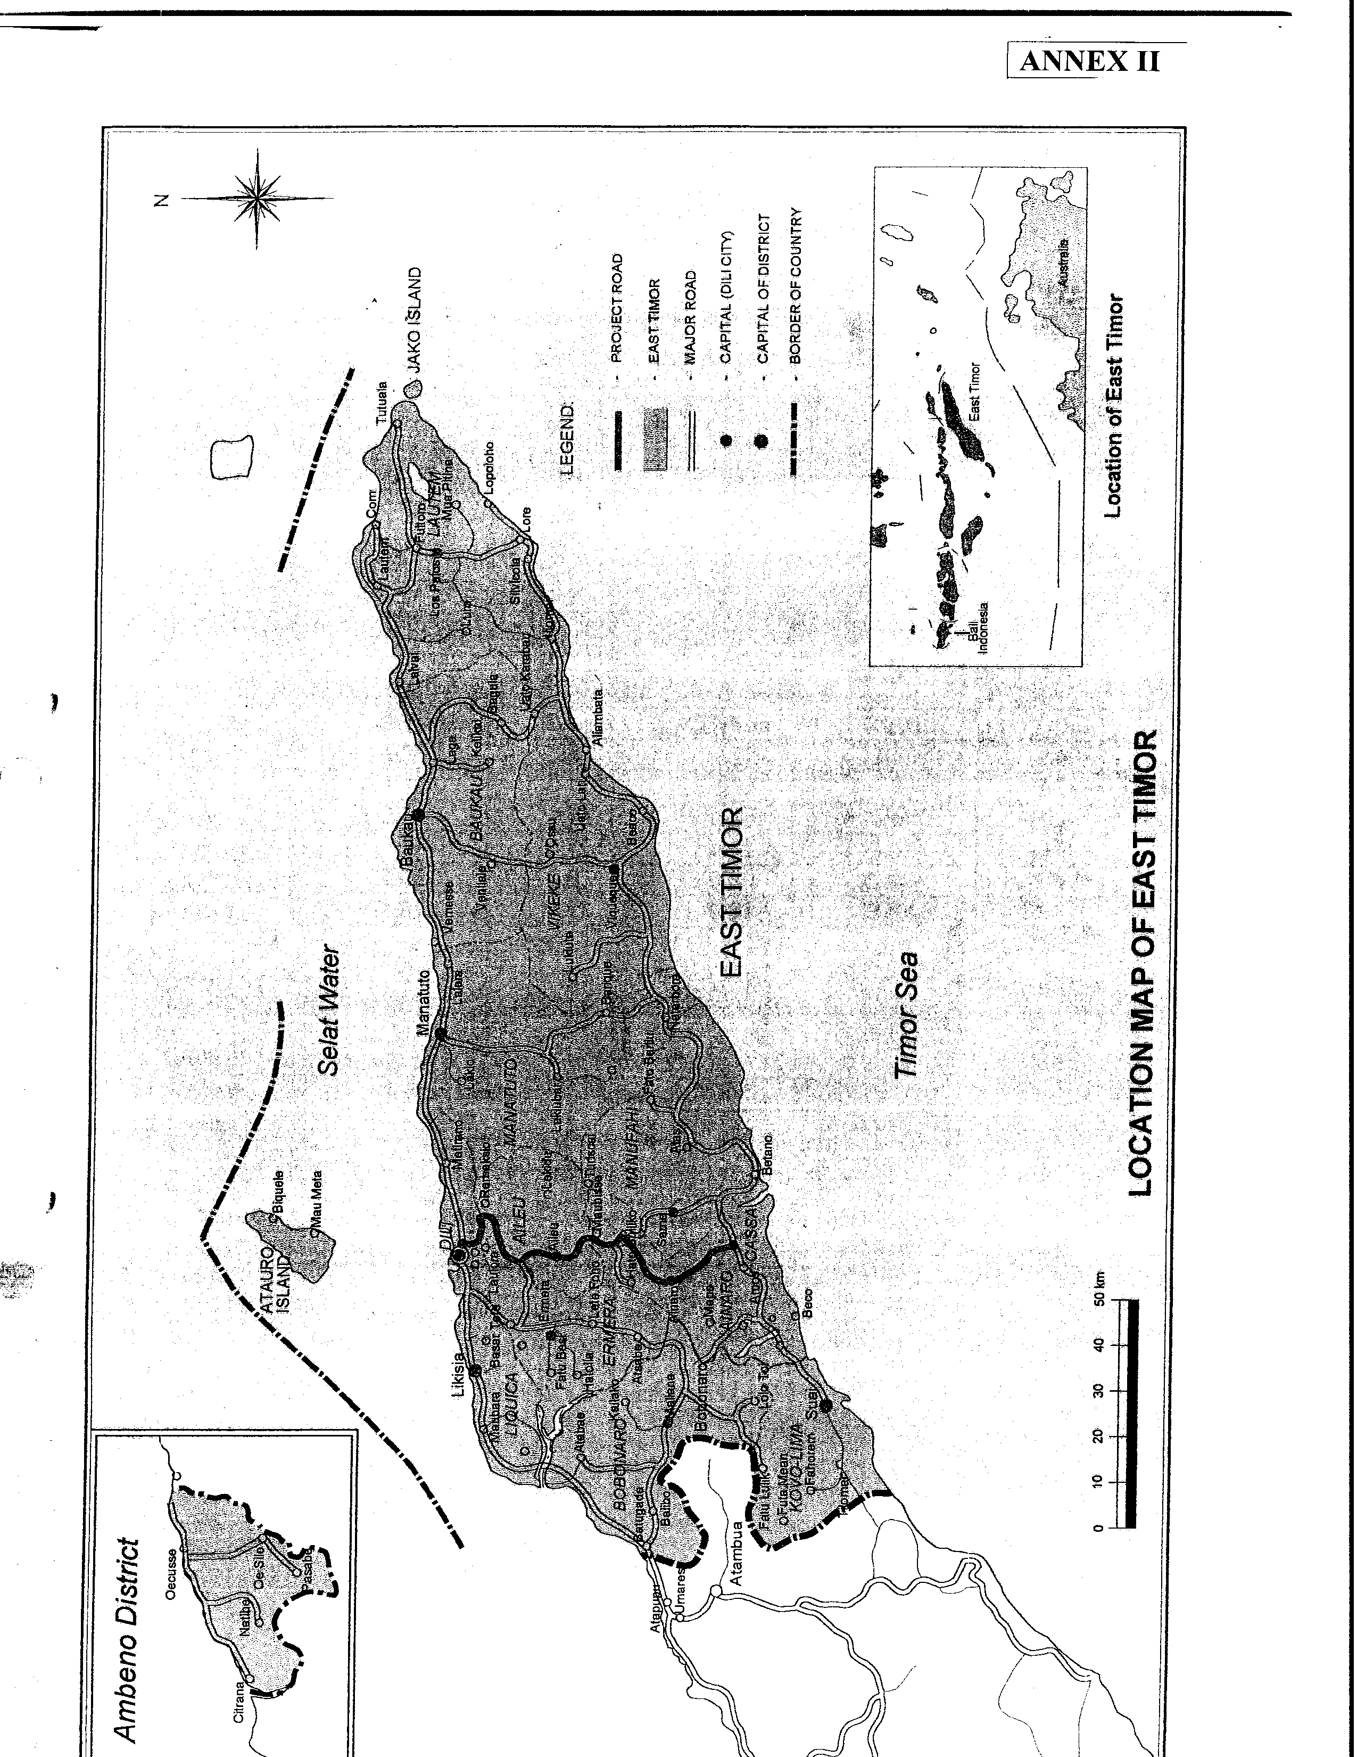

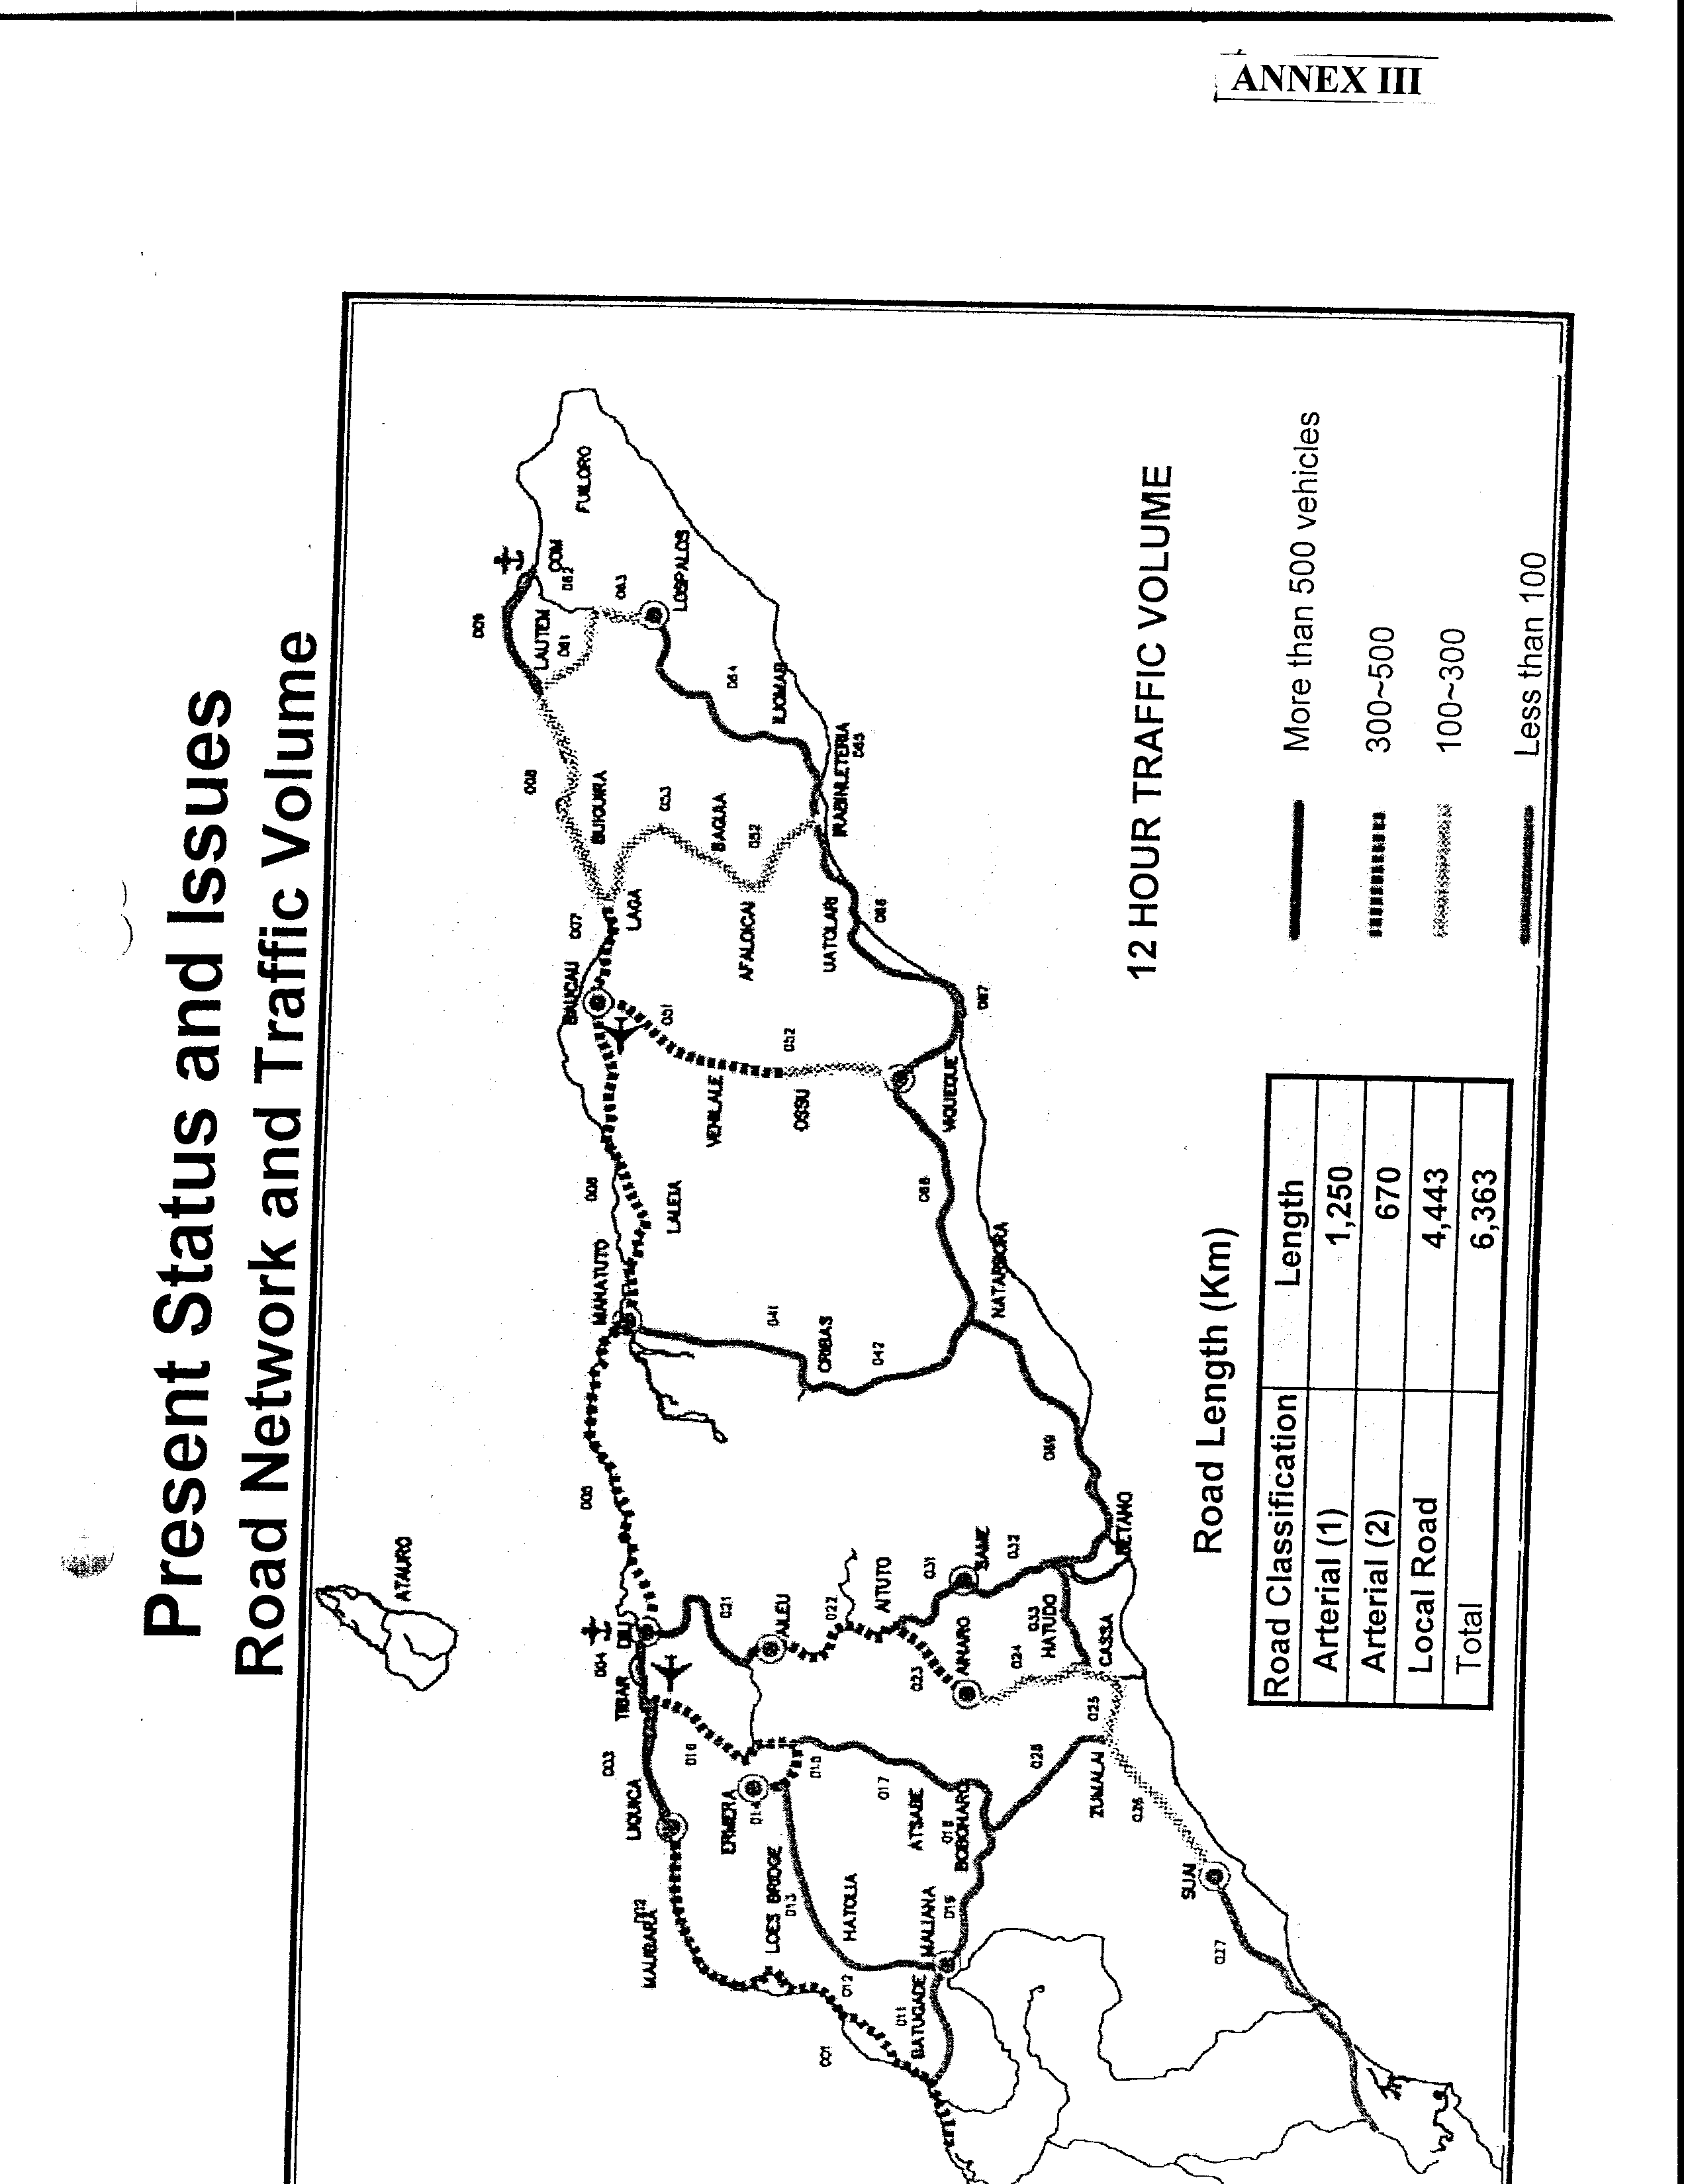

Annex 4: Consulting Firms

The responsibilities of GOTL/DoRB&FC and UNOPS with respect to engaging consulting firms shall be as follows:

GOTL/DPW | UNOPS | Activity
 | X | Preparation of draft Terms of Reference (TOR)
X |  | Review and clearance of TOR
 | X | Revision of TOR
 | X | Prequalification and shortlisting
X |  | Concurrence with shortlist
 | X | Preparation and issuance of Request for Proposal (RFP)
 | X | Evaluation of proposals
 | X | Recommendation for award of contract
X |  | Concurrence with recommendation
 | X | Drafting, negotiation and signing of contract and authorization to proceed
 | X | Contract administration
X |  | Taxes and duties exemption
 | X | Technical monitoring and evaluation
X | X | Review of final report
 | X | Approval of final report
 | X | Payment

Key: X = organisation responsible for action
(X) = organisation shall be consulted before action

Annex 5: Procurement of Works

The responsibilities of GOTL/DoRB&FC and UNOPS with respect to procuring works shall be as follows:

GOTL/DPW | UNOPS | Activity
 | X | Preparation of draft tender documents
X |  | Review and clearance of tender documents
 | X | Revision of tender documents
 | X | Advertising (if required)
 | X | Prequalification (if required)
 | X | Preparation of proposed shortlist
X |  | Concurrence with shortlist
 | X | Issuance of tender
 | X | Evaluation of bids
 | X | Recommendation for award of contract
X |  | Concurrence with recommendation
 | X | Contract preparation, negotiation and signing and authorisation to proceed
 | X | Contract administration
 | X | Technical monitoring of contract
 | X | Performance payments
(X) | X | Certification of completion of work
 | X | Final Payment to contractors |  | Payment to contractors

Key: X = organization responsible for action
(X) = organization to be consulted before action

Part VI: Indicative Work Plan

Category | Activities | 2004 |  |  |  | 2005 |  |  |  | 2006
Category | Activities | Q1 | Q2 | Q3 | Q4 | Q1 | Q2 | Q3 | Q4 | Q1 | Q2
A. Procurement of Consulting Services | 1. TOR | x
A. Procurement of Consulting Services | 2. Prequalification/EOI | x
A. Procurement of Consulting Services | 3. Shortlist | x
A. Procurement of Consulting Services | 4. Request for Proposal | x
A. Procurement of Consulting Services | 5. Evaluation, approval & award contract | x
A. Procurement of Consulting Services | 6. Studies, design &tender documents |  | x | x
B. Procurement of Works | 7. Prequalification/EOI |  | x
B. Procurement of Works | 8. Tender process |  |  | x | x
B. Procurement of Works | 9. Evaluation, approval &award of contract |  |  | x | x | x
B. Procurement of Works | 10. Construction |  |  | x | x | x | x | x | x | x
C. Project Management Unit | 11. Recruit staff | x | x | x
C. Project Management Unit | 12. Procure equipment | x | x
C. Project Management Unit | 13. Install sytems/procedures |  | x | x
C. Project Management Unit | 14. Monitor project |  | x | x | x | x | x | x | x | x

31. Operational Support

  - The existing Project Management Unit (PMU) at the DORB & FC will provide operation support to implement the project with additional resources to cope up with work load. The existing setup of the PMU is shown in
Annex 6.
  - The PMU has completed several other works related to buil
  - ding/ rehabilitation work. The brief of the works achieved are shown in Annex 7.
  - The additional staff who will be brought in under PMU for this work is 4, a Project Manager, two field inspectors and a Secretary

    - The Project Manager (PM) a Civil Engineering graduate with 10 years experience and has experience in similar work. The PM’s duties includes:

      - Oversee all contract work
      - Attend site meeting with contractor
      - Coordination with consultants
      - Provide progress reports
      - Attend PSC and PWC meeting
      - Cost control / variation works for PWC approval
      - Monitoring and evaluation Project
      - Knowledge of design work and engineering concept
      - Other contracting matters

    - Field Inspectors should hold a Degree or Diploma in Civil
Engineering and have 5 years experiences in relevant fields. His duties include:

      - Attending site meeting
      - Ensure work done in accordance with drawing and specification
      - Check quality of works
      - Ensuring good engineering practice is being carried out
      - Provide supporting service to PM
      - Able to read construction drawing

    - Secretary an Art Degree holder and have 5 years experience in
office administration with knowledge of account bookkeeping. Preferable to have ideas of project works and familiar with technical terms.

The services of the project manager and secretary will be needed in the 2nd Quarter when consultant submits their design drawing and tender documents for review. Field inspectors will be required in the 3rd Quarter when work is expected to commence.

32. Road Master Plan

The road master plan is shown in Annex 8. The estimate traffic volume is indicated in Annex 9. The much lower traffic volume is an indication of road system rehabilitation needed to improve communication between towns on the southern part of East Timor.

When the project is completed, households residing along the main records will be able to use it. Access to the Market places will be possible and traveling to other places like Viqueque, Lospalos, Baucau, Manatuto and Dili will take shorter time. Traffic flow will gradually grow. Building of feeder roads and having them connected to the main road will enlarge the area covered and eventually increases traffic load. It is expected that traffic from the northern area will also begin to travel to the southern area for social economic reasons. Traffic load is expected to increase in the future after completion.

33. Monitoring and Evaluation

The following methods will be applicable for monitoring of progress and evaluation of the works:

- Bar charts with indication of milestone in percentage (%)
- Critical path method to check progress and delayed.
- Labour / m/c to check on the capacity of builders
- Variation orders to monitor project cost
- Expenditures / claims for evaluation of project deliveries

34. Project System

The Project system adopted is client-consultant-contractor. This system is for
purpose of control in design, quality and cost where a Bill of Quantities and Specification are use as the basis of tendering and for negotiation for award of work.

35. Engagement of Consultants

(a). Consultants will be engaged to perform the following:

- Feasibility study and recommendation of bridge system
- Undertake to prepare design drawings for tendering / Construction
- Prepare tender documents
- Prepare tender analysis / report for PWC acceptance
- Inpact Survey
- Supervision of work as resident site Engineer with field technical supervisions
- Attend site meetings
- Monitoring of site work
- Prepare reports
- Other site matters

(b). Invitation for Tender Bidding will be made through advertisement for consultants with relevant experience to submit their offer for services. Both local and international consultants will be invited, selection of consultants will be based on the following guidelines:

- Financial standing
- Experience in Engineering works
- Design/Supervision capacity in office
- Year of establishment
- Any Outstanding work
- Partnership CVs
- Persons (partner) in charge of project
- Reference of clients

36. Tender System

(a). Invitation for Tenders pre-qualification will be called by UNOPS trought advertisement Both International and Local pre-qualified contractors will be invited to submit their offer. Contractors qualification to tender are based on the following:

- Years of establishment
- Years of experiences
- Financial account statement form a Bank
- List of projects completed in the past, the cost, name of ownership, description of work, consultants name, dates of commencement / completion
- Names of partners / directors and others CVs
- Name of partner / director designated to look after the proposed project
- List of machinery to be deployed for this project
- Organization chart for proposed work
- Others

(b). Invitation of Tender Bidding will be done trought advertisement. Only
pre qualification Tenderers will be notified to collect tender documents and to submit their tender offers. The date and time will be made known to tenderers for submission of offer. Late tenders will not be accepted after the closing time. Tenderers will be required to supply a tender deposit together with the tender. The deposit will be returned to unsuccessful tenders. Successful tenderer will also be required to supply a Performance Bond from a recognized or Government Bank for the due performance of the contract. The Tender Deposit of the successful tenderer will form part of the Performance Bond. The tender deposit and Performance Bond will be returned to the Contractor on certification of work completion by consultant. Since all Tenderers have been pre-qualified tender Award will be based on the following:

- Competitive pricing
- Completion of offer
- Genuine pricing system
- Contractors “Contract Period”
- Qualification of tender
- Bankers financial statement

37. Construction Strategy

All together 5 bridges will be constructed and it is unlikely that construction of the bridges will start at the same time for all of them. It is practical to stagger the construction. The plan is to get the longer bridge of 220m to commence first as it will take a longer time to build and followed by the shorter bridges. The purpose is to schedule the bridges to complete more or less at the same to put the main road into operation as early as possible. See Annex 10.


