Table of Contents
Acronyms v
Executive Summary 1
RCDRAP - Rehabilitation and Community Development in Rural Areas Programme: 1
Programme Components 1
Access Improvement to Markets in the Eastern Region (AIM) 1
Oecusse Ambeno Community Activation Programme (OCAP) 1
Skills Training for Gainful Employment (STAGE) 1
Programme for Enhancing Rural Women’s Leadership and Participation in Nation-Building in RDTL (PERWL) 2
Programme Summary 2
AIM 2
OCAP 3
STAGE 4
PERWL 5
Summary of Accomplishments 6
AIM 6
OCAP 6
STAGE 8
PERWL 9
Sustainability 10
AIM 10
OCAP 10
STAGE 11
PERWL 11
Lessons Learned 11
Overall programme 11
AIM 12
OCAP 12
STAGE 13
PERWL 13
Donor Visibility 13
AIM 13
OCAP 14
STAGE 14
PERWL 14
Coordination and Monitoring and Evaluation (M&E) 14
Summary of Activities 15
AIM 15
Project History 15
Brief Description of the Project 15
Project Activities 16
Supervision Services Details 16
Contract Progress Tracking 16
Works (Design) 17
Construction 25
Scour Protection and River Training 33
Asphalt Surfacing Course 36
Substantial Completion 37
Bridge Inauguration 39
Individual Costs of each Bridge 40
Contract Cost Variations 41
Quality Control 45
Surveys 48
Rainfall Records on working site 48
OCAP 51
Brief Description of the Project 51
Project Background 52
Project Developments and Key Components 53
Finance 53
National Ownership 54
Incorporation of Lesson Learning Culture 54
Project Activities 55
Result 1: Community participation increased and decision making capacity strengthened 55
Result 2: Increased agricultural production to improve food security and income 58
Result 3: Economic and Social development opportunities identified and feasibility confirmed 65
Result 4: Local Governance Capacity Development 69
Impact Assessment 70
STAGE 71
Brief Description of the Project 71
Project Activities 73
Immediate Objective 1- Strengthening the SEFOPE Capacity and restructure and expand the Employment Vocational Training Fund. 73
Immediate Objective 2 - Strengthening the capacity of existing rural and urban training providers to deliver flexible and integrated vocational and small business training. 102
Immediate Objective 3: Empowering communities through the provision of skills and enterprise training that leads to paid and/or self-employment. 123
PERWL 144
Result 1: Women supported to run for local elections. 144
Result 2: Gender mainstreaming in the nation building process 145
Result 3: Government planning responding to rights of rural women 148
Result 4: Project management 149
Lessons Learnt and Challenges 151
Overall Programme 151
AIM 151
OCAP 152
STAGE 153
PERWL 154
Sustainability 154
AIM 154
OCAP 154
STAGE 155
PERWL 157
Coordination 158
Coordination and M&E Framework of EC-funded Rural Development Programme Package 158
UNDP Control on Operations and Finance 160
Budgeting 160
Programme Implementation 161
Visibility 162
Overall Programme 162
AIM 162
OCAP 162
STAGE 163
PERWL 163
Major Achievements 164
AIM 164
Reconstruction/ construction of major bridges Improving Market Links 164
Capacity building at the Directorate of Roads, Bridges and Flood Control (DRBFC) of the Ministry of Infrastructure 165
OCAP 166
Community Empowerment 166
Food Security 167
SHG Foin Moris Bibese, Usitaqueno, Oesilo 168
SHG Petabon, Bobo Meto, Oesilo 168
Capacity Development: Community Members, National Staff and Civil Servants 169
Water Project, Usi-Taqueno 169
Latrines, Usi-Tasae 170
Irrigation Canal, Lalisuc 170
STAGE 170
SEFOPE Capacity 171
STAGE Geographical Coverage 171
Impact on Community Empowerment 172
Progressive Improvement in Provision of Employment Services to Women 174
PERWL 175
Result 1: Women supported to run for local elections. 175
Result 2: Gender mainstreaming in the nation building process 175
Result 3: Government planning responding to rights of rural women 177
Result 4: Project management (N/A) 177
List of Figures 177
List of Tables 180
List of Annexure 181

Acronyms
AIM Access Improvement to Markets in Eastern Districts
AMCAP Ainaro-Manatuto Community Activation Programme
BoQ Bill of Quantities
CAF Community Activation Facilitator
CBT Competency-Based Training
CDE “Centro de Desenvolvimento Empresarial” (Business Development Centre)
CDF Community Development Fund
CEDAW Convention on the Elimination of All Forms of Discrimination Against Women
CGP Constitutional Government Programme
COA Cattle Owners’ Association
COMPASIS Community Mobilisation for Poverty Alleviation and Social Inclusion in Service Delivery (a multi-UN agency Programme in Oecusse and Ermera funded by UN Trust Fund for Human Security)
CSCBF Civil Society Capacity Building Foundation
CSO Civil Society Organisation
DA District Administrator
DEC District Employment Centre
DESD Division of Employment and Skills Development
DNAFOP SEFOPE National Directorate of Vocational Training
DNAT National Directorate for Territorial Administration
DNE SEFOPE National Directorate of Employment
DRBFC Directorate of Roads, Bridges, and Flood Control
EC European Commission
EVTF Employment and Vocational Training Fund
FDG Focused Discussion Group
FEFOP Fundo de Emprego e Formação Profissional (EVTF)
FTM Forum Tau Matan
GEMS Gender Equality Mainstreaming Strategy
GoTL Government of RDTL
GYBI Generate Your Business Idea training Programme
IADE “Instituto de Apoio ao Desenvolvimento Empresarial”
ILO International Labour Organisation
IMFTL Institute for Microfinance RDTL Instituto Nacional de Desenvolvimento de Maode Ombra
INAP National Institute of Public Administration
INDMO National Labour Force Development Institute
IPC International Programme Coordinator
IPWPDM Integrated Programme for Women in Politics and Decision Making
ITC/ TURIN ILO Turin International Training Centre
IYB Improve Your Business training Programme
JMF Job Mix Formula
LDP Local Development Project
LMI Labour Market Information
M&E Monitoring and Evaluation
MAFF Ministry of Agriculture, Forestry and Fisheries
MAF Ministry of Agriculture and Fisheries
MFI Micro-Finance Institution
MLCR Ministry of Labour and Community Reinsertion
MoED Ministry of Economy and Development
MOU Memorandum of Understanding
MSATM Ministry of State Administration and Territorial Management
MTE Mid-Term Evaluation
MTR Mid-Term Review
NDP National Development Priorities
NES National Employment Strategy
NGO Non-Governmental Organisation
NSW New South Wales (Australia)
NTP Notice to Proceed
O/IPM Organic and Integrated Pest Management
OCAP Oecusse Ambeno Community Activation Programme
OHR Office of Human Rights
OJT On-the-Job Training
OPE Office for Promotion of Equality (later SEPI)
OVI Objectively Verifiable Indicator
PBD Participatory Block Demonstration
PERWL Programme for Enhancing Rural Women’s Leadership and Participation in Nation Building in RDTL
PIU Project Implementation Unit
PRA Participatory Rural Appraisal
PSC Programme Steering Committee
PVC Production-Cum-Verification
PVS Participatory Variety Selection
PWC Programme Working Committee
RCDRAP (The Programme) Rehabilitation and Community Development in Rural Areas Package
RDTL Democratic Republic of Timor-Leste
RLL Radio Lorico Lian
SALT Sloping Agricultural Land Technology
SEFOPE Secretary of State for Vocational Training and Employment
SENAI Brazilian Cooperation Vocational Training Centre
SEPI Secretariat of State for the Promotion of Equality
SHG Self Help Group
SIMU SEFOPE Computerised Labour Market Information Database
SOC Security Operation Centre
SOS Secretary of State
SSLS Secretariat of State for Labour and Solidarity
STAGE Skills Training for Gainful Employment Programme
SYB Start Your Business training Programme
TIDS Timor Institute of Development Studies
TOR Terms of Reference
TOT Training of Trainers
TVET Technical Vocational Education and Training
UNDESA United Nations Department for Economic and Social Affairs
UNDP United Nations Development Programme
UNMIT United Nations Integrated Mission in RDTL
UNOPS United Nations Office for Project Services
UNTAE United Nations Transitional Administration in East Timor
UNV United Nations Volunteers
VT Vocational Training
YES Youth Employment Study

Executive Summary

RCDRAP - Rehabilitation and Community Development in Rural Areas Programme:

Contribution Agreement / Contract #: 2004 / 082-039
Programme Duration: 13th May 2004 to 13th May 2009
Total Budget: € 15,663,361
Contributor(s): European Commission (€ 14,880,193),
The United Nations Development Programme (UNDP) (€ 528,418),
International Labour Organisation (ILO) (€ 236,000),
The United Nations Development Fund for Women (UNIFEM (€18,750)
Additional Funding: UNDP (€ 30,235 for PERWL),
UNIFEM (€ 20,422 for PERWL)
Democratic Government of Timor-Leste (RDTL) (US$ 700,000, approx. € 571,200 for AIM and US$ 490,630 approx. € 312,040.68 of Force Majeure of AIM)

Programme Components

Access Improvement to Markets in the Eastern Region (AIM)
Duration: October 2004 to December 2006 and extended until December 2007 and again extended until 13th May 2009
Budget: € 6,592,110
Contributor(s): EC: € 6,592,110,
Additional Funding: RDTL: US$ 700,000 (approximately € 571,200).
RDTL also compensated the contractor and consultant to the extent of US$ 490,630 (approximately € 312,040.68) on account of Force Majeure events in 2007.

Oecusse Ambeno Community Activation Programme (OCAP)
Duration: 13th May 2004 – 13th May 2009
Budget: € 3,359,257
Contributor(s): EC: € 3,062,089;
UNDP: € 297,168

Skills Training for Gainful Employment (STAGE)
Duration: 13th May 2004 to 13th May 2009
Budget: € 5,086,994
Contributor(s): EC: € 4,650,994;
UNDP: € 200,000; and
ILO: € 236,000.

Programme for Enhancing Rural Women’s Leadership and Participation in Nation-Building in RDTL (PERWL)
Duration: 13th May 2004 to 31st May 2007
Budget: € 625,000
Contributor(s): EC: € 575,000),
UNDP: € 31,250
UNIFEM: € 18,750
Additional Funding: UNDP: € 30,235
UNIFEM: € 20,422

Programme Summary

AIM
The AIM Project in the Eastern Region supports RDTL National Development Plan (2002 - 2007) (NDP) and is designed to facilitate the country’s economic and social development through the rehabilitation and reconstruction of the bridge network in the eastern region (Viqueque and Lautem). The intended key beneficiaries of this project are farmers and traders in the two districts and their surroundings. The government counterpart for this Programme is the Ministry of Infrastructure (MoI).
AIM was implemented by the United Nations’ Office for Project Services (UNOPS) in partnership with UNDP. UNDP also provided general oversight and Monitoring and Evaluation (M&E) for other Projects under the Programme for the EC (EC).
The AIM Project Steering Committee (PSC) constitutes a representative from the MoI as the Chairperson, UNDP, EC and UNOPS. Donor reporting is undertaken by UNOPS and is consolidated by UNDP before submission. UNDP and UNOPS jointly managed the project budget.
With a primary focus on improving access to potential growth centres, the ultimate objective of the Project is to promote socio-economic development in the Viqueque and Lautem Districts as a means of reducing poverty. The Project aimed to achieve this through the provision of five bridges.
The actual construction of bridges was done in three stages. The first stage (Phase I) involved a technical feasibility study and site investigation leading to a Conceptual Design Report. This investigated the topography of the proposed bridge locations, the sub-soil conditions, hydrology, etc, and prepared preliminary designs for the bridging of the rivers. The report also examined socio-economic aspects of the Project including agricultural production, market access, the current situation of the communities living in the area, and any likely environmental impacts.
Phase II built on the Conceptual Design Report, and bridge type options and crossing locations were established and approved by Project team and MoI. It was then agreed that the Project could proceed with detailed designs, Bill of Quantities (BoQ), specifications and tender documents. Subsequent to approval of the detailed designs and tender documents, the Project tender was launched for the five bridges as a single tender to invited contractors who had prequalified from successful submissions. Submitted tenders were evaluated and from the Tender Evaluation Report, the Works Contractor was appointed.
The third stage (Phase III) was the Supervision of Construction phase. The Consultant was responsible for the supervision of carrying out of the construction works by the contractor; Penta Ocean Construction Ltd. who was appointed after the evaluation of the tenders received through an international competitive bidding process.

OCAP
OCAP was based in the enclave of Oecusse, an isolated location where levels of poverty and vulnerability are particularly high. It was designed following a thorough analysis of the problems facing the enclave at the time:
- virtually all households were farmers facing food shortages for 3-4 months of the year;
- deteriorating natural resources;
- traditional farming practices;
- strong cultural beliefs;
- lack of markets; and
- a stagnant economy all posed challenges to the development of sustainable livelihoods.
OCAP focused on all four sub-districts. More than 4,424 people were involved in OCAP Self-help Groups (SHG) and received training in group mobilisation and in their selected livelihood activity. Through the Community Development Fund (CDF), 60 micro-projects benefited not only the people directly involved in their formulation and implementation or those engaged in their construction but also the communities at large who are benefiting from being able to access the new facilities.
OCAP, aimed to contribute to poverty reduction and economic development, targeting the specific issues mentioned above. The Project was implemented by UNDP in partnership with UNOPS, and worked closely with a number of Ministries both centrally and in Oecusse. A leading role was played by the Ministry of Agriculture and Fisheries (MAF) and the Ministry of Economy and Development (MoED). Within Oecusse, under the leadership of the Secretary of State for Oecusse and the guidance of the District Administrator (DA) who headed the PWC, the local public works and SoS offices engaged very actively in the CDF component.
The Project was designed to strengthen communities’ resilience and self-reliance by empowering communities through active participation in their own development process and by building on existing skills and knowledge base. The overall objective of OCAP was to contribute to the NDP overall goal of poverty reduction through the restoration of sustainable livelihood opportunities for the residents of the district. It was envisaged that this would be achieved through four components:
- Community activation aiming to contribute to the objective of promoting self-reliance; empowerment of communities and enhancing social nets;
- Improved agricultural technologies contributing to the objective of enhancing food security and generating supplementary income amongst target households;
- Identification of economic and social development opportunities contributing to the objective of improving the economic and social situation in Oecusse;
- Capacity building of local administration and development partners. This component contributed to the objective of ensuring the sustainability of the processes and activities initiated under OCAP.

STAGE
STAGE was designed to strengthen national capacity to promote better administration and functioning of the labour market; through contributing to the establishment of effective employment services and to the improvement of the quality of courses offered by business and vocational training providers. The three components of the Programme were:
- Secretariat of State for Labour and Solidarity capacity building (SEFOPE);
- Strengthening the capacity of existing rural and urban training providers; and
- Community Empowerment.
Based on the three components above, STAGE covered all 13 districts; with a focus on Dili, Baucau, Lautem, Viqueque, Bobonaro, and Oecusse. The Project built capacity of vocational training providers and facilitated employment for job seekers.
The intended key beneficiaries of the Programme were 8,000 unemployed people through ensuring access to career guidance services and training and employment opportunities; including 6,650 participants in enterprise training and business start-up support, and another 1,350 accessing skills training. Of these: 75% (6,000) were expected to be successful in finding employment or initiating their own income generating activities.
STAGE worked with three different national counterparts. In 2004, when the Programme was launched, it operated under the organizational framework of the Secretariat of State for Labour and Solidarity (SSLS). In 2005, the Secretariat of State for Labour and Solidarity was dissolved and substituted by the Ministry of Labour and Community Reinsertion (MLCR). Finally, in 2007, after the general elections, MLCR was replaced by the Ministry of Social Solidarity (MSS) and SEFOPE (the main counterpart institution of STAGE).
STAGE was implemented by International Labour Organisation (ILO) in partnership with UNDP. The STAGE PSC constituted a representative from the main government counterpart as the Chair, UNDP, EC and ILO. Donor reporting is undertaken by ILO and is consolidated by UNDP before submission. UNDP and ILO jointly managed the project budget.

PERWL
PERWL has served as a model in empowering women’s leadership and participation in nation building. It has highlighted opportunities to work extensively on women’s participation in politics and women’s development in the context of national development.
PERWL was a three-year Programme which aimed to enhance rural women's participation in nation building in RDTL. The Project was developed as part of an integrated strategy focused on facilitating capacity building of women leaders and groups at the local and national levels so that women can participate on an informed basis in the process of nation building including elections and establishment of local government.
The key partners of the Programme are the Office for the Promotion of Equality (OPE, later SEPI) under the Office of the Prime Minister, the National Directorate for Territorial Administration (DNAT) and the National Institute of Public Administration (INAP) under the Ministry of State Administration and Territorial Management (MSATM), Caucus: Feto Iha Politica and REDE Feto amongst others.
The direct beneficiaries of the Programme are primarily the women in 13 districts. The ultimate beneficiaries of the Programme are women, especially the poor and those who have been most affected by the violence, repression and instability of the conflict.
The need for continued training on transformative leadership for local development and change in gender attitude in their communities has also been strongly echoed by incumbent women suco (village) leaders.

Summary of Accomplishments

AIM
AIM has improved access to potential growth centers through the completion of five bridges connecting Viqueque and Lautem Districts. It has also built bridges of peace for the communities in the surrounding project sites by providing short term employment opportunities to youth and economic benefits to the poor in the immediate surrounding areas. The project has improved access to employment, health services and secondary schools. This project has also facilitated capacity building at the Directorate of Roads, Bridges and Flood Control (DRBFC) of the MoI through involving the ministry’s staff in the M&E, inspection and decision making processes. AIM regular PSC meeting has also promoted national ownership and leadership in project management.
AIM provided assistance to the government in meeting national priorities for infrastructure development, linking the two districts to market and promoting growth in the eastern region. Short term local employment has been generated through this project on a rotational basis. Access to school and hospitals and other social services improved (particularly in the rainy season) due to the construction of these bridges.
The bridges have also improved the ways through which security personnel responded to incidents and disturbances. Small business establishments (local kiosks) have increased turnover in the area.
The Project has linked communities and community leaders at local and at national level. During the inauguration of the bridges, the communities listened to the speech of the President of the Republic and representatives from the government regarding the government plans and Programmes vis-à-vis the local development.
The government officials from the concerned MoI were continually engaged in inspection and maintenance of the bridges with the aim to build their capacity.

OCAP
OCAP aimed to restore sustainable livelihood opportunities for the residents of Oecusse by focusing on four specific results. Successes were as follows:
Capacity to participate in and lead the local development process strengthened through the formation of and provision of training to SHG. The 184 SHG formed under the Programme continue to operate. The particular model of SHG chosen was essential in building the capacity of the community to engage in the local development process. The 184 SHG had 3,006 active members, of which 1560 (52%) were women and 1446 (48%) men. 521 women are now independently engaged in vegetable production and have their own source of income. In staple food crop production, 540 women decide jointly with their husbands about the use of funds. 377 women have performed leadership roles.
OCAP provided savings and credit to SHG participants which assisted with access to financial resources to pursue development activities. 160 groups were engaged in income generating activities and savings and credit schemes. Training provided to community groups in sustainable management of savings and credit schemes, generating business ideas, and starting your own business have ensured increased access to basic banking facilities. Income generated from businesses, also fed into the groups’ overall savings. Savings grew steadily throughout the five year period so that by project closure in May 2009, total savings amounted to USD $78,566 (€49,660), representing a substantial benefit for those that are unable to access financial resources from any other source.
Through SHG, OCAP worked to improve food security and income by increasing agricultural production amongst farmers engaged in cattle rearing and small livestock as well as those active in upland and lowland crop production. Members of the SHG received extensive training in improved agricultural methods. 20% of households in Oecusse district (about 2,600 households) have adopted improved technologies (varieties and practices) on food production and sustainable environment. By project closure, 300 households remain engaged in cattle fattening from which they receive regular income of US$ 500 (€316) per household per year. Altogether 2,920 households were involved in agricultural related activities. By October 2007, those SHG putting into practice lessons learned through OCAP agricultural component were making the largest contribution of all SHG to the increased levels of savings. Despite this considerable success, there were also some difficulties with this component. The closure of the agricultural component under OCAP by December 2008 impacted upon the overall targets. In terms of small livestock, although some initial successes were registered, difficulties were encountered including a weak government vaccination scheme and an over-ambitious project design.
The Community Development Fund (CDF) provided a forum for the active engagement of local government and communities in prioritizing their own development needs and identifying projects to address these. This component contributed to capacity building of the local administration through the Project Working Committee (PWC) mechanism and empowered people in local decision-making. The CDF projects made use of local material, local skills and local capacities to address infrastructure needs in a participatory manner. Altogether $649,747 (€410,694) was spent on water and sanitation, infrastructure, flood control, educational facilities, irrigation etc. benefiting 11,129 households in all four sub-districts.
Under OCAP, capacity building focused predominantly on local government, OCAP staff and local Civil Society as important actors in development coordination in the enclave. By project closure, local government officials were efficiently and effectively administering the Community Development Fund component of OCAP through the PSC.
Economic and social development opportunities were identified and support was provided to d evelop a baseline study and M&E framework providing for quantitative and qualitative data gathering, data analysis and measuring and reporting progress.
- Undertake a study on SHG approach being adopted under OCAP focusing on future sustainability.
- Assist government activities on the border regime which culminated in contributions to the draft law on the special status of Oecusse.
Support to a comprehensive local market delineation study as envisaged in the Project Document did not take place due to the completion of a study on this matter by Oxfam.

STAGE
Within the Immediate Objective 1 - Strengthening the Capacity of SEFOPE – the main achievements of the Programme were as follows:
- Directorate of Employment and Directorate of Vocational Training strengthened, including the establishment of a number of new Departments (Gender Cabinet, Labour Market Information, On-The-Job Training, Self-Employment Promotion, Short-Term Employment Creation, and Overseas Employment); recruitment of 34 new staff (absorbed by SEFOPE); and the provision of equipment (office equipment and furniture, motorcycles, generators, etc).
- Establishment of the 4 Employment Centres of Dili, Baucau, Bobonaro and Oecusse, including specific training for the staff, improvement of facilities and procurement of equipment (computers, printers, photocopiers, etc).
- A computerised Labour Market Information System (SIMU) set up to support the collection and dissemination of labour market information, the registration of jobseekers, job mediation, and Programme M&E.
- An Employment and Vocational Training Fund (EVTF) created and approved by decree-law to provide financial support to local partner organizations.
- The National Labour Force Development Institute (INDMO), the institution responsible to move vocational training providers towards a competency-based training system, was established and made operational.
- Labour and employment-related laws were developed and/or revised for submission to the Council of Ministers including national counterpart (MLCR and SEFOPE) Organic Laws, National Labour Force Development Institute law, Employment and Vocational Training Fund law, and the National Labour Code.
Main achievements within the Immediate Objective 2 – Strengthening the capacity of existing rural and urban training providers to deliver flexible and integrated vocational and small business training:
- Managers and trainers (105 in total) have received specific training and capacity building support including Competency-Based Training (CBT), guest trainers, a certificate course in training and assessment for skills training managers and trainers, Training of Trainers (TOT), and refresher courses. Training included: Start Your Business (SYB), Improve Your Business (IYB), Generate Your Business Ideas (GYBI); and improve your exhibition skills for trainers of Business Training Providers.
- Guidelines and training manuals for 35 skills areas were developed in Tetum, published and disseminated and are being used extensively by training providers in all districts.
Main achievements within the Immediate Objective 3 – Empowering Communities through the provision of skills and enterprise training that leads to paid and/or self-employment:
- Over 30,000 unemployed persons at district and national levels were assisted in employment counseling, skills training courses and enterprise training courses. 80% of these were women.
- 2,880 registered unemployed persons accessed micro-credit schemes organised with the support of the STAGE Programme. 99.5% of these were women.
Women represented over 80% of the total beneficiaries of the Programmes supported through the EVTF.

PERWL
Component One promotes women's participation through transformative leadership and citizenship in order to establish an agreed agenda on women's empowerment and ensures a two-way responsive and accountable relationship between the women leaders and their constituencies.
To consolidate the process of transformative leadership and citizenship, particularly for rural women, Component Two aimed to develop methods and materials for capacity building at grassroots level so that women can better understand the process of nation building. This component piloted the training modules and materials developed in the district of Oecusse and Lautem, and further disseminated these.
Component Three generated data required for the formulation of
well-informed Programmes to address the socio-economic needs of rural women
through a baseline study on the situation of rural women. Results from the study fed into the first national report to the Convention on the Elimination of All Forms of Discrimination against Women (CEDAW) Committee.
To consolidate the Programme’s achievements, 4 dissemination workshops were held in Bobonaro, Aileu, Manatuto and Baucau with 172 women representatives. The workshops were facilitated by Forum Tau Matan (FTM) with the use of the rights-based and gender responsive civic education material that was designed and developed by FTM for PERWL Copies of the material were printed and distributed to partners who indicated their willingness and commitment for their continued use.
A baseline study on the situation of rural women in RDTL focusing on feminization of poverty was undertaken. Since the Programme had to end by July 2007, the launch and dissemination of the findings of study did not take place. It was proposed that this launch be done in the context of another UNIFEM Programme on women’s political participation and copies disseminated to members of the National Parliament, CSO/Non-government Organisations (NGO) and government.
PERWL final evaluation was held by an external team of consultants, the PERWL terminal report was completed and final PSC meeting held (including a review of the Project's exit strategy and hand over of office equipment, furniture, etc. to Caucus: Feto Iha Politica.) Details of this were presented in the 7th Progress report.

Sustainability

AIM
The responsibility of bridge maintenance and construction of the access roads to these bridges has been taken over by the MoI. This decision will ensure the sustainability of the use of these bridges. Project assets and facilities were also transferred to the MoI to enhance the capacity of the Ministry in providing continuous monitoring and maintenance of the bridges. In the long-term, it is expected that these bridges will continue to benefit the people in both the districts when agricultural production expands and demand for services increases.
MoI has allocated funds for the maintenance of bridges on yearly basis (including the five bridges built under AIM). MoI has also allocated funds for construction of national roads that will include roads leading to or passing through these bridges.

OCAP
Due to actions taken over the course of OCAP and particularly in the final few months, continued support to the SHG on their route towards federation has been ensured by the involvement of a local NGO in guiding them. The transfer of assets to MAF will further enable the government to sustain OCAP activities.
In terms of the agricultural activities carried out under OCAP, the recruitment of CAF as MAF extension workers has ensured that their knowledge can now be applied to benefit MAF beyond the Project.
The status of the border with West Timor remains a concern and it is essential that work conducted over the course of and with support from OCAP be followed through to ensure that the cattle fattening industry remains viable.

STAGE
Sustainability of STAGE has been ensured through the establishment of institutions and systems that have been adopted by government counterparts, including:
- Establishing a National Labour Market Information System: to manage the EVTF database - a module for computerized registration of employers, vacancies and jobseekers and a reporting module.
- Establishment of an Overseas Employment Unit: New staff were recruited and specific training was designed and conducted, centered on the fundamental concerns of managing an overseas employment process.
- EVTF: To help ensure the continuation of the developmental activities supported by the fund after the conclusion of STAGE. SEFOPE and STAGE cooperated in the preparation of appropriate legislation and fund guidelines aimed at ensuring the sustainability of the process.
- Establishment of INDMO: To develop a system that is relevant for the labour market in RDTL including the needs of the agriculture sector.

PERWL
PERWL handed all assets to Caucus: Feto Iha Politica, a national NGO which focuses on women in politics. Some of the activities under PERWL will continue under UNIFEM new Programme on women’s political participation.

Lessons Learned

Overall programme
Design of the Programme: Four separate Projects were packaged as one Programme with an insufficient Programme level development framework. A key lesson for future Programmes is to develop a clear overall strategy and framework to derive synergies, and communicate this with all stakeholders. It is also necessary to improve recording systems so that changes to the Programme are recorded appropriately for future use.
M&E: A key to measuring the impact of interventions is to have a sound baseline study and clearly defined indicators. In the absence of such a baseline the assessment of Programme impact was largely based on anecdotal evidence. Future Programmes should invest in effective planning for M&E prior to starting work.
PSC of the whole package: Since the Programme was designed as a package it should have been managed as a package to forge synergy among the four different components. There should have been a higher level Steering Committee or Programme Board.
Delayed Communication: The multiple layers of implementation of the Programme hampered smooth and prompt communication among the stakeholders (especially between UNDP and the Donor). This sometimes presented difficulties for decision making, and delayed donor reporting. It is recommended that a robust communication plan be developed at the start of similar Programmes in the future.

AIM
Force Majeure - A critical challenge: a critical challenge to the project occurred in August 2007 where after the announcement of election results the communities in Uatu-Lari engaged in civil unrest resulting in burning of houses and properties. This event caused demobilization of the construction workers from the project site and interrupted the on-going construction activities.
This was considered a force majeure and the additional cost was funded by the government of RDTL. In future, the government should be aware at all stages of the Project (and in any case prior to finalization of contractual arrangement) that they are responsible for force majeure.
Risks outside of the particular control of the Project should also be given more detailed assessment.
Pre-Feasibility study: A pre-feasibility study is essential to determine at the initial stage of the project (including social and economic considerations). Without a detailed pre-feasibility study, it is difficult to assess whether the envisaged economic benefits have occurred. The low traffic at bridge locations, coupled with RDTL small non-oil economy mean that this Project may take time to yield full benefits.
Government capacity building: The government has demonstrated a strong commitment to this Project by shouldering additional funding gaps. The government however should have been more closely involved for transferring capacity to MoI on tendering and contract management.

OCAP
Management of expectations: It is important to prepare a well-thought out socialization and communication plan with a view to manage expectations of the community.
Flexibility: It is important to remain flexible in addressing the needs of individual SHG.
Savings and Credit activities: Savings and credit schemes can have a significant positive impact on group and community solidarity in addition to addressing their immediate financial needs for consumption and production purposes.
CDF: Involvement of community in initial stages of identification and implementation of community infrastructure projects led to greater sustainability.
Multiple Objectives: OCAP turned out to be an overburdened project trying to do many things in a given area within limited resources (financial, technical and human). It would have been more effective for OCAP to address only a few selected priorities, or to establish OCAP as a development Programme in its own right.

STAGE
Implementation: Too many layers of implementation hamper results. In future, implementation should be kept simple.
M&E: A key lesson learnt is to increase the frequency and quality of M&E
Linkages: As mentioned above, there was need to improve linkages with the overall package
Communications: Timely communications is important to achieve results.

PERWL
Transformative Leadership: A major lesson learned was that TLPC (Transformative Leadership, Politics and Community) methodology based on experiential learning has great potential to change attitudes and should have been disseminated more widely.
Prior Preparations in Districts: Delays in implementation in the districts taught us that prior preparation in the districts is essential.

Donor Visibility
In terms of EC visibility, the Programme followed the requirements of the funding agreement, including prominently displaying the EC logo on all Programme vehicles, reports, banners, manuals, presentations, media releases and documents published by the Programme.

AIM
Donor (EC, and RDTL) visibility was ensured through logos posted on project assets and documents and also various media publications showing the logos of the donors and acknowledging their contributions. During the inauguration ceremony, EC T-Shirts and promotional materials were distributed to the communities. The flags of the EC and the Government of RDTL were unfurled on the bridges during the inauguration ceremony.
EC logos were also used in all official communications to the government and other relevant stakeholders. European Union (EU) logo also predominantly featured in news publications and the marble plaques placed at each end of the five bridges informing that the bridge was built with EU funding.

OCAP
The visibility of the EC throughout the whole district has been ensured by the fixing of permanent plaques bearing the EC logo at each of the CDF project sites.
Newspaper articles and web articles have acknowledged EC funding. OCAP stories also appeared in UNDP Newsletter and UNDP headquarters Website.

STAGE
Donors’ (EC, UNDP and ILO) visibility was ensured through logos posted on project assets (vehicles, project sites) and documents (manuals, training material, reports) and also various media publications showing the logos of the donors and acknowledging their contributions. Web articles also prominently acknowledge EC funding. Reference to STAGE was made in a news article on another UNDP-funded project. This project was also covered in a story by IRIN News,, Reliefweb and local newspaper Timor Post besides being picked up for a prominent place by UNDP HQ Website.

PERWL
PERWL met all of the EC visibility requirements and also initiated a range of actions to promote Project and donor visibility. EC logo was prominently displayed on all assets, banners, newsletters, and campaign billboards. EC logo was also used on all training material.

Coordination and Monitoring and Evaluation (M&E)
UNDP managed the coordination and M&E of the Programme. This included establishing a common M&E framework for all the four Programmes: OCAP, AIM, STAGE and PERWL.
An inter-agency coordination group was set up under UNDP chairing to ensure coordination, cooperation and synergies among the Programmes.
Each calendar year, combined delivery reports were generated by UNDP as an internal reporting corporate requirement. All financial reports submitted by agencies were compiled into consolidated reports and reconciled as per UNDP financial and accounting procedures. This sometimes resulted in delays. Semi-annual and annual Programme progress and financial reports signed by Country Director were sent to EC in accordance with the contract.
While narrative reports were invariably ready within reporting timelines, financial reports often required protracted correspondence with agencies due to different financial reporting systems followed. Although from donor perspective it was desirable to have only one agency to deal with (UNDP), from overall efficiency perspective it is perhaps better to fund a joint Programme rather than an agency-executed model followed under the Programme which was implemented as four disparate projects rather than one cohesive Programme.

Summary of Activities
This section contains a summary of each of the four Projects which constitute the Programme. Both the aims of the Projects and the actions completed in order to meet these aims are presented in this section, along with the results of those actions.

AIM
This report incorporates substantial completion for the five bridges. Bridge 1, 2, 4 and 5 were substantially completed on the 29th February 2008. However, since Bridge 3 was not yet substantially completed at that time, the RDTL did not accept until whole of the works were satisfactorily completed. Consequently, a Substantial Completion Certificate was issued to all of the contracted bridges on the 27th September 2008 after completion of Bridge 3.

Project History
The first stage (Phase I) involved a technical feasibility study and site investigation leading to a Conceptual Design Report. The report investigated the topography of the proposed bridge locations, the sub-soil conditions, hydrology, etc, and prepared preliminary designs for the bridging of the rivers. The report also undertook a per functionary examination of the socio-economic aspects involving matters such as agricultural production, market access, the current situation of the communities living in the area, and any likely environmental impacts.
In Phase II, recommendations were discussed based on the Conceptual Design Report, and the recommended bridge type options and crossing locations were approved for proceeding to the detailed designs, BoQ, specifications and tender documents. Subsequent to approval of the detailed designs and tender documents, the project tender was launched for the five bridges as a single tender. Tenders were subsequently evaluated and the appointment of a Works Contractor was approved.
The third stage (Phase III) was the Supervision of Construction phase. The Consultant was responsible for the supervision of carrying out of the construction works by the contractor; Penta Ocean Construction Ltd. who was appointed after the evaluation of the tenders received through an international competitive bidding process.

Brief Description of the Project
The ultimate objective of AIM was to promote socio-economic development in the Viqueque and Lautem Districts of South-Eastern RDTL as a means of reducing poverty.
With a primary focus on improving access to potential growth centres, this Project aimed to do this through the construction of five major bridges along the Viqueque to Los Palos Road: enabling the trafficability of the route during the wet season, and facilitating capacity building at the DRBFC.
The Programme was mainly funded by the EU with significant contributions from the RDTL Government.
The Project also addressed a key priority (infrastructure) under the NDP.
The Project focuses on the construction of five bridges on the Viqueque to Los Palos Road, at the following locations:
Table 1: AIM Bridge Locations
Bridge | River | Bridge Lengths | District
1 | Bebui | 100 m | Viqueque
2 | Wekain | 40 m | Viqueque
3 | Irabere | 200 m | Border of Viqueque and Lautem
4 | Mauma’a | 40 m | Lautem
5 | Lihulu | 35 m | Lautem
Total Bridge Length |  | 415 m

Project Activities

Supervision Services Details
The Works Tender was accepted by the Contracting Authority on 2nd Dec 2003 and the Works Contract Agreement Document was drawn up and executed on 17th December 2003. With a Works Contract now in force the following orders were issued by the Supervisor:
- Commencement Order to Contractor to start the Works, 17th Dec 2003
- Commencement Order to Consultant to start the Phase III, Supervision of the Works on 5th January 2004.

Contract Progress Tracking
Progress on Construction Works was initially tracked by the Engineer using the Tender / Contract Programme. These Programmes became obsolete within a short time due to the excessive delays incurred by the contractor in his contract schedule.
The original contract was for the five bridges to be substantially completed by the 26th July 2007. However, up to this date, the contractor managed only to accomplish 40% of contract schedule, and renegotiated for extension contract up to the 22nd November 2007. Before the realization of the Addendum No. 1, civil unrest took place within the vicinity of Bridge 1 in the first week of August 2007. Consequently, work was suspended on all the bridges on the 9th August 2007 up to 3rd September 2007 for Bridge 2, 3, 4 and 5 and up to the 30th September 2007 for Bridge 1. Force Majeure was declared by the Engineer and was seconded by UNDP. Due to Force Majeure, Addendum No. 2 for 36 days suspension was subsequently introduced.
On the 30th November 2007, an emergency meeting was called on at UNOPS Bangkok to clarify Contractor’s delayed status on his construction Programme particularly Pier No. 3 at Bridge 3. In this meeting, an agreement (though it was not formally approved) was drawn up planning substantial completion of Bridges No. 2 and 4 by 17th December 2007. Physical progress at that time was 87% for Bridge 2 and 84% for Bridge 4 respectively.
Bridge 1 was scheduled to be substantially complete by the 7th January 2008, together with the structural completion of the Cross Head Beam of Pier No. 3, Bridge 3. However, on 7th January 2008, foundation piles for Pier No. 3 had not started and Bridge 1 physical progress was 80%.
Bridge 3 and 5 were scheduled for substantial completion on the 17th February 2008. Physical progress for Bridge 3 as of this date was only 55%.
Not one of the Bridges was completed on the scheduled Substantial Completion dates. Contractor managed to complete Bridges 1, 2, 4 and 5 on the 29th February 2008, 63 days beyond the official completion date of 28th December 2007.
Bridge 3 was substantially completed on the 27th September 2008 including the other four bridges certified earlier. A new substantial completion certificate was re-issued to the other four bridges, despite the fact that these bridges were in use for traffic since March 2008. The Government did not accept earlier substantial completion of the four bridges until all five bridges were complete. Overall physical accomplishment on site as of Substantial Completion was 99.92% of the contract Programme. Only the installation of Bridge Name Plates remained as the balance item of work. These bridge name plates (plaques) were installed before the Inauguration in November 2008.
The late completion of all the five bridges is officially calculated to be 9 months beyond the officially extended Contract Completion date of 28th December 2007, ratified under the latest Contract Addendum No. 2.

Works (Design)

Bridge Locations
The 5 Bridges are located on the south east coast of RDTL, they form river crossings of the A08 road which runs from Los Palos along the coast to Viqueque. This road runs along the low lying plains of the coast for the majority of the route, but is at an elevation higher than the plains, so flooding of the road itself is not common.
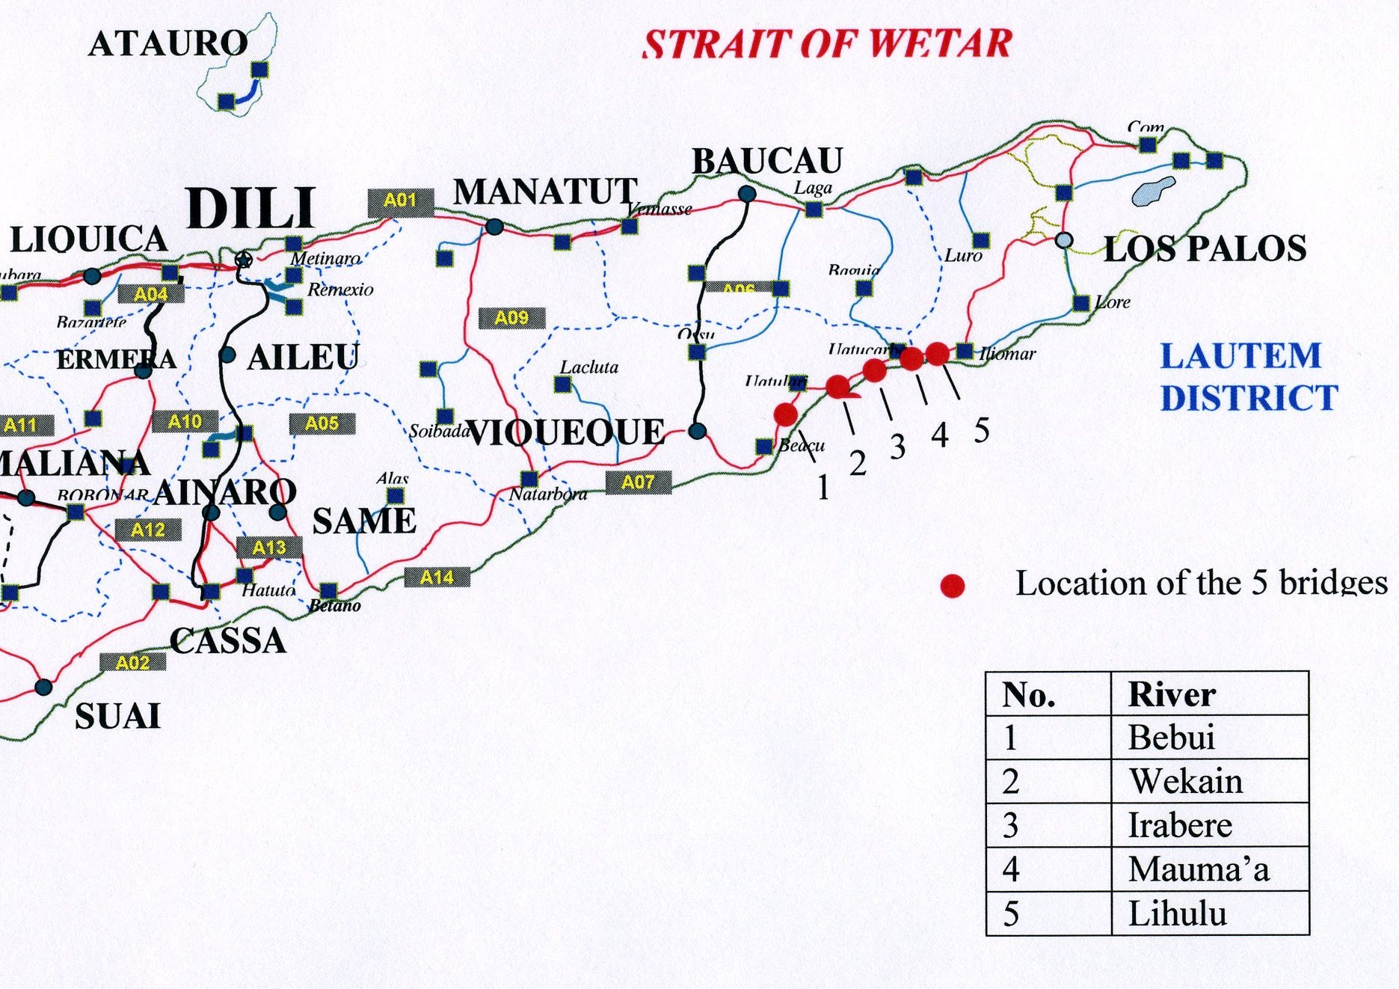
Figure 1: Map of AIM Bridge Locations
Below is a description of the location of each bridge with corresponding aerial photographs of the site locations taken during the inception phase of the bridges.

Bridge 1- Bebui
Bridge 1, which crosses the Bebui River is located on the East side of the village of Uato Lari. This village is one of the largest between Viqueque and Los Palos and during recent turmoil of the August 2007; it was one of the main areas to be affected. The area is nestled between two large hills which increase the flow gradient. It also has a relatively large catchment area of 193 Sq.km. The location of the bridge is roughly 500m upstream of the flood plain area.
Figure 2: Aerial View of Bridge 1, Bebui Location

Bridge 2- Wekain
Bridge 2 is located on the Wekain River which runs through the town of Uato Carabau. The river itself only flows during wet season and remains dry during the dry season. The topography of the catchment area for this river is much smaller. This tends to yield more intense but short lived floods through the river. 50m upstream of the river is an aqueduct, constructed at a much lower elevation than the bridge itself, can act as a buffer to slow the flow rate down before it reaches the bridge.
This bridge is positioned along the A08 approximately 1km upstream of the flood plains.

Figure 3: Aerial View of Bridge 2, Wekain Location

Bridge 3 – Irabere
The third bridge, Irabere is located approximately 1,500 meters upstream from the old road crossing. It is 6 kilometers from Bridge 2 using a newly constructed road from the west side and can traverse at the east side using a 3 kilometer temporary access road provided by the Works Contractor. It is connected to the existing road crossing going to Bridge 4. It has the largest catchment area of 340 sq. kilometers. It is located between the boundaries of sub District Iliomar (Lautem) and Uato Carabao (Viqueque).
Figure 4: Aerial View of Bridge 3, Irabere Location
Bridge 3

Bridge 4 - Mauma’a
The fourth bridge, Mauma’a is located approximately 7km east of Bridge 2 and is the closest bridge to the coastline. Similar in nature to the Wekain River, it is susceptible to intense, short lived flooding. There are no major settlements in the location of this bridge.
Figure 5: Aerial View of Bridge 4, Mauma’a Location

Bridge 5- Lihulu
Located a further 13km from bridge 4, Lihulu Bridge is situated at a much higher elevation than the other four. The river lies at a greater gradient; as a result it is most prone to flash floods during short periods of rain. There is little settlement of people in the proximity of this bridge.
Figure 6: Aerial View of Bridge 5, Lihulu Location
Bridge 5

Foundation Design
Given the remoteness of the bridges for this project, a design of foundation would have to be realized that was logistically plausible. After examination of the geotechnical reports submitted after borehole investigation by Geoteknics Ltd of RDTL, and with consideration of the loading parameters subjected onto the foundations, the design team opted for steel H-piles arranged as shown below, capped with a mass reinforced pile cap.
Figure 7: Bridge Design, including Steel H-Piles
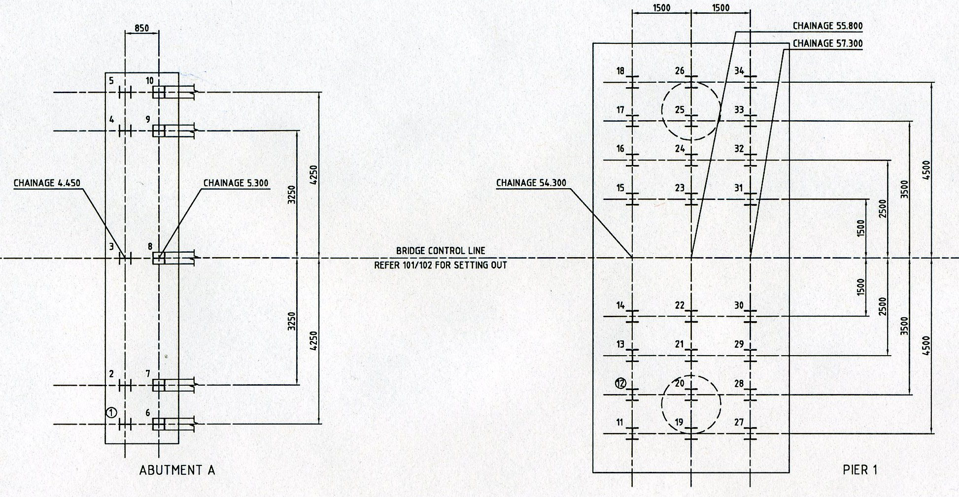

Superstructure Design
The original bridge lengths were indicative lengths of bridge decided after cursory inspections of historical documents and a general site reconnaissance tour. After the detailed investigations, surveys and hydraulic analysis the Consultant produced a Conceptual Design Report which set out the findings and recommended exact crossing locations for each bridge. The surveys of these bridge locations then determined the cross-sectional area of water way required to take the calculated maximum floods based on a number of variations such as channel dimensions, gradient, roughness, embankment conditions etc. The results of the analysis came up with the optimum crossing lengths for each bridge which were contained in the Conceptual Design Report.
Based on the approval and acceptance of the Conceptual Design Report, the Consultant prepared his superstructure designs based on option (c) which promoted a steel truss design of the closed box type.

Steel Truss Design (closed box type)
One of the most common bridge superstructure designs used in the region and in RDTL is the steel truss design.

Advantages:
- Superstructure depth is mostly above the deck level thus permitting maximum availability of waterway area under the deck for a maximum predicted flood levels.
- Being a common form of bridge construction in the region, the economics of a steel truss design were optimum in the Consultant’s estimate of costs.
- Superstructure steel elements are of a manageable size (maximum 7 meters in length) thus permitting the use of standard transport from port to site, and small lifting equipment for assembly.
- Superstructure erection methodology and time frame is much shorter than alternative options with less disadvantages and risk.
- Quality control of construction works is much simpler with fewer experts required and more visible completed product which can be checked thoroughly for acceptance and subsequent maintenance.
- Completed superstructure is more flexible thus providing for ease of member replacement due to accidental buckling or impact damage.

Figure 8 Steel Truss Design (closed box type)
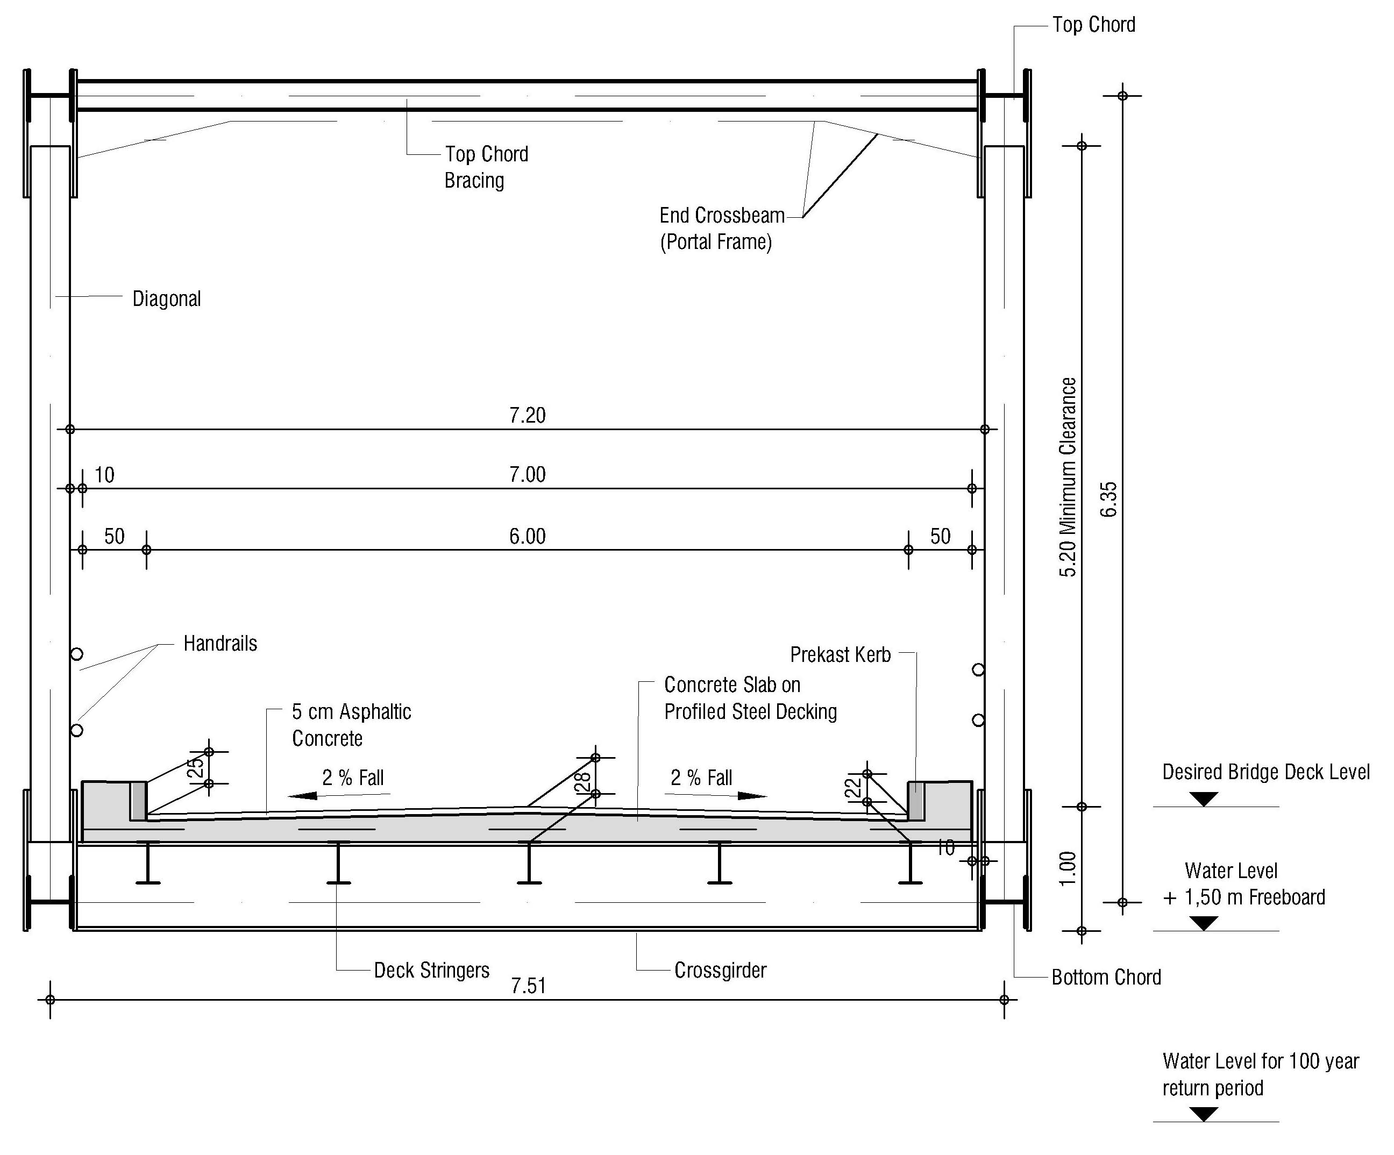

Disadvantages:
- Structural elements configuration will require more long term maintenance inspection and repair facilities.
- Visual concept is more intrusive than the sleeker lines and visual impact of the alternative options.

Conclusion:
The advantages and disadvantages set out above indicated that the Option (c), steel truss box design, was the most suitable and economical option for the project bridges, which had a limited budget for construction, with minimum resources required for erection and less risk of contract disruption or extension due to adverse logistical or climatic conditions. In addition, their use is considered to be more cost effective.
The various spans and sizes demonstrate the economics of the cross sections of bridge superstructures suitable for the medium spans selected and also considering the limited project construction budget and traffic requirements in the foreseeable future.

Chosen Option
As recommended in the Concept Design Report, the superstructures for all the bridges consisted of steel “through” or “box” trusses as shown below. The truss spans vary in length from 35 to 50m and have concrete decks with asphalt surfacing. The road carriageway is 6.0m wide with a two way, 2% crossfall. Footway/kerbs each side are 0.5m wide. All of the truss spans are designed to be simply supported at the piers and abutments. This enables a simple cost effective method for constructing the abutments at either end.
Figure 9: Schematic Diagram of Bridge Design
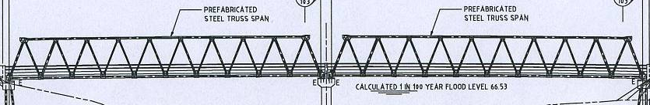

The tender documentation for the superstructures for the five bridges therefore indicated proprietary truss spans. A Project specific specification for the Design Supply and Construction of Prefabricated Steel Truss Bridge Spans was prepared. This is a performance specification that indicates key requirements and parameters such as span and module length, deck configuration, clearances, design loading, design standard, materials etc. Penta Ocean was required to indicate the proposed designer/supplier of the prefabricated truss spans. They submitted full details of the proprietary truss spans that they offered in their tender and proposed to construct. The information submitted included the engineering drawings that fully illustrated the designs being offered. The Engineer reviewed the information submitted for compliance with the performance specification. The performance specification for the truss spans includes requirements to meet the Technical Standards indicated above.
A number of minor structural details at the tops of the abutments and piers were configured to suit the truss spans from the particular designer/supplier. For the drawings produced for the tender documents, the details were developed to suit the truss spans from the particular supplier. This truss design is the one that has been most commonly used by the Indonesian Government in recent years and the spans have been designed to the AASHTO-LRFD Bridge Design Specifications. When the supplier/designer had been confirmed and the details of the required abutment and pier configurations were received, any required modifications to the design drawings were made.
Proprietary truss spans are designed so that they can be constructed with limited or without intermediate support between the abutments and piers. The “piece by piece” cantilever construction method is commonly used and this requires an anchor span to be temporarily connected to the back of the span being constructed. Connection is via “link steel”. To accommodate this erection method and the link steel in particular, it is necessary to separate the bearings of the adjacent spans at the piers by at least 1.7m. For multi span bridges, one of the permanent spans is used as the anchor span. For single span bridges, a temporary propping system was used due to the fact that the bridges were constructed during dry season, meaning the river beds for the single span bridges (2, 4 and 5) were accessible.

Ancillary Designs
The Road approaches to each bridge crossing were designed to be very minimal due to limited budget availability for ancillary works. Each approach road was designed to traverse from the bridge deck to the existing road or ground level under minimum embankment distance (not more than 50 meters). Flexible pavement construction to the approach roads were implemented under the following design:
- Wearing Course 150mm thick specified gravel
- Sub-base 100mm thick specified gravel
- Selected Subgrade - 300mm selected gravel
- Embankment full - depths as required
For the last few meters of road pavement which butted onto the bridge deck over the underneath concrete impact slab, the surface wearing course had an added asphalt layer similar to the bridge surfacing. The foregoing limited design will enable any new permanent road approaches to be started 5 meters from the bridge abutment joint by saw-cutting the existing asphalt on the temporary approach road to form a smooth transition from temporary to permanent road construction.

Scour Protection Works
Theoretical scour calculations for each river bed at the bridge sites were carried out during the design phase and due to high calculated depths of potential scour, the traditional protection methods of gabions or grouted rip-rap were deemed too light. A more robust type of scour protection in the form of flexible heavy rip-rap rocks and stones was specified for four of the bridges with the Lihulo Bridge No. 5 receiving heavy scour protection in the form of heavy duty sheet piles surrounding each abutment.
During the construction phase, when the bridge locations were set out and piling information gave more information on subsurface texture, the Consultant carried out a more detailed investigation of each site in April 2007 for scour protection using the design expert who originally specified the work. This investigation confirmed that the most suitable scour protection was a flexible heavy duty rip-rap system consisting of two types of rock (Class S.1 and S.2) with nominal mass of 40 Kg and 250 Kg respectively. In addition, above the flood water line on the approach road embankments, a protective layer of vetiver grass planting was carried out to protect erosion of embankment from road drainage runoff.

Construction

General Items
The general items in the Construction Contract consisted of compliance with the particular clauses of the specification and provision of facilities to the Supervising Engineering Staff at the Contractor’s Camp and each of the bridge sites. The provision of such general items took much longer than Programmed which contributed to the slow start of the Construction Works.

Earthworks and Roadworks
Limit of these works are established according to construction plans. Before any embankment construction commenced, the surface was cut to a minimum of 150mm thickness from existing ground level, then compacted prior to any embankment fill. Source of embankment materials is checked, approved and is quarried from the river itself, 300meters away from the bridge either in upstream or downstream direction. Bridge 5 is an exception because of a mountain borrow pit, few kilometers away from the bridge introduced as the source materials.
In the absence of site laboratory facilities to check field density tests, laying of fill materials are checked progressively as it was done by mechanical spreading to a depth of 200mm loose volume, then compacted by an appropriate vibro roller (minimum of 10 passes) until satisfactory result is achieved.
Temporary batter boards offset one meter from the edge of the required width are pegged, marked with a 200mm gradation, then progressively filled and compacted until the required final surface.
Except for Bridge 1 which mixed its own roadwork aggregates, road base aggregates were pre-mixed at Bridge 4 before being delivered to other bridges for laying and compaction. Crushed stone aggregates are mixed with river sand and soil to a proportionate ratio approved by the Engineer.
Following the same methodology as used in Earthworks embankment, the process was repeated until the final layer of road base. Bridge 1 accounts most of embankment materials due to lower existing ground profile compared with the finished surface level of the bridge and longer lengths of access tracks. Bridge 5 accounts the least quantity. Bridge 3 east abutment sits on a rock thus no piles driven for foundation at same time minimizes embankment works.
Figure 10: Typical Embankment Construction Photograph Taken at Bridge 1 East Abutment during Construction
Bridge 1 East Abutment
Bridge 1 East Abutment

Approach Ramps
There was a minor change in design of approach ramps construction in order to suit with the situation on site. At Bridge 1, cutting of the mountain slope area at the West Abutment was minimized due to right of way issue. At the East Abutment, the sharp curve linking to the bridge approach was widened and elongated by amending to a bigger radius. More embankment materials were used in the process not necessarily exceeding the quantity in the BoQ.
At Bridge 2, West Abutment was moved 3 meters longitudinally towards the east causing minor changes in the approach ramp embankment quantities. There were no changes at the other bridges.
The above modifications in quantities involved were dictated by site situation with the awareness that it will not add to the overall volume of the contract.
Figure 11: Bridge 4 East Abutment Approach Road during Construction.
Bridge 4 East Abutment

Piled Foundations
Foundations for all Bridges were designed by piling with steel H-beams to the required depth to achieve the specified bearing capacity and scour depths. Driving piles to the calculated depths proved quite difficult in some instances because of the presence of cobbles and hard sub-strata of sandy materials. Pier No. 1, Bridge 1 and both Abutments of Bridge 4 were difficult but piles managed to penetrate and meet the required penetrations accordingly. However, Pier No. 3, Bridge 3 experienced a major difficulty with the Contractor’s selected method of pile driving not being able to contend with the sub-strata encountered for pile installation to at least 12 metres below the pilecap foundation level. This difficulty evolved into a major delay which disrupted the contract work for a protracted duration. The delay and the requirement of the Contractor to provide the necessary resources for pile driving assistance became a major point of dispute and claim.
Two points of Pile Dynamic Analyzer (PDA) tests were conducted for every piling location to ascertain the right penetration depths before piling continues. PDA test results were used as a barometer to assure that right penetration is ascertained corresponding to the required number of blows.

Hereafter is a summary of piling records depth results for steel H-beam driven piles and bored piles.
Figure 12: Bridge 2 East Abutment during Pile Installation
Bridge 2 East Abutment
Figure 13: Sketch Diagram Indicating Pile Measurement

Piling Diagram
c = computed COL (soffit elevation of pilecap + 500mm)
a = required cut-off
level (COL) b = penetration of pile from EGL
d = existing ground elevation
(EGL)
c
CASE 1:
COL above EGL a = required cut-off level
a = b + (c – d) (COL)

CASE 11:
COL below EGL
a = b – (d – c)

Table 2: Steel H-Beams Driven Piles Penetration per Bridge
SUMMARY OF PILING RESULTS
LOCATION | PENETRATION(meters) |  |  | DATE OF PILING |  |  | STATUS | REMARKS
LOCATION | Design | Actual | Variance | Start | End | Days | STATUS | REMARKS
BRIDGE - 1 | 947.7 | 856.2 | (91.5) | 18-12-06 | 28-02-07 | 72 | 100% | under run as per BOQ
BRIDGE - 2 | 391.5 | 504.9 | 113.4 | 18-03-07 | 14-04-07 | 27 | 100% | over run as per BOQ
BRIDGE - 3 | 1,363.9 | 1,418.3 | 54.4 | 09-01-07 | 22-02-07 | 44 | 100% | pier no. 3 adopt 12 nos. of 800mm bored piles. H-piles  over run as per BOQ.
BRIDGE - 4 | 331.3 | 235.3 | (96.0) | 07-03-07 | 27-03-07 | 20 | 100% | under run as per BOQ
BRIDGE - 5 | 821.1 | 437.2 | (383.9) | 03-04-07 | 07-05-07 | 34 | 100% | under run as per BOQ
TOTAL | 3,855.5 | 3,451.9 | (403.6) |  |  | 197 | 100% | under run as per BOQ

Table 3: Bored Piles Depth at Pier No. 3, Bridge 3

BORED  PILE  NOS. | BORED PILES
BORED  PILE  NOS. | STEEL CASING |  |  | CONCRETE
BORED  PILE  NOS. | ELEVATIONS (m) |  |  | BOTTOM  ELEV.  (m) | TOP  LEVEL  (m) | VOLUME  (m³) | DATE | Fc’ (N/mm²⁾  req’d. 27.5
BORED  PILE  NOS. | TOP | BOTTOM | LENGTH |  |  |  |  | 7  Days | 28 Days
1 | 16.05 | 7.80 | 8.25 | 2.86 | 16.05 | 8.0 | 30/05/08 | 23.0 | 29.3
2 | 16.05 | 6.59 | 9.46 | 2.95 | 16.05 | 8.0 | 28/05/08 | 24.7 | 33.8
3 | 16.05 | 5.80 | 10.25 | 2.05 | 16.05 | 9.5 | 22/05/08 | 25.6 | 32.4
4 | 16.05 | 5.47 | 10.58 | 2.25 | 16.05 | 8.0 | 12/06/08 | 24.2 | 28.3
5 | 16.05 | 8.54 | 7.51 | 2.85 | 16.05 | 9.5 | 15/06/08 | 22.8 | 33.0
6 | 16.05 | 7.90 | 8.15 | 2.87 | 16.05 | 8.0 | 01/06/08 | 20.5 | 29.3
7 | 16.05 | 6.44 | 9.61 | 2.79 | 16.05 | 8.0 | 23/05/08 | 26.8 | 33.8
8 | 16.05 | 5.80 | 10.25 | 2.50 | 16.05 | 8.0 | 24/05/08 | 26.2 | 31.6
9 | 16.05 | 7.03 | 9.02 | 2.80 | 16.05 | 8.0 | 29/05/08 | 24.3 | 28.5
10 | 16.05 | 8.26 | 7.79 | 2.90 | 16.05 | 8.0 | 06/06/08 | 23.9 | 30.6
11 | 16.05 | 6.91 | 9.14 | 2.86 | 16.05 | 8.0 | 26/05/08 | 22.5 | 31.5
12 | 16.05 | 6.27 | 9.78 | 3.22 | 16.05 | 8.0 | 25/05/08 | 24.0 | 32.5

Figure 14: Photo taken during Bored Piling at Pier No. 3 Bridge 3

Concrete Abutments and Piers
Concrete Abutments and Piers were erected as per plan location except for Bridge 2 where the bridge was moved 3 meters longitudinally to the east in order to secure a safer clearance from an existing irrigation channel near the West Abutment. Likewise, at Bridge 3, the Pile Cap for Pier No. 2 was lowered by 750mm to suit with the existing ground profile and the Pile Cap for Pier No. 3 was eventually raised by 5 meters from the original design level due to an amended change design introduced by the Contractor to cater for the self created difficulties in constructing the pier during rainy season where flooding is inevitable.
All formworks used are timber lined with ply boards. Circular columns for Piers are lined with a plain galvanize iron sheathing, supported by timber board splices to a circular configuration. It took four months for these manually circular columns form works to be produced and was used at Bridge 1 and later used at Bridge 3.
All supply of concrete products was carried on at Site with two improvised Batching Plants erected at Bridge 1 and 3. Batches are fed manually by excavator with calibrated bucket then delivered to concrete location by a 3 cubic meter capacity Transit Mixers. There was no major variation of the quantity of concrete used at site compared to that of the BoQ.
Figure 15: Typical Concrete Abutment at the Far East and a Pile Cap with Columns and Cross Head at Pier No. 2, Bridge 3

Superstructure Assembly and Bridge Deck
Erecting and launching of Superstructure truss members were carried out by specialist Sub-Contractors provided by proprietary steel truss suppliers. Erection method was the optional conventional direct ground approach using false work supports and the Link Set cantilever method specified in the Construction Drawings. Bridge 2, 4, and 5 which are all single span bridge were erected by direct ground method while multi span bridge like Bridge 1 and 3 were launched by a combination method, erecting the first span by false work method and connecting the succeeding span by the Link Set cantilever approach adopting the first span as an anchor.
Abundance of coconut timber supports on site and the low level of river elevations at the time of truss erection, made it easy for assembly erection of super truss members. Difficulty was the transport of the steel truss members to site from Dili. Contractor schedule was for all truss members to be at site by February 2007 but the last delivery was until May 2007 barely a month prior to original completion of the contract.
There was no major obstacle in the installation of Super structures except for Bridge 1. The August 2007 riot affected the area and work had to be stopped. Launching was on progress at that time. Resumption came later due to the burning of tools associated to truss erection and had to be replaced coming from Jakarta.
Figure 16: Link Set Method in Launching Bridge Members at Span 3, Bridge 3

Bridge Deck Slabs and Parapets were casted in 3 stages proportionate to their length. At site, two options were considered either starting from the edge of the span to the middle or from the middle to the edges. Both concrete pouring methodologies were acceptable in accordance to methodology supplied by the proprietary bridge truss supplier. Concrete pouring sequence for Bridge 2 and 4, span 2 at Bridge 1 and span 4 at Bridge 3 were casted by the former method while Bridge 5, span 1 at Bridge 1 and spans 1, 2, 3 at Bridge 3 were casted by the later.
Concrete strength test results poured at any stage must reach a minimum compressive strength of 70% of the required 28 days strength before the adjoining section can be poured.
Deformed rebars for the deck slab were installed on a pre-fabricated steel galvanized corrugated sheets (permanent formwork), firmly attached to the bridge cross girders and deck stringers to form a composite action.

Figure 17: Bridge 2 During Deck Slab Rebar’s Installation
Bridge 2

Scour Protection and River Training
Scour protection and river training works were accomplished accordingly. Bridge 1 protection work was a combination of stone grading S2 (360kg or higher) at the West Abutment and S3 (125kg or higher) at the East Abutment. Bridge 2 stone grading was relaxed from S2 to S4 (250kg or higher) in Both Abutments. At Bridge 3, there was a slight change in quantity as the River Training for Pier Nos. 1, 2 and 3 was introduced after an inspection of a Hydrologist Specialist on site last April 2007. Stone grading used is S2 to all the Piers coming from a river source 12 kilometers west side from the bridge. At the West Abutment stone grading A (20kg or higher) was used. Bridge 4 is a combination of S1 (40kg or higher) at the upper section and S4 at the lower section in Both Abutments. There was no major variance in the original quantity compared to the actual quantity as reconciliation of quantities was applied as per actual requirement of each bridge.
Bridge 5 has no stone scour protection. Instead, Sheet Piles were hammered to a required depth by a piling machine and vibro hammer along the sides of abutments respectively.
Table 4: Scour Protection (SP) and River Training (RT) Reconciliation of Quantities (Cu.m.)Table 4 below illustrates reconciled quantities after introduction of River Training at Bridge 3. Actual quantity was referred from Construction Drawings and is of a lesser quantity compared from the BoQ.

Table 4: Scour Protection (SP) and River Training (RT) Reconciliation of Quantities (Cu.m.)
SCOUR PROTECTION (SP) and RIVER TRAINING (RT)
RECONCILIATION OF QUANTITIES
Cu.m.
 | From Bill of Quantities |  |  |  | TOTAL | From Drawings |  |  |  | TOTAL | Difference (m³) |  |  |  | TOTAL
Grade | S1 | S2/S3/S4 | Cobbles | A |  | S1 | S2/S3/S4 | Cobbles | A |  | S1 | S2/S3/S4 | Cobbles | A
Bebui
SP | 185 | 300 |  |  | 485 | 99 | 216 | 10 |  | 325 | -86 | -84 | 10 | 0 | -160
RT | 200 | 300 |  |  | 500 | 0 | 406 | 0 |  | 406 | -200 | 106 | 0 | 0 | -94
Wekain
SP | 210 | 420 |  |  | 630 | 174 | 281 |  |  | 455 | -36 | -139 | 0 | 0 | -175
RT | 200 | 400 |  |  | 600 | 0 | 0 |  |  | 0 | -200 | -400 | 0 | 0 | -600
Irabere
SP |  |  |  | 45 | 45 |  |  | 12 | 50 | 62 | 0 | 0 | 12 | 5 | 17
RT |  | 200 |  |  | 200 |  | 1289 |  |  | 1289 | 0 | 1089 | 0 | 0 | 1089
Mauma'a
SP |  | 700 |  |  | 700 | 205 | 452 |  |  | 658 | 205 | -248 | 0 | 0 | -42
RT |  | 500 |  |  | 500 |  |  |  |  | 0 | 0 | -500 | 0 | 0 | -500
TOTAL |  |  |  |  | 3660 | TOTAL |  |  |  | 3195 | (317) | (176) | 22 | 5 | (465)

Figure 18: Scour Protection Stone Placing at the Bridge 1 East Abutment
Figure 19: Sheet Piling Installation at Bridge 5

Asphalt Surfacing Course
Bridge 4 was the first Bridge to be asphalted. Next schedule was Bridge 2, Bridge 1, Bridge 5 and Span No. 1 of Bridge 3. All of these areas were deemed prepared for asphalt works as approved. However in the course of approval and go signal given, application of Asphalt Works took more time than scheduled due to varying reasons. Asphalt works started on the first week of February 2008 up to the first week of March 2008, taking almost a month to complete the approved bridge to be covered.
Problems were encountered, first with the contractor’s failure to submit a required Job Mix Formula (JMF) for asphalt concrete. Next, Batching Plant and associated equipment related problems causing frequent breakdowns. No readily available spare parts are stored on Site and going to Dili to seek for replacement took longer than expected. During asphalt application, lack of coordination was visible (contrary to work request that everything is prepared). It was observed that the Contractor lacked adequate experienced personnel familiar to this kind of job.
Sub-structure works for Bridge 3 were completed and eventual installation of super structure was carried out. Spans 2, 3 and 4 which were not asphalted earlier were finally scheduled on the middle week of August 2008. Subsequently, asphalt surfacing was completed on the 2nd September 2008 formally culminating asphalt works to all of the contracted bridges.
Figure 20: Bridge 1 Asphalt Wearing Course Application

Substantial Completion
Sectional Substantial Completion under Clause 46(2) for Bridge 1, 2, 4 and 5 was initially issued on the 29th February 2008. However it was not accepted by RDTL until the completion of Bridge 3. As a result, a new substantial completion was issued on the 27th September 2008 for all of the Contracted Bridges.
A Draft List of Outstanding Work Items was prepared by the Engineer in accordance to his evaluation of Site after Contractor submitted a notice of Substantial Completion. This was accepted by the Contractor Representative and that all defect items mentioned were remedied during the Defects Liability Period.
In the course of non acceptance by RDTL to a Sectional Substantial Completion Certificate for Bridge 1, 2, 4 and 5, the Contractor remedied defects earlier and the engineer considered the record list closed prior to his reissuance of new Substantial Completion together with Bridge 3 on the 27th September 2008, and with the understanding that any defects that will develop beyond this date will be remedied by the Contractor accordingly. For this Defects Liability Period, a local Site Engineer was designated by the Contractor as its representative on Site. He will be coordinating with his Contractor’s Regional Office in Jakarta, Indonesia.
Certificates of Draft List and final Substantial Completion issued are available on request.
Figure 21: Completed Bridge Taken after Substantial Completion – Bridge 1 Bebui River

Figure 22: Completed Bridge Taken after Substantial Completion – Bridge 2 Wekain River

Figure 23: Completed Bridge Taken after Substantial Completion – Bridge 3 Irabere River

Figure 24: Completed Bridge Taken after Substantial Completion – Bridge 4 Mauma’a River

Figure 25: Completed Bridge Taken after Substantial Completion – Bridge 5 Lihulo River

Bridge Inauguration
24 months after Notice to Proceed (NTP) was ordered for the Contract to start, the inauguration for all five bridges was held at Irabere (Bridge 3) on November 18, 2008.
It was well attended by people within the community as well as other people coming from adjoining districts. The President of the Republic, His Excellency, Dr. Ramos Horta and the Ambassador of the European Union Mr. Juan Carlos Rey were in attendance. They were joined by National and Local leaders with some foreign dignitaries in attendance.
A two day pre-inauguration cultural ceremony was held. Despite the fact that Bridges 1, 2, 4 and 5 were opened to traffic from March 2008 and Bridge 3 from October 2008, this occasion officially marks the opening of the Five Bridges to the public. Figure 26 below shows the official inauguration by the President of RDTL and the Ambassador of European Union.
Figure 26: Bridge Inauguration

Individual Costs of each Bridge
The contract was a fixed lump sum price contract for all five bridges so the individual cost for each bridge was not specified. Table 5 gives an estimate based on the BoQ for each bridge as tendered.
Table 5: Tender Summary Sheet
 | Amount US$
Total Bill No. 0 General Items | 328,979.00
Total Bill No. 1 Bebui River Bridge (Lot 1) | 1,342,697.83
Total Bill No. 2 Wekain River Bridge (Lot 2) | 606,066.46
Total Bill No. 3 Irabere River Bridge (Lot 3) | 2,198,635.60
Total Bill No. 4 Mauma’s River Bridge (Lot 4) | 600,022.50
Total Bill No. 5 Lihulu River Bridge (Lot 5) | 760,966.60
Total Carried Forward to Bid Submission Letter | 5,837,367.99  (€3,689,865.99)

Contract Cost Variations
The additional sum of US$ 459,127 (€290,207) was the negotiated cost of the Contract Suspension under Force Majeure in August/September 2007. This extra cost covered damages for lost equipment during civil strife in the area 07-11 August 2007 together with reimbursement of standing time during the suspension period which is summarized below.
Table 6: Contract Cost Variations
 | Amount (US$)
Reimbursement for damaged / lost equipment | US$ 100,734.34
Direct and indirect costs for 36 days standing | US$ 310,917.71
Direct and indirect costs for additional stoppage at Bebui, Bridge 1 | US$ 47,475.00
Total Additional Cost | US$ 459,127  (€290,207)

Table 7: Bridge Construction Chronology – Bridge 1 Bebui
Bridge No. 1 Bebui
Activity | Date Started | Date Completed | Remarks
Piling West Abutment | 19-Feb-07 | 28-Feb-08
Piling Central Pier | 18-Dec-06 | 29-Jan-07
Piling East Abutment | 05-Feb-07 | 14-Feb-07
West Abutment Pilecap | 06-Mar-07 | 16-Mar-07
Central Pier Pilecap | 28-Apr-07 | 04-May-07
East Abutment Pilecap | 27-Feb-07 | 08-Mar-07
West Abutment Backwall Construction | 14-Nov-07 | 19-Dec-07
Central Pier Construction | 04-May-07 | 17-Jun-07
East Abutment Backwall Construction | 14-Nov-07 | 15-Dec-07
Central Pier Crosshead | 18-Jun-07 | 24-Jul-07
Super Structure Erection – span 1 | 20-Jun-07 | 19-Nov-07 | Erection disturbed by Force Majeure
Super Structure Erection – span 2 | 20-Jun-07 | 19-Nov-07 | Erection disturbed by Force Majeure
Concrete Deck – span 1 | 07-Nov-07 | 13-Dec-07 | Poured in 3 stages on each span
Concrete Deck – span 2 | 07-Nov-07 | 13-Dec-07 | Poured in 3 stages on each span
West Abutment Approach Slab | 21-Jan-08 | 28-Jan-08
East Abutment Approach Slab | 21-Jan-08 | 28-Jan-08
West Abutment Approach Embankment | 10-Jan-08 | 07-Feb-08
East Abutment Approach Embankment | 16-Jan-08 | 02-Feb-08
West Abutment Approach Roadworks | 07-Feb-08 | 16-Feb-08
East Abutment Approach Roadworks | 02-Feb-08 | 14-Feb-08
Asphalt Wearing Course | 27-Feb-08 | 29-Feb-08
Scour Protection West Abutment | 10-Feb-08 | 19-Feb-08
Scour Protection Central Pier | 13-Feb-08 | 22-Feb-08
Scour Protection East Abutment | 29-Jan-08
Substantial Completion | 27 September 2008 |  | Substantial completion certificate issued

Table 8: Bridge Construction Chronology – Bridge 2 Wekain
Bridge No. 2 Wekain
Activity | Date Started | Date Completed | Remarks
Piling West Abutment | 29-Mar-07 | 31-Mar-07
Piling East Abutment | 01-Apr-07 | 14-Apr-07
West Abutment Pilecap | 05-Apr-07 | 20-Apr-07
East Abutment Pilecap | 20-Apr-07 | 23-Apr-07
West Abutment Backwall Construction | 02-Oct-07 | 29-Oct-07
East Abutment Backwall Construction | 19-Sep-07 | 18-Oct-07
Steel Truss Erection | 28-May-07 | 15-Jun-07
Concrete Deck | 13-Jul-07 | 10-Oct-07 | Poured in 3 stages
West Abutment Approach Slab | 08-Nov-07 | 12-Nov-08
East Abutment Approach Slab | 12-Nov-07 | 17-Nov-07
West Abutment Approach Embankment | 15-Feb-07 | 14-Dec-07
East Abutment Approach Embankment | 15-Feb-07 | 14-Dec-07
West Abutment Approach Roadworks | 15-Dec-07 | 23-Dec-07
East Abutment Approach Roadworks | 21-Dec-07 | 23-Dec-07
Asphalt Wearing Course | 21-Feb-08 | 23-Feb-08
Scour Protection West Abutment | 12-Jun-07 | 05-Jul-07
Scour Protection East Abutment | 26-Jun-07 | 03-Aug-07
Substantial Completion | 27 September 2008 |  | Substantial completion certificate issued

Table 9: Bridge Construction Chronology – Bridge 3 Irabere
Bridge No. 3 Irabere
Activity | Date Started | Date Completed | Remarks
Piling West Abutment | 12-Feb-07 | 22-Feb-07
Piling Pier No.1 | 22-Jan-07 | 16-Feb-07
Piling Pier No.2 | 19-Jan-07 | 07-Feb-07
Piling Pier No.3 | 17-Apr-08 | 15-Jun-08 | change to bored piles (Apr 01- Jun 15, 2008)
Piling East Abutment | Spread Footing No Piles Required
West Abutment Pile Cap | 14-Mar-07 | 22-May-07 | start lean concrete
Pier No.1 Pile Cap | 11-Mar-07 | 11-Oct-07 | start lean concrete
Pier No.2 Pile Cap | 12-Mar-07 | 25-Sep-07 | start lean concrete
Pier No.3 Pile Cap | 16-Jun-08 | 27-Jun-08 | start lean concrete
East Abutment Pile Cap | 29-Apr-07 | 01-Aug-08 | start lean concrete
Pier No. 1 Column | 16-Oct-07 | 22-Oct-07
Pier No. 2 Column | 28-Sep-07 | 09-Oct-07
Pier No. 3 Column | 28-Jun-08 | 30-Jun-08
Pier No.1 Crosshead | 27-Oct-07 | 15-Nov-07
Pier No.2 Crosshead | 15-Oct-07 | 09-Nov-07
Pier No.3 Crosshead | 01-Jul-08 | 10-Jul-08
Super Structure Erection – span 1 | 27-Nov-07 | 04-Dec-07
Super Structure Erection – span 2 | 05-Dec-07 | 17-Dec-07
Super Structure Erection – span 3 | 18-Dec-07 | 24-Jul-08
Super Structure Erection – span 4 | 25-Jul-08 | 03-Aug-08
Concrete Deck – span 1 | 10-Dec-07 | 07-Jan-08 | Poured in 3 stages
Concrete Deck – span 2 | 08-Jan-08 | 30-Jul-08 | Poured in 3 stages
Concrete Deck – span 3 | 01-Aug-08 | 10-Aug-08 | Poured in 3 stages
Concrete Deck – span 4 | 11-Aug-08 | 23-Aug-08 | Poured in 3 stages
West Abutment Approach Slab | 18-Feb-08 | 21-Feb-08
East Abutment Approach Slab | 22-Aug-08 | 28-Aug-08
West Abutment Approach Road | 21-Nov-07 | 10-Feb-08
East Abutment Approach Road | 02-Sep-08 | 10-Sep-08
Asphalt Wearing Course – Span 1 | 01-Mar-08
Asphalt Wearing Course – Span 2 | 16-Aug-08
Asphalt Wearing Course – Span 3 | 21-Aug-08
Asphalt Wearing Course – Span 4 | 02-Sep-08
Scour Protection West Abutment | 25-Jan-08 | 04-Feb-08
Scour Protection Pier No. 1 | 12-Aug-08 | 23-Aug-08
Scour Protection Pier No. 2 | 01-May-08 | 10-Jul-08
Scour Protection Pier No. 3 | 24-Aug-08 | 08-Sep-08
Scour Protection East Abutment | 01-Sep-08 | 13-Sep-08 | Guard Rail
Substantial Completion | 27 September 2008 |  | Substantial Completion Certificate issued

Table 10: Bridge Construction Chronology – Bridge 4 Mauma’a
Bridge No. 4 Mauma'a
Activity | Date Started | Date Completed | Remarks
Piling West Abutment | 07-Mar-07 | 24-Mar-07
Piling East Abutment | 24-Mar-08 | 27-Mar-08
West Abutment Pilecap | 03-Apr-07 | 18-Apr-07
East Abutment Pilecap | 14-Apr-07 | 25-Apr-07
West Abutment Backwall Construction | 10-Oct-07 | 19-Oct-07
East Abutment Backwall Construction | 28-Sep-07 | 06-Oct-07
Steel truss Erection | 22-May-07 | 05-Jun-07
Concrete Deck | 06-Jul-07 | 05-Oct-07 | Poured in 3 stages
West Abutment Approach Slab | 05-Nov-07 | 10-Nov-08
East Abutment Approach Slab | 07-Oct-08 | 29-Oct-08
West Abutment Approach Embankment | 03-Jul-07 | 05-Nov-07
East Abutment Approach Embankment | 04-Jul-07 | 26-Oct-07
West Abutment Approach Roadworks | 08-Jan-08 | 29-Feb-08
East Abutment Approach Roadworks | 14-Jan-08 | 29-Feb-08
Asphalt Wearing Course | 08-Feb-08
Scour Protection West Side | 16-May-07 | 07-Mar-08
Scour Protection East Side | 16-May-07 | 01-Mar-08
Substantial Completion | 27 September 2008 |  | Substantial completion certificate issued

Table 11: Bridge Construction Chronology – Bridge 5 Lihulu
Bridge No. 5 Lihulu
Activity | Date Started | Date Completed | Remarks
Piling West Abutment | 03-Apr-07 | 29-Apr-07
Piling East Abutment | 29-Apr-07 | 07-May-07
West Abutment Pilecap | 08-Oct-07 | 08-Nov-07
East Abutment Pilecap | 03-Sep-07 | 26-Oct-07
West Abutment Construction | 12-Nov-07 | 22-Dec-07
East Abutment Construction | 05-Nov-07 | 22-Dec-07
Steel Truss Erection | 15-Dec-07 | 19-Dec-07
Concrete Deck | 14-Jan-08 | 25-Jan-08 | Poured in 3 stages
West Abutment Approach Slab | 05-Feb-08 | 06-Feb-08
East Abutment Approach Slab | 09-Feb-08 | 10-Feb-08
East Abutment Approach Embankment | 29-Jan-08 | 13-Feb-08 | Both sides poorly done with thick lifts and inadequate compaction
West Abutment Approach Embankment | 29-Jan-08 | 13-Feb-08
West Abutment Approach Roadworks | 14-Feb-09 | 15-Feb-08
East Abutment Approach Roadworks | 14-Feb-09 | 15-Feb-08
Scour Protection Sheet Piles West Side | 22-Jul-08 | 14-Dec-08 | Sheet piles initially driven by vibro hammer and completed by diesel drop hammer.
Scour Protection Sheet Piles East Side | 22-Jul-08 | 14-Dec-08
Asphalt Wearing Course | 24-Feb-08 |  | West Abutment approach slab asphalt replaced
Substantial Completion | 27 September 2008 |  | Substantial Completion Certificate issued

Quality Control

Laboratory Testing
On site laboratory testing facilities were poor with only a few concrete cylinder moulds and a compressive testing machine available for a large part of the contract period. Eventually a set of sieves and a suitable balance were supplied so that simple tests such as gradation analyses could be carried out on site without the need to send samples to Dili for testing and wait several weeks for results. Concrete compression testing and dry sieve analyses on aggregates were the full extent of the on-site testing abilities throughout the duration of the contract. All other tests were carried out in Dili.
Initially concrete trial mixes were all done in Dili but as the project progressed these were carried out on site.
No trial mix was done prior to bituminous hot mix production and no laboratory capable of undertaking any asphalt related testing was available during production. Continuous supervision was given to the production and placing but with only limited success as the final product did quite reach the standards expected of an international contractor.

Borrow Pits for Aggregate
Most aggregate used on the project came from the actual rivers with Irabere River being the most prolific producer of aggregates coming from 300 meters down stream of bridge 3 for the concrete works for the project as a whole. Aggregates supplies for Bridge 1 came from stones manually hand picked and crushed in a portable crusher provided on site. Sand aggregates were taken from 200-300 meters away upstream screened and washed before delivery. Sand and aggregates were also supplied for early concrete works at Bridge 2 and 4 with later concrete works coming from batched concrete mix at Bridge 3 batching plant. Mauma’a River was the main source for road making aggregates including subbase, roadbase and bituminous material. Some sand however came from a borrow pit near Viqueque and some aggregate was imported from as far away as Liquica to overcome shortages during certain stages of construction. Sand for the hot mix asphalt which required a finer grading came from Irabere not far from the base camp.
The actual sand sources included:
  - Sand from 200m upstream of Bebui bridge
  - Sand from 300m downstream of Irabere bridge
  - Sand from a borrow pit near Viqueque some 3 hours from the base camp
  - Sand from Irabere river crossing near the base camp

The actual aggregate sources included:
  - Hand picked cobbles from downstream at Bebui
  - River gravel from 300m downstream of Irabere bridge
  - Boulders from upstream and downstream of Mauma’a bridge
  - Crushed aggregate from Liquica, Dili

Aggregate Crushing/Screening/Washing
Aggregates were required on the project for three distinct purposes viz.
  - Aggregates for concrete
  - Aggregates for subbase and roadbase
  - Aggregates for bituminous hot mix.

In general all aggregate should be crushed but because of difficulties with crushing equipment some of the concrete in the early part of the project was produced using uncrushed river gravels apart from concrete produced at Bebui for Bridge 1 where all concrete used crushed aggregate. These came from a number of sources as listed above.
At the beginning of the project a small crusher was set up at Bebui and was used to crush cobbles from the river. The crusher was destroyed during the disturbances and a source of crushed aggregate was located at Liquica to complete the bridge. The materials from this crusher had been sent to Dili for analysis and found to be within requirements. These aggregates were initially used for Bridge 1 and then for Bridges 2 and 4.
The other four bridges were mainly constructed with Irabere aggregates although some concrete was produced for Bridges 4 and 5 using the left over stock from Liquica following completion of Bridge 1.
The sand for concrete for Bridge 1 came from a borrow pit 200m upstream from the bridge. The material was tested in Dili to determine the fines content and found to be acceptable. This sand was subsequently used for all Bridge 1 concrete and partly for Bridges 2 and 4.
The bulk of the sand used on the project came from 300m downstream from Bridge 3 at Irabere. This material was also initially tested in Dili and found to have rather high fines content. This necessitated washing on site prior to use at all locations and occasionally led to concrete pours having to be delayed until the sand was acceptably clean. Fines contents occasionally reached over 20% which required considerable washing before use. This sand was mainly used on Bridges 3 and 5 but were also used to complete Bridges 2 and 4.
Later another source of sand was located near Viqueque about 3 hours from the base camp. This sand was tested in the site and was found to be reasonably clean and suitable for concrete.
A portable screening machine was also set up 300m downstream from Bridge 3 to sort the as-dug river gravels into 10/20, 30/40 and oversize suitable for the concrete mixes. This machine worked on a 24 hour basis initially but this was reduced to 16 hours to allow time for maintenance following frequent breakdowns.
The aggregates from Liquica came ready crushed as 10/20 and 30/40 sizes and had been tested in Dili for Spec compliance which had been found to be acceptable. They were mainly used at Bebui for Bridge 1 but later were used at Irabere on Bridge 3.
At the beginning of the project a portable crusher was set up at Mauma’a but its production was never accepted because the screens were unable to produce an acceptable grading for concrete production. Some of the material produced was later used as subbase for the approach embankments.
A much bigger and semi-permanent crusher was set up at the same location initially to produce aggregate for the approach roadworks. This crusher produced all the aggregates required for the approach roadworks for all five bridges. Unfortunately the aggregate produced by this crusher was very flaky and elongated as a result of the mainly limestone boulders being fed into the primary. In spite of the raw material being slightly metamorphosed it still had a tendency to fracture along the original sedimentary bedding planes resulting in the poor aggregate shape. In addition to these end product problems, mechanical breakdowns (which frequently required replacement parts being brought from Dili), and industrial disputes, were commonplace.

Surveys
Horizontal and vertical surveys are implemented on Site. The Contractor kept a minimum one surveyor through out the project duration. An office engineer who is a qualified surveyor was used to augment survey works in some instances. For the whole works duration, there was no major survey realignment compared to that implied on construction drawings and plans.
Construction deviations and tolerances are within the acceptable limits. An As-Built Survey Drawings submitted by the Contractor shows this data.

Rainfall Records on working site
Details of the rainfall were provided in previous reports. These charts indicate rainfall experienced at or near the main construction camp and do not necessarily give an accurate indication of the construction hold-ups resulting from rainfall.
Rainfall at each bridge location could be extremely localized with heavy rain at one location and none at the other bridges. For the sake of weather representation bridge 3 Irabere river was adopted. Heavy rainfall during the wet season from November to June led on many occasions to rivers being uncrossable by vehicle especially Irabere, Lihulu and Bebui and on a number of occasions to the works being flooded especially at Bridge No. 3.
Records were kept for the year-2007 and 2008 respectively and these are reproduced below in tabular form to give an indication of river situation during that period. While there is less impact on lost time, scheduled waiting time for river levels to subside has led in many instances to wait until the late evening or the next day to come before one can safely cross.
Table 12: Recorded Floods: 2006
ACCESS IMPROVEMENTS TO MARKETS IN TIMOR-LESTE
BRIDGE - 3 RIVER SITUATION
YEAR 2008
Date | Jan | Feb | Mar | Apr | May | Jun | Jul | Aug | Sep | Oct | Nov | Dec
1 | normal | normal | normal | normal | rainy | normal | rainy | normal | normal
2 | normal | normal | normal | normal | rainy | normal | rainy | normal | rainy
3 | normal | normal | flood | normal | rainy | normal | rainy | normal | normal
4 | normal | rainy | flood | rainy | rainy | rainy | normal | normal | normal
5 | normal | rainy | flood | flood | normal | rainy | normal | normal | normal
6 | normal | flood | flood | flood | normal | rainy | normal | normal | normal
7 | normal | flood | flood | flood | normal | rainy | normal | normal | normal
8 | normal | flood | flood | flood | normal | flood | normal | normal | normal
9 | normal | flood | normal | flood | rainy | flood | normal | normal | normal
10 | normal | flood | normal | flood | normal | flood | rainy | normal | normal
11 | normal | normal | rainy | normal | rainy | flood | rainy | normal | normal
12 | normal | normal | rainy | normal | normal | flood | normal | normal | normal
13 | normal | normal | flood | normal | normal | flood | normal | normal | normal
14 | normal | normal | normal | flood | rainy | flood | normal | rainy | normal
15 | normal | normal | rainy | flood | rainy | flood | normal | normal | normal
16 | normal | normal | normal | normal | rainy | normal | normal | normal | normal
17 | normal | rainy | flood | normal | rainy | normal | normal | normal | Demobe to Dili
18 | normal | flood | flood | normal | normal | normal | normal | normal | Demobe to Dili
19 | normal | flood | flood | normal | rainy | rainy | normal | normal | Demobe to Dili
20 | normal | flood | rainy | normal | rainy | flood | normal | rainy
21 | normal | normal | flood | normal | rainy | flood | rainy | rainy
22 | normal | flood | flood | rainy | rainy | rainy | normal | normal
23 | flood | normal | normal | normal | rainy | rainy | rainy | normal
24 | normal | normal | normal | normal | flood | rainy | normal | rainy
25 | normal | flood | normal | normal | rainy | rainy | normal | rainy
26 | normal | flood | normal | normal | rainy | normal | normal | rainy
27 | normal | normal | flood | normal | flood | normal | normal | normal
28 | flood | normal | normal | normal | rainy | normal | normal | normal
29 | flood | normal | normal | normal | normal | rainy | normal | normal
30 | flood |  | normal | rainy | normal | rainy | normal | normal
31 | normal |  | flood |  | normal |  | normal | normal

Table 13: Recorded Floods: 2007
YEAR 2007
Date | Jan | Feb | Mar | Apr | May | Jun | Jul | Aug | Sep | Oct | Nov | Dec
1 | normal | flood | normal | normal | normal | flood | normal | normal | FM | normal | normal | Normal
2 | normal | flood | normal | normal | normal | flood | normal | normal | FM | normal | normal | Normal
3 | rainy | normal | normal | normal | normal | flood | flood | normal | FM | normal | normal | Normal
4 | normal | normal | normal | normal | normal | flood | flood | normal | normal | normal | normal | normal
5 | normal | normal | normal | normal | normal | flood | normal | normal | normal | normal | normal | Normal
6 | rainy | normal | normal | normal | normal | flood | normal | normal | normal | normal | normal | Normal
7 | normal | normal | normal | normal | normal | flood | normal | normal | normal | normal | normal | Normal
8 | normal | normal | normal | normal | normal | flood | normal | FM | normal | normal | normal | Normal
9 | normal | normal | normal | normal | normal | flood | normal | FM | normal | normal | normal | Normal
10 | rainy | normal | normal | normal | normal | flood | normal | FM | normal | normal | normal | Normal
11 | rainy | normal | normal | flood | normal | flood | normal | FM | normal | normal | normal | Normal
12 | rainy | normal | rainy | flood | normal | normal | normal | FM | normal | normal | normal | Normal
13 | rainy | normal | normal | flood | normal | normal | normal | FM | normal | normal | normal | Normal
14 | normal | normal | rainy | flood | normal | normal | normal | FM | normal | normal | normal | Normal
15 | normal | normal | flood | flood | rainy | flood | normal | FM | normal | normal | normal | Normal
16 | normal | normal | flood | flood | normal | flood | rainy | FM | normal | normal | normal | Normal
17 | normal | normal | flood | flood | flood | flood | normal | FM | normal | normal | normal | Normal
18 | normal | normal | flood | flood | normal | flood | normal | flood | normal | normal | normal | Rainy
19 | normal | normal | flood | flood | normal | rainy | normal | flood | normal | normal | normal | Rainy
20 | normal | normal | flood | flood | normal | rainy | normal | flood | normal | normal | normal | Flood
21 | normal | normal | flood | flood | normal | rainy | normal | FM | normal | normal | normal | Flood
22 | normal | rainy | flood | normal | normal | flood | normal | FM | normal | normal | normal | Normal
23 | normal | rainy | flood | normal | normal | flood | normal | FM | normal | normal | flood | Normal
24 | normal | flood | rainy | normal | normal | flood | normal | FM | normal | normal | normal | Normal
25 | normal | flood | rainy | normal | rainy | flood | normal | FM | normal | normal | normal | Normal
26 | rainy | flood | rainy | normal | flood | flood | normal | FM | normal | normal | normal | Normal
27 | normal | normal | normal | normal | flood | flood | normal | FM | normal | normal | normal | Normal
28 | normal | normal | normal | normal | flood | flood | normal | FM | normal | normal | normal | Normal
29 | rainy |  | normal | normal | flood | flood | normal | FM | normal | normal | normal | Normal
30 | normal |  | normal | Normal | flood | flood | normal | FM | normal | rainy | normal | Normal
31 | rainy |  | normal |  | flood |  | normal | FM |  | normal |  | Normal

Notes:
- As a yards stick, Bridge 3 flooding condition was adopted
- FM stands for Force Majeure
- Flood means vehicle can not cross normally. However, crossing for work needs assistance of excavator or wait for lower flood levels to subside below elevation 14.80m before you can safely pass.

OCAP

Brief Description of the Project
One of the greatest challenges facing RDTL is tackling poverty and vulnerability among its rural population. When the Programme began, RDTL was emerging from a violent and turbulent period during which there were numerous socio-psychological traumas facing the general populace. Further to this, the movement from a relief to a development phase presented some key challenges. Firstly, the socio-economic conditions faced by a majority of the population had been such that they have been dependent on external and government-provided support. Secondly, more than 400 years of colonial rule had done little to build national/local capacities or institutions. Oecusse in particular is recognized as a district where these problems are prevalent. OCAP was designed to strengthen communities’ resilience and self-reliance through the social and economic integration of communities in Oecusse. It aimed to do so by working to empower communities through active participation in their own development process and by building on their existing skills and knowledge base.
The overall objective of OCAP was to contribute to the NDP overall goal of poverty reduction through the restoration of sustainable livelihood opportunities for the residents of Oecusse Ambeno district. It was envisaged that this would be achieved through the following four components;
- Community activation;
- Improved agricultural technologies;
- Identification of economic and social development opportunities; and
- Capacity building of local administration and development partners
The community activation component aimed to promote self-reliance and empowerment of communities. Cohesive communities and enhanced social nets were promoted through the formation of SHG.
The agricultural component focused on the sector where the majority of East Timorese are engaged in subsistence level activities with the aim of developing new skills and knowledge, enhancing food security and generating supplementary income.
Various studies aiming to contribute to improving the economic and social situation in Oecusse were also facilitated through OCAP.
At all stages there was a focus on the capacity building of local administration and development partners in order to ensure the sustainability of the processes and activities initiated under the Project. OCAP further assisted in the development of communities’ capacity to identify their own needs and implement activities to address them through the CDF aspect of the fourth component. At the same time vital infrastructure such as water supply systems, irrigation and flood protection works were completed.
The Project began its implementation in May 2004. Since then, more than 4,424 people have been involved in OCAP SHG and have received training both in group mobilisation and in their selected livelihood activity. Through the CDF fund, 60 micro-projects were implemented by communities with support from OCAP and Government. These micro-projects have benefited not only the people directly involved in their formulation and implementation or those engaged in their construction but also the communities at large who continue to benefit from access to the new facilities. 11,129 households from all four sub-districts have directly benefited from the CDF component focusing on drinking water, irrigation, flood protection, market infrastructure and education, and many more have benefited indirectly.
OCAP was approved with a total budget of € 3,359,257 of which € 3,062,089 was contributed by the EC and € 297,168 was contributed by the UNDP. During implementation it was decided to close the Programme in December 2008 due to budget constraints. A rebalancing of international and national personnel allowed the Programme to run to its original date of conclusion in May 2009. This was essential in order to ensure sustainability and to finalize successful handover of activities to MAF and other development partners operating in Oecusse.
Some of the great challenges faced by the project included the crisis of April-May 2006 which led not only to implementation delays but also posed challenges to the very basis upon which OCAP was established. Considerable effort that had been put into developing a sense of self-sufficiency and empowerment amongst the target population was severely challenged when, in the aftermath of the crisis, SHG members and others involved in the project came into contact with agencies and NGO operating in an emergency mode. This legacy continued and is felt to have played a considerable role in the dissolution of many SHG. A further constraint which had considerable impact both at the beginning and during project implementation related to specific operational issues. Efforts were made to address the main bottlenecks and gradually this had a knock-on impact in terms of improving project efficiency.
This report covers the entire OCAP Programme implementation period, from May 2004 to May 2009. It provides a detailed description of the project structure and aims, a summary of major developments and achievements throughout the implementation period, statistical information on beneficiaries, a description of main work activities, implementation challenges and impact assessment. It also presents a photo gallery depicting the main activities under OCAP. (See Annex A: Handover Document of Vocational Training School (OCAP)

Project Background
After independence, the Government of RDTL approved the NDP based on Vision 2020. The NDP established poverty reduction and promotion of equitable economic growth as its overarching goals. The most significant and immediate challenges the NDP sought to address included security, respect for human rights, delivery of basic services, public participation, decentralization of decision making, empowerment of women and communities, and transparency and accountability in the development process. Prior to 2003, international assistance to Oecusse focused on emergency assistance and humanitarian aid following the destruction and civil and social disturbances caused by the 1999 referendum for independence and subsequent Indonesian withdrawal. With a view to making the transition from humanitarian emergency aid, and the ensuing rehabilitation/reconstruction phase, to a longer term development approach with tangible benefits for the rural poor, the EC allocated €25.5 million for 2003 with the Rural Development Programme for East Timor to support the DRTL in attaining its overall objectives of poverty reduction and promotion of economic growth. OCAP was one of the projects under this Programme with a budget of €3.36 million, spread over five years. It was implemented by UNDP in partnership with UNOPS as the executing agency.
OCAP was designed following a thorough analysis of the problems facing the enclave at this time. In particular, the economy of Oecusse had been dramatically affected by the imposition of the new international border following independence in 2002. Virtually all households in Oecusse were farmers facing food shortages for 3-4 months of the year with the remainder being small traders, public servants or service providers. Those engaged in the rural economy fell into two categories: upland farmers who practice traditional slash and burn agriculture, growing maize and upland paddy and a range of cassava, beans, sweet potato, yams/taro, pumpkin and other fruits and vegetables and the low-land paddy farmers. Livestock such as local breeds of cattle, pigs, goats and poultry also play an important role in supporting livelihoods as they act as a form of savings, income generation and wealth creation as well as a coping mechanism during times of stress and for use in traditional “adat” ceremonies. However, deteriorating natural resources such as land and water, traditional farming practices, strong cultural beliefs relating to “adat”, lack of markets and a stagnant economy, all posed challenges to the development of sustainable livelihoods. The introduction of new technologies had been constrained by the low capacity of the government and its staff, entrenched traditional agricultural practices based on managing risk, the small localised market and lack of reliable input supply chains for seeds, vaccines and fertilizers. These constraints posed a considerable constraint to development and the restoration of sustainable livelihoods in the enclave.

Project Developments and Key Components

Finance
Table 14 below sets out the expenditure rate for the project starting in May 2004 and continuing until May 2009. Following initial delays in making project budgets available in the finance system, leading to activities being temporarily charged from UN Agencies’ available funds and to the requirement for reversal of charges in order to have all expenditures reflected in correct budget items remaining issues were ironed out.
Table 14: Rate of Programme Expenditure
Date | Amount Spent | % of Total
November 2004 | € 1,775 | 1%
May 2005 | €248,022 | 7.3%
October 2005 | €480,014 | 14.3 %
April 2006 | €836,480 | 25%
October 2006 | €1,284.967 | 38%
April 2007 | €1,566,303 | 47%
October 2007 | €1,935,938 | 58%
March 2008 | €2,190,011 | 65%

National Ownership
The initiation phase of OCAP, between May and November 2004, was conducted in a highly participatory manner thereby creating ownership extending beyond UNDP and UNOPS and including the MAF, the MoED, the Ministry of State Administration and Local Government Administration. Support from the DA of Oecusse and his team was also forthcoming, and office space was allocated for the OCAP Programme within the DA Office.
Consisting of 27 members representing key stakeholder in Oecusse including members from local government, NGO, church, youth groups and community elders and formed at District level, the PWC was essential in ensuring national ownership of OCAP from the outset. The PWC, and in particular representatives from MAF, actively participated in interview panels for the recruitment of administrative support staff and CAF. Over the course of the Programme, problems in terms of the holding of PWC meetings at irregular intervals were addressed in order to ensure that regular monitoring was taking place, as well as new CDF projects being approved in a timely manner. This sense of ownership was extended to national level through the holding of policy discussions with all concerned stakeholders including MAF, MoED, UNDP, UNOPS and EC as facilitated through the PSC.
The change of government following elections in mid 2007 required OCAP to remain flexible and to build relationships with the new government members to ensure the continued successful implementation of the project. Although challenges were encountered, all parties persevered throughout the life-span of the project and the resulting regular exchange between OCAP and MAF became an essential asset of OCAP. At the same time, the resignation of the Secretary of State for Rural Development together with the delay in replacing him for a considerable period of time has had an adverse effect on the progression of the project. Once more however, the negative effects were mitigated by ensuring constant communication and collaboration with the remaining staff within the Secretariat.

Incorporation of Lesson Learning Culture
From the outset of OCAP, best practice and lessons learned from existing models of capacity building strategy and community based development were incorporated into its strategic approach. This included lessons from Ainaro-Manatuto Community Activation Programme (AMCAP), which had been running in Ainaro and Manatuto Districts since 2002. Within the first year a one week learning visit was made to AMCAP by four national Project Implementation Unit (PIU) staff and two United Nations Volunteers (UNVs). Lesson learning within OCAP was also prioritised and an important example of this was the adoption of an ongoing internal lessons learning approach to the development of the SHG. The MYRADA model allowed for continuous follow up and review and the development of revised training based on the emerging results.
At the outset of OCAP, a specific time-line for the development of the SHG had been envisaged; it was felt still to be very important to pay close attention to the lessons being revealed as the Programme progressed and to take concrete steps to revise it accordingly. As such, amendments were made to the original plan in order to ensure that the Programme was responding to the needs and requirements of the beneficiaries in order to ensure maximum impact. This involved refocusing activities in the community activation component to place a greater focus on capacity strengthening of existing groups than on the establishment of new groups as originally envisaged.

Project Activities
The OCAP Programme began its implementation in May 2004. Since then it might be extrapolated that most households have benefited from OCAP through involvement in OCAP SHG, Cattle Owners Associations and in the Community Development Fund. Many more have also benefited indirectly from OCAP micro-projects which were set up in all four sub-districts of Oecusse. This section will seek to report on the main achievements under each activity of the four main result areas.
Immediate Objective: Restore sustainable livelihood opportunities for residents of Oecusse Ambeno district.

Result 1: Community participation increased and decision making capacity strengthened
The Community Activation component of OCAP proved to be one of the most important aspects of the Programme. Designed to put the people of Oecusse into the driving seat of their own development, by close of project in May 2009 it had made considerable progress. The focus was on the formation of SHG and the recruitment and training of CAF in order to ensure ongoing support and assistance to SHG.

Activity 1.1 Facilitate the formation of community groups
The first twelve months of project implementation were used to put the foundation in place upon which the network of SHG could be built. This involved the recruitment of a skilled PIU including the essential 18 CAF and also the drafting of a Programme Working Strategy deriving from cumulative experiences in the South Asian Region. A key component of this strategy was the building of the capacity of both people and local institutions through the SHG mechanism. Intensive and extensive training of SHG was coupled with a focus on building the capacities of Programme staff, local government and line ministries in this participatory methodology. The MYRADA SHG model was selected as the most suitable to the situation in Oecusse over other potential models such as Grameen and Aghankani which were felt to be either administratively too cumbersome or marginalizing of the poorest.
The MYRADA approach focused on organizing the community into solidarity groups and supporting these with skills training and initial start up support. This is an Indian model promoting the organization of communities into SHG with the purpose of engaging in income generating activities and building savings and credit schemes on the resulting increased revenues. The four basic characteristics of this model are:
1) The generation of volunteerism and an affinity binding members together,
2) SHG set their own agenda and design their own rules and systems of functioning rather than having agendas, rules and systems imposed from the outside,
3) SHG consist of a homogeneous group of members thereby avoiding problems experienced with more heterogeneous SHG models where the voices of the most vulnerable are often not heard,
4) SHG consist of between 15 and 20 members in order to ensure productivity.

Activity 1.2 Mobilize and train CAF and mentors
Within OCAP, the MYRADA model was pursued through a three module approach. The OCAP CAF played an essential role here. By the end of May 2005, training aimed at the Project staff, partner government officials and community facilitators had been held on Module 1 (SHG formed, participatory rural appraisal conducted and basic training provided in SHG concepts and group cohesion). Module 2 training (more structured training to enhance SHG development and to introduce savings and credit schemes) was completed by May 2006 and Module 3 (assessing the impact of the training to date, and ranking the groups in 3 categories: A [highly successful], B [successful but needs improvement / strengthening] and C [successful in their establishment but needs significant improvement] based on a participatory analysis of six elements) a year later. Each training entailed participation in a comprehensive workshop led by MYRADA. Following each training module, CAF conducted the relevant training with each SHG. The specific approach adopted throughout was particularly important for Module 3 as it allowed for the facilitator to sit with group members, many of whom are illiterate, and talk them through the six elements. Following this, the group then requested training to address any weaknesses that they themselves had identified. Six months later the exercise was repeated and in this way progress was mapped and weaknesses addressed.
In terms of group formation, a reconnaissance survey was conducted at the outset and discussions held with communities. This formed the basis of the development of criteria for village selection, namely: to work with the poorest villages where no other NGO was present and the demonstration of interest by the people. The five villages of Malelat, Cunha, Taibeco, Naimeco and Bene Ufe were identified as phase I target villages and by September 2006 all 18 Sucos had been reached. By May 2005, this aspect of OCAP had progressed substantially and the momentum was maintained right up until the end of the project by which time 301 groups in total had been created in all four sub-districts. However 117 had dissolved along the way leaving 184 functioning by May 2009. The original target of forming 800 SHG was abandoned by October 2007 as it was viewed as overly ambitious and to persevere to attain this target would be to sacrifice the quality, cohesion and sustainability of existing groups as providing dedicated quality support to such a large number of groups would not have been possible.

Activity 1.3 and 1.4 Training and mobilization on savings/credit, CDF and income generation
In furtherance of OCAP aim to ensure gender was mainstreamed through all aspects of the Programme, CAF, as members of OCAP that would be dealing most closely with SHG members, received in-depth training in Gender Mainstreaming. In addition, gender sensitization campaign materials were formulated and were used in four sub-districts between May and November 2005. During the same period, the first women’s SHG were formed and along with the other SHG, they established their own savings and credit schemes and income generating activities. By the date of project completion, women figured prominently amongst the SHG membership with 1,560 active female members and 1,446 active male members. Of the women members, 377 performed leadership roles (as chairpersons, treasures etc) along the way. A total of 521 women are independently engaged in vegetable production and have their own source of income. In addition, in staple food crop production, a total of 540 women are sharing income with 790 men, and decide jointly about the use of funds. The women involved in OCAP SHG were also facilitated to share their experiences more widely and one such occasion occurred in October 2007 when OCAP together with Centro Feto Enclave Oecusse organized an exchange of representatives of 200 women’s SHG. These women exchanged their views and experiences with the self help group mechanisms. This experience demonstrated very strongly the shift in thinking that had taken place from “government led development” to “take your development in your own hands”, a development that lay at the core of OCAP.
Savings and Credit Schemes formed a very important part of SHG activities under OCAP. By project end, 160 groups had functioning income generating activities and savings and credit schemes. Savings grew steadily throughout the five year period and from October 2007 CAF began to closely monitor the arrears of the groups as this was seen as a factor which could lead to the dissolution of groups. The table below sets out the steady progression in terms of both amounts saved and loans accessed by group members cumulatively from the time the savings and credit schemes became functional in May 2006 and the end of the project in May 2009.
In this way, training provided to community groups in sustainable management of savings and credit schemes along with the constant accompaniment of the CAF has ensured increased access to basic banking facilities. Some of the income generation activities in which the group members were involved and from which they then paid into their groups’ savings schemes are explained in more detail under component 2 below. In addition, OCAP coordinated with the Business Development Centres set up under STAGE to provide training in GYBI and SYB to include the imparting of knowledge on business awareness and preparing business plans. Income generated from businesses set up subsequently including small handicraft production also fed into the groups’ overall savings.
Table 15: SHG Savings and Credit Levels
Date | Savings | Credit
May 2006 | $15,625 | $3,176
October 2006 | $32,534 | $20,617
April 2007 | $36,820 | $23,820
October 2007 | $51,641 | $33,871
March 2008 | $56,035 | $36,346
September 2008 | $ 64,556 | $42,198
May 2009 | $ 78,566  (€49,660) | $46,450  (€29,360)

Result 2: Increased agricultural production to improve food security and income
The agricultural situation amongst target farmers in Oecusse in 2004 was one in which the majority of farmers practised traditional and subsistence agriculture. Farmers involved in cattle rearing received very little return on their investment and in the upland areas, farmers mostly cultivated local varieties of food crops using traditional seeds, which although well adapted to the local conditions, produced very low yields. The same situation prevailed amongst lowland farmers engaged in rice production. Through the Self-Help Group mechanism, OCAP worked to improve food security and income by increasing agricultural production amongst farmers engaged in cattle rearing and small livestock and amongst those active in upland and lowland crop production. Indeed, by October 2007, those SHG putting into practice lessons learned through OCAP agricultural component were making the largest contribution of all SHG to the increased levels of savings witnessed.

Activity 2.1 Cattle Quality Improvement
In terms of the improvement of cattle quality, the formation of Cattle Owner Associations (COA) to be used as focal points for contact from OCAP and MAF and as a means of providing training and general skill upgrading of cattle owners was pursued. In addition, the Paronisasi system of cattle fattening was introduced to benefit those having access to very little land and the CAF worked through selected farmers as demonstration agents to show the benefits of providing access to water all year and to supplementary fodder during the dry season.
The first step in improving cattle quality was the development of a Cattle Development Strategy which was completed by May 2005 and was followed by the UNV livestock expert establishing dialogue with five phase 1 villages and Paronisasi owners to establish immediate needs in cattle development. By November 2005, 16 cattle owners associations involving 671 farmers and 2,997 cattle had been formed. Within a year 27 further COA were formed comprising of 2,305 members. Hand in hand with COA formation, CAF led discussions with the groups on the concept of COA and COA came to see that they were playing an active part in the overall development of the cattle industry in Oecusse by preparing their own animal vaccination Programme, developing livestock feeds and feeding, and most importantly engaging in the marketing of their livestock. In this regard, throughout the course of the Programme, COA continued to explore markets in Dili and to lobby Government officials in Oecusse to organize border markets with Indonesia for selling cattle. Such efforts included a delegation traveling to Dili with the support of MAF to meet with the management of Lita and Leader supermarkets and five individual butchers at Comoro and Bekora markets. Whilst they pursued every opportunity in this regard, they also supported cattle owners in the sale of their cattle according to existing routes.
At the same time as the COA were being developed, individual farming households were being supported to develop their own livestock. This objective was pursued through the SHG mechanism. The savings and credit schemes introduced through the SHG along with the group dynamic that was created were two elements that were instrumental in ensuring that the households involved were able to increase their production.
The first round of training on livestock nursery establishment had been completed in November 2005 and women in Oemolo village had collectively cultivated three hectares of king grass and one hectare of leguminous trees. Within a year of this date they were not only feeding their own cattle but they also had enough to sell and earn some income. Silage demonstrations held in 2006 and 2007 also imparted important knowledge to allow preservation of this grass for when it was most needed. This activity was however limited in some areas by the fact that insufficient king grass was produced. However demonstrations on rice straw treatment with urea were also carried out which helped to produce much needed supplementary cattle feed from what was previously seen as a waste product.
By March 2008, 315 households were active in cattle fattening. Figures for numbers of cattle sold and amount of income earned became difficult to determine as farmers were unwilling to disclose this information for fear of taxation. At the same time, information that was available showed that, by March 2008, at least 95 cattle had been sold by 10 groups for a value of US $23,915 (€15, 116).
In terms of small livestock production, some successes were initially witnessed in the area of improved productivity of pigs and poultry. For example by October 2006, with the support of OCAP, 34 chicken houses were established in 18 villages allowing for poultry to be retained in one place and thereby improving access for vaccination and a training manual on poultry development had been development for use by MAF. As a result of an invitation from MAF, a livestock vaccination component designed to support MAF existing Programme was included in OCAP. But, at a later stage it became clear that similar activities were being supported through the ERP II Programme and it was jointly agreed that these activities would no longer be continued under OCAP. Severe constraints with MAF vaccination Programme in Oecusse particularly in terms of unavailability of vaccinations had a profound impact and the spread of disease caused significant losses in the poultry and small animal sectors severely impacting on the activities of those being supported by OCAP.

Activity 2.2A Upland Agriculture: introduction and promotion of suitable varieties and cultural practices of crop production and soil and water conservation
In the uplands, OCAP introduced improved high yield varieties with more resistance to attack of insects/pests/disease, and which could be grown in fields with low soil fertility and low moisture conditions. Drawing on experience gained through the AMCAP Programme, a number of technologies were adopted in order to ensure maximum benefit from OCAP interventions. These included Participatory Variety Selection approach (PVS) in order to identify the most suitable varieties of major food crops (maize, rice, beans, etc) based on criteria determined by the farmers and pre- and post-harvest evaluation by farmers and communities; Participatory Block Demonstration (PBD) during the 2nd and 3rd year when the varieties selected under PVS were grown in bigger demonstration plots; Seed multiplication and extension from the 3rd year onwards where mini-kits were distributed containing seeds of the selected varieties, together with leaflets, booklets and posters with additional information and finally large- scale production also from the 3rd year onwards where these seeds were multiplied on a larger scale.
From the beginning of the OCAP upland agriculture component, close collaboration with the Permanent Secretary and Crop Director of MAF in Dili was established. With MAF input, the OCAP Upland Farming Expert worked to develop training packages on up-land farming for CAF, district MAF personnel and community members and by May 2005 these proposals were before the PSC for approval. These packages included PRA methods to guide consultation with participating villages and to develop plans relating to their agricultural activities. All trainings were attended not only by OCAP staff but also by MAF, the District Administrator’s Office and representatives from local NGO. The earlier trainings were also followed by field exercises at pilot villages where data was collected and used to refine OCAP agricultural activities. Beginning with 5 original villages, this approach was later rolled out to all other communities participating in the agricultural component.

Participatory Variety Selection and Participatory Block Demonstration
Based on the resulting agricultural plans, seeds of various crops including rice, maize and beans were collected from MAF, from the Seeds of Life project and some promising local varieties were also purchased in Oecusse and distributed to the farmers to use on a trial basis. The aim of the trials was not only to demonstrate potential yield increases offered by different varieties but also how new crops could be used as an inter-crop to improve soil fertility and to improve nutrition. The Participatory Variety Selection approach offered farmers the opportunity of selecting appropriate varieties of major food crops for their own circumstances thereby increasing food production and income level. Initially 716 people in 159 households of comparatively poor communities in 5 Sucos were formed into PVS groups of 15-22 members and received training from CAF and extension mentors on PVS. Pre-harvest farmers’ field days held at the PVS sites allowed other farmers to experience the results first hand. For the farmers themselves, pre and post harvest assessment criteria that they agreed on were applied leading to the final selection of desired varieties. This process was continued for a second year into 2006 in order to allow farmers reach an informed decision on further expansion beyond the trial sites and seed multiplication. Following this, 16 SHG in 13 Sucos planted promising varieties as “participatory block demonstration” sites. Based on one year figures emerging in October 2007, new varieties selected through PVS and replicated through PBD were already showing higher yield rates compared to the traditional varieties. Taking the example of lowland rice, production figures showed an increase of between 44.3% and 55.3% as compared to local varieties. The yield of selected upland rice showed an increase of 26% and the yield increase in maize varied from 13.9% to 104.6%.

Rice Production in Cunha
Between May and November 2005, a demonstration plot on lowland rice was established in Noininen Aldeia of Cunha Suco by planting 10 kg of improved rice variety IR 64 seeds received from MAF. The performance of the crop was found to be very promising in the field and also once harvested on 22 August 2005. The yield of 5.66 Mt/ha was recorded from the improved variety IR 64 as against 2.46 Mt/ha obtained from a local variety called Membramo. Farmers liked the variety IR 64 for its high yield, comparative tolerance to insects/pests and good grain filling. They did also find however that the cooking quality and taste of this variety was not as good as Membramo. On balance they decided to expand the area under the variety IR 64 and they also shared seeds obtained from the demonstration plot with other farmers.
Following the completion of PVS and PBD, farmers selected the varieties that best suited their needs to move forward with their production. This aspect of OCAP has been extremely successful and, as noted above, by October 2007, income earned from agricultural production was already the single largest contribution made to SHG savings funds.
An important technique in the pursuance of improved upland agricultural was the promotion of Sloping Agricultural Land Technology (SALT) aiming to establish productive agricultural land on hill slopes by planting hedge rows which functioned as a natural soil stabilizer to curb erosion. Slash and mulch techniques were also promoted as a way of increasing soil fertility and reducing use of traditional slash and burn practices. The approach taken to SALT involved the foundation of management groups comprising of between 15 and 20 (representing 108 farming households) members at six sites in each of 6 pilot Sucos between May and November 2005. Intensive training of CAF and extension mentors on SALT and terrace improvement was followed by field level training of management groups after which demonstration plots were established. CAF continued to provide technical assistance to these groups over the course of the Programme. The second stage saw twelve new SHG formed involved in the SALT Programme in 12 new Sucos (representing 187 households). Farmers were particularly satisfied with the results achieved from SALT and many calls were received for assistance with SALT replication right up to the end of the project.

Activity 2.2B Promote Horticultural Commodities (vegetables and fruits) and community tree nurseries
As part of the introduction of an integrated approach to food production at household level, OCAP also sought to introduce vegetable production to interested households by organizing training through the SHG mechanism. This approach aimed not only to increase the amount of produce available for sale but also to contribute to food security at household level by improving diets. Between May and November 2005, 166 household members (61% female and 39% male) in 9 Sucos were involved in ten group demonstration plots where they made use of the production-cum-verification model in order to select suitable varieties of vegetable crops for commercial production. They were supported and mentored by CAF and training mentors who had undergone five days of intensive training and were able to put into practice lessons learned during 4 days of training at field level. Inputs such as seeds of 18 vegetable varieties, plastic hose pipes, polythene bags, watering cans, sprayers, masks, gloves, measuring tapes, pocket balances and fertilizer were also provided as support in the establishment of the demonstration plots. These demonstration plots included a section for compost production and altogether 48 compost pits were built during OCAP. By May 2009, 18 commercial onion and garlic groups had been created and farmers had been enabled to learn from each other through the participation of 42 farmers in an exchange visit to others’ demonstration plots. Through the SHG model, farmers were enabled to work together to produce vegetables, improve their nutritional standards and earn and income through sales of excess vegetables. An exact replication of activities from group plots onto individual plots proved more difficult due to the expense involved in procuring some of the inputs. As a result, farmers seeking to replicate lessons they had learned on their own plots had to rely on more labour intensive methods of production. In this way, although improvements in production levels were reported by individual farmers, the improvements were less dramatic than on the group plots.
A further important input in order to facilitate the production of vegetables all year round and to ensure efficient use of available water resources was the introduction of rain water harvesting and storage technology and appropriate small-scale irrigation technology. OCAP 18 CAF, extension mentors, the agricultural coordinator and MAF representatives received training on the “Construction of Plastic Ponds for Water Harvesting and Storage” and on the establishment of irrigation systems and their proper use. Following this, they conducted training at village level in all 18 sucos. Altogether 43 plastic ponds were constructed in vegetable demonstration plots. Demand for plastic ponds has remained high and upon the request received from ACHAE, a local NGO, one set of plastic sheets was provided to them to establish a demonstration unit in Lele Ufe suco. Thirty sets of low cost irrigation systems were procured and set up in demonstration units at the same time as training was provided at suco level. Farmers reported that this technology was extremely effective for vegetable production during the dry season and they also noted that it saved time in avoiding the need for manual application of water. By November 2005, the sale of vegetables from the demonstration plots was in progress with funds generated feeding into the steady increase of SHG savings. Whereas once vegetables were a rare sight in local markets between the months of November and March, this sight became common by 2007. By January 2007 firm evidence was emerging that training which had encouraged the integration of vegetables into households diet was proving successful. Many households reported consuming vegetables 3-4 times per week.
Part of the OCAP integrated approach to upland farming foresaw the integration of trees into farming practices to function as a source of timber, fodder, natural fertiliser and to help prevent soil erosion. In pursuance of this goal, six commercial community tree nurseries were established in all four sub-districts to produce seedlings of forest and fodder species as well as saplings of suitable fruit crops. Nursery management groups of 15-20 members were formed at each site and a total of 100 households (approximately 450 people, 86% men and 14% women) from six villages were involved. Following comprehensive training on nursery establishment and management, an exposure visit of 12 nursery representatives and 10 CAF to AMCAP sites and five days of on-site coaching by six experienced nursery operators from AMCAP, group members carried out species selection. This was based on considering criteria such as technical feasibility; fodder, soil fertility improvement, economic and medicinal value and environmental benefits. By November 2005, 75,000 seedlings of 11 different forest and fodder species had been raised and purchase by OCAP of 91,520 seedlings worth US$ 14,831 (€9, 374) took place as planned by April 2006. These trees were used under the SALT and watershed management aspects of OCAP. In July 2006 representatives from all nursery groups came together along with MAF, OCAP, Oxfam and Caritas representatives and agreed for coordination purposes to found a district level community tree nursery association “Tamasab Pah Oecusse”. Following the EC Mid-Term Review, the Community Nursery component was handed over to the government. In the early days of OCAP, a MOU was signed with the local MAF office indicating that they would purchase trees from the OCAP nurseries. However, this agreement was later over-ridden by changes in MAF approach centrally which allocated funding to the district MAF offices to set up their own nurseries. As a result, MAF failed to proceed as discussed to organise meetings with the nursery representatives to fix the prices of seedlings and establish a relationship for their supply. This had an immense knock-on effect on the groups involved in nursery production and most of them ceased production.

Activity 2.3 Supporting Government Programmes
Further activities in support of MAF irrigation development master plan and pig and livestock development Programmes were undertaken over the course of the project. Due to constraints within MAF and also to the impossibly broad range of activities OCAP sought to engage in, planned support to the Government’s fisheries Programme did not take place. For the same reason, planned support for the Government’s small livestock Programme was not provided.
After May 2005, previous discussions with MAF personnel on the development of a comprehensive plan for pig and livestock extension service were finalized allowing for the vaccination of 4,589 cattle, 8,404 pigs and 300 chickens by the MAF vaccination Programme with OCAP support for vaccinations and village livestock workers. OCAP support also facilitated the construction of two cattle yards (one at Nipani and one in the middle of Cunha and Lalisuc villages) by November 2008 in order to make more efficient vaccination of larger livestock possible. However, as noted above, OCAP involvement with the vaccination Programme ended due to funding overlaps with the EC and World Bank funded ERP II Programme. Ongoing problems with MAF Oecusse’s vaccination Programme in terms of availability of vaccinations and budget led to a large shortfall in the number of animals reached and meant that many animals continued to remain susceptible to common illnesses.
Despite discussions with MAF prior to May 2005 on three irrigation schemes they had identified as requiring support, this element of OCAP was very much delayed and by November 2005, irrigation equipment was still in Dili en route to Oecusse. By January 2007 the construction of two schemes at Bene Ufe and Bobocase has already been completed whereas the third at Taiboco was completed shortly after. The total beneficiaries of these three projects were 135 community members and about 22 hectare of land which were able to access these schemes to support rice production. Alongside this support to the Government Irrigation Programme, another 16 small-scale irrigation projects were also completed at community level under the Community Development Fund Component of OCAP as set out below.

Result 3: Economic and Social development opportunities identified and feasibility confirmed
The third component of OCAP aimed to provide financial support as necessary for the carrying out of technical and feasibility studies into economic and social development opportunities in Oecusse. Over the course of the project, support was provided to: a baseline study and the development of a follow up M&E framework; a study on the SHG approach being adopted under OCAP and government activities on the border and economic regime in Oecusse.

Activity 3.1 Baseline Survey and Poverty Mapping
Up until November 2005, the TOR for the planned baseline study had been developed and a bidding process for the consultation work was underway. Meantime, the PRA Village Resource Book, as had been used in AMCAP, was developed for 18 Sucos with the intention that it would be used as a baseline. At the end of October 2006, a draft of the Baseline report was released by Mekong Economics and this was followed up between May and October 2007 by work carried out by an M&E Expert on refining OCAP M&E framework. This resulted in the development of a workable indicator framework leading to more clarity and more quantitative and qualitative data gathering, data analysis and progress reporting.

Activity 3.2 Commission a Market Study
Support to a comprehensive local market delineation study as had been envisaged in the Project Document did not materialize due to the completion of a study on this matter by Oxfam. Lessons learned from this report were however fed into OCAP planning and CAF advised SHG members accordingly when they sought to set up micro-industries. Due to a lack of progress on the border regime, transportation and road conditions over the course of the Programme, the focus remained on micro-enterprise activities in order to provide supplementary income to households. OCAP did however support investigations into potential cattle markets in order to complement its livestock improvement activities. Between May and November 2005, the UNV Livestock Specialist together with selected CAF and members of COA undertook a study tour to Dili with the purpose identifying a Cattle Market niche there. This study tour was undertaken with the full support and cooperation of MAF, whose ownership was also evident through its support in identifying the market place as well as negotiating with existing beef sellers in the market.

Activity 3.3 and 3.4 to contribute to studies, discussions, workshops or/and meetings and policy studies in relation to the border and economic regime
From the outset, the OCAP Programme recognized that progress in the satisfactory outcome of profitable import and export with Indonesia, combined with security, stability, and an enabling tax regime, leading to cash and assets accumulation in the enclave was a precondition for the enclave to flourish. Although these were not issues that OCAP set out to solve, it did intend to contribute to advocating the issues and assist to find solutions for implementation by the new government. Over the course of the five years, OCAP placed considerable emphasis on supporting the Office of the Secretary of State for Oecusse in its efforts to devise a beneficial border and economic regime for Oecusse. Every support was extended in order to try to move these issues towards a satisfactory conclusion. Such activities included financial support in April 2005 to the Office of the District Administrator to hold a seminar on border issues in Oecusse District. This was followed with further support to both government and NGO to hold meetings where plans were devised for how to work together to move the issue forward. Out of these plans, a number of activities were recommended and their realization supported by OCAP including: a working visit to West Timor by a Delegation from Oecusse led by the Secretary of State in December 2006 during which bilateral relationships were established and lessons learned. In order to ensure coordination of the various strains of input and to work towards defining the article in the constitution assigning a special status to Oecusse by drafting a law on the issue, the Office of the Secretary of State set up ETAZONE. With the full support of OCAP, ETAZONE assembled all the information collected up to that point, and based on this identified the need to carry out a study on other economic areas operating in a similar context. The resulting study tour to Nusa Dua Bali and Langkawi Malaysia took place in January 2009. A copy of the Study Tour Report was included with the tenth report and was followed by a final workshop in Oecusse in May 2009 (refer to Annex B) during which all interested stakeholders gave their inputs towards finalizing the draft Law (Annex C). Prior to its presentation before the Council of Ministers, ETAZONE plans to hold a high level workshop in Dili.

Activity 3.5 Commission a study on SHG and micro-finance linkages
A final study supported under the third OCAP component was a study into the potential avenues for ensuring the sustainability of the SHG after project closure. This study presented the various options and linkages which would contribute to the sustainability of the SHG including the federation of the SHG, establishing linkages with microfinance organizations and banks, turning the SHG into cooperatives, linking with Oecusse based NGO, linking with the Business Development Centre in Oecusse and linking to social support networks. In practice, it was agreed that none of the approaches should be pursued in isolation but rather a combination of the above approaches was preferred. Rather than focusing in a narrow sense on developing linkages with other microfinance institutions, it was agreed to foster linkages with a variety of other community based organisations. From the time this study was completed in April 2008, developing these linkages formed the main focus of OCAP support to SHG along with a focus on quality improvement and capacity building within the groups.

Activity 3.6 Community Development Fund Mobilization
The CDF component was designed to empower community groups to be able to successfully access funds for community investments that they planned and implemented through the newly elected Suco councils. Whilst CDF principles were being developed, public meetings were held to advise communities on the principles and procedures of CDF. During these meetings a strong emphasis was put on the need for women’s representation and participation at every stage of the process. Community members and leaders were also encouraged to work closely together in order to prioritize their needs and work towards achieving a common objective. Another very important element of these meetings was that they provided a forum where questions and issues could be raised by community members and leadership and addressed by OCAP staff. These meetings were held throughout 2005 and 2006 with the full participation of Xefes de Sucos, Suco Councils, youth representatives, local NGO, PWC members, community leaders and community members. Once the CDF component was up and running, the PSC and PWC remained actively engaged at all times in receiving, assessing and reviewing applications for funding under the CDF component. By May 2009 the following expenditures and numbers of beneficiary households had been witnessed.
Table 16: CDF Details
Sector | Investment | # Beneficiary Households | Cost per HH
Drinking Water | $98,081 | 2,106 | $86
Flood Protection | $156,671 | 1,841 | $143
Irrigation | $113,684 | 1,588 | $108
Market | $43,561 | 2,000 | $22
Latrine | $39,464 | 500 | $72
Schools | $125,368 | 647 | $163
Other | $72,918 | 2,447 | $61
Total | $649,747  (€410, 694) | 11,129 | $58  (€37)

Figures 26 and 27 demonstrate that the majority of projects funded under the CDF component were in the area of flood control, irrigation and drinking water, together making up more than 50% of the allocated funding. The single project of the agricultural training school at Costa (over US$ 70,000 - €44, 245) pushed the figure for “schools” up to 20%. Activities falling under “other activities” included the funding of festival days allowing the interaction of SHG involved in various activities and sharing lessons learned; the provision of support to income generating activities including a brick making machine to a men’s SHG and support to rehabilitate a youth centre in Passabe ensuring a meeting place for youth.
In terms of division of funding between the four sub-districts, it can be seen from the graph below that the original intention of dividing the funds equally between sub-districts was not entirely achieved. Throughout all four sub-districts, the CAF worked hard to mobilize communities and to encourage them to work together to identify their needs and to apply for the available funding. However, the CAF in Pantemakasar were most successful and the largest sub-district in terms of population also received the greatest amount of funding.

Figure 27: Activities by Sector
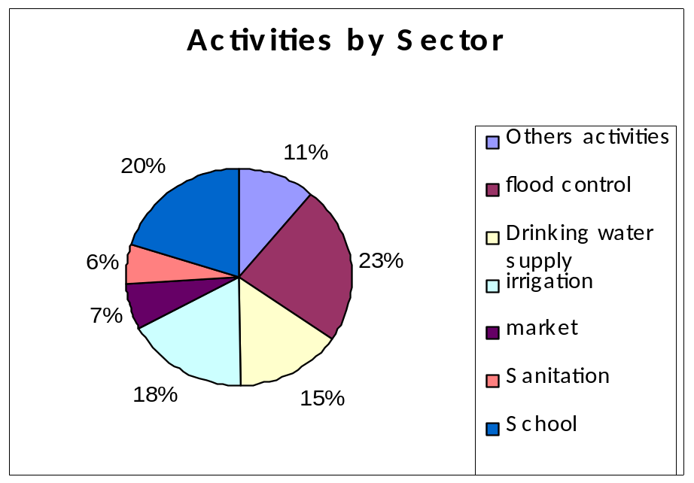
Figure 28: CDF Distribution by Population
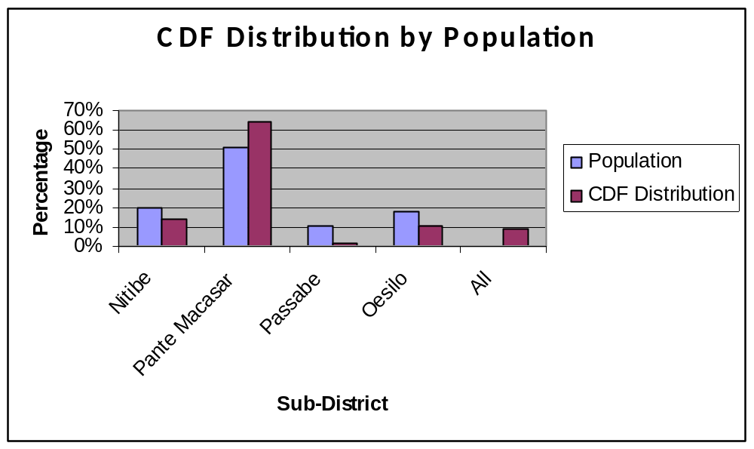
Overall, the CDF disbursed US$ 649,747 (€410, 694) and in doing so, not only provided for some of the essential infrastructural needs of communities throughout Oecusse but also played a significant role in empowering those communities to engage with each other and with local authorities, to plan and work together to realize those plans for their joint benefit. Further details on the type of benefit individuals and communities have derived can be found below.
A delay in the approval of the CDF operating guidelines until October 2006 caused some dissatisfaction among target communities. However, once this obstacle was overcome, every effort was made to process applications as quickly as possible and this was particularly evident in the six month period from May to October 2007 after which local development projects totaling US$293,579 (€185,566) had been approved with another US$95,635 (€60, 499) pending approval. A second challenge posed during the course of CDF implementation related to a failure to include provision for independent technical expertise in the OCAP budget. As a result reliance was placed solely on the technical skills and know-how of local government officers in assessing the validity of CDF plans and designs. However, the PIU point to very good collaboration and cooperation with all involved local government departments and indicated that this had contributed to very strong national ownership of completed infrastructure by project closure.
At this point it is prudent to note that the percentage rate demonstrating the risk of default in repayment of loans appears high, the following factors go some way to mitigate this risk:
a. Loan duration: generally short, so even one day non-payment is classified as “loan overdue”;
b. Non-repeat: repeated loans are not granted until the previous loans are repaid;
c. Community pressure;
d. Refusal Opportunity: The group may loans to a habitual defaulter; and
e. Monitoring by CAF.
These systems have been institutionalized through training under OCAP and it is expected that the groups can conduct savings and credit activities without external support.

Result 4: Local Governance Capacity Development
The fourth and final component of OCAP aimed to enhance the capacity for development coordination within Oecusse and, as a cross-cutting component; it took place simultaneously with initiatives under the first three components. It focused predominantly on local government as duty bearers but also addressed capacity development needs of OCAP staff and local Civil Society as important actors in development coordination in the enclave. As a cross-cutting issue, many of these capacity development elements have already been dealt with above. This section will therefore focus on those aspects of capacity development not already covered. In particular the focus will be on the development of OCAP PIU staff and local development partners’ capacity to manage the Programme.

Activity 4.1 Awareness raising on OCAP Programme thrust and implementation strategies
During the project’s pre-inception period from May to November 2004, the focus of activities was on the establishment of the PIU and of a comprehensive set of operational guidelines, procedures, rules and work-plans for OCAP implementation. From the outset, this element was implemented in close coordination with government counterparts and within the first six months a field visit had been paid to Oecusse in order to hold discussions with the DA and Line Ministries. Progress was slow due to delays in getting PIU staff on board, a fact that had adverse effects on later stages of the project. Nevertheless, a capacity building strategy and an overall Programme strategy were completed and a number of procedures and rules essential for OCAP implementation were put in place by November 2005.
At district level, the pre-inception phase up to November 2004 saw detailed plans being put in place to commence the inception phase in December - the dissemination of the Programme objective to community members, local administration and CSO. This was followed by a district level OCAP orientation workshop in April and May 2005 for District Administrator, Line Ministries (especially MAF) and other stakeholders. A community information campaign focusing on OCAP aim, objectives, strategy and technical areas to be implemented also took place in Nitibe on April 7th 2005 and in Pantemakasar six days later. An essential element in ensuring effective coordination was the setting up of four coordination centres in each of the sub-districts. This step allowed for the effective coordination with sub-district administrators, Suco Chiefs and Suco Councils.

Activity 4.2 Organize training to local government officers including elected suco and aldeias chiefs and suco council
As noted above, the National Programme Manager ensured that this element remained on the agenda of the PWC at all times. PWC members were concerned to ensure that any training provided would be directed at the correct officials and as such were liaising closely with the Ministry of State Administration and Territorial Management. Unfortunately, the process of decentralization remained ongoing throughout the duration of OCAP. The Suco Councils were still not in place and as such could not be trained.

Activity 4.3 Conduct regular meetings between PIU and NPSC/PWC
By May 2005, the National PSC had been established and held policy discussions at national level. The Project Working Committee, chaired by the District Administrator and operating at District level had also been established and met regularly in order to clarify the roles and responsibilities of the PWC and to build understanding on the objectives of OCAP. The focus gradually shifted onto discussions on CDF progress. At all times, the District Administrator, as chair of the PWC, was supported by OCAP PIU with relevant information about the Programme and with logistical arrangements for PWC meetings. Throughout the project period, both PSC and PWC fulfilled essential roles in ensuring the success of the project and their active participation in all relevant trainings ensured their capacity to fulfill this function.

Impact Assessment
UNDP did not undertake a formal systematic Impact Assessment of CDF projects in OCAP. Rather, this report contains data collected by the management team in their frequent field trips. The final evaluation of the Programme commissioned by EU noted the importance of high quality, strategically identified infrastructure projects. Assessment of the project demonstrates that most infrastructures developed through this component are in use by the community.

STAGE

Brief Description of the Project
STAGE aimed to reduce poverty and promote economic growth by reducing the level of unemployment and underemployment in RDTL. Building national capacity to deliver a demand-driven enterprise and skills development training is the entry point. The Project’s overall strategy is three-fold:
  - Capacity building of the SEFOPE, with a specific focus on its National Directorate of Employment, National Directorate of Vocational Training, and DEC;
  - Establishment of a national network of training providers capable of delivering a flexible system of formal and non-formal skills and enterprise training; and
  - Promoting community empowerment through the delivery of an integrated system of skills and enterprise training.
This Final Report covers the period from 13 May 2004 until 12 May 2009, the formal total duration of the Programme. STAGE exceeded all the targets initially defined and reached an outstanding level of sustainability. The ability of the STAGE to interact closely and intensively with SEFOPE and former national counterparts, and the success of the Project in achieving all its outputs was built based on two structural pillars:
- Project design; and
- Project implementation strategy.
STAGE was designed in close consultation and partnership with the initial national counterpart of the Programme, the Secretariat of State for Labour and Solidarity (SSLS), in order to ensure its adeptness to respond not only to the SSLS institutional challenges, but also to the capacity gaps of the active training providers and more importantly, to the needs of the most vulnerable groups of RDTL. The final result of this joint exercise was a comprehensive design that included all the components required to promote employment/self-employment, including career guidance and referral, skills training, enterprise training and micro-credits.
The five-year implementation timeframe with EVFT included from the outset allowed for the building and consolidation of the institutional capacity of the national counterpart and local implementing partners such as vocational training and enterprise training providers.
The fully integrated implementation strategy paved the way to spectacular results in terms of institutional capacity building and sustainability. STAGE worked fully embedded in the organizational structure of its national counterparts. This meant that the Project shared premises with the National Directorate of Employment and National Directorate of Vocational Training, facing “common” constraints like space and equipment limitations, difficult logistic arrangements, power supply shortages and unreliable communication systems, being exposed to the same pressure imposed by the vulnerable groups claiming SSLS, MLCR and SEFOPE services, and representing a continued institution building resource, properly placed to assess, analyse, and respond to the identified capacity and organizational gaps.
The Project also worked directly with national counterpart staff instead of recruiting a number of national Programme officers running under contracts with the international executing agency and reporting to the international chief technical adviser and international experts. In its place, STAGE assigned each international expert to a specific head of department of the national counterpart, and defined administrative arrangements to ensure that all the additional national staff needed to accomplish the planned activities was recruited under government conditions and through the establishment of contracts signed between the staff with the national counterpart. This allowed the building of an enlarged, cheaper and much stronger harmonised and unified team.
The adopted integrated implementation strategy produced a significant impact in building national ownership. It ensured that all the outputs of the Project were achieved through the national counterpart, based on the development of an internal capacity that was projected to other national and international implementing partners and finally to the communities. The approach allowed that the external recognised face of the Project was primarily associated with the staff of the District Employment Centres, and the national counterpart Directors and Heads of Department.
Another advantage of the STAGE integrated implementation strategy was its impact on the sustainability of the Project. Traditionally, structures established and developed by an international project tend to collapse when the Project ends. Reasons for that can be varied, but most commonly; this is related to the inability of government agencies to support additional costs. Through recruiting all national staff under government conditions and through employment contracts issued by the national counterpart, STAGE was able to enhance the sustainability and the absorption of Project outputs.
Upon an initial period inevitably centred on the strengthening of the national counterpart teams at the central and at the district levels, the same Project that was initially planned to cover a maximum of four (4) districts and to create around 6,000 jobs, actually achieved a national coverage organising activities in all the thirteen (13) districts, providing counseling and referral services to more than 27,000 unemployed registered in the DEC and generating more than 11,000 sustainable jobs. Moreover, the national capacity established within SEFOPE represented an assurance of the continuation of the impact of the Project beyond its lifespan.
The STAGE main activities during the entire period of implementation of the Project are described below as per expected Results under each Project Objective.

Project Activities

Immediate Objective 1- Strengthening the SEFOPE Capacity and restructure and expand the Employment Vocational Training Fund.

Strengthening the SEFOPE Capacity to provide secretarial support and services to a National Labour Force Development Institute; develop, coordinate, monitor and deliver vocational enterprise skills development at the urban and rural level; establish and maintain a Management Information System, and restructure and expand the Employment Vocational Training Fund.

Result 1.1 Capacity of SEFOPE strengthened to provide support and services to the National Labour Force Development Institute (INDMO) in developing policies and Programmes to advise the Government on vocational and enterprise skills training at the national, district and community level.
During its five years of implementation, STAGE gradually delivered a set of results that together has bolstered the SEFOPE to quality vocational and enterprise skills training at the national, district and community level. These underlying results are as follows:
- Medium-term national capacity building strategy defined
- The capacity of the Vocational Training Directorate of SEFOPE strengthened
- Legislation improved

Result1.1.A. Medium-term national capacity building strategy defined

Activity A.1: Integrate STAGE within the national counterpart organizational framework
STAGE was implemented as a SEFOPE project with ILO technical and administration support.
The STAGE team from the ILO side comprising Administration Support staff and International Experts was established, including the recruitment of a national Administration and Finance Officer, Administration Assistants and Drivers, international Programme Chief Technical Adviser, and the Specialists for the areas of Enterprise Development, Community Empowerment, Vocational Training, Gender, and Management Information System. The Chief Technical Adviser, the Enterprise Development and the Community Empowerment specialists remained throughout the entire duration of the Project. The Vocational Training expert was employed for a period of two years during 2005-2006 and the Gender and the Management Information System specialists were employed for a period of 1 year in the beginning of the Project.

An Agreement was established with the national counterpart, according to which all national specialists were recruited directly by the Government, and under the Government regular contracts and conditions. Throughout the implementation of the Project a total of 34 staff were selected and recruited using this Agreement. All of them were absorbed by SEFOPE before the completion of the Project.
All equipment was rapidly procured including the one required for the operation of the Directorates of Employment and Vocational Training and DEC. Vehicles respecting the EC Rule of Origin were also procured. At the end of the Project all equipment and vehicles procured with STAGE fund were transferred to SEFOPE.

Activity A.2: Developed a continuous capacity building plan for the Management Staff of the national counterpart
Each STAGE international expert was assigned to a specific Head of Department of SEFOPE in order to ensure day-to-day co-work, and promote the permanent sharing of knowledge, methodologies, and experiences. The same approach was applied to the Project CTA, which divided Project coordination responsibilities with the SEFOPE Directors of Employment and Vocational Training.
Attention was given to creating an enabling structure and an adequate number of staff within SEFOPE so that the defined objectives of STAGE could be met. New departments within SEFOPE created with STAGE support are: the Departments of Self-Employment Promotion, Gender Cabinet, Labour Market Information, Overseas Employment, and On-The-Job Training. Within each department, specific capacity building strategies were developed.

Activity A.3: Established an Overseas Employment Department
In order to support the Ministry of Labour and Community Reinsertion in its efforts to launch a Project to promote the deployment of Timorese workers abroad, STAGE facilitated the establishment of a new Overseas Employment Department in 2005. New staff was recruited and specific training was designed and conducted, centred on the fundamental concerns in managing an overseas employment process.
The Training Project comprised three (3) phases of basic awareness-building process at the level of :
- The Self;
- The Team; and
- The Programme.
The Self-focused phase aimed at creating awareness on what everyone could contribute to the development of the Overseas Employment Department.
The awareness building at the Team-level allowed for the identification of needs for cooperation and the fundamental ways of helping develop a new team, with emphasis on inter-agency relations.
The third phase, the awareness building on the Project, represented the pure technical part where the salient aspects of the Employment Services and Support Programmes for Overseas Employment were discussed.

Activity A.4: Assist SEFOPE in the establishment of the National Labour Force Development Institute (INDMO)
The mismatch between the skills supplied by vocational training providers and those demanded by the labour market is recognised as one of the main constraints hampering the building of a competitive and employable national labour force. STAGE was requested to assist in the creation of a vocational training regulatory agency to ensure direction, uniformity of standards, and international acknowledged certification procedures. During 2005-2007, the Government of RDTL and STAGE worked closely to achieve this goal. Stakeholders consultations at the national and international level were facilitated and relevant legal documentation drafted. Central in the process was the STAGE-facilitated Inter-Ministerial Working Group, involving Officials of the Ministry of Education and Ministry of Labour and Community Reinsertion. By early 2007 a consensus was reached: an endorsement given to the creation of the future “Labour Force Development Institute” (LFDI), the new designation suggested to replace the initial planned name of “National Authority for the Vocational Education and Training”; and the Competency-based Training was to be used as the guiding principle in the development of national skills training systems and certification.
The changes in the RDTL Government in the aftermath of the August 2007 General Election necessitated additional consultations and discussion with the then newly appointed SEFOPE on the goals and composition of the future Labour Force Development Institute. The existing draft law had to be revisited, and revised in close collaboration with SEFOPE and at the advice of the legal advisors of the Council of Ministers. The LFDI draft law was renamed as the decree law of the Instituto Nacional de Desenvolvimento de Mao de Obra (INDMO). It was approved by the Council of Ministers on 6 December 2007.
The creation of the INDMO is an important step in the development of the national technical and vocational education and training system in RDTL. INDMO works with the SEFOPE, the Ministry of Education, employer bodies, worker organisations, vocational training providers and other stakeholders. It is responsible to develop a national skills training that is sensitive to the needs and contexts of RDTL labour market and labour force, including the specific conditions in the agriculture sector and international standards in technical and vocational training. The functions of INDMO are:
- To define and approve the competency standards for the productive sectors in RDTL;
- To certify competence according to the approved standards;
- To certify vocational training centres and enterprises to become places of certification and to certify qualified staff to become assessors.

Result 1.1.B The capacity of the Vocational Training Directorate of SEFOPE strengthened
The strengthening of the Vocational Training Directorate focused on building the understanding of the Directorate’s management staff in effective skills training systems as required by the modern labour market. This was achieved through utilizing the ILO facilities including the ILO Turin International Training Centre (ITC/TURIN) and the Asia Pacific Skills Development Network.

Activity B.1: Training on Supervision and Evaluation of Technical Education and Training
STAGE supported the participation of the DESD (Division of Employment and Skills Development under the former Ministry of Labour and Community Reinsertion) National Coordinator of the Vocational Training (VT) Unit, currently Vocational Training Directorate under SEFOPE, in a three weeks training on Supervision and Evaluation of Technical Educational and Training organised by the ILO Turin International Training Centre. The Project addressed key issues for the mandate of the DESD VT Unit, including:
- Identification of the concept of supervision;
- Selection and application of techniques of supervision;
- Development and implementation of instruments of supervision;
- Identification of concepts, types, and levels of evaluation; and
- Adaptation of the general principles and procedures used for the evaluation of Projects to the characteristics and needs of specific institutions.
The training represented an important step for the development of the DESD capacity to follow-up and evaluatd technical education and vocational training projects executed by the different Timorese institutions.

Activity B.2: Training on Management of Competency Based Training (CBT)
STAGE supported the participation of the Director of the National Directorate of Vocational Training of the SEFOPE in the course on Management of Competency Based training organized by the ITC/TURIN in the first half of 2007.
The course on “Management of CBT” offered a general overview of CBT systems and analyzed in detail the most important aspects related with their management. In particular, the course provided room for in-depth discussion on:
- Systems and models of competency-based training systems;
- Identification and analysis of competences;
- Development of Curriculum for competences;
- Development of modules of training;
- Standardization and certification of competences;
- Training of CBT trainers; and
- Design and development of training instruments. A technical visit to France was included in the course in order to give the participants an exposure to concrete examples of the methodologies discussed and studied.
For SEFOPE, the course contributed to recognition of the potentials of the CBT systems to development and labour market improvement. Further it fostered an understanding of the role of the social partners in the identification of the competences.

Activity B.3: Participation in the second Technical Meeting of the Regional Skills Network
As the SEFOPE considered an establishment of a CBT system, the Project facilitated relevant international contacts for SEFOPE key staff to expose them to models and methodologies adopted by other countries, particularly in Asia and the Pacific region.
STAGE supported the participation of the SEFOPE National Vocational Training Advisor in the second Technical Meeting of the Regional Skills Network that brought together national skills development partner organizations in all ILO member States in the Asia-Pacific (AP) region, including those institutions operated by workers and employers organizations, to discuss skills development issues.
The meeting reviewed the progress made in the revitalization of the AP Regional Skills Network and explored the ways and means to make it more effective as a mechanism for sharing knowledge and expertise with and between countries in the region to contribute to improving economic and social development in ILO member States in AP. The main objectives of this second technical meeting were to:
- Review the skills challenges faced by the countries in the region and discuss the extent to which national training systems are able to respond;
- Discuss the operation of the Regional Skills Network; how the networking and technical cooperation Programmes of participating countries have been implemented, and how these practices can be made more effective to assist other countries;
- Review the current Cooperation Framework for the Network and consider if it needs to be strengthened.
- Promote and facilitate new alliances and forms of collaboration, and technical cooperation among the different partner institutions in the Network

The meeting allowed for the development of an updated common understanding on the Cooperation Framework and implementation strategy for the operation of the Regional Skills Network. It increased the awareness of the challenges facing other countries in the region with respect to developing the skills of their workforces, and the work on international and regional networking and technical cooperation in and between countries in the region, including from the perspective of the social partners.

Result 1.1.C Legislation Improved

Activity C.1: National Labour Code Reform
In general terms, the progress of a country is very much influenced by the quality of its legislation. Sound labour legislation is essential to create good industrial relations and an enabling environment for social and economic development. For RDTL, the National Labour Code has an important role to respond to the social and economic challenges. It establishes a regulatory framework that guarantees transparent and consistent processes and reliable decision-making on issues relating to labour and employment relations in both the private and the public sector.
The current RDTL Labour Code (Reg.05/2002) was approved back in 2002, still in the context of the United Nations Transitional Administration (UNTAET). Since then, RDTL faced many dramatic changes that needed urgently to be reflected in a new piece of legislation.
STAGE has assisted SEFOPE in the preparation of a revised draft Labour Code - a joint exercise with the National Directorate of Labour Relations and the National Directorate of Labour Inspection, and in close consultation with Employer and Worker Organizations and other social partners. At the request of SEFOPE, the new draft RDTL Labour Code was submitted to the Social Dialogue, Labour Law and Labour Administration Branch of the ILO Geneva for expert review to ensure compliance with the international labour standards and labour law best practices.
A number of general and specific comments were produced by the ILO and received by SEFOPE for improvement of the draft. All in all the draft Labour Code was further revised and considered to be a comprehensive and well-structured piece of legislation, representing a very good step forward in bringing RDTL national legislation in line with the principle of freedom of association and collective bargaining, non discrimination, and the effective abolition of child labour and of forced labour. The revised draft of the Labour Code is at the completion of STAGE in the process of review by the Council of Ministers.

Activity C.2: Ratification of ILO Fundamental Conventions
Under the leadership of SEFOPE, STAGE assisted the Government of RDTL to complete the process of ratification of some fundamental ILO Conventions. Although RDTL became a member State of the ILO in 2003, it did not ratify any ILO conventions during the period of 2003-May 2009.
Eight ILO Conventions have been identified by all ILO member States as the constitution of the undeniable fundamental human rights in the world of work, irrespective of the levels of development of individual member States. These rights are considered to be a precondition for all the others in that they provide for the necessary implements to strive freely for the improvement of individual and collective conditions of work. The Fundamental Conventions cover the areas of:
- Freedom of Association:
  - Convention (C) 87- Freedom of Association and Protection of the Right to Organize;
  - Convention (C) 98- Right to Organise and Collective Bargaining
- Abolition of Forced Labour
  - Convention (C) 29-Forced Labour; and
  - Convention (C) 105-Abolition of Forced Labour,
- Equality
  - Convention (C) 100- Equal Remuneration; and
  - Convention (C) 111-Discrimination;
- Elimination of Child Labour
  - Convention (C) 138-Minimum Age; and
  - Convention (C) 182- Worst Forms of Child Labour,
Out of the above, SEFOPE identified an initial group of four Conventions the priorities for RDTL, namely: C 29-Forced Labour Convention; C 87-Freedom of Association and Protection of the Right to Organize; C 98- Right to Organise and Collective Bargaining; and C 182-Worst Forms of Child Labour. A series of meetings were held with the Ministry of Foreign Affairs to discuss the importance and implications of the ratification of the different Conventions, and a positive consideration was issued by the Ministry.
Based on the support from SEFOPE and the Ministry of Foreign Affairs, STAGE assisted the preparation of the ratification documentation for submission to the Council of Ministers and National Parliament and ensured the follow-up of the process until the final ratification.
RDTL ratifications of the four Conventions, C29, C87, C98, and C182, were approved by the Council of Ministers and finally endorsed by the National Parliament in March 2009. Such decisions reflect the RDTL national commitments with regard to:
- C 29: Suppress the use of forced or compulsory labour in all its forms within the shortest possible period;
- C 87: Take all necessary and appropriate measures to ensure that workers and employers may exercise freely the right to organize. Provide workers and employers with the right to establish and, subject only to the rules of the organisation concerned, to join organisations of their own choosing without previous authorisation;
- C 98: Ensure that workers enjoy adequate protection against acts of anti-union discrimination in respect of their employment, and ensure that workers and employers organisations have adequate protection against any acts of interference by each other in their establishment, functioning or administration;
- C 182: Take immediate and effective measures to secure the prohibition and elimination of the worst forms of child labour.

Result 1.2 Skills development and employment management training capacity established within SEFOPE, with systems and expertise in place to design, develop, implement and monitor enterprise skill Programmes, and to provide advisory services for enterprise skills development for the urban and rural districts.
The activities to deliver this result were essentially the cornerstone of the STAGE overall operational capacity. Careful review was given to best design a comprehensive strategy so that STAGE objectives of institutional capacity building and community empowerment could be realized. Eight sub-results were gradually achieved during 2004-2009. They are:
- Human resources management strengthened
- Market assessment methodology defined and implemented
- A structure and capacity for gender mainstreaming created in SEFOPE
- Mechanisms for labour market monitoring
- Assessments and Research
- Employment and Vocational Training Fund legislated
- Core SEFOPE Staff Trained
- Long-term Employment Promotion Strategy defined

Result 1.2.D. Human resources management strengthened

Activity D.1: Defined Recruitment Procedures
Against the Directorates of Employment and Vocational Training’s need for more and better skilled staff, STAGE provided support in defining job descriptions and recruitment procedures of new staff, who would be working for STAGE and trained by the STAGE team. A comprehensive set of instruments including guidelines on short-listing, interviewing, scoring candidates, and preparation of minutes with selection panel recommendations was developed and used in the recruitment process in support of an equal and transparent employment recruitment system.

Activity D.2: Built the Administrative Capacity of the National Counterpart
The implementation of STAGE within the Directorates of Vocational Training and Employment also required a need for a stronger administration capacity within the Directorates.
The two new Officers were the first staff members recruited by the Directorates to deal with administrative, human resources, and logistic matters, and contributed to smooth, organise, and facilitate the implementation of activities, including the operation of the EVTF. On-the-job training was provided by the STAGE Administrative staff.

Result 1.2.E Market assessment methodologies defined and implemented

Activity E.1: Defined methodologies for Labour Market Assessments
STAGE developed a concept for the conduct of systematised rapid market assessments at the community level, based on the assessment of the products and services demanded and supplied by the communities, combined with the organisation of participatory sessions on “Business Ideas Generation” involving different focus group discussions specifically for women, youth, local authorities, and micro-entrepreneurs. To guide the community process, a Market Assessment Manual was prepared, detailing objectives, strategies, criteria for the definition of priority communities, and selection of partner organisations. The Market Assessment Manual was used as a key tool in the training of the Heads of Department of Vocational Training, Employment, Labour Market Information, and Self-Employment Promotion, as well as for the Community Promoters of the partner organisations that participated in the conduction of the field activities.

Activity E.2: Prepared and Disseminate EVTF Operational Guidelines for Partner Organizations
STAGE community-level training was to be delivered by its network of partner organizations. SEFOPE assumed the roles of the central administration with the responsibilities to review and approve proposals that were prepared in accordance with the findings from the Rapid Market Assessment and that were submitted to the EVTF for funding. STAGE supported the SEFOPE in the preparation and dissemination of the Guidelines for Partner Organizations (Provided with the 10th report), detailing all information related with the operation of the Employment and Vocational Training Fund. In order to standardise and facilitate the preparation of proposals, the document provides different types of models, covering activities in the areas of vocational training and enterprise training, on-the-job training, and micro-credits. The Guidelines document was instrumental in making the EVTF operations a transparent process, clarifying all aspects regarding the types of activities financed, the criteria for the evaluation of proposals, and models of contracts to be established with successful candidates. The Guidelines (English and Tetun versions) were massively disseminated through the Division of Employment and Skills Development and its DEC.

Result 1.2.F A structure and capacity for gender mainstreaming created in SEFOPE

Activity F.1: Established a Gender Cabinet
STAGE promoted and supported the establishment of a Gender Cabinet in the Ministry of Labour and Community Reinsertion (MLCR) and the SEFOPE. The Gender Cabinet was composed of a National Gender and Equality Officer, and by two national assistants. It was assisted by the STAGE Gender and Equality International Expert during 2005-2006. The Cabinet ensured the integration of gender and equality concerns in the policies, Programmes and activities of the national counterpart, developed training materials and implemented Gender Awareness Training for all the national staff at the central and district levels.
An initial “Work Plan for Immediate Action” was prepared comprising the following main activities:
(i) Compile a list of gender issues within the institution;
(ii) Hold a gender mainstreaming seminar for the five Divisions Directors;
(iii) Hold a series of gender awareness training workshops for all counterpart staff.
A questionnaire was distributed to the five divisions/directorates within the former Ministry of Labour and Community Reinsertion, and a gender analysis was conducted to form a baseline for action towards greater gender equality within the Ministry. The findings indicated a general dissatisfaction amongst the female staff regarding
- female recruitment;
- promotion;
- training opportunities; and
- incidents of gender-discriminating behaviour from colleagues and superiors. The findings also showed that out of 104 permanent staff members, less than 20% are female (83 men and 19 women) and similarly, that four of the five department directors are male.
The findings above informed the design of a series of Gender Awareness Training Workshops organized in coordination with the Office for the Promotion of Equality (OPE) under the Prime Minister Cabinet, involving all staff members, including directors and district coordinators. STAGE also assisted the Cabinet in the compilation and presentation of gender issues and staff grievances on gender-related matters and to the Directors, and Representatives of the Gender Cabinet under Prime Minister Office.

Activity F.2: Gender Awareness Training
During 2005-2006, the Gender Cabinet organised a series of Gender Awareness Workshops addressed to all national staff, including directors, heads of department, and assistants. The aim of the initiative was to improve gender relations within the institution, create a better understanding of gender issues, and promote greater gender equality.
The plan included five (5) Workshops for a total of more than one hundred (100) participants, tackling the following main topics:
- Introduction to gender awareness and gender terminology;
- Gender relations;
- Gender sensitisation;
- Gender and the workplace;
- Independent RDTL and Gender Equality measures in the constitution and labour laws; and
- Good gender-sensitive practices at work.
The Workshops were considered very successful in terms of the genuine interest generated by the materials made available, and the resulting lively discussions that represented a clear step ahead in comparison with the “aggressiveness” that characterised previous experiences in the districts.

Activity F.3: Gender Annual Work and Enhancing Organizational Capacity
Gender mainstreaming in SEFOPE continued after the departure of the STAGE international Gender Advisor at the end of 2006. In 2007, Attention was given to gear the mainstreaming efforts toward technical matters. The Cabinet was involved in the TVET impact assessment which was also designed to capture specific gender dimensions in vocational training. The findings from the assessment served as a basis for coaching support to the Cabinet staff to understand the gender dimensions in various stages of vocational training. From this, the Cabinet formulated an annual workplan outlining proposals for the creation of a gender focal point system within SEFOPE. In addition, the Cabinet developed specific gender questions for field monitoring and issued a Gender Bulletin on vocational training in 2008.
STAGE also supported the staff of the Cabinet in a four-day training organized by ILO Indonesia in Bandung. The initiative “Enhancing Organizational Capacity to Foster Collective Commitment to Gender Equality through Participatory Gender Audits” was planned to contribute to the building of organizational capacity to identify and design appropriate gender equality promotion measures that best suit the conditions and reality within each locality and organization. The participatory gender audit methodology rests on the recognition that gender equality promotion, in order to be effective, needs to take account of the particular reality and context of the organization in question. It provides a set of tools for organizational staff to identify within their own organizations existing good practices and challenges and to cultivate the organization’s commitment to prioritizing gender equality promotion. The training provided SEFOPE participants – who were also very active in enterprise development and skills training at the community level – a good understanding that gender equality promotion requires both organizational change and individual perceptivity of the specific needs of men and women. Although SEFOPE units have not been gender-audited, the gradual efforts and provision of practical tools for use in field monitoring have been enhanced by the catalytic roles of trained SEFOPE staff.

Activity F.4: Training for SEFOPE Gender Focal Points
Half-day training workshop for SEFOPE Gender Focal Points was organised by SEFOPE, in partnership with the Secretariat of State for the Promotion of Equality (SEPI), and with the support from the STAGE Programme. Eight (8) SEFOPE Gender Focal Points, representing different departments of the National Directorates of Administration, Labour Inspection, Labour Relations, Vocational Training and Employment participated in the workshop.
The workshop was opened by the by the Secretary of State for the Promotion of Equality that strongly encouraged the SEFOPE Gender Focal Points to really work as a team and in close articulation with SEPI in order to:
- Contribute to the harmonization and alignment of Programmes and projects with the priorities of the Government;
- Ensure that gender equality is integrated into the Programmes and projects as a cross-cutting issue;
- Make information available on progress in gender equality to enhance SEPI advocacy and monitoring capacity.
The remaining of the workshop was focused on three fundamental topics:
- Gender Concept, to consolidate the overall understanding of Gender, discuss the importance of gender analysis to identify issues, and examine the need for the definition of a gender mainstreaming strategy to allow effective response to the challenges;
- Gender Monitoring Framework, to discuss social and cultural barriers hampering the access of women to training and employment;
- Terms of Reference, for detailed discussion on the role and responsibilities of the Gender Focal Points.
The workshop encouraged the Gender Focal Points to be systematically involved in meetings and decision-making processes related to Programmeming of activities of the respective department, as these are critical entry points for gender mainstreaming.

Activity F.5: Gender Responsive Budgeting Training
STAGE assisted SEFOPE in the conduct of a Gender Responsive Budgeting Training organized by the Gender Cabinet of SEFOPE. This was a joint initiative of SEFOPE and the Office for the Promotion of Equality. It marked another step for SEFOPE in its pursuit to provide employment support to men and women. The training was designed to introduce SEFOPE officials to gender issues in employment and its relevance to the planning and budgeting process of SEFOPE, as the training took place around the time that SEFOPE was preparing its first annual workplan.
The training took place during 23-24 September 2008. The first day was led by the UNMIT Gender Advisor, and the second day by the ILO Gender Expert assigned to the ILO Office for Indonesia and RDTL. Twenty (20) officials within SEFOPE attended the training, including the Director of the National Directorate of Vocational Training, the Chief of the Secretariat of INDMO, and Heads and Assistants of different SEFOPE Departments.
The training served as a platform to raise the awareness of SEFOPE technical and management staff on gender tools and gender-specific initiatives that could address women’s specific needs. Key concepts in Programme planning, and engaged participants in planning and budget allocation exercises were introduced. Lastly, the training highlighted how gender mainstreaming, budgeting, and planning could be translated in SEFOPE mandates on vocational training and employment. The participants reviewed the draft SEFOPE 2009 Annual Workplan and analyzed the extent to which the draft 2009 workplan was realistic, adequately integrated the specific needs and concerns of Timorese women and men, and feasible in terms of implementation capacity by SEFOPE officials. Specific attention was given to the training needs of SEFOPE officials so that the Project would be implemented with quality. Recommendations from the participants were collected for future analysis, discussion, and technical assistance to SEFOPE and RDTL government’s gender mainstreaming effort at large. The training participants acknowledged the usefulness of the training and the relevance of gender planning and budgeting in their respective work. They also highlighted areas of challenges and training needs that would need to be responded on a regular basis, pertaining not only to gender mainstreaming but to the general work organizations in SEFOPE, and suggesting that gender mainstreaming in SEFOPE cannot be treated as a separate Programme but as an integral part of the SEFOPE overall institutional capacity building.

Result 1.2.G: Mechanisms for labour market monitoring
STAGE ability to achieve its key objectives and targets was contingent upon the extent to which employment services and skills training were responsive to RDTL labour market conditions. The project’s Management Information System to track and trace beneficiaries was designed to capture labour market conditions at best it could. This gave rise to creation of a SIMU, which has proven to be a critical tool for both Programme monitoring and various studies undertaken by SEFOPE and STAGE.

Activity G.1: Developed a Labour Market Information System (SIMU)
A computerised Database system was developed for the District Employment Centres. A Tetun designation was agreed for the computerised Database that adopted the name of “SIMU” – “Sistema Informação Mercado Trabalho”. ‘Simu’ is also the Tetun word for “to receive”, which resonates well with the DEC, and SEFOPE mandate and activity.
Different SIMU parts were initially developed including registration of training and employment seekers, registration of training institutions and employers, and EVTF proposals data entry module. The computerised Database was successfully installed in the DEC including the electronic jobseekers registration. A user-training manual was prepared reflecting the system functionalities, and data entry training was provided to the DEC staff. Reporting formats and a user-friendly data printing facility were also completed.
A groundbreaking Job Mediation concept for the automatic matching between job seekers and vacancies was developed and tested too. The concept introduces a total flexibility in the system, allowing the application of different filters criteria according to the requirements of employers and positions. The concept accepts all types of filters, including, for example, educational level, language abilities, work experience, particular computer skills, professional qualifications, etc.
The SIMU database and the monitoring missions of SEFOPE provide for a clear distinction between the ‘employed’, and the ‘self-employed’:
The ‘employed’ are the individuals registered in the DEC that acquired paid (wage) employment with the support of STAGE and as a result of their registration with the DEC. This group was composed by the clients of the Job Mediation/Placement services of the DEC, and by a part of the graduates of the vocational training courses. The breakdown was as follows:
Table 17: STAGE Beneficiaries in Paid Employment
Job Mediation / Placement | 596
Graduates from Vocational Training that found paid employment | 962
Total | US$ 1,558  (€984.83)
‘Self-employed’ are those registered in the DEC that initiated their own businesses or were engaged in income generating activities. The breakdown was as follows:
Table 18: STAGE Beneficiaries in Self-Employment
Business Start-up through Training and Credit | 6,470
Income Generating Activities | 3,234
Total | US$ 9,704  (€ 6,134.00)

Activity G.2: IT Training for Labour Market Information Department
STAGE organized and supported the participation of two officials of the Labour Market Information Department in two-week full-immersion training on MS-Access and Database Concepts that took place in Yogyakarta. The training focused on Database Design and Application, including System analysis, Database development and implementation, Access Database interface with Visual Basic and preparation of Administration/Archives Information System with MS Access Database. The training increased the expertise and preparedness of the Department to develop computerized databases tailored to the specific needs of the different Programmes and to solve their problems.

Activity G.3: Database In-Service Training for Labour Market Information Department
In order to complement previous IT Training conducted and improve Programmeming skills in Microsoft Access, STAGE conducted a process of continuous (twice a week / two hours per session) In-Service Database Training for all staff of the Labour Market Information (LMI) Department of the SEFOPE. The training contents were essentially focused on:
  - Database Concepts; and
  - Table design and making use of concrete software development needs of the LMI Department as practical examples.

Activity G.4: The STAGE Baseline Study
As part of the overall capacity building process of the Labour Market Information Unit/Department, in 2006 the STAGE Baseline Study was finalised, representing a secondary research exercise aiming at the characterization of the situation of the targeted districts immediately before the launching of the Programme. The Baseline Study contains detailed labour market data. The document formed a useful reference for the Programme in identifying target groups and understanding the nature of employment in RDTL.
The Baseline Study also included estimates of the Unemployment Rate in RDTL according to the international definition, and using the 2004 census as a basis.

Activity G.5: Labour Market Information Workshops
With the assistance of STAGE internal workshops were organised (8th and 18th of July 2008) by the LMI Department of the SFOPE to improve the data-entry process related with the details of the beneficiaries of the services of the National Directorate of Employment and National Directorate of Vocational Training.
The workshops assisted the users of the SIMU to overcome detected difficulties to capture the entire range of services accessed by the beneficiaries in those cases in which they participate in more than one Programme (for example, skills training followed by enterprise training, or enterprise training complemented with access to micro-credit schemes).
In addition, the workshops also contributed to improve the articulation between the LMI and other SEFOPE Departments, representing the starting point for the planning and implementation of weekly meetings.

Activity G.6: SIMU Upgrading
The initial design of the SEFOPE Labour Market Information Database (SIMU) envisaged storing information concerning approximately 5,000 job seekers. Over the years the system, MS-Access based, was continuously upgraded. The SIMU has been installed in Dili, Baucau, Bobonaro and Oecusse, and approximately 60 SEFOPE staffs have been trained and input data into the system that has the following main modules and functional areas:
- Client Registration (issue ID Card);
- Employment Module (Register Client, Employer, Vacancy, local/overseas);
- Vocational Training Module (Client, Provider, Course);
- Self Employment Module(Client, Training Provider, Course, Micro-Finance Institution);
- The Employment and Vocational Training Fund module (proposal registration, beneficiary registration);
- Labour Intensive Works module;
- Reporting Module;
- Job and Vocational Training Mediation Module;
- Data Sharing with District Employment Centres;
SEFOPE is continuously expanding its operations, with a scope that will become nationwide and with a target of more than 200,000 job and training seekers to be registered. In addition, new labour intensive/labour based Programmes have been launched resulting in further and fast increase of the volume of data that needs to be stored and processed by the system.
As part of the application life-cycle, the STAGE Project supported the design and planning of future options for a major upgrading of the SIMU to ensure its responsiveness to the above challenges and that data stored is secured and available at all times. An advanced Technical Architecture Plan was prepared, which recommends the upsizing from the current ‘Microsoft’ (MS) Access database to MS SQL Server and the purchase of dbSynch software tool to provide more robust and comprehensive data consolidation. Due to the expected future size of the SEFOPE operation, was also recommended the installation of a second Server to allow the separation of the functions related with development and testing in one of the Servers, and data consolidation and reporting in the other one.

Result 1.2.H Employment and Vocational Training Fund Legislated

Activity H.1: Review EVTF Guidelines
The EVTF was the engine of the STAGE, representing the mechanism that allowed the Programme to promote the creation of training and self-employment and employment opportunities.
Since the beginning the EVTF was established as a national fund, managed by SEFOPE, supervised by the Ministry of Finance. This distinctive feature of EVTF promoted national ownership and facilitated the future sustainability of the Fund.
STAGE developed clear guidelines regulating the operation of the EVTF for implementing partners and for the DEC. Those Operational Guidelines defined the types of interventions to be supported by the Fund as well as the criteria used for the evaluation and selection of the community proposals to be funded.
After a little more than two years of operation (the EVTF approved the first batch of community proposals in January 2006), SEFOPE and STAGE revised the Guidelines of the Fund in order to reflect lessons learned and expand the scope of activities. Internal operational procedures, related with the responsibilities of the EVTF Secretariat and Evaluation Committees were refined, methodologies for the submission of proposals by the implementing partners were improved, and possibilities to support new types of interventions were introduced.
The revised Operational Guidelines reflected the vision of SEFOPE regarding the importance to further stimulate On-the-Job Training activities, and to explore other new areas considered crucial to facilitate school-to-work transition and, consequently, crucial to promote the access of youth to employment opportunities. In line with this vision, and in addition to the continued support to vocational training, business training, on-the-job training and micro-credits, SEFOPE and STAGE also encouraged Work Experience, to promote improved articulation between training centres and enterprises, and Internships to provide temporary work opportunities for unemployed youth out of school who graduated from secondary school.

Activity H.2: FEFOP-Fundo de Emprego e Formação Profissional (EVTF) – a national fund
As mentioned above, the EVTF was the engine propelling the community empowerment component of the SEFOPE and STAGE and the main existing instrument to promote the creation of training and employment opportunities in the communities.
Recognizing this strategic importance of the EVTF, and in order to promote the continuation of the developmental activities supported by the fund beyond the life span of the STAGE Programme, the SEFOPE and STAGE jointly prepared appropriate legislation aiming to ensure the sustainability of the entire process.
Legislation proposing the establishment of the FEFOP-Fundo de Emprego e Formação Profissional (EVTF) was finalised, submitted to and approved by the Council of Ministers.
The law enables different types of fundamental Programmes to be funded/co-funded through the EVTF and implemented by the Government with the assistance of its development partners:
- Vocational Training, Retraining and Rehabilitation Training Programme (PROFARP): improved the continuing Vocational Training system for registered unemployed contributing to increase their employability. PROFARP awarded grants to training providers with capacity to organize courses matching identified labour market needs.
- Labour Intensive Public Works (PRIMO): promoted livelihood improvement and social stability in rural communities through rural infrastructure development and employment generation. PRIMO targeted unskilled and semi-skilled unemployed and long-term unemployed registered in the District Employment Centres.
- Employment Incentives (PRIEM): improved the chances of the unemployed to find permanent employment. PRIEM targeted specially disadvantaged groups including people with disabilities and long-term unemployed, and will facilitate the access of young women and men to their first job, allowing them to launch a career and gain work experience.
- Self-Employment Promotion (PRIATE): stimulated the creation of self-employment/income-generating activities, promoted integrated micro-enterprise development strategies through the provision of labour market information and career guidance, skills and business training interventions, and linkages to credit.
The EVTF was implemented making extensive use of the revised EVTF Operational Guidelines developed under the activity above.

Result 1.2.I Core SEFOPE Staff Trained
Employment challenges in RDTL presented a need for SEFOPE staff to have both technical and management competency. On technical competency, one emerging area was the use of employment-intensive approaches in rural infrastructure investment. This area became particularly useful in the aftermath of the security crisis in 2006, when a cash-for-work Programme was introduced to quell economic and unemployment pressures which caused social unrest. On management competency, SEFOPE officials of all levels needed to enhance their soft skills for their daily job. STAGE supported the training of SEFOPE core staff in all of these aspects.

Activity I.1: Training on Employment-Intensive Investment Policies and Practices
STAGE promoted and facilitated the participation of the Director of the Division of Employment and Skills Development in the Inter-Regional Workshop on Employment-Intensive Investment Policies and Practices, organised and funded by the ILO International Training Centre in Turin. The 5-day Workshop exposed participants to the employment-intensive concept, and provided practical instruments for local-level planning, participation and job creation, and for the Design and implementation of employment intensive investment Programmes.
The content and timing of the Workshop was considered particularly relevant for the situation of RDTL, the moment in which the Government was set to launch the implementation of a large Programme of public investments in infrastructure development during the 2007 fiscal year.

Activity I.2: Training on Vocational Training Policies and Good Practices and Human Resources Management in the Public Administration
In order to respond to specific capacity gaps previously identified, STAGE promoted and supported the participation of senior staff of the Division of Employment and Division of Vocational Training of SEFOPE in two courses organised by the ITC/TURIN

Course #1: Vocational Training Policies and Good Practices (1 week training):
The course addressed the need to consolidate the ability to guide training institutions towards the promotion of skills relevant to the labour market. It focused on the following main topics:
- Analysis and interpretation of labour market data on a vocational training perspective;
- Analysis of different vocational training systems and identification and understanding of the fundamental elements for the management of vocational training; and
- Identification and discussion of best practices.
The course developed the capacity of analysis and contributed to the elaboration of appropriate vocational training policies as a fundamental requirement for the establishment of a labour market oriented vocational training system and the formulation of vocational training policies at the national, district and local levels.

Course #2: Human Resources Management in the Public Administration (4-weeks training):
The course represented a contribution to build effective leadership skills and improve the quality of the labour market services, exposing participants to modern human resources management techniques and organizing guided study tours promoting the direct contact with different models of public administration. In particular, the course addressed the following main subjects:
- Components, systems and models of Human Resources management;
- Design and auditing of staff training plans;
- Methodologies to increase the staff participation in the administration;
- Effective workforce planning;
- Case studies on the implementation of modern techniques of human resources management, including management by objectives and effective strategies of selection and recruitment of staff; and
- Equal opportunities between women and men.

Activity I.3: Staff Development Survey
STAGE conducted a “Staff Development Survey” to understand better the requirements of potential leaders and officials of the SEFOPE, and devise future appropriate staff development Programmes.
The assessment took take place through completion of questionnaires and through interviews with each staff member. Questionnaires in Tetun, Bahasa Indonesia and English were distributed to the participants in the survey one day before the survey commenced. Actual interviews took place between 24/10/07 and 27/10/07. A total of 25 staff members were interviewed, including three directors and two staff of the Secretariat administration office. Not all interviewed person were in leadership positions or would be considered for leadership positions no matter what the outcome of this survey. The age of the interviewees (excluding directors) ranged from 25 to 41 years. Average age of the interviewees was 32 years.
The Survey report produced important findings and provided useful recommendations for the design and implementation of further staff development interventions: Firstly, it recommended that STAGE considers staff development training at three levels: Directors, Coordinators and Assistant levels, opening the possibility for the case of the Coordinator levels to include assistants who show particular Staff development capabilities or other promising traits that would justify special considerations.
Director Training: Recommendations are for external training leaning heavily towards subjects that cover state administration such as general management, planning budgeting, human resources planning and administration.
Coordinator Training: Coordinator training should cover basic management subjects and conducted through on-site short term courses. The coordinators need all management subjects. However, stress should be put on the courses that most efficiently could help the coordinators better manage their daily duties. Such courses would be – in order of importance: Staff development Concept and Practice, Personnel Management, Motivation Techniques, Customer Service concepts and Practices, Communication and Facilitation Concepts and Practices, General Management Practices and Skills.
Assistant/Staff training should also be on-site courses aimed toward conducting themselves better in their jobs. The main subjects would be Customer Service concepts and Practices, Communication and Facilitation Concepts and Practices, Conflict and Negotiation Handling Skills.
Language Training: Recommendations regarding language training are added to the Staff development training. The issue of language problems in daily work was raised by many interviewees. Almost all mentioned Portuguese as being difficult to learn and not having sufficient opportunity to practice the language. It is also felt by several of the interviewees that English is required; that was particularly the case with the information technology staff that is dependent for further development on a basic knowledge of job-related English.
Computer Training: Computer training of all staff is necessary. Observing the staff operating computers clearly shows lack of any advanced skills. In addition to the user training it would be advisable to improve the skills of the staff responsible for the data base.

Activity I.4: Staff Development Programme
Based on the recommendations of the Staff Development Survey, STAGE designed a tailored Staff Development Programme covering three tiers of organisation: Director, Coordinator, and Staff or Assistant. It was also put into focus that the condition of each staff is unique as far as educational background and needs are concern.
The improvement of staff/assistants and coordinators is done through training and monitoring. Before the development Programme was designed, an additional training need analysis was conducted through direct observation of the staff/assistants at work complemented with more specific interviews to help determine the overall training topics.
The training was conducted separately for the two positions. For staff and assistants position, the Programme focused on:
- Public Service Organization (introduction to the nature of public service organization);
- Customer service (introduction to customer service);
- Customer concept (understanding the concept of external and internal customer);
- Internal and external customer service (understanding the expectations of external and internal costumers);
- Communication (building competency in communication, face-to-face and indirect communication; understanding formal and informal communication and how it affects customers; understanding the role of verbal and non-verbal communication; building a better communication;
- Waiting line management (understanding how to establish and manage a waiting line); and
- Handling difficult customers (understanding and practicing handling difficult customer and angry customer).
On the other hand, the training for coordinators was designed to address the following main subjects:
- Public Service Organization;
- Leadership concept;
- Leadership styles;
- Self-assessment of leadership traits and style;
- Assessment of leadership environment;
- Setting direction (participants work to set their objective or vision);
- Leadership interpersonal skills; and
- Motivating people.

Activity I.5: Language Training
As part of the global plan for the strengthening of the SEFOPE, STAGE created the possibility for all the staff of the Divisions of Employment and Division of Vocational Training to attend English and Portuguese language training in 2008 and 2009. The SEFOPE Staff Development Survey previously conducted by STAGE clearly identified the lack of language skills as a serious barrier to communication and further training. The issue of language problems in daily work was raised by many interviewees. Almost all mentioned Portuguese as being difficult to learn and not having sufficient opportunity to practice the language. It is also felt by most of the interviewees that English is required, particularly in the case of the IT staff whose technical competencies are dependent on further development on a basic knowledge of job-related English.
The language training aims at increasing the motivation and the trainability as well as the self-start and self-development ability of the staff, representing a fundamental component to improve the SEFOPE institutional capacity for labour administration and provision of labour market services.
In both English and Portuguese language courses, the initial level of the staff was assessed and different classes were established accordingly in order to optimise performance and results.
The first cycle of English short-term courses organised by STAGE in 2008, produced obvious positive results. A continuation was considered necessary in order to consolidate and further develop skills and self-confidence.
STAGE established an agreement with the Lorosa’e English Language Institute for the organisation of a second cycle of English language training for staff from the National Directorate of Employment and National Directorate of Vocational Training from SEFOPE. A preliminary placement test was conducted to ascertain the “students” level, and courses were designed based on the specific job functions the employees’ and to respond to their particular needs. Three groups of ten (10) staff members were established in accordance with their different levels of language fluency, and tailored sixty (60) hours courses were implemented for each group.

Activity I.6: Course in Management of Local Development
STAGE encouraged, supported and guided the participation of the Chief of Department and the Technical Coordinator of the Self-Employment Promotion Department of SEFOPE in the distance learning course in Management of Local Development. The course was organised by the Delnet Programme of the ITC/TURIN.
The course uses information and communication technology to provide participants with constant support from a specialized technical team of the ILO International Training Centre of Turin, who uses personalized technical resources and a Virtual Classroom to enable the participants to follow the course and communicate with tutors and with other participants. This electronic platform is reserved to participants only and offers essential elements in order to follow the courses, including:
- Training contents;
- Information about timetable and procedures;
- Self-evaluation forms; and
- The opportunity to communicate with the Programme services and other distance course participants from different countries.
The course aimed to boost personal and institutional capabilities in terms of the design, implementation and evaluation of sustainable local development strategies and policies appropriate to the local socio-economic context. It is designed to support participants in their daily local development work by providing theoretical models and, especially, practical tools.
In terms of contents, the course is comprised of six (6) training units as follows:
- Training Unit 1: Local Development as a motor of Change – offers a reference framework for local development, describing the main trends and strategies in such a way as to construct a vision that combines economic, social and cultural aspects;
- Training Unit 2: Local Development: Decentralization and participation of the civil society. Identifies the key elements for designing local development policies based on the active participation of the civil society and identifies the different alternatives for decentralization;
- Training Unit 3: Strategic Planning. Identifies the key elements and the fundamental objectives of strategic planning, analyses strategic planning in different regions and assess the potential of the participatory strategy in formulating strategic plans;
- Training Unit 4: Structure and management mechanisms. Identifies the potential and limitations of various models for managing local development and the basic principles underlying the establishment and organization of local development actors;
- Training Unit 5: Initiative and Innovation for enterprise development, employment and income generation. Introduces new approaches and identifies measures to support employment and income generation;
- Training Unit 6: Entrepreneurship, the engine of local economic development. Deals with key issues in the field of entrepreneurship promotion and self-employment in micro, small and medium-sized enterprises.

The course comprised 220 hours, spread across 9 months, and was concluded in March 2009. As part of the final evaluation of the course, the SEFOPE participants developed a full project proposal on “Youth Employment Creation through Self-Employment Promotion and Micro and Small Enterprise Development in RDTL Rural Areas”. The document includes all the details on Background, Justification, Target Groups, Project Components and Partners, M&E, Thematic Concerns and Budget, representing a comprehensive and solid proposal that was assessed by the Delnet Programme of the ILO International Training Centre as the best project submitted among all participants. The Delnet network is currently comprised of over 2,200 people and institutions from 71 countries on all five continents.
According to the feedback from the SEFOPE participants, the course represented a strong contribution to enhance their ability to design, develop and monitor skills and employment promotion initiatives. Participants will be provided with Diplomas issued by the ILO International Training Centre.

Result 1.2.J. Study and Policy

Activity J.1: A Youth Employment Study (YES)
In order to allow STAGE to strengthen its youth-oriented activities, as recommended by the Programme Steering Committee Meeting held in October 2006, and to provide the foundation for the planned National Action Plan on Youth Employment, STAGE organised a Youth Employment Study (YES) to analyse the youth employment challenge in RDTL.
The study was implemented through a STAGE-GTZ-World Bank cost-sharing arrangement, and based its analysis on a large scale-survey that collected information on Timorese youth, focusing on the personal identification data of youth, their education and training, their perceptions and aspirations regarding employment and their long term life goals. A specific computerised database was developed to allow appropriate data processing.
The Study sample was constructed to accommodate youth who are ‘In-school’ (664 youth interviewed, representing 2.2% of the total number of graduates in 2006) and those who are ‘Out-of-school’ (2,336 youth interviewed representing 2.2% of the total targeted population). The geographical regions in which this target group was chosen comprised 7 districts (Baucau, Manufahi, Lautem, Ermera, Bobonaro, Oecusse and Dili).
In addition to this, a sample of 20 enterprises was also selected to allow for an analysis of youth employment challenges from an employer’s perspective.
The YES analysed the employment challenges faced by Timorese youth from two perspectives:
- demand side challenges, and
- supply-side challenges.
On the ‘demand-side’, the study identifies slow and volatile growth patterns of the non-oil non-agricultural sector, a consequence of which is the general lack of capacity to accommodate the estimated 15,000-20,000 ‘new entrants’ to the labour market every year. The report shows that the formal (modern) sector remains in an ‘infant state’, with very limited employment opportunities for youth, while the ‘informal economy’ and or ‘subsistence agricultural activities’ have proliferated in size, and is where a large proportion of the ‘working youth’ are employed. Jobs here tend to be characterised by low productive activities, with little or no job security, poor working conditions and low remuneration.
Other ‘demand-side’ constraints, identified by the report, include numerous impediments towards the development of vibrant micro and small enterprises, thereby limiting the potential scope of opportunities for youth to consider self-employment (being an entrepreneur) as a sustainable and productive career alternative. Key barriers to Entrepreneurship include the non-existence of property rights, and difficulties for youth to have access to credit to start up a business. Here youth suffer from ‘age specific’ challenges; as the prevailing formal credit schemes in RDTL, require collateral (which youth do not have) to qualify for a loan, similarly young Timorese men also suffer from ‘gender specific’ challenges, as current micro-finance schemes only tend to women. A direct result of this is that most entrepreneurial activities remain in the informal sector, with limited potential to consolidate and expand in scope and size.
On the ‘supply side’, key issues identified by the study relate to the quality, as opposed to the quantity, of educational and training Programmes. More specifically, education and training institutions and subsequent Programmes tend to be ‘supply-driven’. In other-words, curricula and training materials often do not provide an appropriate ‘level’ or ‘type’ of skills and expertise to its graduates that can be portable to the needs and demands of the different industry sectors. A direct consequence of this is that youth face a mismatch between the skills they acquire from the training and education system and the needs of the labour market, causing youth to be “structurally unemployed”.
For those youth who do overcome this mismatch dilemma, given the lack of linkages between the education/training system and Industry, the general and technical skills they acquire in varied disciplines tends to be of inferior quality having negative implications on productivity and thereby further discouraging employers to hire young people.
In addition to this, and still related with the supply side, formal labour market intermediaries (education and training institutions, public employment services, etc) provide little support for youth in terms of career guidance, or in identifying potential employment prospects and in disseminating credible Labour Market Information. This causes youth to rely on informal sources (family and friends) to acquire labour market and potential employment information, which often tends to be inaccurate or outdated leading youth to develop unrealistic and contradictory expectations regarding their employability in the actual context and conditions of the labour market. A situation that further exacerbates issues related to unemployment and underemployment.
The failure of formal labour market intermediaries to provide appropriate career counseling and guidance leads many youth to spend long periods of time looking for work, ultimately suffering from issues related with long-term unemployment (like the gradual deskilling) and often ending up joining the informal sector in occupations that are not related with the skills they acquired in education. This also sends a wrong signal to youth who are in school or considering to pursue further education, as they fail to see education as “a tool” to improve their ‘employability’ and access to better jobs.
The findings of the study served as a guideline for the Government and other stakeholders in streamlining ‘youth sensitive’ policies and Programmes for improving economic and social welfare for young women and men in RDTL. The final report of this study was provided in the 10th report.

Activity J.2: A National Employment Strategy
STAGE assisted the preparation of a National Employment Strategy (NES), based on a careful review of the first NDP, the IV Constitutional Government Programme (CGP) 2007-2011, the goals and targets set by the country towards meeting the Millennium Development Goals, the Sectoral Investment Programmes and, most of all, based on the current economic and social situation.
The National Employment Strategy aims at developing a mechanism and modalities that enable Timorese women and men work aspirants to access full, productive and freely chosen employment. It also aims at strengthening the employability and productivity of those engaged in precarious jobs and/or are underemployed. The policy has a special focus on country’s youth – in fact their employment is stressed as a priority matter, the handicapped and vulnerable sections of the society. It emphasizes that productive employment objective has to be carefully woven with adequate considerations on raising technical and vocational competence as well as the level of human capital. It also stresses greater and effective integration of human resource development and utilization in the very process of economic development, in setting sectoral priorities and indeed in allocation of financial resources.
The National Employment Strategy proposes a number of specific interventions intended to create conditions for greater and effective private sector participation in economic activities, presenting an action plan covering the following areas:
- Employment Generation in Agriculture;
- Employment Generation in Rural Areas;
- Employment Generation in Infrastructure and Public Works Programmes;
- Employment Generation in Housing;
- Employment Generation in Manufacturing;
- Employment Generation in Domestic Trade;
- Employment Generation in Tourism; and
- Overseas Migration.
As mentioned above, the document emphasizes the need for focused attention and targeted interventions in terms of building human capital that relate well to the conditions of youth and women as well as market needs. The National Employment Strategy points out that the priority task is to address youth challenges and, together with the findings of the YES, provides a framework for the preparation of a National Action Plan on Youth Employment.
The draft was circulated by SEFOPE among the members of the Government and national and international stakeholders, and was finalised with their inputs. The National Employment Strategy was presented to the Council of Ministers in July 2009.

Result 1.3 District Employment Centres (DEC) strengthened, with fully trained staff for labour administration and provision of labour market services, including support, coordinate and monitor centre-based and community-based enterprise skills training and income-generating activities.
This key result comprises two elements, namely DEC staff were trained in core skills and DEC capabilities strengthened in the administration, expansion of services, and expansion of facilities.

Result 1.3.K. DEC Staff Trained

Activity K.1: Training of DEC staff: DEC Work Flow Charts
At the set up of the EVTF, basic operational Work Flow Charts (Annex D: EVTF Operational Guidelines) were prepared to provide room for:
- the discussion and understanding of the role of the DEC in the community empowerment process;
- the debate on the organisation of the Employment Services; and
- the identification of additional training needs to be addressed in subsequent stages.

Activity K.2: Training of DEC staff: Communication Skills
Training Manuals on “Communication Skills” (Annex E.1 and E.2) were developed representing a step-by-step guide focused on the most important components of the relationship between the Employment Services and Employers (part I), and between Employment Services and Jobseekers (part II). The training stimulated the exchange of experiences and ideas through a participatory process involving role-playing supported by audiovisual means, in order to allow the analysis and discussion of real work situations.

Activity K.3: Training of DEC staff: Organization of the Services
STAGE implemented an all-inclusive training Programme for the staff of the District Employment Centres of Dili, Baucau, Bobonaro, and Oecusse. The Programme included the development of organisational methodologies, instruments and techniques covering the full range of services provided by the Employment Centres to the communities, including placement services, labour market information, vocational guidance, vocational training, on-the-job training, and employment and self-employment promotion.

Activity K.4: Training of DEC staff: Career Guidance and Counseling
STAGE was able to secure funding from the French Government, through its Embassy in Bangkok and in coordination with the French Cooperation Office in RDTL, to implement a 5-days training Programme on Career Guidance and Counseling. The Programme received the inputs of a specialist of the Regional Centre for Vocational and Technical Education and Training (VOCTECH).
The training was divided in two parts, with the first two days being devoted to Course Design Enhancement for national counterpart managerial staff, and the remaining days to training implementation involving the participation of 20 staff of the District Employment Centres, as well as Veterans, Women, and Disabled Associations.
The training covered the following topics:
- Employment Centre activities and flowchart;
- Career search process;
- Facilitating clients self-assessment;
- Matching self-assessment results and career fields/options;
- Preparing an effective resume;
- Preparing an effective cover letter;
- Job interviewing;
- Identifying post-training activities;
- Preparing plan of action for the activities identified.
The training was considered by all participants to represent an important contribution to further improve the DEC services.

Result 1.3.L. DEC capabilities strengthened

Activity L.1: Developed DEC Registration System
A new Registration System for DEC clients (jobseekers) and job openings was prepared from scratch in permanent consultation with SEFOPE at the central level. The system was planned to offer multiple possibilities for further development connected with the follow-up of participants in the skills and enterprise training activities organised by the Project, and follow-up of the beneficiaries from the Micro-Credit schemes. Additionally, the system was designed to ensure full compatibility with the future computerized registration.

Activity L.2: Established DEC Job Mediation Services
An original and effective Job Mediation concept for the automatic matching between job seekers and vacancies was developed and implemented, including training for DEC staff. The concept introduced a total flexibility in the system, allowing the application of different filters criteria according to the requirements of employers and positions. The concept accepts all types of filters, including, for example, educational level, language abilities, work experience, particular computer skills, professional qualifications, etc.

Activity L.3: Workplace Surveys
In the scope of the overall objective of promoting gender-equal opportunities in the access to the labour market, STAGE conducted internal surveys in all the four District Employment Centres of Dili, Baucau, Bobonaro, and Oecusse, aiming at the identification of barriers hampering the access of women to the services. In each Office, registration details were analysed, taking in consideration the following fundamental aspects:
- Access to registration information;
- Registration environment;
- Registration area; and
- Registration process.
The surveys provided a number of very concrete and precise recommendations that were used by STAGE as guidance to improve existing conditions and organization of the Employment Services.

Activity L.4: Assist relocation and reestablishment of DEC
As expected, the need for the relocation of the DEC that resulted from the new structure adopted by the IV Constitutional Government of RDTL represented a major additional challenge for the smooth development of the performance of the employment services. The SEFOPE approved the construction of new Employment Centres in the districts of Baucau, Bobonaro, Dili, Ermera and Oecusse, and STAGE assisted the process providing technical support for the design of the layout, organization and refurbishment of the offices.
The set-up of the new District Employment Centres of Dili, Baucau, Bobonaro and Oecusse was completed.

Activity L.5: Enhanced DEC Information and Referral Services through Media Strategy
The vision of the SEFOPE is that the expansion of the Employment Services is crucial to provide Timorese with more, better and equal opportunities in the labour market. Obviously, the geographical coverage of the services plays a fundamental role in the process.
However, physical infrastructures alone are not enough. On the one hand, it is also of paramount importance to invest in the preparedness of the SEFOPE Human Resources, particularly in further training for the staff of the DEC. On the other hand, improving the visibility of the labour market services provided by those Employment Centres is another central pillar of the strategy to enhance the overall performance of the system. While working in the first two areas, as described elsewhere in this report, STAGE also assisted SEFOPE in the design and implementation of a comprehensive Media Campaign to advertise the services provided and the Programmes implemented by the DEC, in close cooperation with their partner organizations/institutions (Vocational Training Providers, Business Training Centres, Employers, NGO and Micro-Finance Institutions) established at the local levels.
STAGE selected and recruited a National Media and Information Officer that received specific in-service training by the Project in RDTL and the ILO Jakarta Office. In order to facilitate knowledge sharing and continuous institutional development, the STAGE Media and Information Officer was integrated in the structure of the Cabinet of the Secretary of State for Vocational Training and Employment, allowing permanent contact and joint planning and design of information kits.
The Media Campaign involved the preparation and dissemination of leaflets, posters, calendars, banners, sign boards, etc, and also the development of specific brochures for some key partner organizations like Business Development Services Providers and Micro-Finance Institutions (MFI) to enhance the counseling services of the DEC towards the objective of self-employment promotion and to provide clients with additional information on partner institutions.

Immediate Objective 2 - Strengthening the capacity of existing rural and urban training providers to deliver flexible and integrated vocational and small business training.

Result 2.1
Capacity of existing Training Providers to manage the delivery of skills and enterprise training for paid and self-employment is enhanced.
STAGE created a network of training providers. Capacity building were provided to both vocational training providers that targeted the populace at large and school teachers to prepare students in entrepreneurship before their entry into the labour market. This result relates to achievements and activities pertinent to the following:
A. Existing managerial human resources in training assessed
B. Progress and refined strategies
C. KAB Programme

Result 2.1.M. Existing managerial human resources in training assessed

Activity M.1: Initial identification of skills training providers
Initial contacts were established with main active Vocational Training providers in the districts of Dili (Padre António Vieira, Tibar-National Employment and Vocational Training Centre, SENAI-National Industrial Skills Education Service, Dom Bosco, and Bekora Technical School) and Baucau (Colleges St. Maria Mazzerela and Fatu Maka, Community Development Centre, and Baucau Catholic Church Training Centre). STAGE objectives were introduced and potential for future cooperation was investigated.
At the same time early in 2005, STAGE initiated the development of a database of training providers (formal and informal), to systematise the collection of details on the available training capacities in the districts of Dili, Baucau, Bobonaro, and Oecusse. The database was to represent an important instrument for the operation of the DEC, which were responsible for the initial selection of suitable institutions, taking in consideration the quality of their services, and their relevance for the local labour market and training seekers expectations. A total of 36 training providers were initially assessed. A brief overview of the data collected and processed showed that:
- One third of the Training Providers was offering computer skills training often combined with language courses (English, Portuguese and Tetun);
- Private enterprises in the textile industry (tailors) offering tailoring courses, represented around one third of the visited;
- Training Providers in the area of agriculture and related techniques were nearly exclusively targeting male participants; and
- More than 50 percent of the visited Training Providers had no training manuals neither training Programmes defined.

Activity M.2: First Training Providers Assessment
Using the initial assessments as a basis, STAGE gradually developed and introduced a methodology to plan, coordinate, monitor, and evaluate training providers and courses. A total of sixty-two (62) Training Providers were identified and assessed in the districts of Dili (36), Baucau (11), Bobonaro (3), and Oecusse (12). Analysis enabled the identification of important bottlenecks affecting the RDTL vocational training system:
- Curriculum presented in different formats making impossible any attempt of comparison, as well as the introduction of standards to measure levels of vocational training/skills and link these with professions and salary scales;
- Lack of coherency in the curricula of the training providers operating in the same area, challenging planning and differentiation;
- Absence (in most of the institutions) of a coherent evaluation of the training and training provider; including the evaluation of the input, output, and the process of the training service;
- Weak communication and exchange of knowledge and experience among training providers operating in the same vocational area;
- Donor oriented of vocational education and training instead of market oriented offer;
- Weak capacity of trainers to set up trainings adapted to the different learning styles of the Timorese adults and a weak capacity to differentiate the delivering of the courses in order to include different target groups and promote equal opportunities;
- Weak linkage with labour developments and opportunities in the private, semi private and public sector as well as in micro enterprise and self employment sector;
- Weak training needs assessment capacity, in the vocational education and training sector.
The assessment allowed for the systematic gathering of fundamental information on the installed capacity and training courses offered by the training providers, including technical areas covered, title of the courses, duration, number of participants disaggregated by sex, number of graduates, number of trainers, certificates issued, participation fees, etc.
With few exceptions, Training Providers displayed an acute need for the improvement of their standards, through the development of capacity building Programmes for managers and training of trainers.
Data collected and bottlenecks identified were used for the development of methodologies introduced and discussed in the scope of the Methodologists Working Groups.

Activity M.3: Vocational Training Performance Indicators
Basic indicators for the evaluation of the performance of training providers were developed, to be included in the Labour Market Information System. Defined indicators referred to:
- Training Quality Standards;
- Training Employability; and
- Training Provider Strengthening. A Performance Indicators Checklist was prepared to standardise and facilitate future implementation.

Activity M.4: Created Community Based Rehabilitation Services
STAGE contributed to the creation of Community Based Rehabilitation Services in RDTL, in cooperation with the Social Services Directorate, supporting the design and implementation of a partnership project to develop human resources in the area. Community Based Rehabilitation (CBR) Facilitators were exposed to specific training before to be recruited by private and semi-private health organizations operating at the district levels, to deliver services to people with restricted abilities.
The training was developed in partnership with six partner organizations (ASSERT, Katilosa, Klibur Domin, Leprosy Mission International, Clinica Ita Nian Uma Aileu, and Spastic Centre NSW), and launched in March 2006. Twenty four people, unemployed registered in the District Employment Centres, were selected to participate. Out of them, twenty one were employed as CBR Facilitators, by the six partner organisations, fulfilling new positions gradually created as the community rehabilitation Programmes begin to be developed and carried out. The training was conducted on a monthly basis to allow the involvement of the participants in the development of community based and centre based rehabilitation Programmes for people with disabilities initiated by the partner organizations.
As part of these arrangements, in December 2006, STAGE organised another Workshop “Including People with Disabilities in Mainstream Programmes for Employment, Microfinance, and Skills Training”. Besides the CBR Facilitators participating regularly in the training activities, staff from the Employment, Training, and Enterprise Development Units of the Ministry of Labour and Community Reinsertion also attended the Workshop. The main topics addressed were as follows:
- Understanding the Experience of Being Disabled;
- Types of Disability and Causes of Disability;
- Impairment, Disability, and Handicap;
- Disability in a Developing Country;
- Situation for Disabled People in RDTL – Disability Services and Mainstream Services they could Access;
- Can Disabled People Work?;
- Barriers to Including People with Disabilities in Mainstream Programmes.
The Workshop provided a number of recommendations on how to include people with disability in the mainstream activities, including what the organisations should do to include people with disability in their Programmes, either by changing their policies or by a positive discrimination approach.

Activity M.5: Introduced a Training/Enterprise Integrated concept (Partnership in Training)
The Training-Enterprise Integrated concept was a new initiative promoted by the EVTF, as a response to the need to create effective bridges between skills training and labour market. Besides promoting the training/enterprise articulation, the concept is also “integrated” in the sense that provides concrete on-the-job assistance to Managers (Managing people, resources, and information) and Trainers (Improve training contents and training methodologies) of the Training Institutions, representing a continuous capacity building instrument.
The concept promotes the rotation of trainees between training centres (class-room training) and enterprises (on-the-job training), which presents enormous advantages for all the parties:
- The trainees are fully motivated by the systematic possibility to apply and test their theoretical concepts, and by the ability to “show-off” their developing skills and commitment to their future potential employers;
- The Training Providers are stimulated by the increased visibility and by the chance to improve the labour market relevancy and quality of their courses and trainers; and
- The employers have the opportunity to shape the training to match their needs, and to select the future workers that best suit the enterprise goals and environment.
The initiative was launched with the participation of the “SENAI” Training Centre, and three enterprises working in the construction area. It aimed to contribute to the strengthening of the Timorese vocational training system, promoting enterprises consolidation and development, and facilitating the training-work transition of the graduates.

Activity M.6: Organised a Vocational Training Providers National Meeting
This first National Vocational Training Meeting involved all Skills Training Providers active in RDTL and aimed at the development of a vocational training system truly oriented to the labour market. The Meeting promoted the introduction of the “Partnership In Training” concept, stimulating the multiplication of local partnerships between training centres and enterprises.
The Meeting resulted in the signature of a MOU between the Ministry of Labour and Community Reinsertion (MLCR) and 12 Vocational Training Centres, establishing a framework of cooperation for the promotion of employment and income generating opportunities. The MOU committed MLCR to provide financial assistance to participating vocational training centres with the purpose of upgrading the training facilities and instructor capabilities of the training centres, improving the quality of the training offered and expanding the training capabilities and capacity.

Activity M.7: Second Training Providers Assessment
The Vocational Training Division of the SEFOPE in partnership with STAGE conducted the second review of vocational training provision in RDTL. The review involved evaluating the information needed, revising the existing forms used for collecting data and working with the Labour Market Information Unit to improve the SIMU database. The information from the 2005 review had been continuously updated and provided the starting point. This was supplemented with information gathered from personal contacts and the data base of all NGO in RDTL. In addition to the centres in Dili, the personnel of the Division of Vocational Training conducted visits to the districts of Aileu, Ainaro, Baucau, Bobonaro, Covalima, Lautem, Liquiça, Manufahi and Viqueque.
The review has identified thirty-nine (39) vocational training providers and twelve (12) vocational technical secondary schools.
The full report on the Review of Vocational Training in RDTL (Annex F), analyses the data according to the geographical spread; the type of providers; the productive sectors covered by the training courses; the method of recruitment and selection of trainees and the groups targeted; the duration of courses; the funding of courses and training centres; curriculum used and the language of delivery; the qualifications of the trainers; the relationship of the training and the providers to the relevant employment sectors and enterprises; and the follow up mechanisms of the training centres. It also identifies gaps in the provision of training, draws conclusions and makes recommendations for future government policy directions for vocational training in RDTL.

Result 2.1.N. Progress and refined strategies

Activity N.1: Organise a Technical Vocational Education and Training Impact
The Vocational Training Directorate of the SEFOPE and STAGE conducted a Technical Vocational Education and Training (TVET) Impact Assessment aiming at:
- Assessing the effectiveness of the Vocational Training Programmes and Training Centres in assisting unemployed, mainly registered with the District Employment Centres of the Secretariat of State for Vocational Training and Employment, to find work or initiating their own income-generating activities;
- Identifying further inputs that may be required for the development of the vocational training strategy of the Secretariat of State for Vocational Training and Employment; and
- Testing a standard tracer study instrument and give on-the-job training to SEFOPE officials in M&E of training courses as provided by various institutions.
The survey assessed the impact of training provided by 21 Vocational Training Centres, which conducted skills training courses during the years 2006 and 2007 to the unemployed registered in the DEC. The locations of the training centres were: Aileu, Baucau, Bobonaro, Covalima, Dili, Lautem and Liquiça.
The total sample of 21 training centres included training centres, which are supported by the Government (3), Church (9), NGO (7) and private institutions (2). Two of the sampled training institutions were technical high schools. From these 21 training institutions the graduates sampled participated in 21 skill areas.
The survey collected information from the supply side (training centres) and demand side (employers), as well as from graduates of the courses, representing an exercise of tracer studies on the effectiveness of the skills training as a factor to promote employability. Consistent with this approach, the survey methodology was based on the development of three specific questionnaires for training centres, employers and graduates, in order to capture and cross information from the three different perspectives.
The graduates who were interviewed were selected from lists of trainees of the sampled training centres. The graduates were all trainees who completed their training during the years 2006 and 2007. A total of 418 graduates were interviewed. Training centre tracer information on graduates was from a sample size of 751 graduates.
The sample of employers was defined by taking into consideration two factors: a) the need to ensure representation of the different main areas of activity of the RDTL economy; and b) employers with consolidated operations, reflecting their understanding of the functioning of the RDTL labour market and, consequently, indicating their capacity to contribute to the identification of the level of relevance of the assessed training centres in a global national perspective. A total of 20 employers from a wide variety of industries were interviewed of which 18 employers are located in the Dili area and two in Baucau.
Of the 418 graduates surveyed, the Impact Assessment puts emphasis on reporting on factors that influenced employability of graduates of the training Programmes, whether through formal employment, self-employment or improvement in their present employment. With 55% of the graduates interviewed being women, particular efforts have been made to address gender determining factors in detail.
From the Impact Assessment report, it also became clear that there was a lack of consensus among stakeholders in training on what suitable training is. There was no agreement on training curricula and duration of training. There is still insufficient understanding of the reasons for poor employability of the trainees once they graduate. Every training institution trains to its own standards. Consultation with possible employers did take place, but on an infrequent basis.
All indications in the report point to the necessity of a nationally regulated vocational training system, designed to accommodate different ownership and operational structures, but also to promote a training provision more uniform and more in tune with the present and future national skills requirements.

Activity N.2: Improved the Participation of Women in the Vocational Training Courses
In parallel with the TVET Impact Assessment, the Vocational Training Directorate of the SEFOPE and STAGE worked on the preparation of a supplementary report that relied on the same survey results as the Impact Assessment but provided a more detailed analysis of the gender dimensions in vocational training in RDTL.
The TVET Impact Assessment Survey looked at the impact of vocational training with the aim of assessing the numbers of:
- Trainees at the commencement of the course
- Graduates of the training course
- Graduates employed in the formal labour market
- Graduates who improve their income primarily in the informal sector
- Graduates who are unemployed
- Graduates who enter university
- Women and men in each category of the survey population mentioned above.
The supplement “Gender Dimensions in Vocational Training” (Annex G) concentrates on the results of the survey in relation to gender with emphasis on the outcomes of training courses, the general training environment, the courses offered and selected by trainees, equality of access and sexual harassment.
The report presents a number of recommendations to strengthen women’s participation in leadership and staff development, to broaden skills training options consistent with labour market demand, and to promote institutional policies and procedures to enable equality of access and encourage reporting of incidents of sexual harassment.

Activity N.3: Organise an Integrated Skills and Enterprise Training Rapid Impact Assessment
In addition to the above Technical Vocational Education and Training Impact Assessment exercise, the Self-Employment Promotion Department of the SEFOPE carried out a Rapid Impact Assessment on graduates of a skills training and enterprise training integrated package.
The training Programmes were implemented by a partnership between the SENAI Vocational Training Centre and the CDE (Business Development Centre) of Dili, established through the Memorandum of Understanding signed by the two institutions.
The Rapid Impact Assessment targeted a sample of 16 participants, randomly identified, which graduated from Skills Training courses and participated in a subsequent Start Your Business course. The Assessment was conducted five months after the conclusion of the Enterprise Training. The main findings are as follows:
- All the interviewed graduates stated that they were satisfied with the quality of the enterprise training and the training materials and that the training made them ready to start a business;
- Out of the 16 respondents, 8 successfully initiated a business activity. The remaining 8 declared that they were planning to start their own business in the next 6 months;
- Seven out of 8 successful graduates managed to obtain a loan from a MFI to which they were referred. One graduate started his business activity with his own funds; and
- In terms of constraints in putting into practice the business concepts learned during the business training the respondents stressed: cash-flow (63 %); costing (14 %); calculation of income (12 %) and marketing (11 %).
In relation to further support needed, 64% mentioned the need of having access to more loan capital in order to consolidate their business; 30% declared they needed more business management support (record keeping, stock control, marketing and costing) and 6% (1 respondent) acknowledged that more specific technical training was required.
The Findings emphasized the crucial importance of building a holistic approach promoting close articulation between the different community empowerment components, in order to improve the potential for employment/self-employment creation and increase the overall impact of the interventions.

Activity N.4: Competency Based Training for Directors of Training Providers
STAGE conducted a two-day Workshop on CBT for Directors of key training providers in RDTL. Thirty people participated including representatives from 24 training providers and six staff from the SEFOPE. For almost all participants the Workshop was their introduction to Competency Based Training, representing their first opportunity to understand and discuss the concept. The evaluation of the Workshop demonstrated the interest of the Directors in the implementation of the CBT in their institutions, despite the existing infrastructural and technical barriers. The group formulated important recommendations, including:
- the organisation of additional workshops for Trainers focusing on developing competencies for particular vocational areas;
- to accelerate the definition and approval of competency standards for priority productive sectors; and
- to initiate, at the institution level, the development of learning modules based on competency standards, as a tool for the identification of areas requiring further investment in the professional development of trainers.

Activity N.5: Certificate IV in Training and Assessment for Vocational Training Managers
SEFOPE, in partnership with Victoria University, Melbourne, Australia, and with the STAGE support, organised the first Programme in the Certificate IV in Training and Assessment. The twenty-seven (27) participants came from nineteen different vocational training institutions covering six districts across RDTL. The productive sectors identified by the SEFOPE for this first course were building and construction, business administration and IT, agriculture, automotive and tourism and hospitality.
The course was delivered in Tetun by national staff (2) from the Dili Institute of Technology and from the SEFOPE (1), assisted by an international advisor from Victoria University. All participants successfully completed the course and will receive an international qualification in vocational teacher training and assessment. The course was delivered over a ten-month period that included four blocks of training for a total of 18 days. During the training the participants undertook visits to training centres in Dili, exposure visits to employers relevant to their area of training and had guest presenters on including people with disabilities in their training and standards for occupational health and safety. Each participant was also visited by members of the training team in their centre and assessed in the workplace for some of the competencies. The course included fourteen competencies in the areas of the learning environment, learning design, delivery and facilitation, assessment, and training advisory services.
The course was an important step in the Secretariat’s vocational training providers’ institutional strengthening Programme. The course evaluations completed by the participants, the directors of the training centres and the training team were overwhelmingly positive. Comments on the relevance of the training to RDTL, the support to training providers to implement the new knowledge and skills and the increased understanding of vocational training methodology and assessment of competency standards indicate the importance of the Certificate IV in Training and Assessment for RDTL. It also sets a benchmark for a formal, internationally recognised qualification for vocational trainers in RDTL. The course was co-funded by AusAID, Victoria University, SEFOPE and the STAGE Programme.

Activity N.6: Accredited Training on Competency-based Training and Assessment of Competency
Twenty-two (22) managers from different training providers and senior officials from SEFOPE, Ministry of Education and the National Institute for Public Administration (INAP), participated in professional development activities to increase their understanding of competency-based training and assessment of competency. The training was the Diploma of Training and Assessment, which represents the second phase of the first course on Certificate IV in Training and Assessment previously finalised. Both courses were conducted by Victoria University, Melbourne Australia in partnership with Dili Institute of Technology, the Norwegian Refugee Council and SEFOPE. The Certificate IV in Training and Assessment was also co-funded by the STAGE Programme.
The Certificate IV in Training and Assessment (TAA), which is a pre-requisite for the present Diploma training, comprised fourteen units of competency packaged into four areas: Learning Design; Delivery and Facilitation; Assessment; and Learning Environment. Twenty two (22) of the participants that completed the initial Certificate IV in Training and Assessment were invited to undertake the Diploma in Training and Assessment. The Diploma Programme was particularly relevant to training centre directors and senior government staff with responsibility for management of the training system.
The Diploma of Training and Assessment is a higher qualification that provides skills in management, administration, design, development and implementation of training and assessment systems. It was conducted over five months with 20 days of training between September 2008 and February 2009. Participants from SEFOPE were selected at the managerial level, including the Director and the National Advisor of the National Directorate of Vocational Training, the Chief of the Department of On-the-Job Training, and the Coordinator of the Gender Cabinet. In addition, there were also thirteen (13) participants from vocational training providers; two (2) from the Ministry of Education; and two (2) from the National Institute for Public Administration. The “Instituto Nacional de Desenvolvimento de Mão de Obra” (Labour Force Development National Institute) (INDMO) had also two (2) participants.
The courses, conducted to international standards, were an important step in the institutional strengthening Programme implemented by the Secretariat of State for Vocational Training and Employment that supports training providers to meet the quality standards for training in RDTL.

Result 2.1.O. Know About Business Programme

Activity O.1: Programme introduction to Directors of Vocational Technical Schools
STAGE promoted the introduction of the KAB package, an ILO business awareness Programme designed for use in vocational education (secondary technical schools) and some training institutions. The Programme aims at stimulating youth, students of technical schools, to think about entrepreneurship, and consider it as a potential future for their professional career.
The KAB builds important bridges leading to the GYBI and SYB Programmes developed by STAGE, representing consequently a powerful link between formal education, training and the labour market.
In order to promote the familiarisation of the managers of the Technical Schools with the KAB methodology, and encourage their involvement in the process of M&E, STAGE organised a comprehensive workshop involving the Directors of all the secondary technical schools of the Ministry of Education and Ministry of Agriculture.
The Workshop was centred on the concrete implementation of the Programme, including the provision of detailed and precise information on the new curriculum adopted by the technical schools due to the integration of the KAB.
Specific monitoring tools were developed, in collaboration with SEFOPE and with the Ministry of Education, and a global Monitoring Plan was prepared involving all technical schools implementing the Programme.

Activity O.2: Established the KAB (Know About Business) Steering Committee
A Steering Committee (SC) for the KAB Programme was established, composed by the Director of the Division of Employment and Skills Development of the Ministry of Labour and Community Reinsertion, the Director of the Division of Technical Education of the Ministry of Education and Culture, the Director of the Division of Training and Technical Services of the Ministry of Agriculture, Forestry and Fisheries, as well as Certified KAB Trainers of Teachers.

Result 2.2.: Technical capacity of training providers to deliver gender sensitive vocational and enterprise training that leads to wage and self-employment is enhanced.
This key result was delivered through a range of activities conducted by training vocational and enterprise training providers and the school teachers delivering the KAB Programme.

Result 2.2.P. Training providers' capacity strengthened

Activity P.1: Organised initial Information Workshop
An Information Workshop for trainers of the Business Development Centre was conducted to provide an overview of STAGE, with a particular focus on the Micro Enterprise Promotion component, and to present the ILO “Start and Improve Your Business Idea” international training Programme in terms of:
- overall objective, worldwide coverage and target groups;
- intervention strategy;
- training material;
- methodology;
- Training Of Trainers Programme; and
- Training Of Master Trainer Programme. Twenty-five (25) trainers and managers from the districts of Dili, Baucau, Bobonaro, Oecusse, and Ainaro actively participated in the Workshop.

Activity P.2: Training of Trainers in Silkworm Cultivation and Egg Breeding Production
In order to provide the Silk Production and Training Centre (LAHO) of Baucau with improved capacity to assist subsistence farmers in the development of successful silkworm cultivation and silk production, STAGE promoted the organisation of a Training of Trainers in Silkworm Cultivation and Egg Breeding Production at the Egg Production Training Centre of PPUS Candiroto in Indonesia.
STAGE supported LAHO since mid 2005 in producing high quality spun and woven textile from silk produced in the district of Baucau by local Timorese farmers. Demand for this product currently far exceeds supplier. Silkworms are reared in house at LAHO and also by local farmers out growers who receive assistance in setting up their rearing facility and are also paid for the cocoons they produce.
The main obstacle in the production was the need to import silkworm eggs every month from Java via Bali. This is inherently risky in terms of short term or long terms obstacles to the source of supply and in terms of quality variations. The training represented a first step to create a capacity for production of eggs in RDTL and ensure a continuous supply of high quality cocoons for silk production in the country.
The training received has assisted LAHO staff to build on and improve their knowledge of mulberry and silkworm cultivation and to develop an understanding of the processes and procedures involved in handling cocoons, adult silk moths and their eggs to produce eggs in-house which can eventually replace imported eggs.

Activity P.3: TOT in Business Counseling and Follow-up Methods
The TOT in Business Counseling and Follow-up Methods, organised in April 2007, represented the STAGE response to the identified need to improve the post-training support services provided by Business Development Centres. The objective of business counseling was to help entrepreneurs solving their own business problems with the knowledge and experience gained in the previous Start Your Business training.
The TOT prepared the trainers of the Business Development Centres for the provision of on-site advice and guidance to each entrepreneur on the actual problems faced, in order to ensure that the entrepreneur will:
- think and apply the acquired knowledge appropriately to the specific situations;
- develop skills in diagnosing problems and finding solutions;
- improve business operation and management skills;
- acquire data and information useful in good business management; and
- improve the performance of the business. A total of 13 trainers participated in the TOT.

Activity P.4: Professional Development for Vocational Trainers
DNAFOP, in partnership with the “Centro Nacional de Emprego e Formação Profissional” (CNEFP) in Tibar, organised two (2) 4-month professional development Programmes for “Guest Trainers”. The Programmes were hosted by CNEFP for trainers from vocational training centres in the districts to work alongside their trainers during courses.
Seven guest trainers from four training centres have participated in this professional development Programme for vocational trainers. The Programme supports the development of skills for vocational trainers in less developed centres in areas that are a national priority for skills training. CNEFP conducts training in plumbing, electrical, masonry and carpentry. The trainers have been supported by the STAGE Programme for wages and living allowance during the course.

Activity P.5: TOT for Start Your Business Trainers (First Group)
Initial Training of Trainers of Business Training was implemented, involving trainers (18) from the “Centro de Desenvolvimento Empresarial” (Business Development Centre) and “Centro Juvenil” (Youth Centre), based in the four districts of Dili, Baucau, Bobonaro, and Oecusse. The participating trainers represented the basis for STAGE to train potential and existing entrepreneurs in the framework of the EVTF funded proposals.
The trained trainers were enabled to:
- Market the training
- Do training needs analysis
- Group entrepreneurs according to training needs
- Design appropriate training interventions
- Deliver business training sessions
- Monitor and evaluate impact of delivered training
- Provide after-training support to entrepreneurs
- Link business training with micro-credit providers
As presented under Result 2.3, the Training of Trainers was supported by a wide range of training materials (training manuals and other relevant training supports in Tetun), which were also developed by STAGE.

Activity P.6: Women’s Enterprise Training of Trainers
STAGE developed and introduced an innovative gender module, “Women’s Work into Women’s Businesses”, in the overall GYBI courses. The “Women’s Work into Women’s Businesses” training Programme aimed at addressing the practicalities of establishing women’s enterprises. It includes:
- Introduction and reasons why women’s business development requires a specific training component within the GYBI;
- Outline of methodology, development and flow of business idea generation;
- Training for literate participants using flowcharts and mind-maps;
- Training for illiterate participants using pictorial mind-maps. Additional details are provided under Result 2.3.

Activity P.7: TOT for Start Your Business Trainers (Second Group)
STAGE organised a second two-weeks Training of Trainers for a new group of 18 Trainers from all the Business Development Centres. The TOT was a fundamental part of the STAGE strategy to expand the national capacity to train potential and existing entrepreneurs in the framework of the community empowerment process, and to create the possibility to implement activities in new districts beyond Dili, Baucau, Bobonaro and Oecusse.

Activity P.8: TOT for Trainers of Improve Your Business
In line with the recommendations of the Mid-Term Evaluation Mission, STAGE organised the first Training of Trainers (TOT) on “Improve Your Business” (IYB) as part of the plan to introduce a more developed package of enterprise training in RDTL. The training on Improve Your Business aims to support existing businesses and represents the natural complement of the training on SYB initiated by STAGE in the beginning of 2006.
The 8-day TOT on Improve Your Business targeted a group of trainers of the “Centros de Desenvolvimento Empresarial” (CDE) (Business Development Centres) based in Dili, Baucau, Bobonaro and Ainaro. A total of 14 trainers (6 women) participated in the TOT, selected on the basis of their previous experience in the implementation of STAGE on Start Your Business.
The training on IYB aimed at the needs of micro and small enterprises lacking appropriate management skills to increase their efficiency and productivity, and consolidate business activities. Besides the specific technical subjects, the TOT provided the participants with additional knowledge on training methods, presentation techniques, training needs analysis and follow-up methodologies for entrepreneurs post-training support through individual and group counseling.
The IYB training Programmes make use of the training manuals previously prepared and published, in Tetun Language, as follows: Marketing, Stock Control, Costing, Record Keeping, Business Planning, Buying, and Business and Family.

Activity P.9: Training of Master Trainers on SIYB
The availability of Master Trainers is an essential factor to contribute to the gradual strengthening of the national capacity to market and deliver Start and Improve Your Business (SIYB) training Programmes as well as to allow their sustainability.
SIYB Master Trainers are internationally certified by the ILO. The Training of Master Trainers is a multistage process that involves:
- selection of the candidates presenting highest potential out of the group of active SIYB trainers;
- training of Master Trainers; and
- competencies assessment and final certification.
STAGE completed the Programme promoting and supporting the participation of two Timorese SIYB Trainers in a two-week Training of Master Trainers organised in Jakarta-Indonesia.

Activity P.10: TOT on Improve Your Business and Business Counseling (Second Group)
In order to continue strengthening the national capacity to deliver business development services to entrepreneurs, particularly in a context of response to the recommendations of the Mid-Term Evaluation to move towards the expansion and consolidation of the geographical coverage of those services, STAGE supported the organization of a second TOT on IYB and Business Counseling. The training on IYB planned to introduce a more developed package of enterprise training in RDTL. As presented above, the training on IYB aimed to support existing businesses (instead to promote business start-up) and represents the natural complement of the training on SYB initiated by STAGE in the beginning of 2006.
This second TOT targeted a new group of eleven (11) trainers of the five (5) CDE of the Ministry of Economy and Development based in Dili, Baucau, Maubisse, Maliana and Oecusse. Out of the eleven (11) trainers, three (3) were women.
The training on IYB addressed the needs of micro and small enterprises lacking appropriate management skills to increase their efficiency and productivity, and consolidate business activities. Similarly to the first IYB TOT, and in addition to the specific technical subjects, the training provided the participants with additional knowledge on training methods, presentation techniques, training needs analysis and, most importantly, with follow-up methodologies for entrepreneurs post-training support through individual and group counseling.
A very distinctive feature of the present TOT was the fact that it was already conducted by the two Timorese Master Trainers (From the Ministry of Economy and Development and from the Secretariat of State for Vocational Training and Employment) that were previously exposed, in RDTL and abroad, to the complete set of TOT, tools and training materials developed and/or adapted by the STAGE. The availability of a nucleus of Timorese Master Trainers is fundamental for the creation of a sustainable capacity for the implementation of the Programmes on SYB and IYB, and for their continued development and adjustment.

Activity P.11: Gender and Entrepreneurship Together Training of Trainers
STAGE promoted the introduction in RDTL of the training package “Gender and Entrepreneurship Together” (GET Ahead). The Get-Ahead Programme aims at assisting local training providers in promoting enterprise development among women in poverty who want to start or are already engaged in small-scale business.
The GET Ahead training package differs from conventional business training materials by highlighting essential entrepreneurial skills from a gender perspective, whether applied to starting or improving an individual, family or group business. It addresses the practical and strategic gender needs of low-income women in enterprise by strengthening their basic business needs and people management skills. It shows women how to manage their personal situations, develop personal entrepreneurial traits and obtain support through groups, networks and institutions dealing with enterprise development. The Get Ahead training material was introduced following the request by the local STAGE partners (CDE and MFI) in order to:
(i) Economically empower their clients, who need management and negotiations skills to transform their survival activities into more productive and profitable business; and
(ii) Socially empower their clients, who need confidence building and networking skills to be able to trust their own judgement and rely on their own strength.
A specific one-week Training of Trainers was co-organised by STAGE with the IADE/CDE (Instituto de Apoio ao Desenvolvimento Empresarial /Centros de Desenvolvimento Empresarial) and SEFOPE. A total of 19 SIYB Trainers (10 women, 9 men) from the 5 CDE of Dili, Baucau, Maliana, Maubisse and Oecusse participated in TOT.

Result 2.2.Q A National Capacity for Know About Business Implementation

Activity Q.1: Training of Teachers of Vocational Technical Schools
In the context of the introduction of the KAB package in the secondary Vocational Technical Schools, STAGE organised a two-week TOT, involving the participation of 24 teachers of the Ministry of Education, Ministry of Agriculture, and Ministry of Development. The KAB Programme was formally adopted and will be implemented by all Technical Schools (17) and Training Centres (5) under the administrative care of the above Ministries.
Pre and Post-Learning Tests indicated a very low previous knowledge of entrepreneurship and business, and consequent difficulties to apprehend training contents and associated teaching techniques. TOT allowed for the establishment of a basic capacity for the launching of the Programme at the national level.

Activity Q.2: TOT in Cebu (Philippines)
In order to consolidate the structure and promote the sustainability of the KAB Programme in RDTL, STAGE sent a delegation of four Timorese officials (three trainers and one decision-maker) from the Ministry of Education and Culture and Ministry of Labour and Community Reinsertion to participate in a two-week KAB Training of Trainers, in Cebu, Philippines. The three trainers represented the backbone of the Timorese teachers’ capacity building. Experience sharing with other colleagues from Indonesia, Philippines, China, Cambodia and Vietnam was perceived as a valuable opportunity to compare the different KAB implementation modalities.

Activity Q.3: Monitoring of Activities
STAGE conducted a four (4) weeks monitoring exercise of the implementation of the KAB Programme in all Secondary Technical Schools of the Ministry of Education and Culture and Ministry of Agriculture, Forestry and Fisheries, throughout the country, and involving Schools Principals, Teachers, and Students.
The exercise identified significant differences among institutions and locations, displaying far better results in the districts outside Dili. Results of the Technical Schools in the district of Dili were compromised by the prolonged unstable security situation that affected the availability of the teachers and the readiness/motivation of the participants. A monitoring report was released in 2007.

Activity Q.4: Refresher Course for KAB Trainers
A one-week Refresher Course for KAB Trainers was organised involving the participation of the 16 Teachers currently implementing the KAB in all the Secondary Technical Schools of the Ministry of Education and Ministry of Agriculture. The four Timorese TOT from the Ministry of Education and from SEFOPE, which were involved in all steps of the development of the training materials and in the previous TOT activities, were the main actors in charge for conducting the Refresher Course, with the backstopping/coaching of the STAGE Master Trainer.
The Course reviewed the modules “How do I find a good business idea?”, “How do I organize an enterprise?”, and “How do I operate an enterprise?”, and introduced the new topics “What are the next steps to become an entrepreneur?” and “How to elaborate one’s own business plan?”.
The activity displayed an impressive progression of the Teachers involved in the implementation of the Project, particularly regarding their command of the KAB participatory training methodology.

Result 2.3 Appropriate Gender sensitive resource materials are available for and being used by training providers and trainers to deliver vocational and enterprise training for wage and self-employment.

Result 2.3.R. SEFOPE assisted in the preparation of training materials in different technical areas

Activity R.1: Development of Business Training Materials
STAGE designed a specific management-training Programme aiming at starting and improving small businesses as a strategy for creating more and better employment in rural areas of RDTL. The final beneficiaries of these training packages were potential and existing micro and small-scale entrepreneurs who were capacitated in basic business management skills, thereby creating sustainable jobs for themselves and others.
The training was supported by a comprehensive package of Business Training materials developed by STAGE, including the following modules:
- Generate Your Business Idea (GYBI);
- GYBI for illiterates;
- SYB;
- Trainers Guide;
- GYBI Sessions Plan;
- SYB Sessions Plan;
- Business Game Manual; and
- M&E toolbox.
The GYBI training targets potential micro-entrepreneurs that are willing to start their own business but do not have a good business idea. The training is designed to support such potential entrepreneurs in generating a feasible business idea that matches their entrepreneurial skills as well as the needs in the local communities.
The Start Your Business training targets potential micro and small-scale entrepreneurs that want to start their own business and already have a realistic business idea. The training, through step-by-step explanations, helps potential entrepreneurs to fill up the Business Plan booklet, which will constitute the basis for negotiating a credit with a financial institution.
The Business Game is a business simulation game in which participants learn basic business management principles by running a virtual venture in the training room. The Business Game is made up of four modules that introduce participants to key concepts of business such as supply and demand, marketing your product, and negotiating effectively. The learning points of each module build incrementally upon each other, and are continually reinforced by the simulation game.
Appropriate M&E tools were also developed for monitoring progress, evaluating the training and measuring results.
The development of the above-mentioned material was conducted in close collaboration with Timorese trainers and in consultation with local micro finance institutions. All Manuals were published in Tetun.
A training module on “Women’s Work into Women’s Businesses” was also finalised and used to support the TOT conducted. The Manual includes components for literate (written mind maps) and illiterate (pictorial mind maps) participants.
An additional package of Enterprise Training materials was developed based on the adaptation of the ILO IYB Programme. The IYB training targets existing micro/small enterprises lacking appropriate management skills to increase their efficiency and productivity, and consolidate their business activities.
All 8 manuals (Marketing, Stock Control, Costing, Record Keeping, Business Planning, Buying, People and Productivity, and Business and Family) were completed and published.

Activity R.2: Development of Know About Business Training Materials
KAB training materials (a trainer handbook and height training manuals) were prepared and published in Tetun Language. Each Manual addresses a specific area of entrepreneurship:
- Module 1: What is Enterprise?
- Module 2: Why Entrepreneurship?
- Module 3: Who are entrepreneurs?
- Module 4: How do I become an entrepreneur?
- Module 5: How do I find a good business idea?
- Module 6: How do I organise an enterprise?
- Module 7: How do I operate an enterprise?
- Module 8: What are the next steps to become an entrepreneur?
The titles of the manuals are in the form of questions, which the trainees should be able to answer after the completion of the module.
Besides the Trainer Handbook, the package included also a workbook for the trainees and a business game, which allowed the simulation of transactions within an enterprise and among market actors.

Activity R.3: Development of “Improve Your Business” Training Materials
A new package of Enterprise Training materials was developed based on the adaptation of the ILO IYB Programme. The IYB training targets existing micro/small enterprises lacking appropriate management skills to increase their efficiency and productivity, and consolidate their business activities.
Training provides inputs on the following main subjects:
- Marketing (knowing the costumers, promoting business and products, and pricing products competitively and strategically);
- Stock Control (keep stock records updated and understandable, stock tacking, and how not to under stock or overstock);
- Costing (calculating direct material costs, calculating direct labour costs, and calculating indirect costs);
- Record Keeping (keeping a record-book updated and understandable, keeping costumer’s account record, and calculating profit/loss);
- Business Planning (Forecasting sales and costs, cash flow planning, following up business plan and adjusting it accordingly);
- Buying (evaluating the needs, choosing and managing the suppliers, and following up your orders);
- People and Productivity (selecting, recruiting and managing staff, encouraging personnel productivity, and commercial relations and productivity); and
- Business and Family (managing relations between business and family)
All manuals were completed and published.

Activity R.4: Manual on Competency Based Training
STAGE developed a Manual on CBT providing fundamental general information on CBT, including basic definitions and framework. The Manual was used as didactic support to the CBT Workshop, and was also disseminated as a CBT Awareness resource available in Tetun, Portuguese, English and Bahasa Indonesia to reach a broad target group involving managers and trainers from Training Centres (Private or supported by the Government or by the Church) and NGO.

Activity R.5: Trainer Guide Manuals for Vocational Training
The STAGE Programme, in partnership with the SENAI Vocational Training Centre, operating under the administrative care of the SEFOPE, completed a set of nine (9) vocational training manuals covering the following areas:
- Building and Construction;
- Hydraulics;
- Electricity;
- Carpentry/furniture;
- Carpentry/construction;
- Industrial Sewing;
- Bakery/pastry;
- Computer skills; and
- Knowledge Transmission Methodologies.
All manuals were prepared in Tetun through a participatory approach involving the national trainers of the SENAI Training Centre in order to ensure clarity and accuracy of the Tetun technical terminology.
The methodology defined for the preparation of the vocational training materials is centred on the need to support and guide the trainers to improve the overall quality of the courses. For each skills area, the training materials comprise three different didactic supports:
- Course Curriculum;
- Theoretical Sessions Plan; and
- Practical Sessions Plan.
The Course Curriculum provides the trainer with information on the objectives of the course, entry requirements, exit profile, training hours distribution, course organization, and training contents. The Theoretical Sessions Plan presents the Objective of the Session and the didactic supports to be used, and provides basic guidelines for the implementation. The Practical Sessions Plan provides support for the simulation exercises, including objectives, raw materials, tools and equipments to be used. It provides also basic indication on the key steps of the simulation.

Immediate Objective 3: Empowering communities through the provision of skills and enterprise training that leads to paid and/or self-employment.

Result 3.1
Community’s opportunities to access appropriate skills and enterprise training and credit schemes are increased.

Result 3.1.S: Community-based Rapid Market Surveys

Activity S.1: Conduct a Community-Based Rapid Market Surveys
STAGE conducted market surveys in the districts of Dili, Baucau, Bobonaro, and Oecusse, involving eighteen communities, and allowing the gathering and processing of primary, secondary, quantitative, and qualitative data:
- Primary quantitative data was obtained from the numbers, ages, and sex of the participants as well as the numbers and frequency of product use of the consumption and production charts.
- Secondary quantitative data (gender and age disaggregated demography, and existing physical and organizational infrastructure) was obtained from local authorities.
- Primary qualitative data (social and lifestyle information) was obtained from the Business Ideas Generation sessions.
- Secondary qualitative data (kinds of products consumed and produced, skills and knowledge present, presence of natural resources) was gained from the production and consumption charts and community profiles.
A total of 3,599 community members took part in the market surveys, composed of 1949 men and 1650 women. The average number of active participants in each survey was 78 (36 women and 42 men), from different backgrounds, social status, language and age groups. Each survey lasted five days and was conducted by teams of specially trained community promoters. Findings were compiled in an “EVTF Reference Guide” providing relevant information to assess potential micro and small business development and community based skills development Programmes.
The survey showed that many enterprise ideas were informed by the thought processes of an agricultural society, in which many (particularly older) people are still concerned with food security issues stemming from years of conflict. The focus on food was illustrated by the number of business ideas that are based on increasing and diversifying food production, forms of food processing, and marketing strategies for selling prepared foods. The needs and wishes of young people were demonstrated by their specific suggestions for community business development. The provision of goods and services that supports sports, entertainment and information technology were a common theme, as are ice production, and party equipment rentals.
A gender divide in both consumption and production was clearly evident; where women seek to commercially develop the traditional skills of cooking, sewing and crafts production, men’s business ideas tend to focus on mechanical and technological skills. Most business ideas reflected the basic and immediate community needs, and were based on local resource development. All suggested a drive towards greater solidarity and self-sufficiency.
Amongst the nation-wide obstacles to successful community enterprise development is the lack of electric power in all rural areas that prevents the use of power tools, limits labour to daylight hours in very hot conditions. Secondly, a prevailing culture of enterprise imitation exists, in which a number of identical businesses spring up rapidly and in close proximity to a successful business, and the ensuing competition causes all to eventually fail. And thirdly, generally low educational and literacy levels, and lack of vocational skills are common throughout the adult population.
The findings of the survey were presented in two different report formats. The “Community Business Opportunities” (Annex H) was prepared for wide dissemination, and provided a generic overview on the survey methodology and main findings. The second volume constituted the “EVTF Reference Guide” that was used by the vocational guidance services of the District Employment Centres and by the partner organizations in the areas of vocational and enterprise training, and micro-credits.

Result 3.1.T. Self-employment bolstered through better Community's access to resources

Activity T.1: Establishment of Micro-Finance Services in Oecusse
In the beginning of the STAGE Programme, no MFI were represented in the enclave of Oecusse, due to the high overhead costs related with installation and operation, and inherent difficulties in terms of monitoring of activities and transferring of funds.
Possibilities to promote business start up improved dramatically with the decision of the MFI “Moris Rasik” to extend its operation to Oecusse.
Moris Rasik was consistently and persistently encouraged by STAGE to consider the possibility to open a new branch in Oecusse to support STAGE and OCAP activities in the field. A joint (Moris Rasik, STAGE and National Counterpart) mission to Oecusse was organised and carried out. Market assessments in all the sub districts, and discussion with the Oecusse Resident Secretary of State and other local authorities further facilitated the process.
Moris Rasik started operations in February 2006.
An important objective of the partnership was to explore intensively the potential of the training and credit combination, in which the STAGE enterprise training Programmes improved considerably the micro-credit schemes effect on the promotion of income generating activities.

Activity T.2: Employment and Vocational Training Fund (EVTF) Inception Workshops
EVTF Inception Workshops were organized throughout RDTL, bringing together the main actors of the STAGE Community Empowerment process, namely, MFI, Training Providers, and DEC. The Inception Workshops aimed at establishing a coordination system for the implementation of the projects promoted through the EVTF at the district levels. A total of 65 staff from the different institutions participated in the workshops, which also included representatives from employers and workers organizations. Topics in the agenda were as follows:
- Presentation of the services provided by the DEC;
- Presentation of the DEC Registration and Monitoring system;
- Presentation of the Business Training Modules developed by STAGE for MFI clients;
- Simulation of the first module of the STAGE Business Game;
- Presentation of the different MFI: Requirements, criteria, areas of intervention, and identification of clients training needs.
The presentations of the CDE and MFI allowed the staff of the DESD (Division of Employment and Skills Development of the Ministry of Labour and Community Reinsertion) to better understand the way those new partners operate. This was particularly relevant for the staff of the DEC that are responsible to refer clients to MFI and CDE. In this sense, the CDE acquired valuable knowledge on the STAGE business training packages being delivered by the CDE and on the requirement/criteria applied by the MFI to lend capital to their clients. This knowledge helped the DEC staff to better identify the needs of the clients and to provide them with useful information on the institutions operating in the districts.
On the other hand the presentation of the services of the DEC clarified many aspects related to the role that they are supposed to play in the process. In all the three workshops, the discussions subsequent to the presentations focused on the following main issues:
- Risk that inappropriate information will tend to increase the delinquency rate of the MFI portfolio, specially if clients are informed that MFI are using Government or international donor funds;
- Some MFI potential clients may refuse to register, due to confusion with “business registration” traditionally associated to the payment of taxes and other obligations;
A simple but effective coordination mechanisms among the different actors (CDE Officials, Trainers of Enterprise-Training Providers, and MFI Credit Officers), previously developed by STAGE, was presented to the Credit Officers of the MFI with the purpose of avoiding problems during the registration process. Moreover, a specific “code of conduct” containing all the “do” and “don’t” was also approved by the presents.

Activity T.3: Better Targeting
STAGE gradually developed its “Better Targeting” approach, promoting the permanent contact and interaction among partner organizations involved in the implementation of skills and enterprise training, under the overall coordination of the CDE. The “Better Targeting” approach was initiated at the level of the preparation of the skills training and enterprise training proposals to be submitted to the EVTF by the organizations. It promoted harmonization and compatibility of objectives in terms of the number and location of training participants, establishing close articulation between skills training and enterprise training, and contributing to the overall improvement of the effectiveness and efficiency of the community empowerment process.
Initially, STAGE created direct links between the Don Bosco Vocational Training Centre and the CDE of Dili, providing the graduates of the Don Bosco skills training courses with access to enterprise training opportunities, and subsequently to micro-finance services. Considering the very encouraging results of the approach, STAGE expanded the initiative promoting also the involvement of the SENAI Vocational Training Centre.

Activity T.4: Better Targeting – MOU between SENAI and CDE
In the context of the expansion of the “Better Targeting” strategy, STAGE promoted the signature of a MOU between the SENAI Vocational Training Centre, supported by the Brazilian Cooperation, and the Dili CDE of the Ministry of Economy and Development. The MOU provided ground for institutional cooperation in which the SENAI graduates in technical areas with potential for self-employment are offered the possibility to participate in the business start-up training provided by the CDE. A total of 160 graduates per year will benefit with the agreement.

Activity T.5: Self-Employment Promotion activities in Atauro
In March 2007, in partnership with UNDESA (United Nations Department of Economic and Social Affairs) and Moris Rasik (MFI), STAGE organised a rapid market assessment in Atauro to survey the feasibility of setting up micro-finance operations, to complement the skills and enterprise training activities to be initiated by the Project on the island. The joint mission met with the Sub-District Administrator, the Development Officer assigned to the local Administration, and the Chief of the “Sucos.” The assessment targeted the four sucos of Villa, Makeli, Beloi, and Beleli, and included visits to the markets and interviews with potential clients.
The results of the interviews showed a demand for training and credit and that many poor women have concrete ideas for feasible micro-businesses related with fish selling and/or dried fish making, buying and selling animals, making snack food, and fixed “Kios”, indicating a level of enterprise that would provide a good basis for productive use of the STAGE self-employment promotion package.
None of the women interviewed had ever taken credit in the past from either banks or NGO. Experience with micro-credit in Atauro since 1999 has not been good. The World Bank funded CEP credit Programme in 2001-2003, as in the rest of Timor, was a failure, with repayment rates of under 30%. Ten fishermen from Makeli defrauded OTL (MFI) in 2006 by pretending to be resident in Dili and not repaying their loans. However, the excellent results of the training/credit combination in other districts demonstrate that the key to the success is exactly the ability to create local partnerships and synergies that while interacting generate important resources to support the developmental process of the communities.
In the present set-up, the operation and performance of the micro-credits was facilitated by the availability of the STAGE skills and enterprise training and UNDESA community development projects, and the infrastructure development works implemented in the context of the EC Funded and ILO/UNDP implemented “Serbisu ba Dame” (Work for Peace) Project. These initiatives smoothened out the seasonal dips in cash flow from fishing and trading caused by bad weather and political strife in Dili. As a result of the assessment, Moris Rasik opened a sub-branch in Atauro that targeted 200 clients in the first year of operation. The dismal credit history in the area called for a very careful selection of clients and the need to encourage members to build up their savings before accessing credit. Through the participation in the enterprise training courses, the women clients were encouraged to invest in their own businesses first, until they are able to generate a weekly cash-flow, before putting any portion of their loans into the more seasonal fishing activities of their husbands.
Moris Rasik disbursements were initiated in June 2007 in coordination with the start of the implementation of the STAGE training courses.

Activity T.6: Gender Awareness Training for Partner Organizations
A series of workshops on Gender Awareness was organised by the SEFOPE Gender Cabinet for managers and officials of MFI and CDE. In a scenario in which, with the active and continued support from STAGE, women are by far the majority in accessing enterprise training and micro-credits, the Workshops, beyond the “traditional” Gender Awareness objective, introduced a new perspective oriented towards:
- the need to improve the quality of the training and of the credit being offered to women; and
- the need to develop products, particularly in the area of credit, with the potential to promote higher participation of men.

Activity T.7: Expansion of Community Empowerment Activities
The continued increase of the number of proposals approved by the EVTF and the improved capacity of the SEFOPE, allowed for a remarkable increase of the coverage of the community empowerment activities of the Project.
Having the four districts of Dili, Baucau, Bobonaro and Oecusse as a “baseline”, during the period SEFOPE and STAGE gradually expanded activities to all other districts, implying an additional mandate for the existing (4) DEC that have to provide support to other districts too, as well as an immense overburden for the teams of the Division of Employment and Division of Vocational Training of SEFOPE based at the central level.

Activity T.8: CDC Business Plan Exercise
The CDC – “Centro de Desenvolvimento Comunitário” was created close to the end of 2004 and was selected as local partner of STAGE since the launching of the STAGE community empowerment process for the district of Baucau in 2005.
STAGE assisted the strengthening of the CDC for the delivery of community based training in different skills areas and for the provision of post-training monitoring and support to the trained community groups.
STAGE and CDC cooperated in the design and implementation of the “Blacksmith” training in Baucau (Besides funding through the EVTF, STAGE provided technical specifications and drawings for the agricultural and civil works tools to be produced during the training) that resulted in a very successful training intervention. To date, the trained Blacksmith group is producing and selling tools for a number of clients in different districts of RDTL.
During the present reporting period, and following the recommendation of the STAGE Mid-Term Evaluation Mission, the Programme supported the organization of a business plan exercise aiming at promoting the sustainability of the CDC. A three-day workshop was organized in Baucau to identify CDC strong points and weaknesses and to provide inputs to the definition of its 5-years strategy and work plan (2008-2012).

Activity T.9: “LAHO” Business Development Plan Exercise
In order to address the only recommendation of the STAGE-Mid-Term Evaluation Mission not attended in previous periods, the Programme worked with the local organization LAHO (Loron Aban Hahu Ohin – The Future Starts Today) in the preparation of a comprehensive Business Development Plan.
The aim of the plan was to develop LAHO from an operating NGO project into a community co-operative whose main impacts will have been to realize the transition from subsistence farming to income generating farming for the local farmers and to provide sustainable employment for staff in the manufacture of silk products.
Although sericulture is a new activity to RDTL, silkworm cultivation and the silk product produced from the silkworm cocoon have a high cash value that is capable of providing additional income to poor rural populations. The relatively high dollar value of silk product is due to the fact that sericulture and the various processing operations involved in the industry are highly labour intensive. All the required resources for a successful sericulture project are available in RDTL, particularly in the districts of Baucau, Viqueque and Lautem, including the labour potential and land that is not being used for other productive purposes. The correct climate, rainfall and soil conditions are also perceived as positive determinants for the successful growing and cultivation of the mulberry leaf.
STAGE aimed to strengthen the RDTL agricultural sector through environmentally sustainable activities and moving towards the following main objectives:
- To produce a high quality silk product that will meet international standards and which will attract local and boutique markets;
- To generate income for the villagers and farming community in the surrounding area of south-west Baucau;
- To increase production and sale by increasing the number of farming groups, the area of land under mulberry cultivation, the quantity of mulberry leaf cultivated, the number of silkworms hatched, and therefore the quantity of silk produced;
- To access the growing tourist industry as a visitor site with saleable items wholly made in RDTL; and
- To negotiate the transfer of responsibility from a NGO project to a community co-operative.
STAGE provided LAHO with a wide range of support, including: staff capacity building, resources for training farmer groups and expansion of activities, and construction of egg breeding plan/laboratory.

Activity T.10: Specific Micro-Credit Interventions to support women’s business growth
Women’s businesses need to expand their market access and improve their interaction with the market to support growth. EVTF targets were essentially business start up and skills training and, consequently, presented limitations to support women business development.
SEFOPE, with the support of STAGE, made an important move with MFI to improve a market promotion Programme for women businesses. Two MFI were selected to implement a market promotion Programme, benefiting around 400 women.

Result 3.2 Community members gained skills and resources that leads to paid and/or self-employment.

Result 3.2.U Community Empowered through EVTF

Activity U.1: Registered Unemployed Job seekers by the DEC
In cumulative terms, 27,017 unemployed were registered in the DEC since the beginning of STAGE and establishment of the employment services in June 2005. Job and training seekers were provided with career guidance and job mediation and, whenever possible, with access to training and employment/self-employment opportunities.
Figure 29: Registered Unemployed 2005 - 2009
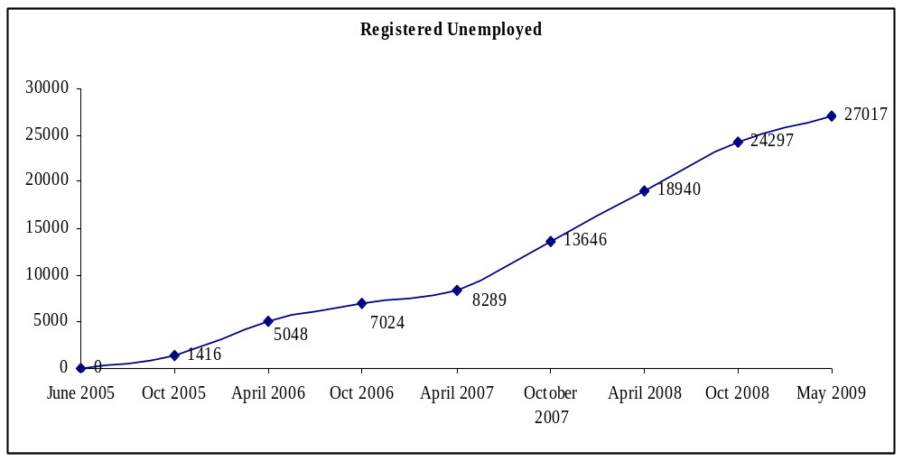
Job seekers with secondary education represented the largest group registered in the DEC (36% of total). Unemployed that never attended school represent the second highest group (17.6%), followed by unemployed that completed secondary technical education (15.2%), and primary school (13%).

Figure 30: Unemployed by Education Level
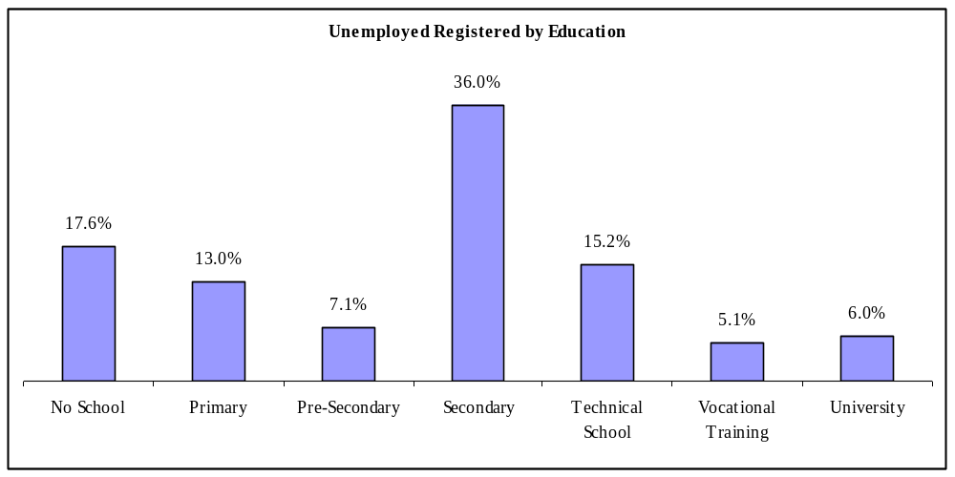
In terms of age, youth (15-29 years) represent by far the largest group corresponding to 64.8% of the total. The second largest group is represented by the age of 25-39 years (53.2%), followed by the age of 15-24 (33.4%).
Figure 31: Unemployed by Age
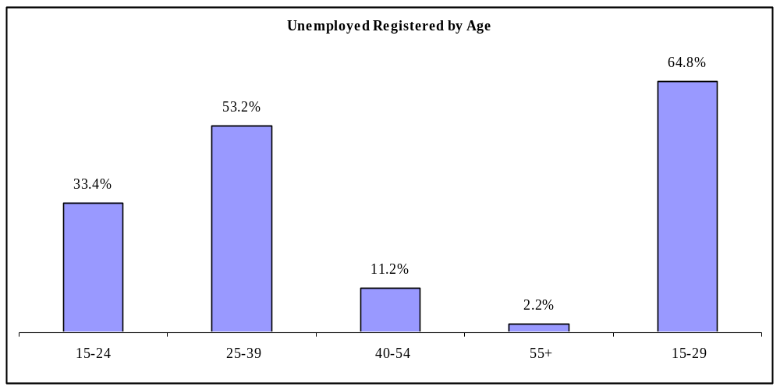
The percentage of women accessing the training and employment services and Programmes provided by the DEC of the SEFOPE, increased throughout the Project. The promotion of equal opportunities within the labour market is an unmistakable label of the STAGE.

Figure 32: Registration of Unemployed Females 2006-2009
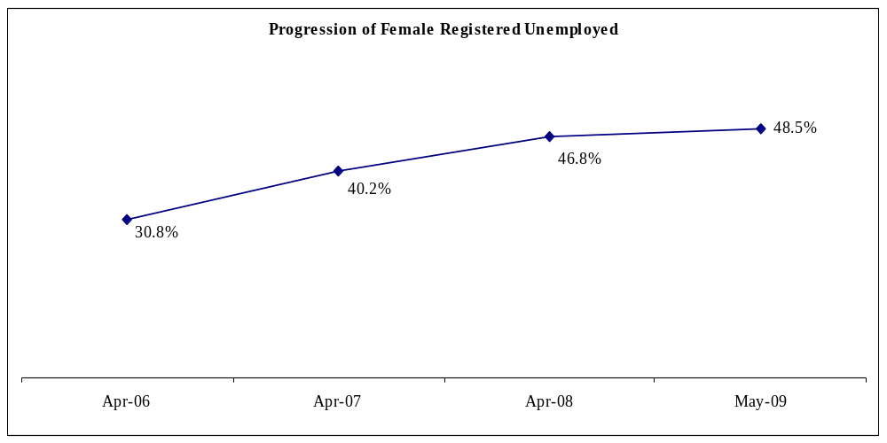

Activity U.2: DEC Placement Services (Employment Mediation)
A total of 596 registered unemployed (30.5% women) found a job with the assistance of the DEC. 31.9% of the job placements successfully mediated by the DEC were in Construction, 24% in Public Administration, 23.3% in the Services sector, 12.4% in Community Services/NGO, and 6.2% in Hotels and Restaurants. Other sectors offered very little employment opportunities as illustrated in Figure 33 below.
Figure 33: Employment Placement by Sector
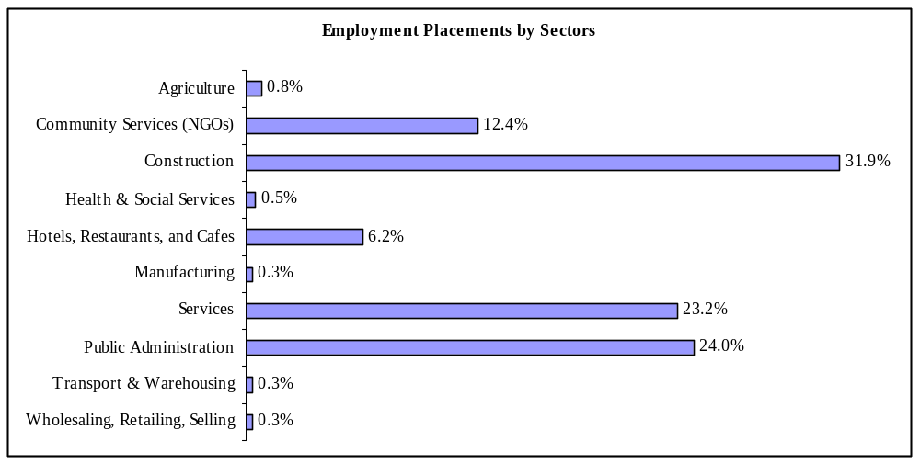

The highest number of placements was for unemployed with secondary education (34.7%), followed by job seekers that attended university (27.3%), and technical schools (14.6%). Graduates from vocational training represent 10.7%, while job seekers with primary school stand for 5.2% and with no school 5.0%. Registered job seekers which attended pre-secondary schools face most difficulties to access to wage employment jobs representing only 2.3% of the total.
Figure 34: Employment Placement by Education
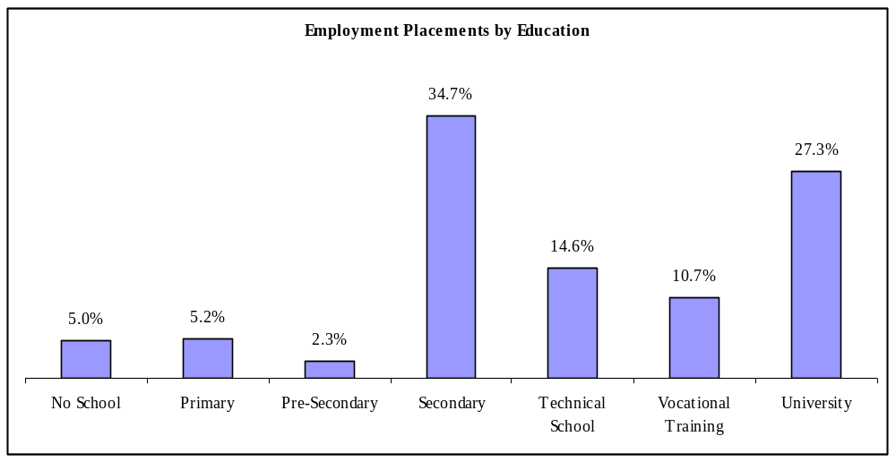
In terms of age-groups, close to 97 % of job seekers that found jobs through the employment mediation services of the DEC have less than 40 years of age. Of these, 63.3% were aged 25-39, and 32.7% were 15-24 years. Youth (15-29) represented 76.7% of the job opportunities identified by the DEC.
Figure 35: Employment Placement by Age
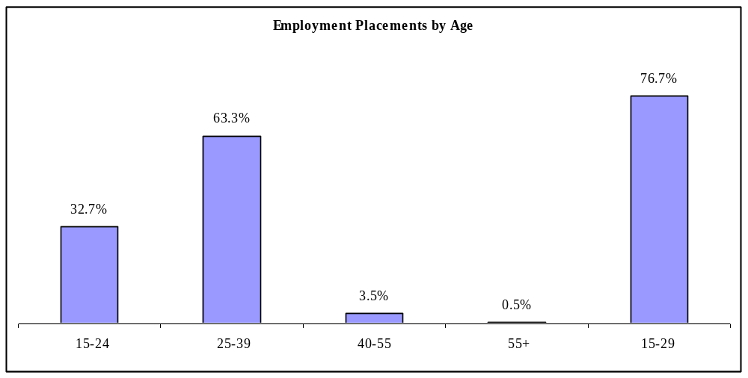
Women face additional difficulties accessing wage employment, and they represented 30.5% of the placements of the DEC. Nevertheless, the gap between male and female was significantly narrowed during the implementation of the STAGE. The percentage of women placed was 11.6% in April 2007, 29.7% in April 2008, and 30.5% in May 2009.
Figure 36: Employment Placement by Gender
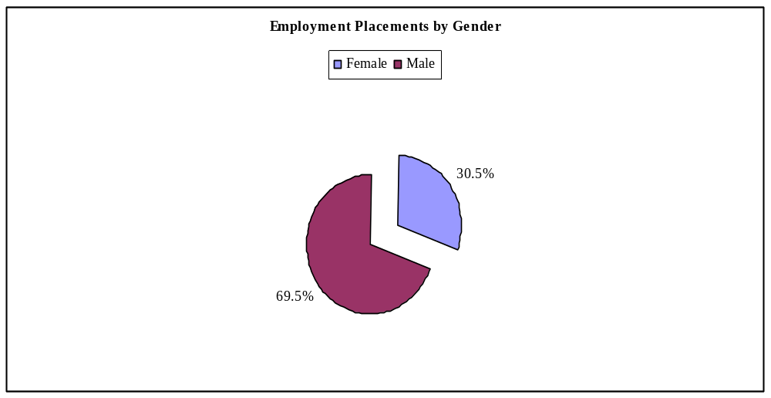
Women had significant participation in Community Services (50%), Public Administration (46.2%), Hotels and Restaurants (45.9%), Services (39.1%), and Health and Social Services (33.3%). Women were nearly absent in the Construction sector where large part of the jobs were concentrated. The 50% of women representation in the sector of Transport and Warehousing is irrelevant due to the very small number of jobseekers placed (2).
Figure 37: Employment Placement by Sector (female)
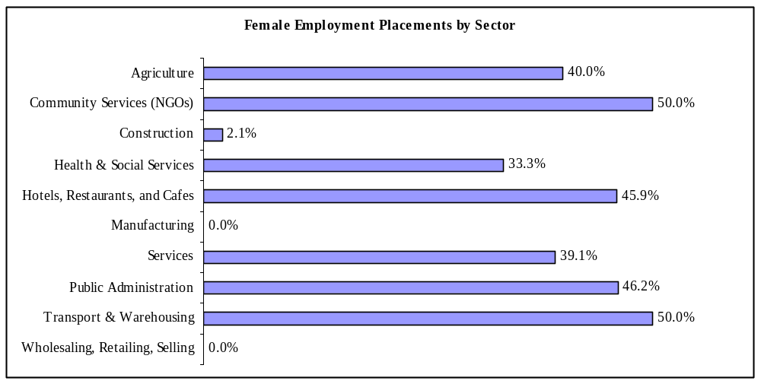

Activity U.3: Vocational Training
In cumulative terms, 1,923 particpants successfully completed vocational training courses. Details provided in Figure 38 below. Overall, the vast majority (70.7 %) of the participants in the vocational training courses have some secondary level education (Pre-Secondary 10.9%, Secondary 39.5%, and Technical School 18.3%). This might reflect maladjustment between the education system and the labour market and the consequent difficulties for graduates to access to jobs.
Figure 38: Skills Training by Area
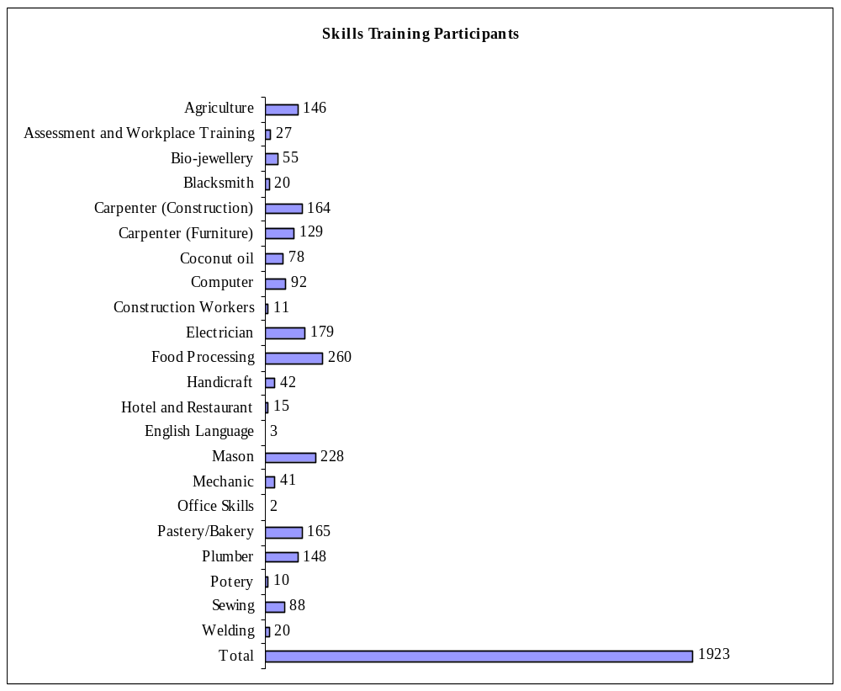

Figure 39: Participation by Education
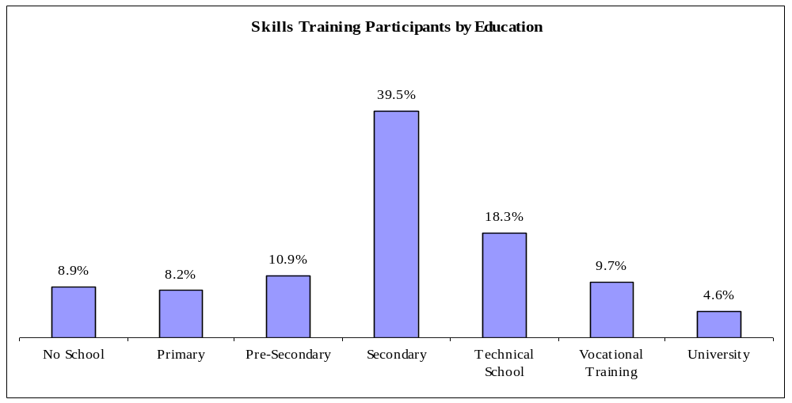
Skills training courses are particularly attractive to the youngest age group who are aiming to upgrade their competencies and enhancing their employability. The 15-24 and the 25-39 age groups are most represented at vocational training, representing 92% of the total.
Figure 40: Participation by Age

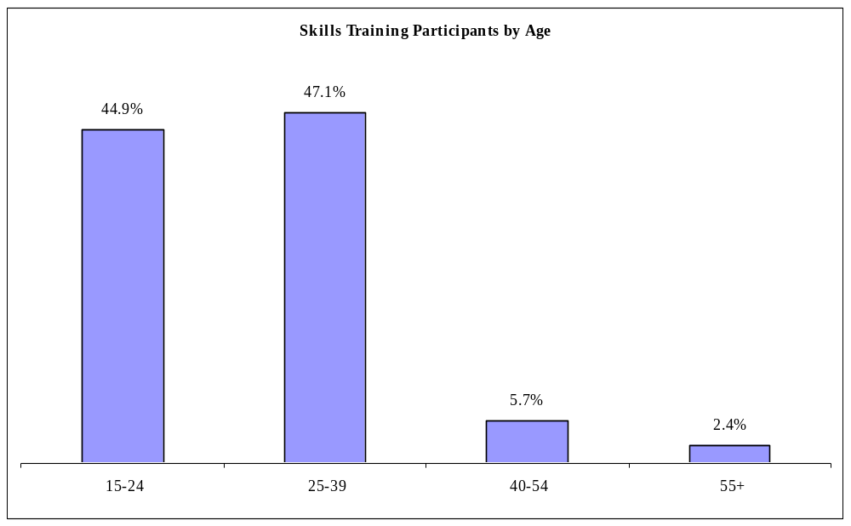

Figure 41: Women’s participation in Skills Training (2007-2009)
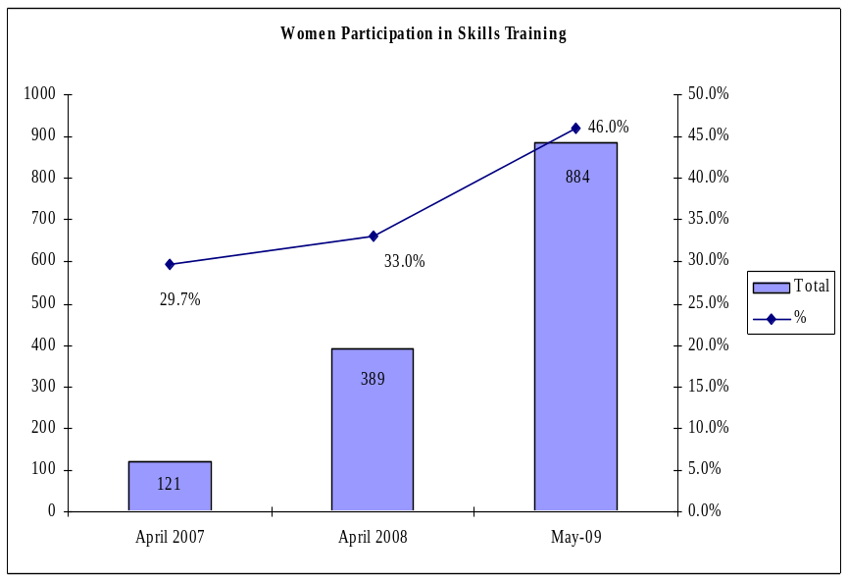
The participation of women in skills training improved dramatically during the last two years of STAGE implementation, reflecting the success of the new Programmes introduced and the improved performance of the implementing partners. The percentage of women enrolled in the courses increased from 29.7% in April 2007 to 46% in May 2009.
The overall improvement in women’s access to training opportunities was largely due to long term co-operation between SEFOPE and STAGE, particularly in identifying activities with potential for self-employment and development of short-courses and livelihood-based skills training interventions. It also reflects the expanded coverage of the Project and the continuous work of DNAFOP promoting and guiding the enhancing of the partner vocational training providers in the districts outside Dili.
During the last year of the Project, SEFOPE and STAGE supported the preparation and implementation of a number of new short duration skills training courses in the areas of handicrafts and food processing covering a broad range of different local products with high market potential.
The new skills training courses marked the start of the implementation of the STAGE self-employment proposal concept which promoted the development of local partnerships in which participants have access to complementary Programmes. This allows participants greater access to skills training, enterprise training and credit schemes, instead of individualised interventions.
Table 19 provides further details on the level of participation of women in training courses.

Table 19: Participation in Skills Training by Gender
Course | Female | Male | Total | % Female
Agriculture | 106 | 40 | 146 | 72,6%
Assessment and Workplace Training | 14 | 13 | 27 | 51,9%
Bio-jewelry | 24 | 31 | 55 | 43,6%
Blacksmith |  | 20 | 20 | 0,0%
Carpenter (Construction) | 20 | 144 | 164 | 12,2%
Carpenter (Furniture) | 24 | 105 | 129 | 18,6%
Coconut oil | 78 | 0 | 78 | 100,0%
Computer | 39 | 53 | 92 | 42,4%
Construction Workers |  | 11 | 11 | 0,0%
Electrician | 4 | 175 | 179 | 2,2%
Food Processing | 240 | 20 | 260 | 92,3%
Handicraft | 42 | 0 | 42 | 100,0%
Hotel and Restaurant | 15 | 0 | 15 | 100,0%
English Language | 3 | 0 | 3 | 100,0%
Mason | 3 | 225 | 228 | 1,3%
Mechanic |  | 41 | 41 | 0,0%
Office Skills | 2 |  | 2 | 100,0%
Pastry/Bakery | 156 | 9 | 165 | 94,5%
Plumber | 17 | 131 | 148 | 11,5%
Pottery | 10 | 0 | 10 | 100,0%
Sewing | 85 | 3 | 88 | 96,6%
Welding | 2 | 18 | 20 | 10,0%
Total | 884 | 1039 | 1923 | 46,0%

Activity U.4: Enterprise Training
In cumulative terms, 4,643 unemployed registered and counseled by the DEC participated in GYBI, “Business Game”, and SYB training courses organised by STAGE in partnership with CDE of the MoED. Courses made exclusive use of the training materials and methodologies developed and introduced by STAGE.
Figure 42: Participation Rates 2006-2009
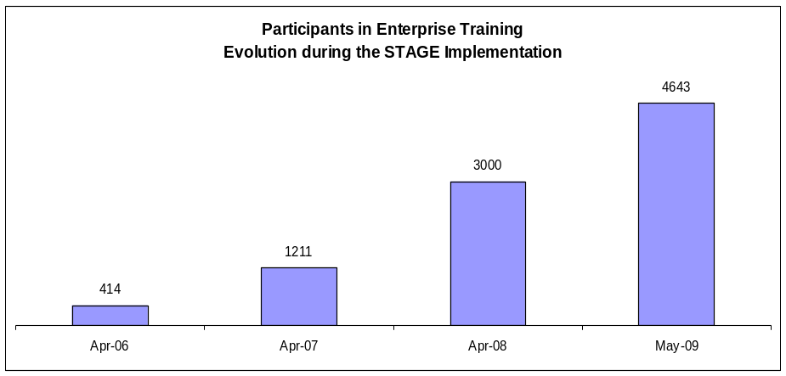
Most participants in the enterprise training Programmes never attended school (40.8%) or completed primary school (33.3%). Figures reflect the large participation of women (on average less educated than men), and more importantly, the predominantly rural environment of the areas covered by the courses. This educational pattern is clearly distinct from the one presented by the participants in the Vocational Training courses that. It also demonstrates that Programmes defined and implemented by the SEFOPE with the STAGE assistance are complementary, offering different products for different target groups.
Figure 43: Participation by Education
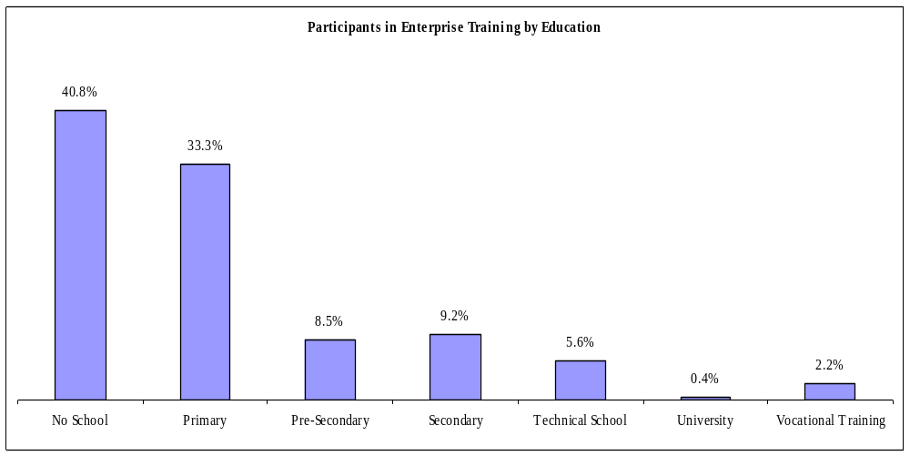
The 25-39 age group was the most represented (57.6%) at enterprise training, while the 40-54 age-group was the second largest (19.5 %). In comparison with the vocational training pattern, the participants in the enterprise training packages were significantly older.
Figure 44: Participation by Age
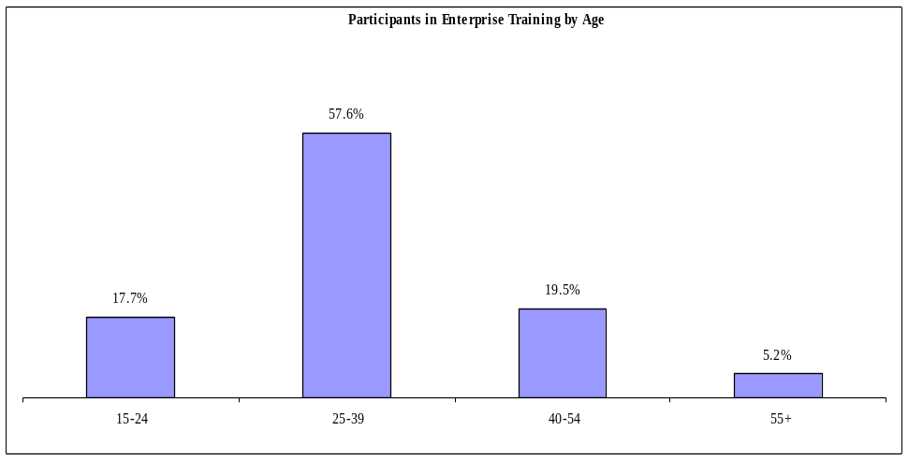
Women represented the large majority of the participants in the enterprise training courses (81.5%). This demonstrates the importance of the Programmes in promoting the start of income generating opportunities for this predominantly vulnerable group.
Figure 45: Participation by Gender
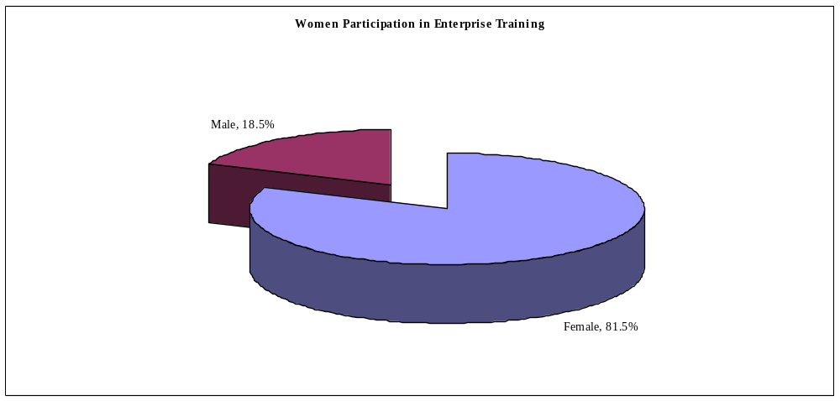

Activity U.5: Micro-Credit Schemes
Micro-credit schemes promoted by STAGE and implemented through selected partner MFI created both skills and business training and a decisive contribution for the success of the community empowerment component of the Project. In cumulative terms, during STAGE implementation 2,880 clients of micro-credits schemes initiated income generating activities.
Figure 46: Number of Micro-Credit Clients
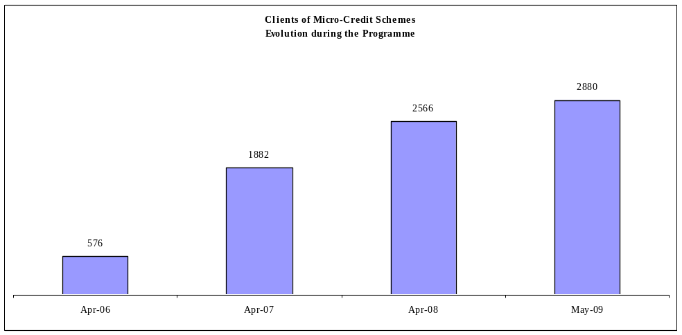
Micro-Credit clients had the lowest education levels of all participating groups. 50.5% of clients of micro-credit schemes never attended school, and another 27.37 percent just reached primary school. This frame was defined by three main factors:
- The predominantly rural context of the implementation of the micro-credit schemes;
- The older age of the participants; and
- High level of participation by women.
Figure 47: Micro-credit Participation by Education
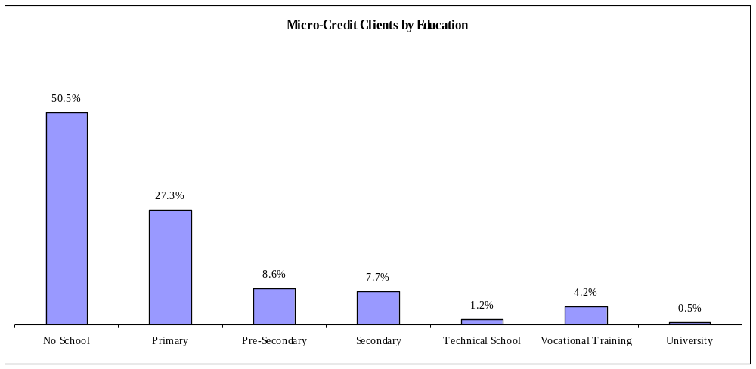
The characteristic RDTL education/age-group relationship, in which the level of education tends to decrease with the increase of the age of the population under consideration, is well reflected in the clients of micro-credit schemes. They are generally less educated and have the oldest average age.
Figure 48: Micro-credit Participation by Age
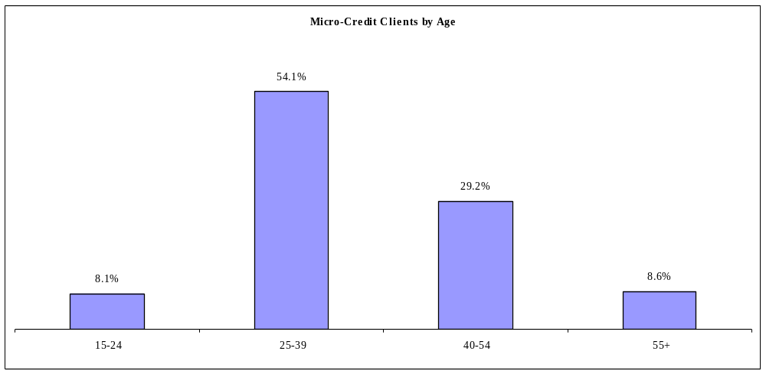
Women represented 99.5% of the clients of micro-credit schemes. They are considered by the MFI as a more reliable target group than men, and are more ready to start an economic activity with a very small loan.
Figure 49: Micro-credit Participation by Gender
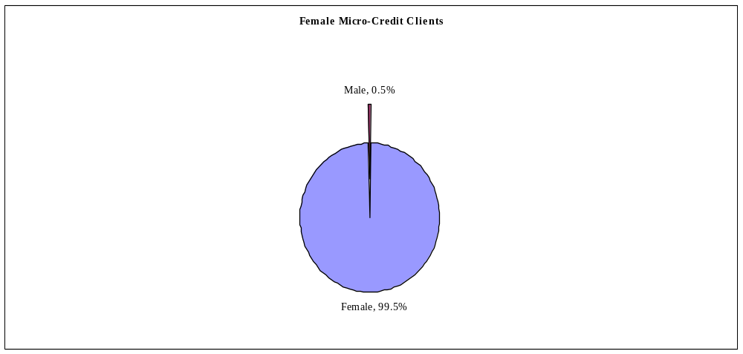
Wholesaling, Retailing, Selling (commerce) with 35.9% was the area in which most businesses were represented. Agriculture with 22.4%, Food Processing with 22.3%, Manufacturing with 10.6%, and Services with 7.5% were other sectors particularly explored by micro-credit clients.
Figure 50: Income Generation Start-up by Activity
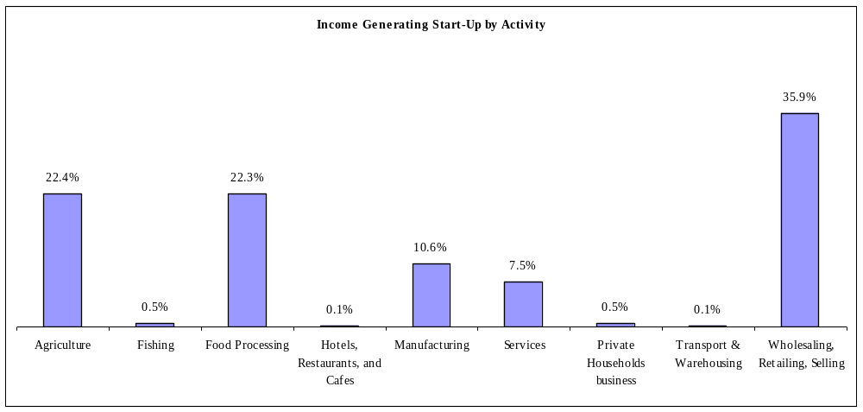

Activity U.6: Self-Employment Promotion Impact Assessment
STAGE completed a comprehensive impact assessment of the Project’s self-employment promotion component, surveying 188 clients (registered unemployed – training and job seekers) of the DEC and referred to local partner organisations operating in the field of self-employment promotion, namely, four business training providers CDE and three micro finance institutions (Moris Rasik, CCF-MEDI and Tuba Rai Metin). The report highlighted the contribution of the business development services and micro finance assistance provided to DEC clients in four districts of RDTL (Dili, Baucau, Bobonaro and Oecusse) and identified some specific recommendations to further improve the impact of the DESD/STAGE self-employment promotion intervention.
Of the 188 entrepreneurs interviewed:
- All benefited from CDE business management training or Moris Rasik, Christian Children Fund (CCF) and Tuba Rai Metin micro-finance services.
- 172 were in business at the time of the interview and 16 did not succeed in starting a business after the business training.
- 181 were women and 7 were men.
- The main findings of the impact assessment are presented in Annex H.

Activity U.7: Routine Monitoring
STAGE assisted SEFOPE in the establishment of a methodology for the continuous monitoring of implementation of proposals supported through EVTF. It involves staff of the Departments of Vocational Training, On-the-Job Training, Self-Employment Promotion, Labour Market Information and Gender Cabinet at the central level, as well as staff of the DEC.
The monitoring function is oriented towards the provision of continued support to the implementing partners, and it is initiated still in the phase of preparation of the proposals to ensure full compliance with the established criteria. All organizations submitting proposals to the EVTF are visited by SEFOPE teams, which have the responsibility to inform the EVTF Committee on the technical details of proposals and on the conditions of the organizations to implement them.
In the particular case of the MFI and their clients (unemployed registered in the DEC), the follow-up process involves collecting and crosschecking information from different sources, as follows:
- Quarterly reporting from partner MFI to SEFOPE;
- SEFOPE teams regularly monitor MFI clients, to assess their progress and difficulties as new entrepreneurs;
- As per the arrangements with SEFOPE in the context of the initiatives promoted by the EVTF, the CDE provide specific business counseling services to MFI clients (unemployed previously registered in the DEC);
- The repayment rate of the clients is included in Quarterly Reports.

The overall Repayment Rate of each Micro-Finance Institution is counterchecked through the AMFITIL (Association of Micro-Finance Institutions of RDTL) reports.

PERWL
Described below are the Project’s accomplishments as per expected results under each Project component during the reporting period.

Result 1: Women supported to run for local elections.

Women supported to run for local elections with increased understanding of their roles/functions and commitment to build capacity of rural women on transformative leadership.

1.1 Develop relevant training manuals and materials on transformative leadership, politics and communities and complete the adapted training manuals in Tetun and Bahasa Indonesia
The adapted training modules on transformative leadership for 3 days finalized by the Civil Society Capacity Building Foundation (CSCBF) with support from the Project’s pool of trainers were revised for printing, in Tetun and Bahasa Indonesia. Copies were distributed to development partners and the Secretary of State for the Promotion of Equality (SEPI). As the lead government partner of PERWL, SEPI provided support in the distribution, dissemination and in monitoring of its use through partners.

1.2 Assess the capacity of local NGO and networks to provide support to elected women officials and establish support structures at the national, local and community levels
The assessment of the capacity of local NGO and networks was continued through the national dialogue and workshops undertaken in 13 districts. Within the 1-day dialogue between national women leaders and elected women representatives in the suco council, a focused group discussion (FGD) was facilitated to enable the women leaders to review and assess the capacity and support being extended by NGO and other structures in the village and the district in general. FGD were conducted during the dialogue in 3 districts; Dili (2), Same and Liquica with a total of 174 participants representing the women council representatives.

National women leaders during the dialogue with women representatives in the suco council held in Baucau.
Figure 51: Women suco representatives in Dili during their FGD
Discussions determined that the strengths of the organizations providing support vary from their ability to provide training, technical assistance and funding for income generating activities, provision of materials for sports facilities, housing, water supply and sanitation facilities, provision of medicines and mosquito nets for prevention of malaria, provision of medicines and supplemental feeding for young children, pregnant and lactating mothers, to technical assistance for agricultural projects. The women leaders were able to realize the availability of these support, which they could maximize and explore other possible assistance from other existing structures particularly in support to their identified needs/problems in the community.

1.3 Organize bi-annual meetings, trainings, study tours and exchange visits
The Project aimed to increase the knowledge and skills of women suco leaders in improving/strengthening linkages with support groups at the local and national levels, through the implementation of a dialogue between national women leaders and women representatives from the suco councils. This dialogue was completed in 13 districts, with a total of 174 women leaders participating from the National Parliament, NGO (represented by Oxfam and REDE Feto), and the Ministry of Health.
The dialogue facilitated information sharing and clarifications on certain concerns and queries which were focused on:
- women leaders’ functions as representatives in the suco council,
- support to the needs of the women in the village,
- incidence of domestic violence,
- support from district, region and national levels of government to the needs of the people in the aldeias and sucos, particularly for women and children, and
- few issues related to the forthcoming presidential and legislative elections.
Moreover, through FGD, the elected women leaders were able to identify a number of ways to improve and/or strengthen linkages with national women leaders and list down the existing support groups in the aldeias/sucos and the districts. Please see Annex J: Summary of Impact of Leadership Training to Women 13 Districts.
As indicated in the work plan, the dialogue with women leaders in all 13 districts could have been completed by first quarter of 2007 but was delayed due to security problems. Schedules for implementation were already set with OPE, the National Directorate for Territorial Administration (DNAT) and the offices of the DA in Same and Liquica but were rescheduled to later dates following advice from authorities including the UNMIT Security Operations Centre (SOC) that restricted travel of UN staff members to these districts.

Result 2: Gender mainstreaming in the nation building process

Understanding, contribution of and benefits for rural communities, in particular women, on gender mainstreaming in the nation building process as a method to further promote transformative leadership, politics and communities enhanced.

2.1 Develop rights-based and gender responsive materials on key elements towards nation building
The packet of materials of rights-based and gender responsive civic education materials on the Constitution of the RDTL consisting of a 10-page illustrative flipchart, a facilitator’s manual and participant’s guide (all in Tetun) with a kit holder was finalized in July 2007. As indicated in the work plan, the finalization should have been completed by end of May 2007 but was extended since the presentation of the results of the pre-test of the civic education materials in Oecusse and Lautem was only held early part of June due to availability of Programme partners. Thereafter, a series of consultations were conducted to ensure the accuracy of the contents of the materials including the interpretation and accuracy of the provisions as reflected in the materials. The last consultation held by FTM and UNIFEM was with the team at the Office for Human Rights (OHR) under the Office of the Prime Minister.
It is important to note that activities under this component were aimed to consolidate the Project’s achievements under Component One that facilitated the promotion of the concepts and principles of transformative leadership. This component involves a capacity building initiative that partners and other relevant stakeholders should continue as part of their activities in support to women’s leadership and participation in nation building in the completion of the Programme.

2.2 Conduct 2 training workshops in the 2 pilot districts - Oecusse and Lautem using the materials developed and conduct pre-training workshop assessment and summative evaluation in the 2 pilot districts
The team presented its first draft of the civic education materials to partners in a series of consultation meetings including a pre-test with a group of 30 women held at the Women’s Resource Center at Alola Foundation, Dili. Substantive comments were received from partners that led the FTM team to make necessary corrections. The revised civic education materials were pilot-tested by FTM through a 1 ½ days in Oecusse in collaboration with OCAP on 16-17 May and Lautem on 24-25 May 2007 with a total of 71 women elected suco representatives. This continued collaboration with OCAP facilitated the follow-up support to the CAF and women members of the self-help groups from several sucos in the district.
Figure 52: Revised copies of the manuals (top photo) and Mr. Rigoberto Monteiro of FTM team during a presentation meeting with Programme partners.
During the pilot testing in Oecusse and Lautem, most women leaders were enthusiastic about the workshop and found it useful. It was an opportunity to know and discuss more thoroughly what the Constitution of RDTL is all about, its importance, its different parts and its relevance and use to their day-to-day life situation as citizens of RDTL. According to the women suco representatives, they were able to comprehend several of the articles due to the colourful and interesting illustrations as presented in the flipcharts and manuals but would have been better if the materials were prepared in their local dialects, for example Baiqueno in Oecusse and Fataluco in Lautem.
Figure 53: Female suco representatives in Aileu during the dissemination workshop held on 21-22 June 2007.

2.3 Revise and finalize developed materials based on feedback from the workshops conducted and recommendations from the PERWL Working Group
The FTM and UNIFEM facilitating team held a presentation workshop and series of follow-up meetings with Programme partners and relevant stakeholders to share what transpired during the pre-testing of the civic education materials in Oecusse and Lautem. On the basis of substantive feedback and suggestions received from partners, the FTM team revised and finalized the packet of civic education materials. A final follow-up discussion was held with the team at OHR to obtain further recommendations including strategies that will ensure effective distribution and dissemination of the materials. A thorough review of the text was carried out by the FTM and UNIFEM facilitating team to ensure accuracy and appropriateness of the language and illustrations used in the materials prior to submission for printing.

2.4 Launch and use the materials through the conduct of 4 training workshops in at least 1 district in each of the 4 regions and explore opportunities for its distribution to other institutions, groups (including men’s groups), NGO/CSO, etc. for further dissemination and promotion
Following the revision of the civic education materials on the Constitution of RDTL, a 2-day dissemination workshop was conducted by the FTM and UNIFEM team in at least 1 district in 4 regions including Bobonaro, Aileu, Manatuto and Baucau. The dissemination workshops were held during 21-22 June 2007 with a total of 172 women suco representatives as participants.
Based on the post-workshop evaluation and interview of the participants, several of the women highlighted that the workshop had enabled them to familiarize further with terms such as the constitution, articles, issues related to discrimination against women, women’s right to participate in politics, gender, equality, that men and women to exercise same rights and are at the same time subject to the same duties and obligations, etc. They have learned about citizens’ participation in political life and the right to petition. Some of the women participants were pleased to know that the Constitution guarantees the rights of the women particularly women leaders in the suco and the need for them to be part in all aspects of development of the suco.
In the submission of its project completion report, FTM included a suggested list of Programme partners that committed for to use or dissemination of the civic education materials in their activities.

Result 3: Government planning responding to rights of rural women

Contributed to government planning, Programmeming, policy development and budget allocation that is based on and responds to the socio-economic situation, needs and rights of rural women.

3.1 Prepare inputs to the first CEDAW State report and shadow report utilizing the preliminary findings from the baseline study
As earlier reported, a copy of the 1st report which is the preliminary findings as prepared by the Timor Institute of Development Studies (TIDS) was forwarded to OPE to enable the inter-agency working team that prepared the first draft CEDAW State report to review and identify possible aspects in the preliminary findings of the study that may be useful to the CEDAW report. The CEDAW draft report is yet to be presented, discussed and approved by the new Council of Ministers of the 4th Constitutional Government of RDTL that was formed in August 2007. The alternative or shadow report from the NGO started in 2008 and was completed in March 2009. The alternative report was presented to the CEDAW Committee in July 2009.

3.2 Finalize, launch and disseminate the baseline study results
The baseline study was completed by the TIDS team with technical support from an Economist/Gender Specialist, Dr. Lorraine Corner. As per work plan, the launch and dissemination of the baseline study report was not carried out as proposed due to delayed completion TIDS. In addition to the changes made on the focus and methodology of the study which was aimed at obtaining more qualitative results to highlight the impact of poverty on women as compared to men, the TIDS team had likewise encountered some internal institutional difficulties that contributed to the delay of finalizing the report.
Due to the delayed completion of the study, the launch and dissemination of the baseline study report were not carried since the Project had to end by July 2007. Considering the importance of the baseline study, it was proposed that the dissemination of the findings will be carried out by UNIFEM with Project partners, within the context of the Integrated Programme for Women in Politics and Decision Making (IPWPDM). As proposed, the results of the baseline study will be disseminated to members of the National Parliament, CSO/NGO and government and were made available for use. Please see Annex K: Baseline Study Report on Feminization of Poverty in RDTL: Deprivation of Women across Sectors.

Result 4: Project management

Project staff recruited and Programme Steering Committee (PSC) fully operational and others.

4.1 Recruit a communications expert to provide support on the dissemination and advocacy campaign for Components Two and Three and continued visibility of PERWL
On the basis of the recommendations in the PERWL communications strategy aiming at increased visibility of the Project and its donors and to promote and increase political participation for both Timorese women and men, the PERWL in collaboration with IPWPDM, had produced and installed 70 campaign billboards in 65 sub-districts in RDTL (1 in each sub-district and additional 5 units in Dili). The campaign billboards were installed by DNAT through its district and sub-district administrators with the commitment that they will monitor the billboards designating the Community Development Officers (CDO) to be directly responsible.
The Radio Lorico Lian (RLL) was likewise engaged in the production of 7 episodes of investigative radio documentary on the experiences, challenges and contributions of Timorese women leaders at the village and sub-district levels. The episodes that will be aired through the community radios in 13 districts were aimed towards the continued promotion of the roles, challenges and contributions of the women leaders in the development efforts at the aldeias/sucos. Finally, CAMS RDTL (CAMSTL) was selected by a Panel composed of representatives from Project partners, to produce the video documentation of the successes of PERWL. The video documentation consists of a 10-minute film in English (with Tetun sub-title) intended for donors and international audiences and a 30-minute film in Tetun (with English sub-title) for Timorese audiences to learn from and continuously promote and advocate the importance of political participation, particularly by women in the rural areas.

4.2 Conduct of end-of-Project evaluation and final audit
The PERWL final evaluation was completed by an external team of experts (2 international and 1 national) in July 2007. The assessment focused on the outcomes of PERWL as per the Project documents and the potentials of PERWL to make impact and draw lessons from its completion for further Programmeming and policy making. The evaluation looked into several areas of the Project including its relevance, appropriateness and feasibility, efficiency, effectiveness, effects or impact, sustainability and lessons learned by the Project. The team’s initial findings and recommendations were presented by the evaluation mission team to the PSC during its meeting held on 30 July 2007.
In summary, the findings of the end-of-Project evaluation indicated that in terms of effectiveness, PERWL has contributed to development of community initiatives and projects, towards women’s networks working to advance their role, had changed attitudes of women: rights & knowledge to participate and the Project has managed to complete a research that is aimed to engendered rural development Project and policies. On efficiency on the other hand, the evaluation reflected that PERWL had adopted certain management modalities that are inconsistent between donors, executing and implementing agencies, the PSC has a diverse membership that led to mutual capacity building and learning, with some national partners being weak in management and reporting. The Project needed to have clearer guidelines and improvements have to be made on coordination within and among government partners.
In terms of relevance/feasibility, the evaluation reflected that PERWL had complemented the affirmative action statute in the Election Law and the implementation of initial Project activities was strategically in time with the first suco council elections. The concepts and principles of transformative leadership were acceptable and understood by Timorese. In addition, the evaluation reflected that the Project budget was too limited to achieve goals with an overall too ambitious Project and the potentials for synergy with the RDP package were lost.
With regard to sustainability, PERWL has worked through national partners to build capacity and ownership, some NGO partners learned regarding management and Programmeming but it is not clear if Project priorities will be replicated. PERWL has selected strategic partners but too many efforts were required to reinforce or strengthen their capacities adequately. The NGO and government partners lacked coordination and communication capacity effectively to undertake tasks. In addition, it is important to note that the changing political leadership and crises impact Programme understanding and mitigate Project goals.
Following the final evaluation of PERWL, a Project terminal report was drafted and presented to the PSC in its meeting held on 30 October 2007 for approval. The PERWL Final Evaluation and PERWL Terminal Report were provided with the 7th progress report.
A medium term audit was conducted in April 2007 which was carried out by an external auditing firm, Lochan & Company based in India, amongst other UNDP projects. The audit results were finalized and shared with EU.
A final audit of PERWL has also been carried out in January 2008 to cover the remaining Programme period beyond what was covered by the mid-term audit. The findings of the report have been shared with EU in April 2010.

4.3 PSC meetings convened on a quarterly basis and agreements made carried out
A meeting of PSC meeting was held on 30 July 2007 with the presentation of the initial findings and recommendations of the PERWL end-of- Project evaluation by the evaluation team.
A final PSC meeting was proposed to be conducted by middle of August but did not materialize due to the change of the Advisor to the Prime Minister at OPE. The then Advisor at OPE was no longer available until the new constitutional government of RDTL announced the upgrading of OPE to Secretary of State for the Promotion of Equality (SEPI) and the new Advisor as Secretary of State. The final PSC meeting was held on 30 October 2007. The agenda included the review of the PERWL exit strategy and formal handover of Project assets and outputs of PERWL to SEPI and other partners, review of the lessons learned of PERWL and approval of the PERWL progress report for the period May-July 2007 and the PERWL Terminal Report.

Lessons Learnt and Challenges
This section contains a summary of the significant difficulties encountered by each of the Projects, and the lessons learnt from these that will improve UNDP implementation capacity and EC Programme design in the future.

Overall Programme
Design of RDP: Four disparate components were packaged as one Programme without a sufficient overarching rural development framework. A key lesson for future Programmes is to develop an overall strategy and framework to derive synergy prior to implementation.
M&E: A key to measuring the impact of interventions is to have a sound baseline study and clearly defined indicators. In the absence of such a baseline the assessment of impact of RDP was largely based on anecdotal evidence. A lesson learned is to spend considerable time before starting the Programme on building strong M&E systems, including baseline studies.
PSC of the whole package: Since the Rural Development Programme was designed as a package it should have been managed as a package to forge synergy among the four different components. There should have been a higher level Steering Committee or Programme Board, in addition to PSC for individual components, for the entire package to ensure linkages and synergy among them.
Delayed Communication: The many layers of implementation hampered smooth communication among the stakeholders, particularly for urgent important decision making and donor reporting. A simpler, single-agency implementation mechanism may have reduced these issues. Future Programmes should clearly set out their communications plan in advance of implementation.

AIM
Force Majeure – a critical challenge: a critical challenge to the project occurred in August 2007 where after the announcement of election results the communities in Uatu-Lari engaged in civil unrest resulting in burning of houses and properties. This event caused demobilization of the construction workers from the Project site and interrupted the on-going construction activities. This was considered a force majeure and the additional cost was funded by the government of RDTL. A lesson learnt is to inform the government during finalization of contractual arrangement that it is the government that bears the responsibility for force majeure. It is also necessary for risk assessments to incorporate unintended Project risks.
Pre-Feasibility study: A pre-feasibility study is essential to determine social and economic expectations prior to implementation. Without a pre-feasibility or a baseline study, it is difficult to determine economic benefits from this Project.
Government’s capacity building: The government has demonstrated a strong commitment to this project by shouldering additional funding gaps. The government should have been more closely involved for transferring capacity to MOI on tendering and contract management.
Difficult work conditions: difficult terrain and consequent delays in mobilization of labors and machines and also flash floods posed additional challenges in timely completion of AIM bridges. Project design should anticipate these delays more thoroughly.

OCAP
Management of expectations: It is important to formulate a well-thought out socialization and communication plan at the beginning of the Project. It is equally important to ensure that this message is reinforced throughout the Project duration.
SHG: The formation and strengthening of SHG as an approach to community activation is not a uniform process and varies from context to context. Whilst working to strengthen the capacity of the groups, care must be taken to gauge their progress so as to remain responsive to their needs.
SHG and social capital: Supporting SHG members to set up and maintain their own savings and credit schemes has proved to be a very effective mechanism to build group coordination and solidarity as well as contributing to solidarity amongst the wider community as witnessed by many groups extending loans to community members not participating in the group.
SHG and traditions: At all stages throughout project design and implementation, it is important to take into account pre-existing local structures and traditions. This is of particular importance in Oecusse where very strong traditions exist with traditional leaders with capacity to have considerable impact on the success or failure of a Project. At an early stage, the OCAP team recognized the primacy of family linkages in Oecusse and was able to adapt the Self Help Group model from India to take account of the local context.
CDF: The CDF mechanism has proven very successful in bringing communities together not only at the initial stage of the process to identify and prioritize their needs but also after the project has been completed to ensure the continued maintenance of the community based infrastructure.
Volunteerism: Getting community participation and contribution, and promoting in them a spirit of volunteerism for their own benefit, can sometimes prove to be very challenging in particular when relief operations are taking place simultaneously. It is probably more desirable to pay for the community labour rather than use it as voluntary contribution as in CDF projects.
Communications with government: In a long-term Project of this type, it is essential to maintain clear lines of communication at all times with government departments. Extra effort is required in particular when there is a change of government and therefore personnel in the counterpart ministries.
Flexibility: The importance of remaining flexible to address the needs of individual SHG also emerged during the implementation of OCAP.
Savings and Credit activities: A key lesson learnt was the positive impact savings and credit schemes can have on group and community solidarity besides addressing their immediate financial needs for consumption and production purposes.
Multiple Objectives: OCAP turned out to be an overburdened project trying to do many things in a given area within limited resources (financial, technical and human). It would have been more effective for OCAP to address only a few selected priorities.
Difficult work environment: The project worked in an environment where communications and transportation connections are not only limited but at times absent. This delayed processing of payments among others. Recruitment and retention of personnel also was another difficulty encountered by the project.
Gender Awareness: Despite extensive training by the gender adviser, it seemed that CAF did not fully recognize the importance of gender balance and lacked gender awareness. The importance of gender was stressed at all times and once the gender adviser’s role was phased out, the CDF coordinator and Deputy National Project Manager, ensured that this issue remained live. Throughout the project, it was witnessed that at community meetings women tended to sit at the back of the assembled group allowing men to occupy centre stage. However, gradually women became more vocal and their active participation in District level events arranged in Oecusse towards the end of the Project was evidence that there has been some improvement in their perception of themselves.
COA: One of the main constraints OCAP faced was the slow progress that was made on the economic status of Oecusse and particular on the border question. Successes that were registered with COA and cattle fattening groups continue to be tempered by the ongoing lack of access to markets outside of Oecusse. Illegal sales do nevertheless continue across the border, and the prices realized from such sales remain as an incentive to continue production. However, the risk involved here is unacceptable and efforts continue to be made to regularize the situation for the many farmers engaged in livestock rearing in Oecusse.

STAGE
The STAGE Project encountered few challenges in implementation, though the following recommendations are made for consideration in developing future Projects:
Implementation: Too many layers of implementation hamper results, as can be seen in the complexity of the STAGE Project. In future, implementation should be kept simple, and strong communications plans should be developed in advance of implementation.
M&E: Thee frequency and quality of M&E should be improved in future, both as a Project and as part of the overall Programme.

PERWL
Transformative Leadership: A major lesson learned was that TLPC (Transformative Leadership, Politics and Community) methodology based on experiential learning has significant potential to change attitudes and should have been disseminated more widely.
Prior Preparations in Districts: Delays in implementation in the districts taught us that prior preparation in the districts is essential. With each Programme partner, an implementation plan was drawn up to ensure that project activities related to the engagement entered with them are carried out vis-à-vis objectives set for the project.
Communication: Some project partners were not able to submit both narrative and financial reports on agreed dates. This meant that follow-up arrangements had to be made to ensure that reports were submitted as required along with the necessary supporting documents. It is recommended that future Programmes develop detailed communication plans prior to implementation.
Underestimated demand for services: It appears that the project did not anticipate that there would be high demand for the capacity building activities offered by the project. UNIFEM has therefore built TLPC tools in their subsequent Projects.

Sustainability

AIM
The responsibility of bridge maintenance and construction of the access roads to these bridges has been taken over by the MoI. This decision will ensure the sustainability of the use of these bridges. Project assets and facilities were also transferred to the Ministry to enhance the capacity of the Ministry in providing continuous monitoring and maintenance of the bridges.
The MoI has allocated funds for the maintenance of bridges on yearly basis which includes the five bridges built under AIM Project. The ministry has also allocated funds for construction of national roads that will include roads leading to or passing through these bridges that have been built.
The hand over of project assets to the government will enable the government to continue doing the regular inspection and maintenance of the bridges. The staff of the department of Roads and Bridges within the ministry has been, in the past, engaged in the joint field visits and inspection conducted by UNDP and UNOPS.

OCAP
Asset handover was completed on May 13th 2009. Prior to asset transfer, every effort was made by OCAP PIU to ensure that the SHG, who have reached a degree of maturity, would be facilitated to continue on their path towards full maturity. In this regard, concurrently with the physical transfer of assets, the Ministry of Agriculture, as the main government counterpart and therefore recipient of OCAP assets, was presented with a proposal from FEEO, a local foundation set up to continue working to ensure OCAP achievements with the SHG are sustained and built upon into the future. Since this time, MAF has agreed to provide its assistance and both office space and transportation have been secured in order to ensure that continued work can be done in order to maintain this essential element of OCAP.
In terms of the agricultural activities carried out under OCAP, the recruitment of CAF in the position of MAF extension workers has helped to ensure that their knowledge gained whilst working under OCAP can now be applied to benefit MAF as it is adopting similar approaches e.g. Participatory Block Demonstrations, seed multiplications, slash and mulch, cattle fattening and others. For example, during three months of on-the-job training conducted by MAF, the former OCAP staff members demonstrated the strength of OCAP approaches. In particular MAF found the formation of community groups to be very important in order to facilitate the introduction of new agricultural skills in Oecusse and over the final months of OCAP, MAF extension workers were often present at SHG meetings. Indeed, a MAF representative noted how during 2009 the former CAF skills in community mobilization were already proving to be of much benefit to MAF as it goes about gathering detailed information for submission along with its request for its 2010 budget. He also noted that successes under MAF for example with PBD and PVD as well as challenges for example with King Grass production were being taken on board by MAF in the development of its approaches.
The status of the border with West Timor remains a concern. It is essential that work conducted over the course of and with support from OCAP be accelerated. This is of particular concern to the individual farmers that have been involved with OCAP. Although investing in fattening cattle remains profitable for them, the risk involved in illegally selling over the border is a constant threat to them. The ETAZONE team should aim to capitalize on the momentum created by the attendance by 200 people of the workshop organized by OCAP between 12th – 14th May and work without delay to convince on the Council of Ministers to prioritize the passing of a Law on the special status of Oecusse including detailed provisions on Oecusse’s economic relations with Indonesia.
In view of the importance of the cattle economy in Oecusse, the proposal to discontinue this activity (due, among others, to absence of legal cross-border market) was not accepted by PSC chaired by MAF (MAF were supporting cattle fattening activities). All cattle-fattening facilities have been handed over to MAF for sustainability. It is our view that unless cross-border trade is legalized, cattle-fattening has rather limited future. Illegality of cross-border trade also prevents interested agencies from investing in improvements in facilities (such as hygienic slaughter houses, cold storage etc). The solution lies in negotiation between Indonesia and DRTL, clearly beyond the scope of this Programme.

STAGE
Sustainability of STAGE was ensured through the establishment of institutions and systems that have been adopted by government counterparts.
The achievements of STAGE in terms of national capacity are impressive. The number of direct beneficiaries and jobs created give a solid evidence of the ability of SEFOPE and the training providers to provide relevant employment services to the community. As SEFOPE is expanding its geographical scope, the impact of STAGE investment will continue beyond the project dates.
In order to further strengthen the national capacity, it is important to ensure that SEFOPE is able to create the DEC in all 13 districts. SIMU functionalities will need to be strengthened so that SEFOPE officials can regularly monitor labour market conditions, appraise the effectiveness of the services, and adjust intervention approaches.
As the RDTL economy will continue to grow, existing employment services will need to expand in scope and sophistication. New services and Programme aiming at improving existing businesses should be added to the portfolio of training providers. For vocational skills training, STAGE has created a good start for a systematic approach to national skills development framework. The INDMO will continue to set up a certification system and national skills standards. Cultivating the capacity of training providers to deliver skills training that meets national standards by qualified trainers will take time. Extensive investment and intensive technical assistance are critical.
STAGE was the only provider of legal advisory services to SEFOPE. A legal office has been set up. Four (4) core ILO Conventions were already ratified by the Government of RDTL, and other ratifications will be realized shortly. The national labour code is under review. Resources will have to be identified to assure that SEFOPE has the ability to apply and enforce labour and employment laws.
In addition, the RDTL private sector remains severely under-developed and many challenges and constraints continue to hamper its sustainable growth and development. Most consumer products are imported, which is a major limitation to the development of a local manufacturing industry. Few enterprises are able to identify and seize business opportunities and access markets, and there is a generalized lack of access to finance, high-end business management training and counseling, investment capital, information, technology, product design and other types of business development services (BDS) that would enable the growth of the SME (Small and Medium Enterprise) sector. Finally, local enterprises have little access to representative organisations that can lobby and access resources and business inputs for their members.
The Timorese Government attaches great importance to developing a vibrant private sector in the coming years through increased domestic and foreign investment, with a particular focus on the area of rural infrastructure, where Timorese contractors will play a key role in the years to come. The Government of RDTL understands well that private sector development is a critical engine for growth and poverty reduction and has started a major effort to improve the business enabling environment through the issuance of a number of proactive policies and regulations, such as the Investment Law, currently under discussion at the Council of Ministers, which will represent the milestone of the reform of the IADE (Institute for Support of Business Development).
In this framework, Timorese Employer Organisations urgently need to build their capacity to provide quality services to their members that require more advanced management skills to be able to consolidate and expand their businesses contributing to the sustainable development of the RDTL private sector, the progress of the economy, the creation of employment and poverty reduction.
Against this backdrop, real need/market-orientated strategies and instruments have to be put in place and the main partners involved in the process of private sector development must operate in an integrated and coordinated manner. A real challenge will also lie in strengthening the ability of rural communities to seize new economic opportunities and translation of growth towards sustainable social development. Relevant public and private institutions will require further support as they strive to deliver need/market-oriented services to entrepreneurs of varying sizes and individuals with different vulnerabilities. An effective coordination and alignment of private sector initiatives with public sector development is an essence of a “private-sector-sound” rural development strategy in the context of RDTL.

PERWL
A review of the Project exit strategy was carried out during the final PSC meeting held on 30 October 2007 led by SEPI as the key main government partner of the Project. The formal handover signified the acceptance and commitment of the PERWL partners towards the sustainability of the Project e.g. continued promotion and advocacy of the concepts and principles of transformative leadership, politics and communities, the strengthening of the role of women leaders in the suco councils, continued dissemination of the rights-based and gender responsive civic education materials on the Constitution of RDTL, the dissemination and advocacy of the findings of the baseline study on the situation of the rural women in the country focused on feminization of poverty amongst others. In addition, follow-up activities will also be carried out in the context of the initiatives undertaken under IPWPDM and working with almost the same set of partners including SEPI and Caucus.
The PSC, during its final meeting held on 30 0ctober 2007, decided to handover the Project’s assets to Caucus: Feto Iha Politica, a national NGO on women in politics, considering the role of this national NGO on initiatives in providing support to women’s political participation and its continued activities that are being supported by REDE Feto and UNIFEM through its other projects including IPWPDM.

Coordination

Coordination and M&E Framework of EC-funded Rural Development Programme Package
In order to ensure adequate coordination, quality control and reporting, a common M&E framework for all the four Programmes, OCAP, AIM, STAGE and PERWL, is established.
In the coordination mechanisms established by UNDP for the overall Package and the coordinating role UNDP has played through the present mechanism.
An inter-agency coordination group consisting of ILO, UNIFEM and UNOPS had been set up under UNDP leadership to ensure coordination, cooperation and synergies among the Programmes. UNDP coordination role has been essential in ensuring that national counterparts are fully engaged in Programme management. UNDP has provided constant guidance to the Programme Management Units throughout the implementation process and liaised with the respective Programme Steering Committee chairs to resolve policy-level bottlenecks.
A common M&E and reporting framework was established as requested by EC at the finalizing stage of the Programmes and it was agreed by EC and all the executing agencies that the M&E framework was financially supported by the four Programmes on a pro-rata basis, i.e. the proportion of their annual budget to a combined total. This arrangement was discussed and agreed between UNDP and the executing agencies with endorsement of the government counterparts before the signing of the Contribution Agreement.
Under the M&E framework, the EC Programme Coordinator (UNDP ARR of Programme Unit) is being assisted by the Planning and Programme Support Unit (PPSU). UNDP also appointed Programme Officers for each of the Programme components to play assurance role. As a result of the coordination work done by UNDP, The periodic report was substantial and standardized. These reports documented project implementation progress, lessons learnt, best practices and explored synergies where possible to be build with the Programme and with other relevant UNDP initiatives in the country.
Meanwhile, some short-term consultants were recruited and deployed to focus on various demands of M&E for each individual project and complement on coordination, quality control and reporting by UNDP.
At the inception stage, an M&E Specialist, assisted by a national M&E associate, helped each component establish a common M&E framework with comprehensive sets of output indicators with technical assistance from a M&E consultancy mission (Mekong Economy in mid-2006).
In the second phase since then to the end of 2006, UNDP recruited an M&E specialist together with the national M&E associate, to help each component to pilot the M&E framework, regularly monitored progress through field visits and reporting, and provided trainings to project teams in the field to use the framework. However, this work was severely hindered by the 2006 crisis and its aftermath. The M&E specialist could only travel to Oecusse after the crisis to conduct trainings and field visits.
Following the recommendations of the EC MTR, UNDP adopted the strategy to deploy respective M&E specialist with specified terms of working for each component in order to strengthen M&E and make preparation for the final evaluation at outcome level by the end of the Programme.
One M&E specialist each was recruited for OCAP and STAGE in Dec 2007 and Feb 2008 respectively working two months each with the project teams to review the indicators system in particular at outcome level and the availability of baseline data and progress data and further trained project teams on M&E.
No additional M&E consultants were recruited for AIM as the supervision company was charged with regular monitoring of construction. UNDP and UNOPS have conducted the first-phase of impact assessment of AIM in 2008 and the final-phase in 2009 after completion of the project. The final assessment report can be found in Annex L.
All the details and mission reports of the above-mentioned M&E activities were shared with EC with the regular Programme progress reports.

UNDP Control on Operations and Finance

Budgeting
Budgets are set up based on budget approved by EC. In the beginning of the project cycle, each respective agency opened initial budget and on annual basis are requesting budget revisions based on annual work plan. Revisions are approved by UNDP only within budget approved by EC. Expenditures are monitored against the approved budget. If any expected over/under spent for more than 15% between budget headings, request for budget addendum is sent to EC. In the Programme period, four addendums were approved by EC.
Each calendar year, Combined Delivery Reports (CDR) are generated by UNDP as internal reporting corporate requirement. All financial reports submitted by agencies are compiled into consolidated reports and reconciled to UNDP General Leger. Semi-annual and annual Programme progress and financial reports signed by Country Director are sent to EC in accordance with the contract.
Table 20: Quality Control Checks undertaken in Signing Reports
Personnel / role | Checks performed
Project Manager / Agency | Preparing progress and financial report as per approved EC Action.
Programme Officer / UNDP | Reviewing progress report : Programme part
Programme Coordinator / UNDP | Verifying progress report: Programme part
PPS Unit / UNDP | Reviewing report and ensuring consistency between financial and technical reports
Finance Unit / UNDP | Reconciling financial report to UNDP General Ledger
Deputy Country Director / Operations | Verifying reports
Country Director | Reviewing and approving reports

Programme Implementation
Figure 54: Flowchart Demonstrating Programme Implementation Responsibilities
UNDP as Overall Coordinator
PERWL
Programmeme Implementation Unit
(UNIFEM)
AIM/OCAP
Programmeme Implementation Units
(UNOPS)
STAGE
Programmeme Implementation Unit
(ILO)
Assistant Resident Representative

M&E Officer
Regular Programmeme Steering Committee and Programmeme Working Committee meetings and interactions with stakeholders
Regular Programmeme Steering Committee and Programmeme Working Committee meetings and interactions with stakeholders
Regular Programmeme Steering Committee and Programmeme Working Committee meetings and interactions with stakeholders
UNDP Prog. Officer
UNDP Prog. Officer
UNDP Prog. Officer
Senior Management
European Commission
Government of RDTL
UN agencies and EC: On top of regular interaction through PSCs and PWCs, semi-annual coordination meetings will be held and progress and financial reports will be submitted.

Government, EC and UN agencies:
On top of regular interaction through PSCs and PWCs, annual joint review meetings (including WB and IOM) will be held.

Visibility

Overall Programme
All Projects included in this Programme followed the requirements for EC visibility as set out in the funding agreement, including:
- EC logo prominently displayed on all Programme vehicles and in all reports and banners related with meetings and workshops organised by the Programme.
- EC logo prominently displayed in all manuals and documents published by the Programme.
- EC funding support acknowledged in any UNDP presentations, media relations et cetera in RDTL about its work.
This section highlights those additional initiatives for EC visibility undertaken through this Programme.

AIM
Marble plates are positioned at either side of each bridge.
Figure 55: Example of the Marble Plates Positioned at Each Bridge

OCAP
The UNDP Communications Officer conducted a field visit to OCAP From the 24th to 26th of October 2007. Subsequently, the article RDTL: UNDP offers new beginning to survivors of ‘Black September’ was highlighted on the UNDP Home page in the UNDP around the World section on October 31, 2007. This article also featured on the Relief Website on November 5, 2007. The article mentions the EC by stating, ‘the € 3.3 million EC funded five-year project which ends in 2009 emphasizes on building institutions for the poor.’
Another article announcing the OCAP Vegetable Field Day was printed in the RDTL national newspaper, Suara Timor Lorosae on October 22, 2007. During the Oecusse cultural festival, OCAP assisted mobilize local communities from selected villages (particularly women) to showcase their agricultural products. The Project covered the cost of transportation of villagers to this event.
The visibility of the CDF component of OCAP has been ensured by the fixing of permanent plaques at each of the project sites throughout all four sub-districts. All plaques are now in place and clearly state the involvement of the EC.

STAGE
The EC logo was prominently displayed in the SEFOPE calendars included in the overall media campaign to promote the employment and vocational training services; EC funding support acknowledged in any ILO presentations, media relations etc. in RDTL about its work; and EC Representatives in RDTL regularly invited to participate in the initiatives of the Programme, like National Workshops (Vocational Training Directors and Competency-Based Training), enlarged Consultation Meetings for policy preparation, (National Employment Strategy), and public presentation of studies (Training Providers Reviews, Impact Assessments, YES findings).
A UNDP article regarding the STAGE Project (Annex M) appeared on the UNDP website, was cross-posted to other sites including, the UNDP Regional Office website and the Humanitarian Action Report, among others. The full Tetun version of the story also appeared on page 7 of the Timor Post newspaper, dated 14 May 2009.
Moreover, STAGE worked with local implementing partners to review the EC visibility tools put in place, and to ensure an EC visibility lasting effect beyond the life span of the Programme.

PERWL
Throughout the Project duration, PERWL/UNIFEM had continued to take the necessary measures to ensure the visibility of the Project and its donors in all of its activities at the national and local levels.
Apart from having continuously displayed the EC logo on the PERWL/UNIFEM vehicle (Land Rover), it was included amongst 3 other logos of key partners (OPE, UNDP and UNIFEM) as the standard logos of PERWL being used as letterheads in all out-going correspondence, reports, documents and folders used. Moreover, desk calendars for the year 2007 were designed, produced and distributed to Project partners in Dili and all of the other districts.
The same set of logos was used in banners (2 pieces set-up inside and outside of the venue) during the PERWL dialogue, desk calendar and in all PERWL publications including the translated version of the training manual on transformative leadership (Bahasa Indonesia), the adapted training modules on transformative leadership for 3 days prepared by CSCBF, the INAP manual on strengthening the role of women leaders, the rights-based and gender responsive civic education materials on the Constitution of RDTL, the publication on women’s voices and other promotional and advocacy materials produced under PERWL.
On the basis of the recommendations in the PERWL communications strategy aiming at increased visibility of the Project and its donors and to promote and increase political participation for both Timorese women and men, the PERWL in collaboration with IPWPDM, had produced and installed 70 campaign billboards in 65 sub-districts in RDTL (1 in each sub-district and additional 5 in Dili). The RLL completed the production of 7 episodes of investigative radio documentary on the experiences, challenges and contributions of Timorese women leaders at the village and sub-district levels and the production of a video documentation of the successes of the Project by CAMSTL.

Major Achievements
This section is designed to highlight the Major achievements of the Programme (in addition to the activities listed in a previous section).

AIM

Reconstruction/ construction of major bridges Improving Market Links
All five bridges were completed, and handed over to the government of RDTL. Early evidence available however shows that the bridges are in use for both economic activities and accessing social services. Bridges also provide a sense of safety to the residents.
AIM primary focus on improving access to potential growth centres, AIM has promoted socio-economic development in Viqueque and Lautem Districts of South-Eastern RDTL as a means of reducing poverty in the two Districts.
AIM has also provided assistance to the government in meeting the national priorities of infrastructure development by linking the two districts to market and promote growth in the eastern region. Short term local employment has been also generated through this project by employing the local laborers of the two districts on rotational basis. Access to schools and hospitals and other social services particularly during the rainy season has greatly improved due to the construction of these bridges. Since most of these rivers are crocodile infested, school children are able to cross the rivers without the risk of being attacked by the beast.
The bridges have also improved the ways through which the security personnel responded to conflicts or incidents and disturbances that occurred in the surrounding communities. Small business establishments like local kiosks have been also thriving in the area due to the improved access to Dili and Baucau especially in wet season.
The project has also linked the communities and community leaders both at local and at national level. During the inauguration of the bridges, the communities turned up on the site to listen to the speech of the President of the Republic and representatives from the government regarding the government plans and Programmes vis-à-vis the local development.

Capacity building at the Directorate of Roads, Bridges and Flood Control (DRBFC) of the Ministry of Infrastructure
The government officials from the concerned MoI were continually engaged in inspection and maintenance of the bridges with the aim to build their capacity. The government officials were also engaged in project management and participated in PSC meeting. Through this process the staff of the concerned government department were trained and exposed to central policy level coordination and over-all guidance of the project. Close involvement of the MoI as the chairperson in this Committee ensures full local ownership of the project. The government officials were also empowered to approve project policies, receive and review the project quarterly reports and resolve any policy level issue raised by the PWC. They were also involved in technical feasibility study and site investigation leading to a Conceptual Design of these bridges. The concerned government staffs were also exposed in the ground during the preliminary ground assessment such as topography of the proposed bridge locations, the sub-soil conditions, hydrology, etc.
The government staff was also engaged in the review of tender and selection of the contractor for the actual construction of bridges.
Government’s involvement in PWC enabled the technical staff of the ministry in directly monitoring the activities and work plans of the consultants and contractors. The PWC discussed issues arising from day-to-day operation of the project. The PWC reviewed periodic progress reports of the consultants and contractors before submitting them to the PSC. The PWC also submitted policy-related proposals and feedback from the PSC. PWC conducted joint inspection of the project. Through this process the capacity of government technical staff were continually built and enhanced in project management particularly related to infrastructure.

OCAP
Despite the various challenges and constraints described above including the social unrest associated with the crisis in 2006 and 2007, operational constraints faced by OCAP and changes within the main Government counterparts, impact can be said to have been demonstrated across all four components of OCAP and there have been a number of success stories registered along the way. The main areas of success relate to community empowerment with a focus on women, food security and wide-ranging capacity development amongst various groups in Oecusse.

Community Empowerment
The community activation component of OCAP can be said to have had considerable impact over the five years of the Project both in terms of the difference involvement in SHG has made in peoples lives and in terms of the benefit that access to credit is bringing to them. In working with members of SHG, men and women, OCAP helped communities to commence saving Programmes as well as income generating activities that are not only enhancing empowerment but also confidence and even pride, in one of the poorest districts in the country. The savings and credit scheme has been particularly beneficial as it has brought Oecusse from a pre- Project situation where only three cooperatives were functioning providing savings and loans to public service staff to a situation where savings and loans are much more widely available. Loans are available in the most remote parts of Oecusse and to those members of communities who would never have been able to access credit through existing sources. Such success goes beyond merely those groups that were actually formed under OCAP but also for a number of other groups that formed once they saw the benefits that such a scheme could bring and were provided with training by the OCAP team along with OCAP SHG.
One of OCAP most important achievements has been the establishment and strengthening of 184 SHG, which have provided a strong foundation for pursuing initiatives to help restore livelihood opportunities of target communities in Oecusse. Furthermore the establishment of the SHG has greatly contributed to democratisation, participation, accountability and human rights, as it has encouraged people to commence savings activities that have led to start-up income-generating activities. In addition, many of these people are of the opportunity-poor groups, such as women and male farmers. In this way, the project has initiated a process of increasing awareness and empowerment that gradually reduces their dependency, and will further boost their confidence to participate in family, community, Suco, district and national decision-making. The changes that Self Help Group participants have experienced are evident from their meetings where their pride of achievement and empowerment can be clearly seen. The case studies below will describe in more details some of the specific changes that have been experienced.

Bon Lae, Bone Mese, Fallo Taos, Moris Foun Oebaqui and Bineni Groups, Usi-Tacae, Oesilo
These five women’s SHG have between 10 and 16 members each and were founded between May 2006 and January 2008. All groups are involved in Savings and Credit and their savings range from $294 to $381, amounts reached through contributions of between 25 and 50 cent per week. Group members have been able to taken loans at 10% interest for using both to pursue economic activities such as vegetable growing and handicraft production as well as for other purposes. In this way, they have been able to access money for school costs and one lady noted how such access had allowed her to daughter to finish her schooling and to travel to Dili for University. Others noted how they had been able to start gathering household assets. A particular benefit the women noted was that as a group they could agree to extend loans for medical care without charging interest.
In terms of the wider benefit gained from group membership the women pointed out that problems experienced previously when accessing money through money-lenders were avoided, that as a group they had more opportunities in terms of establishing linkages with national NGO for training and other purposes, also as group members they had been able to represent their sub-district at a national Congress of women in Oecusse. Finally they pointed to the opportunity group membership gave them to meet together and be united so that they could now speak out on front of others and rather than gossiping they were now focused on how to compete with other SHG in order to improve their own.

SHG Foin Moris Bibese, Usitaqueno, Oesilo
The members of Foin Moris Biebese are enthusiastic about the freedom that group membership has given them in terms of accessing loans easily and without harsh conditions. In particular however, members of this group point to their decision to extend the possibility of accessing loans to members of the wider community. One member expressed the importance they felt as a group of extending the benefit they were experiencing to their neighbours.

Food Security
At the beginning of OCAP, it was noted that outside of Pantemakasar, many of the farmers in Oecusse engaging in food production faced food shortage for at least three months of each year. OCAP aimed to address this situation by improving productivity of the cattle and upland subsistence agriculture sectors amongst target households. Achievements in this regard can be seen from the two case-studies below describing the experiences of groups operating in Oesilo sub-district. These case-studies show that the package of activities introduced by OCAP went some way towards increasing food production, availability of income and improving knowledge and practices in the area of nutrition within households.

SHG Foin Moris Bibese, Usitaqueno, Oesilo
Foin Moris Bibese is a SHG involved primarily in Cattle Fattening. Founded in June 2006, it now has 10 members; 8 men and two women who are both widows and economically responsible for their households. After they formed their SHG, members received training in growing king grass and have constructed shelters for their cattle. The group noted that they found this training very beneficial and that now they are able to feed the cattle enough to fatten them whereas previously they could not. The King Grass is growing well and it is now mixed with those materials previously used. The main benefit they find is in terms of time savings but they have also found that they can produce enough to be able to sell the excess to neighbours.
At the outset only four of the group members owned cattle. By accessing loans of approximately $100 at a 10% interest rate, each household involved now has at least one cow. Altogether they have made over $11,649 in the sale of cattle since they formed their group. However the group still point to the problems they are experiencing in terms of selling their cattle. Their primary route is still to sell illegally across the border in West Timor. Depending on conditions, group members, with the assistance of the local COA can sell as many as five times a year. However at other times it is impossible to get across the border to sell and sales may drop to twice a year maximum. Between 2006 and 2008, each member saved 50 cents per week but due to the challenges faced in selling their livestock; this amount was reduced to 50 cents per month in 2008. However, despite these constraints, group members note that the investment is still worth making as they are considerably better off now than they were before. In particular they value the collaboration between group members and are now actively negotiating with CCT to improve their marketing options.

SHG Petabon, Bobo Meto, Oesilo
Petabon Self Help Group founded in December 2007 is actively engaged in vegetable production. Made up of eleven women and one man, they received extensive training in vegetable production and have also constructed their own water pond with OCAP support. When asked about the difference this support had made in their activities, the group members pointed to the example of making pesticide using local products. They noted how pests died immediately once the pesticide was used and that it was equally effective as the chemical pesticide whilst also being considerably cheaper. They also spoke about the water pond that they had built and how before it was constructed water access was very unreliable and this affected the growing of vegetables. Currently however, due to both techniques learnt and the greater access to water, they have moved from earning $6 a day in the market to $12 a day. Not only that but because they can ensure a regular supply of vegetables of high quality, buyers have started to come to their homes to buy the vegetables thus avoiding the need for them to go to the market and allowing that time to be spent more effectively elsewhere. Vegetables are also forming a part of their diet and they are recognizing the importance of such an addition. In this way, this particular group has witnessed considerable positive changes in terms of food availability, nutrition and income generation through excess production.
The most significant development under the third OCAP component was the support that was provided in order to move towards the re-instatement of a soft border regime with West Timor as a necessary pre-condition for the rebuilding of an economy and the alleviation of poverty. Although the ultimate goal has not yet been achieved, with the support of OCAP, a draft law has now been prepared on the special status of Oecusse and is ready to be presented to the Council of Ministers. The drafting of this law has taken place after wide ranging consultations, studies and inputs from all interested stake-holders, all of which OCAP has provided support for. The Secretary of State of Oecusse has very much taken ownership on this issue and is determined to follow it through to its conclusion.

Capacity Development: Community Members, National Staff and Civil Servants
OCAP also registered some success in terms of developing the capacity of communities, national Programme staff and civil servants. The capacity of national Programme staff and of government staff has been pursued throughout the course of the Programme as set out above. A further unexpected boost to MAF capacity has been realised through the employment by MAF of many former CAF who were extensively trained under OCAP. The extension workers coordinator of MAF was recently highly complimentary of these skills that he saw in new staff members that had been recruited from OCAP. In particular, he pointed to their ability to interact with and encourage community groups such as SHG which is the current focus of MAF work as it has decided to pursue its activities through a community activation approach.
The capacity of local communities has been built largely through the allocation of funding to small-scale community demanded projects through the CDF mechanism. With the support of OCAP CAF, community groups joined together to prioritize their needs and to submit the proposal to the CDF. Following this, they supported the contractors in the implementation of the projects and ensured constant follow up and maintenance of the resulting structures. The case-studies below give greater detail on specific examples of the kind of impact that has been achieved through community empowerment.

Water Project, Usi-Taqueno
In Usi-Tasae, an OCAP formed SHG joined together with other community members to address the water shortage issues they had been experiencing in their village. Not only was there a shortage of locally available water for human consumption but there was also insufficient water available for agricultural purposes. $7,983 was awarded under the CDF to protect two springs and together with the contractor, the community ensured the work was completed satisfactorily. In all, 52 households are benefiting from access to water as the daily 1 km trek that was previously necessary is no longer required. Women now point with pride to the clean faces of their children and men smile about having their evening meal being ready on time as the women no longer have to fit long hours of walking into their schedules. The community recognise the role they have played in bringing about this change in their own situation, and as a group they now continue to ensure that the structures are maintained at all times.

Latrines, Usi-Tasae
In Usi-Tasae, three OCAP women’s SHG came together to prioritise their needs and decided that for them the most important issue they wished to address was the poor sanitation in their areas. With the support of their CAF, they then applied to the CDF for funding to construct 50 latrines servicing 250 households and were awarded $18,766 for this purpose. Women now talk about how they can shower and change in private and how happy they are that their surrounding environment is now clean and without bad smells. They also feel proud when people come to visit and they noted in particular how they have also noticed that their families suffer from fewer stomach complaints than they did previously. As the women spoke there was a strong sense of achievement emanating from them, knowing that it was they themselves that had brought about these immense changes for their entire community.

Irrigation Canal, Lalisuc
In Lalisuc, Pantemakasar Sub-District, a group of 60 rice farmers were having great difficulty in cultivating rice in their fields due to the absence of sufficient water. In early 2007 many of the 60 farmers were unable to produce a harvest. The traditional system of regulation that was in place allowed a certain number of farmers to cultivate at one time but many farmers missed out and had to wait until the following season. Having heard about the CDF scheme, the local CAF came to sit with them to help them formulate their request from the scheme. They received $4,768 to construct an irrigation channel and the work began in September 2007. In the following season, the rice grew well, allowing not only enough rice for consumption but also some for sale at Nitibe and Tono markets. It has also minimised the potential for dispute among the community by allowing all farmers to cultivate their crops simultaneously. Whilst farmers are proud of what they have been able to achieve as a group, they are also keen to ensure that they receive assistance in major maintenance work form local Government and after their experience with the CDF are confident they can as a group go about securing this.

STAGE
As described in the beginning of the present report, despite all the contextual challenges including the very low institutional ground at the start, the social unrest and economic chaos associated with the crisis in 2006 and 2007, and the Governmental changes that forced the STAGE to work with several different national counterparts, the Project defined such challenges. Its achievements surpassed all the defined targets. The full list of main achievements of the Project is presented in the Annex N.
The success of STAGE is more than exceeding its original targets. STAGE created impacts beyond the initial expectations of the national counterparts, implementing partners, and donor. All the comments produced by the participants in all the Steering Committee Meetings during the five years of implementation clearly testify the contributions STAGE has made to the gradual progress in employment and vocational training system in RDTL. They reflect a very evident recognition by the Government, EC, Employer and Worker Organizations and local implementing partners about the performance and outputs of the Project. Details of STAGE implementation and achievements can be found in the STAGE Final Evaluation Report and its summary (Annex O and Annex P respectively). The main highlights of this success are presented below.

SEFOPE Capacity
Back in 2004, the foundations of the initial Division of Employment and Skills Development (DESD) under the Secretariat of State for Labour and Solidarity were extremely weak. At that time, the main constraint was not the lack of skills of the existing staff. On the contrary, the most and immediately visible capacity gap related exactly to the fierce understaffing of the institution, which was undermining any developmental possibilities.
DESD minute workforce was the baseline for the design of the STAGE embedded implementation strategy, which in hindsight proved to be the right response to the identified challenge. From the very beginning, STAGE and its national counterpart formed a single harmonized team that functioned as a whole towards overall common objectives. A key element of this integrated strategy was the establishment of a ‘service agreement’ between STAGE and DESD according to which all the additional national staff required to achieve the proposed objectives was selected, trained and recruited.
Over the years, STAGE has put in place a system of integrated employment and skills training services that are sensitive to labour market conditions. Guidelines for the administration and implementation of the system were developed, introduced, reviewed and legislated. Staff of SEFOPE and counterpart organizations were trained in a range of skills areas so that they could operationalise the system effectively. The STAGE intensive on-the-job training and coaching support, together with the commitment of SEFOPE, bear fruit. In the final year of STAGE Project, a cadre of capable managers and technical trainers has emerged. They are now in charge of implementing various aspects of the integrated employment and skills training services system and expanding the Project.
As the results of STAGE were visible to the community as well as government institutions in the national administration system, SEFOPE was able to secure national budget allocation for STAGE-initiated existing Project and new ones.

STAGE Geographical Coverage
According to its original project document STAGE was designed to support interventions in the three districts of Dili, Baucau and Bobonaro. Rapidly after the start, the Project responded positively to the specific request of the Government and assisted the launching of activities in the District of Oecusse.
The establishment of the SEFOPE in 2007 brought in a new vision and urgency to expand the labour market services provided to the communities, and STAGE was requested to support that goal, within the boundaries of the Project budget. This situation was further emphasized by the recommendations of the Project Mid-Term Evaluation that also pointed out the importance of ensuring the provision of training and employment opportunities at the national level.
Considering that it would be impossible, within the Project budget and lifespan, the construction of DEC in additional districts, STAGE worked with SEFOPE in the design and implementation of an expansion plan based on the strengthening of the existing DEC and also on the increase of the capacity established within DNAFOP and (DNE) at the central level.
Gradually, the DEC reached a real regional coverage. Each DEC was able to positively respond to the request to support activities in a number of districts. At the same time, the Central Teams of the DNAFOP and DNE have been able to fulfill their roles as national bodies as they now promote, support and follow-up on training and employment activities in all the 13 districts of RDTL.
The delivery of services to the districts is a process under the leadership of SEFOPE and implemented by a network of training providers and Micro-Finance Institutions. STAGE worked with SEFOPE in the implementation of an intensive plan to expand the coverage of the community empowerment component. This expansion was enabled by a broad range of preparatory works including the assessment of vocational training providers, an increased capacity of the CDE to implement quality enterprise training, the development of new partnerships with Micro-Finance Institutions, and the improved monitoring and backstopping capacity of the SEFOPE teams at the central level. The combination of these measures has engendered a lasting capacity for self-employment promotion at the district level, with SEFOPE staff ensuring the quality of the services by conducting regular field monitoring.
STAGE assisted SEFOPE to expand its employment-support and skills training Programme to the 13 districts of Ainaro, Aileu, Baucau, Bobonaro, Covalima, Dili, Ermera, Lautem, Liquiça, Manatuto, Manufahi, Oecusse and Viqueque.

Impact on Community Empowerment
During its course, STAGE markedly focused on capacity building. Naturally, the main priority was to develop the institutional capacity of the SEFOPE, as well as the capacity of the implementing partners particularly in the areas of vocational training and enterprise training.
While enhancing the technical and management capacity of SEFOPE staff at the different levels, STAGE made a significant contribution to the social and political stability in the rural RDTL. In addition, the gradually increased capability of SEFOPE allowed the national counterpart staff to start executing STAGE at the community level. The activities and benefits to the communities hence are shown and perceived as the results of SEFOPE initiatives.
Against the context of RDTL turbulent past and the low level of public confidence, STAGE helped position SEFOPE as a highly regarded government institution that can deliver Programmes that meet the economic needs of the people. The process of proposal development and review within the community and at the level of the EVTF / FEFOP assures selections of proposals on a merit basis.
On the other hand, the STAGE success in the economic empowerment of rural communities would have not been possible without the improved institutional capacity among training providers. The technical and management staff of the training providers in the STAGE network were supported to attend a series of technical and management training, became exposed to new concepts and training methodologies, and were provided with new training Programmes and training materials. These opportunities improved the quality of training delivered to the communities and consequently the livelihoods and earning abilities of community members both in the short run and the long run.
The cumulative number of registered unemployed reached 27,017: a figure that is higher than the one reported by the Census 2004. It unmistakably shows the visibility of the DEC and, in turn, reflects the improved quality of their labour market services provided to the communities.
In quantitative terms, the Project exceeded the initially defined targets for the Vocational Training and for the Enterprise Training and Credit components.
Table 21: Profile of STAGE Beneficiaries
Description of services | Total beneficiaries | % of women participation
Registration of unemployed at the DEC | 27,017 | 48.5%
Employment counseling | 27,017 | 48.5%
EC and Vocational Training | 1,923 | 46.0%
EC and Enterprise development | 4,643 | 81.5%
EC and Micro credits | 2,880 | 99.5%
EC and Job Placement | 596 | 30.5%

The number of vocational training, enterprise development training, micro credits, and job placements services provided totals 10,042 (77% benefited by women). Due to the overlaps in the vocational training and enterprise development population, the actual number of beneficiaries is 9,028 (6,951 women).
From the services provided by STAGE, it is possible to calculate the number of jobs created, as seen in the table below.
Table 22: Jobs Created through STAGE
Description | Jobs created | Women (%)
Vocational training | 961  (1,923 x 50%) | 442  (46%)
Self-employment | 9,704  (7,523 x 86% x 1.5) | 8,733  (90%)
Direct job placements | 596 | 182  (30.5%)
Total | 11,262 | 5,358  (55%)

Progressive Improvement in Provision of Employment Services to Women
STAGE original commitment to promoting women’s equal access to employment and training opportunities, has delivered truly encouraging results. But STAGE had a very difficult start. The initial three months of operation of the DEC saw 900 men registered as unemployed and no women registered at all. By the end of the Project in May 2009, women participants outnumbered men in nearly all components. Total Project average shows that women constituted 48.5% of the registered unemployed population and 80% of the EVTF beneficiaries. Women are the dominant beneficiaries of enterprise development and microfinance services.
Vocational training has been an area where women’s participation has been relatively low. In September 2008, women represented only 29.6% of skills trainees. In May 2009, a significant increase is recorded – 46%.
STAGE success to ensure that women, burdened by family responsibilities, have been able to participate in and benefit from SEFOPE employment Programmes does not happened un-engineered. Close monitoring of the SIMU data, regular gender analyses of Project performance, and TVET impact assessment have been instrumental for the SEFOPE team to understand critical issues that hampered women’s participation. These issues are for example selection of courses, course duration, relevance of economic opportunities in the communities, and gender awareness of training providers.
STAGE has been influential in SEFOPE technical units’ recognition of the importance of the “gender agenda.” Technical tools and monitoring kits used bring to the attention of the users the different needs of men and women and the justifications why these tools are to be responded to. More work within each department will be necessary as gender inequality plays itself out differently in each employment sector and evolves in time. The foundation already laid by STAGE will provide for continuation of gender promotion.
It is also important to note that for future directions, efforts will have to focus on attracting rural men into the field of self-employment. Rural RDTL offers limited or no employment opportunities. Men and women are unemployed and need work. If women are the lone group assuming earning responsibilities for the households, while shouldering a full load of domestic work, women’s having access to skills training, business development training and micro credits will have less impact on – or will even entrench – the existing gender inequality in societal at large.

PERWL
The Project’s achievements based on expected results and set objectively verifiable indicators during the period covered are discussed in this section.

Result 1: Women supported to run for local elections.
Women supported to run for local elections with an increased understanding of their roles or functions and commitment to build capacity of rural women on transformative leadership.
Following the completion of the dialogue between national women leaders and women suco representatives in 13 districts, with a total of 727 women participants (including the 174 who participated during the reporting period), had increased their awareness on the problems and issues that affect them as women leaders. Through FGD, they were able to discuss and identify ways on how to develop and strengthen the link between national and local women leaders. Several specific practical recommendations were drawn up including the need for continued dialogue – for national women leaders to come to the district, sub-district or suco, to hold regular meetings, to establish various ways of sharing of information e.g., through notice boards, the community radios or through the DA, Deputy District Administrators (DDA) or Gender Focal Points (GFP) and the sub-District Administrators, through follow-up or submission of requests to their respective suco chiefs and other local leaders, etc. In doing any or all of these interventions, most of the women leaders strongly believe that these will facilitate the realization of the affirmative actions that they had collectively agree on or are yet to discuss with other women in their aldeia or suco.
Having identified the support structures existing in their local communities and at the district level, the women leaders re-affirmed the importance of continued contacts, collaboration and initiatives to explore support from other possible organizations or offices of government that can be of assistance to their specific requirements e.g., training on how to prepare proposals, follow-up leadership trainings, funding support for income generating projects, Whilst a number of the women parliamentarians had actively participated in the dialogue with women suco leaders, several of them were not able to make in the most recent legislative elections. As Programme partners continue with their support to the women suco representatives, follow-up can likewise be carried out by UNIFEM in the context of the IPWPDM.

Result 2: Gender mainstreaming in the nation building process
Understanding, contribution of and benefits for rural communities, in particular women, on gender mainstreaming in the nation building process as a method to further promote transformative leadership, politics and communities enhanced.
Based on the post-workshop evaluation and interview of the participants, several of the women highlighted that the workshop had enabled them to familiarize further with terms such as the constitution, articles, issues related to discrimination against women, women’s right to participate in politics, gender, equality, that men and women to exercise same rights and are at the same time subject to the same duties and obligations, etc. They have learned about citizen’s participation in political life and the right to petition. Some of the women participants were pleased to know that the Constitution guarantees the rights of the women particularly women leaders in the suco and the need for them to be part in all aspects of development of the suco.
Most of the women leaders in the districts elaborated that through continued dissemination of the civic education materials, it will strengthen women’s rights and involvement in the activities of the suco. Following their discussions during the workshops, the women leaders elaborated that their knowledge of their rights and obligations had contributed in the increase and strengthening their partnership with other women leaders, NGO and other organizations or institutions and also with men. Most of the women participants had committed that upon their return to their aldeias/sucos, they themselves will disseminate the new information or topics and lessons that they have learned from the workshop and how they should be applied in their daily lives.

Result 3: Government planning responding to rights of rural women
Contributed to government planning, Programmeming, policy development and budget allocation that is based on and responds to the socio-economic situation, needs and rights of rural women.
The baseline study on feminization of poverty in RDTL was completed by TIDS team with technical support from an Economist/Gender Specialist, Dr. Lorraine Corner. Due to the delayed completion of the report, the launch and dissemination of the baseline study report were no longer carried out as proposed. The dissemination will be carried out in the context of the IPWPDM and involve members of the National Parliament, NGO and government and will be made available for use.

Result 4: Project management (N/A)
Project staff recruited and Programme Steering Committee (PSC) fully operational and others.

List of Figures
Figure 1: Map of AIM Bridge Locations 17
Figure 2: Aerial View of Bridge 1, Bebui Location 18
Figure 3: Aerial View of Bridge 2, Wekain Location 19
Figure 4: Aerial View of Bridge 3, Irabere Location 19
Figure 5: Aerial View of Bridge 4, Mauma’a Location 20
Figure 6: Aerial View of Bridge 5, Lihulu Location 20
Figure 7: Bridge Design, including Steel H-Piles 21
Figure 8 Steel Truss Design (closed box type) 22
Figure 9: Schematic Diagram of Bridge Design 23
Figure 10: Typical Embankment Construction Photograph Taken at Bridge 1 East Abutment during Construction 26
Figure 11: Bridge 4 East Abutment Approach Road during Construction. 27
Figure 12: Bridge 2 East Abutment during Pile Installation 28
Figure 13: Sketch Diagram Indicating Pile Measurement 28
Figure 14: Photo taken during Bored Piling at Pier No. 3 Bridge 3 30
Figure 15: Typical Concrete Abutment at the Far East and a Pile Cap with Columns and Cross Head at Pier No. 2, Bridge 3 31
Figure 16: Link Set Method in Launching Bridge Members at Span 3, Bridge 3 32
Figure 17: Bridge 2 During Deck Slab Rebar’s Installation 33
Figure 18: Scour Protection Stone Placing at the Bridge 1 East Abutment 35
Figure 19: Sheet Piling Installation at Bridge 5 35
Figure 20: Bridge 1 Asphalt Wearing Course Application 36
Figure 21: Completed Bridge Taken after Substantial Completion – Bridge 1 Bebui River 37
Figure 22: Completed Bridge Taken after Substantial Completion – Bridge 2 Wekain River 38
Figure 23: Completed Bridge Taken after Substantial Completion – Bridge 3 Irabere River 38
Figure 24: Completed Bridge Taken after Substantial Completion – Bridge 4 Mauma’a River 39
Figure 25: Completed Bridge Taken after Substantial Completion – Bridge 5 Lihulo River 39
Figure 26: Bridge Inauguration 40
Figure 27: Activities by Sector 68
Figure 28: CDF Distribution by Population 68
Figure 29: Registered Unemployed 2005 - 2009 130
Figure 30: Unemployed by Education Level 131
Figure 31: Unemployed by Age 131
Figure 32: Registration of Unemployed Females 2006-2009 132
Figure 33: Employment Placement by Sector 132
Figure 34: Employment Placement by Education 133
Figure 35: Employment Placement by Age 133
Figure 36: Employment Placement by Gender 134
Figure 37: Employment Placement by Sector (female) 134
Figure 38: Skills Training by Area 135
Figure 39: Participation by Education 136
Figure 40: Participation by Age 136
Figure 41: Women’s participation in Skills Training (2007-2009) 137
Figure 42: Participation Rates 2006-2009 138
Figure 43: Participation by Education 139
Figure 44: Participation by Age 139
Figure 45: Participation by Gender 140
Figure 46: Number of Micro-Credit Clients 140
Figure 47: Micro-credit Participation by Education 141
Figure 48: Micro-credit Participation by Age 141
Figure 49: Micro-credit Participation by Gender 142
Figure 50: Income Generation Start-up by Activity 142
Figure 51: Women suco representatives in Dili during their FGD 144
Figure 52: Revised copies of the manuals (top photo) and Mr. Rigoberto Monteiro of FTM team during a presentation meeting with Programme partners. 146
Figure 53: Female suco representatives in Aileu during the dissemination workshop held on 21-22 June 2007. 147
Figure 54: Flowchart Demonstrating Programme Implementation Responsibilities 161
Figure 55: Example of the Marble Plates Positioned at Each Bridge 162

List of Tables
Table 1: AIM Bridge Locations 16
Table 2: Steel H-Beams Driven Piles Penetration per Bridge 29
Table 3: Bored Piles Depth at Pier No. 3, Bridge 3 29
Table 4: Scour Protection (SP) and River Training (RT) Reconciliation of Quantities (Cu.m.) 34
Table 5: Tender Summary Sheet 40
Table 6: Contract Cost Variations 41
Table 7: Bridge Construction Chronology – Bridge 1 Bebui 41
Table 8: Bridge Construction Chronology – Bridge 2 Wekain 42
Table 9: Bridge Construction Chronology – Bridge 3 Irabere 43
Table 10: Bridge Construction Chronology – Bridge 4 Mauma’a 44
Table 11: Bridge Construction Chronology – Bridge 5 Lihulu 45
Table 12: Recorded Floods: 2006 49
Table 13: Recorded Floods: 2007 50
Table 14: Rate of Programme Expenditure 53
Table 15: SHG Savings and Credit Levels 58
Table 16: CDF Details 67
Table 17: STAGE Beneficiaries in Paid Employment 86
Table 18: STAGE Beneficiaries in Self-Employment 86
Table 19: Participation in Skills Training by Gender 138
Table 20: Quality Control Checks undertaken in Signing Reports 160
Table 21: Profile of STAGE Beneficiaries 173
Table 22: Jobs Created through STAGE 173

List of Annexure

Annex A Handover Document of Vocational Training School (OCAP)
Annex B Draft Report of Discussion about the Draft Basic Law of Oe-cusse Region Special (OCAP)
Annex C Act on Designation and Operation of Free Economic Zones (OCAP)
Annex D EVTF Operational Guidelines (STAGE)
Annex E.1 Training Manuals on “Communication Skills” (STAGE) part I
Annex E.2 Training Manuals on “Communication Skills” (STAGE) part II
Annex F Review of Vocational Training in RDTL (STAGE)
Annex G Gender Dimensions in Vocational Training (STAGE)
Annex H Community Business Opportunities (STAGE)
Annex I STAGE Self-employment Promotion Impact Assessment
Annex J Summary of Impact of Leadership Training to Women 13 Districts (PERWL)
Annex K Baseline Study Report on Feminization of Poverty in RDTL: Deprivation of Women across Sectors (PEWRL)
Annex L AIM Final Assessment
Annex M UNDP Article regarding the STAGE Project
Annex N List of STAGE achievements
Annex O STAGE Final Evaluation Report
Annex P STAGE Final Evaluation Summary

At the start of the Project, this ministry was titled the Ministry of Forestry, Fisheries and Agriculture (MAFF), but the reallocation of Forestry responsibility means that under the current government the shorter title is used. This report shall use the current name for consistency.
Secretariat of State for Labour and Solidarity is now known as Secretariat of State for Vocational Training and Employment
OCAP Annual Report April 2008-May 2009
Approximate Euro values through this report have been given to USD values according to an average exchange rate over the Programmeme period (1:0.623) sourced from Oanda.com http://www.oanda.com/currency/converter/
www.irinnews.org
(Clause 13)
Addendum No. 1
Following detailed assessments carried out with the groups over the course of the project implementation, a fourth module planned at the outset (federation at district level) was dropped in order to allow for the consolidation of existing capacity gains in the groups. First-hand experience by UNDP staff who visited MYRADA groups in India in 2006 confirmed that this was an appropriate adaptation to make.
Vision/Mission: In order to increase their chances of long-term success and survival, groups should have a shared raison d’être to focus their efforts, Organizational Management: Groups must hold frequent meetings in order to ensure that they remain active and working towards their goals. They also need to maintain clear accounts and records of meetings and to enforce the rules and systems that they themselves adopted, Financial Management: It is imperative that groups keep good financial records and maintain transparency with regard to the financial savings and credit, Organizational Accountability: In order to ensure that leadership roles and responsibilities are equally shared and the benefits of group activities and authority to take decisions are not concentrated in a few hands, positions of chairperson, treasurer and secretary should be rotated regularly, Linkages and networking: this is important for SHG to be able to share their experiences with their peers and to be able to learn from them, Learning and Evaluation: Constant evaluation and learning is important in order to ensure groups become as effective as possible in particular in decision making.
Following the EC Mid-Term Review, its recommendation that the livestock activities be discontinued was discussed in detail at the 7th PSC meeting. MAF strenuously disagreed with the phasing out of support to the sector as one with the largest potential for income generation in Oecusse. As such support to cattle improvement went on to the end of the Programmeme although it focused on supporting existing activities rather than on seeking to stimulate new developments in the sector.
All, refers to the complete population of RDTL
RDTL ratifications of these four conventions were registered and accepted by the ILO in June 2009 during the 2009 International Labour Conference in Geneva.
This includes one SHG in Bana-Afi village, two in Usi-Tasae, one at Suni-Ufa village, two at Nipani village and one in Usi-Taqueno village.

