  

February-2018

***Inception Report***

**Preparation of the Third National Communication and Bieenial Update Report (BUR) under UN Framework Convention on Climate Change (UNFCCC)**

**Prepared by:**

**Srikanth Subbarao, PhD.,**

**Subbarao Consulting Services (SCS)**

**New Zealand**

**Contents**

**1.** **Introduction** 2

**2.** **Background** 2

**3.** **Objective** 2

**4.** **Activities Undertaken during Inception Phase** 3

4.1 Project Inception Mission and Workshop 3

4.2 Project Outcome 1: National Circumstances 3

4.3 Project Outcome 2: GHG Inventory and FBUR 4

4.4 Project Outcome 3: Vulnerability Assessment & Adaptation Measures (V&A) 6

4.5 Project Outcome 4: Mitigation Assessment 7

4.6 Project Outcome 6: Constraints, gaps and related technical, financial and capacity needs 9

4.7 Project Outcome 7: Other Information 9

4.8 Project Outcome 8: Submission of FBUR and TNC, Monitoring and evaluation 9

**5.** **Next Steps** 10

**6.** **Annexes** 10

Annex 1 - Inception Workshop Agenda & Photographs 10

Annex 2 – Inception Workshop Participant’s List 13

Annex 3 – TNC and BUR Thematic Working Groups (TWG’s) 15

Annex 3 – Inception Workshop Presentation Slides 17

# **Introduction**

Vanuatu ratified the United Nations Framework Convention on Climate Change (UNFCCC) in 1993 and Kyoto Protocol in 2001. The UNFCCC provides a unified means to combat the effects of climate change and recognizes that increased global temperature leads to climate change. The increased global temperature results from excessive release of greenhouse gases. Thereby one of the primary objectives of the Convention is for the parties to reduce emissions of greenhouse gases.

As per the convention, all Parties must report on the steps they are taking or envisage undertaking to implement the Convention (Articles 4.1 and 12). In accordance with the principle of "common but differentiated responsibilities" enshrined in the Convention, the required contents of these national communications and the timetable for their submission are different for Annex I and non-Annex I Parties. As a Party not included in Annex I UNFCCC Vanuatu submitted its Initial National Communication (INC) in 1999 and Second National Communication in 2016.

One of the main objectives of the National Communication process is to build local, individual and institutional capacity to implement the Convention. The National Communication Process also seeks to enhance general awareness and knowledge on climate change-related issues in Vanuatu; assist in the process of national planning and policy formulation, especially as it relates to mainstreaming vulnerability and adaptation measures within the work programme of the various stakeholder agencies; and contribute to the social and economic development of the country by reducing vulnerability associated with climate change, or proposing options to do.

# **Background**

Vanuatu as a party to the UNFCCC is keen to be part of the global efforts in addressing climate change and intends to fulfill reporting requirements under the convention which includes the Third National Communications (TNC) and the first Biennial Update Report (FBUR). Vanuatu through United Nations Development Programme (UNDP) requested support from Global Environmental Facility (GEF) in order to continue with development and consolidation of it’s national communications and FBUR including technical and institutional capacities and with efforts to integrate climate change into national policies, plans and programs.

Through the Ministry of Climate Change (MoCC), Republic of Vanuatu is currently embarking on preparatory activities leading up to the production of its Third National Communications (TNC) and Biennial Update Report (BUR) to the United Nations Framework Convention on Climate Change (UNFCCC). This is in accordance with paragraph 1 of Article 4 of the UNFCCC. This assignment will enable Vanuatu to fulfill the commitments under the UNFCCC by enabling it to prepare its TNC & BUR in accordance with the Guidelines for the Preparation of National Communications from non-Annex I Parties (17/CP.8) adopted by the Conference of Parties (COP) to the UNFCCC, and to strengthen the National Communication process.

# **Objective**

The objective of the inception phase is to kick-start the TNC and BUR project activities through an inception workshop and stakeholder consultations. In addition, it was also aimed at familiarizing the project team and the stakeholders with the project scope and objectives including key components, activities, roles and responsibilities and deliverables.

# **Activities Undertaken during Inception Phase**

## **4.1 Project Inception Mission and Workshop**

A project inception mission was carried out during 11th – 15th December 2017 by international consultant. The mission was successful in: carrying out detailed assessment of scope of the information required for TNC & BUR reporting components through identified sources and stakeholders; identifying potential stakeholders and conducting preliminary consultations to inform and obtain feedback on the scope and objective of the TNC & BUR project.

Inception meetings were carried out with MoCC and relevant stakeholders on the TNC & BUR objectives, agreed strategy, expected outputs and outcomes and project implementation plan and methodology.

A project inception workshop (See Annex 1 for agenda and Annex 2 for participant’s list) was conducted on 13th December 2017 to bring together all stakeholder in Vanuatu to discuss on the project scope and objective and to finalize on the project implementation roadmap including support needed from the stakeholders during implementation.

As part of inception activities, Thematic Working Groups (TWG’s) on TNC & BUR reporting components such as GHGI, V&A, mitigation analysis etc were established during the inception phase and roles and responsibilities for the TWG’s were communicated to respective groups.

Work plans for each of the TNC & BUR reporting components including activities, outputs, key stakeholders, responsible entities and timelines were discussed and finalized during the inception mission.

Technical handholding was provided to the TNC & BUR project coordinator to familiarize with the various tasks and/or activities that need to be performed in the preparation of national communications in terms of project preparation and design, implementation strategy and delivery mechanism, project management, and presentation of results.

Training was also provided to the project coordinator on the day to day project management, technical, administrative and financial reporting requirement and procedures.

## **4.2 Project Outcome 1: National Circumstances**

A working group was established during the inception phase to carry-out the assessment of the national priorities and national circumstances to address climate change. The stakeholders to be part of the working group were identified through consultations between the project co-ordinator and other relevant stakeholders under the MoCC. Please see Annex 3 for the identified list of stakeholders under the National Circumstances working group.

During the inception workshop and associated meetings, the stakeholders were provided with detailed information on the type and nature of data and information that needs to be collected and compiled for development of national circumstances chapter which includes but not limited to information on national circumstances concerning the physical (geography, topography and climate) and socio-economic (economy, education, population, health, livelihoods) characteristics of Vanuatu and how these might affect the way in which Vanuatu deals with climate change and sustainable development issues in the long term is currently being developed.

The preparation of the National Circumstances chapter under the TNC & BUR is envisaged to strengthen the linkages and facilitate better understanding of the nexus between climate change and development across the sectors. This would also involve review and update of institutional arrangements pertinent to preparation of the TNC & BUR and analysis of policies and plans that are currently being pursued by Vanuatu and their relevance in dealing with climate change issues and concerns.

## **4.3 Project Outcome 2: GHG Inventory and FBUR**

A Thematic Working Group (TWG) on GHG inventory & FBUR consisting of stakeholders from relevant line ministries, institutions and non-government organizations was also established in consultation with MoCC. Please see Annex 3 for the list of stakeholders under the GHGI & FBUR Technical Working Groups.

Stakeholders were provided with an overview of the GHG inventory from Second National Communication (SNC) including key issues and recommendations. The Green House Gas (GHG) inventory as part of the Second National Communications (SNC) estimates the total GHG emissions by sources and removals by sinks for Vanuatu for the reference year 2000. The total national GHG emissions excluding removals in year 2000 were 585.39Gg CO2e, composed of 70.34Gg CO2e from energy; 502.83Gg CO2e from agriculture and 12.21Gg CO2e from waste. Emissions from perfluorocarbons (PFCs), hydrofluorocarbons (HFCs) and sulphur hexafluoride (SF6) in Vanuatu are negligible, as the products containing these gases are not produced in the country. CO2 sequestration by the forestry and land use sector in year 2000 amounted to 7,913.16Gg CO2e. Total GHG emissions, including FOLU, are estimated to be (-) 7327.77Gg CO2e, indicating that Vanuatu is a net sink for GHG emissions.

The contribution of each of the sectors covered for 2000 is as follows:

* Energy (70.34Gg CO2 e.), 12.0%
* Industrial Process (0Gg CO2 e.), 0%;
* Solvent & other product use (0Gg CO2 e.), 0%;
* Agriculture[1] (502.83Gg CO2 e.), 85.9 %;
* Waste (12.21Gg CO2 e.), 2.1 %

The agriculture sector is obviously the biggest source of GHG emissions in Vanuatu. Methane is the main GHG emitted as result of extensive agriculture activities in Vanuatu. Methane is a strong GHG with global warming potential 21 times that of CO2 (160,000 cattle times around 100 kg per annum per animal CH4 emissions gives around 16 Gg annual emissions).

The total removals include the total forestry sink in Vanuatu of around 440, 000 hectares each hectare removing around 20 tonnes per annum or around 8 million tonnes ( 8 000 Gg). As per the UNFCCC guidelines only the changes in forestry use can be used for emissions reductions or additions. Thus the removals in the above table are not relevant in terms of mitigation, except to illustrate that Vanuatu has a relatively large forest area.

**Total GHG Emissions in Vanuatu (CO2, CH4 and N2O) CO2e (Gg)**

|  |  |  |  |
| --- | --- | --- | --- |
| **GHG Sources & Sinks** | **2000** | **2005** | **2010** |
|
| Energy | 70.34 | 94.30 | 122.44 |
| Industrial Processes | - | - | - |
| Solvents and Other Products Use | - | - | - |
| Agriculture | 502.83 | 513.25 | 587.48 |
| Land Use Change and Forestry (removals) | -7,913.16 | -7,910.69 | -7,913.16 |
| Waste | 12.21 | 9.38 | 10.75 |
| **Total GHG Emissions, excl. Removals** | **585.39** | **616.94** | **720.66** |
| **Total GHG Emissions, incl. Removals** | **-7,327.77** | **-7,293.75** | **-7,192.50** |

The existing GHG emissions and BAU projections are also well reported in the SNC and are suggested to amount to around 700 Gg CO2 eq. in 2010. On a per capita basis the 2010 value would give emissions of around 3 tonnes per capita relative to a world average (2014) of around a little over 5 tonnes. Thus, Vanuatu is currently below the world average but emissions projections suggest that this situation will change as emissions are envisaged to more than double by 2025. At this time, per capita emissions are likely to be around 5 tonnes and around the 2014 world average. This situation would be exacerbated if the world does follow the emissions reduction scenario to reduce emissions by 40% by 2030. In this case, Vanuatu would be substantially above the world average emissions by 2025-2030. It is important to note that the problem GHG gasses in Vanuatu are the non CO2 emissions associated with the agriculture sector (mainly ruminants). If just CO2 is counted, the 2010 energy emission value in table 2.9 SNC of 122 Gg would give a per capita emissions level (2010) of around 0.5 Tonnes per capita or well below the world average.

The stakeholders were also briefed on their roles and responsibilities to assist on the data and other requirements for development of GHG inventory and BUR under the TNC. This includes but not limited to:

* Assist in identifying national sources of data in key source categories for selected sectors;
* Support project team in carrying out all the necessary data collection work and investigations (including interviews if needed) to compile information and data required for the work;
* Determine the availability and quality of existing activity data to fill inventory data gaps;
* Describe and evaluate the existing data archiving program and procedures;
* Assit project team to elaborate improved procedures for archiving file Management;
* Document sectoral roles and arrangements (e.g., existing arrangements for obtaining, compiling and reviewing inventory data);
* Recommend improvements to institutional arrangements for strengthening the process of preparation of national GHG inventories for Vanuatu;
* Identify barriers to obtaining existing data for key sources and propose solutions barriers;
* Identify data gaps in the preparation of GHG inventory and make recommendations in relation to filling these gaps through capacity building measures;
* Assess specific capacity building needs of specific institutions and persons and undertake awareness raising and training of lead agencies, as required;
* Support project implementation team to prepare and facilitate training programmes on general inventory practices;
* Assist consultant team to collect data for the six key thematic sectors (Energy, Industrial Processes, Solvent and other Product Use, Agriculture, Land-Use, Land-Use Change and Forestry and Waste).
* Provide inputs to project implementation team to carry out greenhouse gas emission calculation as per IPCC 2006 guidelines for the six key thematic areas of emissions for period 2006 to 2012 (TNC) and 2014 (FBUR).
* Support consultant team to develop chapter on GHG Inventory as part of the TNC for period 2006 to 2012 and
* Archive all GHGI data (activity data, emission factors and estimation of emission factors).
* Apply a QA/QC plan and undertake uncertainty assessment following the established guidelines
* Review and finalize Chapter 2: ‘National Greenhouse Gas Inventory’ to be part of the TNC.

## **4.4 Project Outcome 3: Vulnerability Assessment & Adaptation Measures (V&A)**

Vanuatu is one of the most vulnerable countries in the world with very high exposure to natural disasters and high social vulnerability. The exposure of livelihood dependent and economically pertinent climate sensitive sectors to natural hazards and climate change has always placed adaptation as a continuous priority and one of the core development issues for Vanuatu.

In 2007, Vanuatu completed its National Adaptation Programme of Action (NAPA), which outlined the most urgent and immediate needs with respect to climate change and identified several priority sectors (Agriculture/Food Security, Coastal Zones and Marine Ecosystems, Water Resources and Public Health) for action. Since 2007 the NAPA has been implemented in a de-facto way via a surge in government and non-government action on adaptation in all sectors.

Adapting to climate change and variability is a serious and urgent need for Vanuatu, which is progressing rapidly with the collaboration of many government and non-government partners. The main problem with assessing the impact of climate change and in identifying a cost-effective response is the uncertainty surrounding estimates of the time and magnitude of the changes to be expected.

Despite the great success of literally thousands of adaptation actions taken by a myriad of partners in Vanuatu, much still needs to be done to ensure that Vanuatu is able to reduce the impact of climate change on areas that are already vulnerable and at the same time effectively protect others that are at risk from future changes.

For Vanuatu, as an LDC, the National Adaptation Programme of Action (NAPA) process identified and prioritised adaptation priority needs that were urgent and immediate - those needs for which further delay could increase vulnerability or lead to increased costs at a later stage.

The Vanuatu NAPA identified 11 top adaptation priorities through a national consultation process. These adaptation priorities were further refined to include 5 top priorities for support and implementation. The 5 NAPA priorities include:

1. Agriculture and food security
2. Sustaiable tourism development
3. Community based marine resource management
4. Sustaiable forest management
5. Integrated water resource management

Out of the 5 top priorities, Least Developed Countries Fund (LDCF) financing has been sourced to further elaborate and implement priorities 1 and 5 while a concepts for 2 is being developed. Health, which is among the 6 priorities was not selected for concept development however given interest from key implementing agencies, financing from the LDCF has been secured for concept development and implementation.

The National Climate Change and Disaster Risk Reduction Policy identifies 5 key adaptation strategic priorities and associated actions to further enhance the national adaptation efforts and build resilience across sectors. These strategic priorities from 2015 to 2020 include the need for:

1. Climate Change vulnerability and multi sector impact assessments
2. Integrated climate change and disaster risk reduction
3. Community based adaptation
4. Loss and damage
5. Ecosystem based approaches

A Thematic Working Group (TWG) on V & A consisting of stakeholders from relevant line ministries, institutions and non-government organizations was also established in consultation with MoCC. Please see Annex 3 for the list of stakeholders under the V&A Technical Working Group.

The key roles and responsibilities for the V&A TWG in sourcing the climatic information for Vanuatu including relevant sectoral information on climate vulnerabilities, adaptation priorities and measures as per the TNC reporting requirements were elaborated during the inception phase. This includes but not limited to:

* Elaborating the climatic scenario for Vanuatu including past, present and projection for the future.

* Confirmation of identified vulnerable sectors in Vanuatu based on the national documents and assessments.
* Describing the current vulnerability and adaptation efforts; future risks including national/sectoral adaptation policies, strategies and measures.
* Identifying potential adaptation actions for priority sectors including opportunities and barriers.

## **4.5 Project Outcome 4: Mitigation Assessment**

According to Vanuatu’s SNC mitigation opportunities in Vanuatu needs to focus on reducing emissions in the energy sector. The energy- electricity sector is a win-win situation because if fossil fuels can be replaced by renewable energy sources not only are emissions reduced but the country becomes less reliant on imported fuels and the variability of the costs of these fuels. The downside is the cost of instituting the transition. In addition, there is the problem of limited storage options on the Efate main grid as there is no existing large grid connected hydro system. The electricity sector only mitigation follows from the Vanuatu SNC which states: “There is significant potential for Vanuatu to reduce the GHG emissions by implementing renewable energy technology in the energy sector.” But a provison is added in this report that the investment needed would be largely beyond Vanuatu’s financial capacity and would be only achievable with support from international sources and development partners.

Other opportunities for mitigation exist as part of the Nationally Appropriate Mitigation Programme (NAMA) program, rural electrification (VREP) and energy efficiency. Vanuatu will vigorously pursue these programs to reduce emissions.

In the agricultural sector opportunities will be explored for cooperation with New Zealand and other nations with similar large ruminant emissions problems. For substantial methane reductions, however, the only real option may be to reduce animal numbers. Unfortunately this option would work against the country’s economic development.

There are likely to be possibilities in reducing de-forestation but again this may affect economic development. Forestry sector mitigation will be pursued using existing REDD+ mechanisms.

There have been various recent national studies and documents that have investigated in detail a transition to renewable energy systems in Vanuatu including:

* Updated Vanuatu National Energy Roadmap (2017- 2030).
* The Vanuatu Rural Electrification NAMA design document (2016) and NAMA Feasibility Study (2017)
* Vanuatu IRENA report: Renewables Readiness Assessment (2015)
* Vanuatu Scaling Up Renewable Energy in Low Income Countries (SREP) Investment Plan (2014)

Similar to other TWG’s a Thematic Working Group on Mitigation Assessment consisting of stakeholders from relevant line ministries, institutions and non-government organizations was also established in consultation with MoCC. Please see Annex 3 for the list of stakeholders under the V&A Technical Working Group.

The working group was trained in understanding the process under NC in order to identify and prioritize sectors, actions and projects that could be included in the national emission reduction strategy including the data requirements for carrying out mitigation assessment under the TNC. This includes but not limited to:

* Assist project implementation team in collection and review of all relevant documents, including national and regional policies, plans and strategies.
* Provide all relevant information on past, present and planned mitigation activities.
* Support project team in identifying all potential mitigation options for each sector listed in the GHG inventory.
* Work with consultants to screen mitigation options against criteria including: cost, potential GHG savings, environmental impacts, social/cultural acceptability etc.
* Advise consultants to prioritize mitigation options for each sector and categorize as long, medium and short term priorities.
* Support consultants to prepare a series of mitigation scenarios including a baseline scenario.
* Provide information to consultants to prepare brief mitigation project profiles for possible future implementation.
* Review draft report on mitigation analysis chapter for TNC.

## **4.6 Project Outcome 6: Constraints, gaps and related technical, financial and capacity needs**

All the TWG’s and relevant stakeholders were provided with detailed information on identifying the constraints and gaps in developing the NC reporting to UNFCCC. Further, the stakeholders were provided with detailed information on how to asses the financial, technology, policy and capacity building requirements for addressing the needs to implement the convention and improve the national communication reporting on the continuous basis which included:

* Identifying and implementing activities related to strengthening of the capabilities and expertise of Vanuatu to contribute to, and participate in, research and systematic observation, data collection and processing, archiving, analysis and dissemination identified and documented.
* Capacity-building is regarded as a key issue in all areas of work relating to the preparation of national communication. Elaboration on resources provided for capacity building including details on collaboration and synergy existing between the various Convention processes as they relate to capacity building and technology transfer.
* Assessment of training and awareness-raising activities carried out on climate change issues at the community and national level.
* Study on the needs and constraints relating to financial, technical and capacity gaps with the assistance of bilateral and multilateral organizations.

## **4.7 Project Outcome 7: Other Information**

A Thematic Working Group on research and systematic observation (RSO), capacity-building, education, training, public awareness and information consisting of stakeholders from relevant line ministries, institutions and non-government organizations was also established in consultation with MoCC. Please see Annex 3 for the list of stakeholders under the V&A Technical Working Group.

The key roles and responsibilities for group members was communicated during the inception phase. This include:

* Assist project team to identify and collect information on activities on Research and Systematic Observation such as improvement in data collection, analysis and management; trend analysis on temperature and rainfall data; analysis of the impact of climate change on the frequency of extreme climatic events including El Niño–Southern Oscillation (ENSO) and analysis of rainfall under future climate change scenarios, current climate variability including tropical cyclones and ENSO.
* Compile Information on efforts towards creating “Education, training and public awareness” on climate change through preparation and dissemination of outreach materials ((leaflets, booklets, calendars, posters, quarterly newsletters, videos etc.) through public media (TV, radio, newspapers, magazines, Internet, etc.).
* Collate details on “Information and Networking” activities on climate change issues including information networking with thematic groups; participation and contribution to sub-regional and regional information networks and assessment of current capacity in information communication technologies.

## **4.8 Project Outcome 8: Submission of FBUR and TNC, Monitoring and evaluation**

Work plans for each of the TNC & BUR reporting components including activities, outputs, key stakeholders, responsible entities and timelines was discussed and finalized in consultation with the project co-ordinator and MoCC stakeholders.

In addition, technical handholding was also provided to the TNC project team including the co-ordinator to familiarize with the various tasks and/or activities that need to be performed in the preparation of national communications in terms of project preparation and design, implementation strategy and delivery mechanism, project management, and presentation of results.

Training was also provided to the TNC & BUR project coordinator and team on the day to day project management, technical, administrative and financial reporting requirement and procedures.

# **Next Steps**

The MoCC in association with Vanuatu Central Tender Board is planning to float a call for Expression of Interest (EoI) and Call for proposals in order to short-list and select suitable consulting firm/consultants for implementation of activities under TNC & BUR project. The consulting team is expected to be on board during first quarter of 2018.

# **Annexes**

## **Annex 1 - Inception Workshop Agenda & Photographs**

Inception Workshop – Vanuatu’s Third National Communication (TNC) and Biennial Update report (BUR) to the United Nations Framework Convention on Climate Change (UNFCCC)

13th December 2017

Meteorology Conference Room, Port Vila, Vanuatu

Agenda

|  |  |
| --- | --- |
| **Schedule** | **Sessions** |
| 8:30 – 9:00 | **Registration** |
| 9:00 – 9:15 | ***Opening Address*** |
| 9:15 – 10:00 | ***Climate Change – Where are we at?*** |
| 10:00 – 10:15 ***Morning Tea & Group Photo*** | |
| 10:15 – 11:00 | ***Vanuatu’s Nationally Determined Contribution (NDC) and National Communications – Key Highlights*** |
| 11:00 – 12:00 | ***National Communications & BUR – Background, Guidelines & Process*** |
| 12:00 – 13:00 | ***Vanuatu’s TNC & BUR – Key Aspects & Planned Activities*** |
| 13:00 – 14:00  ***Lunch Break*** | |
| 14:30 – 15:30 | ***Vanuatu’s TNC & BUR Thematic Working Groups (TWG) – Roles & Responsibilities, Institutional Set-up & Work Plan*** |
| 15:30 – 15:45 ***Afternoon Tea Break*** | |
| 15:45 – 16:15 | ***Discussions & Wrap Up*** |

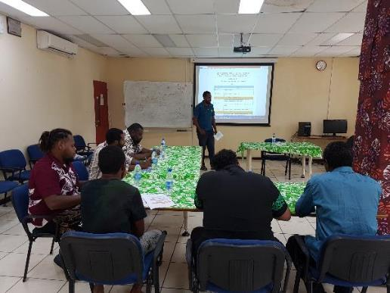

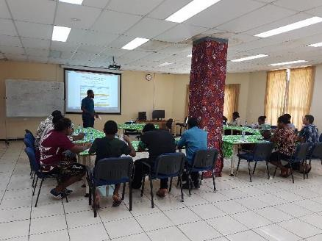

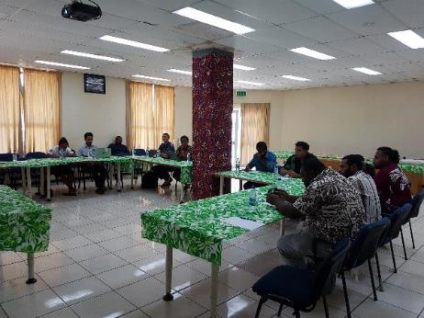

## **Annex 2 – Inception Workshop Participant’s List**

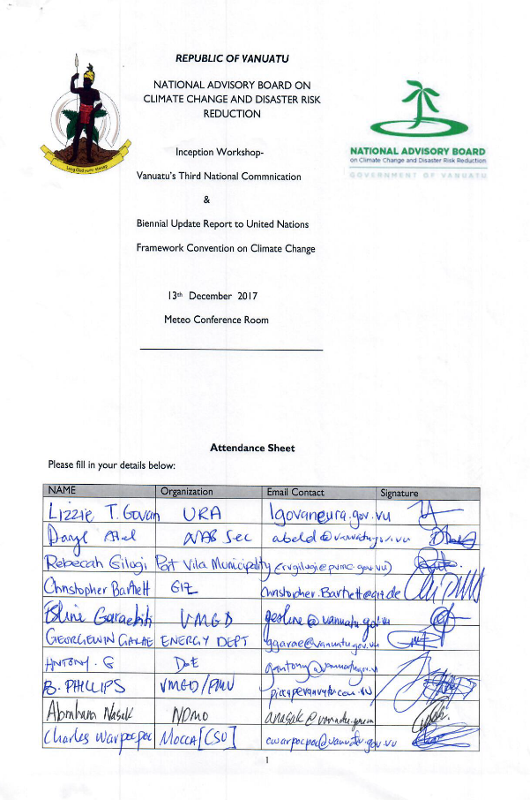

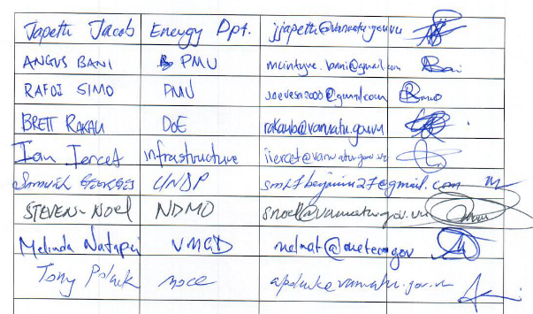

## **Annex 3 – TNC and BUR Thematic Working Groups (TWG’s)**











## **Annex 3 – Inception Workshop Presentation Slides**

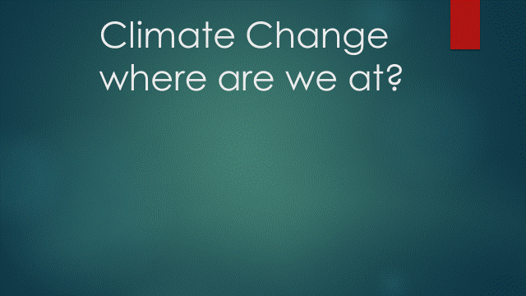 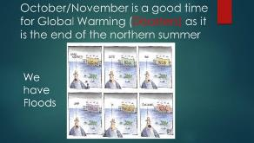

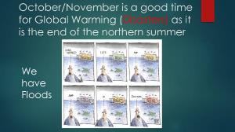 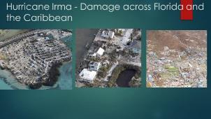

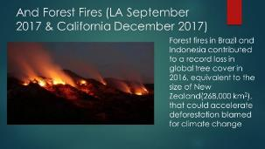 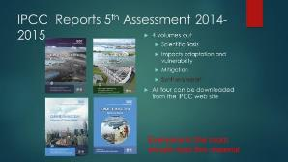

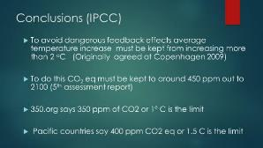 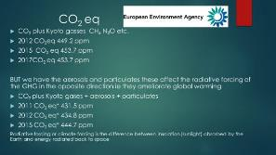

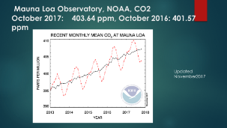 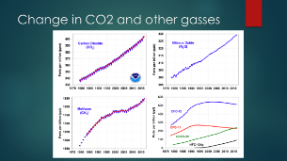

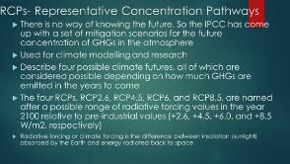 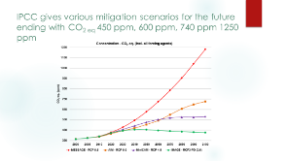

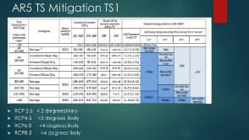 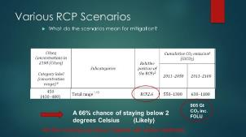

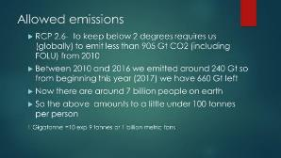 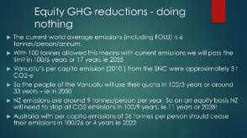

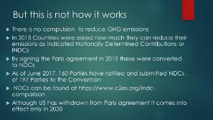 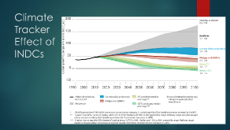

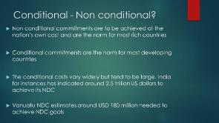 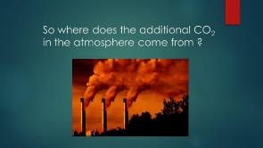

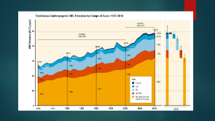 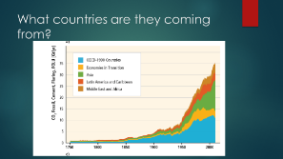

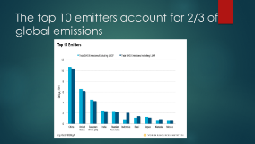 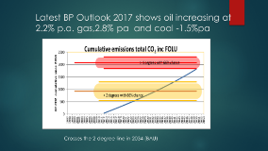

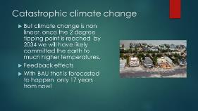 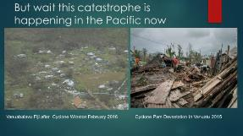

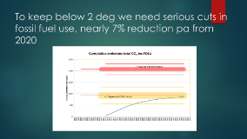 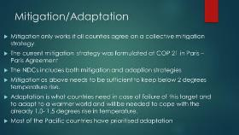

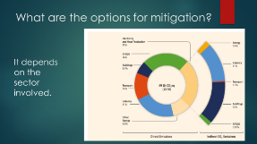 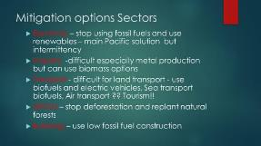

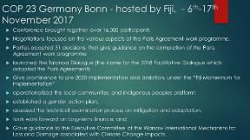 

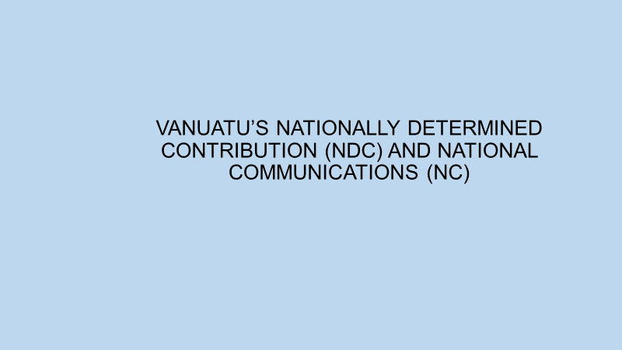 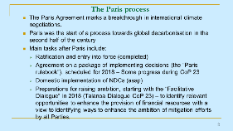

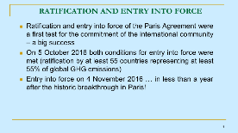 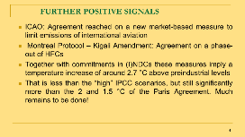

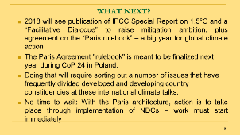 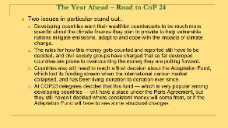

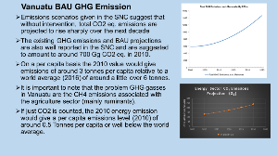 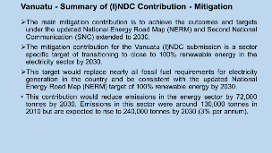

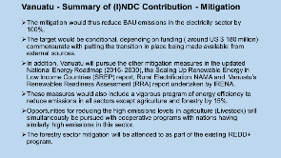 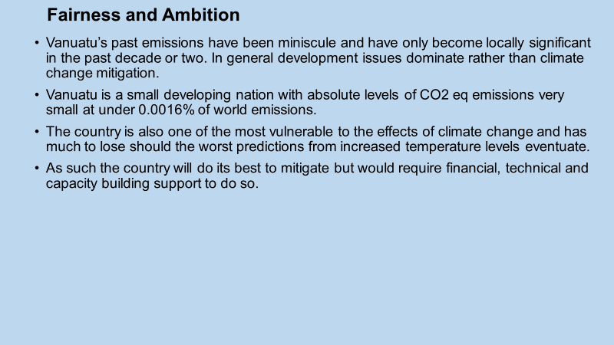

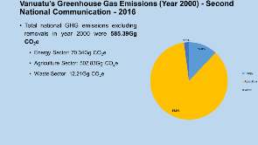 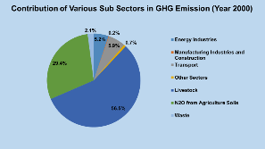

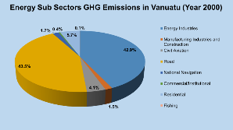 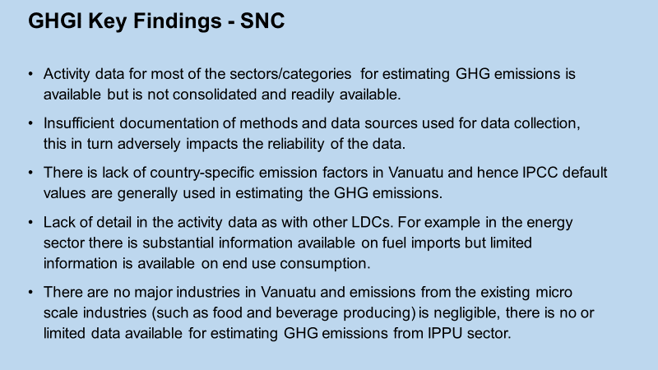

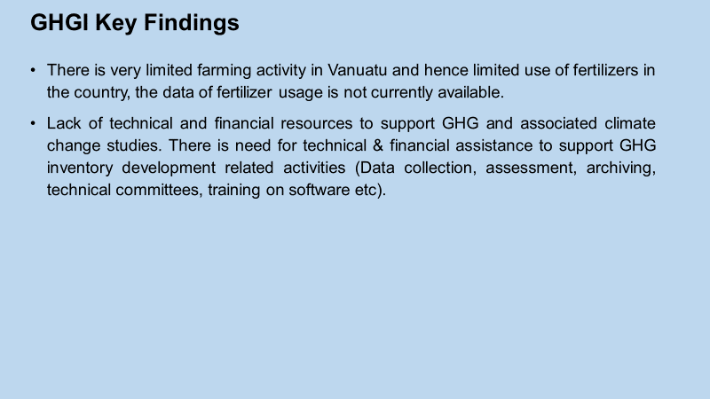 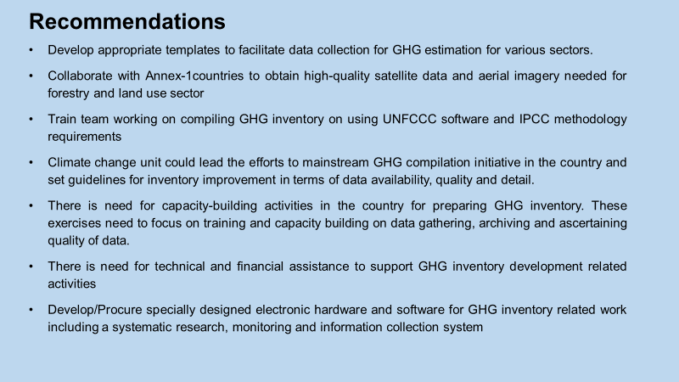

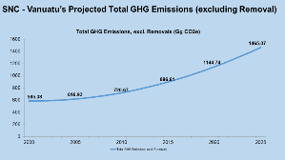 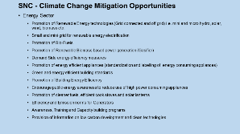

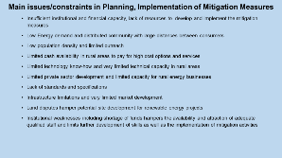 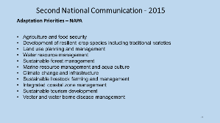

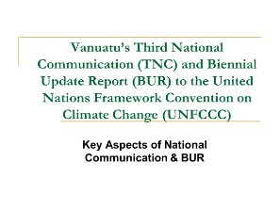 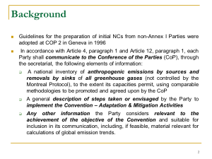

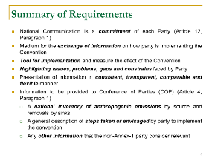 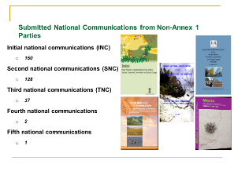

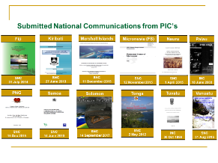 

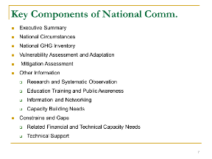 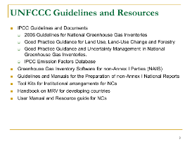

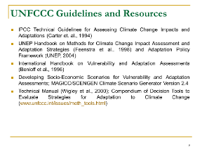 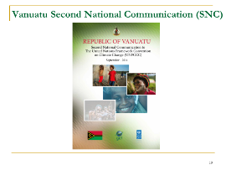

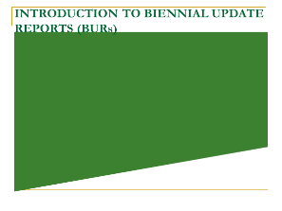 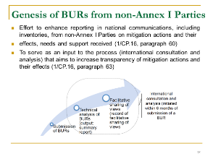

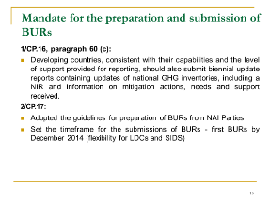 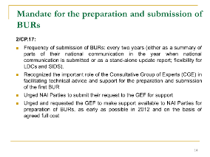

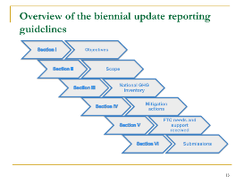 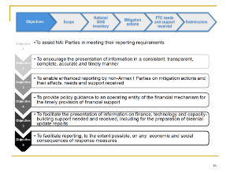

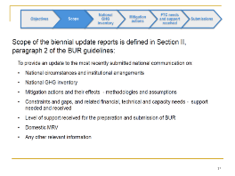 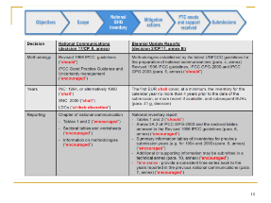

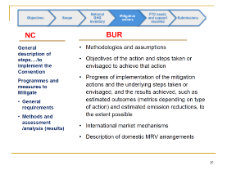 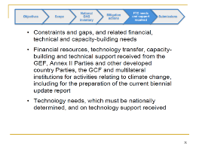

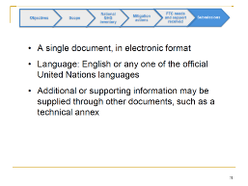 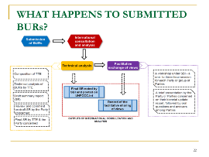

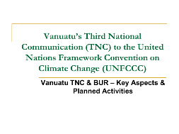 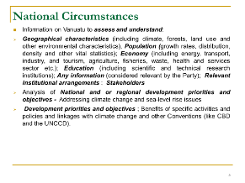

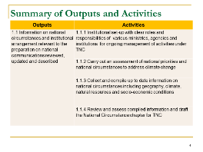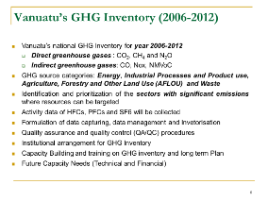

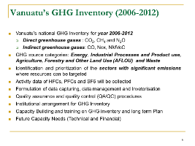 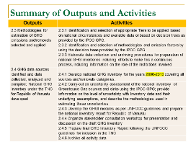

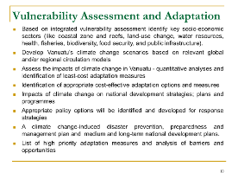 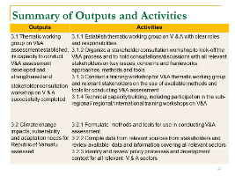

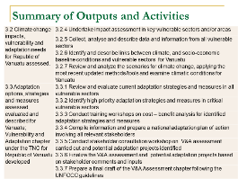 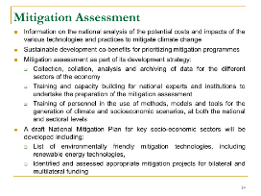

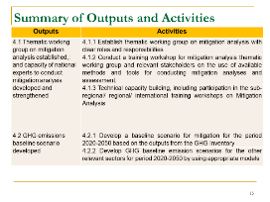 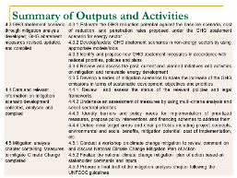

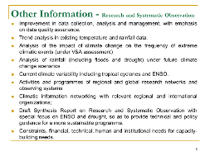 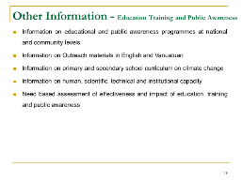

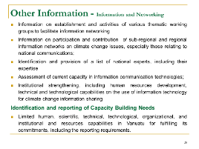 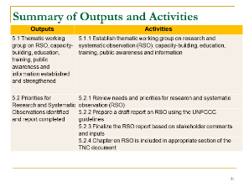

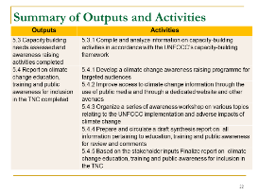 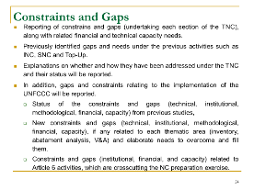

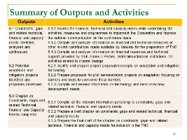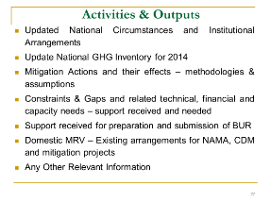

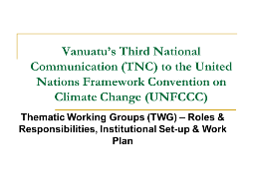 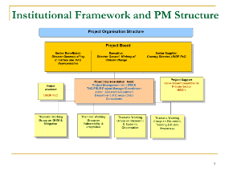

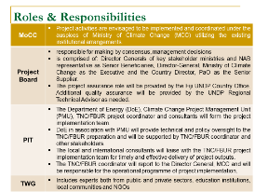 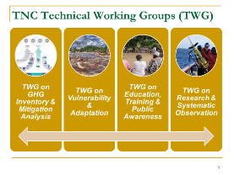

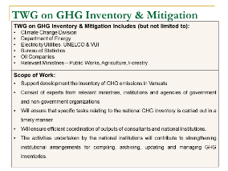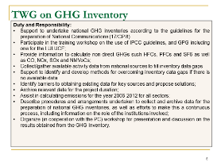

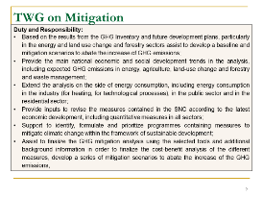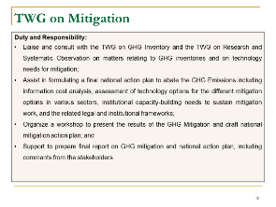

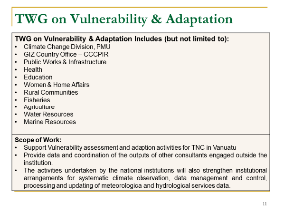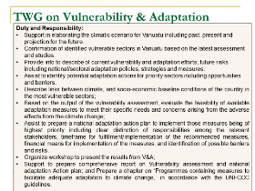

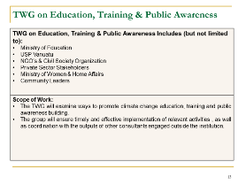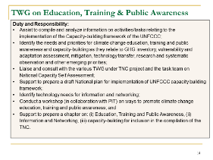

1.