Technical Proposal -

Investment in cost saving and environmental initiatives

Lighting System Data & Replacement Analysis

Cape Verde Country

TABLE OF CONTENTS

1. Introduction 1
1.1 OBJECTIVE 1
1.2 Problem Statement – Descripiton of the nEEDS 2
1.3 Needs STATEMENT 3
2. Proposed TECHNICAL APPROACH 1
2.1 Detail Analys of the Cost 1
3. expediture period 2
3.1 MEASURES of SUCCESS 2

Introduction
Cape Verde is among the top ten countries in world with highest cost of energy. Moreover, the Government is working towards implementing a wide range of measures to reduce the overdependence on fossil fuel and minimize the cost of energy. Recently the Country established as a national goal to go 100% of renewable energy.
Considering the prevailing conditions in the energy sector the UN office in Cape Verde have been actively working for promoting Green Energy in face of the global climate crisis and the urgent need to substantially decrease the high cost of energy consumed in daily activities of UN while reducing the carbon footprint of the office.
In order to accomplish this goal a project was designed with the support of United Nation Industrial Development Organization (UNIDO) in cooperation with ECOWAS regional Center for Renewable Energy Efficiency (ECREEE) to help the United Nation (UN) in Praia, Cape Verde to undertake a comprehensive energy audit of the One Un office building.

OBJECTIVE
The main objective of the project was to install the solar panel system in order to reduce the monthly energy bill of the office and contribute to mitigation effort of Green Houses Gases (GHG) emissions.
The project encompass of two distinct phases i) the energy audit of the building and delivery improvement, to ensure energy saving through integration of on or off-grid solar photovoltaic (PV) system; ii) energy cost reduction through lighting management systems.
The building is a 4-storey with a partially 5th floor, the architectural design and direct exposure of sun radiation contributes to render the office into a highly inhospitable and warm condition to efficiently work.
The first phase has been concluded early this year with the installation of the equipments and materials needed. An inside building grid connected 25kWp PV power plant was installed, with inverters systems adequate to its power. A total of 100 solar panel (PV 230 kwp) was installed on the roof top of UN building in Praia and a “Net-Metering” is recording the exceeding energy produce to facilitate the billing. Preliminary data show 30% reduction on the monthly energy bill. It is estimated that the cost of electric has decrease.
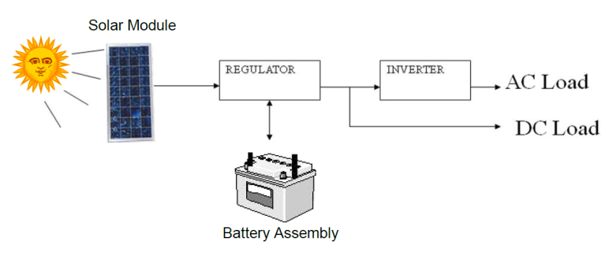
Fig. 1 UN solar PV system schematic (first phase)
For the second phase the aim is to mobilize additional financial resource to implement an overall replacement of the old lamps with newer and a more efficient and smarter lighting in system. Therefore, the UN office in Cape Verde would like to submit for the consideration and approval of the Regional Contingency Fund (RCF) to support the conclusion of the second phase of this project.

Problem Statement – Descripiton of the nEEDS
The cost electricity continues to rise in Cape Verde. On average the office pays over $6,400 USD on electricity bill monthly. Although the renewable energy system is installed the benefits in terms of costs saving and environmental gains remains to be achieved due to a highly inefficient lighting system still in place.
Insufficient financial resources to carry out the retrofitting work of the office and the substitution of old lamps and their appropriate disclosure remains to be major concern. Lighting fixtures at the building is predominantly fluorescent. It is either the 11-watt Compact Fluorescent Lamp (CFLs) in the hallways and 2X2-foot fixture with four 18-watt lamps or the 4-foot fixtures with two 36-watt lamps. They are all surface-mounted and have egg-crate diffusers. There are a few high intensity discharges (HID), 400-Watt mercury vapor light fixtures mounted along the security fence and the parking lot.

Needs STATEMENT
The lighting system at the UN building is not efficient in terms of energy consumption. The existing lighting systems should be replaced with similar fluorescent fittings with T5 lamps and electronic ballasts, while the aesthetics of the existing lighting system is maintained. These changes will reduce the lighting energy consumption by approximately 35 percent.
In addition, the lighting system must be controlled for best performance. Installation of occupancy sensors is recommended to remove operating sequence from manual to automatic controls. The sensors monitor specific areas and automatically turn lights ON when occupancy is detected. When the area is no longer occupied, the sensors automatically switch the lights OFF after a user selected time interval. Lighting typically accounts for 30 – 40 percent of an office building's energy bill, yet many offices and other areas are unoccupied for a significant part of the day. The lighting systems at the may be ON up to 12 hours daily in some areas. In some cases the lights could be turned off for periods when the space is unoccupied to reduce energy consumption. This must be done automatically with Occupancy Sensors. Typical sensor operating benefits are shown in the table below:
The principal stakeholder of this project is agencies Country Office (Joint Office of UNDP, UNICEF and UNFPA).

TECHNICAL APPROACH
The existing lighting systems are manually operated by the occupants. Therefore lighting may be on continuously until the custodians are leaving the building after clean up hours. Individual offices and private spaces have isolated single or double wall switches. The present system without planned sequence of lighting utility sustains a significant energy waste. This should be streamlined with proper control technologies.
It is recommended that occupancy sensors be installed in all the lighting circuitry as necessary to curtail energy waste. This will minimize and prevent inadvertent lighting power consumption. Individual offices will have the existing lighting switch adapted with wall-mounted occupancy sensors, while lighting in the common opened office spaces will be controlled with ceiling-mounted sensors. The lighting sensors shall have dual technology (infrared and ultrasonic) specifications for the required versatility. The ceiling-mounted (just like the existing smoke detectors) sensors will be tied into the existing lighting circuitry in a matrix to provide complete coverage of the floor spaces. The lighting switches will be left in the ‘on’ position for the sensors to control lighting energy based on occupancy and timed ‘off’ setup. In this system areas are only lit based on actual occupancy or detected motion, thereby preventing lighting energy waste while serving the dual purpose of energy conservation and security alert.

Detail Analys of the Cost
The One UN Building is considering the conversion of all lighting systems at the Chancery to the T5 high efficient units to reduce the current lighting energy use by approximately 35 percent. Technical option and analysis of annual savings, payback time in years and cost is also provided in the supporting document supporting document f
The total cost of the project to replace the lighting system of the Cape Verde´s UN country office is estimated to be $118,892 USD (see Table 1). Besides the materials and the required accessories (including replacements) it covers the transport and insurance, installation works and management and maintenance costs.

As one of agencies that shares the same permises UNIDO has pledged $50,000 to cover part of this project. Therefore, we request the RCF to review this proposal and make decision to allocate to Cape Verde country 60,000 USD to be utilized for greening the UN premises and set a standard that could be modeled.
Table 1. Cost breakdown by component
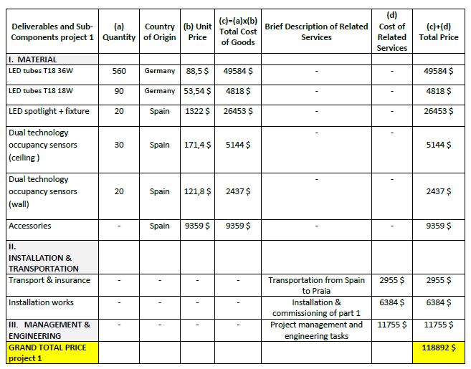

expediture period
The RCF resources will be used to purchase the materials and acessories, therefore most of the available fund will be likely to allocate in full when the materials are delivered in Cape Verde. The procurement process, adjudication and the arrival of the necessary parts would take between 3 to 5 months. The installation, testing and management plan will be carried out in two weeks.
Table 2. Cost Breakdown by Deliverables
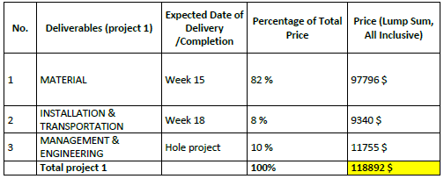

MEASURES of SUCCESS
The office top management and operations will be fully engaged to enlist the support of all UN agencies that share the UN Office headquarters in Cape Verde. In addition our regional partner ECOWAS ECREEE will also provide technical backstopping during the procurement process and installation. Local companies will be involved to guarantee that the maintenance plan is properly implemented for the sustainability of this investments.

