FAQs
e-Services Phase II
Service Contract Holders
Contents
How to get Started 3
1. Where do I get the log-in details 3
2. How to setup my leave for the first time 3
3. Who is my HR focal point and what is his/her role 6
4. Who is my leave monitor what is his/her role 6
5. Who is my supervisor 6
Annual Leave (AL) 7
7. How do I apply for AL 7
8. Can I apply for advance AL 9
9. Can I apply for leave beyond my expected end date of contract 9
10. Will I keep accumulating AL days if I don't take any leave 9
11. Will I get paid for unused AL days upon separation 9
12. Can I carry over any accumulated AL to my renewed contract 9
13. How does the system calculate my AL if it coincides with official holiday especially for lunar days? 9
14. Can I apply for a half day of AL 9
15. Can I apply for an AL retroactively (F) 9
16. Will the updated leave balance be automatically reflected in Atlas 10
Maternity and paternity leave (ML&PL) 10
17. Can I split my ML/PL requests 10
18. Does ML/PL include official holidays and weekends 10
19. Does ML/PL need to be approved by my leave monitor/supervisor in e-Services 10
20. How do I apply for ML and what supporting documents needs to be attached 11
21. How do I apply for PL and what supporting documents needs to be attached 12
22. Is ML/PL prorated based on part time status 12
23. Do I still accumulate AL days during ML/PL 12
24. When do I have to start my ML/PL, how well in advance 12
Certified Sick Leave (CSL) and uncertified sick leave (USL) 13
25. How do I apply for SL 13
26. How do I apply for Uncertified Sick Leave (USL) 14
27. Does CSL/USL need to be approved by my leave monitor/supervisor in e-Services 14
28. How many days do I have for USL and what is the maximum number of consecutive days of USL 14
29. Do I need to attach/upload my medical report/certificate in Atlas for the CSL 14
30. Can I apply for a CSL in advance 15
31. Can I carry over any unused SL days to my renewed contract 15
32. Can I apply for extended CSL beyond the contract end date 15
Cancelling and editing the leave request 15
33. How do I cancel/edit the leave request in e-Services 15
34. Can my leave monitor enter/change/cancel leave on my behalf 16
35. How can I view absence report/leave history and attendance card in e-Services 16
Reporting 17
36. Review of the absence reports and leave balance for the SC Holders 17
Leave Types not in e-Services 18
37. Do we still need to use the paper forms for leave requests 18
38. How to record my official business (OB) 18
39. How to record my CTO 18

How to get Started

Where do I get the log-in details
The HR eServices Leave Module is located in Atlas HCM. An Atlas user name is required to access it. Link: https://hr.partneragencies.org.
If you have a user name, but do not remember credentials click “Forgotten Password” and follow instructions. A temporary password will be emailed to you within a few seconds. If you don’t have an Atlas user name, contact your HR focal point to coordinate creating a profile for you through the office Argus focal point.
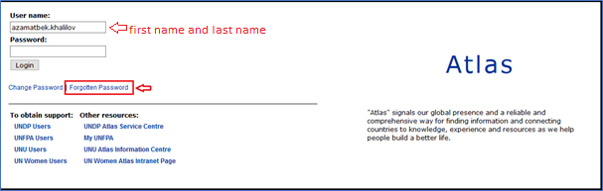
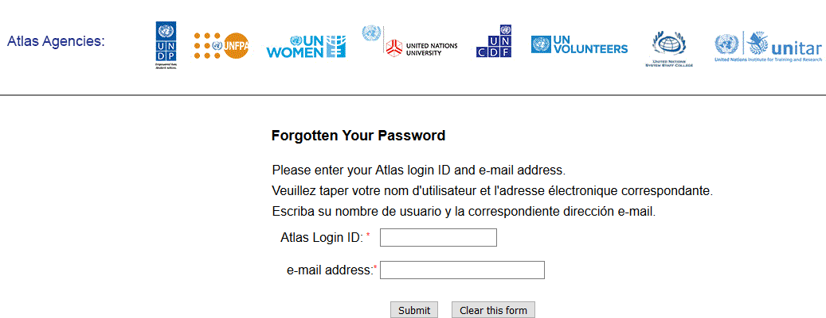

How to setup my leave for the first time
Once you are logged in to Atlas HCM click the e-Services folder:
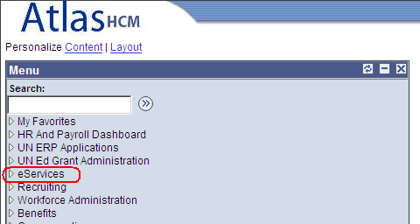
Enter the name of your supervisor, HR focal point and leave monitor. Click SAVE once the required information is recorded:
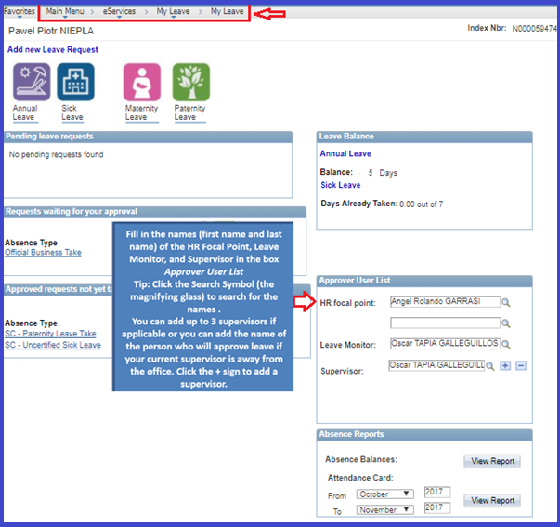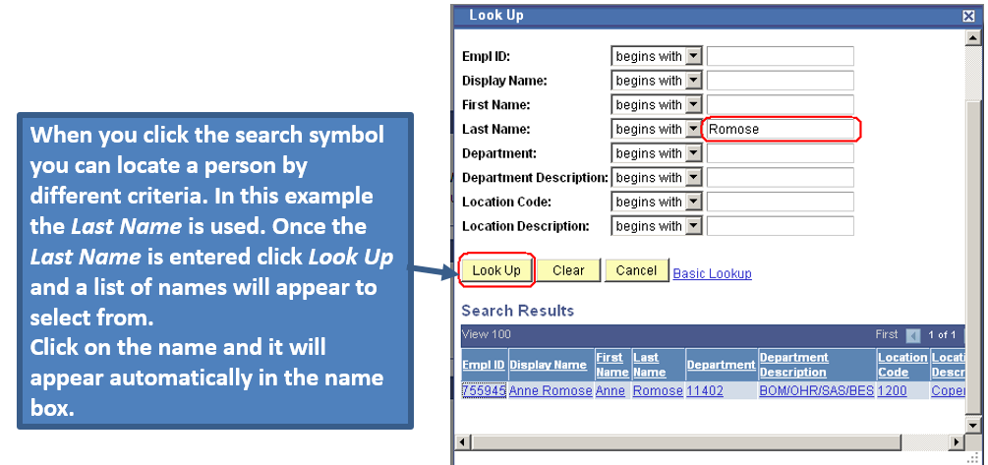
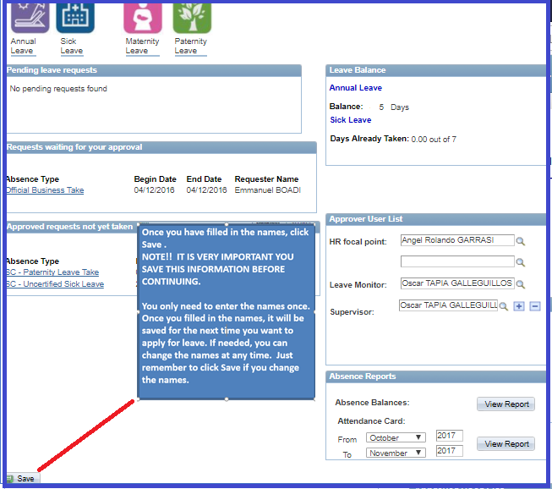

Who is my HR focal point and what is his/her role
Your HR focal point in e-Services is someone from your local HR department in the country office whom you contact on HR related matters.
The role of your HR focal point in e-Services is to ensure that your leave requests are in line with the established respective leave policies and procedures for SC holders.

Who is my leave monitor what is his/her role
Your leave monitor is someone in your office who administers your leave, handles you the monthly attendance cards for signature, and certifies your presence/absence on duty. Depending on your office set up, HR focal point may be your leave monitor, too.
The role of your leave monitor in e-Services is to ensure that your leave balances are accurate, your leave takes are in accordance with your accrued/entitled leave balances, etc.

Who is my supervisor
Your supervisor is a UN/UNDP official to whom you report directly.
The role of your supervisor in e-Services is to review your leave requests and approve/deny them subject to exigencies of services and your contractual obligations.
- Is it possible to add/change the existing HR focal point/leave monitor/supervisor in case they are on leave/absent
Yes, you may override the name of the HR focal point/leave monitor/supervisor on the My Leave page in e-Services module. Updating the information in Atlas is done prior to applying for leave. Do not forget to click “Save” once you have updated information on the HR focal point/leave monitor/supervisor. You may add up to 3 supervisors if there is a need, and select the needed one when you submit a particular leave request.

Annual Leave (AL)

How do I apply for AL

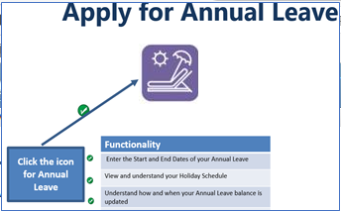
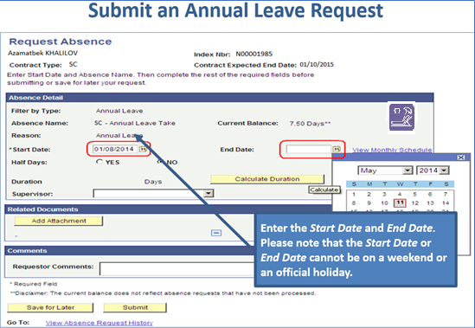

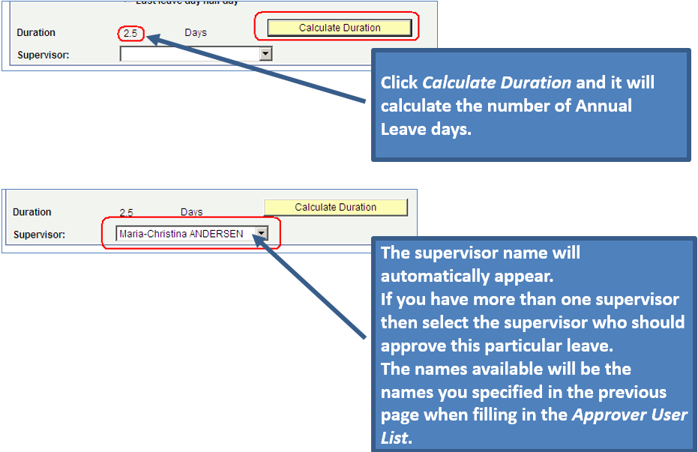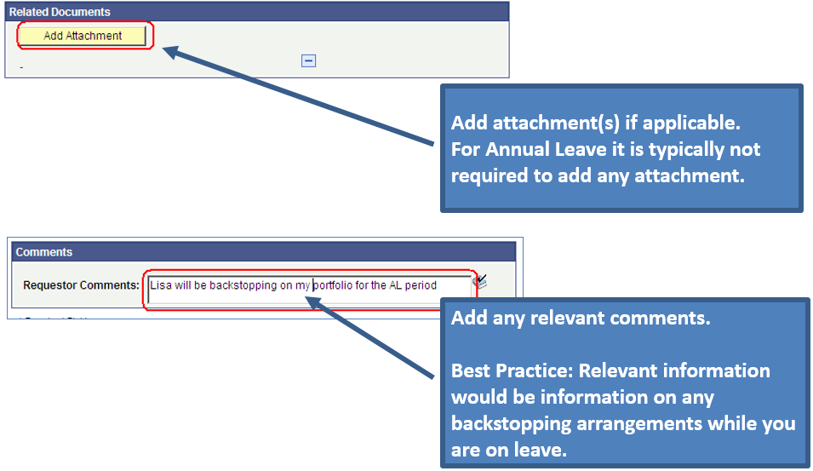

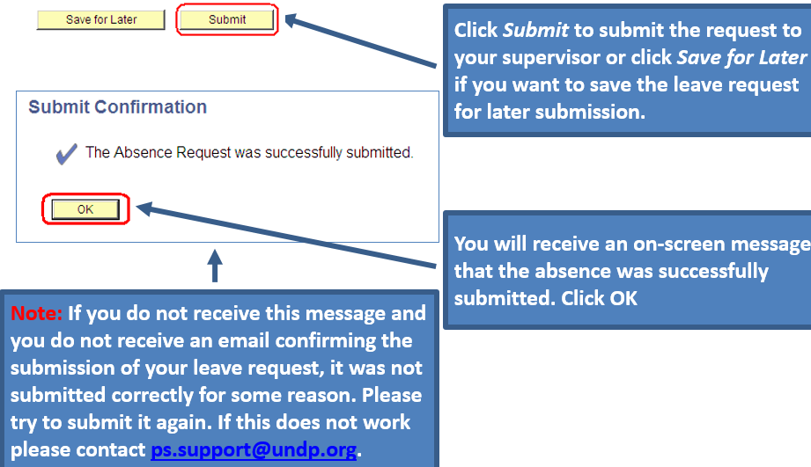

Can I apply for advance AL
No, there is no provision of advance AL for Service Contract holders. Your leave will not go through if you apply for more AL days than your current balance.

Can I apply for leave beyond my expected end date of contract
Leave days should be applied for and taken within the existing contract period.

Will I keep accumulating AL days if I don't take any leave
Yes, the AL is accrued on a monthly basis for each completed month of work in accordance with terms and the conditions of your contract.

Will I get paid for unused AL days upon separation
No, any unused AL days at the time of separation are forfeited.

Can I carry over any accumulated AL to my renewed contract
Yes, if your SC is extended for additional period, up to 18 days of accrued annual leave may be carried forward upon contract extension.

How does the system calculate my AL if it coincides with official holiday especially for lunar days?
Official holidays and non-working days are excluded from the period of AL, e.g.: if the SC holder applies for AL from Monday till Wednesday (3 days) and Tuesday is an official UN holiday in the duty station, Atlas will only deduct 2 days from the AL balance.

Can I apply for a half day of AL
Yes, when creating the AL request you have an option to select half days.
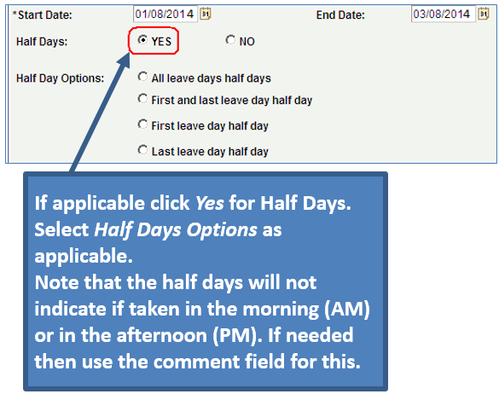

Can I apply for an AL retroactively (F)
Leave should be planned and agreed with the supervisor in advance, and approved in Atlas prior to start date of leave. For any unusual circumstances or technical problems, contact your local HR focal point for advice.

Will the updated leave balance be automatically reflected in Atlas
The leave balances are updated when payroll is processed which is typically between the 10th -18th of a month.
Example:
- If you apply in advance for leave in December, then your leave balance will be updated in December on the day payroll is processed (10th -18th of a month).
- If you apply for leave in the end of the current month (after payroll is processed) and it is approved end of current month, then the leave balance will be updated the following month

Maternity and paternity leave (ML&PL)

Can I split my ML/PL requests
There is no provision for split of maternity leave. The paid maternity leave is established in accordance with the SC contract. The ML must fall within and be taken during the contract period.
The paternity leave can be taken in one or two equal periods during the first twelve months from the birth of a child. The paid PL is established in accordance with the SC contract. The SC holder must have had at least 6 months of service with UNDP at the time of the birth of the child. PL is limited to once a year, regardless of the number of children born during that year, and can only be availed at a maximum up to six times during the total engagement within the UN system. The PL must fall within and be taken during the contract period.

Does ML/PL include official holidays and weekends
Yes, both maternity and paternity leave include holidays and weekends. Once you select the begin date of ML/PL, Atlas will default the end date to a date 112 or 28 calendar days later. Any in-between holidays will not affect the calculation.

Does ML/PL need to be approved by my leave monitor/supervisor in e-Services
Both ML and PL requests in e-Services will require approval from your supervisor and the HR focal point.

How do I apply for ML and what supporting documents needs to be attached
Select the respective icon for the ML on the main page of e-Services:
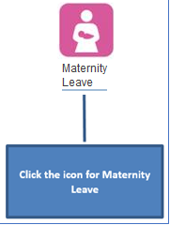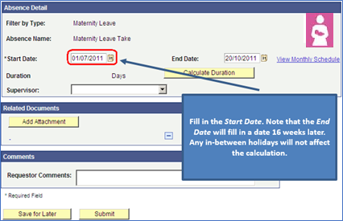
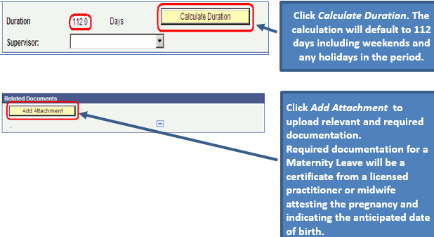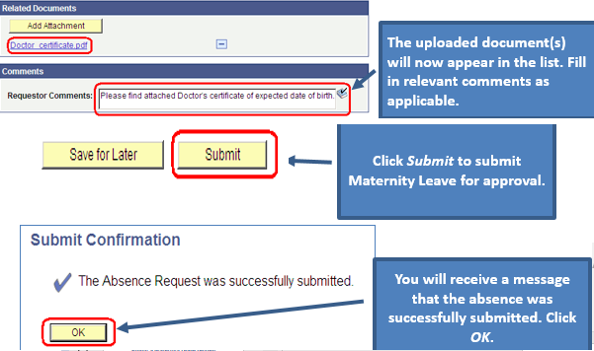

How do I apply for PL and what supporting documents needs to be attached
Select the respective icon for the PL on the main page of e-Services:
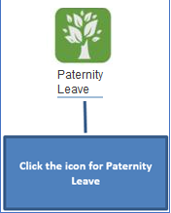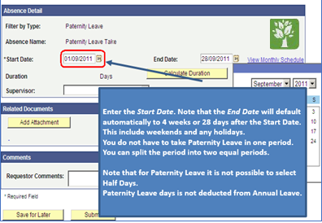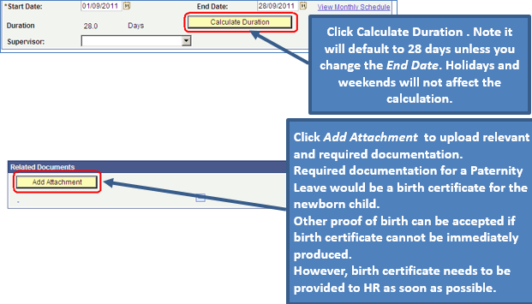
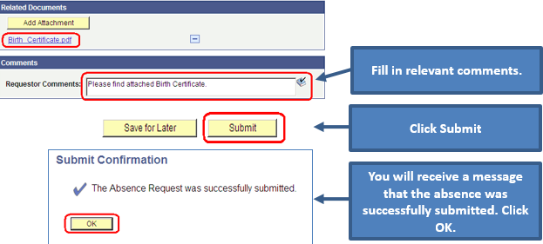

Is ML/PL prorated based on part time status
ML/PL is calculated based on full calendar days from the start date of the ML/PL.

Do I still accumulate AL days during ML/PL
Yes, during the ML/PL period, you continue to accumulate AL days.

When do I have to start my ML/PL, how well in advance
The start date of ML/PL is as per established CO practice, in accordance with the local market practice; if it is not specified, UNDP standards may apply.

Certified Sick Leave (CSL) and uncertified sick leave (USL)

How do I apply for SL
Select the respective icon for the SL on the main page of e-Services:
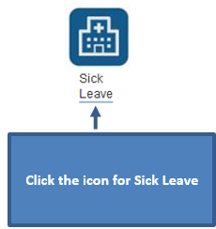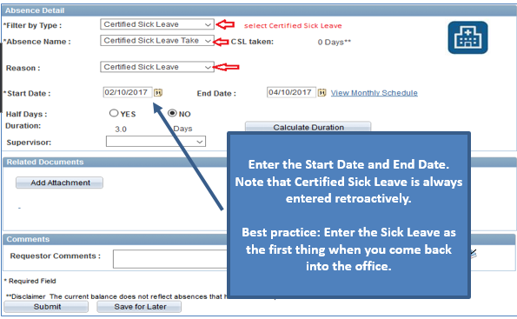
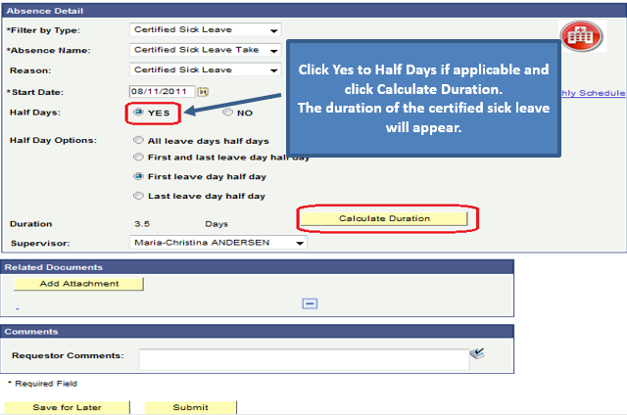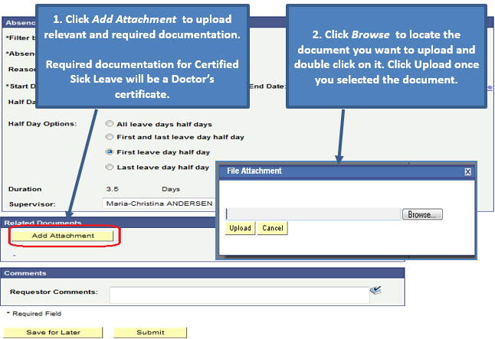

How do I apply for Uncertified Sick Leave (USL)
Select the respective icon for the SL on the main page of e-Services, then in the dropdown menu select the Leave type: Uncertified Sick Leave:
USL is part of the sick leave: 3 days in total for the 12 months of contract period and is part of the total sick leave period. Hence, days used as USL are deducted from the total balance of the SL.

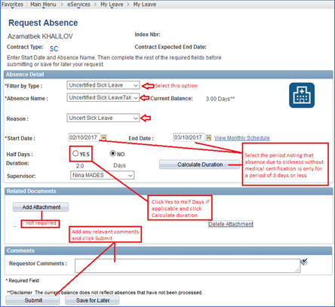

Does CSL/USL need to be approved by my leave monitor/supervisor in e-Services
USL (sick leave without certification) does not require approval from the supervisor or the leave monitor, however e-mail notifications are generated.
The certified SL requires approval from your supervisor. Once your supervisor approves the CSL request, your leave monitor is notified.

How many days do I have for USL and what is the maximum number of consecutive days of USL
Sick Leave of 3 days or less (cumulative or consecutive) in contract period of min 6 months and max 12 months does not require medical certification. For any additional medically related absence, medical certificate is required for the rest of the contract period.

Do I need to attach/upload my medical report/certificate in Atlas for the CSL
Yes, for CSL request you need to upload the respective medical certification from your doctor.

Can I apply for a CSL in advance
Yes, it is possible to apply for the CSL in advance, provided it is supported by the medical certificate.

Can I carry over any unused SL days to my renewed contract
The calculation of the SL for SCs is done in accordance with the SC contract and is linked to the contract duration up to 12 months at a time. After 12 months of service (including amendments) unused SL is not carried over to a next contract extension, the calculation starts from the new extension up to a next 12 months. Also, unused SL is not commutable to cash at the end of service/contract period.

Can I apply for extended CSL beyond the contract end date
No leave should be granted beyond the contract expiry date. The SL days when applicable should be applied for and taken within the existing contract period.

Cancelling and editing the leave request

How do I cancel/edit the leave request in e-Services
If you need to cancel/edit leave request in Atlas e-Services, follow the navigation: Main Menu>eServices>My Leave>View Absence Request History
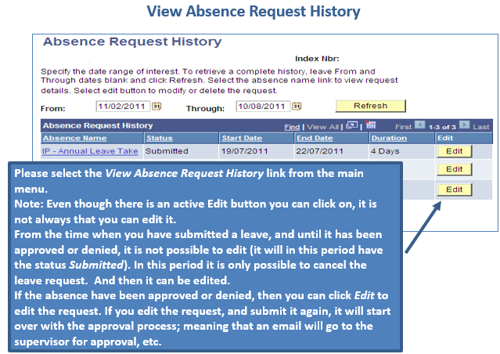

Can my leave monitor enter/change/cancel leave on my behalf
Yes, technically it is possible. Sometimes when SC holders are not physically able to manage their leave request in e-Services (e.g. SC is in hospital etc.) the respective leave monitor have the tool in Atlas HCM module to enter/change/cancel a leave on SCH’s behalf.

How can I view absence report/leave history and attendance card in e-Services

The absence Request history can be viewed by following the navigation below. The absence balances report will provide the balances as of the previously finalized payroll calendar. The Attendance Card form can be instantly generated for a specific period selected as per the screenshot below.

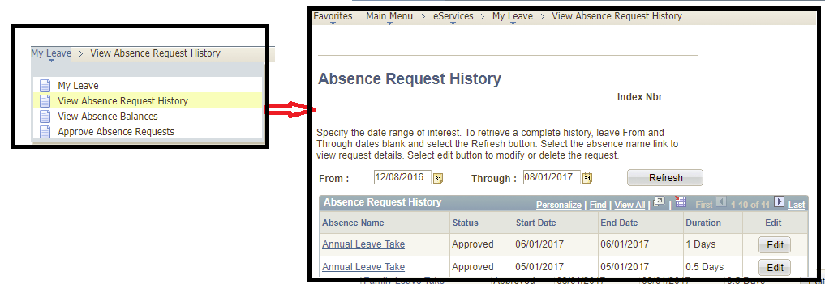

Reporting

Review of the absence reports and leave balance for the SC Holders
SC holders are advised to view their attendance reports and leave balances on regular bases through the reporting tools available on the main page of the e-Services/My Leave
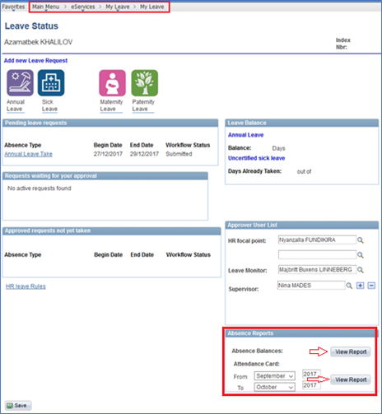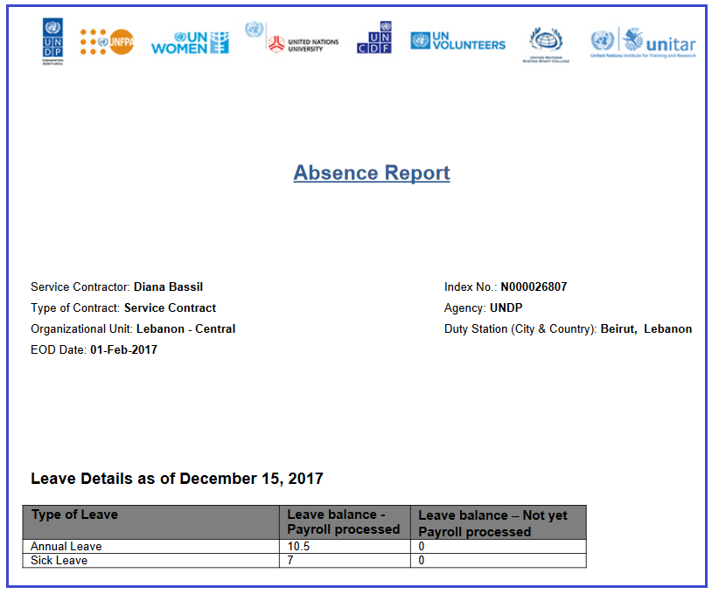

Leave Types not in e-Services

Do we still need to use the paper forms for leave requests
For leave types that are administered in e-Services, and once the SC holder has been granted access rights to eServices, there is no need to continue using the paper forms such as request for AL/SL/ML/PL (except for the supporting documents that should be uploaded to e-Services as medical certificate/birth certificate of the child, etc…).
However, for leave types that are not yet in e-Service module, such as official business, CTO etc., the paper-based practice should continue as per CO practice.

How to record my official business (OB)
Official business mission for SC Holders is not yet part of e-Services module, hence it should be recorded either outside of Atlas HCM based on the established practice in your office, or the leave monitor may enter the absence take on the Absence Events page in Atlas HCM.

How to record my CTO
Compensatory Time Off (CTO) is not part of e-Services module. Your HR Focal Point and Leave Monitor may record the CTO in Atlas for you. Same as overtime, CTO is applicable only to SB1-SB3 levels. Where local practice favours CTO, subject to exigencies of service, SCs shall be compensated on the basis of one and half the normal rate. The CTO must be utilized within four months following the month in which the overtime work is done, otherwise it is forfeited.
Overtime/CTO must be requested and approved by the supervisor in advance of the extra work period to be performed. The respective approval as well as overtime request forms should be kept in the SC holder’s personal files. Overtime may be approved for a maximum of 40 hours per month.

