**How to install SuperOffice**

1. Close MS Outlook
2. Run this program: "O:\SuperOffice7_SAS\SuperOffice 7 Server\Client\SuperOffice7.exe"
3. The below window appears – Click “Install”

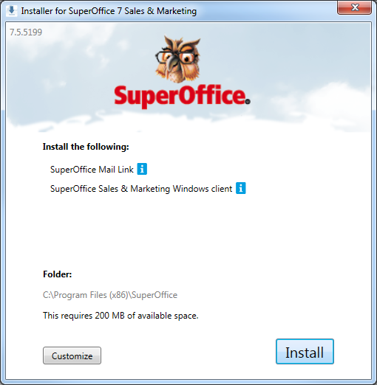

1. If you get the below message – please click “OK”

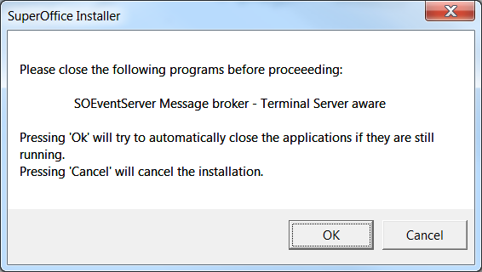

1. Once you open Outlook, you may get prompted for username and password - Simply enter your SuperOffice credentials and click “OK”.

