- Brief Description
Growth Area 2 & 3: Alternative financing and private sector
Thematic Area 1: Sustainable development

UNDP Albania proposed intervention seeks to mobilise private sector financing for piloting of an Employment and Skills Development Fund for persons with disabilities, whose employment and training needs remain largely unaddressed. The relevant government legal framework currently in place has not been implemented and has failed to instigate concrete results. To date people with disabilities are recipients of passive disability benefits (over 150,000), which is disproportionate to the numbers of those actively seeking employment (less than 500). The overall aim is to convene the private sector and catalyze their capital for social and developmental impact and to address this discrepancy through a social impact fund.

In Albania, private sector financing and government cost-sharing for issues of human and social rights are very limited, even though the commitment to the agenda and will are present. This is especially so for the rights and services of PWD and Roma and Egyptian communities. The proposal will fill this gap and provide the practical means of how to direct the funds as well as pilot targeted programmes. The specific objectives of the proposal are multiple, to 1) leverage the significantly larger capital, equity and assets of the private sector for a social cause with the ultimate aim of raising income of people with disabilities by providing them with opportunities/interventions to acquire productive skills and strive towards independent lives; 2) operationalizing the Government law in favour of persons with disabilities and setting up the Fund and mechanism for private investments and government cost-sharing, and eventually for loans and levies for future blended financing; and 3) promoting social impact investments and public private partnerships.

The intervention will seek to reach people not covered by mainstream interventions such as the active labour market programmes implemented by the National Employment Service. It builds on the Government’s own policies and systems, as well as years of UNDP leadership and programming. It will result in a) the set-up and operationalization of the Employment and Skills Development Fund for Persons with Disabilities, b) the piloting of a mechanism for partnership between private companies, public sector and organisations for PWDs, and c) eventually provide evidence of financial viability for interventions of a larger scope and magnitude. Some key activities would be: 1) Stakeholder consultations/negotiations (including the Ministry of Finance, IMF, private sector representative organizations, CSOs supporting people with disabilities, end beneficiaries (both in urban and rural settings), including the setting up of a platform for continued private sector engagement; 2) Designing the Fund, including detailed operational and financial modalities, roles of stakeholders, management costs and needed funding structure; 3) Private sector and Target group analysis – data collection and analysis; and, 4) Design and implementation of the interventions/funding windows (e.g. skills training, support to start-ups and social enterprises, improved accessibility, subsidized employment, workplace adjustment, etc.) with the government, private sector, CSOs and other relevant actors.

The role of the private sector in the proposed intervention will be two-fold. On one hand, the intervention will promote the collection of private sector contributions into the fund, and on the other hand enable the private sector to tap into the Fund. Through the engagement of private sector intermediary organizations (i.e. chambers of commerce) during the piloting phase, it is envisaged that private sector financing will be solicited alongside RBEC Impact Investment Facility funds. It is also aimed that end beneficiaries be engaged at all stages, starting from the initial consultations, to the design and the implementation of the intervention. Innovative approaches such as design thinking will be utilized in the design of interventions that fit the needs of the target group. The Platform will also allow for conversations on innovation and partnerships around social impact, development performance, alternative financing, etc.

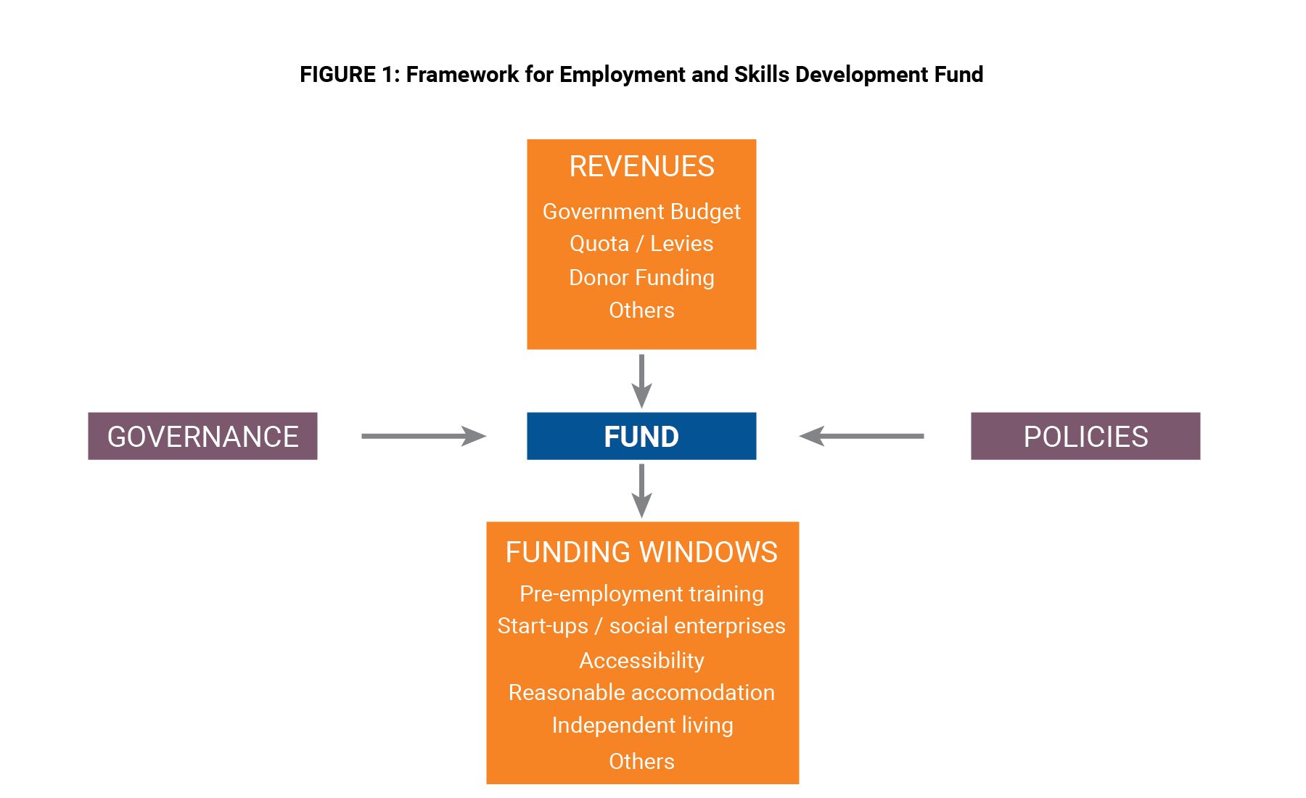

Provided that UNDP’s experience spans across policy and implementation, UNDP will undertake the structural set-up of the Fund, as well as the piloting, with the ultimate objective that private sector contributions and levies will be collected and managed. This initial setup is expected to evolve and eventually be scaled up so the Fund has blended financing of government cost-sharing, private sector, IFIs as well as other alternative financing mechanisms such as reward crowdfunding.

The initiative builds on UNDP partnerships, past work and experience, including in employment and skills development, social inclusion and private sector engagement. Over the past 9 years, UNDP Albania, has implemented several skills development/employment related interventions and it has built a strategic vision that recognizes the importance of creating employment opportunities as a means to addressing both poverty reduction and inequalities and exclusion. UNDP continues to have significant contributions towards improving the governance and transparency of government funds dedicated to employment promotion, territorial reform and public administration reform in the country. Specific programmes currently up and running include: Skills Development for Employment, Economic & social Empowerment of Roma & Egyptians (ESERE), Social Inclusion for PWD and Roma & Egyptians, and “Leave No One Behind” (LNB).

UNDP is already working with the private sector on finding alternative financing mechanisms in support of the social agenda, and youth startups. Joint work in support of the 2030 agenda is already agreed as two consultations with the private sector on SDGs will take place in December. An assessment of the private sector readiness to engage in equity crowdfunding will be presented. Additional ways to galvanize the support of the private sector are currently being discussed. All these actions have already created a spirit of cooperation that is expected to be intensified offer concrete results in the short run.

Direct contribution is made to the achievement of SDG 8 and SDG 10 by providing decent employment opportunities for people with disabilities and promoting their economic inclusion. In addition, it contributes to SDG 4 and SDG 11.

Beyond this pilot targeting people with disabilities, the ultimate aim is to support the Government of Albania in establishing an extra-budgetary Employment and Skills Development Fund that beyond addressing the employment of people with disabilities, could support efforts to raise the productivity, competitiveness, and incomes of enterprises and individuals by providing them with needed skills. UNDP is well positioned to pursue the establishment of this fund, as one of the few international organizations supporting the employment and skills development agenda at the policy and local level, and has experience in Fund establishment and management.

- Effectiveness and risk management

Labour market data suggest that the economic growth experienced in Albania during the last two and a half decades has not been translated into significant labour market improvements. In 2017, labour force participation rates remain below European averages, with women participation rates significantly lower than men’s (66.8% overall, 57.7% for women and 75.7% for men). Youth participation rates are considerably lower than for the rest of the population (45.7% overall, with the gender gap at over 15%) and data indicate that since 2007 Albanian youth face increased difficulties in the labour market compared to other adults. The youth unemployment rate in the second quarter of 2017 declined to 26.4%, its lowest level since 2012 (with young women faring better than young men – 24.7% and 27.4% respectively). Registered unemployment has also experienced a very sharp decline (39%), from a high of over 152,000 in Q3 of 2015 to just over 92,000 in Q2 of 2017. Among the registered unemployed jobseekers 482 are persons with disabilities, less than a quarter of those registered in 2014. Arguably, the decline can be attributed both to administrative changes in the registration of unemployed jobseekers and to the economic upturn. Nonetheless, for people with disabilities, the decline can be attributed additionally to burdensome administrative procedures, and the lack of trust, as only 26 and 33 people with disabilities were employed through intermediation by the National Employment Service in 2015 and 2016 respectively. One active labour market measures implemented by NES targets people with disability directly; however, the number of beneficiaries in 2016 remained meagre with only 47 people benefiting, and only 1% of the overall ALMM budget going to PwD.

The Law “On inclusion of and accessibility for persons with disabilities” recognizes the right to independent living, including access to employment. The Law “On employment promotion” in 1995 introduced quota/levies for the employment of people with disabilities by public and private employers. Every company or public institution with over 24 employees must employ a person with disabilities for every 25 employees. However, levies in the law against employers who fail to meet these quotas are not enforced, largely because the envisaged National Employment Fund was never established nor operationalized. In addition, the private sector exhibited low levels of awareness, maturity and responsiveness. Estimates of forgone contributions that could subsequently be used for employment promotion, skills upgradation of people with disabilities and reasonable workplace adjustment amount to USD 17.5 – 21 million annually (considering only private sector contributions). An additional USD 10 – 17 million could be contributed by the public sector entities.

The Government of Albania approved the National Action Plan on People with Disabilities 2016-2020 with the support of UNDP, and it aims to promote the inclusion of persons with disabilities in the Albanian society, prevent discrimination, and eliminate any barriers to accessing public services and the fulfillment of their rights. The new government programme 2017-2021, places emphasis on reducing unemployment to single digit numbers, and increasing employment of women and other vulnerable groups.

The law on employment promotion is currently being revised and prepared for approval by the Council of Ministers. The law withholds the principle that enterprises have the obligation to hire one PWD for every 25 employed persons, otherwise they will be subject to penalties. Following the approval of the law, in early 2018, a series of instructions will be developed for its implementation. The employment Fund that was supposed to accommodate the penalty payment, was never established admittedly due to its complicated extra-budgetary character.

It is agreed with both deputy Ministers of Finance and Economy – in charge of budget and employment that with the support of this proposed intervention, a thorough investigation needs to take place about the concrete issues behind this non-compliance so far. The analysis will look at the legal and management elements of the fund in order to learn from the past and come up with a functional mechanism that will have the buy in of the private sector. As the purpose of this intervention is to ensure that levies that will be collected will go to the benefit of PwD, in the absence of reliable administrative records, an enforcement and monitoring mechanism will be established to account for the employment of people with disability. Discussions with the Chamber of Tirana for Commerce and Industries (the largest in Albania) are also advanced and they see both approaches as acceptable (whether through budget or extra-budgetary). Similarly, the deputy minister of health and social protection sees this as an important step to address the serious gap of access of PWD to the job market.

UNDP is seen as the lead partner with above ministries in the areas of the social inclusion of PWD, employment measures for targeted groups, and skills for development and VET. The private sector also sees UNDP work as central in these areas. It was highlighted that some companies were already had some initiatives but that this would provide more awareness, provide a framework for those who wanted to contribute but not implement, and encourage new companies to take part. There have been consultations with all partners and we have their buy-in.

During the preparation of this proposal two main risks were identified that could have negative effects on its success.

Risk 1: A tight fiscal framework might inhibit the Ministry of Finance from the establishment of the Fund.

Mitigation: The untapped private and public-sector contributions (amounting to 27 – 38 million USD annually) might serve as a persuasive argument in the negotiations with the Ministry of Finance and IMF. In addition, the fact that employment and VET are under the purview of the Ministry of Finance, negotiations with the latter might be easier to undertake.

Risk 2: Coordination across multiple line Ministries could be very difficult particularly as employment and skills development on one hand and social inclusion of people with disabilities are no longer remain in the portfolio of the same Ministry.

Mitigation: Provided that UNDP Albania continues to work closely with the Ministry of Finance and Economy and the Ministry of Health and Social Protection, all efforts will be made to rely on the strong partnerships built with stakeholders at all levels.

- Budget

The overall budget requested for this intervention is USD 300,000, $150,000 in programmatic resources and $150,000 for management and operational costs.

 | Activity | Budget | Programmatic | Management | Timeframe
1. | Inception Phase  - Data collection and analysis  - Conceptualization and design of the structure of the fund  - Consultations and validation | National Expertise (IC and Institutional) |  | $ 20,000 | By March 2018
 |  | International Expertise |  | $ 20,000
 |  | Technical Assistance / data collection and analysis | $ 40,000
 |  | Consultation related costs (workshops, etc.) | $ 10,000
 |  | Project staff |  | $ 10,500
2. | Operationalization of the Fund  - Design of the interventions  - Implementation of the funding windows | National expertise (IC and Institutional) |  | $ 35,000 | By end of December 2018
 |  | International Expertise |  | $ 15,000
 |  | Capacity development / training | $ 10,000
 |  | Funds for piloting and direct implementation | $ 90,000
 |  | Project staff |  | $38,500
3. | Operational costs | Other operational costs |  | $11,000
 | TOTAL |  | $ 150,000 | $ 150,000

- Targeted Resource Mobilization

The establishment of the Employment and Skills Development Fund has the potential of generating USD 27 – 38 million annually in uncollected levies from public and private sector entities. It is envisioned as a social impact fund. There is the ambition for replication to other employment target groups. The platform will provide the space for evidence-based studies, discussions that engage the private sector, civil society and the government and advocate for innovative and alternative mechanisms to fund the development and social agenda. The initiative will also be a demonstration and catalyst through the initiatives to be piloted. This will allow partners to brainstorm on all the above, as well as on Social Impact Investment, Development Performance Investments, Social Bonds, Equity Funds and innovative and alternative mechanisms.

The approach is both holistic and multidisciplinary; the strategy to be applied will ensure the employment issues of PWD is addressed from various angles. The strategy includes consultations, studies, and the full involvement of staff and communities from ongoing related projects to ensure a holistic approach and to make use of successful initiatives and lessons learned. The full involvement of the Ministry of Finance ensures sustainability and the studies will allow for evidence-based decisions. Finally, the piloting of initiatives will allow all partners to focus on one specific vulnerable group and through a reiterative process arrive at the best solution in the Albania context.

Appropriate communication and discussions will take place to provide open and transparent details of the management of the fund. Consultations with the private sector representatives emphasized the need for incentivizing companies to become part of the scheme. Incentives ought to be based at the criteria and standards that will be applied as well as the real potential to accommodate the employment of PwD. The scheme initially can start with large companies and then expand.

Resource mobilization. Discussions with the Chamber of Commerce and Industry pointed out that there are 4,000 large companies in the country that employ 50 people and more. We aim to target these large companies to contribute to the fund following consultations, reach out and public awareness. The law stipulates that a company of 50 persons should employ or pay the minimum wage of two people. As a first cautious incentivizing step, instead of immediately asking companies to pay for two we will ask for one person’s annual minimum wage. The minimum monthly wage is 24,000 ALL which is equal to 220 USD (at the exchange rate of November 2017), and equivalent to an annual amount of 2,544 USD.
Number of companies | Initial annual contribution | Total RM in One year
4,000 | 2,640 USD | 10,560,000 USD

This is the projection for UNDP resource mobilization target for year 1. The understanding is that the fund will be annually replenished and scaled up. RM mechanism will be pursued through the following options:

- UNDP supports the establishment of the entire scheme and the collected levies are channeled to Government, and Government passes the amount to UNDP through government cost sharing to complete the implementation including the monitoring mechanisms (government cost sharing).
- The fund will be established directly in partnership of UNDP with the private sector. The entire set up will be managed and monitored jointly with the Chamber of Commerce and Industries of Tirana (alternative financing from private sector through extra budgetary fund).
- The above two options are not mutually exclusive. There is also a third scenario where both options will be pursued in order to maximize potential, mitigate any issues and associated risks (blended)

The target RM figure referenced above is the same regardless of the RM mechanism or methodology applied. Government, private sector and UNDP will be decided in due course and based on evidence identifying the best option to apply.

Option 1. How to roll out the initiative in stages, details of how the amounts will be collected, and other operational issues will be discussed and detailed with the support of this intervention. The government cost-sharing agreement will also have the added benefit of addressing an issue reported by the European Commission. As part of the accession process, the EU requires the government of Albania to start preparation for establishment of the necessary structures to attract and manage structural funds. Indeed, the European Commission has expressed concern on lack of action towards establishment of a precursor structure of the European Social Fund and suggests quick and prompt action in this direction. The government is more likely to start at a smaller scale in order to manage the risk of this being seen as an additional fiscal measure. Following initial results, the fund will be expanded and scaled up. The entire scheme will be a welcome development from the EU and will be likely to be reported as an achievement.

Option 2. This stipulates that UNDP enters into an agreement with the Chamber of Commerce and Industry for the management of the fund as well as of the measures that will be jointly articulated and implemented. As indicated in our joint discussions, the agreement can be foreseen for a period of up to five years with adequate monitoring and evaluation procedures.

No matter the format, it is clear that such intervention requires the commitment of three partners – government, private sector and UNDP. Such a partnership is a novelty and both the government and the private sector representatives recognize this and reiterate their support to the facilitating and implementing role of UNDP in this initiative.

