QUARTERLY REPORT

OCTOBER - DECEMBER 2013

Training for Restoration and Display of the Dar al-Athar a-Islamiyyah Collection at the Kuwait National Museum

KUWAIT

الكــــويت

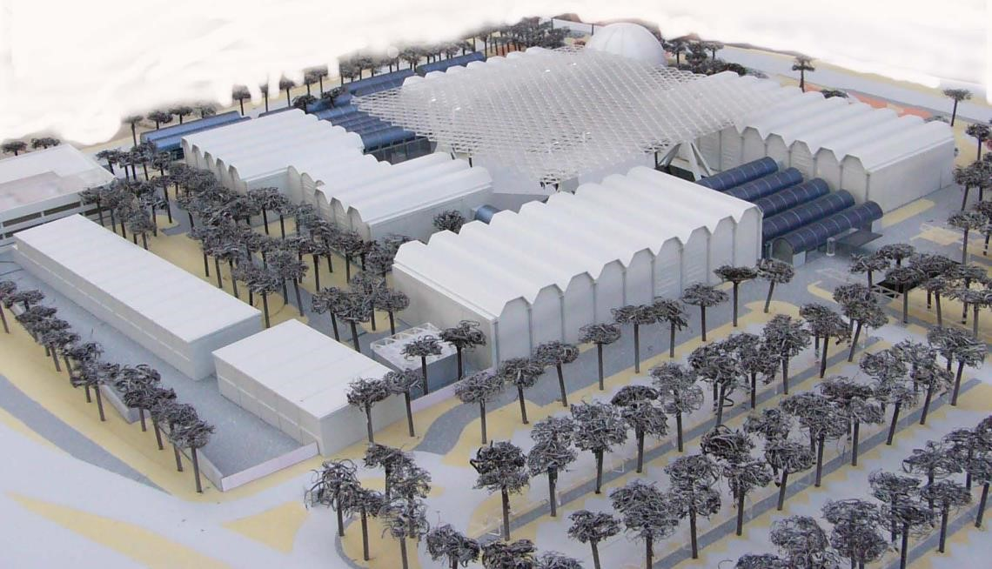
Implementing Partner | Supreme Ministry of Planning (SCPD)
Responsible Parties | Dar al-Athar al-Islamiyyah
Project Title | Training for Restoration and Display of the Dar al-Athar a-Islamiyyah Collection at the Kuwait National Museum
Project Duration | 2010 – 2013 (extended 2014)
Project Budget (USD) | 734.000,00 USD (including GSM 22.020,00)
Reporting Period | July – September 2013
Funds Available (USD) | 466.620,70 USD (Dec. 2013)
Contact Person | Dr. Roberto Fabbri architect, UNDP Consultant Project Manager  ^{mail:} r.fabbri@unibo.it mob.: +965 60946770

Table of Contents
Title | Page No.
1. Executive Summary | 4
Offline risk log | 7
2. Introduction | 10
3. Progress Review | 11
4. Challenges and lessons learned | 13
5. Partnerships and sustainability | 13
6. Financial summary | 14
ANNEX I: 2012 AWP | 15

ACRONYMS

ACC | Amricani Cultural Centre
CTC | Central Tender Committee
DAI | Dar al-Athar al-Islamiyyah
KNM | Kuwait National Museum
MPW | Ministry of Public Works
NCCAL | National Council for Culture, Arts and Letters
PACE | Pan Arab Consultant Engineering
PM | Project manager
SCPD | Supreme Ministry of Planning

Executive summary

This quarterly progress report reviews progress from October to December 2013 the accomplishment of project objectives.

DAI-UNDP Experts’ programme for training local professionals.
The Experts’ programme for training Kuwait DAI employees is fully operative and on-going to train professionals into two different museum fields: conservation and exhibition design. Furthermore the re-habilitation works of the National Museum offers the possibility to train DAI engineers / architect into museum construction management. The program includes the involvement of more experts with different specializations from what already available, in order to cover all the possible fields in museum.

Key developments

A total of four new expert positions on a short terms mission (3 months each) have been advertised in October to empower the DAI capabilities in conservation and educational programs.
The process of evaluation of the submissions ended in November and assigned three experts to the project. In the Board Meeting with DAI, SCPD and UNDP, the PM’s evaluation was presented, discussed and approved. The shortlisted experts (two conservators and one educator) were contacted and are actually in the paperwork process of joining DAI in Kuwait. They are expected to arrive and start working in January.
The training program, previously extended to the Junior docent program, in collaboration with DAI education department, finished its first round. The PM was involved in training 5 junior docents in museum and exhibition design.

Key challenges (risks and issues)

As mentioned in the last Quarterly Report the main obstacle in training programme is the lack of consistency of (some) DAI trainees. In the past years there was a big turnover of employees and plus some long term leaves that reduced the capability of the training program to build a consolidated working structure. To an extent, it seems difficult for DAI to build a long term relations with its employees, especially the young generation, and to have them investing in this training opportunity. With some (very positive) exceptions, young employees and trainees tend to stay a maximum of one year with DAI, to move then to other governmental sectors or to go back to study. DAI Engineering / architectural department is very understaffed. So is the conservation office. This means that the UNDP experts have to constantly deal with daily minor tasks, which could be easily undertaken by the trainees as part of their learning, and at the same time taking some of load out of the expert shoulders. This issue involves the general recruitment policy of DAI, which being a governmental institution has to proceed according to the local regulations. For this reason is difficult for the PM to take a direct action to tackle this challenge.

Recommendations (on risks, issues and way forward if applicable)
Mitigation: The new output (see next point) set up within the UNDP/DAI project shall address this issue in the “awareness campaign’’ to promote DAI in Kuwait and make it more attractive even as a place to work and to collaborate with. Moreover several meeting were taken, and more will are planned, to work with DAI senior staff on this issue.

DAI-UNDP - SCPD new output: Raising awareness in Kuwaiti population about culture and art.
DAI’s collection is one of the most representative collections of Islamic art in the world. It includes objects from a wide range of geographical areas and Islamic periods. The collection is a scholarly one that includes objects that are art historically important as well as of aesthetic significance. Also, DAI’s cultural season events offer patrons opportunities to gather knowledge and information about Islamic art and culture like they never have before.
Despite that, a minimal number of the general local public knows about DAI and their annual cultural activities. Therefore, DAI needs to increase its general awareness, and effectively communicate all of its events and activities.
Furthermore, DAI needs to show that it is a cultural institution that is here for the good and wellbeing of Kuwait. DAI is not an institution that is especially designed to cater to a specific segment of the population, but an institution that can provide intellectual and cultural knowledge to all patrons.
Therefore, the new output should not only build the awareness of the general public, but also establish an appreciation for art and culture. To do so, DAI must strengthen the internal capabilities to effectively and efficiently communicate to the public at large scale.

Key developments

UNDP and DAI decided to call for an expert to help to define the scope of work of the agency that will be procure at a later stage An international expert position was advertised in October. The submission were reviewed and evaluated by the PM, together with DAI counterpart. Unfortunately none of the profiles were satisfactory. The discussion was brough up to the Project Board meeting at SCPD and the conclusion was to re-advertise the position. The new call deadline is set for December 21st. New evaluation process will follow

Key challenges (risks and issues)
This idea of interposing a media expert between DAI and the procured Agency will definitively add quality to the project, but a t the same time the recruitment is taking time and is delaying the start of the project. At the moment, no tangible results can be presented for this output, despite several months of work.

KNM
At the beginning of 2013 The KNM project team was reshaped by the N.C.C.A.L. in order to adapt it to the new structure of the institution. The result of this operation is that the engineering department of N.C.C.A.L. took the project management position in order to follow on site the work of the contractor for Bidpack 4. This decision, endorsed by DAI General Director, shifted the position of DAI architects/engineers and the UNDP/DAI consultant to the role of advisors and enduser representatives in the pipeline of the project. Despite this fact, the major decisions are still taken collectively consulting all the parties involved. Nevertheless this decision put the engineering department of DAI less autonomous in taking action.

Key developments

Bidpack 4 - In the last three month the activities were small. All the documents and the contracts are now in the hands of governmental bodies which are dealing with the appointed contractor. Some legal/bureaucratical issues were raised up and the project consultants PACE with the
N.C.C.A.L. is trying to solve them. DAI and UNDP expert are not involved in this process and there is no much that can be done.

Key challenges (risks and issues)

The main issue for Bidpack 4 is to coordinate the actual delay, due to bureaucratic problems, with the upcoming phases. N.C.C.A.L. engineering department seems to have problems in solving this issue related to the tender, and moreover, to fix the pending snag list for the previous Bidpack. The latter is affecting the handover of the Building 9 with consequential delay on the collection relocation in the KNM area.

Recommendations (on risks, issues and way forward if applicable)

Mitigation: action were taken to compensate and re-adjust the timeline in the work plan, but for a more effective decision chain, the issue is an internal balance between DAI and NCCAL, and it is out of the UNDP consultant’s depth.

Conservation Office

This last year has been both busy and rewarding and very successful. Two excellent exhibitions have been installed in Kuwait and we have made numerous contributions in the form of loans to other international institutions.
Training which is foremost in the expert’s remit has continued apace with most of my efforts geared towards improving the skills of our staff.
Extensive and complex work on objects in the collection has been undertaken in preparation for exhibitions loans and publications.

Key developments

Expert Sophie Budden has been largely involved in supervising Kuwaiti assistant conservators with the conservation and preparation of objects for the planned loans, exhibitions and publications. Alongside this is the logistical preparation for transporting objects overseas and, managing the laboratory on a daily basis to ensure that work can continue.
I contribute to the Dar al Athar al Islamiyyah’s outreach programme by giving public seminars on the conservation and care of collections, by training junior and adult docents at DAI, and by communicating conservation where possible with other institutions in Kuwait such as the KNM and Sadu House.

Key challenges (risks and issues)

The key challenges are to be running a laboratory without sufficiently skilled staff. The collection suffers from only having one fully trained conservator available.

Recommendations

Ideally the valuable work done at the collection needs to be supported by another qualified conservator whose specialist training could complement my own. This would allow the staff to be trained in different aspects of collection care management and the conservation of objects.

Annex
OFFLINE RISK LOG

Project Title: Training for Restoration and Display of the Dar al-Athar a-Islamiyyah Collection at the Kuwait National Museum | Award ID: | Date: Dec. 2013

# | Description | Date Ident ified | Type | Impact &  Probabi  lity | Countermeasure  s / Mngt  response | Owner | Submitte  d,  updated by | Last  Update | Sta tus
1 | Lack of consistency of (some) DAI trainees. In the past years there was a big  turnover of employees and plus some long term leaves that reduced the capability of the training program  to build a consolidated working structure. To an extent, it seems difficult for DAI to build a long term relations with its  employees,  especially the young generation, and to have them investing in this training opportunity.  With some  (positive) exceptions, young employees and  trainees tend to stay a maximum of one year with  DAI | Jan 2013 | Organizatio  nal | P = 3  I = 4 | the new output in the project shall address this issue in the “awareness campaign’’ to promote DAI in Kuwait and make it more attractive even as a place to work and to collaborate with.  On the other end, the Governmental side of DAI  (NCCAL) should be advised to start a more strategic HR policy to recruit the correct. | DAI HR  dept. | DAI HR dept. | Sept 2013 | No cha nge

Introduction

Preamble
The KNM is situated between Saif Palace and the Parliament and was planned by architect Michel Ecochard. In 1960, the Government of Kuwait approached UNESCO with a view to establishing a programme for a National Museum. It took some time to begin the works and the construction finally started in 1981, though the project and plans were made long back in 1960.
The inauguration of two of the four buildings of the KNM was held in 1983 and the museum’s planetarium opened in 1986.
The museum exhibited at that time the excavations from Failaka island and, as of 1983, the Islamic Art Collection owned by Sheikh Nasser Sabah Al-Ahmad Al-Sabah and his wife Sheikha Hussah Sabah Al-Salem Al-Sabah, who is also the Director of Dar Al-Athar al-Islamiyyah (DAI), lent to the State of Kuwait (Ministry of Information 1983-1999), after that with the National Council for Culture, Arts and Letters (NCCAL) from 2000.
During the Gulf War (1990-1991), two buildings and the Planetarium suffered severe damage. The Islamic art collections were taken and moved to Iraq. After the war the most part of the collection was returned to the State of Kuwait. At that time Building No. 3 previously hosting the Al-Sabah collection was partially burned.
Since 2003 the re-arranged building No. 2 of the KNM features the Ethnographic Museum (Museum of local popular traditions) with the reproduction of the old Souk with its social, economic, political and religious life.
Since 2005 the KNM is exhibiting artefacts from the excavations in Failaka, in the building No. 1 which was meanwhile rehabilitated. The initial plan was to keep the other buildings in ruins as memorial of the invasion, but the idea changed and reconstruction began in 2000. In 2001, a project (KUW/01/003) was started to develop plans for a new museum.
During the summer of 2001, NCCAL and DAI selected a qualified consultant to study Buildings No. 3 and No. 4 and prepare plans for their restoration.

The Works were subdivided in two phases:
Phase 1 – Survey and Concept Design
Phase 2 – Detailed Design and Constructions

Phase 1 was completed during the first UNESCO Mission. Between March 2002 and February 2004, UNESCO provided the assistance of 13 different experts on 7 short term missions .
These experts gave mainly advice to the local consultant on the concept of the museum and proposed to add 5 additional buildings to the complex in aid to the rehabilitation the 2 pre-existing buildings.

Phase 2 has been also divided in 5 sub-phases (Bidpacks). In January 2004 the rehabilitation project was so much increased in terms of sizes and complexity that DAI called for a full-time international professional, through UNDP, to follow the design part, the supervision and to coordinate with the NCCAL. This expert’s duty was/is to train Kuwaiti professionals (architects and engineers) and coordinate with locals institutions / consultants and other UNDP experts involved in the programme.

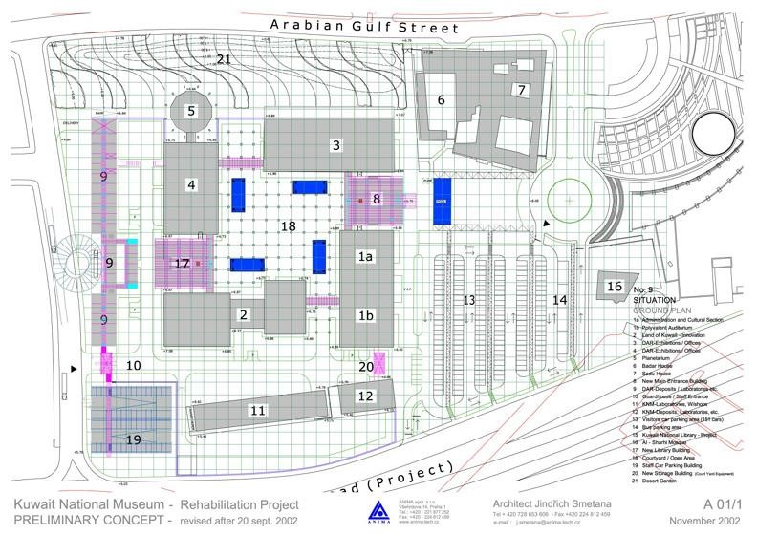

KNM Phase 2 – Bidpack1 (Infrastructures) COMPLETED
This phase scope of work was the construction of the power station that supplies the entire compound. The Central Plant (Building n.11) started on January 2005 and was completed and has been functional since December 2005.

KNM Phase 2 – Bidpack2 (Buildings 9 and 21) 90% COMPLETED
This phase of the work consisted in the final design and construction of two new buildings: Building n. 9 (Collection office and Archive, Conservation department and labs , Curators department, Photography labs and Architecture / Engineering department) and Building n.21 (Museum employees car park).
The construction started in February 2008 and was completed in 2011. Several months were spent in 2012 to provide Building 9 with electrical power. At the moment this building is going through a small snag list (minor adjustments) and will be furnished and operative by the beginning of 2013. It will become the centre of the activities for the preparation of the galleries (and the artefacts) of the National Museum. Building 21 is also completed but due to a structural failure in one concrete slab the case was brought to the court. In the short terms this case should come to a solution.

KNM Phase 2 – Bidpack 3 (Underground services) COMPLETED
This phase consisted in the net of underground services which connects the whole compound. The Bidpack was tendered in June 2009 and finished in 2011. Despite the fact that it is not visible, for its own nature, this was a very important part in the restoration process of bringing back the museum to life. This service network is necessary to provide the existing buildings of all that most advanced technical apparatus vital for a contemporary museums.

KNM Phase 2 – Bidpack 4 (Buildings 3, 4, 8, 17, 19 and 20) TENDERED / READY TO START
This phase’s scope of work is the civil works for the complete restoration of the two original buildings (Bldg. 3 and 4) including the finishes and the furniture, plus the construction of two new volumes which will host the main entrance (Bldg. 8) and the Library (Bldg. 17). In addition to this the connections between the buildings (bridges 19 and 20) and the landscape and outdoor arrangement are included. The detailed design phase was completed and approved in 2011 and the package was tendered in June 2012. The start of the construction phase is expected in 2013.

KNM Phase 2 – Bidpack 5 (Museums Galleries and artefact installation) PREPARATION TO TENDER
This phase’s scope of work is the complete arrangement of the museum galleries, including show cases production and displacements, objects installation, graphics and text contents, audio-visuals.
The working drawings and the tender procedure were submitted by the main consultant in July 2012. The documents were commented by the project managements in the last months and after the necessary adjustments the package will proceed to tender. The tender result is expected in late 2013.

DAI-UNDP Experts’ programme for training local professionals ON-GOING
All the above-mentioned phases were coordinated, supervised and managed by an international consultant provided to the project by UNDP. Three experts covered the role of Project Manager since the program started: eng. Martin Buxtorf from 2001 to 2010; eng. Eisa al-Sarraf from 2011 to 2012; arch. Roberto Fabbri from June 2012.
The projects manager trained, along the process of the KNM construction history, two Kuwaiti professionals in the field of building design and construction; restoration; museum design; public work procedure; tender procedure; supervision and project management. These local professionals were always on the side of the project manager in order to have a direct experience of this complex project.
The UNDP – DAI - SCPD programme is not only focused on the museum building, but also on the artefacts that will be displayed in the galleries. For these purpose, under the coordination of the PM the programme brought experts to work on the objects and their display systems: Ms. Sophie Budden, expert in artefacts conservation, is training from September 2010, two local assistant conservators from DAI collection office, in the technique of cleaning and protection, in conservation ethic and methodology and installation of ancient objects. In January 2011 Roberto Fabbri, as expert in museum and exhibition design, joined the program training 5 DAI employees at the Amricani Cultural Centre. In June 2012 the position of expert in museum and exhibition design was merged with the position of project manager and is currently hold by Roberto Fabbri.
In September 2012 a Project coordinator is been added to the program in order to have a better coordination between the 3 different locations involved in the program (ACC; Collection Office, KNM). This new figure, Amal al-Ahzaah helped the implementation of programme, as planned in the yearly work plan. in late 2013 the program will issue a call for an expert for training in artefact installation and display (mounts maker) and in the same timespan two other conservators, specialized in metal and ivory, plus an expert/trainer in museum educational and communication programs. The Project coordinator’s job was completed at the end of 2012 leaving the program with a better structure in terms of coordination and communication between the parties.
In the last trimester of 2013 DAI is expecting to have a total of four new expert-consultant each on a 3 months mission to empower the capability of the conservation office and to build a stronger educational programme.

Quarterly Progress Report | October-December 2012 | Kuwait National Museum

Progress Review: January – December 2013 (transaction updated to 10 Dec. 2013)
Output 3.1  Training of Kuwaiti engineers and architects in construction management and supervision, especially in the rehabilitation of the building .  Baseline:  2 kuwaiti arch./eng.  Indicators:  Continue of training  Targets:  - 2 trained Kuwaiti arch./eng. For design and supervision. | Provide training to Kuwaiti architects / engineers in application of tender documents during the construction phase.  Provide training in construction supervision  Provide training in contractors’ submittals checking  Provide training in technical meeting  Provide training in maintenance supervision  Undertake any other tasks pertaining to the consultancy deemed  appropriate by DAI and UNDP  Local and international experts’ reports reviews | 135.000,00 | 131.146,98 |  | - Trainees Kuwaiti architects/engineers were involved in the tender procedure for KNM .  - Trainees Kuwaiti architects/engineers were involved in the review of the contractors offer for the tender.  - Trainees Kuwaiti architects/engineers were involved in technical meeting while decisions were taken.  - Trainees Kuwaiti architects/engineers were involved in the supervision of the maintenance works at the ACC. | Indicators:  Trainees Kuwaiti architects/engineers are now more familiar with the tender procedure for this type of public works (Partially achieved).  Targets:  Qualified DAI project staff capable of participation with project manager, team leaders and project consultant in project execution (Partially achieved).
11
Quarterly Progress Report | October-December 2012 | Kuwait National Museum

Output 1.1  Training of Kuwaiti nationals in conservation of ancient artefacts.  Beseline:  1 Kuwaiti national  Indicators:  Continue of training  Targets:  1 trained Kuwaiti national in conservation | Assist Kuwaiti Authorities to undertake conservation work on the collection of the museum and undertake any other work in connection with the conservation of the collection  Provide training and advise to assistant conservators in the conservation work on the collection of the museum  Liase with other curatorial staff  Manage the conservation  laboratories  Train and implement a program of environmental monitoring  Train and implement a Pest management programme  Train the strategies for the ‘housekeeping’ of the collection in the storage and on display  Outsource and manage external  specialized expertize | 105.000 | 110.070,00 | - Trainees Kuwaiti assistant conservators were involved in conservation work on the collection.  - Trainees Kuwaiti assistant conservators were involved in management for the conservation laboratories, in ‘house keeping’ of the collection and in the implementation of Pest management programme.  - Trainees Kuwaiti assistant conservators were involved in environmental monitoring of the ACC galleries. | Indicators:  Trainees Kuwaiti assistant conservators are now more aware with the necessary steps for conservation and organization of a collection of ancient artefacts according to international-standard. execution (Partially achieved).  Targets:  Qualified DAI project staff capable of participation with project manager, experts, team leaders and project consultant in project execution (Partially achieved).
 |  | 240.000,00 | 241.217,4
GSM / FNA | / | 10.710,00 | 26.161,9
 | / |  | 267.379,3
12

Quarterly Progress Report | October-December 2012 | Kuwait National Museum

Challenges and lessons learned

Ch. 1 - Strengthening the quality control on the contractors offer in KNM tender procedure.

Ch. 2 - Strengthening the time control during the construction phase of the KNM

Ch. 3 – Consolidation of the exhibition plan as much as possible, not only to address an high level cultural offer to DAI visitors, but also because exhibitions are events in which many different DAI departments are involved and are called to give answers on a common project. For DAI and its employees the exhibitions and the related events are very good opportunities to strengthen the teamwork strategies and to exchange knowledge. Exhibitions at ACC are very important training sessions for all the DAI staff (collection, conservation, design, PR, management, etc.) in order to be ready to run bigger and more complex events in KNM.

Partnerships and sustainability

This project is involving several local and international institutions at different levels.
In particular the exhibition events, which are providing a ‘’learning by doing’’ experience to Kuwaiti trainees, have been developed with major international institutions such as the Institute du Monde Arabe of Paris (IMARABE) or the Japan Foundation and locals like the NCCAL and local universities. More recently, the new events brought a large number of international scholar to the inauguration, due to the importance of the objects in display.
A full day conference introduced the venue and saw the presentations of scholars and curators from Europe and America, but also from the Region: Iran, Iraq and Afghanistan.
The DAI educational program is often organized around the subjects of the exhibitions and is working in close contact with public and private schools to provide training to students of any age. The incoming season is trying to build up more bridges at local level like with universities and other cultural organization.
13
Quarterly Progress Report | October-December 2012 | Kuwait National Museum

Financial Summary

The following table presents an overview of expenditures incurred during the reporting period (Jan.-Sept.2013 transaction updated until 29 Aug.2013).

CATEGORIES | EXPENDITURE (USD $)
International Consultants | 241.217,4
Local Consultants | /
Travel Costs (DSA-international) | /
Facilities & Administration | 26.161,9
TOTAL | 267.379,3
14

KUWAIT

الكــــويت

Training for Restoration and Display of the Dar al-Athar a-Islamiyyah Collection at the Kuwait National Museum
2013 YEARLY WORKPLAN PRESENTATION:
AMENDMENT JULY 2013

Implementing Partner | Supreme Ministry of Planning (SCPD)
Responsible Parties | Dar al-Athar al-Islamiyyah
Date | January 2013 and July 2013
Contact Person | Dr. Roberto Fabbri architect, UNDP Consultant Project Manager  ^{mail:} r.fabbri@unibo.it mobile: +965 60946770

The key developments for the project in 2013 will be the following:
- The beginning of construction phase for the 4th stage of the civil works on the KNM buildings. The final preparation of the specifications and the issue of next stage tender (Bidpack 5).
- Relocation of the DAI Collection office in the Building 9 of the KNM compound.
- The addition of an new output (named output 4) for strengthening the communication abilities of DAI in order to promote its cultural activities and be more efficient in addressing the potential public.

In order to do that the project shall support DAI to:
A1. Follow the construction phase to be sure that all the decisions and actions will meet DAI standards and needs in the display of the collection.
A2. Provide training to the local engineers in dealing with this level of complexity in building construction, site supervision and tender management.
A3. Control, advise and teach the correct way to shape the next stage tender.
B1. Organize advice and train local employees in all the steps needed for preparing the spaces in the new collection office (building 9).
B2. Organize advice and train local employees in all the steps needed for preparing the objects for the relocation in the new collection office (building 9).
B3. Organize advice and train local employees in all the steps needed in terms of logistics and transportation.
C1. Procurement of specific expertise to build up the knowledge of managing communication strategies in DAI media department.

The project shall confirm the following figures:
- Project Manager: his duties, among the others, are to run the project, to coordinate with the other experts, to lead and follow all the task mentioned above (with a particular emphasis on A 1,2,3) . The PM is also acting as an Exhibition design consultant to DAI for all the issues that are involving museum galleries and fit outs.
- Wood and stone conservator (Ref 1): her main duties is to lead, train and advice the local assistant conservators. This expert also will act as a technical coordinator with the other incoming experts in conservation. This expert will also play a key role in the relocation process of the collection (B 1,2,3).

The project shall call for the following experts:
- Expert in conservation: metal (non-organic) (Ref4). This expert’s duty is to coordinate with the head of conservation to prepare specific type of objects for the relocation and the future display. Moreover the expert will advise and provide training to the local assistant conservators on specific type of objects.
- Expert in conservation: metal (organic)(Ref5). This expert’s duty is to coordinate with the head of conservation to prepare specific type of objects for the relocation and the future display. Moreover the expert will advise and provide training to the local assistant conservators on specific type of objects.
- Expert in mount-making (Ref 3). This expert’s duty will be to coordinate with the head of conservation in order to study the feature that will hold the objects in display (mounts). The expert will provide training and advise to the local installers and assistant conservators on this very specific museum field.
- Expert in educational program for museums (Ref6). This expert is needed to stat the development of the contents that the KNM and the collection will deliver. The Museum shall start planning in advance the level of communication and education in order to meet international standard. The Expert will coordinate with DAI educational department, will advise on the set up of the educational plan and provide training to local DAI employees about communication and education.
- Expert or professional agency experienced in cultural campaign for Museums and communication for art educational institutions (new output).

See the Project Staff timeline and the Annual Workplan for details.

Attachment:
  - Project staff timeline
  - AnnualWorkplan2013 (Annex1) – Amendment

Project staff timeline (2 years projection)
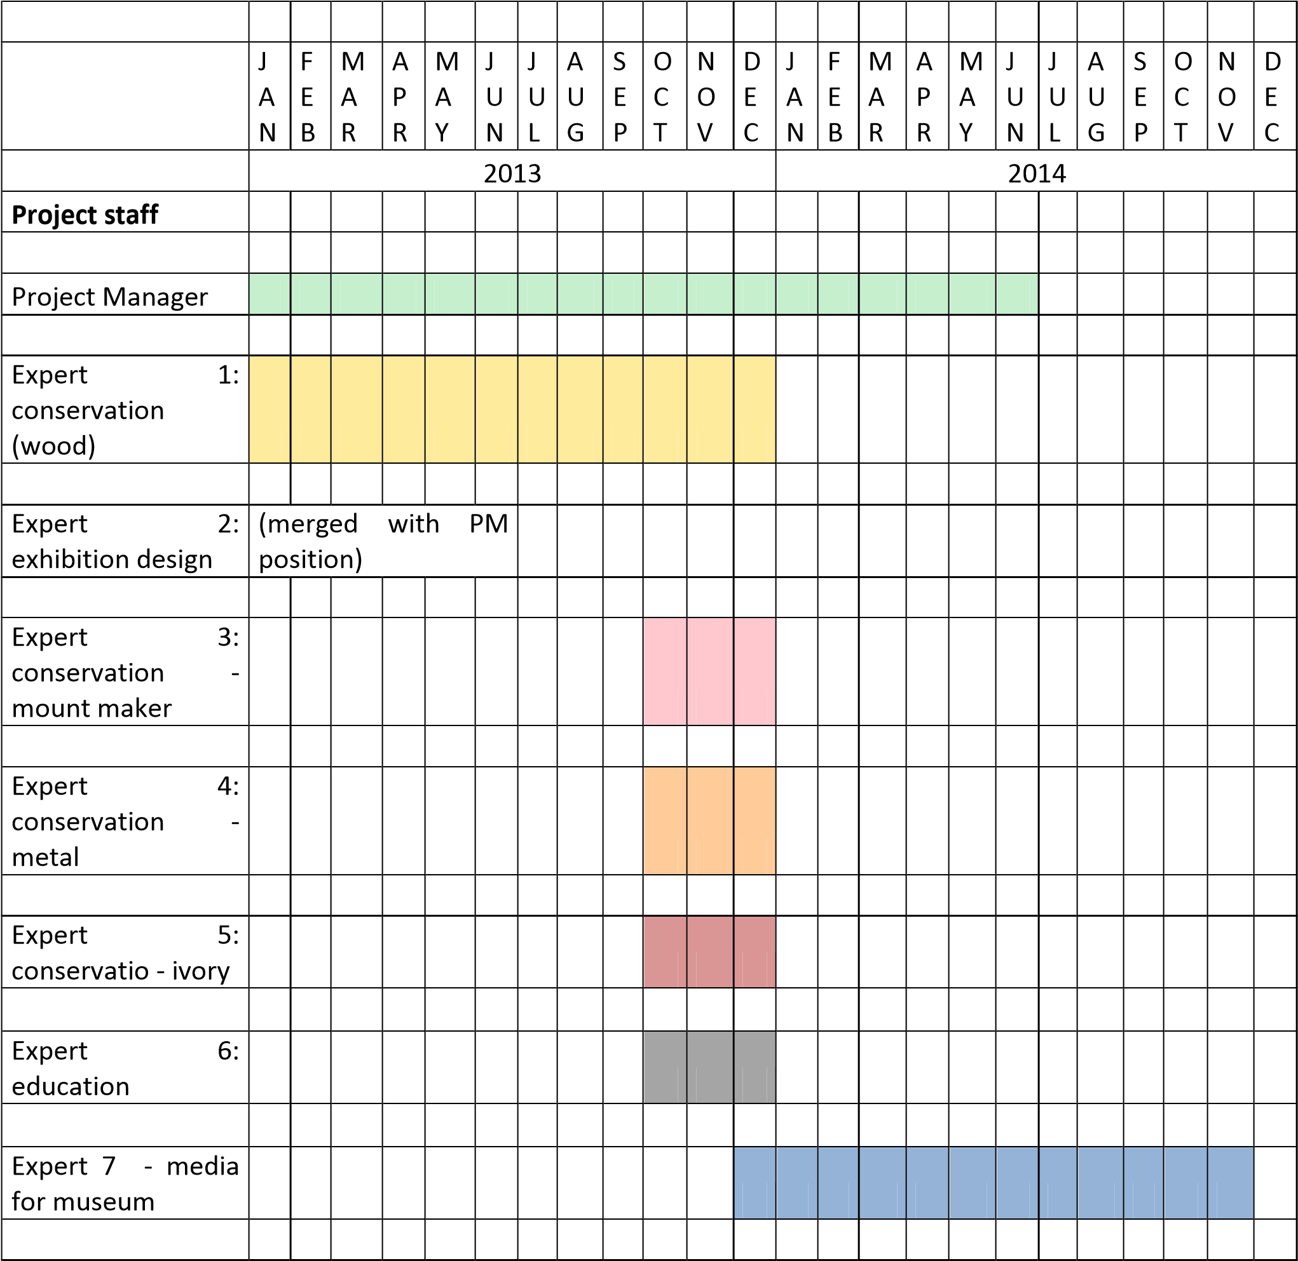

3.
Presented by: Roberto Fabbri architect Ph.D

UNDP consultant and KNM P.M.

Output 3.1  Management of the project of KNM, planning the different phases, control, supervise and advise on the museum design,  galleries  preparation and installation of the museum fit out and artefacts. Training of  Kuwaiti engineers and architects in construction  management and supervision.  Baseline:  2 Kuwaiti arch./eng.  Indicators:  Continue of  training  Targets:  2 trained Kuwaiti arch./eng. For design and supervision. | Manage, Coordinate and supervise the works for the museum rehabilitation, the galleries development, the new exhibition layout, the showcases displacement, the objects display and the graphic and AV conception. | 3  M | 3  M | 3  M | 3  M | Dar alAthar alIslamiyyah | UND  P | Contract for internati onal consulta nt(PM) | 135.000
 | Coordinate the works between the consultants, the contractors, the experts and the DAI project committee
Train DAI architects and engineers in
construction supervision
 | Provide training to Kuwait engineers and architects in application of the tender documents during the construction phase.
 | Train in museum and exhibition design, galleries preparation, objects installation.
 | Train in review all reports submitted by all consultants, local and international.
 | Train in checking the submittals from the contractors.
 | Train the architects / engineers in technical meetings.

Train in museum
maintenance supervision.
Undertake any other tasks pertaining to the consultancy deemed appropriate by DAI and
UNDP
Output 2.1 (2)  Training Kuwaiti employees designing, preparing installing mus exhibitions: (mount making Baseline:  2 Kuwaiti employees Indicators:  Identification trainees  Targets:  2 trained Ku nationals mount making. | of  DAI in  and eum  ).  DAI  of  waiti in | Train in manufacturing of mounts and fixation for artefacts(together with the conservation experts) | 2  M | 1  M |  |  | Dar alAthar alIslamiyyah | UND  P | Contract for internati onal consulta  nt | 25.000
 |  | Provide training in installation of the artefacts in the exhibitions.
 |  | Undertake any other tasks pertaining to the consultancy deemed appropriate by DAI and UNDP
Output 2.3  Training Kuwaiti employees education program museums. Baseline:  0 Kuwaiti employees Indicators:  Identification trainees  Targets:  2 trained Ku nationals  museum  education programs. | to  DAI in for  DAI  of  waiti in | Provide training in preparing educational programs, such as pottery, painting and other manual works. |  |  | 2  M | 1  M | Dar alAthar alIslamiyyah | UND  P | Contract for internati onal consulta  nt | 25.000
 |  | Provide training in testing educational programs.
 |  | Training in guiding educational programs with students.
Undertake any other tasks pertaining to the consultancy deemed appropriate by DAI and
UNDP
Output 1.1  Training of  Kuwaiti nationals in conservation of wood and stone artefacts. |  | Assist Kuwaiti  Authorities to undertake conservation work on the collection of the museum and undertake any other work in connection with the conservation of the  collection | 3  M | 3  M | 3  M | 3  M | Dar alAthar alIslamiyyah | UND  P | Contract for internati onal consulta nt. | 105.000

Baseline:  1 Kuwaiti national  Indicators: Continue training  Targets:  1 trained Kuwaiti  national conservation | of  in | Provide training and advise to assistant conservators in the conservation work on the collection of the museum
liaise with other
curatorial staff
Manage the
conservation laboratories
Train and implement a program of
environmental monitoring
Train and implement a
Pest management
programme
 |  | Train the strategies for the ‘house-keeping’ of the collection in the storage and on display
 |  | Outsource and manage external specialized expertize
Train and implement and carry out a programme of in-house conservation (approx..
33.000 objects)
 |  | Support the expert for the display of the artefacts in the museum
Undertake any other tasks pertaining to the consultancy deemed appropriate by DAI and
UNDP
Output 1.2  Training of  Kuwaiti nationals in conservation of metal artefacts.  (non - organic)  Baseline:  0 Kuwaiti national  Indicators: Identification of the trainees.  Targets:  3 trained Kuwaiti nationals in  conservation |  | Assist Kuwaiti  Authorities to undertake conservation work on the collection of the museum and undertake any other work in connection with the conservation of the  collection |  |  | 1  M | 2  M | Dar alAthar alIslamiyyah | UND  P | Contract for internati onal consulta nt. | 25.000
 |  | Provide training and advise to assistant conservators in the conservation work on the collection of the museum
liaise with other
curatorial staff
Undertake any other tasks pertaining to the consultancy deemed appropriate by DAI and
UNDP

Output 1.3  Training of  Kuwaiti nationals in conservation of ivory artefacts.  (organic)  Baseline:  3 Kuwaiti  nationals  Indicators:  Continue of  training  Targets:  1 trained Kuwaiti national in  conservation | Assist Kuwaiti  Authorities to undertake conservation work on the collection of the museum and undertake any other work in connection with the conservation of the  collection |  | 2  M | 1  M |  | Dar alAthar alIslamiyyah | UND  P | Contract for internati onal consulta nt. | 25.000
 | Provide training and advise to assistant conservators in the conservation work on the collection of the museum
Liaise with other
curatorial staff
Undertake any other tasks pertaining to the consultancy deemed appropriate by DAI and
UNDP
Output 4  Expert and  professional agency experienced at international level specific in cultural campaign for Museums and  communication for educational  Institutions  Baseline:  3 Kuwaiti trained in media for museum. | Provide training in cultural communication campaign for museums |  |  |  | 3  M | Dar alAthar alIslamiyyah | UND  P | Contract for Internati onal expert and procure ment  internati onal agency | 200.000
to develop a system to communicate and to
gather information
 | To increase overall awareness as a measureable objective and to strengthen the public response towards the museum’s offerings.
Undertake any other tasks pertaining to the consultancy deemed appropriate by DAI and
UNDP
Indicators:
Continue of
training

Targets:
3 trained Kuwaiti DAI employees for museum media and
cultural
communication
 |  |  |  |  |  |  |  |  | SUM | 540.00  0
Monitoring and  Evaluation  (MAE) |  | ✓ | ✓ | ✓ | ✓ | UNDP |  | UND  P | Cost for MAE  activities  (5%) | 28.100
 |  |  |  |  |  |  | SUM 568.100,00
Miscellanea (unforeseen) |  | ✓ | ✓ | ✓ | ✓ | DAI | UNDP |  | Costs | 45.700
General Management Support (GMS) |  | ✓ | ✓ | ✓ | ✓ | UNDP | UNDP |  | Cost for FNA  activities  (3%) | 16.200
 |  |  |  |  |  |  | TOTAL 630.000,00
July 25th 2013

