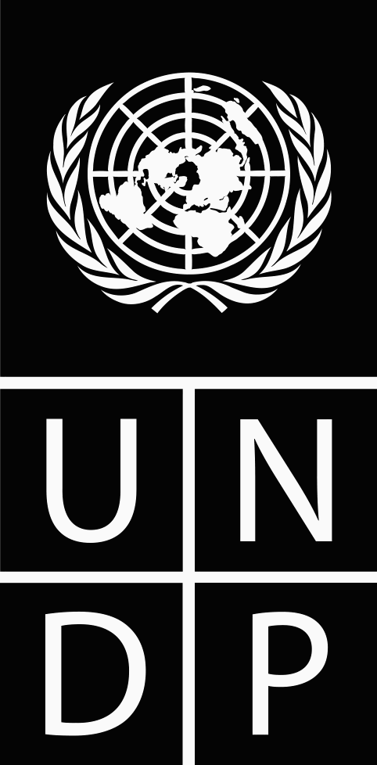UN Development Programme
Mauritania - Nouakchott
11/12/2017
00089672
Award ID:
MRT Direct Project Costing
Award Title:
Start Year:
End Year:
2018
2015
Implementing Partner
(Executing Agency):
UNDP
Budget (US$) as of Last Revision on
Amount
Fund
Donor
UNDP
TRAC (Lines 1.1.1 and 1.1.2)
307,000.00
04000
UNDP
XB GMS funds
40,000.00
11300
UNDP
XB Cost Center Retained Stock
20,000.00
11301
Total Budget (
Total Expenditure (
Award Total
Unprogrammed/Unfunded
367,000.00
378,635.00
11,635.80
00.00
and Beyond )
2018
2017
and Prior ) )
Responsible Party
(Implementing Agent):
UNDP
Revision Type:
Brief Description:
Agreed by:
Agreed by:
Agreed by:
Agreed by:

