FAQs
e-Services Phase II
HR Focal Points/Leave Monitors
The Role and Profile of the Leave Monitor
1. What is the role of the leave monitor in e-Services
2. Which ATLAS profile is required to be a leave monitor

Absence Module: e-Services
3. Where to see and how to approve pending leave requests in e-Services
4. Which SC leave requests in e-Services will require approval of HR focal point/leave monitor
5. Will the leave monitor receive notifications when the leave request is submitted/approved
6. How to add, delete or edit leave in the Absence Module

Leave Balances
7. How can I check if manual adjustments were made to the leave balance and how can I adjust the leave balance, if necessary
8. Do I need to 'zero' out the leave balance upon separation of an SC holder
9. Leave balances for Servicer Contract holders that do not have access in e-Services
10. How to understand the different balances in the leave module
11. How to check if an annual leave period was deducted from the annual leave balance

Attendance Record Card
12. How to run the absence record card
13. Who are the signatories on the absence record card

Holiday and Work Week Schedules
14. How to view/assign/adjust the holiday schedule
15. How to assign two different holiday schedules
16. How to assign Work Week Schedule

Reports and Queries
17. Which query is the best to run to see monthly absence report by department or country
18. Review of the absence reports and leave balance for the SC Holder

Miscellaneous
19. Do we still need to use the paper forms for leave management?
20. Do we need to keep sick leave certificates
21. How to record an official business in Atlas HCM
22. How to record claim of CTO for SC? What supporting documents should be kept in files?

The Role and Profile of the Leave Monitor

What is the role of the leave monitor in e-Services
With the introduction of eServices, the role and functions of leave monitors have changed. E-Services has reduced the need for leave monitors to record and administer leave in the Atlas Absence module. At present, annual leave, sick leave, maternity and paternity Leave are requested, recorded and approved directly in e-Services module, between the SC holders and their supervisors. As such, the leave monitor’s functions have shifted away from recording of absence takes towards monitoring and advising functions on questions of leave.
More specifically:
- Provide information and training to new SC holders on how to use My Leave in eServices;
- Assist SC holders on questions related to leave administration;
- Assist SC holders/ HR adjusting the leave balance;
- Enter leave types that are not yet included in e-Services (such as Compensatory Time Off, Official Business etc.) in the Atlas Absence module;
- Ensure that the attendance cards are signed by the SCs
- Signing off on leave balances at prescribed intervals
- Keep management informed on any issues pertaining to leave.

Which ATLAS profile is required to be a leave monitor
As a leave monitor your Argus focal Point should set you up with the ‘Absence Processor’ profile
Please note that the roles of HR Administrator and Absence Processor can be combined, hence it is possible for same person to be both HR focal point and leave monitor for SC holders.

Absence Module: e-Services
The e-Services Leave module is linked to the Absence Module. Approved leave in e-Services will automatically be reflected into the payroll module for absences. The Absence module – or more correctly the Absence Event page - is located in Global Payroll & Absence Mgmt / Payee Data / Maintain Absences. On this page you can view leave history for your SC holders, check the status (approved, submitted, …) and whether the leave was entered through e-Services (Entry Source will say 'Employee Self Service') or by the leave monitor (Entry Source will say 'Administrator').
In addition, if you click the link 'Details' you can check the status of leave request:
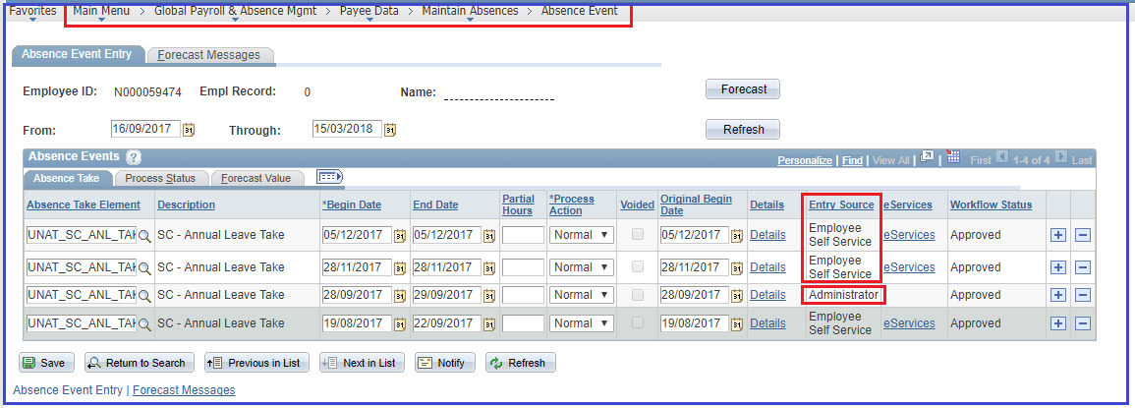
- If it has been processed by payroll, the status will show Finalized and leave balances updated.
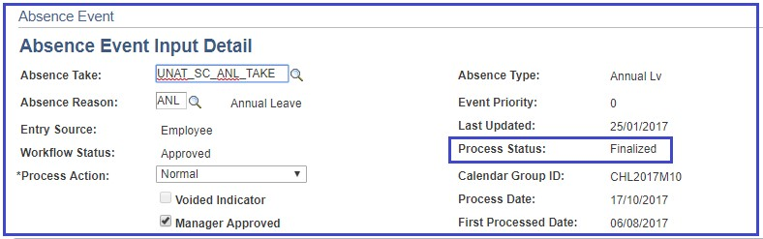
- If the status is 'Not Processed' it means the leave has not been updated.

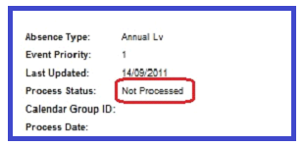

Where to see and how to approve pending leave requests in e-Services
Please follow the navigation below in order to view and process the pending absence requests as a leave monitor
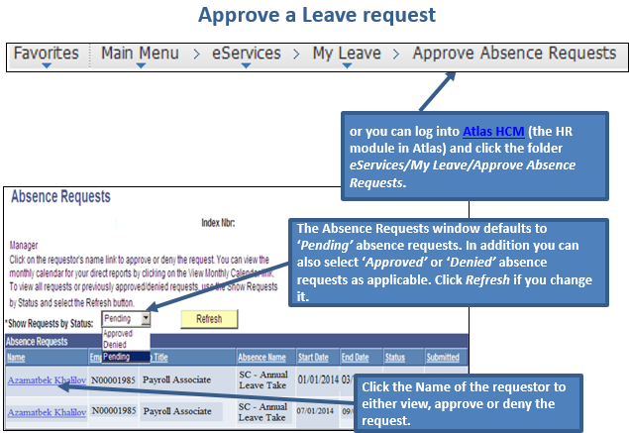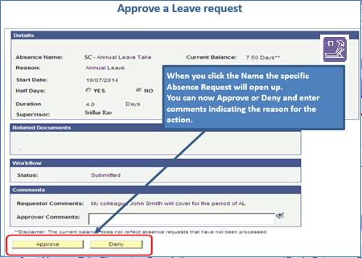

Which SC leave requests in e-Services will require approval of HR focal point/leave monitor
Maternity and paternity leave will require approval of supervisor and HR focal point. Leave monitor gets notified of approvals of all leave types.

Will the leave monitor receive notifications when the leave request is submitted/approved
Yes, each time the leave request is processed in e-Services i.e. submitted/denied/approved, the respective leave monitor receives an email notification.

How to add, delete or edit leave in the Absence Module
In the Absence Module you can enter leave, delete or edit the leave request on behalf of SC. For leave type that is not yet in e-Services E.g. Compensatory Time Off (CTO), you can manually enter the new leave.
In addition, you can use the Absence Module as a ‘back-door’ entry to assist SCs with leave entered through e-Services. Normally, leave monitor should not use the Absence Module to adjust leave entered by SC holders, but sometimes it may be needed e.g. if SC does not have access to internet or computer and needs to amend a submitted or approved leave. Any adjustments to the submitted leave, need to be done with the consent of the SC holder’s supervisor.
In the Absence Event page, the leave monitor can:
- Change the dates of the leave period: note that ‘Original Begin Date’ should be the same as ‘Begin Date’, click ‘Save’
- Delete leave request: click the minus (-) sign next to the leave and click ‘Save’. Any annual leave balance already deducted will automatically be granted back after payroll is recalculated. But it is a good practice to check that this happens when next payroll is processed.
- Change the status of the leave request to ‘Approved’: click the ‘Details’ link, tick ‘Manager Approved’, and click ‘Save’
- Add leave request manually: click the plus (+) sign, select the leave type and enter the period, click ‘Details’ and ‘Manager Approved’ and click ‘Save’.
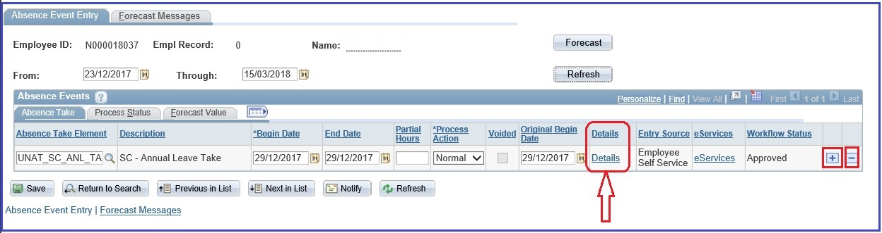

Leave Balances

How can I check if manual adjustments were made to the leave balance and how can I adjust the leave balance, if necessary
Annual leave and sick leave balance are automatically processed when entered and approved through eServices. In certain cases, leave monitor may need to manually adjust leave balance in Atlas.
When you adjust the leave balance, make the adjustment for the current month.
When making an adjustment ensure that you select the correct search parameters such as Pay Group and Calendar ID. The formula for the leave adjustment:
Adjustment figure = Correct leave balance as per HR records – Current balance in Atlas HCM
Remember that you cannot enter an adjustment for the same element twice for the same month and calendar group. You would need to combine them into one adjustment for that element.
The navigation to view and enter the adjustment is shown below:
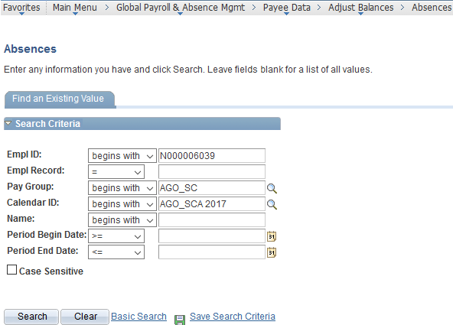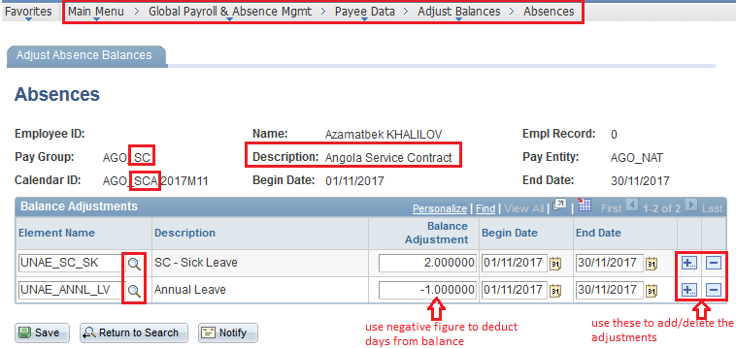
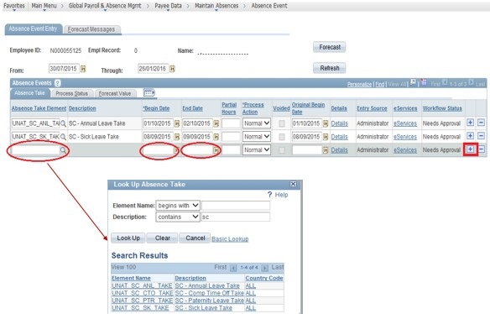

Do I need to 'zero' out the leave balance upon separation of an SC holder
No, there is no need to zero out the leave balance upon separation of an SC holder

Leave balances for Servicer Contract holders that do not have access in e-Services
Atlas will continue showing leave balances for all SC holders in your office regardless of their access to e-Services. If SC holders do not have access to eServices, but their leave absences are administered through Atlas, then the respective leave monitor will need to manually process their leave takes in Absence Module and adjust the balances as needed.
For those SC holders whose leave is not administered in Atlas HCM, the absences will need to be administered manually as per the paper-based practice.

How to understand the different balances in the leave module
Currently, there are only 4 leave types available in e-Services balances of which will also appear in the leave reports and queries. Leave entitlements for SCs are guided by the terms and conditions indicated in the SC contract

How to check if an annual leave period was deducted from the annual leave balance
For any leave take recorded in Atlas, payroll must be processed in order for leave to be deducted from the SC holder’s leave balance. Once payroll is processed (opened, recalculated, finalized) you can run the query below and review the latest leave balances:
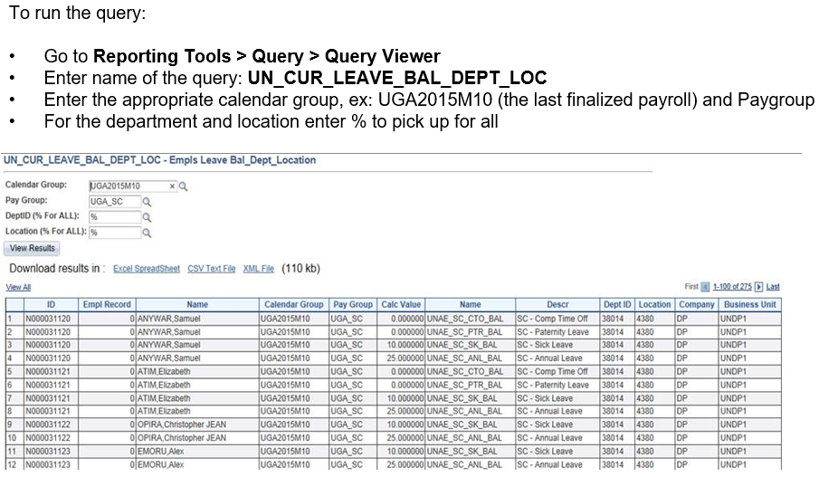

Attendance Record Card

How to run the absence record card
Follow the navigation below in Atlas HCM:
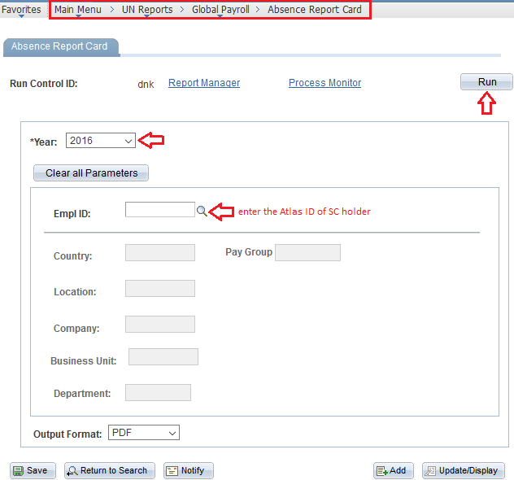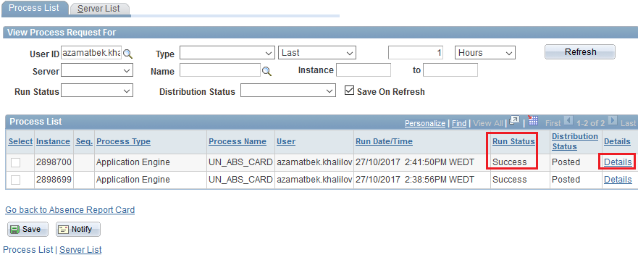
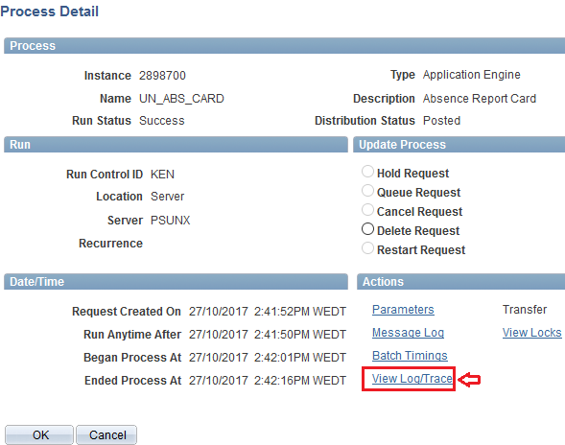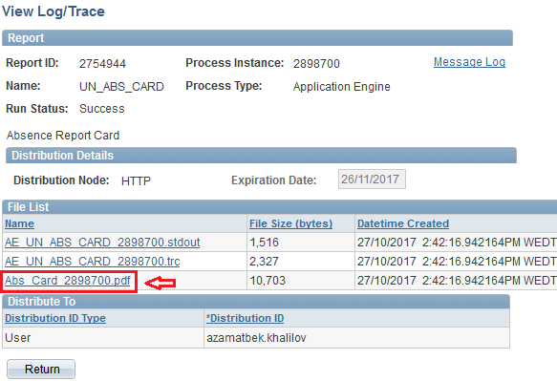

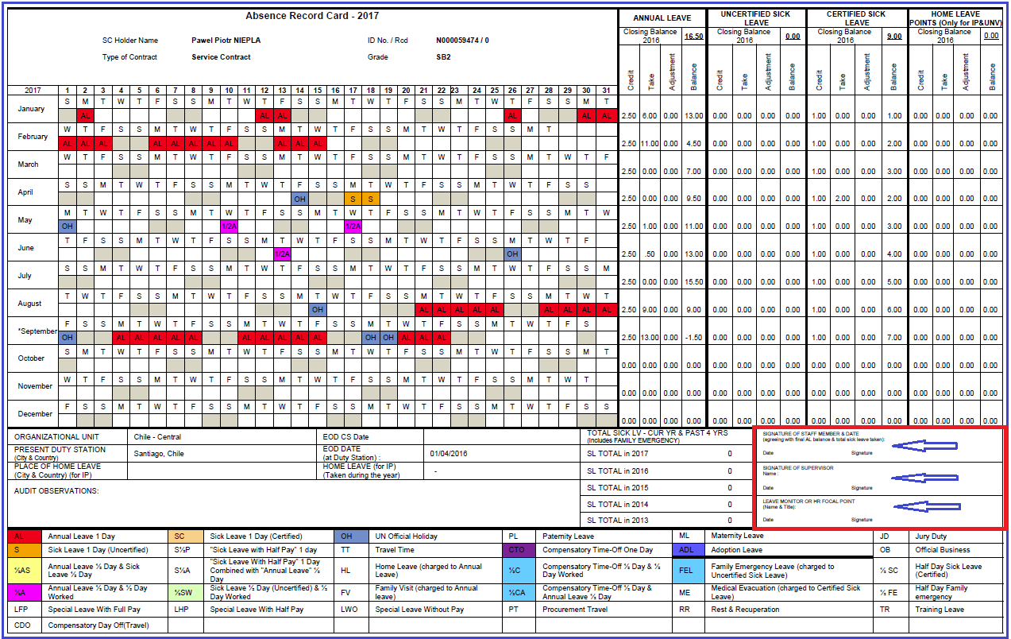

Who are the signatories on the absence record card
The absence record card should be signed by following on an annual basis:
- SC Holder (agreeing with final AL balance and total Sick Leave taken)
- Supervisor
- Leave monitor or HR focal point

Holiday and Work Week Schedules

How to view/assign/adjust the holiday schedule
The holiday schedule based on the duty station is assigned to SC holders. The holiday schedule is located on Atlas HCM: Workforce Administration - Job Information - Job data page. If you have an HR profile, you will be able to view and edit this. The HR Administrator assigns the holiday schedule upon hire of the SC holder in Atlas.
If you have an HR profile, you can view duty station’s holiday schedule in Atlas HCM: Set Up HRMS - Common Definitions – Payroll - Holiday schedule. You can modify the existing holiday schedule for your CO (override the existing entry if there is a need to correct an error), remove and/or add a new holiday event by clicking on “+” and “-”boxes.
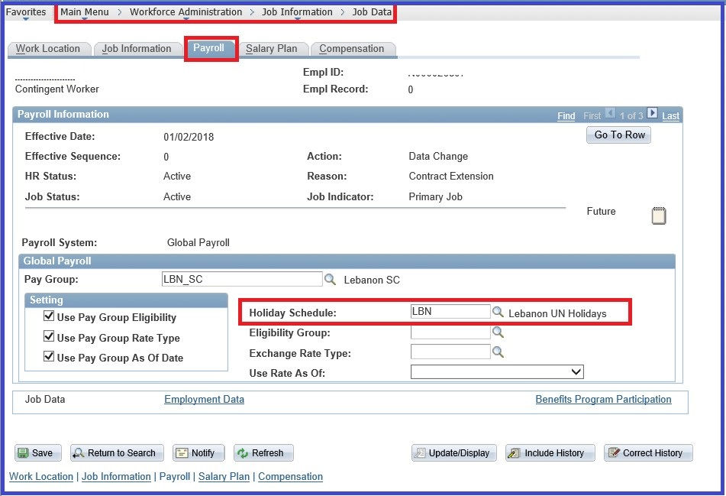
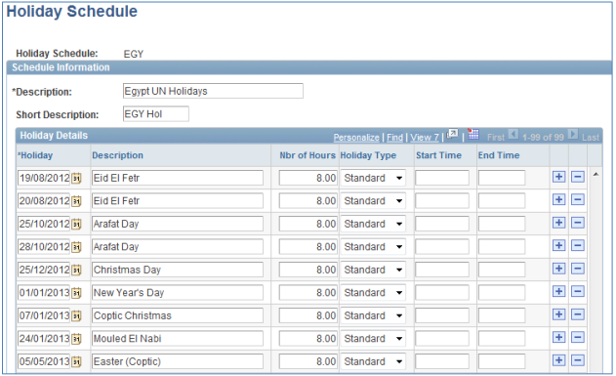

If you don’t have an HR profile, there is a ‘public’ query where you can view the holiday schedule using the query UN_HOLIDAY_SCHED_DETAILS. Enter “%” for all countries or click the prompt button to select a country and enter From and To date.

How to assign two different holiday schedules
Please contact your Regional Payroll Associate focal point in GPS/Copenhagen if there is a need to have two holiday schedules for one duty station.

How to assign Work Week Schedule
Please contact your Regional Payroll Associate focal point in GPS/Copenhagen if there is a need to assign a different work-week schedule other than the default one for your duty station.

Reports and Queries

Which query is the best to run to see monthly absence report by department or country
We recommend running the query UN_CUR_LEAVE_BAL_DEPT_LOC. This query gives the latest leave balances as of the last processed payroll status.
Please follow the navigation below to run the query:

Review of the absence reports and leave balance for the SC Holder
As mentioned in Q.18 you may run a query UN_CUR_LEAVE_BAL_DEPT_LOC to have an overview of the SC leave balances.
There is also a query UN_ABSENCE_EVENT_ESERVICE that will show when leave was submitted, when it was approved or denied and who approved/denied it:
Besides, the Absence Event page, although not a report, can give you a good overview on the leave takes of a particular SC holder.
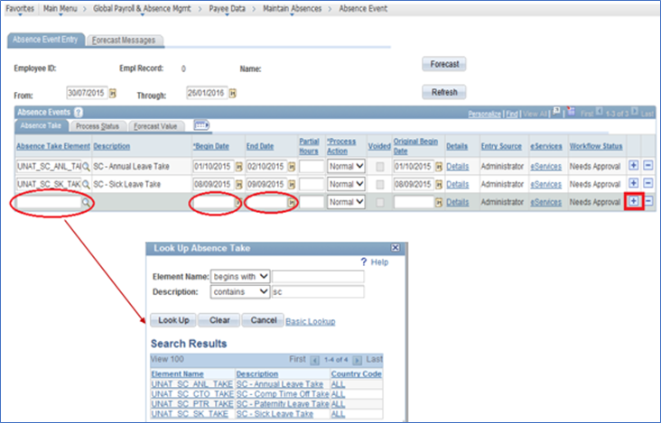
SC holders are advised to view their attendance reports and leave balances on regular bases through the reporting tools available on the main page of the e-Services/My Leave
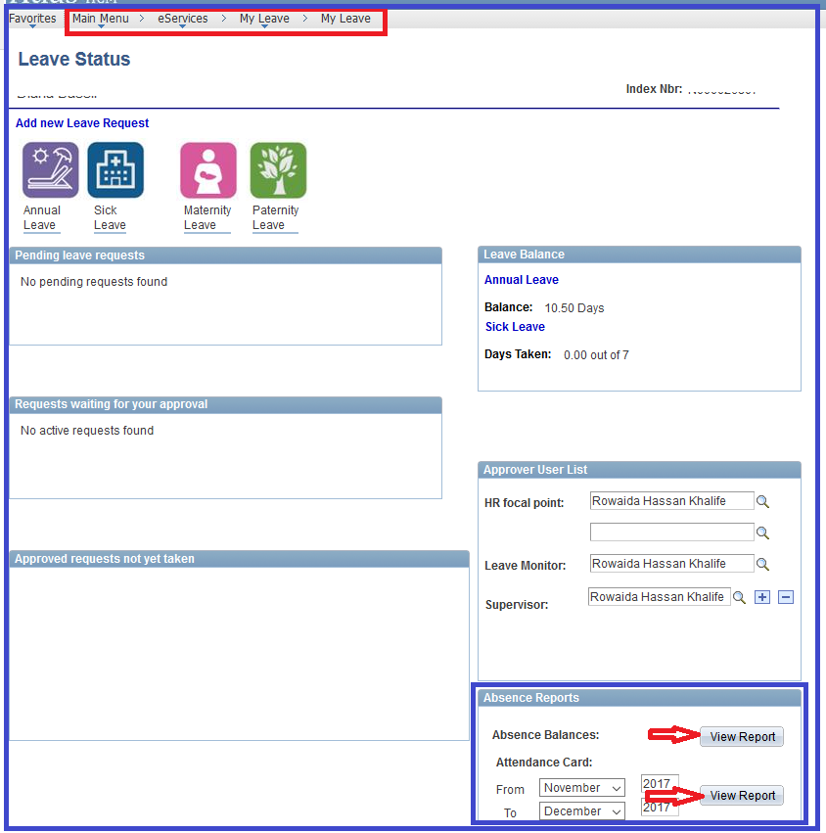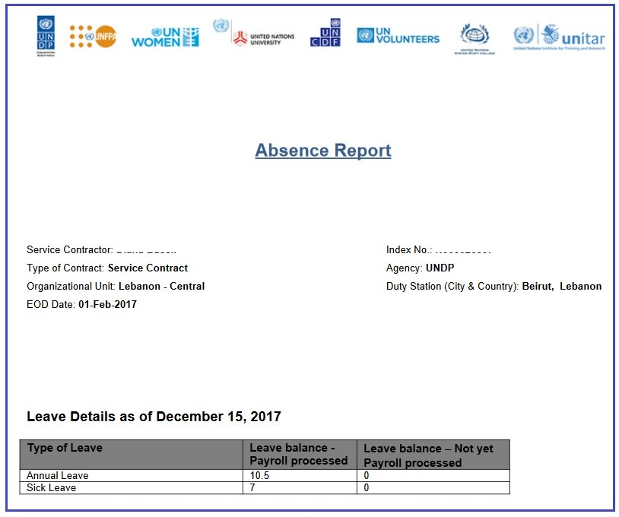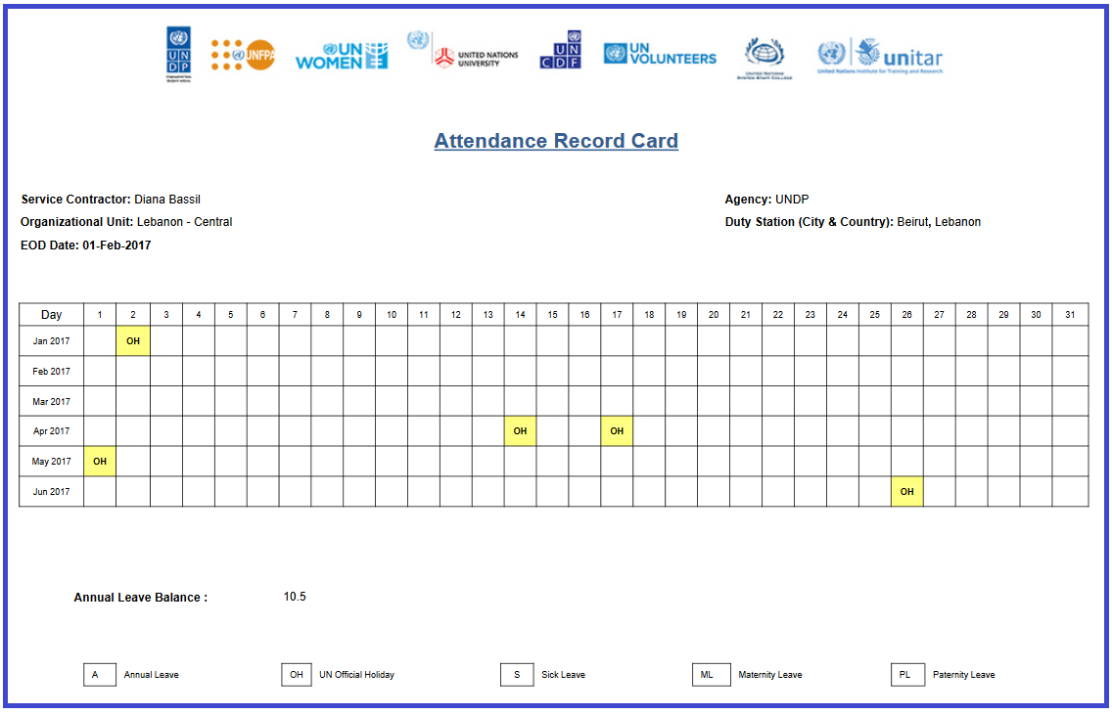

Miscellaneous

Do we still need to use the paper forms for leave management?

Yes, for some SC leave types (e.g. CTO, official business, absence without remuneration etc.) you would still need to use the paper forms based on the practice established in your office and they need to be attached to the attendance record card. These are the leave types not yet in e-Services.

Do we need to keep sick leave certificates
For those SC holders who do not have access to eServices and whose leaves are still administered via the paper based processes, it is required to keep all the respective attachments (ex. the medical certificates, etc) in HR files for audit purposes.

How to record an official business in Atlas HCM
Official business mission for SC Holders is not yet part of e-Services module, hence it should be recorded either outside of Atlas HCM using a paper form based on the established practice in your office, or the leave monitor can enter the respective absence take on the Absence Events page in Atlas HCM (See Q.7 on how to make an entry on the Absence Events Page).

How to record claim of CTO for SC? What supporting documents should be kept in files?
Compensatory Time Off (CTO) is not part of e-Services module. The leave monitor can record the CTO in Atlas on the Absence Events Page (See Q.7 on how to make an entry on the Absence Events Page).
Same as overtime, CTO is applicable only to SB1-SB3 levels and shall not exceed 40 overtime hours per month. Where local practice favours CTO, subject to exigencies of service, SCs shall be compensated on the basis of one and half the normal rate. The CTO must be utilized within four months following the month in which the overtime work is done, otherwise it is forfeited.
Overtime/CTO must be requested and approved by the supervisor in advance of the extra work period to be performed, subject to the availability of funds and exigencies of services. Hence, the respective approval as well as overtime request forms should be kept in files.
- Will the absence without remuneration be administered through Atlas absence module?
Absence without remuneration will continue to be handled at the CO level as an option that needs to be reviewed by the Office management and approved on an exceptional basis if it is in compliance with the SC guidelines. The HR focal point then records the period Absence without remuneration in Job data.

