User Guide
for Service Contract (SC)
Atlas eServices

Table of contents

1. How to get started: Log in and Enter the name of your Supervisor, HR Focal Point and Leave Monitor 2
2. Submit an Annual Leave request 7
3. Submit a Paternity Leave request 13
4. Submit a Sick Leave request 15
5. Submit a Maternity Leave request 20
6. Common Absence Features 22
6.1. Save an Absence Request 22
6.2. View Monthly Schedule (Holiday and Weekend schedule) 23
6.3. View Absence Request History 26
6.4. View Absence Balances 29
6.5. Edit an Absence Request 31
7.1. Approve an Absence Request (as a Supervisor) 34
7.2 Checklist for SC holders 40
8. Monitoring Leave (for Leave Monitors) 41
8.1. The role of the Leave Monitor 41
8.2. Create an Absence Report 41

How to get started: Log in and Enter the name of your Supervisor, HR Focal Point and Leave Monitor

The HR eServices Leave Module is located in Atlas HCM, link: https://hr.partneragencies.org.
An Atlas user name is required to access. If you have a user name, but do not remember credentials click “Forgotten Password” and follow instructions.

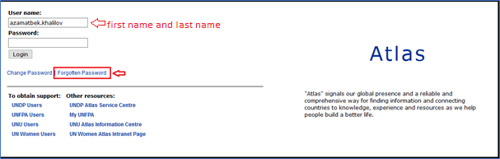

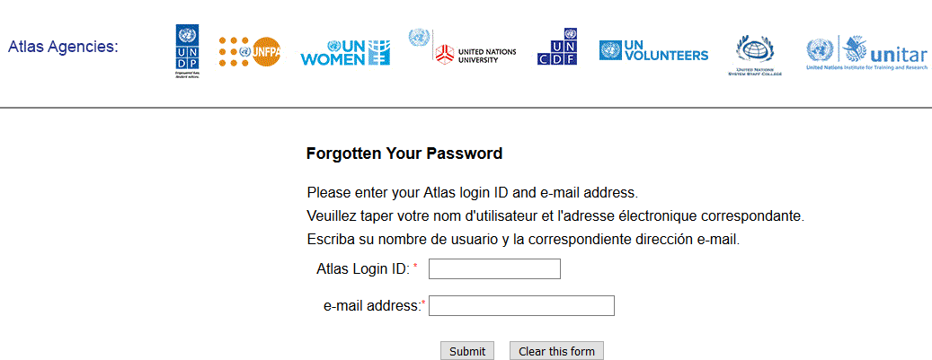

A temporary password will be sent to your business e-mail address within a few seconds. You will then be prompted with a page where you can enter a new password. You will then need to use the new password the next you access Atlas eServices.
If you do not have access to eServices or to Atlas at all, contact your HR focal point to coordinate creating a profile for you through the office Argus focal point.
UNFPA and UNWOMEN should contact their own Agency focal point.

- Once you have logged into Atlas HCM click the folder eServices.

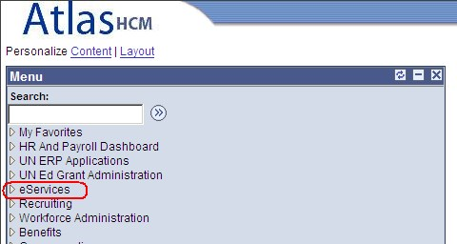

- Click the folder My Leave, and the sub menu My Leave. You will see 4 different icons representing the different types of leaves which are available for SC holders under eServices.
- Annual Leave
- Sick leave
- Maternity leave
- Paternity leave

You will also see applicable leave balances for Annual Leave and Sick Leave showing at the right side of the page.

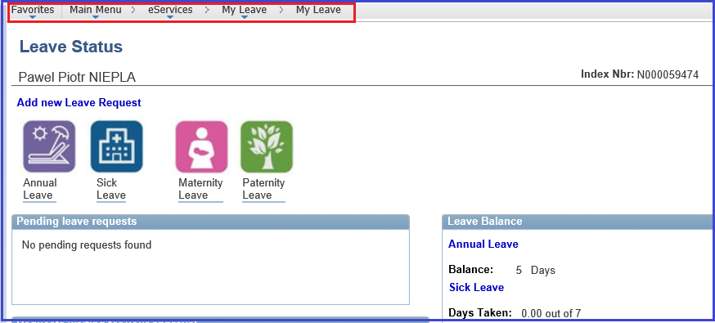

- Prior to submitting a leave request via eServices, you should to fill in the name of your Supervisor, HR Focal Point and Leave Monitor in the box Approver User List. If in doubt, please ask your local HR office to clarify who is your HR Focal Point and Leave Monitor.
You only need to do this once. Once you filled in the names, it will be saved for the next time you want to apply for leave. If needed, you can edit it at any time.
If the names cannot be located then use the search function by clicking the search symbol. You can add up to 3 supervisors if applicable or you can add the name of the person who will approve leave if your current supervisor is away from the office. Click the + sign to add a supervisor.

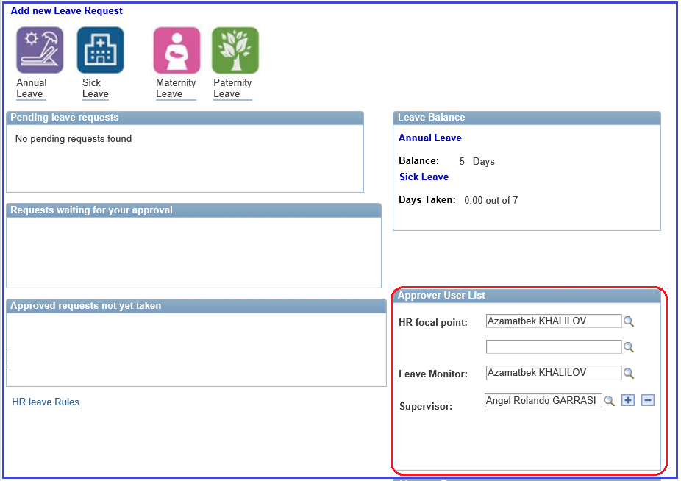

When you click the search symbol you can locate a person by different criteria. In this example, the
Last Name is used. Once the Last Name is entered click Look Up and a list of names will appear to select from.

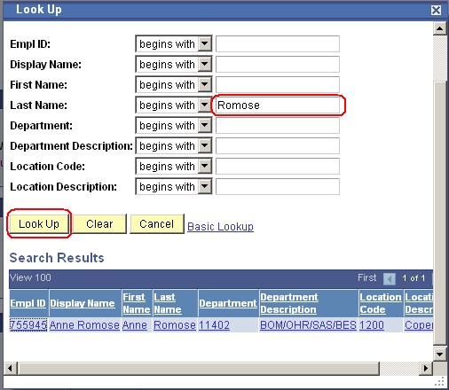

Once you have filled in the names, click Save

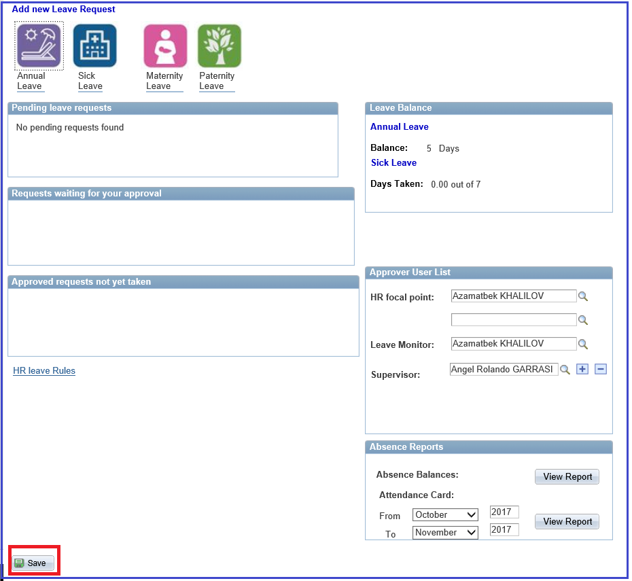

Submit an Annual Leave request

- Log into Atlas HCM (the HR module in Atlas) and click eServices, My Leave and then the sub menu My Leave. Fill in the names of the HR Focal Point, Leave Monitor, and Supervisor by following the steps described under: How to get started

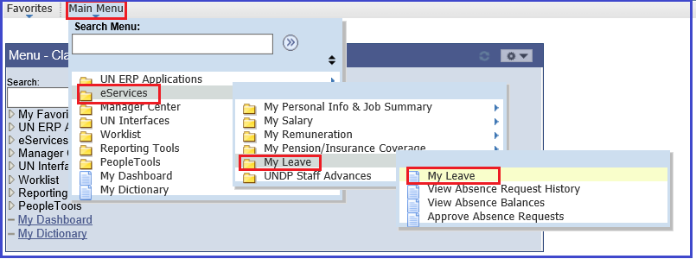

You will notice that your annual leave balance is showing on the right side of the main page. Note that this is the balance as of the last finalized payroll month, and does not include the annual leave taken during the current month, if the payroll is still open.
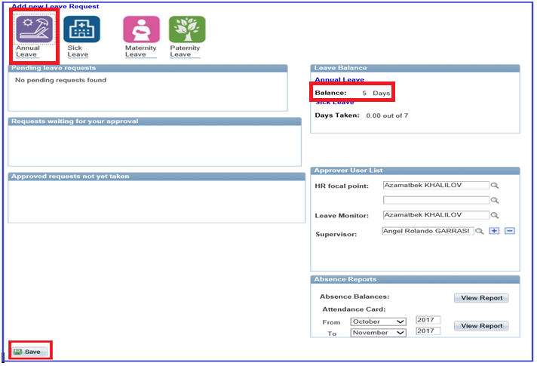

Click the icon for Annual Leave

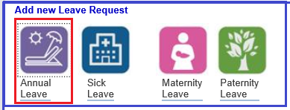

- Enter the Start Date and End Date.
Please note that the Start Date or End Date cannot be on a weekend or an official holiday.
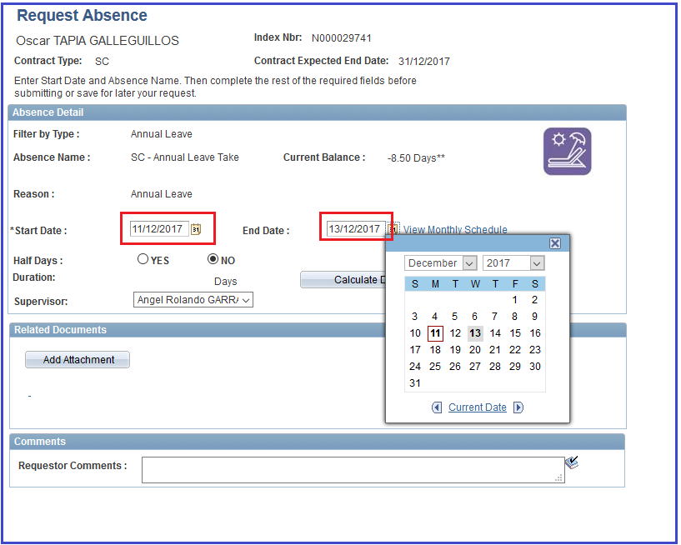
- If applicable click Yes for Half Days. Select Half Days Options as applicable.
Note that the half days will not indicate if taken in the morning (AM) or in the afternoon (PM), so you can use the comment field for this.
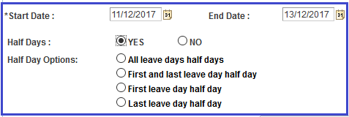

- Click Calculate Duration tab and it will calculate the number of Annual Leave days you are requesting.

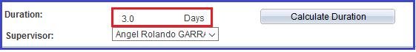

- Select Supervisor. The names available will be the names you specified in the previous page when filling in the Approver User List.

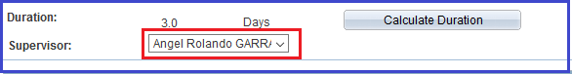

- Add any relevant comments. In the case below relevant information is the backstopping arrangements while you are on leave and specification on the Half Annual Leave takes period.
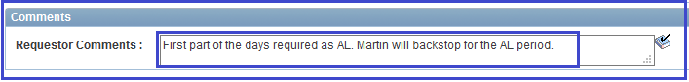
- You have the options to:
- submit the request to your supervisor right away by Clicking the Submit button or
- save the leave request for later submission by clicking Save for Later button

Note: If you do not receive this message and you do not receive an email confirming the submission of your leave request, it means for some reason the request was not submitted correctly. Please try to submit it again. If this request does not go through again please contact ps.support@undp.org.

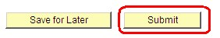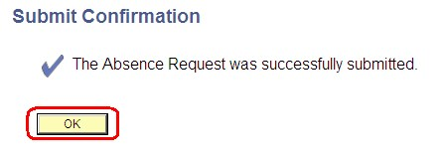

You will receive a message that the absence was successfully submitted. Click
OK

- Once you click OK you will receive a confirmation email. This is to confirm that the leave request has been submitted correctly. See example below.

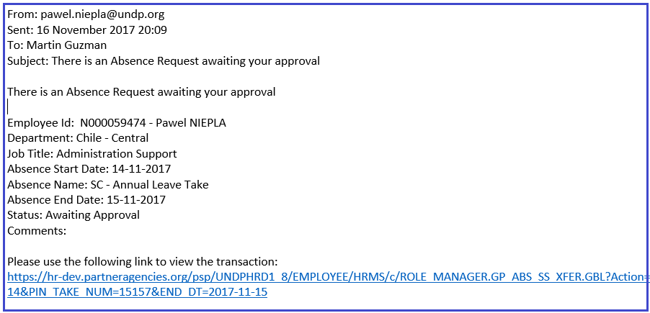

- At the same time an email is forwarded to the Supervisor for approval. See example below.

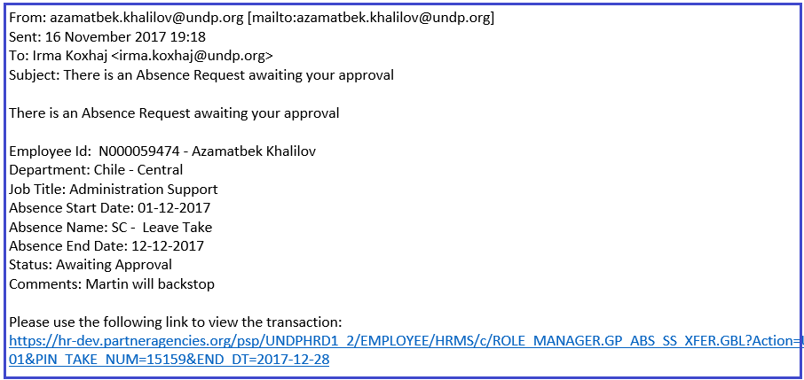
- Once the Supervisor has approved the Annual Leave in Atlas eServices you will receive an email notification the leave has been approved, and the status of the Annual Leave will change from Submitted to Approved.
At the same time the Leave Monitor will be copied on this email.

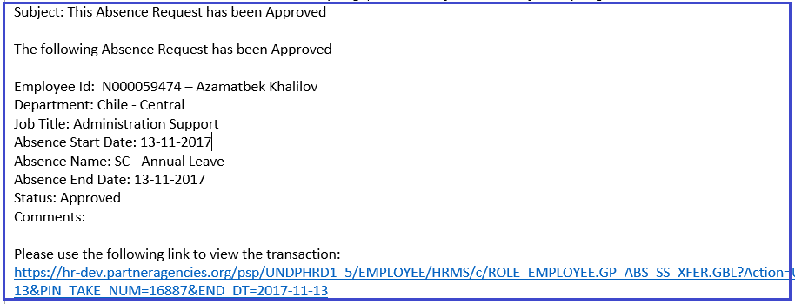
- Your Annual Leave balance will be updated with the approved leave request, once payroll is finalized. This takes place in the end of the month, and your new balance will appear in the Statement of Earnings and Deductions. You can read more on how to view your leave balance in the section View Your Balance in this document.

Note. When the Service Contract is extended for an additional period, it is possible that the SC may be allowed to carry an accumulated annual leave to a maximum of 18 days. This is automated in the system, hence you will notice that on the first month of your contract extension, your annual leave balance will show 18 days.
The accumulated annual leave must be used within the contract period, otherwise it is forfeited upon separation. In case of re-hire of an SC to a new position, the AL will start to recalculate from 0.

3. Submit a Paternity Leave request

- Log into Atlas HCM and fill in the names of the HR Focal Point, Leave Monitor, and Supervisor by following the steps described under: How to get started

- Enter the Start Date. Note that the End Date will default to 28 days later and holidays are not considered. Holiday schedule will not affect the calculation. For Paternity Leave it is possible to take less than 28 days or divide the 28-day period into two periods. Amend the End Date if applicable.
Note:
- Paternity Leave days are not deducted from Annual Leave.
- A message will show on top of the request page informing the SC holders on the Eligibility criteria. As you see, SC holders “must have had at least 6 months of service with UNDP at the time of the birth of the child.” If you are eligible to apply for PL, you can continue with the next step.
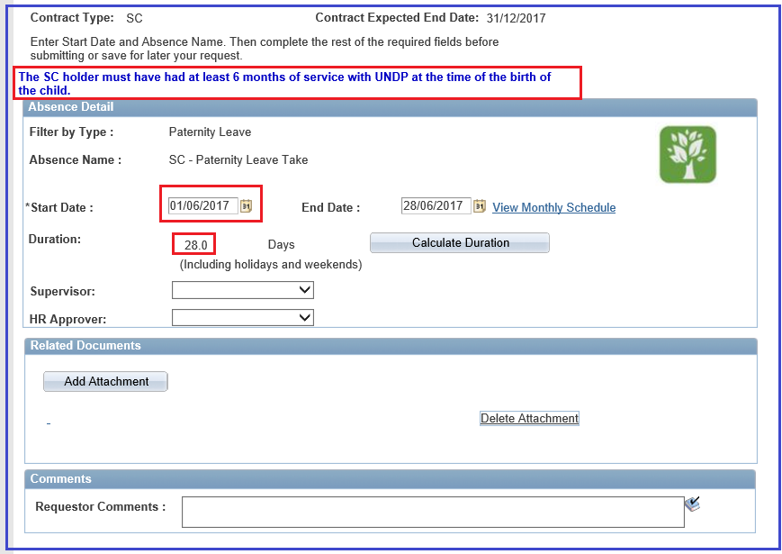

g. Select the supervisor:

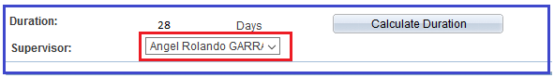
- Click the Add attachment to upload relevant and required documentation. Required documentation for a Paternity Leave would be a birth certificate for the new-born child
- Click Browse to upload relevant and required documentation, locate the document you want to upload and click Upload
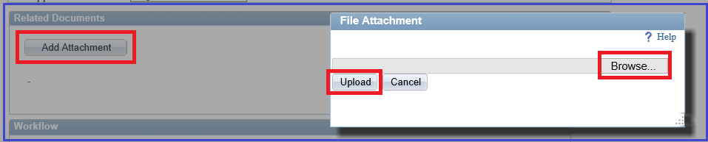

- The uploaded document(s) will now appear in the list. Fill in comments as applicable.
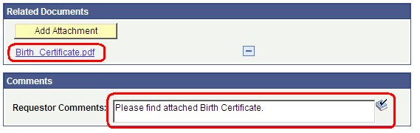

- Click Submit to submit Paternity Leave for approval.

l
. You will receive a message that the absence was successfully submitted. Click
OK

Note: If you do not receive this message and you do not receive an email confirming the submission of your leave request, it was not submitted correctly for some reason. Please try to submit it again. If this does not work please contact ps.support@undp.org.

- E-mail Notifications:
Paternity Leave requires approval of both the supervisor and the HR focal Point.

- Once you submitted the leave request you will receive an email that the leave has been submitted.
- At the same time, an email is forwarded to your supervisor for approval.
- Once approved by your supervisor, an email is forwarded to the HR Focal Point for final approval of eligibility for Paternity Leave and confirmation that required documentation has been received.
- When approved by the HR Focal Point you and the Leave Monitor will receive confirmation.

4. Submit a Sick Leave request

- Log into Atlas HCM and fill in the names of the HR Focal Point, Leave Monitor, and Supervisor by following the steps described under: How to get started
- Click the folder My Leave, and the sub menu My Leave. Click the icon for Sick Leave
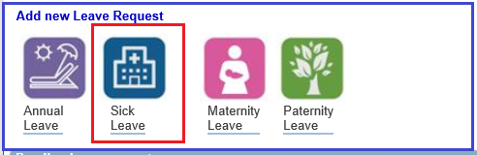

- Select in the dropdown Filter by Type if it is Certified Sick Leave or Uncertified Sick Leave
Uncertified Sick Leave USL is part of the sick leave and is counted as part of the SL entitlement: 3 days in total for the 12 months of contract period including amendments. USL days are deducted from the total balance of the Sick Leave.

- Select in the dropdown Absence Name the applicable leave: Certified Sick Leave or Uncertified Sick Leave the Absence Names

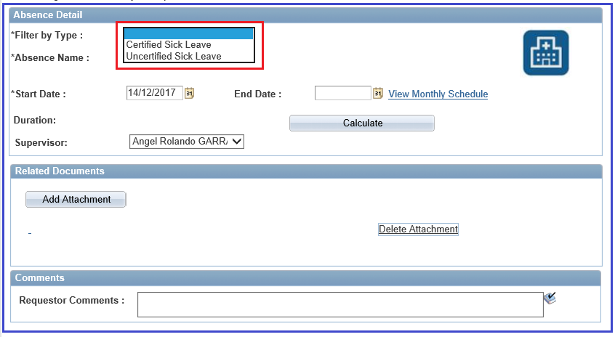

- Once the Leave Type is specified, the Absence name is populated automatically. In the case below when Uncertified Sick Leave is selected, the absence Type SC-Sick Leave Take appears.

Note: 3 days or less can be used as USL and there is no supervisor approval. If you select more than 3 days as uncertified sick leave, an error message occur and the absence cannot be requested. See screenshot below.

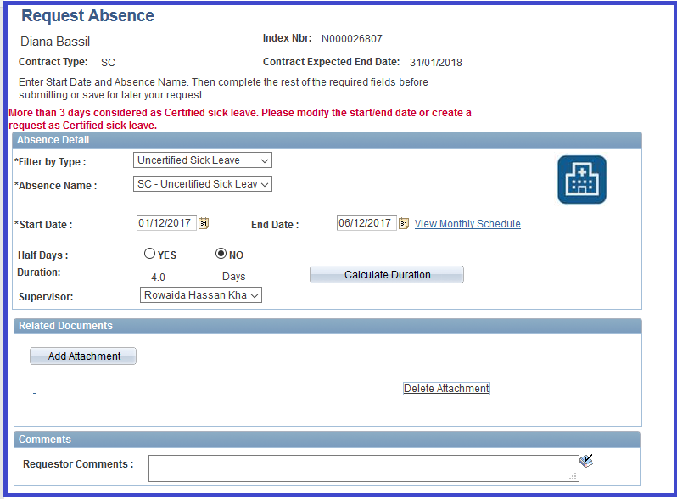

- When you request Certified Sick Leave the SC- Sick Leave Take will automatically appear under the Absence name field. You will also notice that the Current Balance of Sick Leave shows. This is the sick leave balance for the period from your contract start date up the last finalized payroll.
If you need to apply for SL and use the entitlement for your entire contract period, contact your HR focal Point who will advise you on the necessary actions that need to be taken.
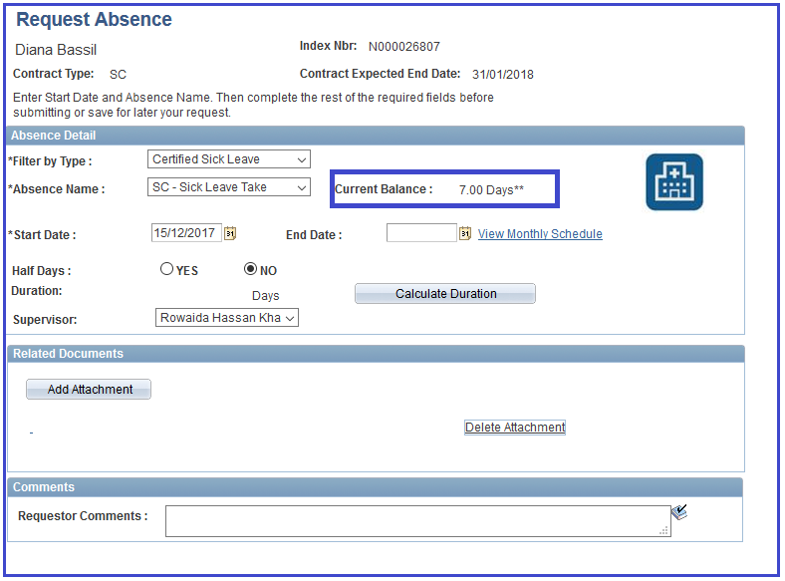

- To apply for SL, select the Start Date and End Date (Half Days are possible) and click Calculate Duration

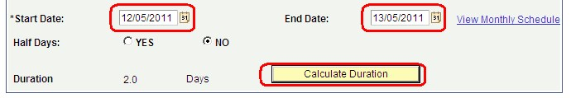

- Click Add Attachment to upload relevant and required documentation if applicable.
Required documentation for Certified Sick Leave will be a Doctor’s medical certificate. If you do not have the certification at the time of requesting the Certified Sick Leave, a medical certification should be submitted to your Leave Monitor upon return to the office.
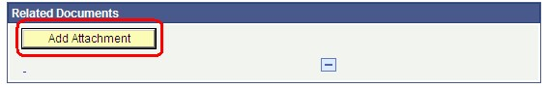

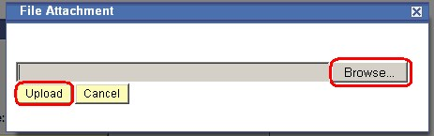
j
. Click
Browse
, locate the document you want to upload and click
Upload

- The uploaded document(s) will now appear in the list. Fill in comments as applicable.
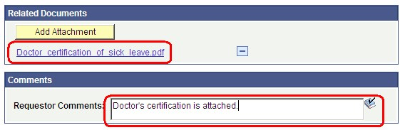

- Click Submit to submit Sick Leave

- You will receive a message that the absence was successfully submitted. Click OK

Note: If you do not receive this message and you do not receive an email confirming the submission of your leave request, it was not submitted correctly for some reason. Please try to submit it again. If this does not work please contact ps.support@undp.org.

- Email Notifications for Sick Leave:
- Once you submitted the Sick leave request you will receive an email that the leave has been submitted.
- A notification is also sent to your supervisor who needs to review and approve.
- You will be notified via e-mail once the SL is approved.
- At the same time an email is forwarded to your Leave Monitor for their information and records.

5. Submit a Maternity Leave request

- Log into Atlas HCM and fill in the names of the HR Focal Point, Leave Monitor, and Supervisor by following the steps described under: How to get started

- Click the folder My Leave, and the sub menu My Leave

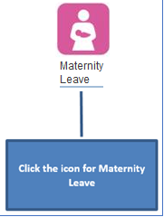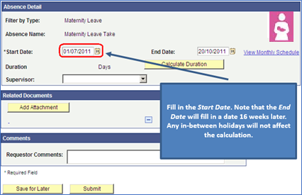

g. Fill in the Start Date. Note that the End Date will fill in with a date 16 weeks later. The Holiday schedule will not affect the calculation. Half Days Option is available for Maternity Leave. Contact your HR focal point for more information.

- Click Add Attachment to upload relevant and required documentation. Required documentation for a Maternity Leave will be a certificate from a licensed practitioner or midwife attesting the pregnancy and indicating the anticipated date of birth.

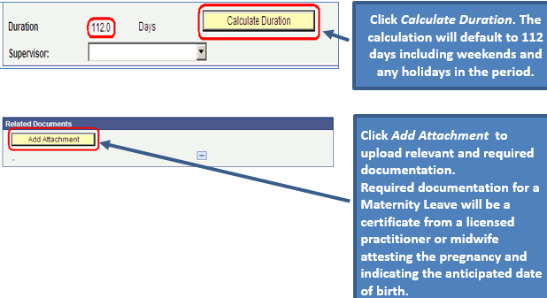

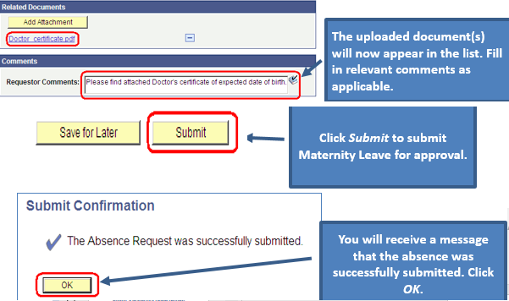

- Click Submit to submit Maternity Leave for approval.

n. You will receive a message that the absence was successfully submitted. Click
OK

Note: If you do not receive this message and you do not receive an email confirming the submission of your leave request, it was not submitted correctly for some reason. Please try to submit it again. If this does not work please contact ps.support@undp.org.

Note. Email Notifications:
- Once you submitted the Maternity Leave request you will receive an email that the leave has been submitted.
- At the same time an email is forwarded to your supervisor for approval.
- Once approved by your supervisor, an email is forwarded to the HR Focal Point for final approval of Maternity Leave and confirmation that the required documentation has been received.
- When approved by the HR Focal Point you and the Leave Monitor will receive confirmation of approval.

6. Common Absence Features

6.1. Save an Absence Request

For all absences you may decide to Save the request for later submission.

- If you click Save (instead of Submit) you will receive the following on-screen confirmation.
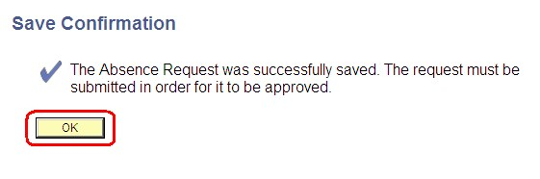

- The next time you log on to My Leave, your saved request(s) will show under Pending Leave Requests. The status will show ‘Saved’.

- If you click the link, the saved leave request will open. You can now Submit it as you would normally do or edit if needed and then submit.

6.2. View Monthly Schedule (Holiday and Weekend schedule)

- For all absence requests you can view the monthly schedule. In the link View Monthly Schedule you can view the Holiday schedule, the Weekend schedule and the planned absences.
Note: In UNDP we operate with different Holiday schedules. Some holidays are common to UNDP and are shared with all offices, but some are specific to the country you are working in. The holidays you can see in View Monthly Schedule will both be the common UNDP holidays, as well as the holidays specific to your duty station.
In addition we work with 4 different weekend schedules – Thursday/Friday, Friday/Saturday, Saturday/Sunday and Sunday/Monday. It is important that you are on the correct weekend schedule, otherwise your balances may calculate incorrectly.
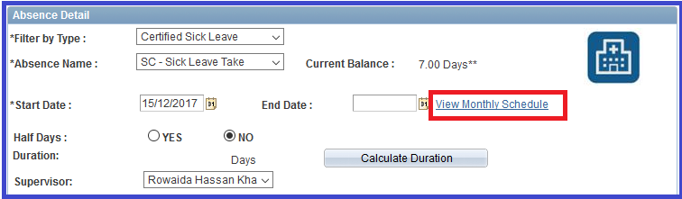

- If you click the link View Monthly Schedule the following will appear. You will note that there are different symbols for Holidays and Planned Absences . Note that in this example, the weekend is Saturday/Sunday.
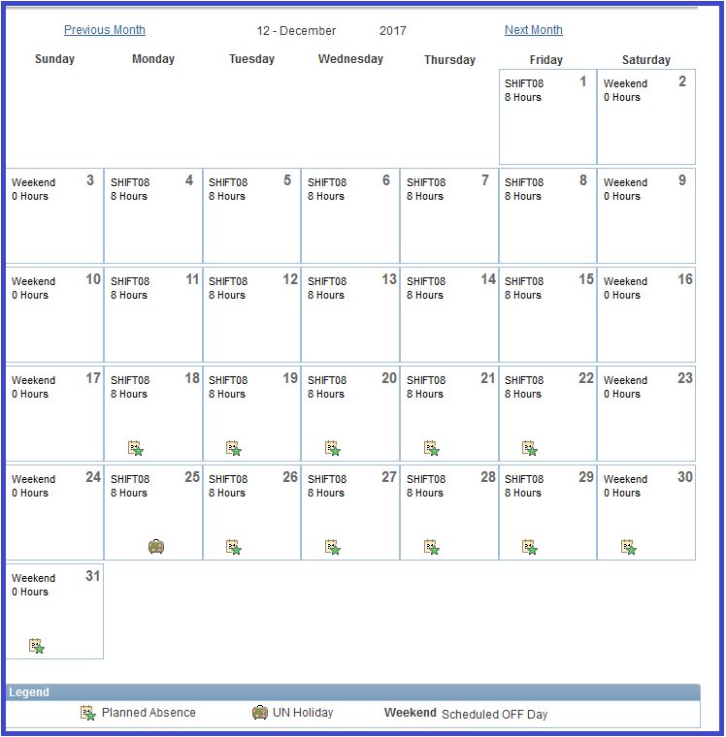
- If you request an absence where the absence starts or ends on a holiday or a weekend, you will receive the following error notification. Note that this is not applicable for Maternity and Paternity leave. For these absences the period may start or end on a holiday or a weekend.

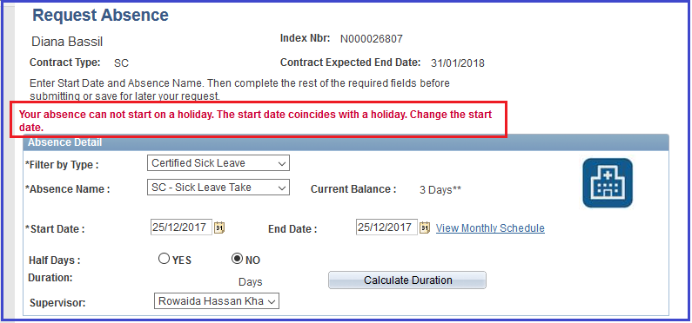

6.3. View Absence Request History

- You can view the absence history in the link Absence Request History in the left menu or View Absence Request History in the bottom of the leave request.

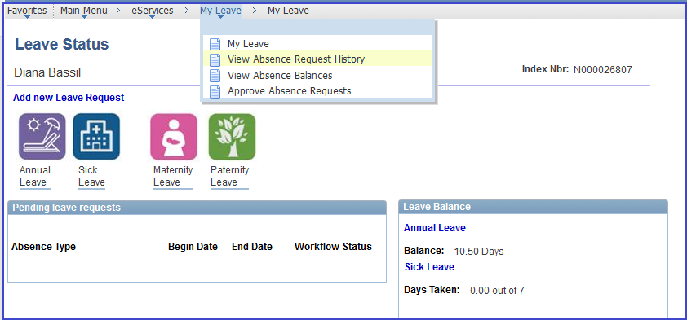

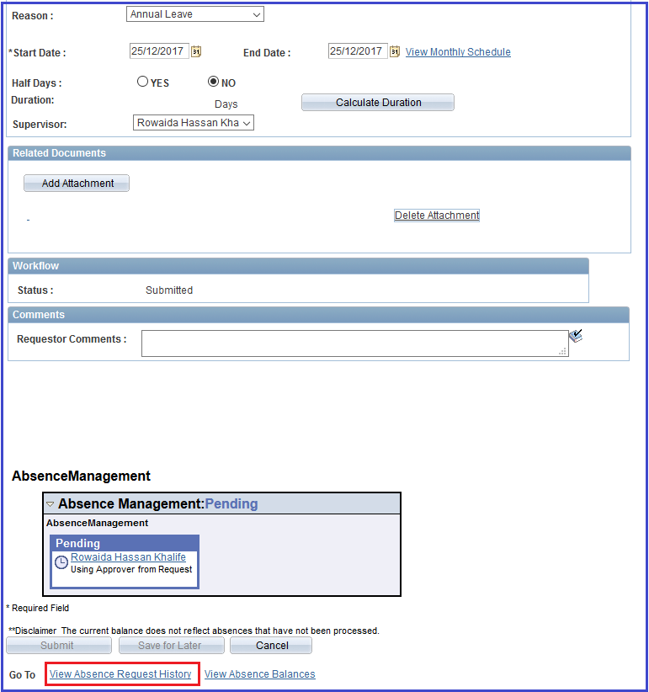

- When you click the link View Absence Request History you will see the following screen.
Note: Even though there is an active Edit button you can click on, it is not always that you can edit it. From the time when you have submitted a leave, and until it has been approved or denied, it is not possible to edit (it will in this period have the status Submitted). In this period it is only possible to cancel the leave request.
If the absence has been approved, denied/Re-work then you can click Edit to edit the request. If you edit the request, and submit it again, it will start over with the approval process; meaning that an email will go to the supervisor for approval, etc.
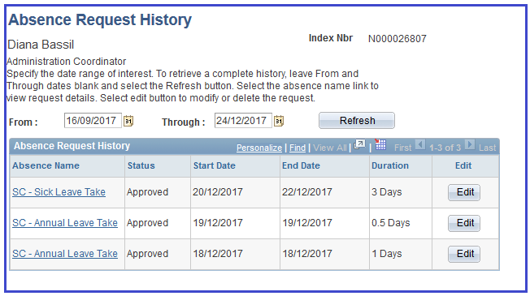

6.4. View Absence Balances

- You can view your absence balances by clicking the link Absence Balances on the menu or the View Absence Balances that will appear in the bottom of the absence window.
Note: The absence balances are updated when the Payroll Process is run. So even if you have an approved absence in the system, it will only be reflected in the balances when the Payroll Process is run.

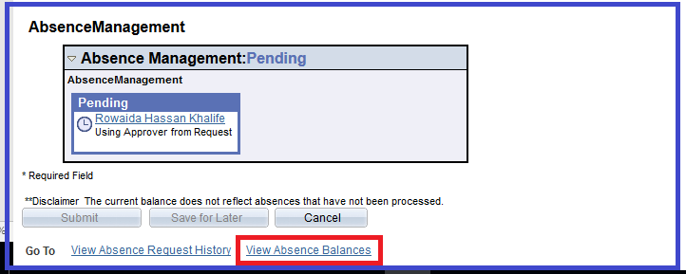

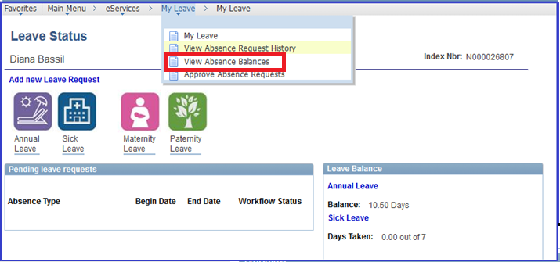

- When you click Absence Balances you can view the balance of your absences.

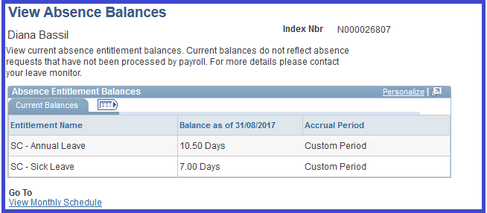

6.5. Edit an Absence Request

a. To edit a leave click the left menu Absence Request History.

- You cannot edit a leave that has the status Submitted. At this time, the leave can only be cancelled.

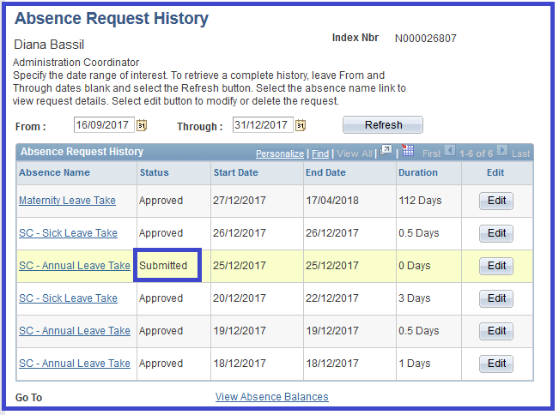
Note: From the period that you have submitted the leave and until your supervisor has approved or denied it, you cannot edit a leave. The option you have is to Cancel the request. The leave request will then get a status of Rework. Once it has the status of Rework you can edit the request. Or you can wait for the request to be approved or denied. Then you can also edit it.

- You can edit a leave that has the status Approved, Denied, Rework or Saved.

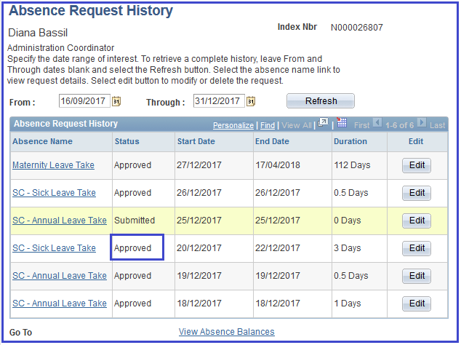

Note: If you edit a leave request that has been approved, denied or cancelled, it will need to be reapproved. A new email will therefore be forwarded to your Supervisor, etc.

7. Approve an Absence Request

7.1. Approve an Absence Request (as a Supervisor)

- To approve an absence request as a supervisor, you can either click the link in the bottom of your email notification
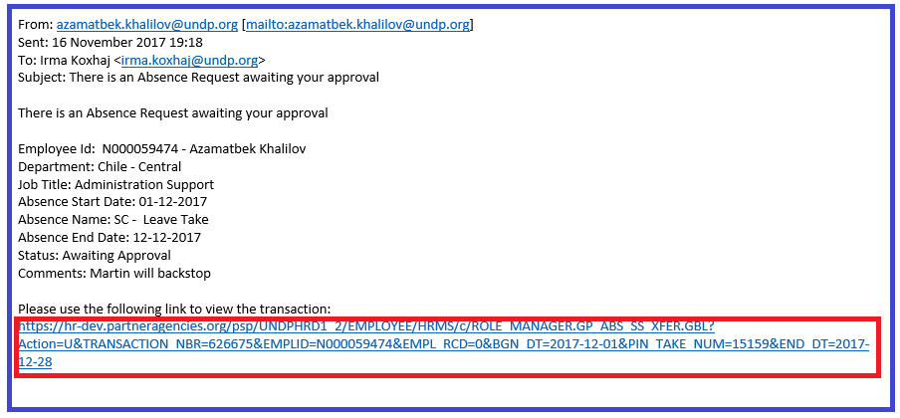

You can also log into Atlas HCM (the HR module in Atlas) and click the folder eServices/My Leave/Approve Absence Requests or directly to the link of the page Approve Absence Requests. In this page you will see all the Leave requests that have been submitted for your review/Approval.

- The Absence Requests window defaults to ‘Pending’ absence requests. In addition, you can also select ‘Approved’ or ‘Denied’ absence requests.

- Click the Name of the requestor to either view, approve or deny the request.

- When you click the Name the specific Absence Request will open up.

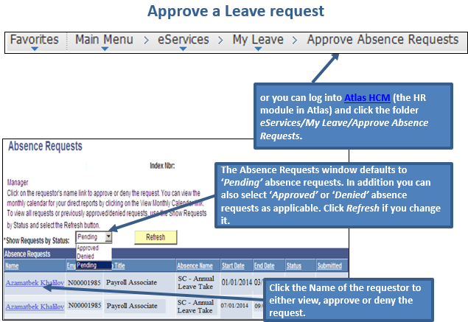

Important! Take note of the important warning messages:

- In case the contract is extended for an additional period, the SC holder may be allowed to carry an accumulated AL to a maximum of 18 days.
- In case the contract will not be extended further, any unused accumulated AL days cannot be commuted to cash: the AL days can be used within the contract period, otherwise they are forfeited.
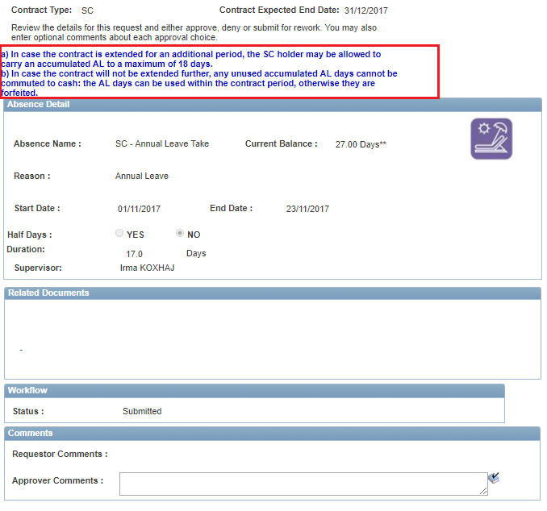

- If you click Approve you will be asked to confirm the approval.
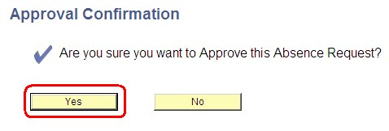

- If you click No to this Approval Confirmation you will be taken back to the absence request. If you click Yes you will receive an on-screen confirmation. Click OK
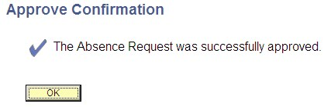

- In addition to the on-screen confirmation you will also receive email notification that it has been approved.
Depending on the type of absence various ‘roles’ will be notified:
  - For Annual Leave and Sick Leave: the SC Holder and the Leave Monitor will be notified
  - For Maternity and Paternity Leave the notification is sent to the HR Focal Point also. Once approved by HR, the SC Holder and the Leave Monitor will be notified.

9b. Approve a Maternity Leave Request (as HR Focal Point)

- The approval flow for a Maternity Leave Request is that it first forwarded for approval to the Supervisor. Once the Supervisor approves the leave an email is forwarded to the HR Focal Point for review of the Eligibility criteria. The link in bottom of the email will take you directly to the leave request.
- or you can log into Atlas HCM (the HR module in Atlas) and click the folder eServices eServices/My Leave/Approve Absence Requests.

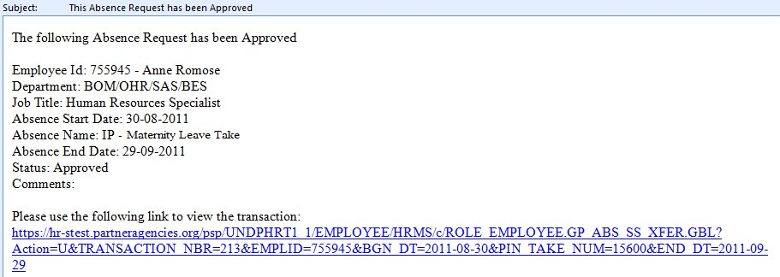

- To process Maternity Leave you will need to ensure that the SC Holder is eligible, that required documentation has been received (medical doctor or midwife certification of expected date of birth), and contract period is sufficient to cover the Maternity Leave.

- Best practice when you receive a ML request for processing is to inform the SC Holder on the process going forward. A way to save time is to insert the standard email for ML within the Leave Modules text box for approver comments. The staff member will then receive this information automatically with the approval notification.
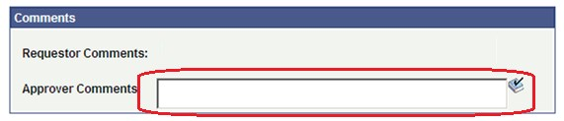

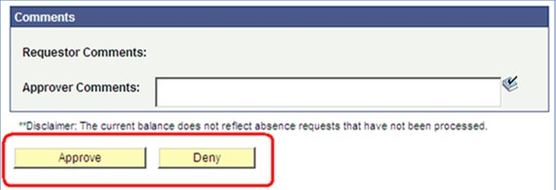

- If you click Approve you will be asked to confirm the approval.

- If you click No to this Approval Confirmation then you are taken back to the particular absence request. If you click Yes you will receive an on-screen confirmation. Click OK

- In addition to the on-screen confirmation you will also receive email notification that it has been approved.

7.2 Checklist for SC holders

This e-mail introduces you to some of the main aspects to be aware of when applying for Maternity Leave. The best place to start is to contact your HR Focal point to confirm the Maternity Leave Entitlement in your office. Normally the minimum entitlement is 16 weeks of leave with full pay.

PREPARING FOR MATERNITY LEAVE
The following documents should be submitted to this office prior to the delivery date:
- The online request for Maternity Leave should be send to your supervisor for approval least 3 months in advance of the expected delivery date. A certificate from a licensed practitioner or midwife attesting the pregnancy and indicating the anticipated date of birth should be attached to this online request. (Mandatory)
- Maternity Leave may be postponed to less than six weeks before birth (no later than two weeks before birth however). However, this requires a certificate from a licensed medical practitioner or midwife that indicates that that the staff member is fit to work. (Mandatory if applicable)
AFTER BIRTH
If you are covered under Cigna Medical Insurance, you have the option to add your new born baby in the Medical Insurance plan. For that, Service contract holders should use the SCH request for change form from CIGNA (also available in French and in Spanish).
Insurance form (to include child in insurance, should be submitted within 30 days after birth, otherwise the child can only be enrolled during the annual UN Insurance enrolment campaign in June/July of every
For insurance and reimbursement of medical expenses contact your HR focal Point for a copy of Cigna Brochure.

Please do not hesitate to contact your HR office if you have any questions.
.

8. Monitoring Leave (for Leave Monitors)

8.1. The role of the Leave Monitor

Please note that the roles of HR Administrator and Absence Processor can be combined, hence it is possible for same person to be both HR focal point and leave monitor for SC holders.

- And for unforeseen reasons, there may be a need to assist with adjusting leave balances.

8.2. Create an Absence Report
a. You can create an Absence Report from Atlas / UN Reports => Global Payroll => Absence Reports (see below) or the direct link Absence Reports. In this you can specify if you want to view the leave report for the whole office, just a specific department or where you are the Leave Monitor or the Supervisor.
